Smarter Balanced Assessment Consortium

Administration and Registration Tools User Guide

Updated **October 27, 2014**

Contents

Overview of the Administration and Registration Tools System 7

Interrelation between the Administration and Registration Tools System and other Smarter Balanced Systems 7

User Roles and Permissions 7

Understanding the Smarter Balanced Hierarchy 11

About Microsoft Excel Files 13

Introduction to This User Guide 14

Test Registration and Administration Checklist 15

Accessing the Administration and Registration Tools System 17

Logging on to ART 17

Switching Between Smarter Balanced Systems (Single Sign On System) 17

Understanding the ART Interface 18

ART Home Screen 18

ART Banner 19

Task Bar. 19

Assessment Tasks 20

Select Tests from the Test Specifications Bank (TSB) 20

Sort the TSB search results. 21

Update a test from the TSB 22

Managing an Assessment 23

Setting assessment attributes. 23

Understanding test eligibility. 26

Explicit eligibility. 26

Implicit eligibility rules. 26

Understanding test windows, delay, and opportunities. 26

Understanding test windows and time zones. 27

Modifying assessments 28

Searching for assessments. 28

Understanding the search results table on the Test Search screen. 29

Modifying an assessment. 29

Exporting assessments 30

Export all assessments. 30

Export selected assessments. 30

Deleting Assessments 30

Test Registration Tasks 31

Creating and Modifying Records in ART 31

File Uploads. 31

Download File Templates. 32

Creating an Upload File. 33

Uploading Files. 34

Creating/Modifying Individual Records. 37

About Data Columns and Edit Fields. 40

Managing Records 41

Managing State Groups. 41

Create or modify state groups. 41

Upload state groups. 42

Managing States. 43

Create or modify states. 43

Upload states. 44

Managing District Groups. 46

Create or modify district groups. 46

Upload district groups. 47

Managing Districts. 49

Create or modify a district. 49

Upload districts. 50

Managing Institution Groups. 52

Create or modify institution groups. 52

Upload institution groups. 53

Managing Institutions. 55

Create or modify an institution. 55

Upload Institutions. 56

Managing Users. 58

Create or modify a user record. 58

Modifying proctor details. 61

Upload users. 62

Managing Students. 64

Create or modify a student. 64

Upload students. 65

Managing Student Groups. 71

Create or modify a student group. 71

Upload student groups. 73

Managing Student Eligibility. 74

Managing Accommodations. 77

Create or modify a student’s accommodations. 77

Upload accommodations. 78

Test Administration Tasks 84

Creating Test Schedules 85

Specifying Proctor Roles. 85

Adding Test Platforms. 87

Adding Accessibility Equipment. 89

Adding Test Facilities. 91

Adding Facility Time Periods. 93

Creating Schedules. 96

Viewing and Modifying Schedule Results. 99

Viewing Test Administration Reports 101

Participation Reports. 101

Participation Summary Reports. 101

Participation Details Reports. 105

Proctor Schedule Reports. 107

Student Schedule Reports. 108

Appendix A. Manage System Settings 111

Client Configuration 111

Manage Subjects 112

Appendix B. Opening a CSV File in Excel 115

Appendix C. Common Errors with File Uploads 116

Appendix D. About the Calendar Widgets 118

List of Figures

Figure 1. Simple Smarter Balanced Hierarchy 11

Figure 2. Smarter Balanced Hierarchy with Groupings 12

Figure 3. Login Screen 17

Figure 4. ART Home Screen for the Client Role 18

Figure 5. Task Bar 19

Figure 6. Test Specifications Bank Search Screen 20

Figure 7. Test Specifications Bank Assessment Search Screen with Update Notification 22

Figure 8. Add/Modify Assessment Information Screen 23

Figure 9. Effect of Test Windows, Delay, and Opportunities 27

Figure 10. Effect of Time Zones on Test Windows 27

Figure 11. Test Search Screen with Search Results Table 28

Figure 12. Download Templates Screen 32

Figure 13. Sample Template for District Records 33

Figure 14. Upload File, Step 1: Choose the File 34

Figure 15. Upload File, Step 2: Preview Records 35

Figure 16. Step 3: Successful Validation 36

Figure 17. Failed Validation 36

Figure 18. Upload File, Step 4: Confirmation 37

Figure 19. Sample Create/Modify [Record Type] Screen 38

Figure 20. Comparison Between Labels for Edit Fields and Data Columns 40

Figure 21. Group of States Search Screen 41

Figure 22. State Search Screen 43

Figure 23. Group of Districts Search Screen 46

Figure 24. District Search Screen 49

Figure 25. Institution Group Search Screen 52

Figure 26. Institution Search Screen 55

Figure 27. User Search Screen 58

Figure 28. Proctor Information Screen 61

Figure 29. Student Search Screen 64

Figure 30. Student Groups Search Screen 71

Figure 31. Add Student Group Information Screen 72

Figure 32. Eligible Assessments Section on the Edit Student Information Screen 75

Figure 33. Accommodations Section on the Edit Student Information Screen 77

Figure 34. Test Administration Screen 84

Figure 35. Proctor Roles Screen 85

Figure 36. Edit Proctor Role Screen 86

Figure 37. Test Platform Search Screen 87

Figure 38. Add Test Platform Information Screen 88

Figure 39. Accessibility Equipment Search Screen 89

Figure 40. Add Accessibility Equipment Screen 90

Figure 41. Facility Search Screen 91

Figure 42. Add Facility Information Screen 92

Figure 43. Facility Availability Screen 93

Figure 44. Add Facility Availability Screen 95

Figure 45. Schedule Search Screen 96

Figure 46. Add Schedule Information Screen 97

Figure 47. Schedule Summary Search Filter Screen 99

Figure 48. Edit Schedule Screen 100

Figure 49. Institution-level Participation Summary Report 101

Figure 50. Generating a Participation Summary Report 104

Figure 51. Participation Details Report 105

Figure 52. Generating a Participation Details Report 106

Figure 53. Proctor Schedule Report 107

Figure 54. Proctor Schedule Report Screen 108

Figure 55. Student Schedule Report 109

Figure 56. Student Schedule Report Screen 110

Figure 57. Client Configuration Screen 111

Figure 58. Subjects Table 112

Figure 59. Settings Drop-Down List 113

Figure 60. Add Subject Information Screen 113

Figure 61. Merge Subject Screen 113

Figure 62. Sample Error Message 116

Figure 63. Calendar Widget 118

Figure 64. Calendar Widget: Year View 118

List of Tables

Table 1. Standard ART User Roles 7

Table 2. User Roles and Associated Permissions 8

Table 3. Key Icons and Elements 14

Table 4. Fields in the TSB Test Search Results Table 21

Table 5. Fields in the Add Test Information Screen 24

Table 6. Fields in the Test Search Results Table 29

Table 7. File Upload Screens 34

Table 8. Record Management Screens 37

Table 9. Upload State-Group File Requirements 42

Table 10. Upload State File Requirements 45

Table 11. Upload District-Group File Requirements 47

Table 12. Upload District File Requirements 51

Table 13. Upload Institution Group File Requirements 54

Table 14. Upload Institution File Requirements 56

Table 15. Upload User File Requirements 62

Table 16. Upload Student File Requirements 66

Table 17. Upload Student-Group File Requirements 74

Table 18. Upload Student Eligibility File Requirements 75

Table 19. Upload Accommodation File Requirements 78

Table 20. Participation Summary Report Columns 102

Table 21. Participation Details Report Columns 105

Table 22. Proctor Schedule Report Columns 107

Table 23. Student Schedule Report Columns 109

Table 24. Key Icons and Elements 112

# Overview of the Administration and Registration Tools System

The Administration and Registration Tools (ART) system manages registrations of students for assessments. ART also allows authorized users to create and manage records for students, users, and entities such as states, districts, and institutions. You can upload records in groups or manage them individually in ART. You may also manage the assessments settings and accommodation information for students.

## Interrelation between the Administration and Registration Tools System and other Smarter Balanced Systems

ART has connections to the following Smarter Balanced systems.

* **Single Sign On (SSO)**: This system is responsible for user authentication and authorization, and allows you to log in to the Smarter Balanced systems provided by the American Institutes for Research (AIR). After logging in, you can switch between systems without logging in and out of each individual system. Users added through ART are automatically added to SSO, and users added to SSO can log in to ART.
* **Program Management**: This system stores information about the tenants who have subscribed to the Smarter Balanced systems. When logging in to ART, only users who are associated with tenants in good standing are allowed access.
* **Permissions**: This system stores the list of roles and associated permissions to ART features. When you sign on to ART, Permissions checks your role, and gives you access to those features associated with your role. For additional information about permissions, see the User Roles and Permissions section.
* **Consortium Data Warehouse**: This system stores registrations and results for assessments, as well as other information shared among Smarter Balanced members.
  + If a state does not wish to share identifying student information, then that state must provide its own local data warehouse.
* **Test Authoring System**: This system constructs the tests for which students are registered in ART. Tests created in the Test Authoring System are stored as test packages in the **Test Specifications Bank.**
* **Test Delivery System (TDS)**: This system delivers assessments to the students. TDS delivers only those tests for which a student is registered through ART.

## User Roles and Permissions

ART restricts access to certain tasks based on your designated role. You can access the data stored in ART and perform tasks based on your permissions. Table 1 lists the standard roles in ART.

Table . Standard ART User Roles

| User Role | Description |
| --- | --- |
| **Client Coordinator** | Client Coordinators can create State Coordinator, District Coordinator, School Coordinator, and Test Administrator accounts. They can upload data across all states, districts, and institutions that belong to the client. |
| **State Coordinator** | State Coordinators can create other State Coordinator accounts as well as District Coordinator, School Coordinator, and Test Administrator accounts. They can upload data across all districts and institutions within their states. |
| **District Coordinator** | District Coordinators can create other District Coordinator accounts as well as School Coordinator and Test Administrator accounts. They can upload data across all institutions within their districts. |
| **School Coordinator** | School Coordinators can create other School Coordinator and Test Administrator accounts. They are able to upload data for their institution only. |
| **Test Administrator** | Test Administrators can search for, view, and change students and accommodations. They can change accommodations with the Create/Modify Studentstask, but not through file uploads. They can also deliver summative assessments. |
| **Interim Test Administrator** | Interim Test Administrators can search for, view, and change students and accommodations. They can change accommodations with the Create/Modify Studentstask, but not through file uploads. They can also deliver formative and interim assessments. |

For each of the user roles listed in Table 1, there are associated permissions. Table 2 lists the permissions associated with the standard ART user roles.

Table . User Roles and Associated Permissions

| Permission | Permission Description | School  Coordi­nator | District  Coordi­nator | State  Coordi­nator | Client Coordinator | Test Administrator | Interim Test Administrator |
| --- | --- | --- | --- | --- | --- | --- | --- |
| Accessibility Equipment Modify | Modify accessibility equipment types for scheduling |  |  | ✓ | ✓ |  |  |
| Accessibility Equipment Read | View accessibility equipment types for scheduling | ✓ | ✓ | ✓ | ✓ | ✓ | ✓ |
| Accommodations Modify | Modify student accommodations | ✓ | ✓ | ✓ | ✓ | ✓ | ✓ |
| Accommodations Read | View student accommodations | ✓ | ✓ | ✓ | ✓ | ✓ | ✓ |
| Accommodations Upload | Upload student accommodations files | ✓ | ✓ | ✓ | ✓ |  |  |
| Assessment Import | Import assessments into ART |  |  | ✓ | ✓ |  |  |
| Assessment Modify | Modify assessment information such as test windows and implicit eligibility rules |  |  | ✓ | ✓ |  |  |
| Assessment Read | View assessments in ART | ✓ | ✓ | ✓ | ✓ | ✓ | ✓ |
| Client Administrator | Perform client configuration functions and manage allowable subjects |  |  | ✓ | ✓ |  |  |
| Entity Modify | Able to modify entities such as states, districts, and institutions subject to user's role level and jurisdiction | ✓ | ✓ | ✓ | ✓ |  |  |
| Entity Read | Able to view entities such as states, districts, and institutions subject to user's role level and jurisdiction | ✓ | ✓ | ✓ | ✓ | ✓ | ✓ |
| Entity Upload | Able to upload entities such as states, districts, and institutions subject to user's role level and jurisdiction | ✓ | ✓ | ✓ | ✓ |  |  |
| Facility Modify | Able to create and modify testing facilities | ✓ | ✓ | ✓ | ✓ |  |  |
| Facility Read | Able to view testing facilities | ✓ | ✓ | ✓ | ✓ | ✓ | ✓ |
| Facility Availability Modify | Able to modify availability of testing facilities | ✓ | ✓ | ✓ | ✓ |  |  |
| Facility Availability Read | Able to view availability of testing facilities | ✓ | ✓ | ✓ | ✓ | ✓ | ✓ |
| Participation Detail Report Read | Able to view detailed participation reports | ✓ | ✓ | ✓ | ✓ | ✓ | ✓ |
| Participation Summary Report Read | Able to view summary participation reports | ✓ | ✓ | ✓ | ✓ | ✓ | ✓ |
| Proctor Modify | Able to modify proctor preferences | ✓ | ✓ | ✓ | ✓ | ✓ | ✓ |
| Proctor Read | Able to view proctor settings | ✓ | ✓ | ✓ | ✓ | ✓ | ✓ |
| Proctor Role Modify | Able to set which roles can act as test proctors for scheduling |  |  | ✓ | ✓ |  |  |
| Proctor Role Read | Able to view which roles can act as test proctors for scheduling |  |  | ✓ | ✓ | ✓ | ✓ |
| Proctor Schedule Report Read | Able to view proctor schedule reports | ✓ | ✓ | ✓ | ✓ | ✓ | ✓ |
| Schedule Modify | Able to create and modify testing schedules | ✓ | ✓ | ✓ | ✓ |  |  |
| Schedule Read | Able to view testing schedules | ✓ | ✓ | ✓ | ✓ | ✓ | ✓ |
| Student Modify | Able to create and modify student data | ✓ | ✓ | ✓ | ✓ |  |  |
| Student Read | Able to view student data | ✓ | ✓ | ✓ | ✓ | ✓ | ✓ |
| Student Upload | Abe to upload student data | ✓ | ✓ | ✓ | ✓ |  |  |
| StudentGroup Modify | Able to create or modify student groups | ✓ | ✓ | ✓ | ✓ | ✓ | ✓ |
| StudentGroup Read | Able to view student groups | ✓ | ✓ | ✓ | ✓ | ✓ | ✓ |
| StudentGroup Upload | Abe to upload student groups | ✓ | ✓ | ✓ | ✓ |  |  |
| Student Schedule Report Read | Able to view student schedule reports | ✓ | ✓ | ✓ | ✓ | ✓ | ✓ |
| Template Download | Able to download template files | ✓ | ✓ | ✓ | ✓ |  |  |
| Test Platform Modify | Able to create or modify test platforms for scheduling |  |  | ✓ | ✓ |  |  |
| Test Platform Read | Able to view test platforms for scheduling |  |  | ✓ | ✓ | ✓ | ✓ |
| Test Status Modify |  | ✓ | ✓ | ✓ | ✓ |  |  |
| Test Status Read |  | ✓ | ✓ | ✓ | ✓ | ✓ | ✓ |
| User Modify | Able to create or modify users and user data | ✓ | ✓ | ✓ | ✓ |  |  |
| User Read | Able to view users and user data | ✓ | ✓ | ✓ | ✓ | ✓ | ✓ |
| User Upload | Able to upload users and user data | ✓ | ✓ | ✓ | ✓ |  |  |
| Warehouse Extract Admin | This is a special automation permission that allows a system administrator to manually initiate transfer of registration data to the Data Warehouse. |  |  |  |  |  |  |
| Eligibility Extract | This is a special permission that allows a system administrator to manually initiate recalculation of student eligibility for tests based on implicit eligibility rules. |  |  |  |  |  |  |

## Understanding the Smarter Balanced Hierarchy

The Smarter Balanced hierarchy organizes students and users with relationship to entities at various levels of a fixed hierarchy. For the purposes of this user guide, the term “entity” refers to institutions, groups of institutions, districts, groups of districts, states, and groups of states. Figure 1 provides a simple hierarchy. In this case, a student attends an institution, the institution is in a group of institutions, the group of institutions is in a district, the district is in a group of districts, the group of districts is in a state, the state is in a group of states, and the group of states is a member of the Smarter Balanced Assessment Consortium. You may construct hierarchies with different structures as well.

|  |  |
| --- | --- |
|  | You can rename any of these entity levels. For example, you may choose to rename “Institution” and “Group of Institutions” as “School” and “Group of Schools,” respectively. |

Figure . Simple Smarter Balanced Hierarchy

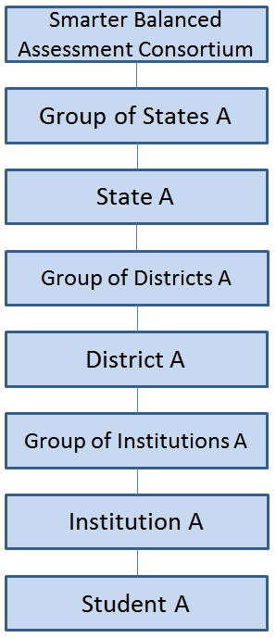

In a more complex example, there can be groups of students within institutions, groups of institutions within districts, groups of districts within states, and groups of states within the Smarter Balanced consortium. See Figure 2.

Figure . Smarter Balanced Hierarchy with Groupings

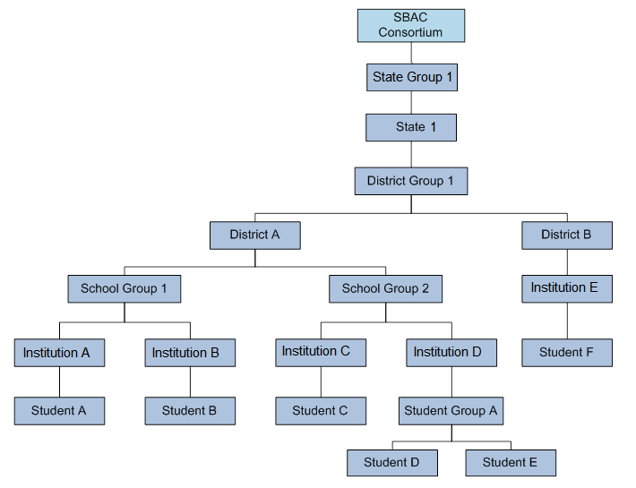

The following rules apply when designing hierarchies:

* An entity or student must have only one “parent.” The parent is the entity to which another entity, user, or student belongs. For example, a student can attend only one institution, an institution can be in only one district, and a district can be in only one state.
* An entity (excluding students or student groups) must be the “child” of an upper-level entity. The child is the student, user, or entity that belongs to another entity. For example, an institution can be the child of any entity from institution group to state; a district can be the child of a district group or a state.
* A student or student group must be the child of an institution.
* All relationships are limited by permissions. For example, a user at the institution level cannot add users or entities to the district level, but a user at the district level can add students to institutions within that district.

## About Microsoft Excel Files

The Administration and Registration Tools system allows you to upload files in one of two formats: .csv and .xlsx. Your version of Excel impacts the file format you should select or use.

CSV (comma-separated values):

If you have Excel 2003 or earlier, AIR recommends that you download exported records in .csv format. CSV files do not automatically preserve leading zeros (numbers that begin with at least one zero at the beginning, e.g., 0001234). Therefore, to ensure that student data (especially SSIDs) appear in Excel correctly when using the .csv file, follow the instructions in Appendix B. Opening a CSV File in Excel.

Excel:

Microsoft Excel 2007 .xlsx files automatically preserve leading zeros. Excel 2007, 2010, or 2013 must be used to correctly open these files. These files cannot be opened using an earlier version of Excel.

# Introduction to This User Guide

This user guide provides information about using ART to create and manage assessment registrations and schedules. This introduction describes the contents of this document and includes a key for identifying icons and elements.

This user guide includes the following sections:

* Accessing the Administration and Registration Tools System explains how to log in to ART.
* Understanding the ART Interface describes the overall layout of the ART interface.
* Assessment Tasks explains how to select, create, and manage assessments.
* Test Registration Tasks describes how to create and manage assessment registrations, as well as how to create various user, student, student group, and institution records.
* Test Administration Tasks describes how to create schedules and view test administration reports.
* Appendix A. Manage System Settings explains how to configure system settings and manage subjects.
* Appendix B. Opening a CSV File in Excel explains how to open comma-separated value files in Excel.
* Appendix C. Common Errors with File Uploads explains how to resolve some common errors that may occur while uploading files in ART.
* Appendix D. About the Calendar Widgets explains how to use calendar widgets in ART.

Table 3 describes icons and typographical elements that appear in this user guide.

Table . Key Icons and Elements

| Icon | Description |
| --- | --- |
|  | **Warning:** This symbol appears with text that contains extremely important information regarding actions that may cause errors. |
|  | **Caution:** This symbol appears with text that contains important information regarding a task. |
|  | **Note:** This symbol appears next to text that contains helpful information or reminders. |
|  | Text that appears in gray boxes provides instructions relevant to the task described.   * Numbered (ordered) lists provide step-by-step instructions. * Bulleted lists provide instructions that do not need to be done in a specific order. |
| [**Text**] | Text in brackets is used to indicate a link or button that is clickable. |
| Text | Text in bold italics indicates a screen name. |
| Text | Text in italics indicates field names or labels. |

# Test Registration and Administration Checklist

The following checklist provides a summary of the essential tasks involved in the assessment configuration workflow. You must complete each of these tasks in order to properly set up the assessments for which students are registered in ART. These tasks are described in greater detail in their respective system user guides.

|  |  |
| --- | --- |
|  | This checklist includes steps that you must complete in other Smart Balanced systems. These systems’ user guides may also include a checklist of the steps required to complete the respective workflow. Please refer to each system’s user guide for a complete list of steps that you must complete before setting up tests in ART. |

**Before accessing ART, you must do the following:**

* **In the Test Authoring System (TAS), construct a preliminary test, including segments and forms. For more information about constructing tests, refer to the TAS user guide.**
* **If the test includes adaptive segments, in the CAT Simulator System, run a simulation of the test package to ensure that the adaptive segments are functioning properly. For more information about running test simulations, refer to the CAT Simulator user guide.**
* In TAS, publish the test package to the Test Specifications Bank. **For more information about publishing tests, refer to the TAS user guide.**

**In ART, you must do the following:**

* **On the *Client Configuration* screen, set a time zone for your client and select the assessment type(s) to be delivered in TDS. For more information, see** Appendix A. Manage System Settings**.**
* **On the *Manage Subjects* screen, add the subjects that may be associated with assessments in ART. For more information, see** Appendix A. Manage System Settings**.**
* **Select a test to add to ART from the Test Specifications Bank. For more information on selecting tests, see the section** Select Tests from the Test Specifications Bank (TSB)**.**
* Set the assessment attributes. This step includes several sub-steps:
  + Set the delay rules for the assessment. For more information on delay rules, see the section Understanding test windows, delay, and opportunities.
  + Set up at least one test window for the assessment. For more information on test windows, see the section Understanding test windows, delay, and opportunities.
  + Set the total opportunities for each test window and the total global test opportunities for the assessment. For more information on test windows, see the section Understanding test windows, delay, and opportunities.
  + Select an eligibility type for the assessment. For more information on eligibility types, see the section Understanding test eligibility.
    - If you selected “Implicit” as the eligibility type, then you must create the implicit eligibility rules for the assessment. If you did not select “Implicit” as the eligibility type, then you may skip this step. For more information on setting implicit eligibility rules, see the section Implicit eligibility rules.
* Create assessment schedules for proctors and students. This step includes several sub-steps.
  + On the Proctor Roles screen, identify roles that can act as proctors. For more information, see the section Specifying Proctor Roles.
  + On the Test Platform Search screen, add the devices that students will use to take assessments. For more information, see the section Adding Test Platforms.
  + On the Accessibility Equipment Search screen, add the accessibility equipment that students with the appropriate accommodations will use to take assessments. For more information, see the section Adding Accessibility Equipment.
  + On the Test Platform Search screen, add the devices that students will use to take assessments. For more information, see the section Adding Test Platforms.
  + On the Facility Search screen, add the facilities in which students will take assessments. For more information, see the section Adding Test Facilities.
  + On the Facility Availability Search screen, add the time slots in which students will take assessments. For more information, see the section Adding Facility Time Periods.
  + On the Schedule Search screen, generate the assessment schedule. For more information, see the section Creating Schedules.
  + On the Schedule Summary Search Filter screen, review and modify the generated schedule. For more information, see the section Viewing and Modifying Schedule Results.

# Accessing the Administration and Registration Tools System

This section contains information about how to log on to ART, how to reset a forgotten password, and how to switch between other Smarter Balanced systems.

## Logging on to ART

To access the Administration and Registration Tools System, you must have an authorized username and password. Since the Administration and Registration Tools System is an open-source system, your system administrator will be responsible for setting up your user account and providing you the login credentials.

To log in to the Administration and Registration Tools System:

|  |  |
| --- | --- |
| 1. Open your web browser and navigate to the Administration and Registration Tools System using the URL provided to you. You will be directed to the Single Sign On Login screen as shown in Figure 3. 2. In the *Username* field, enter your username. 3. In the *Password* field, enter your password. 4. Click [**Log In**]. You will be directed to the Administration and Registration Tools System home screen, provided your login is authenticated. | Figure . Login Screen |

## Switching Between Smarter Balanced Systems (Single Sign On System)

Smarter Balanced systems, including ART, use an integrated Single Sign On (SSO) system that allows users to log in one time and access all available applications. SSO integrates the following applications:

* Test Administrator (TA) Interface
* TA Training Site
* Online Reporting System
* Administration and Registration Tools System (ART)
* Test Authoring System (TAS)
* Item Authoring and Item Pool
* Digital Library

Reminder: Access to all systems and their tasks and features is dependent on your user role.

# Understanding the ART Interface

## ART Home Screen

The first screen you see after logging in to ART is the ART home screen. You can click the button for a task to begin working on that task. The tasks that are available on the home screen depend on your user role. Figure 4 displays the home screen for the Client Administrator role.

Figure . ART Home Screen for the Client Role

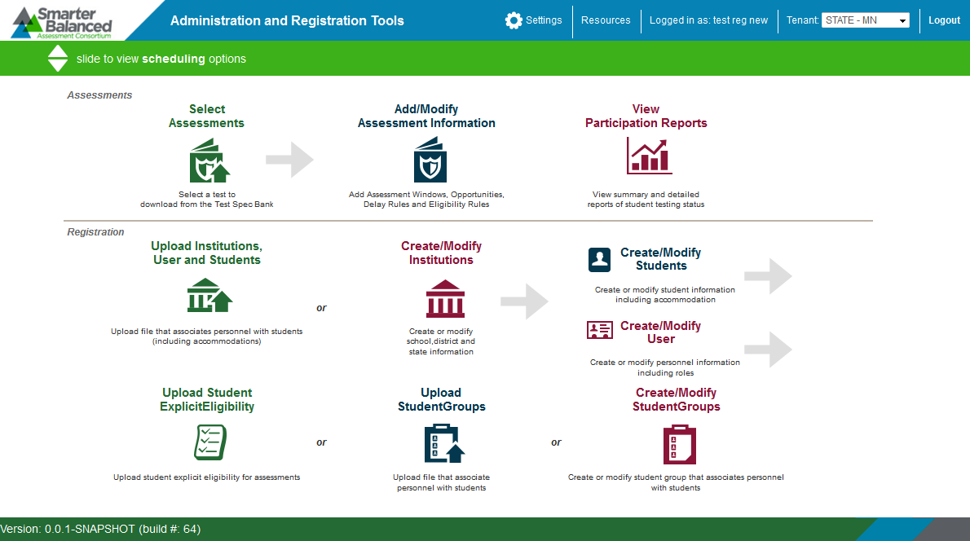

|  |  |
| --- | --- |
|  | Do not have more than one ART browser tab or window open simultaneously. Changes made in one tab or window may overwrite changes made in another, resulting in loss of data. |

The ART home screen provides brief directions for the required workflow. The arrow () symbols indicate precedence: you must complete a task to the left of the symbol before performing the task to the right. The “or” indicates a choice between one of the tasks. For instance you must upload institutions before you can create students or users, etc. Refer to Figure 4 for examples of the following workflows:

Modifying assessments

1. Select assessments, then
2. Modify assessments.

Uploading student groups

1. Upload institutions, then
2. Upload students, then
3. Upload users, then
4. Upload student group

Other workflows are available through the ART interface, as long as they follow the precedence indicated on the home screen.

## ART Banner

The ART banner at the top of the screen displays the following information and links:

* **[Smarter Balanced**] logo—Click to return to the home screen at any time.
* [**Settings**]—Click to configure system-wide settings and manage subjects. For information about these settings, see Appendix A. Manage System Settings.
* [**Resources**] —Click to access the ***Download Templates*** screen or view the user guide.
* Your user name.
* Tenant—Your tenancy, the state or client associated with your logon.
* [**Logout**]—Click to log out of the site.

### Task Bar.

The task bar below the banner enables you to switch between registration tasks and assessment administration tasks, such as scheduling. By default, the home screen displays the registration tasks. To view the assessment administration tasks, click the arrows shown in Figure 5.

Figure . Task Bar



|  |  |
| --- | --- |
|  | Although the View Participation Reports task appears on the home screen by default, this is essentially an administration task. For more information on participation reports, see the section Participation Reports. |

# Assessment Tasks

This section describes how to select and manage assessments. The overall process is as follows:

1. Select available tests or retrieve updated versions of tests from the Test Specifications Bank.
2. Assign settings to the assessment, such as test windows, number of opportunities, and eligibility rules.

## Select Tests from the Test Specifications Bank (TSB)

ART pulls available tests from the Test Specifications Bank (TSB). You can view which tests are available in the TSB, and then create assessment settings for them. Note: The actions described in this section are available to users with a client- or state-level role.

Figure 6 shows the Test Specifications search screen.

*Note: The actions described in this section are available to users with a client- or state-level role.*

Figure . Test Specifications Bank Search Screen

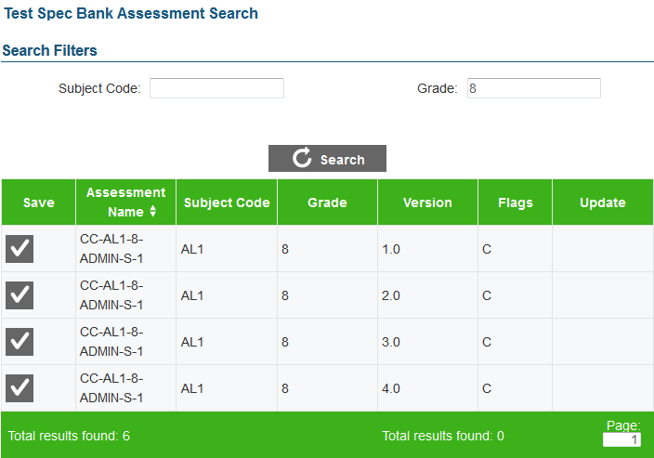

To select a test from the TSB:

|  |
| --- |
| 1. On the ART home screen, click [**Select Assessments**]. The Test Spec Bank Assessment Search screen appears with a listing of tests. 2. To filter the listing, do the following:    1. In the Subject Code and Grade filter fields, enter values by which you want to filter the search results.    2. Click [**Search**]. ART displays the matching tests available in the TSB. 3. To add a test to your assessment pool, click [ ] in the Save column. |

Table 4 describes the fields in the TSB test search results table.

Table . Fields in the TSB Test Search Results Table

| Column | Description |
| --- | --- |
| Save | If a check [] button appears in this column, you can save this test in your assessment pool. |
| Assessment Name | Name of the test. |
| Subject Code | Abbreviated subject code associated with the test. |
| Grade | Grade or grades to which the assessment is administered. |
| Version | Most recent version of the test. The version number is in x.x format, where the number before the decimal point is the major version number and the number after the decimal point is the minor version number. |
| Flags | Test’s status compared to the version in the TSB.   * E: The latest version of the test is already in ART. * C: The latest version of the test has not been imported into ART yet. * U: The test exists in ART but a newer version is available in the TSB. |
| Update | If a check [] button appears in this column, the version in the TSB is more recent than the one in ART. |

### Sort the TSB search results.

To sort the TSB search results:

|  |
| --- |
| 1. On the Test Spec Bank Assessment Search screen (see Figure 6) click a column header. ART sorts the results by the selected attribute in ascending order. A double arrow () icon indicates the currently sorted column. 2. To sort the results in the opposite order, click the column header again. |

## Update a test from the TSB

Users of the Test Authoring System may release new versions of a test. When that happens, a check () appears in the Update column. Referring to Figure 7, the version for the “CC-REA-5-TIMTEST-I-1” test in Test Authoring System is newer than the one in ART.

Figure . Test Specifications Bank Assessment Search Screen with Update Notification

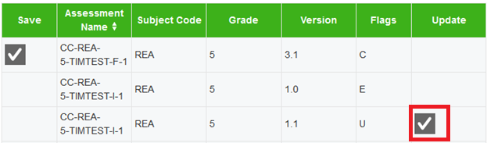

When you update a test version, ART replaces the old version of the test with the new version. Any assessments that you designed with the old version will now have the new version.

To update a test from the TSB:

|  |
| --- |
| * In the Update column of the Test Specifications Bank Assessment Search table, click [ ]. |

## Managing an Assessment

This section describes how to manage assessment attributes, and discusses details that impact an assessment, such as eligibility rules, test windows, and time zones.

*Note: The actions described in this section are available to users with a client- or state-level role.*

### Setting assessment attributes.

After you select a test from the TSB, you can manage the assessment’s attributes on the ***Add Test Information*** screen. This screen loads automatically after you select a test from the TSB. You can also display this screen by clicking [ ] next to an assessment on the Add/Modify Assessment Information screen (see Figure 8). Note: Changes you make to a test imported from the TSB only affect the test for students in your tenant, even if the test in the TSB is shared with other tenants.

Figure . Add/Modify Assessment Information Screen

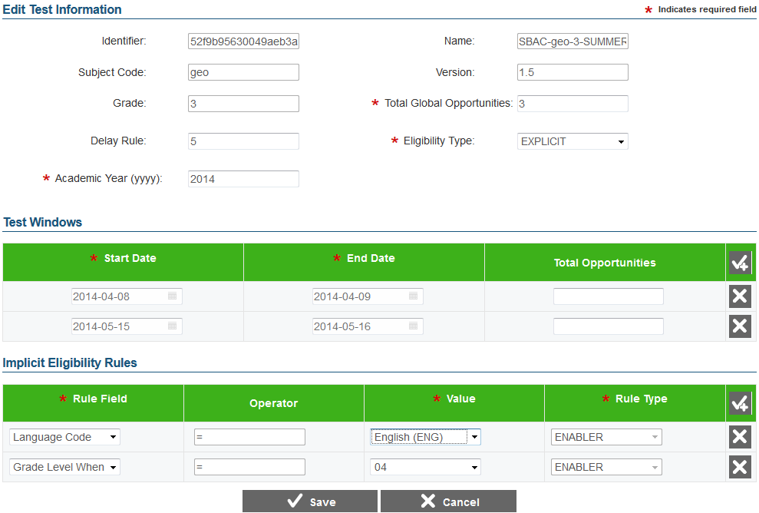

To set assessment attributes:

|  |
| --- |
| 1. In the Total Global Opportunities field, enter the number of opportunities a student has to take the test across all of the test windows. 2. From the Eligibility Type drop-down list, select “IMPLICIT” or “EXPLICIT,” depending on the rules used to determine which students are eligible to take the test. (For an explanation of implicit and explicit eligibility, see the Understanding test eligibility section.) 3. In the Academic Year field, enter the ending year of the academic year for the assessment. |

To set test window information:

|  |
| --- |
| 1. In the Test Windows section, click [ ]. A new row for defining a test window appears. 2. In the Start Date and End Date fields, click the calendar [ ] icon and select dates from the calendar windows that pop up. 3. In the Total Opportunities field, enter the number of test opportunities for this window. Note: This step is available only if you add more than one test window. 4. To add additional test windows, repeat steps 1–3 as required. |

To set rules for implicit eligibility:

|  |
| --- |
| *Note: These instructions only apply if you selected “Implicit” as the assessment’s eligibility type.*   1. In the Implicit Eligibility Rules section, click [ ]. A new row for defining a test eligibility rule appears. 2. From the Rule Field drop-down list, select one of the available options. 3. From the Operator drop-down list, select one of the operators (if available). 4. From the Value drop-down list, select one of the available values. 5. From the Rule Type drop-down list, select one of the following:    * “ENABLER”—select if the student must satisfy this condition to take the test.    * “DISABLER”—select if the student must **not** satisfy this condition to take the test. 6. To add additional eligibility rules, repeat steps 1–5 as required. ART automatically registers for the assessment those students who meet the eligibility rules. |

To save the assessment attributes:

|  |
| --- |
| 1. Click [**Save**] at the bottom of the screen. ART saves the assessment in your assessment pool. |

Table 5 provides detailed information about the attribute fields in the Add Test Information screen.

Table . Fields in the Add Test Information Screen

| Field | Description |
| --- | --- |
| Add Test Information | |
| Identifier | Unique identifier for the selected test. |
| Name | Descriptive name for the selected test. |
| Subject Code | Subject code corresponding to the selected test. |
| Version | Version of the selected test. |
| Grade | Grade levels to which the selected test applies. |
| Total Global Opportunities | Total number of times a student can take this test across all of the test windows. For additional information about this field, see the section Understanding test windows. |
| Delay Rule | Number of calendar days between test opportunities. For additional information about this field, see the section Understanding test windows. |
| Eligibility Type | Method by which eligibility for an assessment is determined.   * “Implicit”—The list of students eligible to take this test is implicitly derived from a set of criteria. * “Explicit”—The list of students eligible to take this test comes from a file upload.   For an explanation of these rules, see the section Understanding test eligibility. |
| Academic Year | Calendar year in which the academic year ends. For example, if the academic year is 2014–2015, the value in this field is “2015.” |
| Test Windows | |
| Start Date | Date when the test window starts. |
| End Date | Date when the test window ends. |
| Total Opportunities | Number of times student can take this test during the test window.   * If you have one test window, ART sets the Total Opportunities to be equal to Total Global Opportunities. * If you have more than one test window, the sum of all Total Opportunities fields must be equal to or greater than the Total Global Opportunities.   For example, if Total Global Opportunities is 3, then the sum of all Total Opportunities for all test windows must be equal to or greater than 3. For additional information about this field, see the section Understanding test windows. |
| Implicit Eligibility Rules | |
| Rule Field | Student demographic or accommodation category whose value you want to base the rule on. |
| Operator | A comparison operator. The list of available operators changes depending on what you select from the Rule Field drop-down list. |
| Value | Value against which the rule field is compared. |
| Rule Type | One of the following:   * “ENABLER”—Student must satisfy this condition to take the test. * “DISABLER”—student must not satisfy this condition to take the test.   For more information about rule types and how they impact eligibility, see the section Understanding test eligibility |

### Understanding test eligibility.

#### Explicit eligibility.

If you specify “Explicit” as the eligibility type for an assessment, you must provide an explicit list of students that can take the test. This option is useful if there is a great deal of fragmentation regarding test eligibility. For example, when administering End of Course assessments, the system cannot automatically determine which students are registered for a particular course.

You specify explicit eligibility rules by uploading a list of students and their associated eligibilities. For detailed information, see the section Managing Student Eligibility.

#### Implicit eligibility rules.

If you specify “Implicit” as an eligibility type for an assessment, you must provide a set of eligibility criteria in the Implicit Eligibility Rules section (see Figure 8). The students in ART who meet all of the implicit criteria for an assessment will automatically be registered for that assessment.

There are two types of implicit eligibility rules:

* Enabler—A student must satisfy all enabler eligibility criteria to take the test.
* Disabler—A student must fail all disabler eligibility criteria to take the test.

Referring to the example in Figure 8, there are two enabler rules: “Language Code = English” and “Grade Level When Tested = 4.” This means that all students who primarily communicate in English and who are in fourth grade at the time of the assessment are eligible to take the test.

### Understanding test windows, delay, and opportunities.

There are three interrelated factors that determine if a student may take an available assessment:

* Test Window—The start and end date when a test is available in TDS. An assessment can have one or more test windows.
* Opportunities—The number of times a student can take an assessment within a window, and the number of times a student can take the assessment over all the test windows.
* Delay—The number of calendar days that must pass between student test opportunities.

In Figure 9, an example assessment has two test windows: May 5–9 and May 19–23. Students have two opportunities to take the test in each window. The total number of opportunities over all windows is three. The delay period for the assessment is three days.

* The first student, indicated by a blue star (), takes the test for the first time on May 5. To take the second opportunity, the student waits three days until May 8. To take the test a third time, the student must wait until May 19. After that, the student cannot take the test again; even though there is another test opportunity available in Test Window 2, the student already exhausted all three global opportunities.
* The second student, indicated by a green star (), takes the test for the first time on May 7. To take the second opportunity, the student must wait three days until May 10, but the next test window starts on May 19, so the student waits until then for the second opportunity.
* The third student, indicated by a yellow star (), takes the test for the first time on May 19, then waits three days, until May 22, to take the test again. After that, the student cannot retake the test, because the delay of three days is outside Test Window 2, which is the final window.

Figure . Effect of Test Windows, Delay, and Opportunities

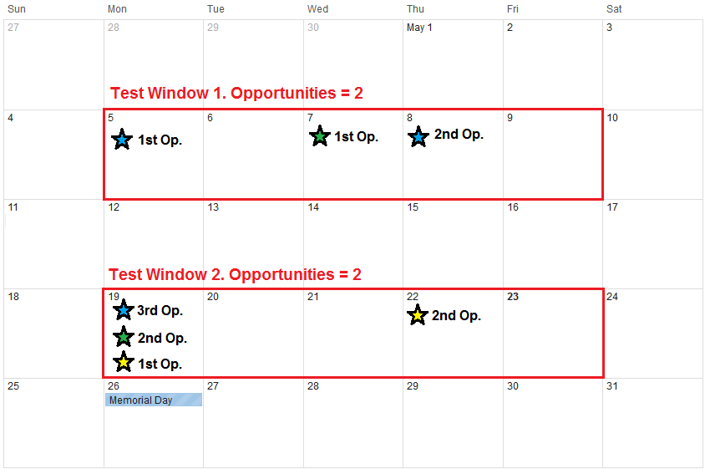

### Understanding test windows and time zones.

Time zones impact the availability of a particular test. ART has a global setting for the time zone at the consortium level. All dates for test windows are at midnight in that time zone. If a local institution delivers a test in a different time zone, the students must start and end the test accordingly. For example, the consortium’s time zone is EST, and a member institution’s time zone is PST. If a test window is from March 8 through March 12, students in the EST time zone can take the test from midnight March 8, through midnight March 12; students in the PST time zone can start taking the test earlier, from March 7, 9:00 PM, and must end the test earlier, by March 11, 9:00 PM. See Figure 10.

Figure . Effect of Time Zones on Test Windows

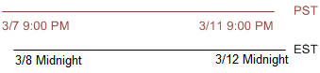

## Modifying assessments

This section describes how to modify existing assessments. The overall process for modifying assessments consists of two main steps:

1. Search for and select the assessment.
2. Adjust the assessment’s attributes.

The following subsections describe how to perform each of these steps.

*Note: The actions described in this section are available to users with a client- or state-level role.*

### Searching for assessments.

Figure 11 shows the Test Search Screen results.

Figure . Test Search Screen with Search Results Table

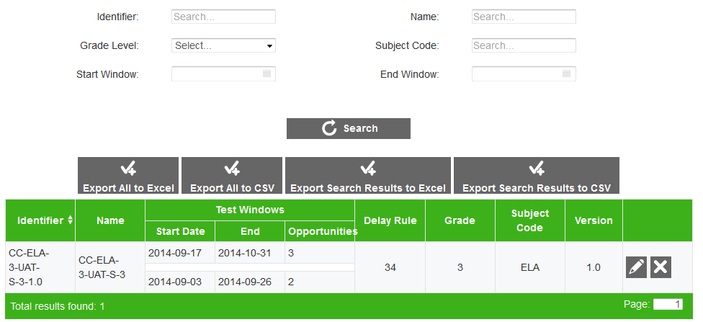

To search for an assessment:

|  |
| --- |
| 1. On the ART home screen, click [**Add/Modify Assessment Information**]. The Test Search screen appears. 2. In the filters provided at the top of the screen, enter the necessary search parameters and click [**Search**]. The assessments that meet the selected search parameters appear in the table on this screen. A search can be filtered by the assessment’s Identifier, Name, Entry Grade Level, Subject Code, Start Window, or End Window. |

### Understanding the search results table on the Test Search screen.

Table 6 describes the columns in the Test Search table. Each row in the table also contains two icons:

* —Accesses the Edit Test Information screen, where you modify the assessment attributes.
* —Deletes the assessment and all registrations associated with that assessment.

Table . Fields in the Test Search Results Table

| Column | Description |
| --- | --- |
| Identifier | Unique identifier for the assessment. |
| Name | Descriptive name for the assessment. |
| Test Windows | One row for each window during which students can take the test.  Start Date—Date when the test window starts.  End—Date when the test window ends.  Opportunities—Number of times student can take this test during the test window. |
| Delay Rule | Number of calendar days between test opportunities. For additional information about this field, see the section Understanding test windows. |
| Grade | Grade levels to which the selected test applies. |
| Subject Code | Subject code corresponding to the selected test. |
| Version | Version of the selected test. |

### Modifying an assessment.

Use the following procedure to modify an assessment.

To modify an assessment:

|  |
| --- |
| 1. On the Test Search screen (see Figure 11), click [ ]. The ***Edit Test Information*** screen appears. This screen is a populated version of the screen used to set attributes for a new assessment (see Figure 8). 2. Using Table 5 as a reference, modify the assessment’s attributes. 3. Click [**Save**]. |

## Exporting assessments

You can export assessment search results as a .csv file, which can be opened using Excel or a spreadsheet application. You can also export results as an.xls file, which must be opened with Excel.

You can choose to export all available assessments or only those assessments that display in the search results.

*Note: The actions described in this section are available to users with a client- or state-level role.*

### Export all assessments.

You can export a data file that contains all assessments available to you in ART.

To export all assessments:

|  |
| --- |
| 1. On the Test Search screen (see Figure 11), click [**Export All to Excel**] or [**Export All to CSV**]. A file dialog box appears. 2. Save the file to the desired location on your computer, and open the file using Microsoft Excel or a compatible program (for .csv files). |

### Export selected assessments.

You can export a data file that contains only the filtered assessments from the search results table on the **Test Search** screen.

To export selected assessments:

|  |
| --- |
| On the Test Search screen (see Figure 11), click [**Export Search Results to Excel**] or [**Export Search Results to CSV**]. A file dialog box appears.  Save the file to the desired location on your computer, and open the file using Microsoft Excel or a compatible program (for .csv files). |

## Deleting Assessments

You can delete assessments from the table on the ***Test Search*** screen.

*Note: The actions described in this section are available to users with a client- or state-level role.*

|  |  |
| --- | --- |
|  | **WARNING: DELETING ASSESSMENTS** When you delete an assessment, ART deletes all associated test windows, delay rules, and student registrations (but not student records). |

To delete an assessment:

|  |
| --- |
| 1. In the right-hand column of the Test Search screen (see Figure 11), click [ ]. 2. In the confirmation dialog box, click [**OK**]. ART deletes the assessment. |

# Test Registration Tasks

After adding and configuring assessments, you can begin the test registration process. This process assigns assessments to students. The overall process consists of the following main steps:

1. Build a hierarchy of entity records from the state level to the institution level. You can upload entity and user records in groups, or create each record individually with the ART user interface.
2. Assign students to the institutions. You can upload multiple student records simultaneously or create each record individually with the ART user interface.
3. Assign assessments:
   1. If assessments with implicit eligibility exist in ART, then all students who meet the implicit eligibility criteria are eligible for the assessment.
   2. If you need to assign students to an assessment with explicit eligibility, then you must upload a file of students who are eligible for the assessment.

The following sections describe the registration tasks in detail.

## Creating and Modifying Records in ART

You can create or modify records using the following methods:

* **File Uploads:** This feature allows you to upload many records using predefined templates, which can be constructed in Excel. Depending on your user role, you can upload state, group of states, district, group of districts, institution, group of institutions, user, student, student group, student accommodation, and student eligibility records. In most cases, you can use file uploads to modify or delete existing records.
* **Create/Modify Records:** This feature allows you to create individual records using the forms provided on the ART user interface. Depending on your user role, you can create state, group of states, district, group of districts, institution, group of institutions, user, student, student group, and student accommodation records. You can also use the **Create/Modify** features to modify or delete existing records in ART.

### File Uploads.

The process for uploading files to ART consists of three main steps:

1. Download the appropriate file template for the record type.
2. Fill out the template by entering the information for each record in a new row.
3. Save and upload the file to ART.

#### Download File Templates.

|  |  |
| --- | --- |
| The best way to create upload files for the various types of records is to use one of the available file templates shown in Figure 12. These templates organize records into tables, and you enter data into the tables—one row for each record. Using the template reduces the risk of errors, and helps to ensure that your file upload is successful.  Templates are available in .csv, .xlsx, .tab, and .xls formats.  *To download file templates:* | Figure . Download Templates Screen |
| 1. In the ART banner, select “**Download Templates**” from the *Resources* drop-down list. The ***Download Template*** screen opens. 2. Mark the checkboxes corresponding to the templates you want to download. For example, if you want to download templates for states and districts, mark the State and District checkboxes. 3. Mark the checkboxes corresponding to the format you want to download. For example, if you want to download templates in the .csv format, mark the CSV checkbox. The [**Download**] button appears. 4. Click [**Download**]. Your browser downloads the files. Depending on your browser’s configuration, the files open in the appropriate application or are stored on your computer. |

#### Creating an Upload File.

Each template consists of columns appropriate for the record type you selected. The top row in the template contains the data columns for which you enter the appropriate information. You enter the information for each record in the subsequent rows as shown in Figure 13.

Figure . Sample Template for District Records

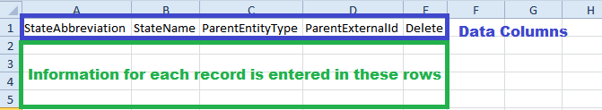

|  |  |
| --- | --- |
|  | **CAUTION: Validation Errors.** Editing values in the top row of a template file results in validation errors when uploading the file. Do not edit values in the top row of a template file. |

To create an upload file:

|  |
| --- |
| After downloading the appropriate template, open the file in Microsoft Excel or a compatible spreadsheet program.  Enter each record’s information in a separate row. Be sure to adhere to the field requirements described in the appropriate table provided in the Managing Records section.  *Note: Upload templates are case-sensitive. Data must be entered as standard text. Any formatting, such as boldface, highlighting, or italics, will be lost during the upload.*   * + To delete an existing record, enter “DELETE” in the Delete column for that record.   + To modify an existing record, enter the new information for that record. The old record will be replaced upon uploading the file. To modify the key value of a record (e.g., the e-mail address of a user record), you must delete the original record and create a new one. The tables in the Managing Records section identify key columns with a plus (+).   Note: Some record types cannot be deleted or modified via the file upload task. You must delete or modify those records from the Create/Modify screen for that record type.  Save the upload file in one of the following file formats: .csv, .xls, .xlsx, or .txt*.* After the file is saved, you can upload it to ART. |

#### Uploading Files.

The file upload process has four main steps: (1) Choose File, (2) Preview File, (3) Validate File, and (4) Confirmation. This process allows you to confirm that the correct file was uploaded and that it contains no errors. When uploading a file, you must use the correct upload screen for that record type. See Figures 14–18.

Table 7 describes the available screens and the file types that they upload.

Table . File Upload Screens

| Screen | Description |
| --- | --- |
| Upload Institutions, Users, and Students | Use this screen to upload state, group of states, district, group of districts, institution, group of institutions, user, student, and student accommodation files. |
| Upload Student Eligibility | Use this screen to upload student eligibility files for assessments with explicit eligibility. |
| Upload Student Group | Use this screen to upload student group files. |

Step 1: Upload File

Figure . Upload File, Step 1: Choose the File

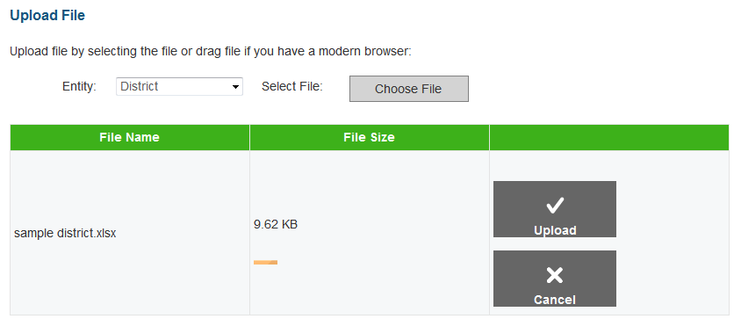

|  |
| --- |
| 1. On the home screen, navigate to the appropriate file upload screen for the record type. 2. Select the record upload type from the Entity drop-down list on the Upload File screen. 3. Click [**Choose File**] and select the saved file on your computer. The file name and file size appears in the table on the screen. Note: If you are using a modern browser, you may also click and drag the file directly into the table provided on the upload screen*.* 4. Verify that the name of the file is correct, and then click [**Upload**]. |

Step 2: Preview File

Figure . Upload File, Step 2: Preview Records

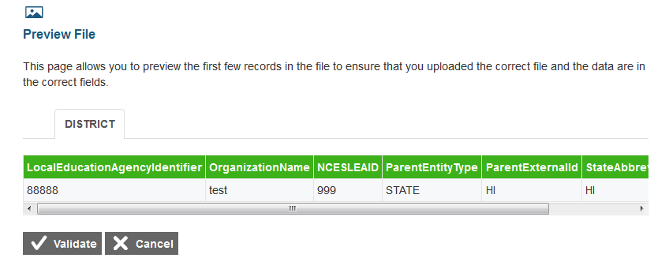

|  |
| --- |
| 1. To ensure that you uploaded the correct file, you can preview the file you selected in the table on this screen.Note: Only the first few records in the file are visible on this preview screen. 2. To begin the file validation process, click [**Validate**]. |

|  |  |
| --- | --- |
|  | **Caution:** If your file is large, uploading it may take a long time. DO NOT cancel the upload and try again, because ART may have already begun processing some of the records. If your file is too large to upload while you are online, you will be asked to provide an e-mail address. When the file is processed, you will receive an e-mail. |

|  |  |
| --- | --- |
| Step 3: Validate File  If the file passes validation, a message appears, indicating that no validation errors were found (see Figure 16). You can click [**Save**] to proceed to the final step.  If the file contains records with errors, an error message appears (see Figure 17). Depending on the severity of the error, either the entire file will fail or just the records with errors will fail.  Files with data that are not in the correct format as shown in the template will generate error messages by row, identifying the errors in the file.  The “Understanding Error Types” section in the column to the right provides a brief explanation of the three possible error types: fatal errors, record errors, and record warnings. | Figure . Step 3: Successful Validation |
| *Understanding Error Types*   * **If the entire file fails**, note the errors and the corresponding record numbers. Click [**Cancel**], update your file, and then restart the upload process from Step 1: Choose File. * **If the file contains record errors**, these records will not be committed to ART. The records that passed validation can be committed. You may elect to fix the errors in your file and re-upload it, or to add these records individually on the appropriate Create/Modify [Record] screen. * **If the file contains record warnings**, these records will be saved to ART. However, you are strongly encouraged to review the associated records. You may edit these records using the appropriate Create/Modify [Record] screen. |

Figure . Failed Validation

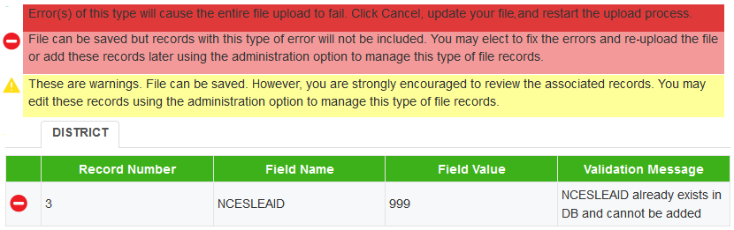

Step 4: Confirmation

After you click [**Save**], the accepted records will be uploaded to ART. A table appears, confirming the type of records uploaded, the number of records deleted, and the number of records inserted.

Figure . Upload File, Step 4: Confirmation

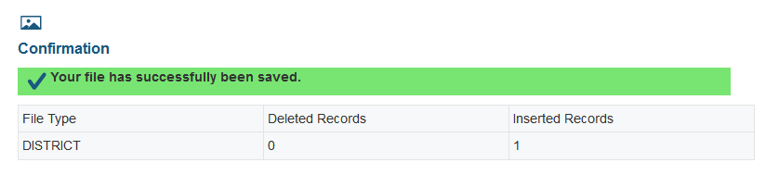

### Creating/Modifying Individual Records.

The ***Create/Modify***screens in ART allow you to add, modify, and delete individual records. You can also use these screens to search for and export records. When working with a record, you must use the appropriate screen for that record type. Table 8 describes the available screens and the record types that they process. See Figure 19 for a sample Create/Modify [Record Type] screen.

Table . Record Management Screens

| Screen | Description |
| --- | --- |
| Create/Modify Institutions | Use this screen to manage state, group of states, district, group of districts, institution, and group of institutions records.  Note: When managing entity records, you must select the appropriate entity type from the links provided at the top of the screen. |
| Create/Modify Students | Use this screen to manage student records, including student accommodation and test eligibility information |
| Create/Modify Users | Use this screen to manage user records. |
| Create/Modify Student Group | Use this screen to manage student group records. |

Figure . Sample Create/Modify [Record Type] Screen

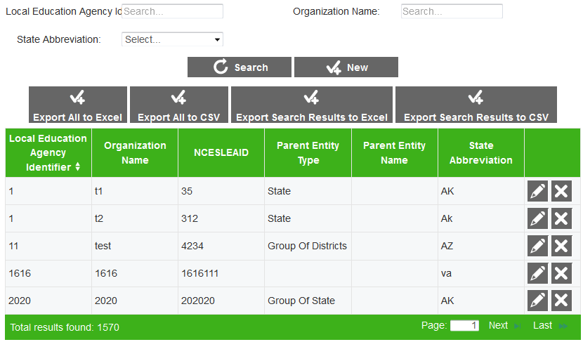

The following items are available on every ***Create/Modify*** screen:

* Filter fields and [**Search**] button used to search for records. Some Create/Modify screens also include a checkbox that filters the search results table to only display records with errors.
* [**New]** button used to create new records.
* Various [**Export**] buttons used to export data for all records or just records in the table.
* Search results table that displays existing records. By default, this table displays all existing records. The table includes action buttons used to edit or delete individual records.

|  |  |
| --- | --- |
|  | The actual filter fields and table columns on the Create/Modify screens vary for each record type. For more information, see the Managing Records section. |

To add a new record:

|  |
| --- |
| 1. Click [**New**]. The ***Add [Record Type] Information*** screen appears. This screen displays fields for creating a new record. 2. Enter the record’s information in the provided fields. Be sure to adhere to the field requirements described in the appropriate table provided in the Managing Records section. 3. Click [**Save**]. |

To search for records:

|  |
| --- |
| 1. On the ***Create/Modify*** screen, enter values in the filter fields and click [**Search**]. The table updates to display only the records that meet the entered criteria. |

To export records:

|  |
| --- |
| * To export all the records as an .xls file, click [**Export All to Excel**]. * To export all the records as a .csv file, click [**Export All to CSV**]. * To export only the filtered records included in the table as an .xls file, perform a search and click [**Export Search Results to Excel**]. * To export only the filtered records included in the table as a .csv file, perform a search and click [**Export Search Results to CSV**]. |

To modify an existing record:

|  |
| --- |
| 1. In the search results table, click [ ] for a record. The ***Edit [Record Type] Information*** screen appears. This screen is similar to the screen used for adding new records. 2. You can modify the record’s information in the available fields. Be sure to adhere to the field requirements described in the appropriate table provided in the Managing Records section. 3. Click [**Save**]. |

To delete a record:

|  |
| --- |
| 1. In the search results table, click [ ] for a record. A warning message appears, asking you to verify the action. 2. In the warning dialog box, click [**OK**]. The record will be removed from ART. **Caution: This action cannot be undone.** |

|  |  |
| --- | --- |
|  | **Caution:** If you delete the record for a parent entity, then all the child entities that belong to that parent will also be removed from ART. For example, if you delete a district record from ART, then all the institutions that belong to that district are also deleted. |

### About Data Columns and Edit Fields.

For a given record type, the fields displayed on the ***Add [Record] Information*** and ***Edit [Record] Information*** screens correspond with the data columns included in the template used to upload that same record type. Column labels on the template use CamelCase (each compound word begins with a capital letter), while fields on the ***Add [Record Type] Information*** and ***Edit [Record] Information*** screens use Title Case. Otherwise, these labels are usually identical.

For example, the ***Add District Information*** screen includes the *Organization Name* field. The corresponding column on the District template is “OrganizationName.” See Figure 20.

|  |  |
| --- | --- |
|  | The “Delete” column in upload templates does not have a corresponding field on the ***Add [Record] Information*** and ***Edit [Record] Information*** screens, because individual records are deleted directly from the search results table on their ***Create/Modify*** screen. |

Figure . Comparison Between Labels for Edit Fields and Data Columns

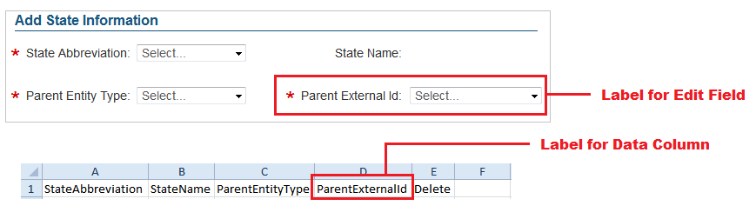

## Managing Records

The following sections provide instructions for creating or modifying the various record types, and also provide detailed information about creating, modifying, or deleting records through file uploads.

### Managing State Groups.

When building the hierarchy of entities in ART, you must start at the state or state group level. A state group consists of multiple states that are associated together and belong to the same client. See Figure 21.

*Note: The actions described in this section are available to users with a client-level role.*

|  |  |
| --- | --- |
|  | State Group levels in the Smarter Balanced Assessment Consortium hierarchy are optional. You can configure and rename these entity group levels, but you cannot change their order in the hierarchy. |

#### Create or modify state groups.

Figure . Group of States Search Screen

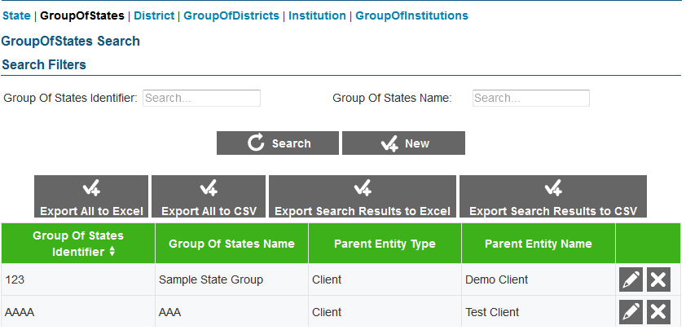

To create a state group:

|  |
| --- |
| 1. On the ART home screen, click [**Create/Modify Institutions**]. 2. On the Create/Modify Institutions screen, click the [**Group of States**] link. 3. On the ***Group of States Search*** screen, click [**New**]. 4. On the ***Add Group of States Information*** screen, enter the information for the state group in the provided fields. For an explanation of these fields, see Table 9. 5. Click [**Save**]. |

To modify a state group:

|  |
| --- |
| 1. On the ***Group of States Search*** screen, search for a state group record. 2. In the search results table, click [ ] for a state group record. 3. On the ***Edit Group of States Information*** screen, modify the information for the state group in the provided fields as required. For an explanation of these fields, see Table 9. 4. Click [**Save**]. |

To delete a state group:

|  |
| --- |
| 1. On the ***Group of States Search*** screen, search for a state group record. 2. In the search results table, click [ ] for a state group record. 3. In the warning box that pops up, click [**OK**].   **Caution: If you delete a state group, all the child entities within that group will also be deleted.** |

#### Upload state groups.

You can add, modify, or delete state groups by uploading a file to ART.

To upload a state group file:

|  |
| --- |
| 1. Download the Group of States template, following the instructions provided in the Download File Templates section. 2. Using Table 9 as a reference, enter a row of information for each state group you want to add, modify, or delete.    1. To update an existing state group record, enter the new information for the record in its own row. The previous record will be replaced upon uploading the file.    2. To delete an existing state group record, enter “DELETE” in the Delete column. 3. On the ART home screen, click [**Upload Institutions, Users and Students**]. 4. Upload the state group file, following the instructions provided in the Uploading Files section. |

Table 9 describes the columns in the state-group file, and lists acceptable values in **bold type**. These columns also correspond with the fields on the ***Add Group of States Information*** screen. Columns marked with an asterisk (*) are required for add or modify actions; columns marked with a plus (+) are required for delete actions.

Table . Upload State-Group File Requirements

| Column | Description |
| --- | --- |
| GroupOfStatesIdentifier*+ | Unique identifier for a state group.  **Up to 20 characters.** |
| GroupOfStatesName* | Descriptive name of state group.  **Up to 50 characters.** |
| ParentEntityType* | State group’s parent in the Consortium’s hierarchy. Must be the following:   * **CLIENT**—Indicates the state group is a direct member of the consortium.   For a description of the Consortium’s hierarchy in ART, see the section Understanding the Smarter Balanced Hierarchy. |
| ParentExternalId* | Parent entity’s identifier.  **Up to 20 characters of an existing client’s ID.** |
| Delete+ | Flag for deleting the state group.   * **DELETE**—Delete the state group associated with the GroupOfStatesIdentifier. * **<blank>**—Add the new state group or modify the existing one. |

### Managing States.

After adding state groups, you can create states that belong to that group. You can also create states that belong to a client. See Figure 22.

*Note: The actions described in this section are available to users with a client-level role.*

#### Create or modify states.

Figure . State Search Screen

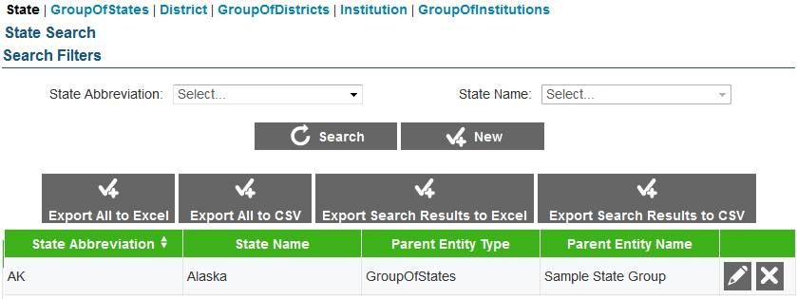

To create a state:

|  |
| --- |
| 1. On the ART home screen, click [**Create/Modify Institutions**]. 2. On the Create/Modify Institutions screen, click the [**State**] link. 3. On the ***State Search*** screen, click [**New**]. 4. On the ***Add State Information*** screen, enter the information for the state in the provided fields. For an explanation of these fields, see Table 10. 5. Click [**Save**]. |

To modify a state:

|  |
| --- |
| 1. On the ***State Search*** screen, search for a state record. 2. In the search results table, click [ ] for a state record. 3. On the ***Edit State Information*** screen, modify the information for the state in the provided fields as required. For an explanation of these fields, see Table 10. 4. Click [**Save**]. |

To delete a state:

|  |
| --- |
| 1. On the ***State Search*** screen, search for a state record. 2. In the search results table, click [ ] for a state record. 3. In the warning box that pops up, click [**OK**].   **Caution: If you delete a state, all of the child entities within that state will also be deleted.** |

#### Upload states.

You can add, modify, or delete states by uploading a file to ART.

To upload a state file:

|  |
| --- |
| 1. Download the State template, following the instructions provided in the Download File Templates section. 2. Using Table 10 as a reference, enter a row of information for each state you want to add, modify, or delete.    1. To modify an existing state record, enter the information for the new record in its own row. The old record will be replaced upon uploading the file.    2. To delete an existing state record, enter “DELETE” in the Delete column. 3. On the ART home screen, click [**Upload Institutions, Users and Students**]. 4. Upload the state file, following the instructions provided in the Uploading Files section. |

Table 10 describes the columns in the state file and lists acceptable values in **bold type**. These columns also correspond with the fields on the ***Add State Information*** screen. Columns marked with an asterisk (*) are required for add/modify actions; columns marked with a plus (+) are required for delete actions.

Table . Upload State File Requirements

| Column | Description |
| --- | --- |
| StateAbbreviation*+ | State’s abbreviation. **Any standard two-letter state abbreviation is valid.** In addition, the following are also valid:   * **AA**—Armed Forces Americas * **AE**—Armed Forces Africa, Canada, Europe and Mideast * **AP**—Armed Forces Pacific * **TS**—Test State * **OT**—Other |
| StateName* | Full state name.  **Up to 50 characters.** |
| ParentEntityType* | State’s parent in the Consortium’s hierarchy. One of the following:   * **CLIENT**—Indicates the state is a direct member of the consortium. * **GROUPOFSTATES**—Indicates the state is a member of a group of states.   For a description of the Consortium’s hierarchy in ART, see the section Understanding the Smarter Balanced Hierarchy. |
| ParentExternalId* | Parent entity’s identifier.  **Up to 20 characters of an existing client’s or state group’s ID.** |
| Delete+ | Flag for deleting the state.   * **DELETE**—Delete the state associated with StateAbbreviation. * **<blank>**—Add the new state record or modify the existing one. |

### Managing District Groups.

After adding state records, you can create district group records. District groups contain districts that are associated together and belong to the same state, state group, or client. See Figure 23.

Note: The actions described in this section are available to users with a state- or client-level role.

|  |  |
| --- | --- |
|  | District Group levels in the hierarchy are optional. You can configure and rename these entity group levels but you cannot change their order in the hierarchy. |

#### Create or modify district groups.

Figure . Group of Districts Search Screen

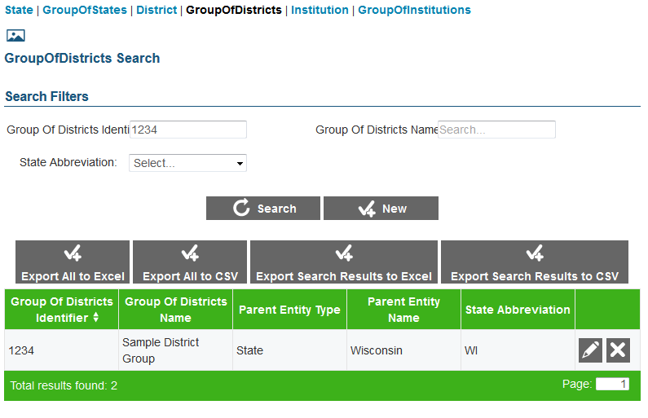

To create a district group:

|  |
| --- |
| 1. On the ART home screen, click [**Create/Modify Institutions**]. 2. On the Create/Modify Institutions screen, click the [**Group Of Districts**] link. 3. On the ***Group of Districts Search*** screen, click [**New**]. 4. On the ***Add Group of Districts Information*** screen, enter the information for the district group in the provided fields. For an explanation of these fields, see Table 11. 5. Click [**Save**]. |

To modify a district group:

|  |
| --- |
| 1. On the ***Group of Districts Search*** screen, search for a district group record. 2. In the search results table, click [ ] for a district group record. 3. On the ***Edit Group of Districts Information*** screen, modify the information for the district group in the provided fields. For an explanation of these fields, see Table 11. 4. Click [**Save**]. |

To delete a district group:

|  |
| --- |
| 1. On the ***Group of Districts Search*** screen, search for a district group record. 2. On the search results table, click [ ] for a district group record. 3. In the warning box that pops up, click [**OK**].   **Caution: If you delete a district group, all of the child entities within that group will also be deleted.** |

#### Upload district groups.

You can add, modify, or delete district groups by uploading a file to ART.

To upload a district-group file:

|  |
| --- |
| 1. Download the GroupOfDistricts template, following the instructions provided in the Download File Templates section. 2. Using Table 11 as a reference, enter a row of information for each district group you want to add, modify, or delete.    1. To modify an existing district group record, enter the new information for the record in its own row. The old record will be replaced upon uploading the file.    2. To delete an existing district group record, enter “DELETE” in the Delete column. 3. On the ART home screen, click [**Upload Institutions, Users and Students**]. 4. Upload the district group file, following the instructions provided in the Uploading Files section. |

Table 11 describes the columns in the district-group file and lists acceptable values in **bold type**. These columns also correspond with the fields on the ***Add Group of Districts Information*** screen. Columns marked with an asterisk (*) are required for add or modify actions; columns marked with a plus (+) are required for delete actions.

Table . Upload District-Group File Requirements

| Column | Description |
| --- | --- |
| GroupOfDistrictsIdentifier*+ | Unique identifier for group of districts.  **Up to 20 characters.** |
| GroupOfDistrictsName* | Descriptive name for group of districts.  **Up to 100 characters.** |
| ParentEntityType* | District group’s parent in the Consortium’s hierarchy. One of the following:   * **CLIENT**—Indicates the district group is a direct member of the consortium. * **GROUPOFSTATES**—Indicates the district group is a member of a group of states. * **STATE**—Indicates the district group is a member of a state.   For a description of the Consortium’s hierarchy in ART, see the section Understanding the Smarter Balanced Hierarchy. |
| ParentExternalId* | Parent entity’s identifier.  **Up to 20 characters of an existing client’s, state group’s, or state’s ID.** |
| StateAbbreviation*+ | State in which the district group is located. **Any standard two-letter state abbreviation is valid.** In addition, the following are also valid:   * **AA**—Armed Forces Americas * **AE**—Armed Forces Africa, Canada, Europe and Mideast * **AP**—Armed Forces Pacific * **TS**—Test State * **OT**—Other |
| Delete+ | Flag for deleting the district group.   * **DELETE**—Delete the district group associated with the combination of GroupOfDistrictsIdentifier and StateAbbreviation. * **<blank>**—Add the new district group or modify an existing one. |

### Managing Districts.

After adding district group records, you can create district records. Districts can belong to a district group, state, state group, or client. See Figure 24.

*Note: The actions described in this section are available to users with a state- or client-level role.*

#### Create or modify a district.

Figure . District Search Screen

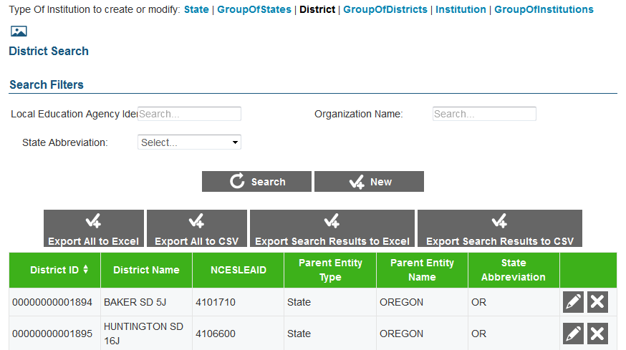

To create a district:

|  |
| --- |
| 1. On the ART home screen, click [**Create/Modify Institutions**]. 2. On the Create/Modify Institutions screen, click the [**District**] link. 3. On the ***District Search*** screen, click [**New**]. 4. On the ***Add District Information*** screen, enter the information for the district in the provided fields. For an explanation of these fields, see Table 12. 5. Click [**Save**]. |

To modify a district:

|  |
| --- |
| 1. On the ***District Search*** screen, search for a district record. 2. In the search results table, click [ ] for a district record. 3. On the ***Edit District Information*** screen, modify the information for the district in the provided fields. For an explanation of these fields, see Table 12. 4. Click [**Save**]. |

To delete a district:

|  |
| --- |
| 1. On the ***District Search*** screen, search for a district record. 2. In the search results table, click [ ] for a district record. 3. In the warning box that pops up, click [**OK**].   **Caution: If you delete a district, all of the child entities within that district will also be deleted.** |

#### Upload districts.

You can add, modify, or delete districts by uploading a file to ART.

To upload a district file:

|  |
| --- |
| 1. Download the District template, following the instructions provided in the Download File Templates section. 2. Using Table 12 as a reference, enter a row of information for each district you want to add, modify, or delete.    1. To modify an existing district record, enter the information for the new record in its own row. The old record will be replaced upon uploading the file.    2. To delete an existing district record, enter “DELETE” in the Delete column. 3. On the ART home screen, click [**Upload Institutions, Users and Students**]. 4. Upload the district file, following the instructions provided in the Uploading Files section. |

Table 12 describes the columns in the district file and lists acceptable values in **bold type**. These columns also correspond with the fields on the ***Add District Information*** screen. Columns marked with an asterisk (*) are required for add or modify actions; columns marked with a plus (+) are required for delete actions. Note: Some of the labels on the district template differ from those on the **Add District Information** screen. The unique labels from the **Add District Information** screen are provided in parentheses under the labels in the template.

Table . Upload District File Requirements

| Column | Description |
| --- | --- |
| LocalEducationAgencyIdentifier*+  (District ID) | A unique number or alphanumeric code assigned to a local education agency by a school system, a state, or other agency or entity.  **Up to 20 alphanumeric characters.** |
| OrganizationName*  (District Name) | District Name.  **Up to 60 characters.** |
| NCESLEAID | Unique nationwide district identifier.  **Up to 20 numbers.** |
| ParentEntityType* | District’s parent in the Consortium’s hierarchy. One of the following:   * **CLIENT**—Indicates the district is a direct member of the consortium. * **GROUPOFSTATES**—Indicates the district is a member of a group of states. * **STATE**—Indicates the district is a member of a state. * **GROUPOFDISTRICTS**—Indicates the district is a member of a group of districts.   For a description of the Consortium’s hierarchy in ART, see the section Understanding the Smarter Balanced Hierarchy. |
| ParentExternalId* | Parent entity’s identifier.  **Up to 20 characters of an existing client’s, state group’s, state’s, or district group’s ID.** |
| StateAbbreviation*+ | State in which the district is located. **Any standard two-letter state abbreviation is valid.** In addition, the following are also valid:   * **AA**—Armed Forces Americas * **AE**—Armed Forces Africa, Canada, Europe and Mideast * **AP**—Armed Forces Pacific * **TS**—Test State * **OT**—Other |
| Delete+ | Flag for deleting the district.   * **DELETE**—Delete the district associated with the combination of LocalEducationAgencyIdentifier and StateAbbreviation. * **<blank>**—Add the new district, or modify the existing district. |

### Managing Institution Groups.

After adding district records, you can create institution group records. Institution groups contain institutions that are associated together and belong to the same district, district group, state, state group, or client. See Figure 25.

Note: The actions described in this section are available to users with a district-, state-, or client-level user role.

|  |  |
| --- | --- |
|  | Institution Group levels in the hierarchy are optional. You can configure and rename these entity group levels, but you cannot change their order in the hierarchy. |

#### Create or modify institution groups.

Figure . Institution Group Search Screen

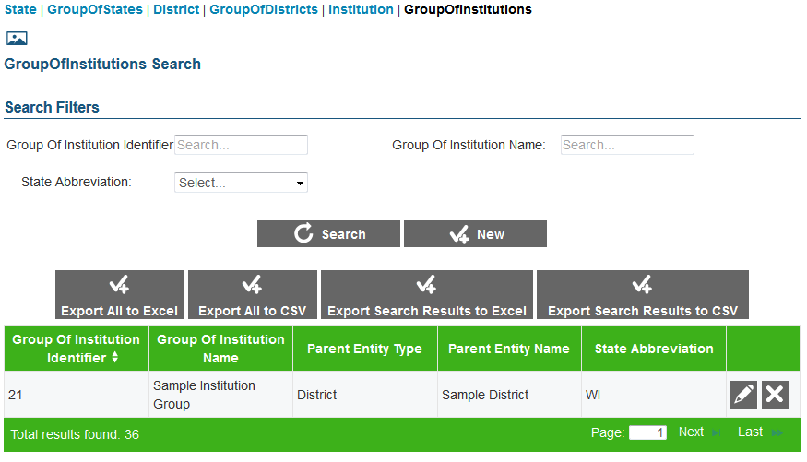

To create an institution group:

|  |
| --- |
| 1. On the ART home screen, click [**Create/Modify Institutions**]. 2. On the Create/Modify Institutions screen, click the [**Group Of Institutions**] link. 3. On the ***Group of Institutions Search*** screen, click [**New**]. 4. On the ***Add Group of Institutions Information*** screen, enter the information for the institution group in the provided fields. For an explanation of these fields, see Table 13. 5. Click [**Save**]. |

To modify an institution group:

|  |
| --- |
| 1. On the ***Group of Institutions Search*** screen, search for an institution group record. 2. On the search results table, click [ ] for an institution group record. 3. On the ***Edit Group of Institutions Information*** screen, modify the information for the institution group in the provided fields. For an explanation of these fields, see Table 13. 4. Click [**Save**]. |

To delete an institution group:

|  |
| --- |
| 1. Perform a search for a particular institution group record on the ***Group of Institutions Search*** screen. 2. On the search results table, click [ ] for an institution group record. 3. In the warning box that pops up, click [**OK**].   **Caution: If you delete an institution group, all the child entities within that group will also be deleted.** |

#### Upload institution groups.

You can add, modify, or delete institution groups by uploading a file to ART.

To upload an institution group file:

|  |
| --- |
| 1. Download the GroupOfInstitutions template, following the instructions provided in the Download File Templates section. 2. Using Table 13 as a reference, enter a row of information for each institution group you want to add, modify, or delete.    1. To modify an existing institution group record, enter the information for the new record in its own column. The old record will be replaced upon uploading the file.    2. To delete an existing institution group record, enter “DELETE” in the Delete column. 3. On the ART home screen, click [**Upload Institutions, Users and Students**]. 4. Upload the institution group file, following the instructions provided in the Uploading Files section. |

Table 13 describes the columns in the institution group file and lists acceptable values in **bold type**. These columns also correspond with the fields on the ***Add Group of Institutions Information***. Columns marked with an asterisk (*) are required for add or modify actions; columns marked with a plus (+) are required for delete actions.

Table . Upload Institution Group File Requirements

| Column | Description |
| --- | --- |
| GroupOfInstitutionsIdentifier*+ | Unique identifier for institution group.  **Up to 20 alphanumeric characters.** |
| GroupOfInstitutionsName* | Institution group’s name.  **Up to 60 alphanumeric characters.** |
| ParentEntityType* | Institution group’s parent in the Consortium’s hierarchy. One of the following:   * **CLIENT**—Indicates the institution group is a direct member of the consortium. * **GROUPOFSTATES**—Indicates the institution group is a member of a group of states. * **STATE**—Indicates the institution group is a member of a state. * **GROUPOFDISTRICTS**—Indicates the institution group is a member of a group of districts. * **DISTRICT**—Indicates the institution group is a member of a district.   For a description of the Consortium’s hierarchy in ART, see the section Understanding the Smarter Balanced Hierarchy. |
| ParentExternalId* | Parent entity’s identifier.  **Up to 20 characters of an existing client’s, state group’s, state’s, district group’s, or district’s ID.** |
| StateAbbreviation*+ | State in which the institution group is located. **Any standard two-letter state abbreviation is valid.** In addition, the following are also valid:   * **AA**—Armed Forces Americas * **AE**—Armed Forces Africa, Canada, Europe and Mideast * **AP**—Armed Forces Pacific * **TS**—Test State * **OT**—Other |
| Delete+ | Flag for deleting the institution group.   * **DELETE**—Delete the institution group associated with the combination of GroupOfInstitutionsIdentifier and StateAbbreviation. * **<blank>**—Add the new institution group or modify an existing institution group. |

### Managing Institutions.

After adding institution group records, you can create institution records. Institutions can belong to an institution group, district, district group, state, state group, or client. See Figure 26.

*Note: The actions described in this section are available to users with a district-, state-, or client-level role.*

|  |  |
| --- | --- |
|  | “Institution” rather than “School” is the default terminology because ART may accommodate institutions of higher learning. System administrators can change the name of this hierarchy level based on state preferences, but some labels may still use “institution,” such as the upload file types. |

#### Create or modify an institution.

Figure . Institution Search Screen

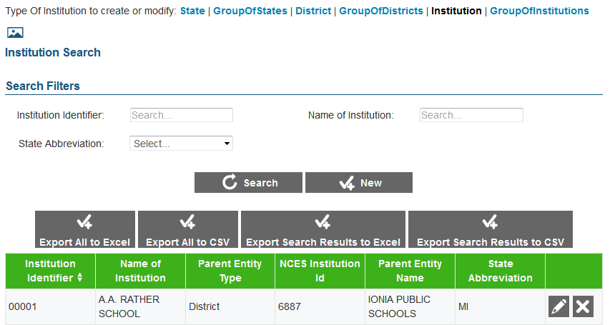

To create an institution:

|  |
| --- |
| 1. On the ART home screen, click [**Create/Modify Institutions]**. 2. On the Create/Modify Institutions screen, click the [**Institution**] link. 3. On the ***Institution Search*** screen, click [**New**]. 4. On the ***Add Institution Information*** screen, enter the information for the institution in the provided fields. For an explanation of these fields, see Table 14. 5. Click [**Save**]. |

To modify an institution:

|  |
| --- |
| 1. On the ***Institution Search*** screen, search for an institution record. 2. In the search results table, click [ ] for an institution record. 3. On the ***Edit Institution Information*** screen, modify the information for the institution in the provided fields. For an explanation of these fields, see Table 14. 4. Click [**Save**]. |

To delete an institution:

|  |
| --- |
| 1. On the ***Institution Search*** screen, search for an institution record. 2. In the search results table, click [ ] for an institution record. 3. In the warning box that pops up, click [**OK**].   **Caution: If you delete an institution, all of the child entities within that institution will also be deleted.** |

#### Upload Institutions.

You can add, modify, or delete institutions by uploading a file to ART.

To upload an institution file:

|  |
| --- |
| 1. Download the Institution template, following the instructions provided in the Download File Templates section. 2. Using Table 14 as a reference, enter a row of information for each institution you want to add, modify, or delete.    1. To modify an existing institution record, enter the information for the new record in its own row. The old record will be replaced upon uploading the file.    2. To delete an existing institution record, enter “DELETE” in the Delete column. 3. On the ART home screen, click [**Upload Institutions, Users and Students**]. 4. Upload the institution file, following the instructions provided in the Uploading Files section. |

Table 14 describes the columns in the institution file and lists acceptable values in **bold type**. These columns also correspond with the fields on the ***Add Institution Information*** screen. Columns marked with an asterisk (*) are required for add or modify actions; columns marked with a plus (+) are required for delete actions.

Table . Upload Institution File Requirements

| Column | Description |
| --- | --- |
| InstitutionIdentifier*+ | Unique identifier for the institution.  **Up to 20 alphanumeric characters.** |
| NameOfInstitution* | Institution name.  **Up to 60 alphanumeric characters.** |
| ParentEntityType* | Institution’s parent in the Consortium’s hierarchy. One of the following:   * **CLIENT**—Indicates the institution is a direct member of the consortium. * **GROUPOFSTATES**—Indicates the institution is a member of a group of states. * **STATE**—Indicates the institution is a member of a state. * **GROUPOFDISTRICTS**—Indicates the institution is a member of a group of districts. * **DISTRICT**—Indicates the institution is a member of a district. * **GROUPOFINSTITUTIONS**—Indicates the institution is a member of a group of institutions.   For a description of the Consortium’s hierarchy in ART, see the section Understanding the Smarter Balanced Hierarchy. |
| NCESInstitutionId* | Institution’s unique nationwide identifier. You can look up an NCES identifier at <http://nces.ed.gov/ccd/schoolsearch/>. |
| ParentExternalId* | Parent entity’s identifier.  **Up to 20 characters of an existing client’s, state group’s, state’s, district group’s, district’s, or institution group’s ID.** |
| StateAbbreviation*+ | State in which the institution is located. Any standard two-letter state abbreviation is valid. In addition, the following are also valid:   * **AA**—Armed Forces Americas * **AE**—Armed Forces Africa, Canada, Europe and Mideast * **AP**—Armed Forces Pacific * **TS**—Test State * **OT**—Other |
| Delete+ | Flag for deleting the institution.   * **DELETE**—Delete the institution associated with InstitutionIdentifier. * **<blank>**—Add the new institution or modify an existing one. |

### Managing Users.

You can create user records and add roles that are associated with entities that are within your entity and below your level of the hierarchy. You cannot create user records for a higher entity level or for an entity to which you do not belong. For example, if you belong to District A, you can only create user records in District A with roles that are associated with District A or schools within District A. Once users and students are both added to ART, students can be associated to users via student groups. Figure 27 shows a user search screen.

Note: The actions described in this section are available to client-, state-, district-, and institution-level users.

|  |  |
| --- | --- |
|  | System administrators can change the term “users” to “personnel” or any other preferred terminology. |

#### Create or modify a user record.

Figure . User Search Screen

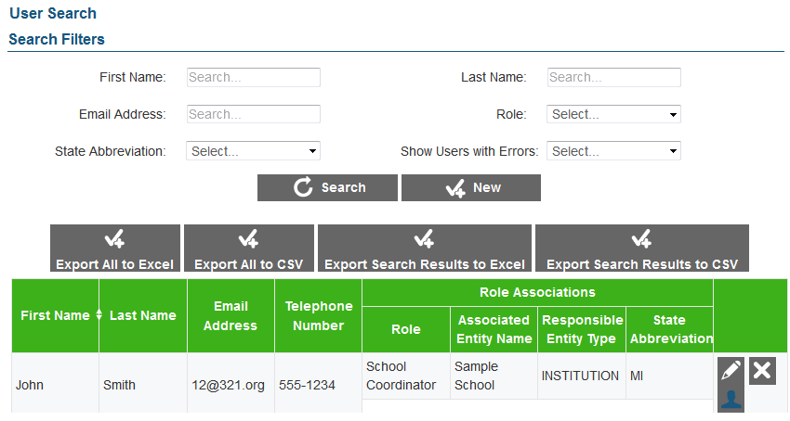

To create a user record:

|  |
| --- |
| 1. On the ART home screen, click [**Create/Modify Users**]. 2. On the ***User Search*** screen, click [**New**]. 3. On the ***Add User Information*** screen, enter the information for the user record in the provided fields. For an explanation of these fields, see Table 15. 4. To associate the user with a role, do the following:    1. Click [ ] in the *Role Associations* section.    2. Select options from the drop-down menus provided in this section.    3. Repeat steps a–b to add additional roles as necessary. 5. *Optional*: To ensure the user’s information is current across the Single Sign-On System, in the Actions section click [**Sync**]. 6. *Optional*: To reset the user’s password, click [**Reset Password**]. 7. *Optional*: To prohibit the user from logging in, click [**Lock User**] at the bottom of the screen. 8. Click [**Save**]. |

To modify a user record:

|  |
| --- |
| 1. On the ***User Search*** screen, search for a user record. 2. On the search results table, click [ ] for a user record. 3. On the ***Edit User Information*** screen, modify the information for the user in the provided fields. For an explanation of these fields, see Table 15. 4. To associate the user with a role, do the following: 5. Click [ ] in the *Role Associations* section.    1. Select options from the drop-down menus provided in this section.    2. To remove a role association, click [ ] next to that role. 6. *Optional:* To ensure the user’s information is current across the Single Sign-On System, in the Actions section click [**Sync**]. 7. *Optional:* To reset the user’s password, click [**Reset Password**]. 8. *Optional:* To prohibit the user from logging in, click [**Lock User**] at the bottom of the screen.    1. To allow a locked user to log in, click [**Unlock User**] at the bottom of the screen. 9. Click [**Save**]. |

To delete a user record:

|  |
| --- |
| 1. On the ***User Search*** screen, search for a user record. 2. On the search results table, click [ ] for the record you want to delete. 3. In the warning box that pops up, click [**OK**]. |

#### Modifying proctor details.

If you create a user record with a role that has been identified as a valid proctor role in ART, then you can also modify the proctor affinities and availability for that user (see Figure 28). Proctor affinities specify a user’s assessment administration preferences based on grade, subject, and assessment. If a proctor’s affinities are set as “strict,” then the system only schedules that proctor for testing opportunities that satisfy the designated affinities. For more information on proctor roles, see the section Specifying Proctor Roles.

|  |  |
| --- | --- |
|  | **Note:** In order to edit a user’s proctor information you must first add that user’s role as a valid proctor role on the Proctor Roles screen. |

Figure . Proctor Information Screen

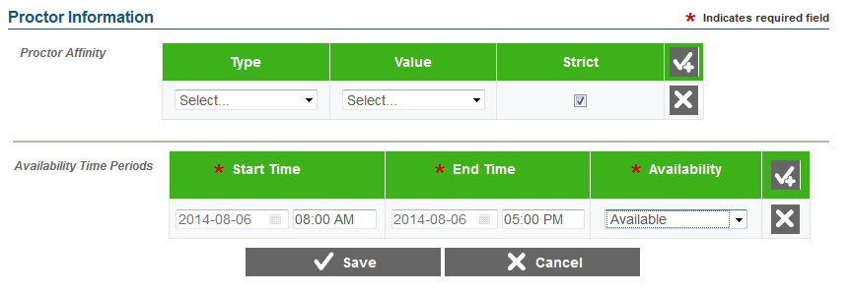

To modify proctor details:

|  |
| --- |
| 1. On the ***User Search*** screen, search for a user record. 2. On the search results table, click [] for a user record with proctor permissions. 3. To add affinities, click [ ] in the *Proctor Affinity* section on the Proctor Information screen. If you create multiple affinities, add them in the order of priority.    1. Select an affinity type from the Type drop-down list then select the corresponding value for that affinity from the Value drop-down list.    2. If you wish to set this as a strict (mandatory) affinity, mark the Strict checkbox. 4. To add availability time slots, click [ ] in the *Availability Time Periods* section on the Proctor Information screen. You can add multiple time slots.    1. Enter a date range in the Start Time and End Time columns.    2. From the Availability drop-down list, select an availability status. 5. Click [**Save**]. |

#### Upload users.

You can add, modify, or delete users by uploading a file to ART. You can also add multiple user role and entity associations for a single user record.

To upload a user file:

|  |
| --- |
| 1. Download the User template, following the instructions provided in the Download File Templates section. 2. Using Table 15 as a reference, enter a row of information for each user record you want to add, modify, or delete.    1. To add multiple roles for a user, enter each role association in its own row of the template.    2. To delete an existing user record, enter “DELETE” in the Delete column. Note: You must delete each role association record to remove the user record.    3. If you want to replace a user record, you must delete the original record and then create a new one, otherwise the system may regard the new record as an additional role. 3. On the ART home screen, click [**Upload Institutions, Users and Students**]. 4. Upload the user file, following the instructions provided in the Uploading Files section. |

Table 15 describes the columns in the user file and lists acceptable values in **bold type**. These columns also correspond with the fields on the ***Add User Information*** screen. Columns marked with an asterisk (*) are required for add or modify actions; columns marked with a plus (+) are required for delete actions. Note: Some of the labels on the user template differ from those on the **Add User Information** screen. The unique labels from the **Add User Information** screen are listed in parentheses below the labels from the template.

Table . Upload User File Requirements

| Column | Description |
| --- | --- |
| FirstName* | User’s first name.  **Up to 35 characters.** |
| LastOrSurname*  (Last Name) | User’s last name.  **Up to 35 characters.** |
| ElectronicMailAddress*+  (E-mail Address) | User’s e-mail address.  **Up to 128 characters in standard e-mail address format.** |
| TelephoneNumber | Telephone number including the area code, and optional extension.  **Up to 24 characters in XXX‑XXX‑XXXX xNNNNNN or XXX‑XXX‑XXXX xNNNNNN format.** |
| Role* | Role assigned to the user.  **Up to 30 characters.** |
| AssociatedEntityID* | Identifier of entity associated with the user.  **Up to 20 characters.** |
| Level*  (Responsible Entity Type) | User-role combination’s parent in the Consortium’s hierarchy.   * **CLIENT**—Indicates the user is a direct member of the consortium. * **GROUPOFSTATES**—Indicates user is a member of a group of states. * **STATE**—Indicates user is a member of a state. * **GROUPOFDISTRICTS**—Indicates user is a member of a group of districts. * **DISTRICT**—Indicates user is a member of a district. * **GROUPOFINSTITUTIONS**—Indicates user is a member of a group of institutions. * **INSTITUTION**—Indicates user is a member of a group of an institution.   For a description of the Consortium’s hierarchy in ART, see the section Understanding the Smarter Balanced Hierarchy. |
| StateAbbreviation*  (State) | State with which the user is associated. **Any standard two-letter state abbreviation is valid.** In addition, the following are also valid:   * **AA**—Armed Forces Americas * **AE**—Armed Forces Africa, Canada, Europe and Mideast * **AP**—Armed Forces Pacific * **TS**—Test State * **OT**—Other |
| Delete+ | Flag for deleting the user-role combination.   * **DELETE**—Delete the user-role combination associated with the ElectronicMailAddress. * **<blank>**—Add the new user record or modify an existing one. |

### Managing Students.

After adding institution records, you can add students to ART, along with their demographic information. Students can only belong to institution entities. Once students are added to ART, any student who meets the implicit eligibility criteria for an assessment already added to ART will automatically be registered for that assessment. Figure 29 shows the student search screen.

Note: The actions described in this section are available to users with a client-, state-, district-, or institution-level role.

#### Create or modify a student.

Figure . Student Search Screen

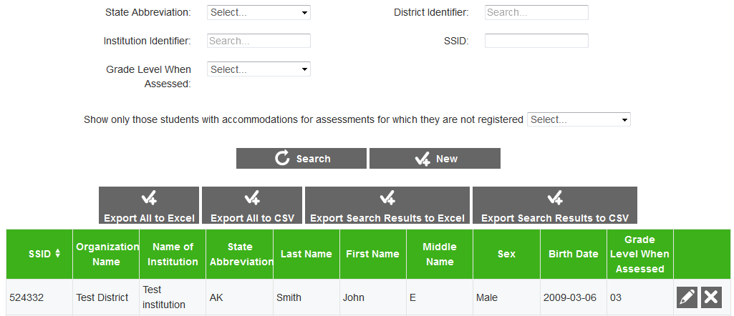

To create a student record:

|  |
| --- |
| 1. On the ART home screen, click [**Create/Modify Students**]. 2. On the ***Student Search*** screen, click [**New**]. 3. On the ***Add Student Information*** screen, enter the information for the student, including demographic information, in the provided fields. For an explanation of these fields, see Table 16. 4. To add an accommodation for the student, click [ ] in the Accommodations section, and enter the accommodation information in the provided fields. For more information about managing accommodations, see the Managing Accommodations section. 5. Click [**Save**]. |

To modify a student record:

|  |
| --- |
| 1. On the ***Student Search*** screen, search for a student record. 2. In the search results table, click [ ] for a student record. 3. On the ***Edit Student Information*** screen, modify the information for the student, including demographic information, in the provided fields. For an explanation of these fields, see Table 16. 4. To add an accommodation for the student, click [ ] in the *Accommodations* section, and enter the accommodation information in the provided fields. For more information about managing accommodations, see the Managing Accommodations section. 5. To remove an accommodation, click [ ] next to that accommodation. 6. Click [**Save**]. |

To delete a student:

|  |
| --- |
| 1. On the ***Student Search*** screen, search for a student record. 2. In the search results table, click [ ] for a student record. 3. In the warning box that pops up, click [**OK**]. |

#### Upload students.

You can add, modify, or delete students by uploading a file to ART.

To upload a student file:

|  |
| --- |
| 1. Download the Student template, following the instructions provided in the Download File Templates section. 2. Using Table 16 as a reference, enter a row of information for each student you want to add, modify, or delete.    1. To modify an existing student record, enter the information for the new record in its own row. The old record will be replaced upon uploading the file.    2. To delete an existing student record, enter “DELETE” in the Delete column. 3. On the ART home screen, click [**Upload Institutions, Users and Students**]. 4. Upload the student file, following the instructions provided in the Uploading Files section. |

Table 16 describes the columns in the student file and lists acceptable values in **bold type**. These columns also correspond with the fields on the ***Add Student Information*** screen. Columns marked with an asterisk (*) are required for add or modify actions; columns marked with a plus (+) are required for delete actions. Note: Some of the labels on the user template differ from those on the **Add Student Information** screen. The unique labels from the **Add Student Information** screen are listed in parentheses below the labels from the template.

Table . Upload Student File Requirements

| Column | Description |
| --- | --- |
| StateAbbreviation*+ | State in which the student attends school. **Any standard two-letter state abbreviation is valid.** In addition, the following are also valid:   * **AA**—Armed Forces Americas * **AE**—Armed Forces Africa, Canada, Europe and Mideast * **AP**—Armed Forces Pacific * **TS**—Test State * **OT**—Other |
| ResponsibleDistrictIdentifier*  (District Identifier) | Identifier for the district related to the student.  **Up to 30 alphanumeric characters of an existing district ID.** |
| ResponsibleInstitutionIdentifier*  (Institution Identifier) | Identifier for the institution related to the student.  **Up to 30 alphanumeric characters of an existing institution ID.** |
| LastOrSurname  (Last Name) | Student’s last name.  **Up to 35 characters.** |
| FirstName | Student’s first name.  **Up to 35 characters.** |
| MiddleName | Student’s middle name.  **Up to 35 characters.** |
| Birthdate | Student’s birth date.  **YYYY-MM-DD format with leading zeros for month and day.** |
| StudentIdentifier*+  (SSID) | State-assigned student identifier (SSID).  **Up to 30 characters.** |
| ExternalSSID*  (Alternate SSID) | Alternative state-assigned student Identifier. If a state chooses not to share its students’ SSIDs with consortium members, ART provides this number instead.  **Up to 50 characters.** |
| GradeLevelWhenAssessed* | Student's enrolled grade.   * **IT**—Infant/toddler * **PR**—Preschool * **PK**—Prekindergarten * **TK**—Transitional kindergarten * **KG**—Kindergarten * **01**—First grade * **02**—Second grade * **03**—Third grade * **04**—Fourth grade * **05**—Fifth grade * **06**—Sixth grade * **07**—Seventh grade * **08**—Eighth grade * **09**—Ninth grade * **10**—Tenth grade * **11**—Eleventh grade * **12**—Twelfth grade * **13**—Grade 13 * **PS**—Postsecondary * **UG**—Ungraded |
| Sex* | Student's gender.   * **Male** * **Female** |
| HispanicOrLatinoEthnicity* | Hispanic Ethnic Flag.   * **Yes** * **No** |
| AmericanIndianOrAlaskaNative* | American Indian/Alaskan Native Race Flag.   * **Yes** * **No** |
| Asian* | Asian Race Flag.   * **Yes** * **No** |
| BlackOrAfricanAmerican* | African American Race Flag.   * **Yes** * **No** |
| White* | White Race Flag.   * **Yes** * **No** |
| NativeHawaiianOrOtherPacificIslander* | Native Hawaiian/Other Pacific Islander Race Flag.   * **Yes** * **No** |
| DemographicRaceTwoOrMoreRaces* | A person having origins in any of more than one of the racial groups.   * **Yes** * **No** |
| IDEAIndicator* | Student Enrolled in IEP.   * **Yes** * **No** |
| LEPStatus* | Student identified as LEP.   * **Yes** * **No** |
| Section504Status* | Student with 504 plan.   * **Yes** * **No** * **Unknown/Cannot Provide** |
| EconomicDisadvantageStatus* | An indication that the student met the state’s criteria for classification as having an economic disadvantage.   * **Yes** * **No** |
| LanguageCode | Three-character code for the specific language or dialect that a person uses to communicate. For a listing of acceptable values, see <https://ceds.ed.gov/languageCodes.aspx>. |
| EnglishLanguageProficiencyLevel | An indication of the progress made by a student toward English proficiency.  **Up to 20 characters.** |
| MigrantStatus | Persons who are, or whose parents or spouses are, migratory agricultural workers, including migratory dairy workers or migratory fishers, and who, in the preceding 36 months, in order to obtain, or accompany such parents or spouses, in order to obtain, temporary or seasonal employment in agricultural or fishing work (A) have moved from one LEA to another; (B) in a state that comprises a single LEA, have moved from one administrative area to another within such LEA; or (C) reside in an LEA of more than 15,000 square miles, and migrate a distance of 20 miles or more to a temporary residence to engage in a fishing activity.   * **Yes** * **No** * **<blank>** |
| FirstEntryDateIntoUSSchool | The year, month, and day of a student’s initial enrollment into a United States school.  **YYYY-MM-DD format with leading zeros for month and day.** |
| LimitedEnglishProficiencyEntryDate | The year, month, and day a student classified as limited English proficient entered the LEP program.  **YYYY-MM-DD format with leading zeros for month and day.** |
| LEPExitDate | The year, month, and day a student classified as limited English proficient exited the LEP program.  **YYYY-MM-DD format with leading zeros for month and day.** |
| TitleIIILanguageInstructionProgramType | Title III Language Instruction Program Type.   * **DualLanguage**—Dual language * **TwoWayImmersion**—Two-way immersion * **TransitionalBilingual**—Transitional bilingual * **DevelopmentalBilingual**—Developmental bilingual * **HeritageLanguage**—Heritage language * **ShelteredEnglishInstruction**—Sheltered English instruction * **StructuredEnglishImmersion**—Structured English immersion * **SDAIE**—Specially designed academic instruction delivered in English (SDAIE) * **ContentBasedESL**—Content-based ESL * **PullOutESL**—Pull-out ESL * **Other** – Other |
| PrimaryDisabilityType | The major or overriding disability condition that best describes a student’s impairment.   * **AUT**—Autism * **DB**—Deaf-blindness * **DD**—Developmental delay * **EMN**—Emotional disturbance * **HI**—Hearing impairment * **ID**—Intellectual disability * **MD**—Multiple disabilities * **OI**—Orthopedic impairment * **OHI**—Other health impairment * **SLD**—Specific learning disability * **SLI**—Speech or language impairment * **TBI**—Traumatic brain injury * **VI**—Visual impairment |
| Delete+ | Flag for deleting the record.   * **DELETE**—Delete the student associated with the combination of StateAbbreviation and StudentIdentifier. * **<blank>**—Add the new student or modify the existing student. |

### Managing Student Groups.

After adding student records, you can group students together and associate them with a user in student groups. See Figure 30.

*Note: The actions described in this section are available to users with a client-, state-, district-, or institution-level role.*

#### Create or modify a student group.

Figure . Student Groups Search Screen

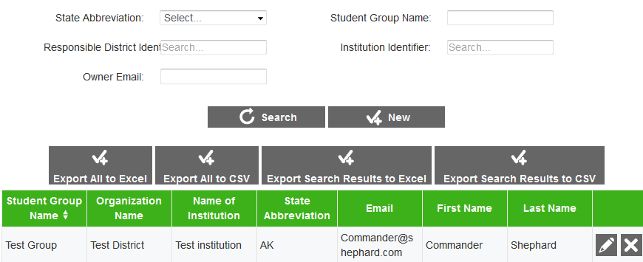

To create a student group:

|  |
| --- |
| 1. On the ART home screen, click [**Create/Modify Student Group**]. 2. On the ***Student Groups Search*** screen, click [**New**]. 3. On the ***Add Student Groups Information*** screen, enter the information for the student group in the provided fields. For an explanation of these fields, see Table 17. 4. To add students to the group, do the following:    1. Enter any additional search criteria in the provided fields and click [**Search Students**]. At a minimum you must specify a state abbreviation, district identifier, and institution identifier. Students who match those criteria appear in a table on the right side of the screen (see Figure 31).    2. Mark the checkbox next to each student you wish to add, or mark the Select All checkbox to select all of the students in the search results.    3. Click [**Add selected to group**]. The selected students will be added to the group and displayed in the student group table on the left.    4. To remove a student from the student group, mark the checkbox next to that student in the table on the left side of the screen and click [**Remove selected from group**]. 5. Click [**Save**]. |

Figure . Add Student Group Information Screen

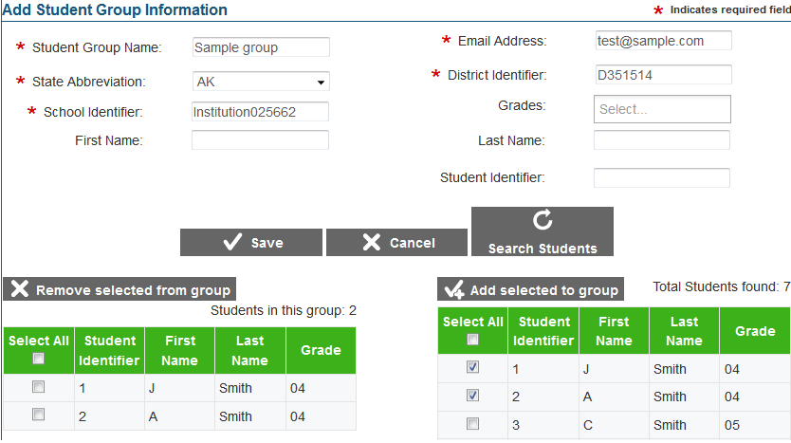

To modify a student group:

|  |
| --- |
| 1. Perform a search for a particular student group record on the ***Student Group Search*** screen. 2. On the search results table, click [ ] for a student group record. 3. On the ***Edit Student Groups Information*** screen, modify the information for the student group in the provided fields. For an explanation of these fields, see Table 17. 4. To add students to the group, do the following:    1. Enter any additional search criteria in the provided fields and click [**Search Students**]. At a minimum you must specify a state abbreviation, district identifier, and institution identifier. Students who match those criteria appear in a table on the right side of the screen.    2. Mark the checkbox next to each student you wish to add, or mark the Select All checkbox to select all of the students in the search results.    3. Click [**Add selected to group**]. The selected students will be added to the group. 5. To remove a student from the student group, mark the checkbox next to that student in the table on the left side of the screen and click [**Remove selected from group**]. 6. Click [**Save**]. |

To delete a student group:

|  |
| --- |
| 1. Perform a search for a particular student record on the ***Student Groups Search*** screen. 2. On the search results table, click [ ] for a student group record. 3. In the warning box that pops up, click [**OK**]. The student group will be removed from ART.   Note: Deleting a student group deletes the student and user associations with that student group, but does not delete the individual student or user records. |

#### Upload student groups.

You can add, modify, or delete student groups by uploading a file to ART. You can create multiple student groups and associate the same student to multiple groups within the same upload. A student group is created when a student is associated with a user (identified by that user’s e-mail address) in a row of the template. Each additional row that references that student group builds the group’s membership.

|  |  |
| --- | --- |
|  | If the user associated with a student group is removed from the group, the student group will continue to exist without a user association. In order to remove an entire student group via upload, you must remove each student’s association with that group. |

To upload a student group file:

|  |
| --- |
| 1. Download the Student Group template, following the instructions provided in the Download File Templates section. 2. Using Table 17 as a reference, enter a row associating a student with a user. This creates the student group. Then, using the same student group name, enter a row of information for each additional student that should be added to that group. You can repeat this step with different student group names to create additional student groups.    1. To modify an existing student group, enter a row of information for the new record, including the student-student group association. The old record will be replaced upon uploading the file.    2. To delete an existing student group, enter “DELETE” in the Delete column for **every** student record associated with that group. 3. On the ART home screen, click [**Upload Student Groups**]. 4. Upload the student group file, following the instructions provided in the Uploading Files section. |

Table 17 describes the columns in the student group file and lists acceptable values in **bold type**. These columns also correspond with the fields on the ***Add Student Groups Information*** screen. Columns marked with an asterisk (*) are required for add or modify actions; columns marked with a plus (+) are required for delete actions. Note: Some of the labels on the user template differ from those on the **Add Student Groups Information** screen. The unique labels from the **Add Student Groups Information** screen are listed in parentheses below the labels from the template.

Table . Upload Student-Group File Requirements

| Column | Description |
| --- | --- |
| InstitutionIdentifier*+ | Identifier for the institution related to the student group.  **Up to 20 alphanumeric characters of an existing institution ID.** |
| ElectronicMailAddress*  (E-mail) | E-mail address of the user designated as the “owner” of the Student Group. E-mail address must belong to a user in the system  **Up to 50 characters in standard e-mail address format.** |
| StudentGroupName*+ | Descriptive name of student group.  **Up to 50 alphanumeric characters.** |
| StudentIdentifier*+ | State-assigned student identifier (SSID).  **Up to 30 characters.** |
| StateAbbreviation*+ | State where the student group is located. **Any standard two-letter state abbreviation is valid.** In addition, the following are also valid:   * **AA**—Armed Forces Americas * **AE**—Armed Forces Africa, Canada, Europe and Mideast * **AP**—Armed Forces Pacific * **TS**—Test State * **OT**—Other |
| ResponsibleDistrictIdentifier*  (District Identifier) | Identifier for the district related to the student-group.  **Up to 30 alphanumeric characters of an existing district ID.** |
| Delete+ | Flag for deleting the student group-student pair.   * **DELETE**—Delete the student group-student pair associated with the combination of InstitutionIdentifier, StudentGroupName, StudentIdentifier, and StateAbbreviation. * **<blank>**—Add the new student group or modify an existing student group. |

### Managing Student Eligibility.

If you defined an assessment with explicit eligibility, then you must upload a file containing the students eligible for that assessment. You cannot use the eligibility upload task to register students for assessments with implicit eligibility.

A list of the tests for which a student is eligible appears on the ***Edit Student Information*** screen (see Figure 32), which can be accessed from the ***Create/Modify Students*** feature (for more information, see the section Create or modify a student).

*Note: The actions described in this section are available to users with a client-, state-, district-, or institution-level role.*

Figure . Eligible Assessments Section on the Edit Student Information Screen

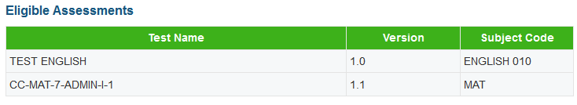

|  |  |
| --- | --- |
|  | You cannot manage a student’s eligibility from the Create/Modify Students screen. The only way to add, modify, or delete a student’s eligibility for an explicit assessment is to upload a student eligibility file. Eligibility rules for assessments with implicit eligibility must be edited on the Add/Modify Assessment Information screen and are determined automatically. |

To upload a student eligibility file:

|  |
| --- |
| 1. Download the Explicit Eligibility template, following the instructions provided in the Download File Templates section. 2. Using Table 18 as a reference, enter information for each eligibility record you want to add.    * To register a student to multiple assessments, add a row for each student-assessment pair. 3. To delete an existing student eligibility record, enter “DELETE” in the Delete column. 4. To modify a student eligibility record, do the following:    1. Delete the original record in one row.    2. Enter the information for the new eligibility record in a new row. 5. On the ART home screen, click [**Upload Student Explicit Eligibility**]. 6. Upload the student eligibility file, following the instructions provided in the Uploading Files section. |

Table 18 describes the columns in the student eligibility file and lists acceptable values in **bold type**. Columns marked with an asterisk (*) are required for add actions; columns marked with a plus (+) are required for delete actions.

Table . Upload Student Eligibility File Requirements

| Column | Description |
| --- | --- |
| StudentIdentifier*+ | State-assigned student identifier (SSID).  **Up to 30 characters.** |
| AssessmentAdministrationAssessmentFamily* | An identifier for the test administration program.  **Up to 60 characters.** |
| StateAbbreviation*+ | State with which the student eligibility is associated. **Any standard two-letter state abbreviation is valid.** In addition, the following are also valid:   * **AA**—Armed Forces Americas * **AE**—Armed Forces Africa, Canada, Europe and Mideast * **AP**—Armed Forces Pacific * **TS**—Test State * **OT**—Other |
| ResponsibleDistrictIdentifier* | Identifier for the district related to the student eligibility.  **Up to 30 alphanumeric characters of an existing district ID.** |
| Subject* | The subject of the assessment the student is eligible to take.  **Up to 20 characters.** |
| TestName*+ | The specific name of the assessment the student is eligible to take.  **Up to 200 characters.** |
| TestVersion*+ | Part of the unique key to identify a particular assessment.  **Up to 50 characters.** |
| TestForm | The specific name of the form assigned to the student.  **Up to 50 characters.** |
| Delete+ | Flag for deleting the student eligibility.   * **DELETE**—Delete the eligibility associated with the combination of StudentIdentifier, StateAbbreviation, TestName, and TestVersion. * **<blank>**—Add the new student-eligibility pair, or modify the existing student-eligibility pair. |

### Managing Accommodations.

If a student requires test accommodations in a particular subject, you can create and manage these accommodations on the ***Create/Modify Students*** screen (see Figure 33). You can also add accommodations for multiple students and subjects via the file upload task, but you cannot use the upload task to delete existing accommodations.

Note: The actions described in this section are available to users with a client-, state-, district-, or institution-level role.

#### Create or modify a student’s accommodations.

Figure . Accommodations Section on the Edit Student Information Screen

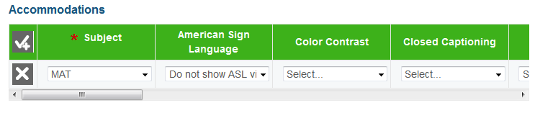

To create, modify, or delete a student’s accommodations:

|  |
| --- |
| 1. In ART, click [**Create/Modify Students**]. The Student Search screen appears. 2. On the Student Search screen, search for a particular student record. 3. On the search results table, click [ ] for a student record. The Edit Student Information screen appears, displaying the student’s accommodations in the *Accommodations* section near the bottom of the screen (see Figure 33). 4. To add an accommodation for the student, do the following:    1. Click [ ] in the Accommodations section. A new row of blank accommodation fields and drop-down menus appears.    2. Enter the accommodation information in the provided fields. For a description of these fields, refer to Table 19.    3. Repeat steps a–b to add additional accommodations. 5. To edit an existing accommodation, select different values from the fields provided for that accommodation in the Accommodations section. 6. To delete an accommodation, click [ ] next to that accommodation. 7. Click [**Save**]. |

|  |  |
| --- | --- |
|  | The subject selected for an accommodation must match one of the subjects that were configured in ART. If the necessary subject is not included in the drop-down list, notify a State or Client Coordinator. For more information on configuring subjects, see the section Manage Subjects. |

#### Upload accommodations.

Use this task to add or modify accommodations. You cannot delete accommodations using file uploads. To delete an accommodation, you must use the ***Edit Student Information*** screen.

To upload an accommodations file:

|  |
| --- |
| 1. Download the Accommodations template, following the instructions provided in the Download File Templates section. 2. Using Table 19 as a reference, enter a row of information for each accommodation you want to add or update.    * To add accommodations for multiple subjects for a single student, enter a row of accommodations for each subject.    * To update an existing accommodation record for a student, enter a new row of information for that record. Once uploaded, the new accommodation record will replace the previous one. 3. On the ART home screen, click [**Upload Student Institutions, Users and Students**]. 4. Upload the student accommodation file, following the instructions provided in the Uploading Files section. |

Table 19 describes the columns in the accommodations file, and lists acceptable values in **bold type**. These columns also correspond with the fields on the Edit Student Information screen. Columns marked with an asterisk (*) are required for add actions.

Table . Upload Accommodation File Requirements

| Column | Description |
| --- | --- |
| StudentIdentifier* | State-assigned student identifier (SSID).  **Up to 30 characters.** |
| StateAbbreviation* | State in which the student attends school. **Any standard two-letter state abbreviation is valid.** In addition, the following are also valid:   * **AA**—Armed Forces Americas * **AE**—Armed Forces Africa, Canada, Europe and Mideast * **AP**—Armed Forces Pacific * **TS**—Test State * **OT**—Other |
| Subject* | Subject for which the accommodations apply.  **Up to 20 characters.** |
| AmericanSignLanguage | Allows students to view test content translated into ASL by a human signer.   * **TDS_ASL0**—Do not show ASL videos. * **TDS_ASL1**—Show ASL videos. |
| ColorContrast | By default, tests are presented with black text on a white background. Students who require a different combination of text and background are assigned one of the following:   * **TDS_CC0**—Black on White * **TDS_CCInvert**—Reverse Contrast * **TDS_CCMagenta**—Black on Rose * **TDS_CCMedGrayLtGray**—Medium Gray on Light Gray * **TDS_CCYellowB**—Yellow on Blue |
| ClosedCaptioning | Provides subtitles for audio portions.   * **TDS_ClosedCap0**—Closed captioning not available * **TDS_ClosedCap1**—Closed captioning available |
| Language | Language in which the tests are presented.   * **ENU**—English * **ENU-Braille**—Braille * **ESN**—Spanish (stacked translation), math only |
| Masking | Blocks off content that is not of immediate need or that may be distracting to the student.   * **TDS_Masking0**—Masking not available * **TDS_Masking1**—Masking available |
| PermissiveMode | Permissive mode enables access to accessibility software in order to interact with the test (e.g., screen readers, magnifiers). When permissive mode is disabled, the only application that can be open on the computer is the secure browser.   * **TDS_PM0**—Permissive mode disabled * **TDS_PM1**—Permissive mode enabled |
| PrintOnDemand | Allows student to request printing of stimuli.   * **TDS_PoD0**—None * **TDS_PoD_Stim**—Stimuli   Note: If a student will require items to be printed, contact the Smarter Balanced Help Desk at Educational Testing Service ([smarterbalancedhelpdesk@ets.org](mailto:smarterbalancedhelpdesk@ets.org)) and provide the student’s state, SSID, and the reason for the request. |
| PrintSize | Sets print size the student views when starting a test. The selected print size becomes the default for all items in that student’s test.   * **TDS_PS_L0**—No default zoom applied * **TDS_PS_L1**—Level 1 * **TDS_PS_L2**—Level 2 * **TDS_PS_L3**—Level 3 * **TDS_PS_L4**—Level 4   The default typeface is as follows:   * The default print size for all tests is 14 pt. * The default font for ELA tests is Times New Roman. * The default font for mathematics tests is Verdana. |
| StreamlinedInterface | By default, all tests use the standard interface. This interface is compatible with all supported desktops and tablets.  The streamlined interface presents the test in an alternative, simplified format in which the items are displayed below the stimuli. All tool and navigation buttons are on the bottom of the screen.  The streamlined interface is not intended to be tablet compatible.   * **TDS_TS_Modern**—Standard * **TDS_TS_Accessibility**—Streamlined |
| TexttoSpeech | Sets student’s text-to-speech accommodation. Students with this test setting enabled may listen to the read-aloud of the items or stimuli in the assessment. (Text-to-speech is not available in Spanish.)   * **TDS_TTS0**—None * **TDS_TTS_Item**—Items Only (ELA only) * **TDS_TTS_Stim**—Stimuli Only (ELA only) * **TDS_TTS_Stim&TDS_TTS_Item**—Stimuli and Items |
| Translation | Sets student’s glossary accommodation.  Students can open a glossary to view terms presented in the test that may be unfamiliar to them.  By design, all students can access the English glossary word list as a universal tool, unless this field is set to “TDS_WL0” (none) or overridden by another language.   * If a combination glossary is selected (e.g., English and Arabic or English and Russian), then the student has access to both. * If a single glossary is selected (e.g., Mandarin), then the student has access to only that glossary. The English glossary is not available.   The English glossary is available for both ELA and mathematics tests. Translated glossaries are available for mathematics tests only.   * **TDS_WL_Glossary**—English * **TDS_WL_ArabicGloss** (Math only)—Arabic * **TDS_WL_CantoneseGloss** (Math only)—Cantonese * **TDS_WL_ESNGlossary** (Math only)—Spanish * **TDS_WL_KoreanGloss** (Math only)—Korean * **TDS_WL_MandarinGloss** (Math only)—Mandarin * **TDS_WL_PunjabiGloss** (Math only)—Punjabi * **TDS_WL_RussianGloss** (Math only)—Russian * **TDS_WL_TagalGloss** (Math only)—Filipino * **TDS_WL_UkrainianGloss** (Math only)—Ukrainian * **TDS_WL_VietnameseGloss** (Math only)—Vietnamese * **TDS_WL_Glossary&TDS_WL_ArabicGloss** (Math only)—English & Arabic * **TDS_WL_Glossary&TDS_WL_CantoneseGloss** (Math only)—English & Cantonese * **TDS_WL_Glossary&TDS_WL_ESNGlossary** (Math only)—English & Spanish * **TDS_WL_Glossary&TDS_WL_KoreanGloss** (Math only)—English & Korean * **TDS_WL_Glossary&TDS_WL_MandarinGloss** (Math only)—English & Mandarin * **TDS_WL_Glossary&TDS_WL_PunjabiGloss** (Math only)—English & Punjabi * **TDS_WL_Glossary&TDS_WL_RussianGloss** (Math only)—English & Russian * **TDS_WL_Glossary&TDS_WL_TagalGloss** (Math only)—English & Filipino * **TDS_WL_Glossary&TDS_WL_UkrainianGloss** (Math only)—English & Ukrainian * **TDS_WL_Glossary&TDS_WL_VietnameseGloss** (Math only)—English & Vietnamese * **TDS_WL0** – None |
| NonEmbeddedDesignatedSupports | Some non-embedded designated supports may need to be provided to students during testing. These should be provided only to those students who are unable to use the embedded test settings.  Non-Embedded Designated Supports for ELA:   * **NEDS0**—None * **NEDS_BD**—Bilingual Dictionary * **NEDS_CC**—Color Contrast * **NEDS_CO**—Color Overlay * **NEDS_Mag**—Magnification * **NEDS_RA_Items**—Read Aloud Items * **NEDS_SC_Items**—Scribe Items (Non-Writing) * **NEDS_SS**—Separate Setting   Non-Embedded Designated Supports for Math:   * **NEDS0**—None * **NEDS_CC**—Color Contrast * **NEDS_CO**—Color Overlay * **NEDS_Mag**—Magnification * **NEDS_RA_Items**—Read Aloud Items * **NEDS_SC_Items**—Scribe Items (Non-Writing) * **NEDS_SS**—Separate Setting * **NEDS_TArabic**—Arabic Glossary * **NEDS_TCantonese**—Cantonese Glossary * **NEDS_TFilipino**—Filipino Glossary * **NEDS_TKorean**—Korean Glossary * **NEDS_TMandarin**—Mandarin Glossary * **NEDS_TPunjabi**—Punjabi Glossary * **NEDS_TRussian**—Russian Glossary * **NEDS_TSpanish**—Spanish Glossary * **NEDS_TUkrainian**—Ukrainian Glossary * **NEDS_TVietnamese**—Vietnamese Glossary |
| NonEmbeddedAccommodations | Some accommodations may need to be provided to students during testing. These should be provided only to those students who are unable to use the embedded test accommodations.   * **NEA0**—None * **NEA_AR**—Alternate Response Options * **NEA_RA_Stimuli** (ELA only)—Read Aloud Stimuli * **NEA_SC_WritItems** (ELA only)—Scribe Items (Writing) * **NEA_STT**—Speech-to-Text * **NEA_Abacus** (Math only)—Abacus * **NEA_Calc** (Math only)—Calculator * **NEA_MT** (Math only)—Multiplication Table |
| Other | Other designated supports or accommodations that are not listed here.  **Up to 300 characters.** |

# Test Administration Tasks

The green task bar at the top of the screen allows you to access the test administration tasks in ART (see Figure 34). Test administration tasks include setting up testing facilities, managing administration schedules, and viewing test administration reports.

Figure . Test Administration Screen

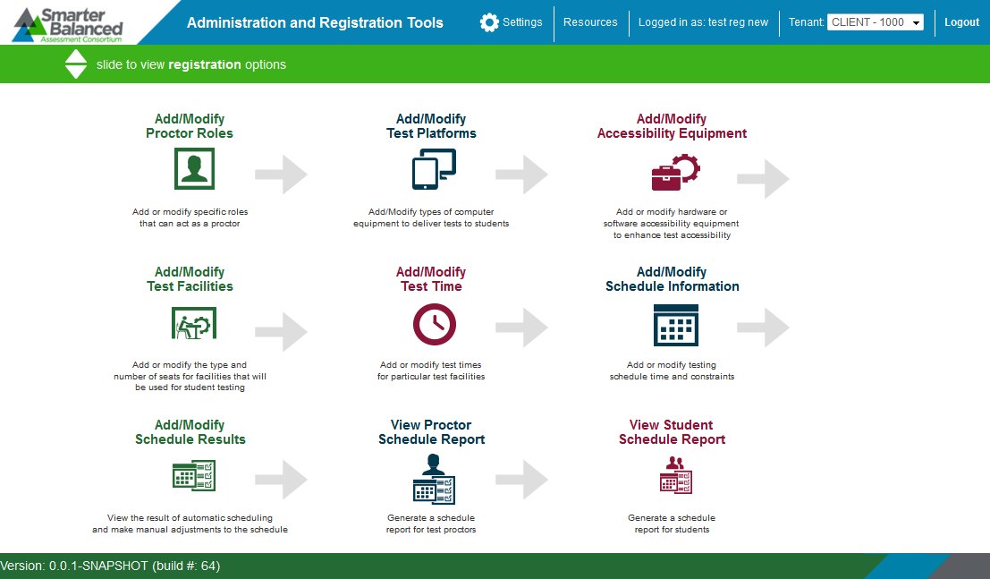

When you click the task bar from the ART home screen, the **Test Administration** screen appears (see Figure 34). This screen displays placards for the tasks available in this section of the ART site, with the arrow () symbols indicating precedence. You must complete the task to the left of an arrow before completing the task to the right.

## Creating Test Schedules

Schedules provide information about the proctor, testing equipment, facility, and date details for a test administration. ART automatically creates schedules based on the entered details. The basic workflow for creating test schedules is as follows:

Specify proctor roles

Add test platforms

Add accessibility equipment

Add facilities

Add testing times

Automatically create schedule

Manually modify schedule

### Specifying Proctor Roles.

Proctors are users who are authorized to administer tests to students. ART does not automatically recognize which roles are authorized to act as proctors, so you must specify these roles manually as shown in Note: The actions described in this section are available to users with a client- or state-level role.

Figure 35.

*Note: The actions described in this section are available to users with a client- or state-level role.*

Figure . Proctor Roles Screen

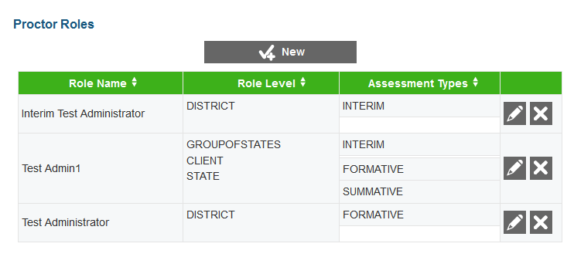

You can manage proctors on the Proctor Roles screen (see Figure 36). The table on this screen displays the role name, role level, and associated assessment type for each proctor role in ART.

To specify proctor roles in ART:

|  |
| --- |
| 1. On the Test Administration screen, click [**Add/Modify Proctor Roles**]. The Proctor Roles screen opens. 2. Click [**New**]. The Add Proctor Role screen opens. 3. On the Add Proctor Role screen, select a role from the Role Name drop-down list. This drop-down list contains roles added to the Permissions system. When you select a role, the Role Level field automatically populates with that role’s associated entity levels. 4. From the Assessment Types drop-down list, select “Formative,” “Interim,” or “Summative.” You may select multiple assessment types for a role. 5. Click [**Save**]. The role appears on the Proctor Roles table. |

Figure . Edit Proctor Role Screen

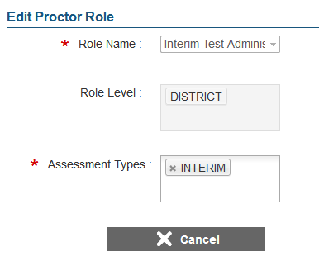

To modify a proctor role:

|  |
| --- |
| 1. In the table on the ***Proctor Roles*** screen, click [ ] for a proctor record. 2. On the ***Edit Proctor Role*** screen (see Figure 36), you can add or remove assessment types associated with the proctor role, but you cannot modify the *Role Level* or *Role Name*. 3. Click [**Save**]. |

To delete a proctor role:

|  |
| --- |
| 1. In the table on the ***Proctor Roles*** screen, click [ ] for a proctor record. 2. In the warning box that pops up, click [**OK**]. |

### Adding Test Platforms.

After adding proctors to ART, you must specify the testing equipment that you will use to administer tests. You must enter a record for each type of testing platform, but not for each individual platform. Note: The actions described in this section are available to users with a client- or state-level role.

Figure 37 shows the Test Platform Search screen.

*Note: The actions described in this section are available to users with a client- or state-level role.*

Figure . Test Platform Search Screen

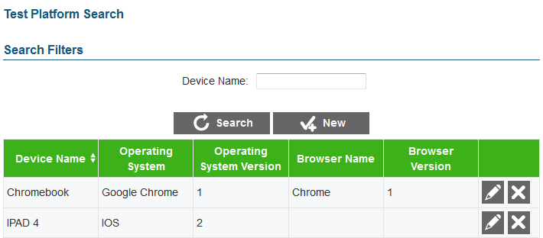

You can manage testing equipment records on the ***Test Platform Search*** screen. The *Device Name* filter field and [**Search**] button allow you to search for specific testing platforms. The search results table on this screen displays the device name, operating system, operating version, browser name, and browser version for each testing device.

To add test platforms to ART:

|  |
| --- |
| 1. On the Test Administration screen, click [**Add/Modify Test Platforms**]. The Test Platform Search screen opens. 2. Click [**New**]. The Add Test Platform Information screen opens as shown in Figure 38. 3. On the Add Test Platform Information screen, enter a device name, operating system and version, and browser name and version in the appropriate fields. 4. Click [**Save**]. The test platform appears on the search results table. |

Figure . Add Test Platform Information Screen

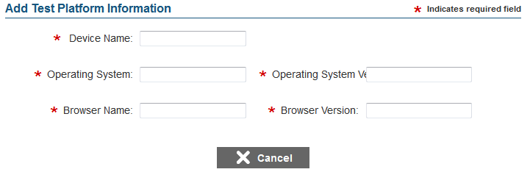

To modify a test platform:

|  |
| --- |
| 1. In the table on the Test Platform Search screen, click [ ] for a test platform record. 2. On the Add Test Platform Information screen, modify any of the fields. 3. Click [**Save**]. |

To delete a test platform:

|  |
| --- |
| 1. In the table on the Test Platform Search screen, click [ ] for a test platform record. 2. In the warning box that pops up, click [**OK**]. |

### Adding Accessibility Equipment.

After adding testing platforms to ART, you must specify the accessibility equipment that you will use to administer tests (see Figure 39). You must enter a record for each accessibility equipment model, but not for each individual device.

*Note: The actions described in this section are available to users with a client- or state-level role.*

Figure . Accessibility Equipment Search Screen

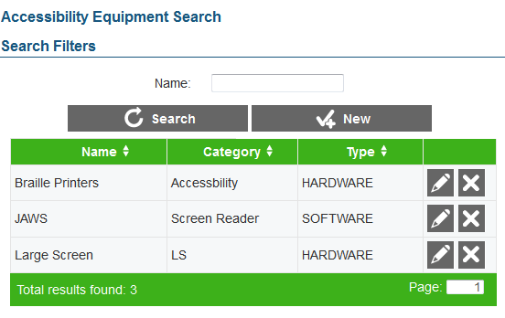

You can manage testing equipment records on the ***Accessibility Equipment Search*** screen. The *Name* filter field and [**Search**] button on this screen allow you to search for specific accessibility devices. The search results table on this screen displays each device’s name and accessibility category as well as a column indicating whether the specified equipment is hardware or software.

|  |  |
| --- | --- |
|  | When adding accessibility equipment you can create eligibility rules for the equipment based on student accommodations and demographic information. Students who satisfy the criteria are automatically assigned to the selected equipment when schedules are created. |

To add accessibility equipment to ART:

|  |
| --- |
| 1. On the Test Administration screen, click [**Add/Modify Accessibility Equipment**]. The Accessibility Equipment Search screen opens. 2. Click [**New**]. The Add Accessibility Equipment screen opens as shown in Figure 40. 3. Enter a name, category, and type for the equipment in the appropriate fields. 4. To set up eligibility rules for the equipment, click [ ] in the Equipment Rules section. A new row displays on the table in this section. You may add multiple rules, if necessary.    1. Select a demographic attribute or accommodation from the Rule Field drop-down list. An equals operator (=) automatically populates in the Operator field. *Note: For date type attributes or accommodations, additional operators are available that you can select from.*    2. Select a corresponding value from the *Value* drop-down list. 5. Click [**Save**]. |

Figure . Add Accessibility Equipment Screen

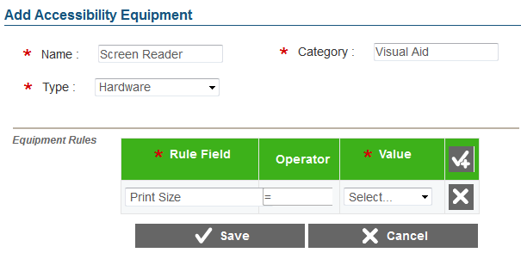

To modify an accessibility equipment record:

|  |
| --- |
| 1. In the table on the Accessibility Equipment Search screen, click [ ] for the equipment. 2. On the Edit Accessibility Equipment screen, modify any of the fields. 3. Click [**Save**]. |

To delete an accessibility equipment record:

|  |
| --- |
| 1. In the table on the Accessibility Equipment Search screen, click [ ] for the equipment. 2. In the warning box that pops up, click [**OK**]. |

### Adding Test Facilities.

After adding accessibility equipment to ART, you must specify the facilities that you will use to administer tests. You must enter a record for each facility and specify the number of seats and type of equipment available in that facility. See Figure 41.

*Note: The actions described in this section are available to users with a client-, state-, district, or school-level role.*

Figure . Facility Search Screen

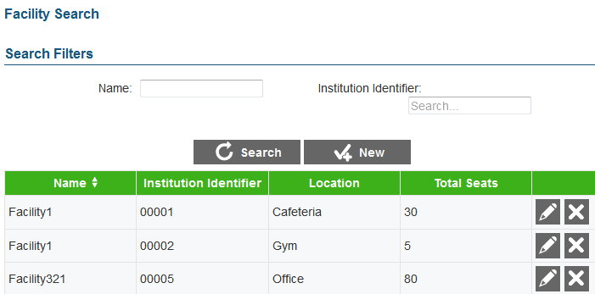

You can manage test facility records on the ***Facility Search*** screen. The *Name* and Institution Identifier filter fields and [**Search**] button on this screen allow you to search for specific test facilities. The table on this screen displays each facility’s name, institution identifier, location, and total seats.

|  |  |
| --- | --- |
|  | When adding test facilities, you can create seating configurations based on the combinations of test platforms and accessibility equipment available. The scheduling tool will add students to the facility based on the seating and equipment available. |

To add test facilities to ART:

|  |
| --- |
| 1. On the Test Administration screen, click [**Add/Modify Test Facilities**]. The Facility Search screen opens. 2. Click [**New**]. The Add Facility Information screen opens as shown in Figure 42. 3. Enter a name, and location for the equipment in the appropriate fields. The Name field cannot contain any spaces. 4. From the Institution Identifier field, select the institution with which the facility is associated. 5. To enter the seating configurations for the facility, click [ ] in the Configure Seats section.    1. Select a test platform from the Test Platform drop-down list and a type of accessibility equipment from the *Accessibility Equipment* drop-down list. Then enter the number of seats available in the facility with that combination of platform and equipment.    2. Add more configurations for each platform-equipment combination available in the facility. 6. Click [**Save**]. |

Figure . Add Facility Information Screen

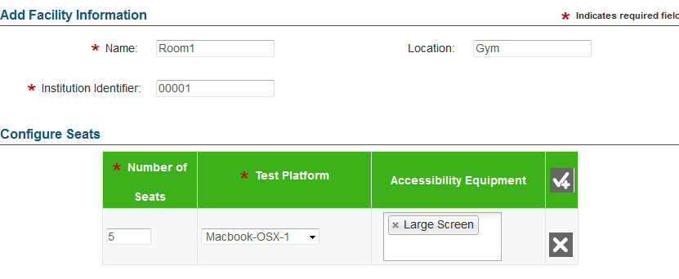

To modify a facility record:

|  |
| --- |
| 1. In the table on the Facility Search screen, click [ ] for a facility. 2. On the Edit Facility Information screen, modify any of the fields. 3. Click [**Save**]. |

To delete a facility record:

|  |
| --- |
| 1. In the table on the Facility Search screen, click [ ] for a facility. 2. In the warning box that pops up, click [**OK**]. |

### Adding Facility Time Periods.

After adding test facilities to ART, you must specify the days and times that each facility is available (see Figure 43). When you add a new facility availability record you can also specify assessment, subject, and grade affinities for each testing slot.

*Note: The actions described in this section are available to users with a client-, state-, district, or school-level role.*

|  |  |
| --- | --- |
|  | ART assumes that students can complete one complete test opportunity during any single time slot. Administrators must ensure that the time slot is long enough to complete a test opportunity or the schedule calculations will be inaccurate. |

|  |  |
| --- | --- |
|  | Affinities specify criteria by which the scheduling tool assigns students to a facility’s particular testing slot. For instance, if you create an affinity for grade 5, the scheduling tool attempts to place only 5th grade students in the selected testing slot. |

Figure . Facility Availability Screen

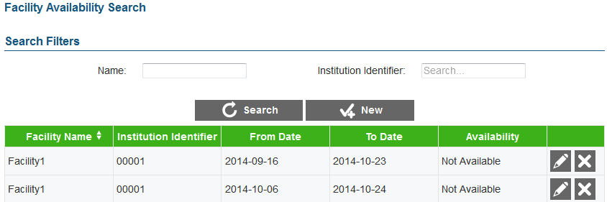

You can manage test facility records on the ***Facility Availability Search*** screen. The *Name* and Institution Identifier filter fields and [**Search**] button on this screen allow you to search for specific test facilities. The table on this screen displays the facility, institution identifier, and availability status and window for each facility availability record.

|  |  |
| --- | --- |
|  | In addition to specifying when facilities are available for testing, you can use the Add/Modify Test Times task to specify when facilities are unavailable for testing. |

To add facility availability information to ART:

|  |
| --- |
| 1. On the Test Administration screen, click [**Add/Modify Test Time**]. The Facility Availability Search screen opens. 2. Click [**New**]. The Add Facility Availability Information screen opens (see Figure 43). 3. Enter a school identifier, facility, date range, and availability status in the appropriate fields. The Testing Slots table appears. 4. To enter the testing slot information, click [ ] in the Testing Slots section. A new row displays on the table in this section. If you selected “Available” as the status, this table includes an Affinity column and a Seat Configurations column.    1. Enter a time range for the selected availability status in the appropriate columns.    2. To specify an affinity for the testing slot, click [**Add**] in the Affinity column.       1. Click [ ] in the Add/Edit Affinities window. A new row appears.       2. Select either “Assessment,” “Subject” or “Grade” from the Type drop-down list and then select the corresponding value. You can add multiple types for a single affinity.       3. If you wish to make this a mandatory affinity, mark the Strict checkbox and click [**OK**]. When an affinity is strict, the scheduling tool **only schedules students and proctors who** satisfy that affinity. When an affinity is not strict, the scheduling tool schedules students and proctors who satisfy that affinity first and then fills in leftover seats with additional students who may not satisfy the affinity.    3. To specify seating options for the test slot, click [**Add**] in the Seating Configurations column. The Add Seat Configuration window opens, displaying the configurations available for that facility, as specified on the ***Add Facility Information*** screen (see Figure 44).       1. Enter the required number of seats for each seating configuration listed in the Add Seat Configuration window and click [**OK**]. 5. Click [**Save**]. |

|  |  |
| --- | --- |
|  | You can create multiple time slots per facility on the same school day, but time slots cannot overlap and ART can only schedule one testing opportunity for each time slot. |

Figure . Add Facility Availability Screen

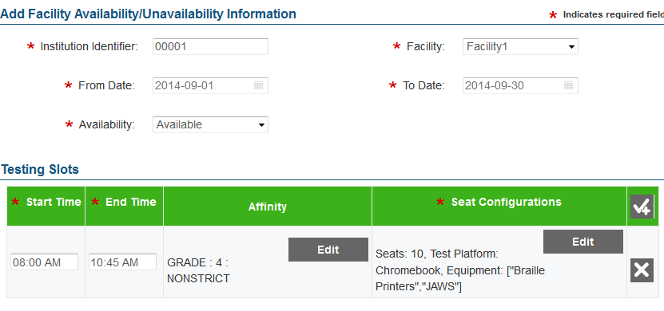

To modify a facility availability record:

|  |
| --- |
| 1. In the table on the Facility Availability Search screen, click [ ] for a facility. 2. On the Edit Facility Availability Information screen, modify any of the fields. 3. Click [**Save**]. |

To delete a facility record:

|  |
| --- |
| 1. In the table on the Facility Availability Search screen, click [ ] for a facility. 2. In the warning box that pops up, click [**OK**]. |

### Creating Schedules.

After establishing facility availability, you can create the assessment administration schedules using the schedule tool in ART (see Figure 45 and Figure 46). This tool automatically places proctors and students in the specified facility time slots based on the information entered up to this point.

*Note: The actions described in this section are available to users with a client-, state-, district, or school-level role.*

|  |  |
| --- | --- |
|  | Before you can use the schedule tool, student records and assessments must already exist in ART and students must be eligible for the given assessments. The assessment must have windows during the entered date range for the schedule. |

Figure . Schedule Search Screen

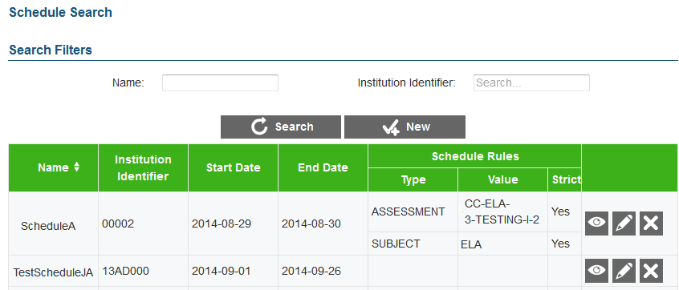

The *Name* and Institution Identifier filter fields and [**Search**] button on the Schedule Search screen allow you to search for specific schedules. The table on this screen displays the name, institution identifier, date range, and rules for existing schedule.

The [] button on this table allows you to view a summary of schedule information.

Figure . Add Schedule Information Screen

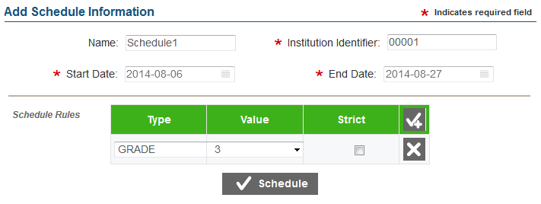

When creating schedules, you can set schedule rules based on assessment, grade, subject, and/or student group. You must add rules in order of priority. You may also mark rules as “strict.” **When rules are in place, the tool schedules students who satisfy those rules and fills in leftover seats with additional students. If the rules are strict, the tool** only schedules students who satisfy those rules.

|  |  |
| --- | --- |
|  | **Notes:**  Although schedules are created automatically, you can also edit them manually via the ***Add/Modify Schedule Results*** screen.  Schedules created in ART do not restrict test administration in TDS. Students can still join proctored sessions for which they are not scheduled in ART. The schedule automatically recalculates on a daily basis to account for students that deviate from the schedule. |

To create a new schedule:

|  |
| --- |
| 1. On the Test Administration screen, click [**Add/Modify Schedule Information**]. The Schedule Search screen opens. 2. Click [**New**]. The Add Schedule Information screen opens (see Figure 46). 3. Enter a name, institution identifier, and date range for the schedule in the appropriate fields. 4. To enter schedule rules, click [ ] in the Schedule Rules section. A new row displays on the table in this section. When creating multiple rules, you should add rules in the order of priority.    1. From the *Type* drop-down menu, select either “Grade,” “Subject,” or “Assessment.”    2. From the *Value* drop-down list, select the corresponding value.    3. If you want to set the rule as mandatory, mark the *Strict* checkbox. 5. To create the schedule click [**Schedule**]. The scheduling tool automatically groups eligible students into the available facility testing slots based on the selected rules. You can now view the scheduling tool’s output on the Schedule Summary Search Filter screen. |

To modify a facility availability record:

|  |
| --- |
| 1. In the table on the Schedule Search screen, click [ ] for a schedule. 2. On the Edit Schedule Information screen, modify any of the fields. 3. Click [**Save**]. |

To delete a facility record:

|  |
| --- |
| 1. In the table on the Schedule Search screen, click [ ] for a schedule. 2. In the warning box that pops up, click [**OK**]. |

### Viewing and Modifying Schedule Results.

After creating a schedule, you can view the output and manually modify the schedule details and assigned students on the Schedule Summary Search Filter screen (see Figure 47 and Figure 48).

*Note: The actions described in this section are available to users with a client-, state-, district, or school-level role.*

Figure . Schedule Summary Search Filter Screen

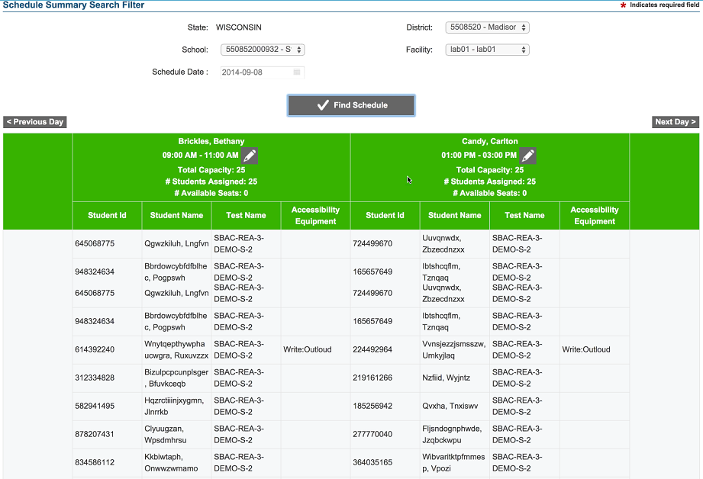

You can use the filter fields and [**Find Schedule**] button to locate a particular schedule. The table that generates below displays schedule information, including the proctor, time slot, facility, tests, and accessibility equipment. This table includes a row of information for each scheduled student. If a second time slot is scheduled for the same day, it is displayed to the right of the first time slot. If multiple slots are scheduled, use the navigation widgets to browse through the different time slots.

To view schedule results:

|  |
| --- |
| 1. On the Test Administration screen, click [**Add/Modify Schedule Results**]. The Schedule Summary Search Filter screen opens (see Figure 47). 2. In the filter fields, select a district, institution, and facility and enter a schedule date. 3. Click [**Find Schedule**]. The schedule table displays in the section below the filter fields. |

Figure . Edit Schedule Screen

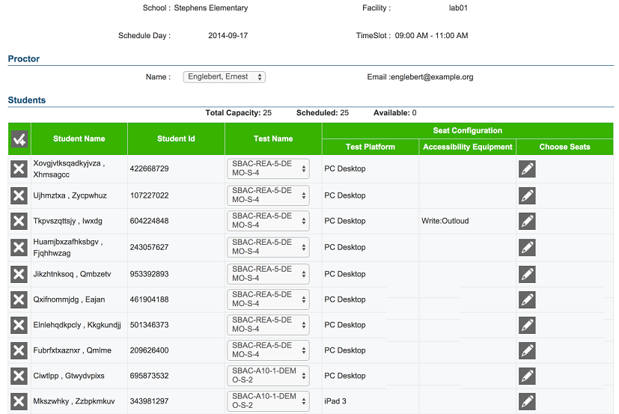

To modify schedule details:

|  |
| --- |
| 1. On the schedule table (see Figure 47), click [ ].for the time slot that you wish to modify. The ***Edit Schedule*** screen opens (see Figure 48). 2. Make the necessary modifications.    * To change the test that a student is scheduled to take, select the required test from the drop-down list in the Test Name column.    * To remove a student from the schedule, click [] for that student.    * To change the seat allocated to a student,    * Click [] in the Choose Seats column. A pop-up window appears listing the seats available for the time slot along with the test platform and available accessibility equipment information.    * Click the radio button for the seat that you wish to assign to the student.    * Click [**OK**]. 3. Click [**Save**] to save your changes. |

## Viewing Test Administration Reports

You can view reports about the assessments, eligible students, and schedules created in ART. There are three types of test administration reports available in ART:

* Participation Reports—Accessible from the home screen, these reports provide information about students’ testing statuses at various entity levels. There are two types of Participation Reports: Summary reports and Details reports.
* Proctor Schedule Reports—Accessible from the Test Administration screen, these reports provide information about proctors’ schedules in a selected date range.
* Student Schedule Reports—Accessible from the Test Administration screen, these reports provide information about students’ assessment schedules in a selected date range.

|  |  |
| --- | --- |
|  | **Notes:**  **You must create at least one schedule in ART in order to view Proctor Schedule Reports and Student Schedule Reports.**  **The reports in ART do not provide any information about students’ assessment scores.** |

### Participation Reports.

Participation Reports provide information about students’ testing statuses for their eligible assessments. There are two types of Participation Reports: Summary and Details.

#### Participation Summary Reports.

Participation Summary Reports provide aggregate test status data for the students in a selected entity level (see Figure 49 and Figure 50). These reports are available at the client, state group, state, district group, district, institution group, and institution level.

|  |  |
| --- | --- |
|  | **Note:** You can only view reports that are focused to your entity level or within your entity level. For example, a district-level user can only view district-level reports and reports for institutions or institution groups within that district. |

Figure . Institution-level Participation Summary Report

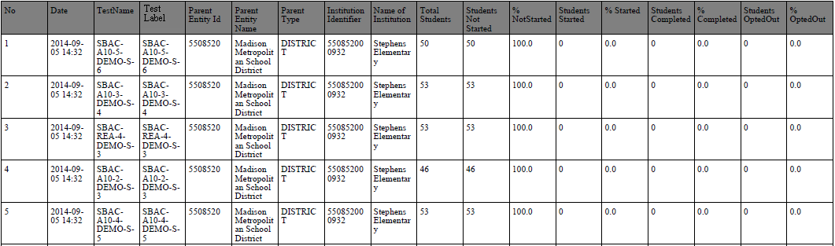

Table 20 provides a description of the columns that appear in Participation Summary Reports. The columns available in a report depend on the selected entity level (*Report Type*). Columns that appear in every report type are displayed in bold font.

Table . Participation Summary Report Columns

| Column Header | Column Description |
| --- | --- |
| **No** | Automatically generated number indicating the row number in the report |
| **Date** | Date on which the report is generated. |
| **Test Name** | Name of the assessment in ART. |
| **Test Label** | Label for the test in ART. |
| **Parent Entity ID** | Identifier of the selected entity’s parent entity. |
| **Parent Entity Name** | Name of the selected entity’s parent entity. |
| **Parent Type** | Selected entity’s parent in the Consortium’s hierarchy. |
| Group of States Identifier | Identifier for the state group.  This column only displays when you select “Group of States” from the Report Type drop-down list. |
| Group of States Name | Name of the state group.  This column only displays when you select “Group of States” from the Report Type drop-down list. |
| State Abbreviation | Abbreviation for the state.  This column only displays when you select “State” from the Report Type drop-down list. |
| State Name | Name of the state.  This column only displays when you select “State” from the Report Type drop-down list. |
| Group of Districts Identifier | Identifier for the district group.  This column only displays when you select “Group of Districts” from the Report Type drop-down list. |
| Group of Districts Name | Name of the district group.  This column only displays when you select “Group of Districts” from the Report Type drop-down list. |
| Local Education Agency Identifier | Identifier for the district.  This column only displays when you select “District” from the Report Type drop-down list. |
| Organization Name | Name of the district.  This column only displays when you select “District” from the Report Type drop-down list. |
| Group of Institutions Identifier | Identifier for the institution group.  This column only displays when you select “Group of Institutions” from the Report Type drop-down list. |
| Group of Institutions Name | Name of the institution group.  This column only displays when you select “Group of Institutions” from the Report Type drop-down list. |
| Institution Identifier | Identifier for the institution.  This column only displays when you select “Institution” from the Report Type drop-down list. |
| Name of Institution | Name of the institution.  This column only displays when you select “Institution” from the Report Type drop-down list. |
| **Total Students** | Total number of students in the selected entity who are eligible for the assessment. |
| **Students Not Started** | Number of eligible students in the selected entity who have not started the assessment. |
| **% Not Started** | Percent of eligible students in the selected entity who have not started the assessment. |
| **Students Started** | Number of eligible students in the selected entity who have started the assessment. |
| **% Started** | Percent of eligible students in the selected entity who have started the assessment. |
| **Students Completed** | Number of eligible students in the selected entity who have completed the assessment. |
| **% Completed** | Percent of eligible students in the selected entity who have completed the assessment. |
| **Students Opted Out** | Number of eligible students in the selected entity who have opted out from the assessment. |
| **% Opted Out** | Percent of eligible students in the selected entity who have opted out from the assessment. |

Figure . Generating a Participation Summary Report

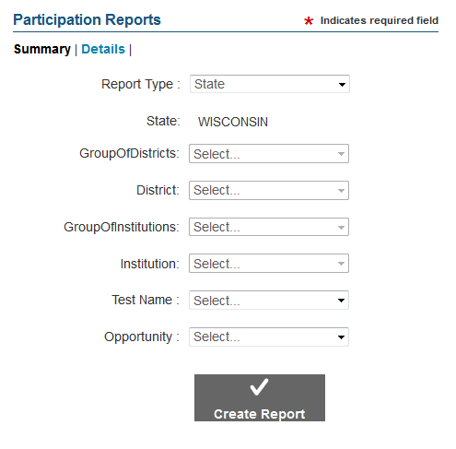

To create a Participation Summary Report:

|  |
| --- |
| 1. On the ART home screen, click [**View Participation Reports**]. 2. On the Participation Reports screen (see Figure 50), click [**Summary**]. 3. From the Report Type drop-down list, select the entity level for the report. 4. From the available entity drop-down lists, select specific entities, as required. Note: The entity drop-down lists available depend on your user role and the selected report type. 5. Optional: From the Test Name drop-down list, select the name of the test to include in the report. 6. From the Opportunity drop-down list, select the test opportunity number for which you wish to view participation information. 7. Click [**Create Report**]. The Participation Summary Report displays in a new tab. |

|  |  |
| --- | --- |
|  | **Note:** When building a report, you can select a specific test or all available tests for the selected entity. |

#### Participation Details Reports.

Participation details reports provide the test status information for individual students within an institution as shown in Figure 51 and Figure 52. These reports are only available at the institution level. These reports display one row of information for each student for each eligible test.

Figure . Participation Details Report

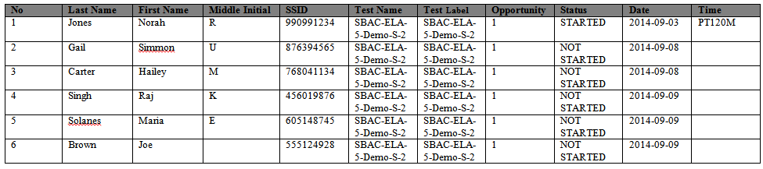

Table 21 provides a description of the columns that appear in Participation Detail Reports.

Table . Participation Details Report Columns

| Column Header | Column Description |
| --- | --- |
| No | Automatically generated number indicating the row number in the report. |
| Last Name | Student’s last name. |
| First Name | Student’s first name. |
| Middle Initial | Student’s middle initial. |
| SSID | Student’s state assigned student identifier. |
| Test Name | Name of the assessment in ART. |
| Test Label | Label of the assessment in ART. |
| Opportunity | Selected opportunity number for the assessment. |
| Status | Student’s status for the assessment. |
| Date | Date on which the student started or completed the test. This column is blank if the status is “not started” or “opted out.” |
| Time | Time at which the student started or completed the test. This column is blank if the status is “not started” or “opted out.” |

Figure . Generating a Participation Details Report

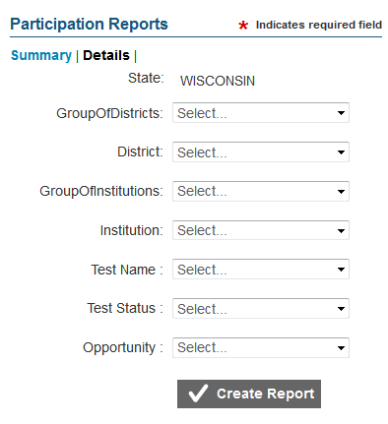

To create a Participation Details Report:

|  |
| --- |
| 1. On the ART home screen, click [**View Participation Reports**]. 2. On the Participation Reports screen (see Figure 50), click [**Details**]. 3. From the entity drop-down lists, select entities until you can select the required institution. Note: The entity drop-down lists available depend on your user role. 4. Optional: From the Test Name drop-down list, select the name of the test to include in the report. 5. From the Opportunity drop-down list, select the test opportunity number for which you wish to view participation information. 6. Click [**Create Report**]. The Participation Details Report displays in a new tab. |

|  |  |
| --- | --- |
|  | **Note:** When building a report, you can select a specific test or all available tests for the selected institution. |

### Proctor Schedule Reports.

Proctor Schedule Reports provide information about the schedules for a selected institution’s proctors during a specified time period as shown in Figure 53 and Figure 54. In order to generate a Proctor Schedule Report, you must first create a schedule in ART. These reports are only available at the institution level.

Figure . Proctor Schedule Report

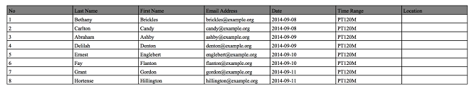

The Proctor Schedule Report displays a row of information for each proctor who is scheduled for a test session on each date in the specified date range. The report displays the scheduled time slot and associated facility for each proctor and date. If a proctor is scheduled multiple times, a separate row will be displayed for each of the time slots for which he or she is scheduled.

Table 22 provides a description of the columns that appear in the Proctor Schedule Report.

Table . Proctor Schedule Report Columns

|  |  |
| --- | --- |
| Column Header | Column Description |
| No | Automatically generated number indicating the row number in the report. |
| Last Name | Proctor’s last name. |
| First Name | Proctor’s first name. |
| E-mail Address | Proctor’s e-mail address. |
| Date | Date on which the proctor is scheduled to administer a test session. |
| Time Range | Time slot during which the proctor is scheduled to administer a test session. |
| Location | Facility in which proctor is scheduled to administer a test session. |

Figure . Proctor Schedule Report Screen

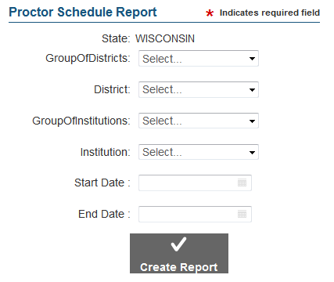

To create a Proctor Schedule Report:

|  |
| --- |
| 1. On the Test Administration screen, click [**View Proctor Schedule Report**]. The Proctor Schedule Report screen opens. 2. From the entity drop-down lists, select entities until you can select the required institution. Note: The entity drop-down lists available depend on your user role. 3. Enter the date range for the report in the Start Date and End Date fields. 4. Click [**Create Report**]. The Proctor Schedule Report opens in a new tab. |

### Student Schedule Reports.

Student Schedule Reports provide information about the testing schedules for a selected institution’s students during a specified time period as shown in Figure 55 and Figure 56. In order to generate a Student Schedule Report, you must first create a schedule in ART. These reports are only available at the institution level.

Figure . Student Schedule Report

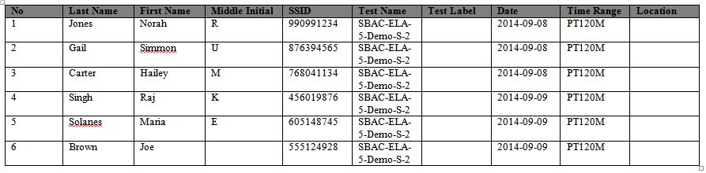

The Student Schedule Report displays a row of information for each student scheduled for a test session on each date in the specified date range. The report displays the scheduled time slot and associated facility for each student and date.

Table 23 provides a description of the columns that appear in the Student Schedule Report.

Table . Student Schedule Report Columns

|  |  |
| --- | --- |
| Column Header | Column Description |
| No | Automatically generated number indicating the row number in the report. |
| Last Name | Student’s last name. |
| First Name | Student’s first name. |
| Middle Initial | Student’s middle initial. |
| SSID | Student’s state assigned student identifier. |
| Test Name | Name of the assessment the student is scheduled to take. |
| Test Label | Label of the assessment the student is scheduled to take. |
| Date | Date on which the student is scheduled to take the assessment. |
| Time Range | Time slot during which the student is scheduled to take the assessment. |
| Location | Facility in which student is scheduled to take the assessment. |

Figure . Student Schedule Report Screen

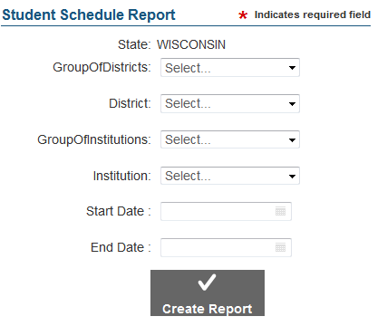

To create a Student Schedule Report:

|  |
| --- |
| 1. On the Test Administration screen, click [**View Student Schedule Report**]. The Student Schedule Report screen opens. 2. From the entity drop-down lists, select entities until you can select the required institution. Note: The entity drop-down lists available depend on your user role. 3. Enter the date range for the report in the Start Date and End Date fields. 4. Click [**Create Report**]. The Student Schedule Report opens in a new tab. |

# Appendix A. Manage System Settings

Depending on your user role, the Settings drop-down list in the ART banner allows you to configure client settings and manage subjects.

## Client Configuration

The ***Client Configuration*** screen allows you to configure system settings that affect how ART appears and processes registrations as shown in Figure 57. For a description of the fields on this screen, see Table 24.

Figure . Client Configuration Screen

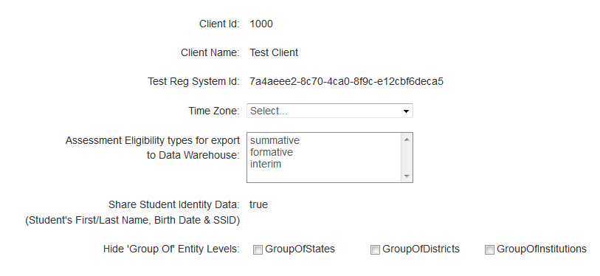

To configure system settings:

|  |
| --- |
| 1. In the ART banner, select “Client Configuration” from the Settings drop-down list.    * To change the time zone, select a value from the Time Zone drop-down list.    * To indicate the type of assessments to deliver, select one or more options from the Assessment Eligibility types for export to Data Warehouse drop-down list.    * To show or hide the grouping options for states, districts, or institutions, mark or clear the appropriate checkboxes. 2. Click [**Save**]. |

Table 24 describes the fields on the ***Client Configuration*** screen.

Table . Key Icons and Elements

| Field | Description |
| --- | --- |
| **Client ID** | Unique identifier for the client you belong to. |
| **Client Name** | Name of the client that you belong to. |
| **Test Reg System ID** | Unique system ID among all ART deployments. |
| **Time Zone** | Time zone used to consider the end of a day and the beginning of the next day. For information about the impact of time zones on test windows, see the section Understanding test windows and time zones. |
| **Assessment Eligibility types for export to Data Warehouse** | Indicates which assessments TDS delivers during the test window. For example, if you select only “summative,” then TDS delivers only summative assessments during the test window. If you select “summative” and “formative,” TDS delivers both summative and formative assessments during the test window. |
| **Share Student Identity Data** | If set to “True,” ART stores each student’s first name, last name, birth date, and SSID in the Smarter Balanced data warehouse.  If set to “False,” ART stores only each student’s External SIS number in the Smarter Balanced data warehouse. |
| **Hide Group Of Entity Levels** | If checked, the corresponding grouping does not appear in the user interface for the current tenant. For example, if you mark the Group Of Districts checkbox, and your tenancy is Wisconsin, then no users in the Wisconsin tenancy can view, add, modify, or delete district groups. |

## Manage Subjects

The **Subject Search** screen allows you to search for, add, modify, delete, and merge subjects that may be associated with assessments (see Figure 58 to Figure 61). You cannot modify, delete, or merge any subjects that are already associated with an assessment in ART.

The table in Figure 58 displays the subject codes you add to ART. You can use the Subject Code field and the [**Search**] button to filter the table information to a specified subject.

Figure . Subjects Table

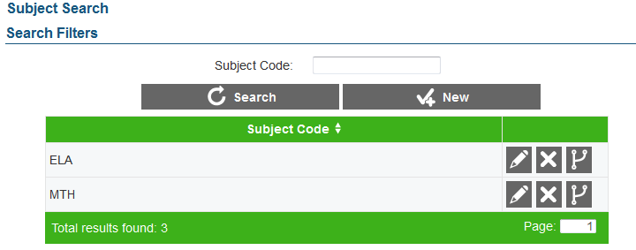

Figure . Settings Drop-Down List

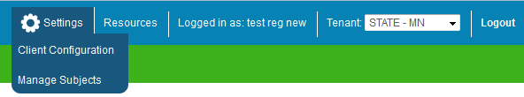

To access the **Manage Subjects** screen:

|  |
| --- |
| 1. In the ART banner, select “Manage Subjects” from the Settings drop-down list (see Figure 59). |

Figure . Add Subject Information Screen

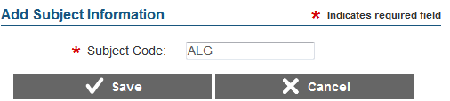

To add a subject:

|  |
| --- |
| 1. On the **Subject Search** screen, click [**New**]. The ***Add Subject Information*** screen loads. 2. In the *Subject Code* field, enter the code for the new subject. 3. Click [**Save**]. The new subject code displays on the Subjects table. |

To modify a subject:

|  |
| --- |
| 1. On theSubjectstable, click [] next to a subject. The ***Edit Subject Information*** screen loads. 2. In the *Subject Code* field, modify the code for the subject. 3. Click [**Save**]. The modified subject code displays on the search results table. |

To delete a subject:

|  |
| --- |
| 1. In the search results table, click [ ] for a student record. 2. In the warning box that pops up, click [**OK**]. |

Figure . Merge Subject Screen

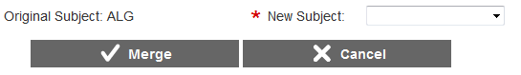

To merge a subject with a new subject:

|  |
| --- |
| 1. On theSubjectstable, click [ ] next to a subject. The ***Merge Subject*** screen loads. 2. From the *New Subject Code* drop-down list, select the new subject with which to merge. 3. Click [**Merge**]. The original subject merges with the new subject. |

# Appendix B. Opening a CSV File in Excel

|  |  |
| --- | --- |
| 1. Open Microsoft Excel, and click the [**Data**] menu tab. 2. In the Data menu, click the “From Text” icon. The Import Text File dialog window will open. |  |
| 1. Navigate to the location where you saved the file. Select the file and then click [**Import**]. |  |
| 1. The Text Import Wizard window will open. You will have to navigate through three steps: |  |
| * 1. **Step 1:** Make sure “Delimited” is selected, and click [**Next**].   *Note: This window also has a preview of the data in the file you selected. This allows you to verify that you selected the correct file.* |
| * 1. **Step 2:** Click the check box next to “Comma” and click [**Next**]. |  |
| * 1. **Step 3:** Format numerical data as text.      1. In the Data Preview section, click a column. (The selected column will have a black background.)      2. In the Column Data Format section, click the radio button next to “Text.”      3. Repeat for each column.  1. Click [**Finish**]. The data should populate in separate columns in Excel. |  |

# Appendix C. Common Errors with File Uploads

For upload tasks, common errors can prevent records from being added or modified correctly.

File Validation

ART “screens” each file to check for any errors in the file. If your file has no errors, you will see “Your file has successfully been saved.” This message indicates that the file was uploaded successfully and contains no errors. (The file has not yet been committed to ART.) Records without errors are automatically accepted by the system.

***If your file has errors***

Files with data not in the correct format as shown in the template generate error messages by row, identifying the errors by line (row) for each invalid record in the file. See Figure 62 for a sample.

Some errors prevent a record from uploading (e.g., invalid parent entity). A table of validation messages appears and contains information about the errors. *Note: It is possible for a single record to have multiple errors.*

Figure . Sample Error Message

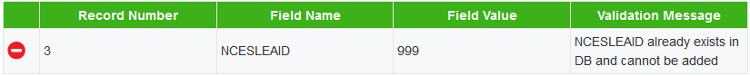

* **Record Number:** The row in the file in which the error appeared
* **Field Name:** The column name that contains the error
* **Field Value:** The text that you entered in the cell
* **Validation Message:** A brief description of the error

Depending on the severity of the error(s), one of the following will occur:

* The file will fail to upload.
* The file will upload, but ART will exclude the record(s) that had errors.
* The file will upload, and ART will accept the record(s) that had errors. (These records will need to be fixed in ART or uploaded in a new file.)

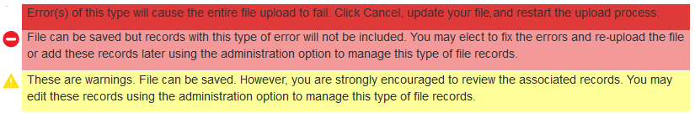

If your file included errors, you have two options:

* **Abort the upload.** Click [**Cancel**], and then click [**OK**]. You can then make edits to the upload file, save it, and begin the upload process again.
* **Proceed with the upload, and add the information to ART.** To do so, click [**Save**]. Only error-free records or records with acceptable errors (rows in yellow) will be uploaded to the system.

These are some common errors:

* Having blank rows between records
* Inserting invalid characters (refer to appropriate user guide sections for information about accepted formats)
* Uploading a file that contains parent entities that do not already exist in ART.
* Uploading a file for students or users in an institution or district with which you are not associated.

# Appendix D. About the Calendar Widgets

A number of fields throughout the ART interface require you to enter a date. Each of these fields contains a calendar widget that allows you to select a date easily.

|  |  |
| --- | --- |
| * To access the calendar widget, click the calendar [] icon. The widget pops up as shown in Figure 63. * To select a date, simply click the date on the calendar. * To navigate to a different month, use the arrow buttons in the upper corners. * To select today’s date, click [**Today**] in the bottom left corner. * To clear the entered date in the field, click [**Clear**] in the bottom left corner. * If you click the [**Weeks**] button, the widget displays the number for each week, where the first full week of the calendar year is “1.” * To quickly navigate to different months and years, click the month name at the top of the widget. The widget displays names of months rather than calendar dates. In this view, the arrow buttons in the corners allow you to navigate to different years. * To close the widget, click [**Close**]. | Figure . Calendar Widget    Figure . Calendar Widget: Year View |