System Design Document — Agentic AI System
Assignment: Agentic AI System for Multi-Step Tasks

1. Project Overview
This document describes the system design of an Agentic AI System capable of handling complex multi-step tasks. The system decomposes user tasks, routes them through specialised AI agents via an async message queue, and streams partial responses back to the user in real time.
1.1 Problem Statement
Traditional AI systems process user queries in a single pass. Complex tasks — such as researching a topic, analysing findings, and producing a structured report — require multiple coordinated steps. This system solves that by orchestrating a pipeline of specialised agents, each responsible for one part of the task.
1.2 Goals
- Accept complex multi-step user tasks via REST API
- Decompose tasks into discrete steps automatically
- Execute each step using a specialised agent (Retriever, Analyser, Writer)
- Communicate between components using an async message queue (Redis)
- Stream partial responses to the user via Server-Sent Events (SSE)
- Handle failures gracefully with retry logic and dead-letter queuing

2. System Architecture
2.1 High-Level Architecture Flow

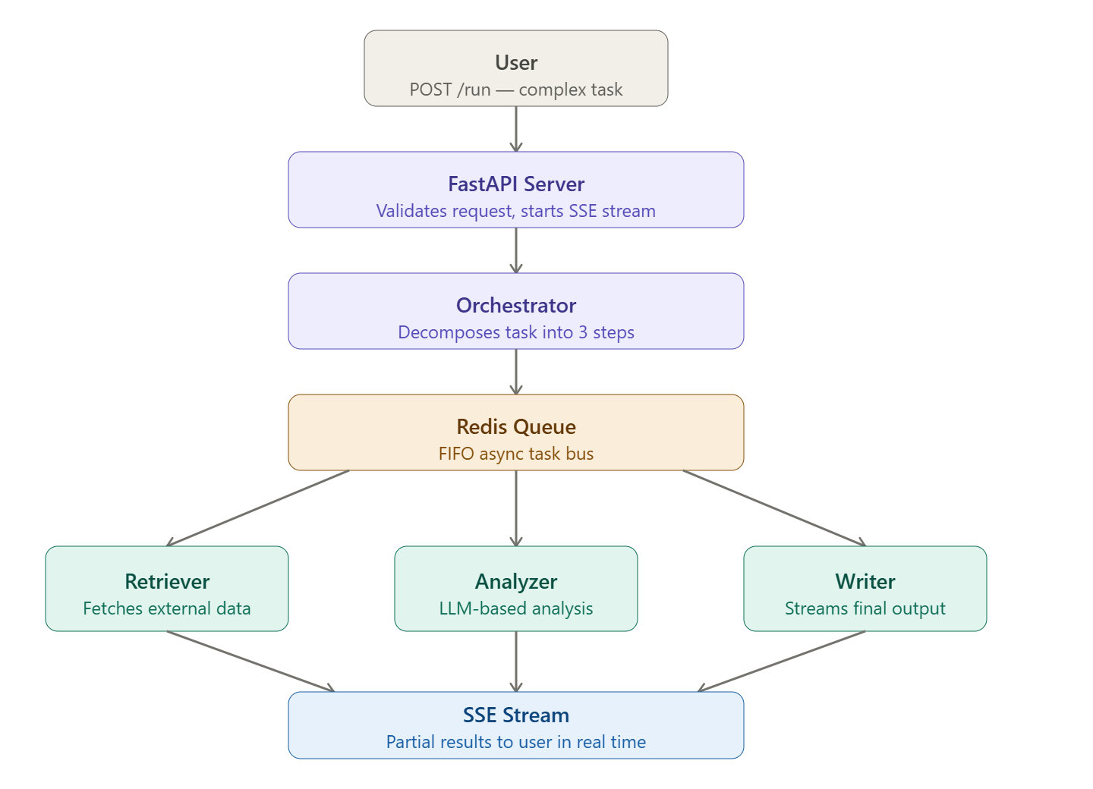
2.2 Component Overview Table
Component | Role | Technology
FastAPI Server | Accepts user tasks, streams responses via SSE | FastAPI + Uvicorn
Orchestrator | Decomposes tasks, dispatches to agents, aggregates results | Python asyncio
Redis Queue | Async FIFO message bus between orchestrator and agents | Redis LPUSH/BRPOP
Retriever Agent | Fetches external data, documents, and web content | httpx + async
Analyzer Agent | Processes and summarises retrieved content via LLM | OpenAI API
Writer Agent | Generates final structured output with streaming | OpenAI API + SSE
Dead-Letter Queue | Stores failed tasks after max retries | Redis List

3. Component Design
3.1 FastAPI Server (server.py)
The server is the entry point for all client interactions. It exposes three endpoints and manages the application lifecycle, including Redis connection setup and teardown.
Endpoint | Method | Description
/health | GET | Returns system health status
/run | POST | Accepts task, returns SSE stream of agent progress
/queue/status | GET | Returns current queue depths for monitoring

3.2 Orchestrator (orchestrator.py)
The Orchestrator is the brain of the system. It receives the user task, breaks it into steps, dispatches each step to the appropriate agent, and aggregates results into the final streaming response.
Task Decomposition
Every task is decomposed into exactly 3 sequential steps:
- Step 1: RETRIEVE: Fetch relevant data from external sources
- Step 2: ANALYZE: Process and extract key insights from retrieved data
- Step 3: WRITE: Generate a structured, formatted final response
Context Passing
Each step's output is stored in a shared context dictionary and passed to the next step. The Retriever's output becomes the Analyser's input; the Analyser's output becomes the Writer's input.

3.3 Base Agent (base_agent.py)
Parameter | Value | Purpose
max_retries | 3 | Maximum attempts before marking the task failed
retry_delay | 1.0s | Base delay — doubles each retry (1s, 2s, 4s)
dead_letter | True flag | Failed tasks flagged for the dead-letter queue

3.4 Specialised Agents
Retriever Agent
- Responsible for fetching external data based on the user query
- Supports mock mode (simulated data) and real HTTP mode (httpx)
- Returns structured data including retrieved_data, source, and query fields
Analyzer Agent
- Uses OpenAI GPT-4o-mini to analyse and summarise retrieved content
- Falls back to mock analysis if no API key is configured
- Returns analysis text and token usage statistics
Writer Agent
- Generates final formatted response using OpenAI GPT-4o-mini
- Supports both batch execution (execute) and streaming (stream_execute)
- In streaming mode, yields output word by word for real-time display

3.5 Redis Message Queue (redis_queue.py)
The queue acts as the communication backbone between the Orchestrator and agents. It uses Redis Lists with LPUSH (enqueue) and BRPOP (dequeue) for FIFO ordering.
Queue Name | Purpose
task_queue | Main queue for dispatching steps to agents
dead_letter_queue | Stores failed tasks after all retries were exhausted.

Mock Mode: If Redis is unavailable, the queue runs in mock mode — all operations are logged locally, and the system continues to function without a real Redis instance.

4. Data Flow
4.1 Request Lifecycle
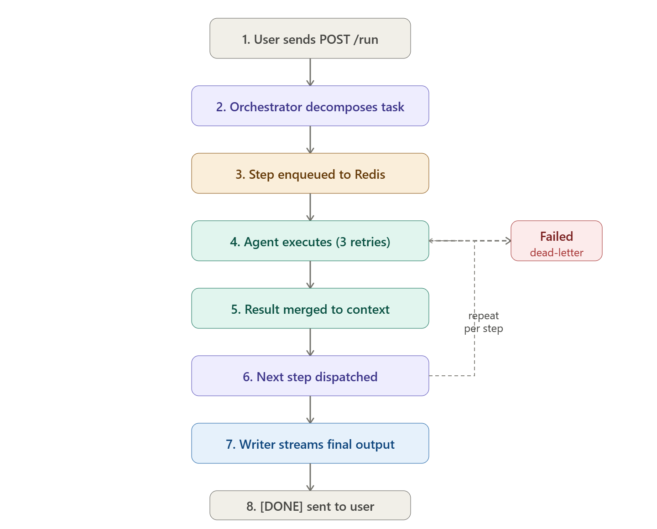

4.2 Failure Handling Flow
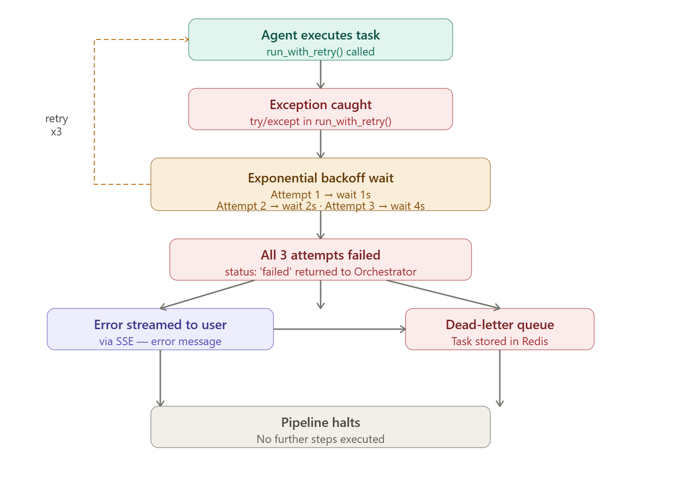

5. Technology Stack
Technology | Version | Justification
FastAPI | 0.136.0 | Async-native, auto API docs, supports SSE
Uvicorn | 0.44.0 | ASGI server for async FastAPI
Redis | 7.4.0 | Sub-ms FIFO queue with LPUSH/BRPOP
OpenAI SDK | 2.32.0 | Async LLM inference with streaming
httpx | 0.28.1 | Async HTTP client for agent-to-API calls
SSE-Starlette | 3.3.4 | Server-Sent Events for FastAPI
Pydantic | 2.13.2 | Request/response validation
asyncio | built-in | Native async concurrency — no extra deps

6. Scalability Considerations
6.1 Current Limitations
- Single shared Redis queue — all agent types compete for the same queue
- One Orchestrator per request — no distributed state management
- Sequential pipeline — steps cannot run in parallel, even if independent
- No horizontal scaling of agent workers out of the box
6.2 Scaling Strategy
Bottleneck | Solution
Shared queue saturation | Per-agent queues: retriever_queue, analyzer_queue, writer_queue
Single orchestrator | Distributed scheduler: Celery, Temporal, or Prefect
Sequential steps | DAG task planner for parallel independent sub-tasks
Single Redis | Redis Cluster or Redis Streams with consumer groups
Agent worker capacity | Kubernetes HPA — scale agent pods per queue depth

7. API Reference
GET /health
Returns the health status of the system.
Response: { "status": "ok", "service": "agentic-ai-system" }

POST /run
Accepts a complex user task and returns a streaming SSE response showing agent progress and final output.
Request Body: { "task": "string — the user's complex task" }
Response: text/event-stream — SSE chunks including step progress and final streamed text
Example SSE output:
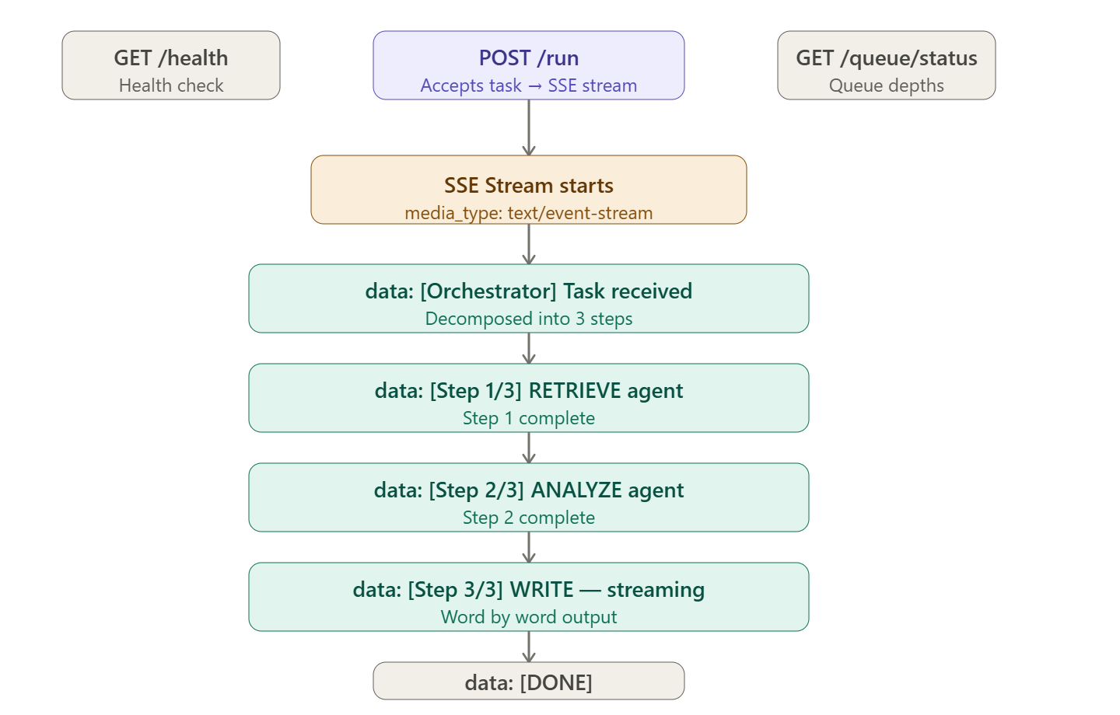
GET /queue/status
Returns the current depth of task queue and dead-letter queue for monitoring.
Response: { "task_queue": 0, "dead_letter_queue": 0 }

8. Deployment
8.1 Local Development
- Python 3.11+ with virtual environment
- Redis via Docker: docker run -d --name redis -p 6379:6379 redis:7-alpine
- Server: uvicorn src.server:app --reload --port 8000
- Mock mode available without Redis or OpenAI API key

8.2 Docker Compose
Full containerized deployment with docker-compose up --build. Includes Redis service with healthcheck and API service with environment variable injection.
8.3 Environment Variables
Variable | Default | Description
OPENAI_API_KEY | (empty) | System works in mock mode without it
REDIS_HOST | localhost | Redis server hostname
REDIS_PORT | 6379 | Redis server port

