OpenMANIPULATOR X Project Weekly Report
Week 5 | 21 to 27 September 2026 | ISU XR LAB

OpenCV cube evidence, scan geometry, and supervised pick and place
This week has the strongest timestamped camera and motion trail. The local V3 OpenCV CSV begins on 21 September, a 34 frame pilot was captured on 22 September, annotated scan overlays and logs were saved on 23 September, and a supervised pick/place run log records phases on 24 September. Pick/place controls and diagnostics were committed on 25 September.

Work completed and evidence

OpenCV baseline
The V3 CSV has 73 detection rows, which are detections across tests rather than 73 independent scenes. One 21 September frame at 19:10:03 +03:00 reports a cube center of 240, 299 pixels, about 67 by 87 pixels, threshold 87, and 38.025 ms processing. This is scene evidence under the recorded lighting and camera pose, not detector accuracy.

Pilot capture and scan
The 22 September manifest lists 34 images at 640 by 480 from camera index 1 and records a fixed_rigid mount and motor angles 170.156, 161.895, 333.896, 125.420 degrees. The 23 September scan CSV and annotated screenshots show landmark overlays, provisional plate plane XY estimates, and explicit no robot motion labels on the images. The moving view transfer and plate mapping still require physical validation.

Supervised pick/place
The 24 September run log records MOVE_TO_WORK, travel and approach waypoints, LOWER_TO_PICK, CLOSE_AND_CONFIRM with ID15 RAW 2642 and current 54, LIFT, place approach, RELEASE at RAW 1402, and RETRACT. These are recorded controller phases. The log does not include independent cube position, jaw contact, or a post place success measurement; the empty calibration/pick_trial_log.csv template makes that evidence gap visible.

Route and failure handling
The pick/place documentation describes preflight reachability checks, user entered Z values, gripper RAW limits and current cutoff, and abort on TARGET_NOT_REACHED without automatic retry. Some changed destination Y values pass offline route checks, while other routes do not. Geometric reachability alone cannot certify clearance or grip.

Gamepad path
The separate F710 to Python to OpenCR Cartesian bridge was prepared. The report does not establish compilation, upload, or physical testing of that sketch in this week.

Selected visual record
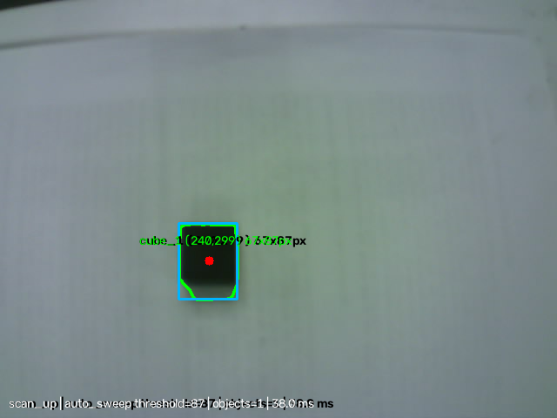
21 September V3 OpenCV annotated frame. One local cube detection was measured at pixel center 240, 299.
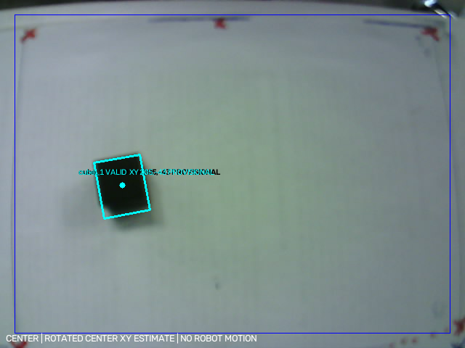
23 September saved CENTER scan overlay. Its provisional XY label is a preview, and the image states that no robot motion occurred.

Weekly outcome
Camera captures, annotated scans, and a supervised controller sequence were recorded. The evidence does not verify accurate physical grasp and placement.

Next verification step
Measure camera to robot mapping, cube and jaw geometry, ID15 endpoints/current, and observed final cube location in a supervised trial.

Source record
Primary timeline: docs/OPENMANIPULATOR_PROJECT_REPORT_2026-10-04.md. Local records checked for this week:
- data/opencv_tests_v3/opencv_test_results_v3.csv, 73 rows
- dataset/raw/capture_manifest.csv, 34 frames
- data/vision_scan_logs/total_scan_20260923_173137.csv and images
- openmanipulator_repeatability_project/data/pick_place_experiments/pick_place_trials_v1.csv
- PICK_PLACE_EXPERIMENT.md and BOX_CALIBRATION_AND_PICK_TRIAL.md
Date note: image, CSV, and run timestamps identify local experiments where available. Git dates identify source publication. The two are not necessarily the same event.

