OpenMANIPULATOR X Project Weekly Report
Week 6 | 28 September to 4 October 2026 | ISU XR LAB

Gripper and jogging changes, physical Z gap, and vision model preparation
The last report week combined controller changes with an audit of physical calibration and model readiness. Commits on 28 September added the gripper/gamepad protocol and dual MOTOR/XYZ jogging. The camera fine tuning, real camera test set, and digit classifier preparation followed through 2 October; the retrospective report is dated 4 October.

Work completed and evidence

Controller and tests
The new UI supports MOTOR angle and XYZ jog modes, with bounded rates and tracking checks. The calibration/controller offline suite reported 51 tests OK. That result covers code paths and model calculations, not a newly verified hardware deployment or safe grasp.

Ground plane discrepancy
A nominal model Z of 0 did not ensure contact with the actual ground. The project README describes a 7 mm observed gap at X 180, Y 0 and an adjusted finger center extension. The retained calibration parameter screenshot also reports physical FK mean error 19.126 mm, RMS 23.307 mm, and maximum 39.607 mm across its fitted poses. Those values make the gap between numerical consistency and physical accuracy concrete. The report calls for settled RAW readings and a direct finger center to ground measurement at the same pose before changing tool offset again.

Camera model evidence
The camera fine tune configuration lists seed 42, 60 epochs, 640 pixel images, and batch 8. A 24 image development validation reports precision 0.6009, recall 0.8825, mAP50 0.7633, and mAP50 to 95 0.5005 at confidence 0.25. This is development validation, not an independent live camera assessment. The no motion YOLO preview path was prepared; the earlier device attempts did not produce requested live frames.

Real camera and digit data
The local real camera shape manifest records captures beginning 1 October. The annotation guide specifies box labels for cube, cylinder, sphere, and pyramid. On 2 October, Git records digit dataset preparation and a classifier comparison notebook. The digit dataset report says 357,793 crops were prepared, but the complete image by image validation was stopped and the set is not fully validated. This work is separate from robot grasp evidence.

Current decision
The framework has substantial source, logs, and selected visual evidence. A defensible next milestone is a small supervised measurement campaign: settle the TCP to ground offset, establish a live camera feed, validate camera to robot coordinates, then record grasp and repeatability outcomes independently of encoder FK.

Selected visual record
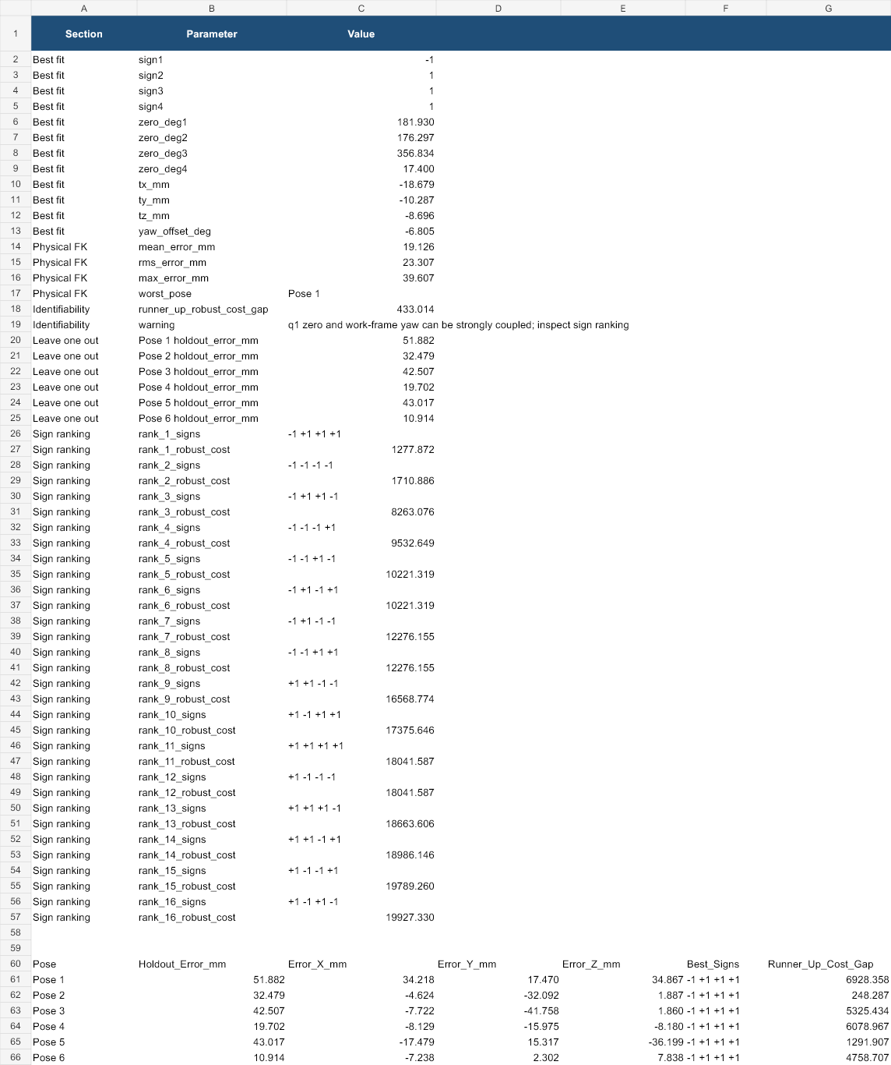
Retained calibration parameter screenshot. Its physical FK summary reports mean error 19.126 mm and maximum error 39.607 mm.
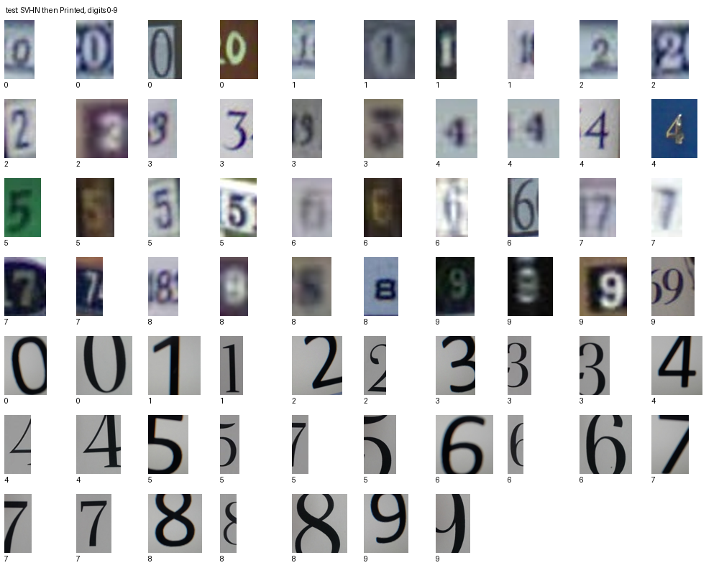
Local digit test sample gallery. It documents the separate classifier dataset; it does not assess robot grasp performance.

Weekly outcome
Offline controller checks and development model scores were recorded. Physical TCP accuracy, live deployment, and autonomous end to end pick/place remained unproven by 4 October.

Next verification step
Run supervised calibration and live camera validation with a separate held out real camera set; retain physical measurements and failure cases.

Source record
Primary timeline: docs/OPENMANIPULATOR_PROJECT_REPORT_2026-10-04.md. Local records checked for this week:
- openmanipulator_repeatability_project/README.md, ground and gamepad sections
- openmanipulator_repeatability_project/python_app/run_tests.py
- REAL_CAMERA_SHAPE_TEST.md and dataset/real_camera_shape_test_v1/capture_manifest.csv
- output/DIGIT_CLASSIFICATION_V1/dataset_report.md
- Git commits 3da992d, c4ddfc6, be23a77, ac286fd
Date note: image, CSV, and run timestamps identify local experiments where available. Git dates identify source publication. The two are not necessarily the same event.

