student performance

Ayobamidele

2025-05-16

#setwd("C:/Users/Peace/OneDrive/Documents/Data Analytic Term 2")  
sp <- read.csv("C:/Users/Peace/OneDrive/Documents/Data Analytic Term 2/student_habits_performance.csv", stringsAsFactors = T)

str(sp)

## 'data.frame': 1000 obs. of 16 variables:  
## $ student_id : Factor w/ 1000 levels "S1000","S1001",..: 1 2 3 4 5 6 7 8 9 10 ...  
## $ age : int 23 20 21 23 19 24 21 21 23 18 ...  
## $ gender : Factor w/ 3 levels "Female","Male",..: 1 1 2 1 1 2 1 1 1 1 ...  
## $ study_hours_per_day : num 0 6.9 1.4 1 5 7.2 5.6 4.3 4.4 4.8 ...  
## $ social_media_hours : num 1.2 2.8 3.1 3.9 4.4 1.3 1.5 1 2.2 3.1 ...  
## $ netflix_hours : num 1.1 2.3 1.3 1 0.5 0 1.4 2 1.7 1.3 ...  
## $ part_time_job : Factor w/ 2 levels "No","Yes": 1 1 1 1 1 1 2 2 1 1 ...  
## $ attendance_percentage : num 85 97.3 94.8 71 90.9 82.9 85.8 77.7 100 95.4 ...  
## $ sleep_hours : num 8 4.6 8 9.2 4.9 7.4 6.5 4.6 7.1 7.5 ...  
## $ diet_quality : Factor w/ 3 levels "Fair","Good",..: 1 2 3 3 1 1 2 1 2 2 ...  
## $ exercise_frequency : int 6 6 1 4 3 1 2 0 3 5 ...  
## $ parental_education_level : Factor w/ 4 levels "Bachelor","High School",..: 3 2 2 3 3 3 3 1 1 1 ...  
## $ internet_quality : Factor w/ 3 levels "Average","Good",..: 1 1 3 2 2 1 3 1 2 2 ...  
## $ mental_health_rating : int 8 8 1 1 1 4 4 8 1 10 ...  
## $ extracurricular_participation: Factor w/ 2 levels "No","Yes": 2 1 1 2 1 1 1 1 1 2 ...  
## $ exam_score : num 56.2 100 34.3 26.8 66.4 100 89.8 72.6 78.9 100 ...

sp <- sp[-1] #dropping the ID column  
str(sp)

## 'data.frame': 1000 obs. of 15 variables:  
## $ age : int 23 20 21 23 19 24 21 21 23 18 ...  
## $ gender : Factor w/ 3 levels "Female","Male",..: 1 1 2 1 1 2 1 1 1 1 ...  
## $ study_hours_per_day : num 0 6.9 1.4 1 5 7.2 5.6 4.3 4.4 4.8 ...  
## $ social_media_hours : num 1.2 2.8 3.1 3.9 4.4 1.3 1.5 1 2.2 3.1 ...  
## $ netflix_hours : num 1.1 2.3 1.3 1 0.5 0 1.4 2 1.7 1.3 ...  
## $ part_time_job : Factor w/ 2 levels "No","Yes": 1 1 1 1 1 1 2 2 1 1 ...  
## $ attendance_percentage : num 85 97.3 94.8 71 90.9 82.9 85.8 77.7 100 95.4 ...  
## $ sleep_hours : num 8 4.6 8 9.2 4.9 7.4 6.5 4.6 7.1 7.5 ...  
## $ diet_quality : Factor w/ 3 levels "Fair","Good",..: 1 2 3 3 1 1 2 1 2 2 ...  
## $ exercise_frequency : int 6 6 1 4 3 1 2 0 3 5 ...  
## $ parental_education_level : Factor w/ 4 levels "Bachelor","High School",..: 3 2 2 3 3 3 3 1 1 1 ...  
## $ internet_quality : Factor w/ 3 levels "Average","Good",..: 1 1 3 2 2 1 3 1 2 2 ...  
## $ mental_health_rating : int 8 8 1 1 1 4 4 8 1 10 ...  
## $ extracurricular_participation: Factor w/ 2 levels "No","Yes": 2 1 1 2 1 1 1 1 1 2 ...  
## $ exam_score : num 56.2 100 34.3 26.8 66.4 100 89.8 72.6 78.9 100 ...

sapply(sp, function(x) sum(is.na(x)))

## age gender   
## 0 0   
## study_hours_per_day social_media_hours   
## 0 0   
## netflix_hours part_time_job   
## 0 0   
## attendance_percentage sleep_hours   
## 0 0   
## diet_quality exercise_frequency   
## 0 0   
## parental_education_level internet_quality   
## 0 0   
## mental_health_rating extracurricular_participation   
## 0 0   
## exam_score   
## 0

factor_col <- sp[sapply(sp, is.factor)]  
lapply(factor_col, function(x) table(x))

## $gender  
## x  
## Female Male Other   
## 481 477 42   
##   
## $part_time_job  
## x  
## No Yes   
## 785 215   
##   
## $diet_quality  
## x  
## Fair Good Poor   
## 437 378 185   
##   
## $parental_education_level  
## x  
## Bachelor High School Master None   
## 350 392 167 91   
##   
## $internet_quality  
## x  
## Average Good Poor   
## 391 447 162   
##   
## $extracurricular_participation  
## x  
## No Yes   
## 682 318

num_col <- sp[sapply(sp, is.numeric)]  
lapply(num_col, function(x) summary(x))

## $age  
## Min. 1st Qu. Median Mean 3rd Qu. Max.   
## 17.00 18.75 20.00 20.50 23.00 24.00   
##   
## $study_hours_per_day  
## Min. 1st Qu. Median Mean 3rd Qu. Max.   
## 0.00 2.60 3.50 3.55 4.50 8.30   
##   
## $social_media_hours  
## Min. 1st Qu. Median Mean 3rd Qu. Max.   
## 0.000 1.700 2.500 2.506 3.300 7.200   
##   
## $netflix_hours  
## Min. 1st Qu. Median Mean 3rd Qu. Max.   
## 0.000 1.000 1.800 1.820 2.525 5.400   
##   
## $attendance_percentage  
## Min. 1st Qu. Median Mean 3rd Qu. Max.   
## 56.00 78.00 84.40 84.13 91.03 100.00   
##   
## $sleep_hours  
## Min. 1st Qu. Median Mean 3rd Qu. Max.   
## 3.20 5.60 6.50 6.47 7.30 10.00   
##   
## $exercise_frequency  
## Min. 1st Qu. Median Mean 3rd Qu. Max.   
## 0.000 1.000 3.000 3.042 5.000 6.000   
##   
## $mental_health_rating  
## Min. 1st Qu. Median Mean 3rd Qu. Max.   
## 1.000 3.000 5.000 5.438 8.000 10.000   
##   
## $exam_score  
## Min. 1st Qu. Median Mean 3rd Qu. Max.   
## 18.40 58.48 70.50 69.60 81.33 100.00

factor_name <- names(sp[, sapply(sp, is.factor)])  
  
  
lapply(factor_name, function(x) {  
 barplot(table(sp[x]), main = x, ylab= "Frequency", xlab = x,col=c("green","black"))  
})

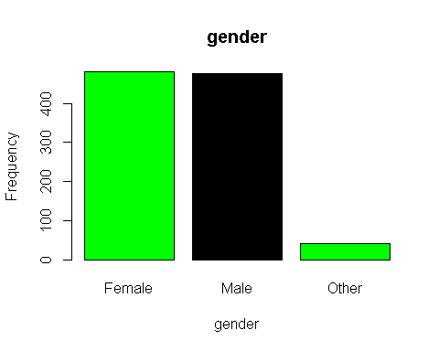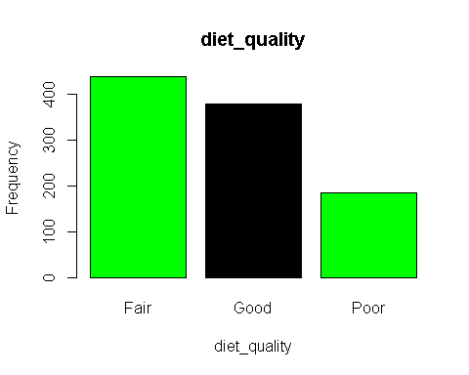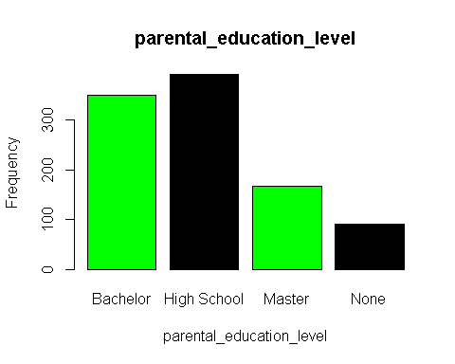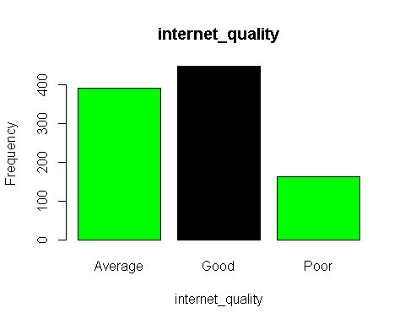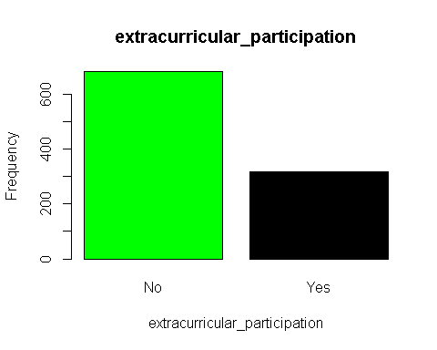

## [[1]]  
## [,1]  
## [1,] 0.7  
## [2,] 1.9  
## [3,] 3.1  
##   
## [[2]]  
## [,1]  
## [1,] 0.7  
## [2,] 1.9  
##   
## [[3]]  
## [,1]  
## [1,] 0.7  
## [2,] 1.9  
## [3,] 3.1  
##   
## [[4]]  
## [,1]  
## [1,] 0.7  
## [2,] 1.9  
## [3,] 3.1  
## [4,] 4.3  
##   
## [[5]]  
## [,1]  
## [1,] 0.7  
## [2,] 1.9  
## [3,] 3.1  
##   
## [[6]]  
## [,1]  
## [1,] 0.7  
## [2,] 1.9

numeric_col <- names(sp[sapply(sp, is.numeric)])  
#names(sp[, sapply(sp, is.factor)])  
cols<- numeric_col[-9]  
for (i in cols){  
 plot(sp[[i]], sp[[15]], main = paste("Scatter Plot of Exam_Score against", i), xlab = i, ylab = "Exam Score")  
}

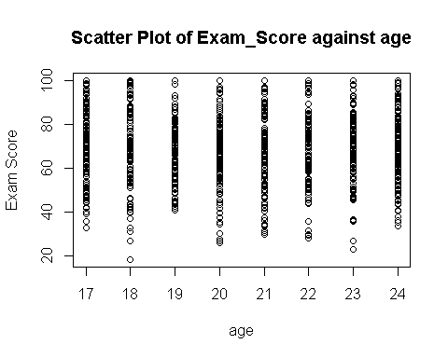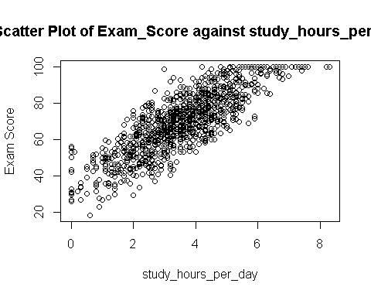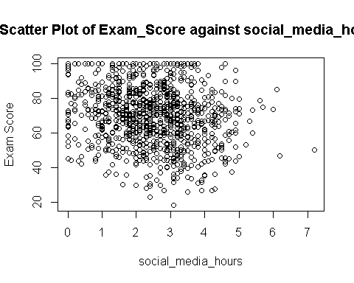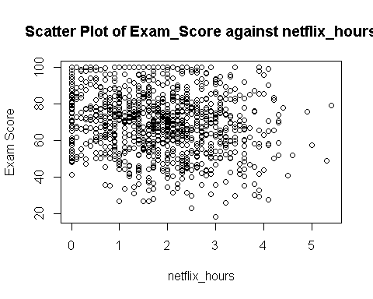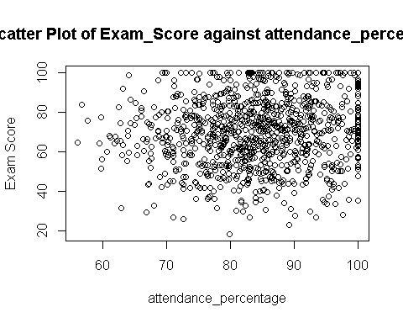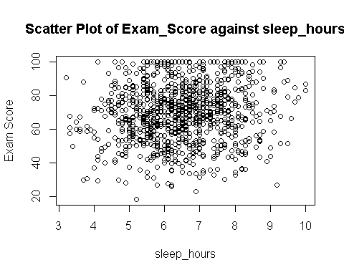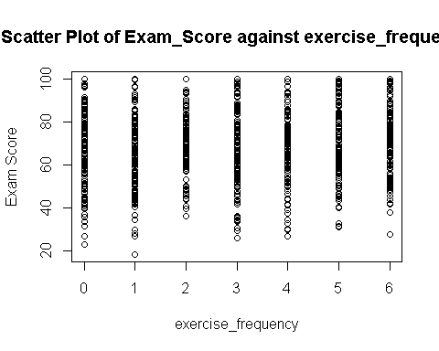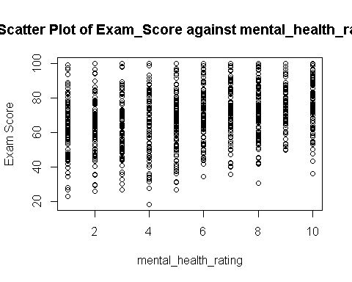

hist(sp$exam_score, main = "Distribution of Exam Score")

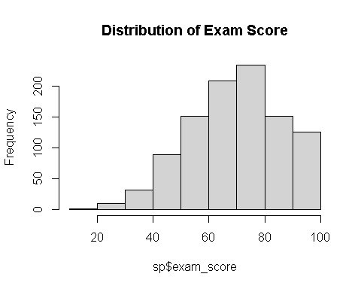

boxplot(sp$exam_score)

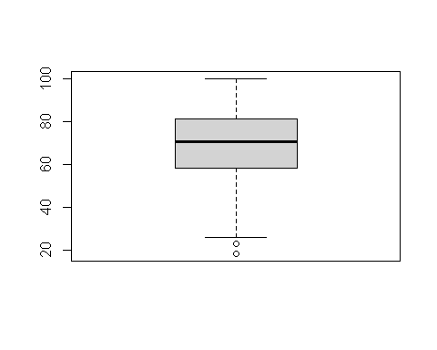

num_col <- sp[sapply(sp, is.numeric)]  
cor(num_col)

## age study_hours_per_day social_media_hours  
## age 1.000000000 0.003971179 -0.009151199  
## study_hours_per_day 0.003971179 1.000000000 0.020282314  
## social_media_hours -0.009151199 0.020282314 1.000000000  
## netflix_hours -0.001174104 -0.031158347 0.011476564  
## attendance_percentage -0.026055201 0.026264118 0.040478792  
## sleep_hours 0.037481916 -0.027757114 0.018236260  
## exercise_frequency -0.003836236 -0.028701192 -0.037319003  
## mental_health_rating -0.045101361 -0.003767826 0.001496491  
## exam_score -0.008906872 0.825418509 -0.166732885  
## netflix_hours attendance_percentage sleep_hours  
## age -0.0011741040 -0.026055201 0.0374819156  
## study_hours_per_day -0.0311583466 0.026264118 -0.0277571140  
## social_media_hours 0.0114765638 0.040478792 0.0182362596  
## netflix_hours 1.0000000000 -0.002091540 -0.0009345491  
## attendance_percentage -0.0020915397 1.000000000 0.0137560647  
## sleep_hours -0.0009345491 0.013756065 1.0000000000  
## exercise_frequency -0.0064482222 -0.007857196 0.0197690236  
## mental_health_rating 0.0080342346 -0.018744560 -0.0065079649  
## exam_score -0.1717792385 0.089835602 0.1216829106  
## exercise_frequency mental_health_rating exam_score  
## age -0.0038362359 -0.0451013606 -0.008906872  
## study_hours_per_day -0.0287011920 -0.0037678263 0.825418509  
## social_media_hours -0.0373190028 0.0014964907 -0.166732885  
## netflix_hours -0.0064482222 0.0080342346 -0.171779238  
## attendance_percentage -0.0078571964 -0.0187445601 0.089835602  
## sleep_hours 0.0197690236 -0.0065079649 0.121682911  
## exercise_frequency 1.0000000000 -0.0002422927 0.160107464  
## mental_health_rating -0.0002422927 1.0000000000 0.321522931  
## exam_score 0.1601074644 0.3215229307 1.000000000

# Split data into training and test sets  
library(caret)

## Warning: package 'caret' was built under R version 4.4.3

## Loading required package: ggplot2

## Warning: package 'ggplot2' was built under R version 4.4.3

## Loading required package: lattice

set.seed(1234)  
trainIndex <- createDataPartition(sp$exam_score, p = 0.8, list = FALSE)  
trainData <- sp[trainIndex, ]  
testData <- sp[-trainIndex, ]  
str(trainData)

## 'data.frame': 801 obs. of 15 variables:  
## $ age : int 20 21 21 21 23 18 19 23 19 19 ...  
## $ gender : Factor w/ 3 levels "Female","Male",..: 1 2 1 1 1 1 1 2 1 1 ...  
## $ study_hours_per_day : num 6.9 1.4 5.6 4.3 4.4 4.8 4.6 3.9 3.7 3.4 ...  
## $ social_media_hours : num 2.8 3.1 1.5 1 2.2 3.1 3.7 2.4 2.1 2.7 ...  
## $ netflix_hours : num 2.3 1.3 1.4 2 1.7 1.3 0.8 2.5 0.4 2.7 ...  
## $ part_time_job : Factor w/ 2 levels "No","Yes": 1 1 2 2 1 1 1 1 2 1 ...  
## $ attendance_percentage : num 97.3 94.8 85.8 77.7 100 95.4 77.6 71.7 81.1 89.3 ...  
## $ sleep_hours : num 4.6 8 6.5 4.6 7.1 7.5 5.8 7.9 4.5 4.7 ...  
## $ diet_quality : Factor w/ 3 levels "Fair","Good",..: 2 3 2 1 2 2 1 1 1 1 ...  
## $ exercise_frequency : int 6 1 2 0 3 5 1 2 1 4 ...  
## $ parental_education_level : Factor w/ 4 levels "Bachelor","High School",..: 2 2 3 1 1 1 4 1 1 1 ...  
## $ internet_quality : Factor w/ 3 levels "Average","Good",..: 1 3 3 1 2 2 2 1 2 2 ...  
## $ mental_health_rating : int 8 1 4 8 1 10 3 1 9 10 ...  
## $ extracurricular_participation: Factor w/ 2 levels "No","Yes": 1 1 1 1 1 2 1 1 1 1 ...  
## $ exam_score : num 100 34.3 89.8 72.6 78.9 100 63.3 74.4 76.9 75.8 ...

library(caret)  
ctrl <- trainControl(method = "cv", number = 5)  
  
# Define list of models and their tuning grids  
models <- list(  
 lm = list(method = "lm", tuneGrid = NULL),  
   
 rpart = list(  
 method = "rpart",  
 tuneGrid = expand.grid(cp = seq(0.001, 0.1, by = 0.01))  
 ),  
   
 svmRadial = list(  
 method = "svmRadial",  
 tuneGrid = expand.grid(sigma = 0.01, C = seq(0.5, 2, by = 0.5))  
 ),  
   
 nnet = list(  
 method = "nnet",  
 tuneGrid = expand.grid(size = c(3, 5, 7), decay = c(0.1, 0.5)),  
 trace = FALSE  
 ),  
   
 rf = list(  
 method = "rf",  
 tuneGrid = expand.grid(mtry = c(2, 4, 6))  
 ),  
   
 gbm = list(  
 method = "gbm",  
 tuneGrid = expand.grid(interaction.depth = c(1, 3, 5),  
 n.trees = c(50, 100, 150),  
 shrinkage = c(0.01, 0.1),  
 n.minobsinnode = 10)  
 ),  
   
 knn = list(  
 method = "knn",  
 tuneGrid = expand.grid(k = seq(3, 15, by = 2))  
 )  
)

results <- list()  
rmse_results <- data.frame(Model = character(), Test_RMSE = numeric(), stringsAsFactors = FALSE)

for (model_name in names(models)) {  
 cat("\nTraining model:", model_name, "\n")  
 model_info <- models[[model_name]]  
   
 model_fit <- train(  
 exam_score ~ .,  
 data = trainData,  
 method = model_info$method,  
 trControl = ctrl,  
 tuneGrid = model_info$tuneGrid  
 )  
   
 # Predict on test data  
 pred <- predict(model_fit, newdata = testData)  
 test_rmse <- RMSE(pred, testData$exam_score)  
   
 # Save result  
 results[[model_name]] <- list(fit = model_fit, rmse = test_rmse)  
 rmse_results <- rbind(rmse_results, data.frame(Model = model_name, Test_RMSE = test_rmse))  
}

##   
## Training model: lm   
##   
## Training model: rpart   
##   
## Training model: svmRadial   
##   
## Training model: nnet   
## # weights: 64  
## initial value 3246332.009817   
## iter 10 value 3210300.288763  
## iter 20 value 3209731.026894  
## iter 30 value 3209715.674224  
## final value 3209715.321174   
## converged  
## # weights: 106  
## initial value 3271207.382047   
## iter 10 value 3209764.974372  
## iter 20 value 3209714.919804  
## final value 3209714.100004   
## converged  
## # weights: 148  
## initial value 3230856.315142   
## iter 10 value 3210339.254271  
## iter 20 value 3209717.798696  
## iter 30 value 3209714.201638  
## final value 3209713.493275   
## converged  
## # weights: 64  
## initial value 3249393.269403   
## iter 10 value 3209916.532355  
## iter 20 value 3209735.275767  
## iter 30 value 3209728.610055  
## final value 3209727.380878   
## converged  
## # weights: 106  
## initial value 3270409.713293   
## iter 10 value 3209808.718043  
## iter 20 value 3209730.794203  
## iter 30 value 3209724.301257  
## final value 3209722.766479   
## converged  
## # weights: 148  
## initial value 3282107.510887   
## iter 10 value 3209743.166641  
## iter 20 value 3209738.594000  
## iter 30 value 3209721.767901  
## final value 3209720.236914   
## converged  
## # weights: 64  
## initial value 3233055.719131   
## iter 10 value 3206196.812805  
## iter 20 value 3206189.775334  
## final value 3206189.720992   
## converged  
## # weights: 106  
## initial value 3264773.898459   
## iter 10 value 3206458.367750  
## iter 20 value 3206189.441026  
## final value 3206188.542587   
## converged  
## # weights: 148  
## initial value 3256457.702855   
## iter 10 value 3206201.702666  
## final value 3206187.935404   
## converged  
## # weights: 64  
## initial value 3234897.416289   
## iter 10 value 3206658.283880  
## iter 20 value 3206203.683962  
## final value 3206201.907865   
## converged  
## # weights: 106  
## initial value 3236620.702495   
## iter 10 value 3207115.577853  
## iter 20 value 3206207.478419  
## iter 30 value 3206197.679549  
## final value 3206197.611365   
## converged  
## # weights: 148  
## initial value 3267722.364445   
## iter 10 value 3206382.679576  
## iter 20 value 3206199.628046  
## iter 30 value 3206195.692996  
## final value 3206194.634331   
## converged  
## # weights: 64  
## initial value 3254638.599840   
## iter 10 value 3222316.906267  
## iter 20 value 3221786.998529  
## final value 3221785.398189   
## converged  
## # weights: 106  
## initial value 3244842.610264   
## iter 10 value 3222540.720810  
## iter 20 value 3221785.654692  
## final value 3221784.169884   
## converged  
## # weights: 148  
## initial value 3248726.443271   
## iter 10 value 3221813.577575  
## iter 20 value 3221783.830756  
## final value 3221783.449590   
## converged  
## # weights: 64  
## initial value 3274995.987311   
## iter 10 value 3222373.327085  
## iter 20 value 3221797.535267  
## iter 20 value 3221797.524544  
## final value 3221797.396305   
## converged  
## # weights: 106  
## initial value 3276114.003575   
## iter 10 value 3221938.421497  
## iter 20 value 3221802.968250  
## iter 30 value 3221795.512670  
## final value 3221792.758249   
## converged  
## # weights: 148  
## initial value 3255930.426208   
## iter 10 value 3221957.861475  
## iter 20 value 3221793.950423  
## final value 3221792.675921   
## converged  
## # weights: 64  
## initial value 3241455.188430   
## iter 10 value 3204112.027322  
## iter 20 value 3203573.719705  
## iter 30 value 3203570.617712  
## iter 30 value 3203570.604671  
## iter 30 value 3203570.596635  
## final value 3203570.596635   
## converged  
## # weights: 106  
## initial value 3270718.750334   
## iter 10 value 3203593.083864  
## iter 20 value 3203572.521385  
## iter 30 value 3203569.531784  
## final value 3203569.419698   
## converged  
## # weights: 148  
## initial value 3241588.961853   
## iter 10 value 3204282.954577  
## iter 20 value 3203570.477082  
## iter 30 value 3203568.907629  
## final value 3203568.783398   
## converged  
## # weights: 64  
## initial value 3263276.230853   
## iter 10 value 3203657.734852  
## iter 20 value 3203590.923179  
## iter 30 value 3203583.383995  
## final value 3203582.692970   
## converged  
## # weights: 106  
## initial value 3255559.851871   
## iter 10 value 3203593.850240  
## iter 20 value 3203582.475171  
## iter 30 value 3203579.735168  
## iter 30 value 3203579.722237  
## final value 3203578.014817   
## converged  
## # weights: 148  
## initial value 3268839.748212   
## iter 10 value 3205062.662559  
## iter 20 value 3203587.336013  
## iter 30 value 3203579.537886  
## final value 3203578.073595   
## converged  
## # weights: 64  
## initial value 3245197.234648   
## iter 10 value 3190700.404735  
## final value 3190665.900505   
## converged  
## # weights: 106  
## initial value 3247389.887485   
## iter 10 value 3190795.853597  
## iter 20 value 3190655.677847  
## final value 3190655.400968   
## converged  
## # weights: 148  
## initial value 3236525.624475   
## iter 10 value 3191764.507470  
## iter 20 value 3190658.454258  
## iter 30 value 3190654.849890  
## iter 30 value 3190654.839670  
## final value 3190654.736443   
## converged  
## # weights: 64  
## initial value 3244854.613981   
## iter 10 value 3191458.847365  
## iter 20 value 3190673.097872  
## final value 3190668.650958   
## converged  
## # weights: 106  
## initial value 3264903.962262   
## iter 10 value 3190738.747456  
## iter 20 value 3190669.040844  
## iter 30 value 3190666.551268  
## final value 3190665.893002   
## converged  
## # weights: 148  
## initial value 3225206.452883   
## iter 10 value 3190774.912024  
## iter 20 value 3190666.385505  
## iter 30 value 3190661.807272  
## final value 3190661.507197   
## converged

## Warning in nominalTrainWorkflow(x = x, y = y, wts = weights, info = trainInfo,  
## : There were missing values in resampled performance measures.

## # weights: 148  
## initial value 4043786.253025   
## iter 10 value 4008365.745571  
## iter 20 value 4007980.515731  
## iter 30 value 4007977.437651  
## final value 4007976.912093   
## converged  
##   
## Training model: rf   
##   
## Training model: gbm   
## Iter TrainDeviance ValidDeviance StepSize Improve  
## 1 285.5692 nan 0.0100 2.4619  
## 2 283.0251 nan 0.0100 2.4269  
## 3 280.5526 nan 0.0100 2.3773  
## 4 278.1782 nan 0.0100 2.1803  
## 5 275.7888 nan 0.0100 2.1764  
## 6 273.3120 nan 0.0100 2.3096  
## 7 270.9453 nan 0.0100 2.0660  
## 8 268.7533 nan 0.0100 2.2047  
## 9 266.5543 nan 0.0100 2.1364  
## 10 264.3878 nan 0.0100 2.0988  
## 20 243.6864 nan 0.0100 1.7868  
## 40 211.8899 nan 0.0100 1.4074  
## 60 186.7243 nan 0.0100 1.1907  
## 80 167.0356 nan 0.0100 0.7648  
## 100 151.8712 nan 0.0100 0.7411  
## 120 139.8191 nan 0.0100 0.5444  
## 140 129.7216 nan 0.0100 0.3404  
## 150 125.1634 nan 0.0100 0.3690  
##   
## Iter TrainDeviance ValidDeviance StepSize Improve  
## 1 284.4183 nan 0.0100 3.6384  
## 2 280.7078 nan 0.0100 3.4920  
## 3 277.0903 nan 0.0100 3.7204  
## 4 273.5157 nan 0.0100 3.5584  
## 5 270.0866 nan 0.0100 3.3953  
## 6 266.8616 nan 0.0100 3.2523  
## 7 263.7124 nan 0.0100 3.2379  
## 8 260.5572 nan 0.0100 3.2946  
## 9 257.3660 nan 0.0100 3.1476  
## 10 254.3359 nan 0.0100 2.9346  
## 20 225.7739 nan 0.0100 2.6244  
## 40 181.6667 nan 0.0100 1.7226  
## 60 150.0387 nan 0.0100 1.3432  
## 80 127.5948 nan 0.0100 0.9325  
## 100 110.4102 nan 0.0100 0.5897  
## 120 97.1705 nan 0.0100 0.5775  
## 140 87.3201 nan 0.0100 0.3968  
## 150 83.2094 nan 0.0100 0.3287  
##   
## Iter TrainDeviance ValidDeviance StepSize Improve  
## 1 283.9455 nan 0.0100 4.1112  
## 2 279.8959 nan 0.0100 3.3357  
## 3 276.0121 nan 0.0100 4.0042  
## 4 272.3273 nan 0.0100 3.7310  
## 5 268.5099 nan 0.0100 3.2792  
## 6 264.8148 nan 0.0100 3.5468  
## 7 261.1123 nan 0.0100 3.4695  
## 8 257.6831 nan 0.0100 3.2411  
## 9 254.1659 nan 0.0100 3.3966  
## 10 250.6538 nan 0.0100 3.2159  
## 20 219.6727 nan 0.0100 2.7020  
## 40 172.4780 nan 0.0100 1.9533  
## 60 138.4838 nan 0.0100 1.4032  
## 80 114.1592 nan 0.0100 0.9334  
## 100 96.5720 nan 0.0100 0.7281  
## 120 83.3371 nan 0.0100 0.4855  
## 140 72.7647 nan 0.0100 0.3707  
## 150 68.3673 nan 0.0100 0.3369  
##   
## Iter TrainDeviance ValidDeviance StepSize Improve  
## 1 264.0625 nan 0.1000 23.0149  
## 2 241.7552 nan 0.1000 18.9822  
## 3 224.4457 nan 0.1000 18.0936  
## 4 210.0330 nan 0.1000 14.0510  
## 5 195.7078 nan 0.1000 13.2466  
## 6 183.9440 nan 0.1000 10.7964  
## 7 173.2168 nan 0.1000 10.4692  
## 8 164.8093 nan 0.1000 8.0204  
## 9 155.9790 nan 0.1000 8.0511  
## 10 149.3109 nan 0.1000 5.8865  
## 20 103.5795 nan 0.1000 3.1913  
## 40 68.8086 nan 0.1000 1.0347  
## 60 51.6596 nan 0.1000 0.3442  
## 80 41.5027 nan 0.1000 0.2522  
## 100 35.2993 nan 0.1000 0.1288  
## 120 31.1209 nan 0.1000 0.0757  
## 140 28.4464 nan 0.1000 -0.0191  
## 150 27.4806 nan 0.1000 0.0374  
##   
## Iter TrainDeviance ValidDeviance StepSize Improve  
## 1 252.8925 nan 0.1000 33.6412  
## 2 224.0195 nan 0.1000 26.3842  
## 3 199.2440 nan 0.1000 24.1552  
## 4 180.1020 nan 0.1000 19.8514  
## 5 163.8717 nan 0.1000 15.5176  
## 6 149.3108 nan 0.1000 12.8389  
## 7 136.5786 nan 0.1000 12.3819  
## 8 125.2209 nan 0.1000 11.0654  
## 9 115.2611 nan 0.1000 9.6468  
## 10 107.0230 nan 0.1000 6.9659  
## 20 67.0519 nan 0.1000 2.1070  
## 40 37.3179 nan 0.1000 0.4735  
## 60 27.0748 nan 0.1000 0.0638  
## 80 23.0038 nan 0.1000 -0.1146  
## 100 21.1173 nan 0.1000 -0.0741  
## 120 19.8178 nan 0.1000 -0.0836  
## 140 18.6810 nan 0.1000 -0.0871  
## 150 18.2165 nan 0.1000 -0.0512  
##   
## Iter TrainDeviance ValidDeviance StepSize Improve  
## 1 249.5461 nan 0.1000 35.2193  
## 2 217.1588 nan 0.1000 30.4734  
## 3 190.9558 nan 0.1000 23.6362  
## 4 168.4313 nan 0.1000 21.0764  
## 5 149.6226 nan 0.1000 16.8131  
## 6 134.5702 nan 0.1000 16.3399  
## 7 121.6870 nan 0.1000 11.5285  
## 8 111.8809 nan 0.1000 8.7660  
## 9 102.2058 nan 0.1000 8.5707  
## 10 95.0343 nan 0.1000 6.5309  
## 20 52.1492 nan 0.1000 2.0152  
## 40 27.6904 nan 0.1000 0.3824  
## 60 20.9539 nan 0.1000 -0.1197  
## 80 18.3699 nan 0.1000 -0.0796  
## 100 16.7090 nan 0.1000 -0.0590  
## 120 15.1733 nan 0.1000 -0.1230  
## 140 13.8462 nan 0.1000 -0.1209  
## 150 13.2642 nan 0.1000 -0.0950  
##   
## Iter TrainDeviance ValidDeviance StepSize Improve  
## 1 275.7749 nan 0.0100 2.4170  
## 2 273.2159 nan 0.0100 2.3780  
## 3 270.9781 nan 0.0100 2.3381  
## 4 268.5362 nan 0.0100 2.3724  
## 5 266.1358 nan 0.0100 2.2489  
## 6 263.9043 nan 0.0100 2.2490  
## 7 261.5849 nan 0.0100 2.2074  
## 8 259.4377 nan 0.0100 2.2204  
## 9 257.3273 nan 0.0100 2.0850  
## 10 255.1478 nan 0.0100 2.0872  
## 20 234.9907 nan 0.0100 1.7100  
## 40 203.8495 nan 0.0100 1.3482  
## 60 180.2782 nan 0.0100 0.9676  
## 80 162.0315 nan 0.0100 0.6650  
## 100 147.6552 nan 0.0100 0.5922  
## 120 135.8427 nan 0.0100 0.4613  
## 140 125.9575 nan 0.0100 0.4777  
## 150 121.4664 nan 0.0100 0.3745  
##   
## Iter TrainDeviance ValidDeviance StepSize Improve  
## 1 274.6531 nan 0.0100 3.2851  
## 2 271.4614 nan 0.0100 3.7067  
## 3 268.1712 nan 0.0100 3.4309  
## 4 264.9419 nan 0.0100 3.0155  
## 5 261.6371 nan 0.0100 2.9030  
## 6 258.3622 nan 0.0100 3.2916  
## 7 255.0848 nan 0.0100 2.8299  
## 8 252.1412 nan 0.0100 2.9628  
## 9 249.0543 nan 0.0100 2.8714  
## 10 246.1574 nan 0.0100 2.9839  
## 20 219.0624 nan 0.0100 2.5242  
## 40 177.3158 nan 0.0100 1.9077  
## 60 147.0179 nan 0.0100 1.1553  
## 80 124.6821 nan 0.0100 0.9401  
## 100 107.9711 nan 0.0100 0.6382  
## 120 95.5209 nan 0.0100 0.4772  
## 140 85.5662 nan 0.0100 0.3287  
## 150 81.4064 nan 0.0100 0.3213  
##   
## Iter TrainDeviance ValidDeviance StepSize Improve  
## 1 274.3066 nan 0.0100 3.6175  
## 2 270.5173 nan 0.0100 3.3350  
## 3 266.7528 nan 0.0100 3.5141  
## 4 263.1180 nan 0.0100 3.2821  
## 5 259.5773 nan 0.0100 3.8351  
## 6 255.9617 nan 0.0100 3.5302  
## 7 252.4577 nan 0.0100 3.3084  
## 8 248.9411 nan 0.0100 3.2184  
## 9 245.5873 nan 0.0100 2.9321  
## 10 242.2170 nan 0.0100 3.1827  
## 20 212.2535 nan 0.0100 2.7460  
## 40 167.1523 nan 0.0100 1.8893  
## 60 135.0521 nan 0.0100 1.3863  
## 80 111.8731 nan 0.0100 0.9781  
## 100 94.9606 nan 0.0100 0.7359  
## 120 82.1812 nan 0.0100 0.4412  
## 140 72.3836 nan 0.0100 0.3428  
## 150 68.1969 nan 0.0100 0.3565  
##   
## Iter TrainDeviance ValidDeviance StepSize Improve  
## 1 255.8328 nan 0.1000 22.7695  
## 2 234.6784 nan 0.1000 21.2974  
## 3 217.4869 nan 0.1000 16.0917  
## 4 202.4000 nan 0.1000 14.0763  
## 5 190.9120 nan 0.1000 11.1273  
## 6 179.2877 nan 0.1000 10.9341  
## 7 168.8542 nan 0.1000 8.7943  
## 8 160.6657 nan 0.1000 8.3448  
## 9 152.7195 nan 0.1000 6.8322  
## 10 145.9458 nan 0.1000 5.8563  
## 20 102.9394 nan 0.1000 2.2953  
## 40 68.7043 nan 0.1000 0.8760  
## 60 51.8556 nan 0.1000 0.6441  
## 80 41.8501 nan 0.1000 0.0876  
## 100 35.4873 nan 0.1000 0.0531  
## 120 30.8533 nan 0.1000 0.1016  
## 140 27.7965 nan 0.1000 0.1062  
## 150 26.6439 nan 0.1000 0.0395  
##   
## Iter TrainDeviance ValidDeviance StepSize Improve  
## 1 244.0065 nan 0.1000 31.3878  
## 2 217.8167 nan 0.1000 27.4456  
## 3 194.9019 nan 0.1000 22.4952  
## 4 175.1650 nan 0.1000 19.9682  
## 5 157.8908 nan 0.1000 16.1055  
## 6 144.2303 nan 0.1000 13.2610  
## 7 131.7111 nan 0.1000 11.0663  
## 8 121.4642 nan 0.1000 9.5650  
## 9 112.4449 nan 0.1000 7.2941  
## 10 105.5503 nan 0.1000 7.3580  
## 20 64.9806 nan 0.1000 1.7850  
## 40 35.9257 nan 0.1000 0.4041  
## 60 25.4728 nan 0.1000 0.0382  
## 80 21.1403 nan 0.1000 -0.1172  
## 100 19.1478 nan 0.1000 -0.0066  
## 120 17.8408 nan 0.1000 -0.0670  
## 140 16.8866 nan 0.1000 -0.1058  
## 150 16.4195 nan 0.1000 -0.0541  
##   
## Iter TrainDeviance ValidDeviance StepSize Improve  
## 1 240.7393 nan 0.1000 35.0408  
## 2 212.3601 nan 0.1000 29.7362  
## 3 186.6747 nan 0.1000 22.6651  
## 4 165.2772 nan 0.1000 21.4153  
## 5 147.0460 nan 0.1000 16.1841  
## 6 131.9286 nan 0.1000 13.6919  
## 7 119.4828 nan 0.1000 12.6023  
## 8 109.3121 nan 0.1000 10.2828  
## 9 100.8814 nan 0.1000 7.9372  
## 10 93.7243 nan 0.1000 6.4855  
## 20 51.4301 nan 0.1000 1.9342  
## 40 26.5826 nan 0.1000 0.2196  
## 60 19.5055 nan 0.1000 -0.1627  
## 80 16.6058 nan 0.1000 -0.0777  
## 100 15.0682 nan 0.1000 -0.0998  
## 120 13.5804 nan 0.1000 -0.1029  
## 140 12.5236 nan 0.1000 -0.0598  
## 150 12.0645 nan 0.1000 -0.0849  
##   
## Iter TrainDeviance ValidDeviance StepSize Improve  
## 1 274.3083 nan 0.0100 2.4840  
## 2 271.8971 nan 0.0100 2.3766  
## 3 269.4610 nan 0.0100 2.3019  
## 4 267.2128 nan 0.0100 2.2758  
## 5 264.8312 nan 0.0100 2.1584  
## 6 262.4466 nan 0.0100 2.1563  
## 7 260.3285 nan 0.0100 2.0264  
## 8 258.2662 nan 0.0100 2.1743  
## 9 256.0583 nan 0.0100 2.1215  
## 10 253.9993 nan 0.0100 2.0246  
## 20 234.4991 nan 0.0100 1.8262  
## 40 203.9404 nan 0.0100 1.2576  
## 60 181.6688 nan 0.0100 0.9737  
## 80 163.8741 nan 0.0100 0.7190  
## 100 149.5292 nan 0.0100 0.4340  
## 120 138.1721 nan 0.0100 0.4389  
## 140 128.3492 nan 0.0100 0.3859  
## 150 124.0693 nan 0.0100 0.3552  
##   
## Iter TrainDeviance ValidDeviance StepSize Improve  
## 1 273.6068 nan 0.0100 3.0425  
## 2 270.2209 nan 0.0100 3.1309  
## 3 267.0444 nan 0.0100 3.3419  
## 4 263.7527 nan 0.0100 3.1090  
## 5 260.4477 nan 0.0100 2.9939  
## 6 257.3635 nan 0.0100 3.1343  
## 7 254.2976 nan 0.0100 2.9934  
## 8 251.2886 nan 0.0100 2.6049  
## 9 248.3462 nan 0.0100 3.1455  
## 10 245.5228 nan 0.0100 2.6850  
## 20 219.2122 nan 0.0100 2.1170  
## 40 177.6864 nan 0.0100 1.6288  
## 60 148.4093 nan 0.0100 1.2281  
## 80 126.0291 nan 0.0100 0.8591  
## 100 109.9616 nan 0.0100 0.6901  
## 120 97.4152 nan 0.0100 0.5331  
## 140 87.5225 nan 0.0100 0.4112  
## 150 83.2477 nan 0.0100 0.3082  
##   
## Iter TrainDeviance ValidDeviance StepSize Improve  
## 1 272.9742 nan 0.0100 3.4222  
## 2 269.2471 nan 0.0100 3.8276  
## 3 265.5753 nan 0.0100 3.7175  
## 4 262.0959 nan 0.0100 3.2166  
## 5 258.5297 nan 0.0100 3.2104  
## 6 255.0243 nan 0.0100 3.2984  
## 7 251.5903 nan 0.0100 3.3778  
## 8 248.1769 nan 0.0100 3.1203  
## 9 244.9383 nan 0.0100 3.1099  
## 10 241.6202 nan 0.0100 3.1462  
## 20 211.8771 nan 0.0100 2.5104  
## 40 166.9269 nan 0.0100 1.6084  
## 60 135.1719 nan 0.0100 1.3077  
## 80 112.3723 nan 0.0100 0.8922  
## 100 95.5704 nan 0.0100 0.7061  
## 120 82.9131 nan 0.0100 0.5467  
## 140 73.2316 nan 0.0100 0.3462  
## 150 69.1561 nan 0.0100 0.2973  
##   
## Iter TrainDeviance ValidDeviance StepSize Improve  
## 1 252.4718 nan 0.1000 22.8085  
## 2 233.7539 nan 0.1000 17.9071  
## 3 217.1794 nan 0.1000 17.0236  
## 4 203.7114 nan 0.1000 12.9611  
## 5 193.3394 nan 0.1000 10.1492  
## 6 180.6887 nan 0.1000 12.1921  
## 7 169.8364 nan 0.1000 9.9401  
## 8 161.5980 nan 0.1000 6.5366  
## 9 153.2179 nan 0.1000 7.9630  
## 10 146.7519 nan 0.1000 5.5279  
## 20 103.3400 nan 0.1000 3.1120  
## 40 70.6019 nan 0.1000 1.0034  
## 60 53.6576 nan 0.1000 0.5463  
## 80 43.0893 nan 0.1000 0.3771  
## 100 36.6636 nan 0.1000 0.1728  
## 120 32.1287 nan 0.1000 0.0235  
## 140 29.2203 nan 0.1000 0.0123  
## 150 28.1423 nan 0.1000 -0.0035  
##   
## Iter TrainDeviance ValidDeviance StepSize Improve  
## 1 243.9736 nan 0.1000 32.7067  
## 2 216.9237 nan 0.1000 26.3019  
## 3 196.1255 nan 0.1000 18.1705  
## 4 175.8631 nan 0.1000 20.3107  
## 5 160.4403 nan 0.1000 14.1524  
## 6 145.8399 nan 0.1000 13.7172  
## 7 133.5022 nan 0.1000 10.8204  
## 8 122.7021 nan 0.1000 9.9594  
## 9 114.5345 nan 0.1000 7.6578  
## 10 107.7218 nan 0.1000 6.0190  
## 20 66.5324 nan 0.1000 1.4952  
## 40 37.8162 nan 0.1000 0.5850  
## 60 27.4047 nan 0.1000 0.1266  
## 80 23.3611 nan 0.1000 -0.0651  
## 100 21.2823 nan 0.1000 -0.0762  
## 120 19.9428 nan 0.1000 -0.1478  
## 140 18.8775 nan 0.1000 -0.0666  
## 150 18.2803 nan 0.1000 -0.0943  
##   
## Iter TrainDeviance ValidDeviance StepSize Improve  
## 1 240.0644 nan 0.1000 34.5754  
## 2 209.8832 nan 0.1000 28.2985  
## 3 184.8776 nan 0.1000 25.0639  
## 4 164.9480 nan 0.1000 20.8704  
## 5 147.4219 nan 0.1000 16.1478  
## 6 132.9178 nan 0.1000 13.7550  
## 7 121.6077 nan 0.1000 10.2466  
## 8 111.4404 nan 0.1000 9.6368  
## 9 101.9874 nan 0.1000 8.3448  
## 10 94.6543 nan 0.1000 6.3878  
## 20 53.9270 nan 0.1000 1.3076  
## 40 28.1944 nan 0.1000 0.1230  
## 60 21.0253 nan 0.1000 -0.1232  
## 80 18.1575 nan 0.1000 -0.1301  
## 100 16.4531 nan 0.1000 -0.0347  
## 120 15.0753 nan 0.1000 -0.1096  
## 140 13.9330 nan 0.1000 -0.0414  
## 150 13.2920 nan 0.1000 -0.1030  
##   
## Iter TrainDeviance ValidDeviance StepSize Improve  
## 1 288.5463 nan 0.0100 2.5347  
## 2 285.9763 nan 0.0100 2.4748  
## 3 283.3748 nan 0.0100 2.3984  
## 4 281.0028 nan 0.0100 2.4215  
## 5 278.5844 nan 0.0100 2.3924  
## 6 276.0967 nan 0.0100 2.3426  
## 7 273.7389 nan 0.0100 2.3201  
## 8 271.3519 nan 0.0100 2.2587  
## 9 268.9865 nan 0.0100 2.1720  
## 10 266.6016 nan 0.0100 2.0614  
## 20 246.5159 nan 0.0100 1.8111  
## 40 213.4273 nan 0.0100 1.2780  
## 60 188.5231 nan 0.0100 1.0041  
## 80 168.7364 nan 0.0100 0.7451  
## 100 153.1822 nan 0.0100 0.5969  
## 120 140.8419 nan 0.0100 0.4584  
## 140 130.4398 nan 0.0100 0.3974  
## 150 125.8159 nan 0.0100 0.4403  
##   
## Iter TrainDeviance ValidDeviance StepSize Improve  
## 1 287.4243 nan 0.0100 3.5746  
## 2 283.7602 nan 0.0100 3.4171  
## 3 280.1201 nan 0.0100 3.5334  
## 4 276.7332 nan 0.0100 3.1319  
## 5 273.0303 nan 0.0100 3.3916  
## 6 269.5131 nan 0.0100 3.3924  
## 7 266.1104 nan 0.0100 3.2980  
## 8 262.6615 nan 0.0100 3.1349  
## 9 259.3563 nan 0.0100 3.2582  
## 10 256.2483 nan 0.0100 3.4028  
## 20 227.9657 nan 0.0100 2.4091  
## 40 183.7755 nan 0.0100 1.7553  
## 60 151.9278 nan 0.0100 1.2638  
## 80 128.4156 nan 0.0100 0.9032  
## 100 111.2253 nan 0.0100 0.6832  
## 120 98.2390 nan 0.0100 0.5000  
## 140 88.1809 nan 0.0100 0.3714  
## 150 83.8596 nan 0.0100 0.3081  
##   
## Iter TrainDeviance ValidDeviance StepSize Improve  
## 1 287.0988 nan 0.0100 4.0268  
## 2 283.1331 nan 0.0100 4.0279  
## 3 279.3579 nan 0.0100 3.3944  
## 4 275.4952 nan 0.0100 3.7041  
## 5 271.7603 nan 0.0100 3.7752  
## 6 268.0781 nan 0.0100 3.7813  
## 7 264.4116 nan 0.0100 3.3978  
## 8 260.8620 nan 0.0100 3.5441  
## 9 257.3954 nan 0.0100 3.5890  
## 10 254.0875 nan 0.0100 3.2968  
## 20 222.5248 nan 0.0100 2.7568  
## 40 173.2845 nan 0.0100 1.9005  
## 60 139.3703 nan 0.0100 1.3401  
## 80 114.7575 nan 0.0100 0.9083  
## 100 96.9285 nan 0.0100 0.7030  
## 120 83.3894 nan 0.0100 0.4481  
## 140 73.2221 nan 0.0100 0.3559  
## 150 69.0103 nan 0.0100 0.3262  
##   
## Iter TrainDeviance ValidDeviance StepSize Improve  
## 1 266.7368 nan 0.1000 24.6109  
## 2 246.9437 nan 0.1000 20.2984  
## 3 229.7894 nan 0.1000 18.7873  
## 4 214.3003 nan 0.1000 14.3049  
## 5 199.8194 nan 0.1000 14.9522  
## 6 187.5898 nan 0.1000 10.8080  
## 7 176.6903 nan 0.1000 9.5038  
## 8 167.6191 nan 0.1000 8.7558  
## 9 158.7912 nan 0.1000 8.5349  
## 10 151.8369 nan 0.1000 7.1162  
## 20 105.1528 nan 0.1000 3.2002  
## 40 70.1681 nan 0.1000 0.6058  
## 60 53.4695 nan 0.1000 0.4817  
## 80 43.3558 nan 0.1000 0.3699  
## 100 37.0635 nan 0.1000 0.1212  
## 120 32.6655 nan 0.1000 0.0335  
## 140 29.6474 nan 0.1000 0.0608  
## 150 28.3852 nan 0.1000 0.0273  
##   
## Iter TrainDeviance ValidDeviance StepSize Improve  
## 1 256.3306 nan 0.1000 34.6907  
## 2 227.6815 nan 0.1000 25.0728  
## 3 204.3049 nan 0.1000 22.5589  
## 4 182.9476 nan 0.1000 18.5869  
## 5 164.3083 nan 0.1000 17.7620  
## 6 149.6479 nan 0.1000 15.0886  
## 7 136.6655 nan 0.1000 11.1368  
## 8 125.6709 nan 0.1000 9.4480  
## 9 116.5165 nan 0.1000 8.6302  
## 10 109.2360 nan 0.1000 6.6599  
## 20 68.2257 nan 0.1000 2.4045  
## 40 38.2826 nan 0.1000 0.4044  
## 60 27.6398 nan 0.1000 0.1332  
## 80 23.3258 nan 0.1000 -0.0773  
## 100 21.3023 nan 0.1000 -0.0611  
## 120 19.9672 nan 0.1000 -0.0508  
## 140 18.8759 nan 0.1000 -0.0661  
## 150 18.4029 nan 0.1000 -0.0567  
##   
## Iter TrainDeviance ValidDeviance StepSize Improve  
## 1 252.1485 nan 0.1000 38.0230  
## 2 220.4575 nan 0.1000 30.7944  
## 3 193.7615 nan 0.1000 26.1306  
## 4 171.0491 nan 0.1000 23.8208  
## 5 151.7463 nan 0.1000 16.8369  
## 6 135.9280 nan 0.1000 14.3918  
## 7 123.7956 nan 0.1000 10.7043  
## 8 112.2588 nan 0.1000 11.5814  
## 9 103.1721 nan 0.1000 7.3132  
## 10 95.7077 nan 0.1000 7.0872  
## 20 53.1556 nan 0.1000 1.8149  
## 40 27.9338 nan 0.1000 0.4206  
## 60 20.8012 nan 0.1000 -0.1405  
## 80 18.2474 nan 0.1000 -0.1008  
## 100 16.6586 nan 0.1000 -0.0878  
## 120 15.4339 nan 0.1000 -0.1854  
## 140 14.1983 nan 0.1000 -0.1491  
## 150 13.6079 nan 0.1000 -0.0913  
##   
## Iter TrainDeviance ValidDeviance StepSize Improve  
## 1 278.6418 nan 0.0100 2.3891  
## 2 276.1130 nan 0.0100 2.2697  
## 3 273.6543 nan 0.0100 2.4052  
## 4 271.3962 nan 0.0100 2.3550  
## 5 268.8693 nan 0.0100 2.2589  
## 6 266.5282 nan 0.0100 2.2704  
## 7 264.2310 nan 0.0100 2.2976  
## 8 262.0682 nan 0.0100 2.1080  
## 9 259.8646 nan 0.0100 2.1047  
## 10 257.7280 nan 0.0100 2.1348  
## 20 237.8727 nan 0.0100 1.6258  
## 40 207.1601 nan 0.0100 1.2653  
## 60 183.7974 nan 0.0100 0.8874  
## 80 165.3326 nan 0.0100 0.7317  
## 100 150.7594 nan 0.0100 0.6193  
## 120 139.3395 nan 0.0100 0.4284  
## 140 129.6480 nan 0.0100 0.3976  
## 150 125.2549 nan 0.0100 0.2482  
##   
## Iter TrainDeviance ValidDeviance StepSize Improve  
## 1 277.6638 nan 0.0100 3.2215  
## 2 274.0902 nan 0.0100 3.3838  
## 3 270.4225 nan 0.0100 3.2604  
## 4 267.1104 nan 0.0100 3.1296  
## 5 263.8748 nan 0.0100 2.9549  
## 6 260.7577 nan 0.0100 3.0632  
## 7 257.5648 nan 0.0100 3.1183  
## 8 254.7519 nan 0.0100 3.1870  
## 9 251.8188 nan 0.0100 2.8141  
## 10 248.7186 nan 0.0100 2.8954  
## 20 221.9551 nan 0.0100 2.5880  
## 40 180.7180 nan 0.0100 1.5418  
## 60 150.9004 nan 0.0100 0.9442  
## 80 128.8077 nan 0.0100 0.8713  
## 100 112.2350 nan 0.0100 0.6029  
## 120 99.5620 nan 0.0100 0.5104  
## 140 89.6757 nan 0.0100 0.4028  
## 150 85.3088 nan 0.0100 0.2921  
##   
## Iter TrainDeviance ValidDeviance StepSize Improve  
## 1 277.0598 nan 0.0100 3.9236  
## 2 273.4157 nan 0.0100 3.5794  
## 3 269.7111 nan 0.0100 3.6511  
## 4 266.0569 nan 0.0100 3.5476  
## 5 262.2056 nan 0.0100 3.4150  
## 6 258.6909 nan 0.0100 3.6363  
## 7 255.2505 nan 0.0100 3.3161  
## 8 251.8533 nan 0.0100 3.2014  
## 9 248.3790 nan 0.0100 3.2803  
## 10 245.0516 nan 0.0100 3.4160  
## 20 215.6987 nan 0.0100 2.4994  
## 40 170.2462 nan 0.0100 1.8470  
## 60 137.9500 nan 0.0100 1.3514  
## 80 114.5755 nan 0.0100 0.9631  
## 100 97.4109 nan 0.0100 0.5720  
## 120 84.4550 nan 0.0100 0.5131  
## 140 74.5001 nan 0.0100 0.3566  
## 150 70.3072 nan 0.0100 0.3435  
##   
## Iter TrainDeviance ValidDeviance StepSize Improve  
## 1 256.9041 nan 0.1000 23.6535  
## 2 236.5042 nan 0.1000 19.4930  
## 3 219.6781 nan 0.1000 15.8345  
## 4 203.4627 nan 0.1000 14.0242  
## 5 191.5636 nan 0.1000 11.4330  
## 6 179.8619 nan 0.1000 9.7242  
## 7 170.8649 nan 0.1000 9.0273  
## 8 161.5503 nan 0.1000 8.6437  
## 9 154.7079 nan 0.1000 6.4940  
## 10 147.9139 nan 0.1000 6.4331  
## 20 107.7381 nan 0.1000 2.2678  
## 40 70.0067 nan 0.1000 0.5934  
## 60 53.5150 nan 0.1000 0.3302  
## 80 43.2614 nan 0.1000 0.1981  
## 100 36.8271 nan 0.1000 0.1153  
## 120 32.4452 nan 0.1000 0.0324  
## 140 29.6465 nan 0.1000 -0.0017  
## 150 28.5345 nan 0.1000 0.0445  
##   
## Iter TrainDeviance ValidDeviance StepSize Improve  
## 1 247.3004 nan 0.1000 32.6275  
## 2 220.6184 nan 0.1000 27.6217  
## 3 197.1496 nan 0.1000 23.0321  
## 4 177.2291 nan 0.1000 19.4402  
## 5 160.4129 nan 0.1000 13.9172  
## 6 146.7528 nan 0.1000 12.2738  
## 7 135.6765 nan 0.1000 11.1496  
## 8 124.0631 nan 0.1000 10.0912  
## 9 116.1999 nan 0.1000 7.5209  
## 10 108.9883 nan 0.1000 6.6456  
## 20 66.8339 nan 0.1000 1.8423  
## 40 38.2889 nan 0.1000 0.4654  
## 60 27.1806 nan 0.1000 0.0687  
## 80 22.7751 nan 0.1000 0.0534  
## 100 20.7237 nan 0.1000 -0.0347  
## 120 19.3016 nan 0.1000 0.0097  
## 140 18.3744 nan 0.1000 -0.0684  
## 150 17.9178 nan 0.1000 -0.1170  
##   
## Iter TrainDeviance ValidDeviance StepSize Improve  
## 1 244.3762 nan 0.1000 36.2039  
## 2 213.2982 nan 0.1000 29.6900  
## 3 188.8920 nan 0.1000 26.5265  
## 4 167.5327 nan 0.1000 18.2185  
## 5 149.0561 nan 0.1000 18.1361  
## 6 134.6974 nan 0.1000 12.9504  
## 7 122.7401 nan 0.1000 10.3347  
## 8 112.1519 nan 0.1000 9.4051  
## 9 103.6979 nan 0.1000 7.7638  
## 10 95.7729 nan 0.1000 7.1969  
## 20 53.7503 nan 0.1000 1.5441  
## 40 28.6647 nan 0.1000 0.1312  
## 60 21.6060 nan 0.1000 -0.0784  
## 80 18.6774 nan 0.1000 -0.1531  
## 100 16.9823 nan 0.1000 -0.0653  
## 120 15.3638 nan 0.1000 -0.1251  
## 140 14.0379 nan 0.1000 -0.0979  
## 150 13.4008 nan 0.1000 -0.0519  
##   
## Iter TrainDeviance ValidDeviance StepSize Improve  
## 1 250.1534 nan 0.1000 31.0689  
## 2 221.7941 nan 0.1000 25.3776  
## 3 198.5693 nan 0.1000 21.5074  
## 4 180.0274 nan 0.1000 19.4656  
## 5 163.5257 nan 0.1000 16.1980  
## 6 150.3729 nan 0.1000 12.9644  
## 7 139.3989 nan 0.1000 11.2302  
## 8 128.7703 nan 0.1000 9.8126  
## 9 118.8187 nan 0.1000 9.2550  
## 10 110.5808 nan 0.1000 7.8889  
## 20 68.5739 nan 0.1000 1.8137  
## 40 39.0737 nan 0.1000 0.1047  
## 60 28.1164 nan 0.1000 0.0136  
## 80 23.7576 nan 0.1000 0.0252  
## 100 21.8754 nan 0.1000 -0.0515  
##   
##   
## Training model: knn

best_model <- rmse_results[which.min(rmse_results$Test_RMSE), ]  
print(rmse_results)

## Model Test_RMSE  
## 1 lm 5.140508  
## 2 rpart 7.947125  
## 3 svmRadial 5.288091  
## 4 nnet 70.287639  
## 5 rf 6.437972  
## 6 gbm 5.278645  
## 7 knn 10.965078

cat("\nBest model on test data:", best_model$Model, "with RMSE =", best_model$Test_RMSE, "\n")

##   
## Best model on test data: lm with RMSE = 5.140508

final_model_sp<-lm(exam_score~., data=trainData)  
final_model_sp

##   
## Call:  
## lm(formula = exam_score ~ ., data = trainData)  
##   
## Coefficients:  
## (Intercept) age   
## 8.11323 -0.05878   
## genderMale genderOther   
## 0.35823 0.95514   
## study_hours_per_day social_media_hours   
## 9.60733 -2.56183   
## netflix_hours part_time_jobYes   
## -2.29904 0.33956   
## attendance_percentage sleep_hours   
## 0.13082 2.09703   
## diet_qualityGood diet_qualityPoor   
## -0.74387 0.17830   
## exercise_frequency parental_education_levelHigh School   
## 1.41448 0.03364   
## parental_education_levelMaster parental_education_levelNone   
## 0.08639 -0.49008   
## internet_qualityGood internet_qualityPoor   
## -0.37878 -0.56862   
## mental_health_rating extracurricular_participationYes   
## 1.92785 0.10794

summary(final_model_sp)

##   
## Call:  
## lm(formula = exam_score ~ ., data = trainData)  
##   
## Residuals:  
## Min 1Q Median 3Q Max   
## -22.4203 -3.5280 0.0068 3.4805 16.3778   
##   
## Coefficients:  
## Estimate Std. Error t value Pr(>|t|)   
## (Intercept) 8.11323 2.84198 2.855 0.00442 **   
## age -0.05878 0.08385 -0.701 0.48354   
## genderMale 0.35823 0.39646 0.904 0.36650   
## genderOther 0.95514 0.91619 1.043 0.29750   
## study_hours_per_day 9.60733 0.13160 73.002 < 2e-16 ***  
## social_media_hours -2.56183 0.16492 -15.534 < 2e-16 ***  
## netflix_hours -2.29904 0.18169 -12.654 < 2e-16 ***  
## part_time_jobYes 0.33956 0.46082 0.737 0.46142   
## attendance_percentage 0.13082 0.02020 6.477 1.65e-10 ***  
## sleep_hours 2.09703 0.15779 13.290 < 2e-16 ***  
## diet_qualityGood -0.74387 0.42815 -1.737 0.08271 .   
## diet_qualityPoor 0.17830 0.53754 0.332 0.74020   
## exercise_frequency 1.41448 0.09509 14.875 < 2e-16 ***  
## parental_education_levelHigh School 0.03364 0.44828 0.075 0.94020   
## parental_education_levelMaster 0.08639 0.58664 0.147 0.88296   
## parental_education_levelNone -0.49008 0.70965 -0.691 0.49003   
## internet_qualityGood -0.37878 0.41967 -0.903 0.36704   
## internet_qualityPoor -0.56862 0.57745 -0.985 0.32507   
## mental_health_rating 1.92785 0.06774 28.458 < 2e-16 ***  
## extracurricular_participationYes 0.10794 0.41526 0.260 0.79498   
## ---  
## Signif. codes: 0 '***' 0.001 '**' 0.01 '*' 0.05 '.' 0.1 ' ' 1  
##   
## Residual standard error: 5.414 on 781 degrees of freedom  
## Multiple R-squared: 0.899, Adjusted R-squared: 0.8966   
## F-statistic: 366.1 on 19 and 781 DF, p-value: < 2.2e-16

predicted_score<- predict(final_model_sp, testData)  
testData<-cbind(testData, predicted_score)  
View(testData)