Comprehensive Summer Camp Report
One-Night & Two-Day Educational Trip to Gulmarg

Camp Details
Organized by: GD Goenka Public School, Handwara
Venue: Gulmarg & Baba Reshi, Jammu & Kashmir
Dates: Friday, 3rd July 2026 – Saturday, 4th July 2026
Departure: 6:45 AM from GD Goenka Public School, Handwara
Return: 10:00 PM to GD Goenka Public School, Handwara
Accommodation: Hotel Star Inn, Tangmarg

Camp Overview
A total of 59 students (35 boys and 24 girls) participated in the one-night and two-day summer camp. The camp was accompanied by 15 escort staff members, 4 drivers and 2 helpers. The programme was designed to promote experiential learning, adventure, environmental awareness and holistic development in a safe and supervised environment.

Accompanying Staff
The One-Night & Two-Day Summer Camp was conducted under the supervision of the following escort staff members:
- 1. Mr. Maqbool Bhat – Chairman
- 2. Mr. Imtiyaz Dilawar Khan – Transport Incharge
- 3. Ms. Jasmine – Principal
- 4. Ms. Qurat-ul-Fayaz – Academic Coordinator
- 5. Ms. Heena Firdous – Head Teacher
- 6. Ms. Syed Shyesta – Teacher
- 7. Mr. Mudasir – Teacher
- 8. Mr. Aamir Hussain – Teacher
- 9. Ms. Iram – Teacher
- 10. Ms. Ruqsana Raziq – Teacher
- 11. Ms. Bisma – Teacher
- 12. Ms. Shariqa – Teacher
- 13. Ms. Seema – Teacher
- 14. Ms. Falaq – Teacher
- 15. Mr. Ishfaq Hussain (Daim) – IT Head
- Supporting Staff: 4 Drivers and 2 Helpers

Objectives
- To promote experiential learning beyond the classroom.
- To build confidence, leadership and teamwork.
- To encourage physical fitness through trekking and outdoor activities.
- To develop environmental awareness and appreciation of nature.
- To strengthen student-teacher relationships.

Programme Highlights
The camp commenced at 6:45 AM on Friday, 3rd July 2026, from GD Goenka Public School, Handwara. Students travelled to Gulmarg, had refreshments, enjoyed trekking, outdoor games, water activities and lunch before checking into Hotel Star Inn, Tangmarg. In the evening, team-building games were organised. On the second day, students enjoyed horse riding, cycling, balloon rides and other recreational activities before visiting Baba Reshi. After evening refreshments, the group returned safely to the school at 10:00 PM on Saturday, 4th July 2026. Upon arrival, all students were safely handed over to their parents under the supervision of the accompanying teachers.

Photographic Evidence
Students participating in trekking and outdoor learning.
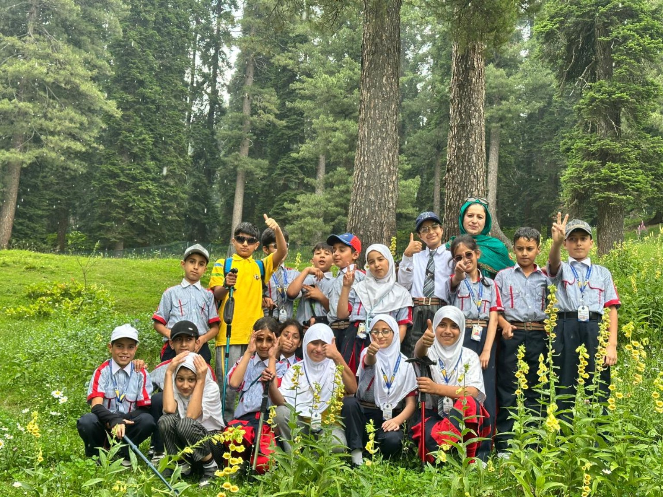
Students and escort teachers during the summer camp.
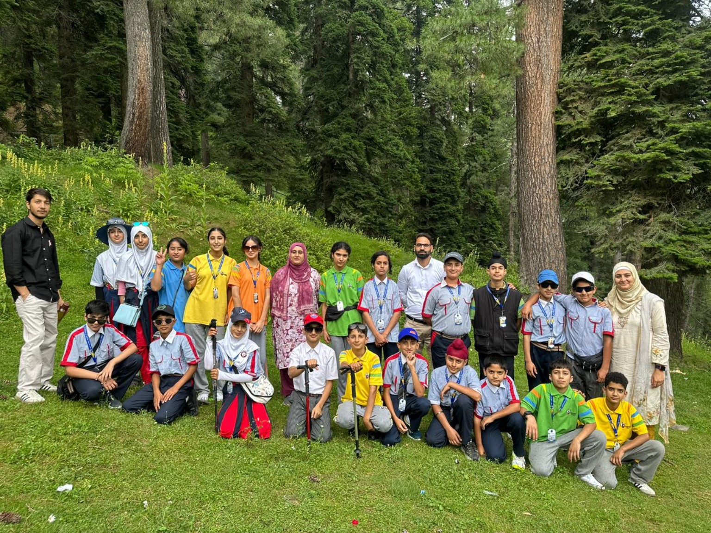
Group photograph amidst the scenic beauty of Gulmarg.
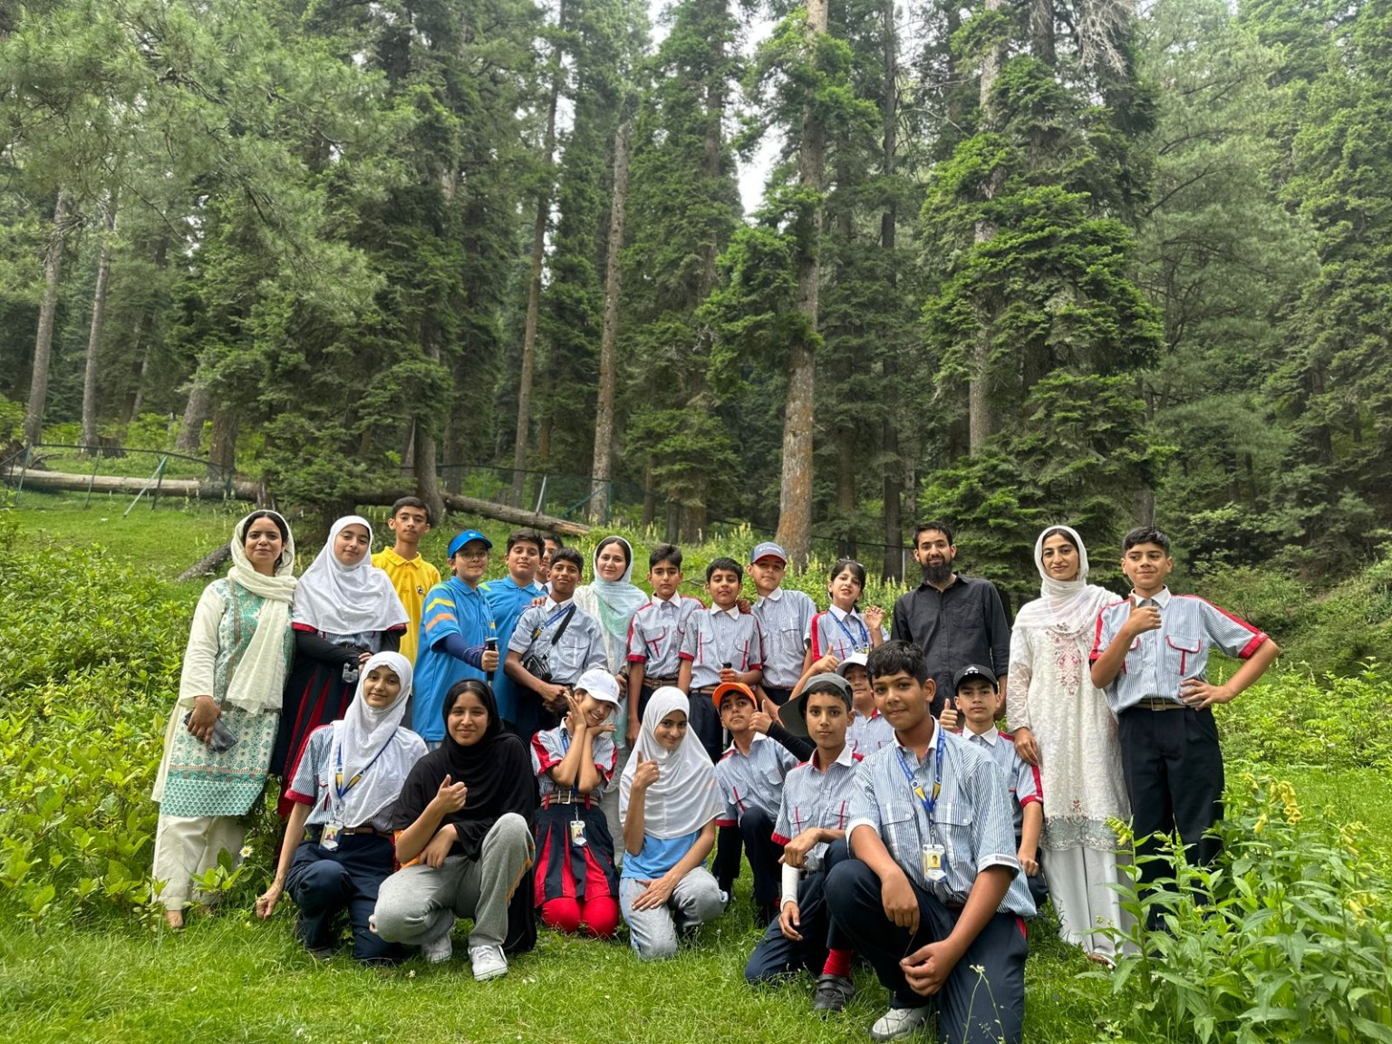

Safety Measures
- Continuous supervision by escort teachers.
- Attendance at every halt and activity point.
- Safety briefing before all outdoor activities.
- Supervised accommodation at the hotel.
- Availability of first-aid support.
- Students remained in groups throughout the tour.

Learning Outcomes
- Improved confidence, teamwork and leadership.
- Developed responsibility and discipline.
- Greater appreciation for nature and environmental conservation.
- Enhanced communication and social interaction.
- Created lasting memories through experiential learning.

Conclusion
The One-Night & Two-Day Summer Camp to Gulmarg was a resounding success, achieving its educational, recreational and developmental objectives. Students experienced learning beyond the classroom by engaging in adventure, teamwork and nature-based activities that strengthened their confidence, independence and problem-solving abilities. The camp also fostered discipline, cooperation, environmental awareness and respect for local culture while enhancing the bond between students and teachers. The meticulous planning, dedicated efforts of the school management, escort staff, drivers and helpers, and the enthusiastic participation of the students ensured the smooth and safe execution of the programme. Overall, the camp proved to be an enriching and memorable experience that contributed significantly to the holistic growth and personality development of every participant.

