RJA-40 Robotic Joint Actuator Module
Design Document • Rev. B • Ayr Robotics • Doc. No. DD-RJA40-B

1. Overview
The RJA-40 is an integrated brushless-motor joint actuator for collaborative robot arms, combining a BLDC motor, a two-stage planetary/harmonic drivetrain, an absolute encoder, and an onboard joint controller in a single module. It is designed for direct EtherCAT or CAN daisy-chaining across a 6- or 7-axis arm.

2. System Architecture
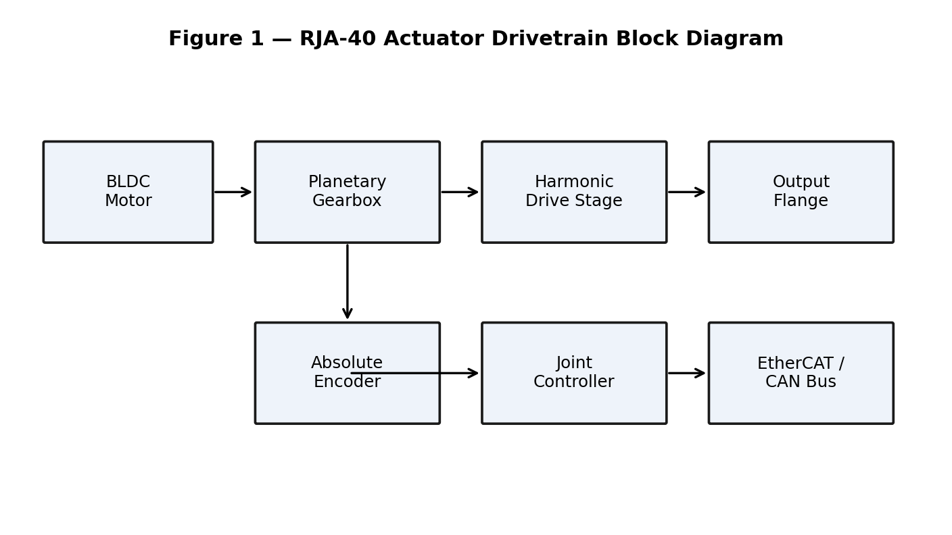
Figure 1 — RJA-40 drivetrain block diagram: motor, gearbox, harmonic drive stage, output flange, encoder feedback, and joint controller.
The absolute encoder reports output-flange position at 16-bit resolution to the joint controller, which closes a local current/velocity/position control loop at 4 kHz and exposes a CiA 402-style profile over EtherCAT or CAN to the arm's central controller.

3. Electrical & Mechanical Specifications
Parameter | Value | Notes
Rated torque | 40 N·m | continuous, output flange
Peak torque | 120 N·m | 1 s max
Gear ratio | 101:1 | planetary + harmonic stages
Rated output speed | 35 rpm | continuous
Operating voltage | 48 V DC | ±10%
Continuous current | 8 A | bus current
Peak current | 22 A | 1 s max
Encoder resolution | 16-bit absolute | output side
Backlash | < 3 arcmin | measured at output flange
Operating temperature | 0 °C to 50 °C | housing surface
Weight | 1.35 kg | module only
Ingress protection | IP54 | shaft seal fitted

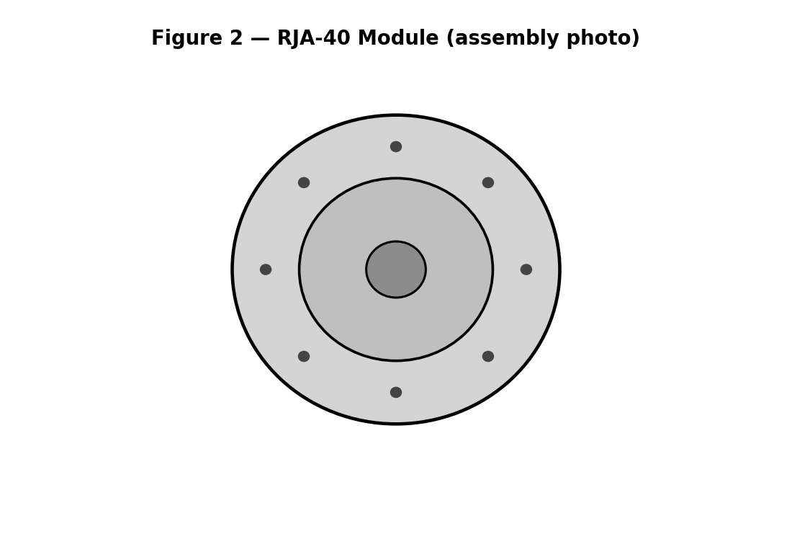
Figure 2 — RJA-40 module, assembled view.

4. Known Limitations
The Rev. B module does not include an integrated torque sensor at the output flange; torque is estimated from motor current, which is less accurate under high-friction or high-backlash conditions. A strain-gauge-based torque sensor is planned for Rev. C.

