E-Commerce Purchase Conversion Analytics
Data Analytics with AI Internship – Capstone Project

1. Executive Summary
This project analyzes online shopping sessions to understand the behavioral signals associated with purchase completion. The objective is to convert session-level data into practical business insights that can support conversion optimization, campaign planning and customer experience decisions.
The UCI dataset contains 12,330 sessions. According to the UCI dataset description, 1,908 sessions ended in a purchase and 10,422 did not, giving an overall purchase conversion rate of 15.47%.

2. Business Problem
E-commerce businesses generate large amounts of session-level behavioral data, but raw activity counts do not directly explain which sessions are more likely to result in a purchase. The project therefore focuses on identifying useful behavioral patterns and translating them into business actions.

3. Objectives
- Measure the overall purchase conversion rate.
- Compare conversion behavior across visitor types.
- Examine monthly and weekday/weekend conversion patterns.
- Study page-value and engagement signals associated with purchase completion.
- Identify traffic and behavioral segments that can support targeted conversion initiatives.
- Present the findings through an interactive dashboard and reproducible Python analysis.

4. Dataset
Dataset: UCI Online Shoppers Purchasing Intention Dataset. It contains 12,330 sessions and 18 attributes, with Revenue as the binary purchase outcome. The dataset has no missing values and is licensed under CC BY 4.0.
Source: UCI Machine Learning Repository — Online Shoppers Purchasing Intention Dataset. DOI: 10.24432/C5F88Q.

5. Key KPI Snapshot

The detailed KPI table is generated by analysis.py and saved to outputs/kpi_summary.csv.
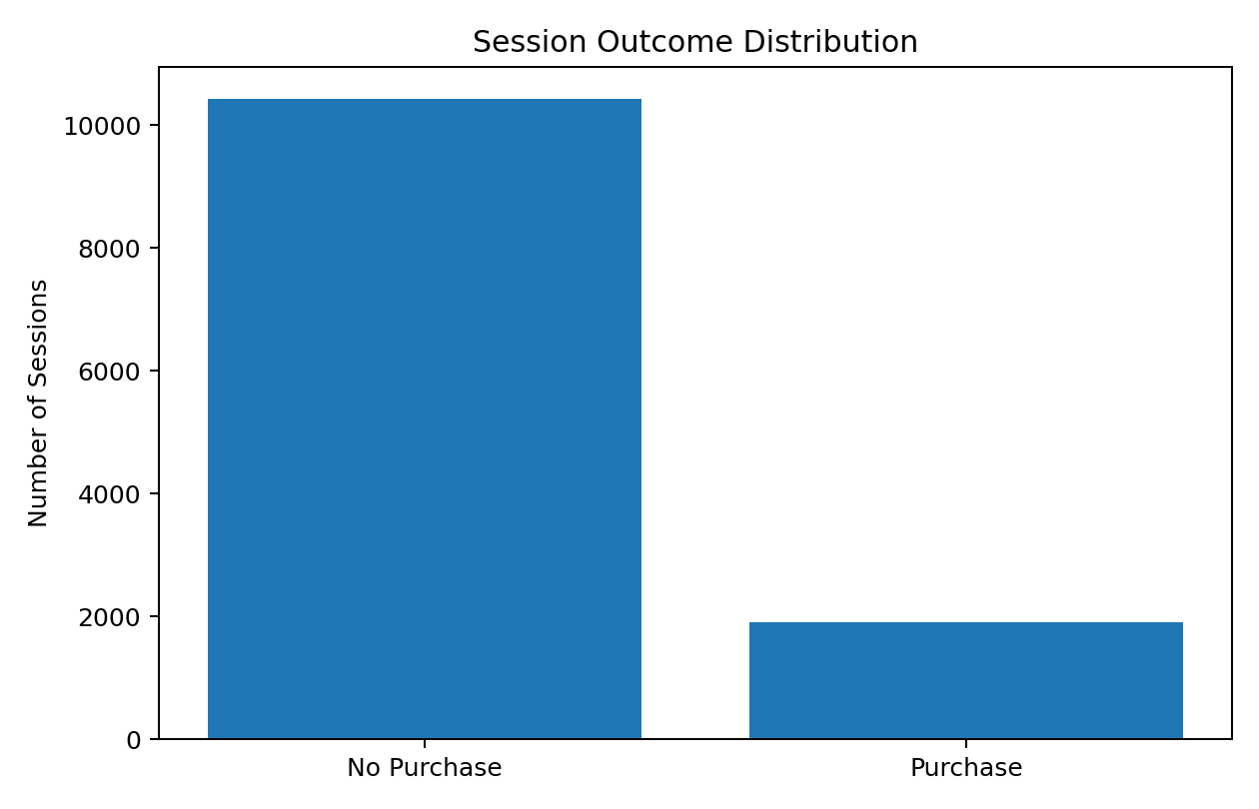
Figure 1. Purchase vs non-purchase session distribution.

6. Analytical Approach
- Load the UCI dataset programmatically using ucimlrepo.
- Standardize boolean purchase and weekend fields.
- Create business-friendly visitor segments.
- Calculate KPI measures and conversion rates.
- Compare conversion by visitor type, month, weekend status, page-value bands, traffic type and exit-rate segments.
- Generate charts and CSV summaries for reproducibility.
- Expose the analysis through an interactive Streamlit dashboard.

7. Dashboard Design
The dashboard is implemented in app.py using Streamlit. It contains KPI cards for sessions, purchases, conversion rate and average page value, followed by conversion comparisons for visitor type, month, weekday/weekend behavior and page-value bands. Filters allow the user to explore visitor type and month.

8. Business Insights Framework
- Acquisition vs retention: compare new and returning visitors to identify where conversion opportunities differ.
- Timing: use month and weekday/weekend patterns to guide campaign timing and operational planning.
- Engagement: use product-related activity and duration as indicators of session engagement.
- Commercial intent: use page-value bands to identify sessions with stronger purchase-related signals.
- Traffic optimization: compare traffic types to identify segments that merit deeper channel analysis.

9. Recommended Actions
- Monitor conversion rate as the main business outcome KPI.
- Create separate conversion strategies for new and returning visitors rather than treating all sessions equally.
- Use high-intent behavioral signals to prioritize conversion-focused experiences.
- Use monthly and weekly patterns when planning campaigns and website resources.
- Review low-conversion traffic sources for landing-page, audience or channel-quality improvements.
- Use the dashboard as a recurring decision-support tool and refresh it when new session data becomes available.

10. Limitations
The dataset represents historical online shopping sessions and does not contain business-specific profit, customer lifetime value or campaign-cost fields. Therefore, the analysis focuses on conversion behavior rather than profitability or return on advertising spend. The project is designed as an analytics and decision-support solution; a predictive model is not required for the core business analysis.

11. Reproducibility and Submission Files
The repository contains analysis.py, app.py, requirements.txt, README.md and the Jupyter notebook. Running analysis.py produces KPI and conversion tables under outputs/. Running app.py launches the interactive dashboard.
Before final submission, run the notebook or analysis.py once and capture the resulting dashboard and charts for the final report screenshots.

12. Conclusion
The project demonstrates a complete business analytics workflow: collecting a suitable dataset, preparing and analyzing session data, measuring conversion, visualizing behavioral patterns, and translating the findings into actions. The implementation is reproducible and can be extended with predictive modeling or additional business data when required.
Dataset reference: Sakar, C. & Kastro, Y. (2018). Online Shoppers Purchasing Intention Dataset. UCI Machine Learning Repository. DOI: 10.24432/C5F88Q.

