**Daniel Rodríguez Gamboa**

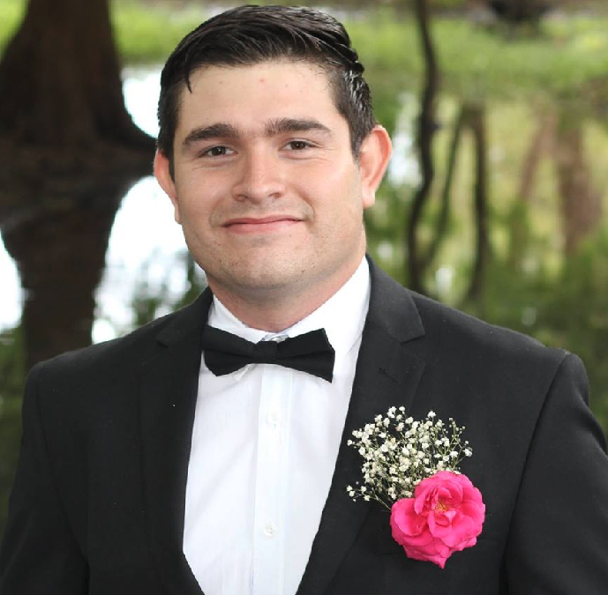**Contact information:**

Mobile number: +52(614) 395-27-95

Phone: +52(614) 388-21-34

E-mail: [danygamboar4@gmail.com](mailto:danygamboar4@gmail.com)

GitLab: <https://gitlab.com/Danielpok>

**Professional summary:**

I am a developer focused on web development with a goal of learning new technologies to grow my knowledge. As a professional I am a person who follows directions, I like to work as a team being an effective contributor to the project and give ideas to solve problems, customer satisfaction is my highest priority so my effort is to deliver a final product that meets the agreed specifications.

**Education:**

Instituto Tecnológico de Chihuahua II, Chihuahua, Chi. México.

**Work History:**

Aug, 2019 - Current **Avance y tecnología en plásticos / Full Stack Developer**

|>Migration of a POS system created in PHP to .Net Core MVC, in which the response time has been reduced by up to 80%, making the sales process more efficient.

|>Implementation of automation scripts to the credit and collection process, speeding up the process and improving customer service.

|> PHP POS application with Microsoft Dynamics 365.

|> Development of new software modules for multiple area needs.

|> Connection with API’S and WEB SERVICES.

|> Version control implementation with GIT with development flow.

|> Process automation with .Net Core console apps.

|> Automation of the selling process with Santander WEB PAY and generation of payment links with automatic conciliations.

|> Development of parcels management system, with connection to the point of sale and the Microsoft Dynamics ERP system, being implemented in the 22 branches of the company

Jan, 2019 – Jul, 2019 **Aurom / Full Stack Developer**  |>Development of IN HOUSE ERP system.

|>Implementation and standardization of the version control flow with GIT.

|>Development and implementation of Human Resources, Finance and Accounting, Logistics and Refunds modules.

|>Implementation of the system to production environment and replacement of previously used system, as well as the training.

|>Use of MVC framework Codeigniter PHP.

Jan, 2017 – Dec, 2018 **Edukscan / Technical partner (Chihuahua, Chih.)**

|>Technical consultant.

|>Frontend Developer on web and mobile app.

|>Linux web server administrator (VPS Linode).

As a technical partner I participated in the selection of the application infrastructure as well as the technologies and libraries used. I was in charge on the management and the activities to create the UX of both applications.

2015 – 2018 **Personal Projects**

|>Android game using Phaser 3 and Cordova. (2018)

|>Hackatón AgroHacks ITESM with Kuwí. (2016)

|>Hackatón Centro Fox Web Autoempleo. (2016)

|>Hackatón Auditoria Superior. (2015)

|>Hackatón HackCUU with Neuron (2015)

**Programming languages:**

* PHP
* C#
* JavaScript

**WEB Technologies:**

* HTML 5
* CSS
* Jquery + Ajax

**Frontend and Backend Frameworks:**

* Twitter Bootstrap
* Materialize CSS
* Razor Pages (.Net Core)
* .Net Core
* Zend 2 (PHP)
* Codeigniter (PHP)
* NodeJs (Javascript)

# DB-Engines:

* MySQL, MariaDB
* MS SQL Server
* PostgreSQL

**OS:**

* Linux (Advance User) Debian Based Distros
* Microsoft Windows

**IDE’s:**

* Microsoft Visual Studio 2019
* Atom(Text Editor)
* Visual Studio Code (Text Editor)

**Version Control:**

* GIT (GitHub, GitLab)