**COMPUTING APTITUDE**

**Student Name:** Ayushi Aggarwal **UID:** 21MCA2806

**Branch:** MCA  **Section/Group:**8B

**Semester:** II Sem **Date of Performance:**07 Mar’2022

**Subject Name:** Computing Aptitude  **Subject Code:** 654

1. **Aim/Overview of the practical:**

**Experiment 1.1.1**

You are provided an array A of size N that contains non-negative integers. Your task is to determine whether the number that is formed by selecting the last digit of all the N numbers is divisible by 10.

Note: View the sample explanation section for more clarification.

Input format

• First line: A single integer N denoting the size of array A

• Second line: N space-separated integers.

Output format

If the number is divisible by 10, then print Yes. Otherwise, print No.

Constraints

1≤N≤1050≤A[i]≤105

**Experiment 1.1.2**

A bracket sequence is a string that contains only characters '(' and ')'. A correct bracket sequence is a bracket sequence that can be transformed into a correct arithmetic expression by inserting characters '1' and '+' between the original characters of the sequence. For example, bracket sequences '()()' and '(())' are correct. The resulting expressions of these sequences are: '(1)+(1)' and '((1+1)+1)'. However, '(', ')(', and '(' are incorrect bracket sequences.

You are given a bracket sequence s(s1s2……sn) , where denotes the type of 's bracket (open or close). It is not mandatory that s is necessarily correct. Your task is to determine the number of 's such that si si+1… sn s1 s2…si-1 is a correct bracket sequence.

Input format

K The single line contains sequence s.

Output format

Print the number of shifts denoting the correct bracket sequence.

Constraints

|s|<=5*105

**Experiment 1.1.3**

You are given 2 arrays A and B, each of the size N. Each element of these arrays is either a positive integer or -1. The total number of -1s that can appear over these 2 arrays are >=1 and <=2.

Now, you need to find the number of ways in which we can replace each -1 with a non-negative integer, such that the sum of both of these arrays is equal.

Input format

First line: An integer N

Second line: N space-separated integers, where the of these denotes A[i]

Third line: N space-separated integers, where the ith of these denotes B[i]

Output format

If there exists a finite number X, then print it. If the answer is not a finite integer, then print 'Infinite'.

Constraints

1<= N <= 105

-1<=A[i], b[i] <= 109

The -1’s may spread out among both arrays, and their quantity is between 1 and 2 (both inclusive)

1. **Task to be done:**

**Experiment:1.1.1:**

#include<stdio.h>

int main()

{

int n,a[100],sum=0;

printf("Enter Size of an Array:");

scanf("%d",&n);

printf("enter elements of an array:");

for(int i=0;i<n;i++)

{

scanf("%d",&a[i]);

}

for(int i=0;i<n;i++)

{

int rem=a[i]%10;

sum=sum*10+rem;

}

printf("sum:%d\n",sum);

if(sum%10==0)

{

printf("%d Divisible by 10",sum);

}

else

{

printf("%d Not Divisible by 10",sum);

}

return 0;

}

**Experiment:1.1.2:**

#include<stdio.h>

#include <string.h>

#include<stdbool.h>

char stack[100001];

int top = -1;

void push(char x)

{

top++;

/* if(top == n)

{

//printf("Stack overflows");

return;

}*/

stack[top] = x;

}

void pop()

{

if(top == -1)

{

//printf("No element to pop..");

return;

}

top--;

}

bool isEmpty()

{

if(top == -1)

return true;

else

return false;

}

bool isBalanced(char s[100001], int n, int i)

{

for(int j=i;j<i+n;j++)

{

if(s[j%n]=='(')

push('(');

else

if(s[j%n]==')' && isEmpty()== false)

pop(); // for ) bracket

else

{

return false;

}

}

if(isEmpty() == true) return true;

return false;

}

void main()

{

char s[100001];

gets(s);

int n = strlen(s);

int ans=0;

for(int i=0;i<n;i++)

{

int c=0;

if(s[i]=='(') // run only when first bracket = '('

{

if(isBalanced(s,n,i) == true) // if correct seq then only increasing ans

{

//printf("Hello ");

ans++;

}

}

}

printf("Ans : %d",ans);

}

**Experiment:1.1.3:**

#include <stdio.h>

int mod(int x)

{

if(x<0) return -1*x;

return x;

}

int main()

{

int n;

printf("Enter the size of an array:");

scanf("%d", &n);

int a[n],b[n];

int freq1=0, freq2=0;

int sum1=0, sum2=0;

printf("enter the element of 1st array:");

for(int i=0;i<n;i++)

{

scanf("%d",&a[i]);

}

printf("enter the element of 2nd array:");

for(int i=0;i<n;i++)

{

scanf("%d",&b[i]);

}

for(int i=0;i<n;i++)

{

if(a[i] == -1)

freq1++;

else

sum1+=a[i];

if(b[i] == -1)

freq2++;

else

sum2+=b[i];

}

if(freq1>0 && freq2>0)

{

printf("Infinite");

}

else

if( (freq1==1 && freq2==0 && sum1<sum2) || (freq1==0 && freq2==1 && sum1>sum2))

{

printf("1");

}

else

if((freq1>=1 && freq2==0 && sum1>sum2) || (freq1==0 && freq2>=1 && sum1<sum2))

{

printf("0");

}

else

{

printf("%d",mod(sum2-sum1) +1);

}

return 0;

}

1. **Result/Output/Writing Summary:**

**Experiment:1.1.1:**

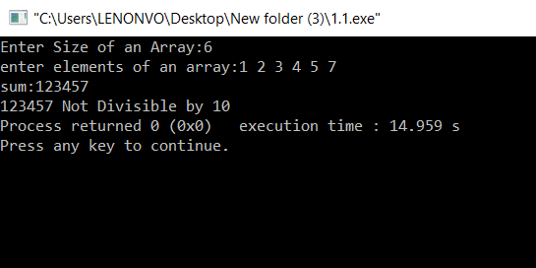

**Experiment:1.1.2:**

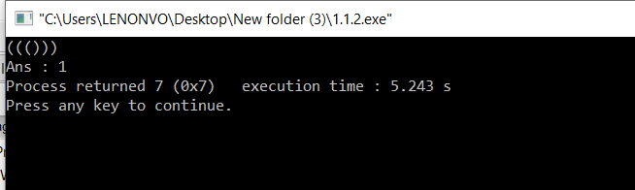

**Experiment:1.1.3:**

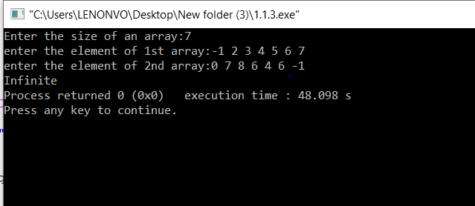

**Learning outcomes (What I have learnt):**

**1. Learnt about array and conditional statement.**

**2. Learnt about stack**

**3. Learnt about string.**

**Evaluation Grid:**

|  |  |  |  |
| --- | --- | --- | --- |
| Sr. No. | Parameters | Marks Obtained | Maximum Marks |
| 1. | Worksheet |  | 10 |
| 2. | Demonstration/Performance /Pre Lab Quiz |  | 5 |
| 3. | Post Lab Quiz |  | 5 |