Experiment: 1.2

# Student Name: Ayushi Aggarwal UID:21MCA2806

**Branch: MCA Section/Group:21MCA/8B**

**Semester: 2nd Date of Performance:07-03-2022**

**Subject Name: Computing Aptitude Subject Code:21CAP654**

1. **Aim/Overview of the practical:**

Program of n-participants problem and seven segment display problem.

# Task to be done:

## Experiment 1.2.1

You are conducting a contest at your college. This contest consists of two problems and n participants. You know the problem that a candidate will solve during the contest.

You provide a balloon to a participant after he or she solves a problem. There are only green and purple-coloured balloons available in a market. Each problem must have a balloon associated with it as a prize for solving that specific problem. You can distribute balloons to each participant by performing the following operation:

* 1. Use green-coloured balloons for the first problem and purple-coloured balloons for the second problem
  2. Use purple-coloured balloons for the first problem and green-coloured balloons for the second problem

You are given the cost of each balloon and problems that each participant solve. Your task is to print the minimum price that you have to pay while purchasing balloons.

Input format

* First line: T that denotes the number of test cases (1<= T <=10)
* For each test case:

First line: Cost of green and purple-coloured balloons

Second line: n that denotes the number of participants (1 <= n <=10)

Next n lines: Contain the status of users. For example, if the value of the jth integer in the ith row is 0, then it depicts that the ith participant has not solved the problem. Similarly, if the value of the jth integer in the ith row is 1, then it depicts that the ith participant has solved the jth problem.

Output format

For each test case, print the minimum cost that you have to pay to purchase balloons.

## Experiment 1.2.1

You all must have seen a seven-segment display. If not here it is:

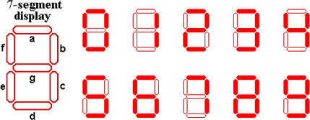

Alice got a number written in seven segment formats where each segment was created used a matchstick.

Example: If Alice gets a number 123 so basically Alice used 12 matchsticks for this number.

Alice is wondering what is the numerically largest value that she can generate by using at most the matchsticks that she currently possesses. Help Alice out by telling her that number.

Input Format:

First line contains T (test cases). Next T lines contain a Number N. Output Format:

Print the largest possible number numerically that can be generated using at max that many number of matchsticks which was used to generate N.

Constraints:

1<=T<=100

1<=length(N)<=100

# Steps/Commands involved to perform practical: Experiment 1.2.1:

#include<iostream> using namespace std; int main()

{

int t,n,g,p,a[10][2],sum1,sum2,ans; cin>>t;

for(int i=0;i<t;i++)

{

sum1=sum2=0; cin>>g>>p>>n; for(int j=0;j<n;j++)

{

for(int k=0;k<2;k++) cin>>a[j][k];

}

for(int j=0;j<n;j++)

{

if(a[j][0]==1)

sum1=sum1+g; if(a[j][1]==1)

sum1=sum1+p;

}

for(int j=0;j<n;j++)

{

if(a[j][0]==1)

sum2=sum2+p; if(a[j][1]==1)

sum2=sum2+g;

}

ans=sum1>sum2?sum2:sum1; cout<<ans<<endl;

}

}

**Experiment 1.2.2:** #include<iostream> using namespace std; int main()

{

int T; cin >> T;

string str; int t =0;

while( t != T){ cin >> str; t++;

int arr[10] = {6,2,5,5,4,5,6,3,7,6};

int m = str.size(); int a[m];

for(int i = 0; i<m; i++){ a[i] = str[i] - '0';

}

int sum = 0;

for( int i = 0; i<m; i++){ sum += arr[a[i]];

}

while(sum != 0){

if(sum%2 != 0){

sum -= 3;

cout << 7;

}

else{

sum -= 2;

cout << 1;

}

}

cout << endl;

}

}

* 1. **Result/Output/Writing Summary: Output Experiment 1.2.1:**

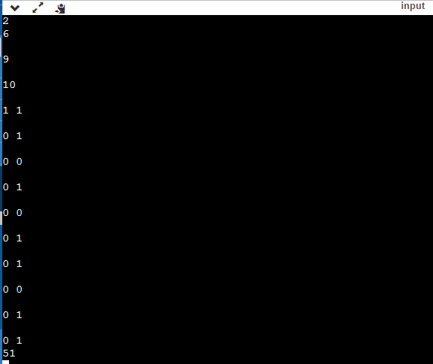

**Output Experiment 1.2.2:**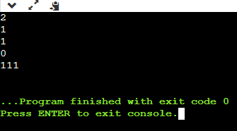



**Learning outcomes (What I have learnt): 1.Learn about Cost of Balloon Problem.**

**2.Learn About Seven Segment Display Problem.**

## Evaluation Grid:

|  |  |  |  |
| --- | --- | --- | --- |
| Sr. No. | Parameters | Marks Obtained | Maximum Marks |
| 1. | Worksheet |  | 10 |
| 2. | Demonstration/Performance  /Pre Lab Quiz |  | 5 |
| 3. | Post Lab Quiz |  | 5 |