**Experiment No 2.3**

**Student Name: Ayushi Aggarwal UID: 21MCA2806**

**Branch: MCA Section/Group: 8B**

**Semester: 2nd Date of Performance: 23-03-2022**

**Subject Name: Computing Aptitude Subject Code: 21CAP-654**

1. **Aim/Overview of the practical:**
2. **Task to be done:**

A book shop maintains the inventory of books that are being sold at the shop. The list includes details such as author, . If it is not, an appropriate message is displayed. If it is, then the system displays the book details and requests for the number of copies required. If the requested copies book details and requests for the number of copies required. If the requested copies are available, the total cost of the requested copies is displayed; otherwise, the message “Required copies not in stock” is displayed. title, price, publisher and stock position. Whenever a customer wants a book, the sales person inputs the title and author and the system searches the list and displays whether it is available or not

Design a system using a class called books with suitable member functions and Constructors. Use new operator in constructors to allocate memory space required. Implement C++ program for the system.

1. **Code for experiment/practical:**

#include<iostream>

#include<string.h>

#include<stdlib.h>

using namespace std;

class book {

private:

char *author,*title,*publisher;

float *price;

int *stock;

public:

book() {

author= new char[20];

title=new char[20];

publisher=new char[20];

price= new float;

stock=new int;

}

void feeddata();

void editdata();

void showdata();

int search(char[],char[]);

void buybook();

};

void book::feeddata() {

cin.ignore();

cout<<"\nEnter Author Name: "; cin.getline(author,20);

cout<<"Enter Title Name: "; cin.getline(title,20);

cout<<"Enter Publisher Name: "; cin.getline(publisher,20);

cout<<"Enter Price: "; cin>>*price;

cout<<"Enter Stock Position: "; cin>>*stock;

}

void book::editdata() {

cout<<"\nEnter Author Name: "; cin.getline(author,20);

cout<<"Enter Title Name: "; cin.getline(title,20);

cout<<"Enter Publisher Name: "; cin.getline(publisher,20);

cout<<"Enter Price: "; cin>>*price;

cout<<"Enter Stock Position: "; cin>>*stock;

}

void book::showdata() {

cout<<"\nAuthor Name: "<<author;

cout<<"\nTitle Name: "<<title;

cout<<"\nPublisher Name: "<<publisher;

cout<<"\nPrice: "<<*price;

cout<<"\nStock Position: "<<*stock;

}

int book::search(char tbuy[20],char abuy[20] ) {

if(strcmp(tbuy,title)==0 && strcmp(abuy,author)==0)

return 1;

else return 0;

}

void book::buybook() {

int count;

cout<<"\nEnter Number Of Books to buy: ";

cin>>count;

if(count<=*stock) {

*stock=*stock-count;

cout<<"\nBooks Bought Sucessfully";

cout<<"\nAmount: Rs. "<<(*price)*count;

}

else

cout<<"\nRequired Copies not in Stock";

}

int main() {

book *B[20];

int i=0,r,t,choice;

char titlebuy[20],authorbuy[20];

while(1) {

cout<<"\n\n\t\tMENU"

<<"\n1. Entry of New Book"

<<"\n2. Buy Book"

<<"\n3. Search For Book"

<<"\n4. Edit Details Of Book"

<<"\n5. Exit"

<<"\n\nEnter your Choice: ";

cin>>choice;

switch(choice) {

case 1: B[i] = new book;

B[i]->feeddata();

i++; break;

case 2: cin.ignore();

cout<<"\nEnter Title Of Book: "; cin.getline(titlebuy,20);

cout<<"Enter Author Of Book: "; cin.getline(authorbuy,20);

for(t=0;t<i;t++) {

if(B[t]->search(titlebuy,authorbuy)) {

B[t]->buybook();

break;

}

}

if(t==1)

cout<<"\nThis Book is Not in Stock";

break;

case 3: cin.ignore();

cout<<"\nEnter Title Of Book: "; cin.getline(titlebuy,20);

cout<<"Enter Author Of Book: "; cin.getline(authorbuy,20);

for(t=0;t<i;t++) {

if(B[t]->search(titlebuy,authorbuy)) {

cout<<"\nBook Found Successfully";

B[t]->showdata();

break;

}

}

if(t==i)

cout<<"\nThis Book is Not in Stock";

break;

case 4: cin.ignore();

cout<<"\nEnter Title Of Book: "; cin.getline(titlebuy,20);

cout<<"Enter Author Of Book: "; cin.getline(authorbuy,20);

for(t=0;t<i;t++) {

if(B[t]->search(titlebuy,authorbuy)) {

cout<<"\nBook Found Successfully";

B[t]->editdata();

break;

}

}

if(t==i)

cout<<"\nThis Book is Not in Stock";

break;

case 5: exit(0);

default: cout<<"\nInvalid Choice Entered";

}

}

return 0;

}

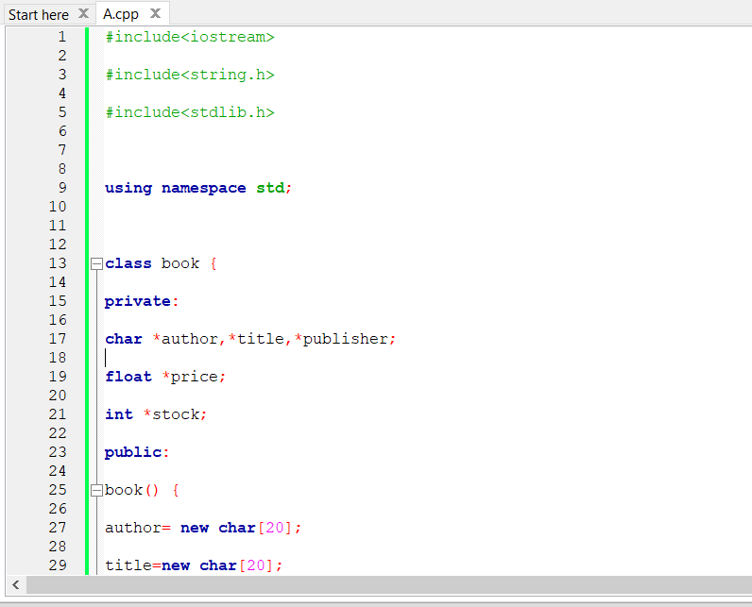

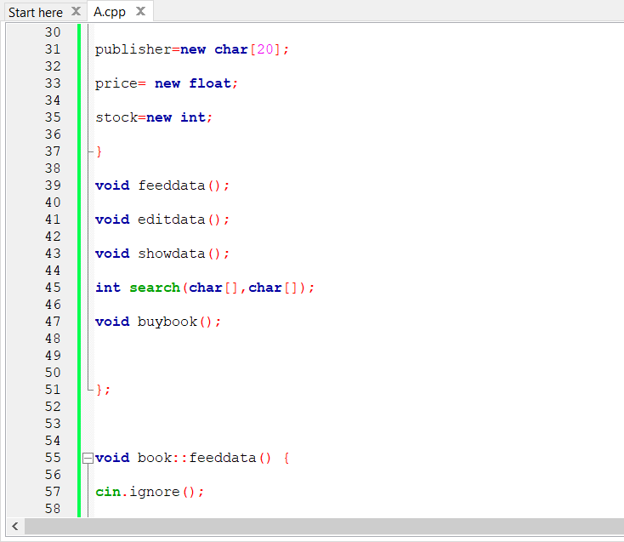

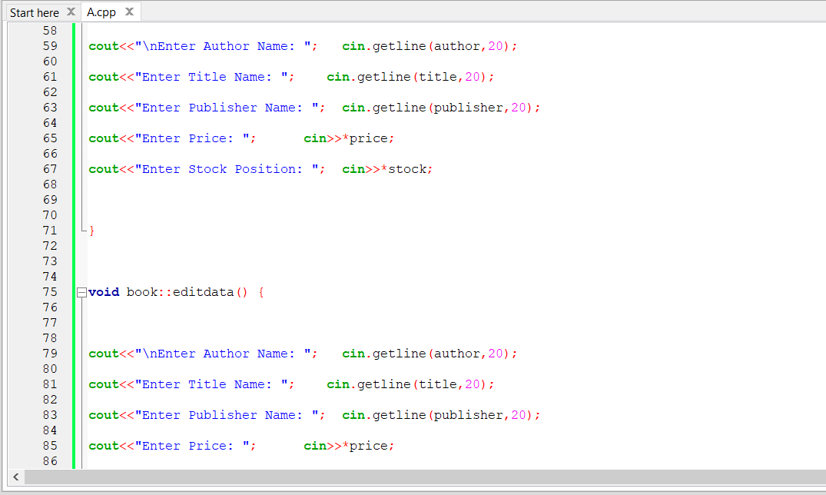

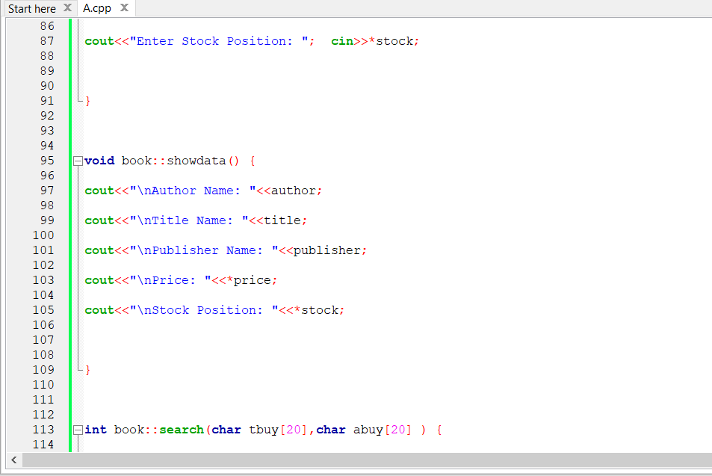

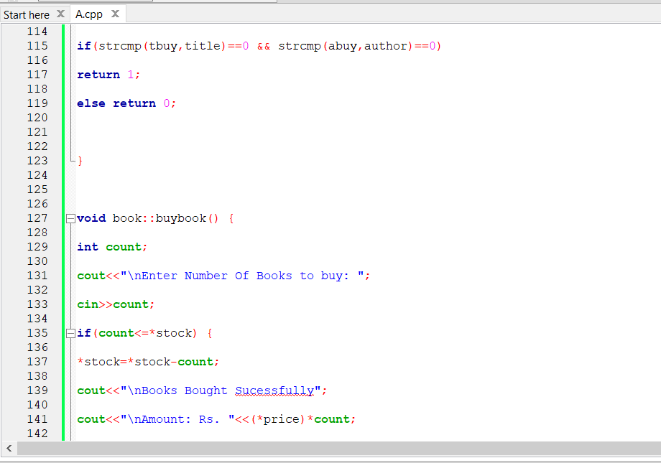

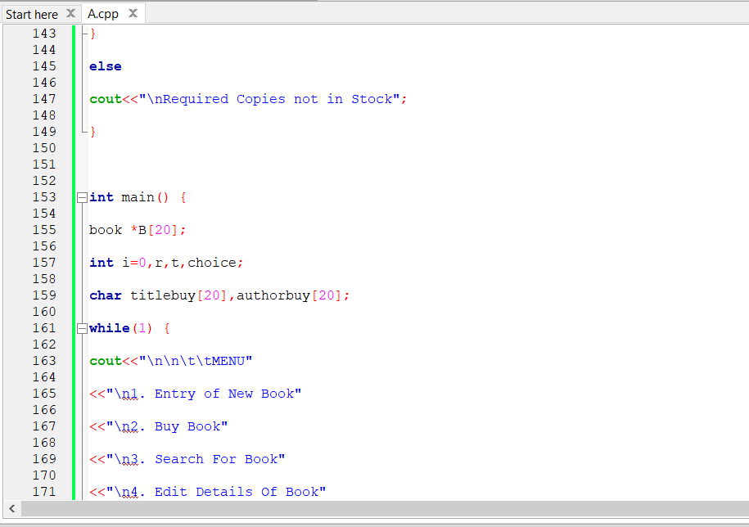

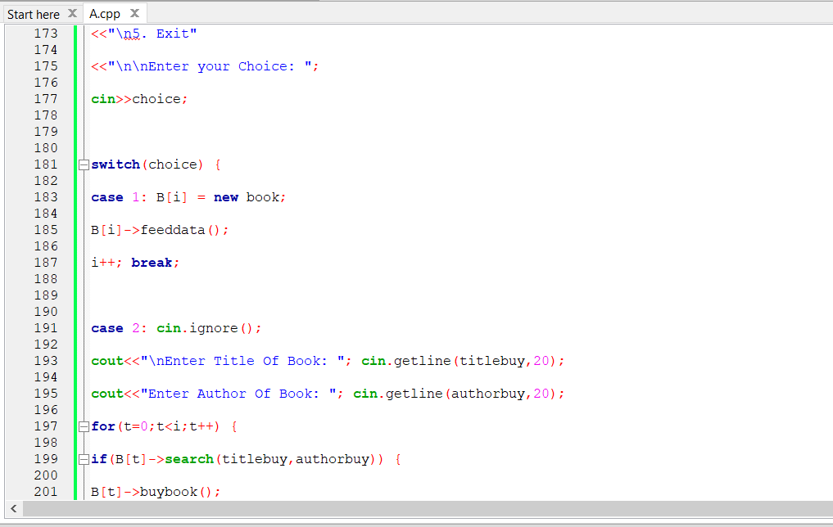

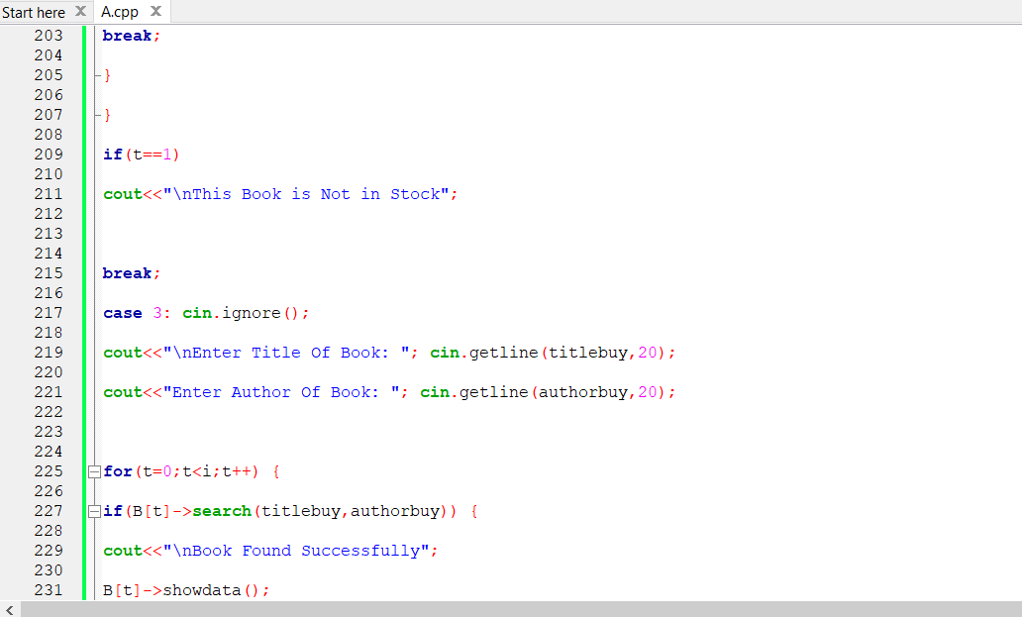

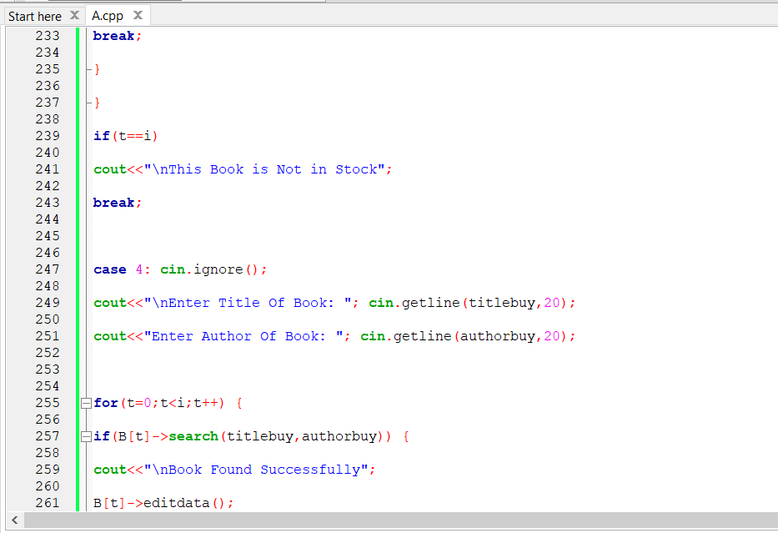

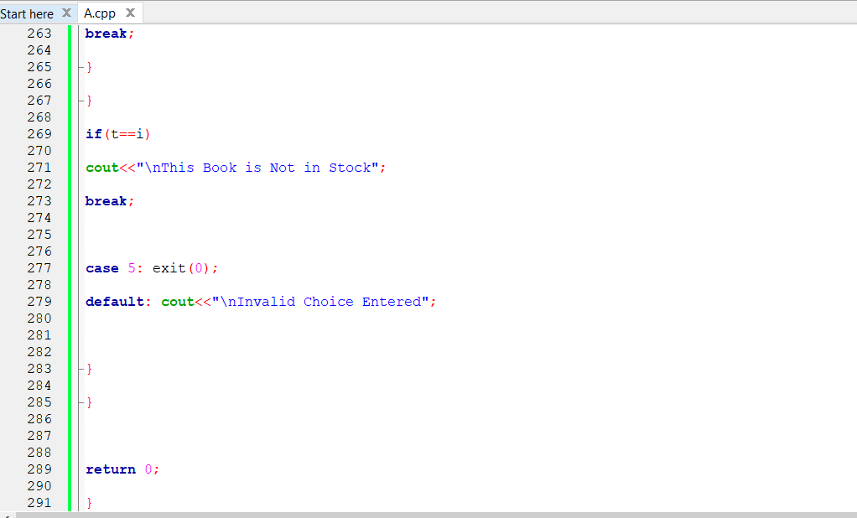

1. **Result/Output/Writing Summary:**

**Output: -**

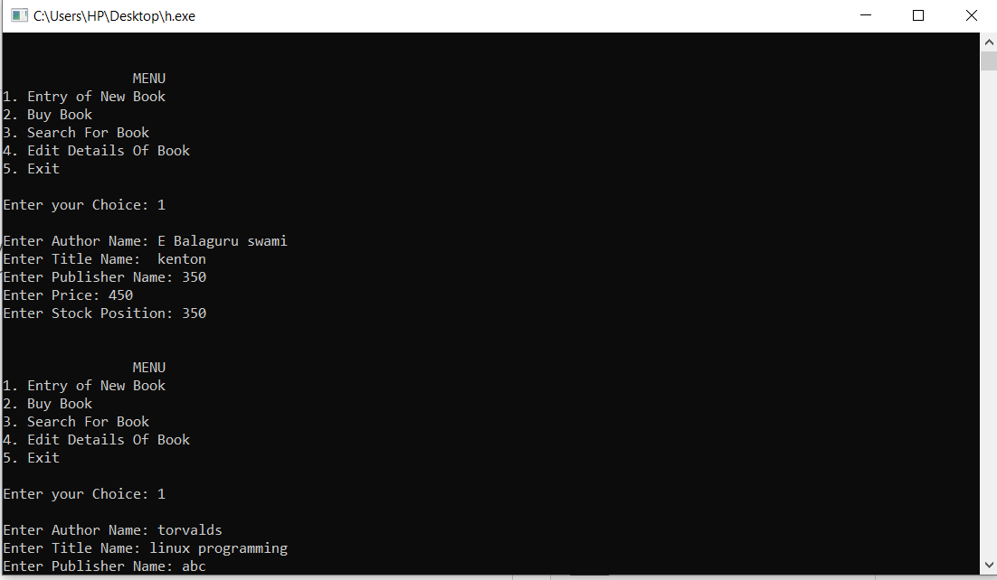

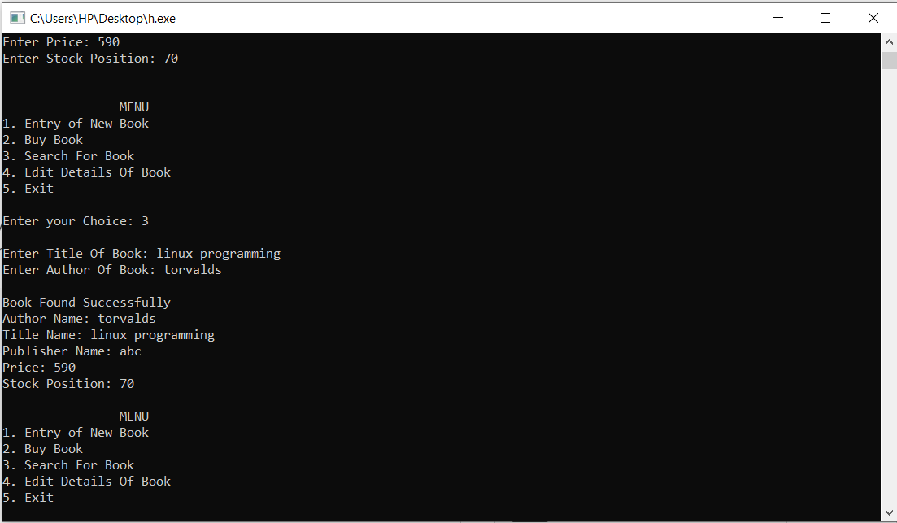

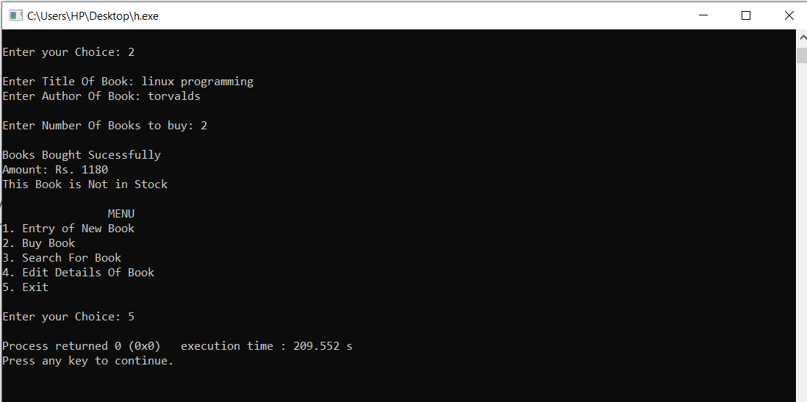

**Evaluation Grid:**

|  |  |  |  |
| --- | --- | --- | --- |
| Sr. No. | Parameters | Marks Obtained | Maximum Marks |
| 1. | Demonstration and Performance |  | 5 |
| 2. | Worksheet |  | 10 |
| 3. | Post Lab Quiz |  | 5 |