**Experiment 2.1**

**Student Name: Ayushi Aggarwal UID:21MCA2806**

**Branch: MCA Section/Group8B**

**Semester: 2ND Date of Performance:14-03-2022**

**Subject Name: Computing Aptitude Subject Code:21CAP-654**

1. **Aim/Overview of the practical: Apply the concept of c++**

**Task to be done:**

**1.** Consider an array A of size N. You start from the index 0 and your goal is to reach index N-1 in exactly M moves.

At any index, you can move forward or backward by a number of steps that is equal to a prime divisor of the value which exists at that index. You cannot go beyond the array while going forward or backward.

Write a program to determine whether it is possible to reach index N-1 in M moves.

Input format

First line: T (number of test cases)

First line in each test case: N

Second line in each test case: N space-separated integers (denoting the array A)

Third line in each test case: M

Output format

For each test case, print YES or NO depending upon the result.

Constraints

1<= T <=10

2<= N <=20

1<= A[i] <=106

1<= M <=106

**2.**

Alice has the following two types of taxis:

* Online taxi: It can be booked by using an online application from phones
* Classic taxi: It can be booked anywhere on the road

The online taxis cost Oc for the first Of km and Od for every km afterward. The classic taxis travel at a speed of Cs km per minute. The cost of classic taxis are Cb, Cm, and Cdthat represents the base fare, costfor every minute that is spent in the taxi, and cost for each kilometer that you ride.

You are going to the office from your home. Your task is to minimize the cost that you are required to pay. The distance from your home to the office is D. You are required to select whether you want to use online or classic taxis to go to your office. If both the taxis cost the same, then you must use an online taxi.

Input format

* First line: Single integer D that denotes the distance from your house to the office
* Next line: Three integers Oc*,*Of, andOd
* Next line: Four integers Cs, Cb, Cm, and Cd

Output format

If you select an online taxi to travel, then print a string 'Online Taxi'. Otherwise, select 'Classic Taxi'. You can print this string in a new, single line.

Constraints

1 ≤ D, Oc, Of, Od, Cs, Cb, Cm, Cd ≤ 109

1. **Steps/Commands involved to perform practical:**

**1.** #include<iostream>

#include<bits/stdc++.h>

using namespace std;

typedef long long int ll;

int primes[] = {2,3,5,7,11,13,17,19,23,29,31,37};

bool solve(ll a[], ll start, ll moves, ll target){

if( moves == 0 && start == target){

return true;

}

else if( moves == 0 && start != target)

{

return false;

}

if(start < 0 || start > target){

return false;

}

else{

for(int i = 0; i < 12; i++){

if(a[start] % primes[i] == 0){

return (solve(a, start + primes[i], moves - 1, target) || solve(a, start - primes[i], moves - 1, target));

}

}

}

return false;

}

int main(){

int t;

cin >> t;

while(t--){

ll size;

ll i;

cin >> size;

ll a[size];

for(i = 0; i < size; i++){

cin >> a[i];

}

ll m;

cin >> m;

if(solve(a, 0, m, size-1)){

cout << "YES" << endl;

}

else{

cout << "NO" << endl;

}

}

return 0;

}

2. #include<stdio.h>

int main()

{

long long int d,oc,of,od,cs,cb,cm,cd;

long long int cost1,cost2;

scanf("%lld",&d);

scanf("%lld %lld %lld",&oc,&of,&od);

scanf("%lld %lld %lld %lld",&cs,&cb,&cm,&cd);

cost1=oc+((d-of)*od);

cost2=cb+((d/cs)*cm)+(d*cd);

if(cost1<cost2||cost1==cost2)

printf("Online Taxi");

else

printf("Classic Taxi");

return 0;

}

1. **Result/Output/Writing Summary:**

**1.**

.

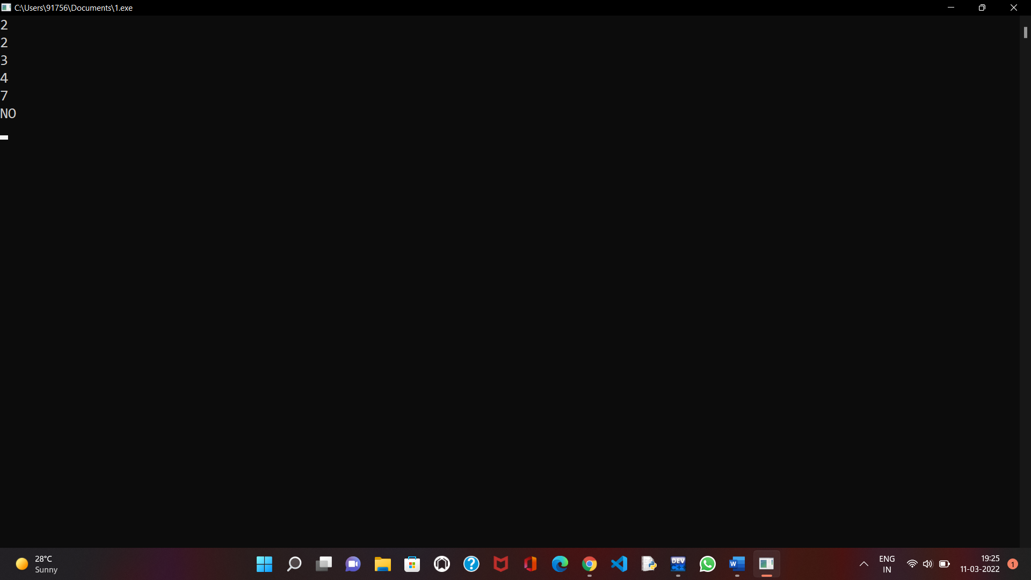

**2.**

