BlazeDemo Flight Booking

Prepared By: Ayush Sharma
Github: https://github.com/AYUSH-YL/Capstone_project
Site: https://blazedemo.com/reserve.php

Defect – 1
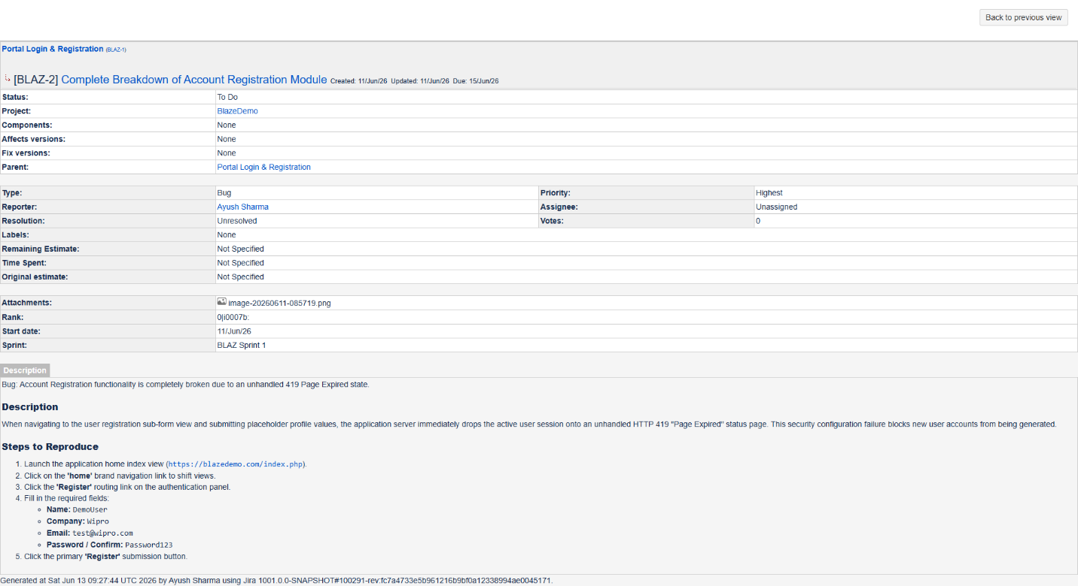

Defect – 2
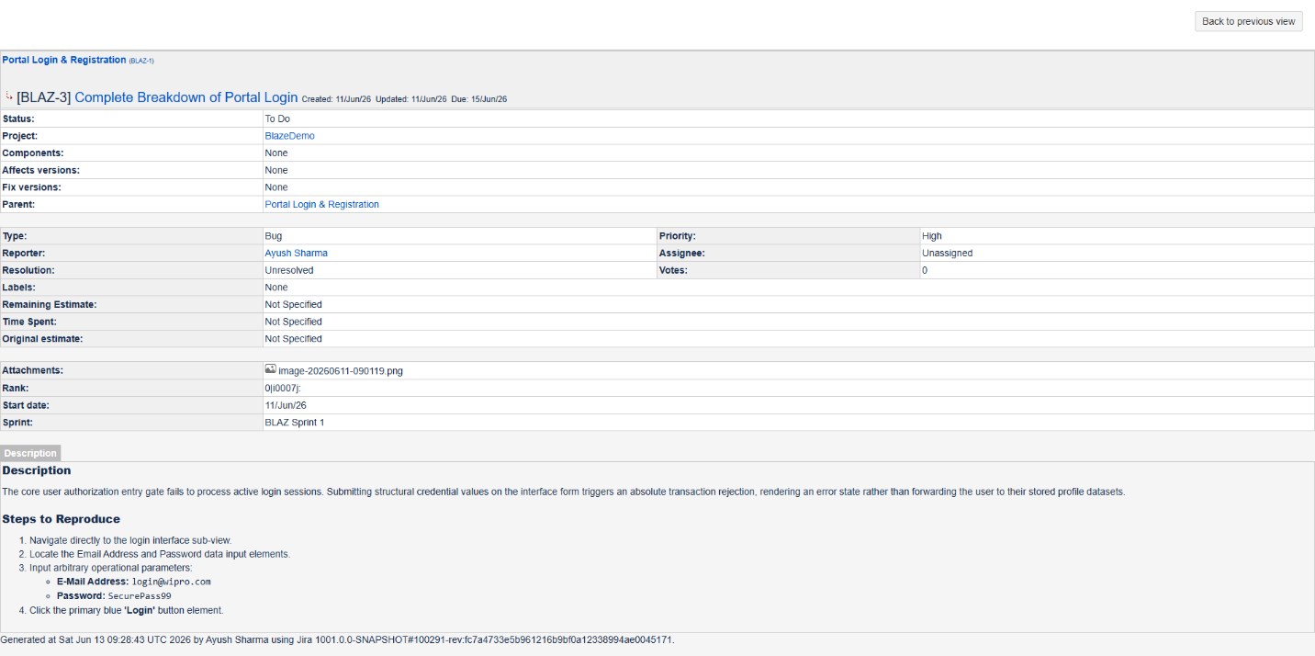

Defect – 3
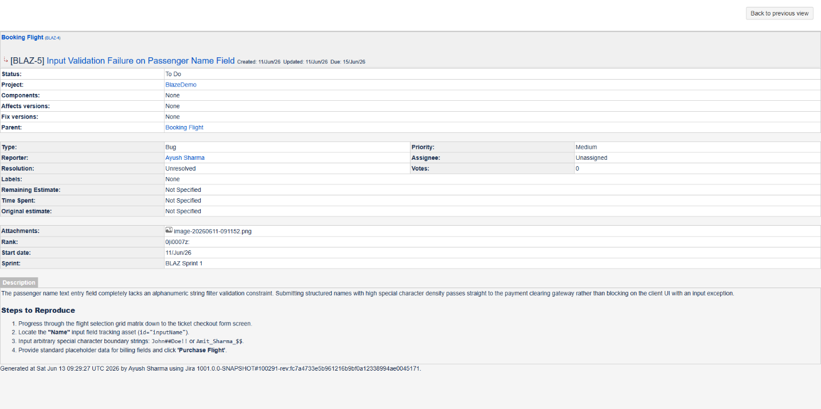

Defect – 4
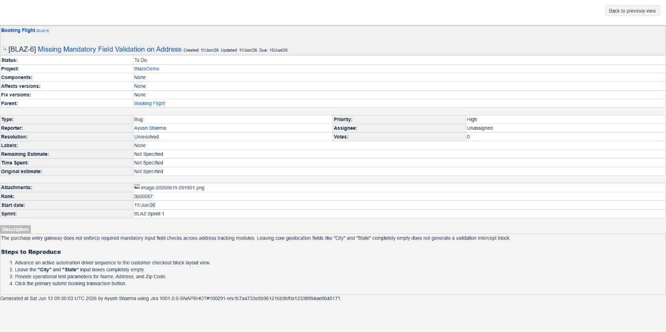

Defect – 5
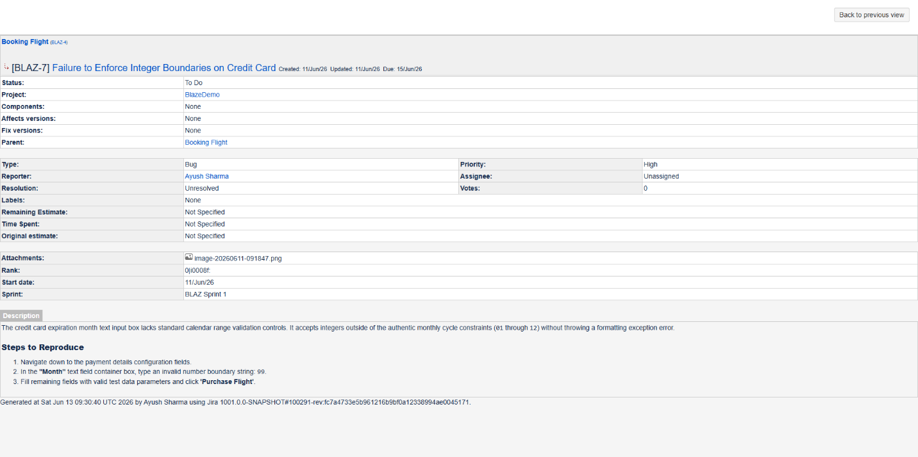

Defect – 6
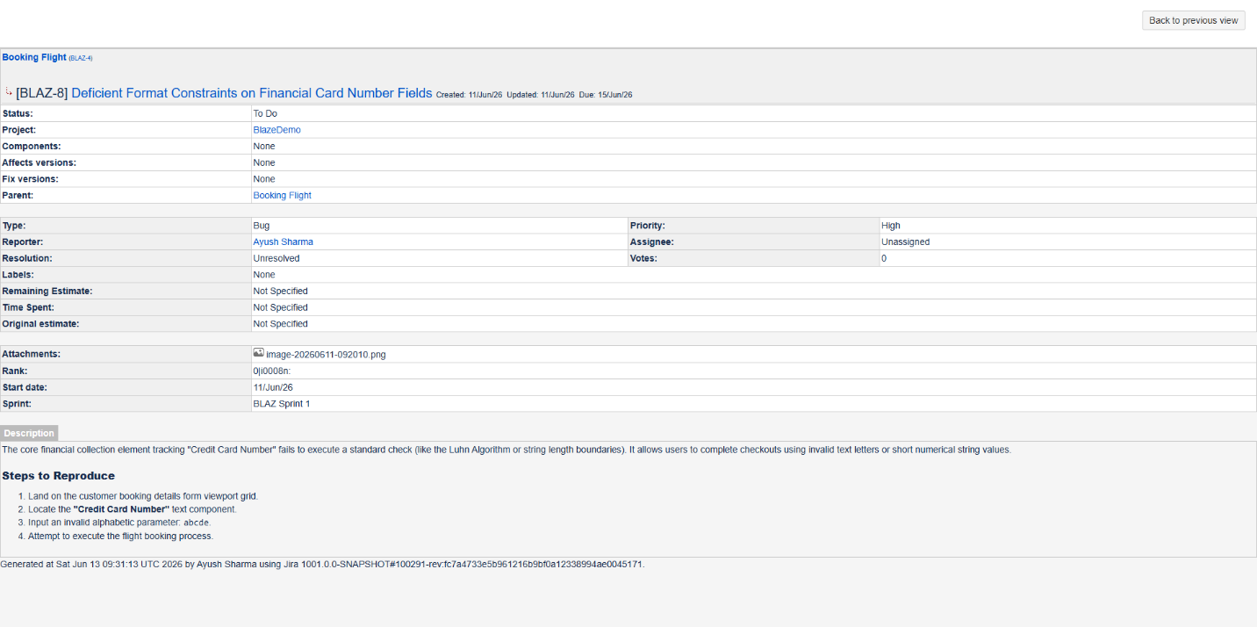

Defect – 7
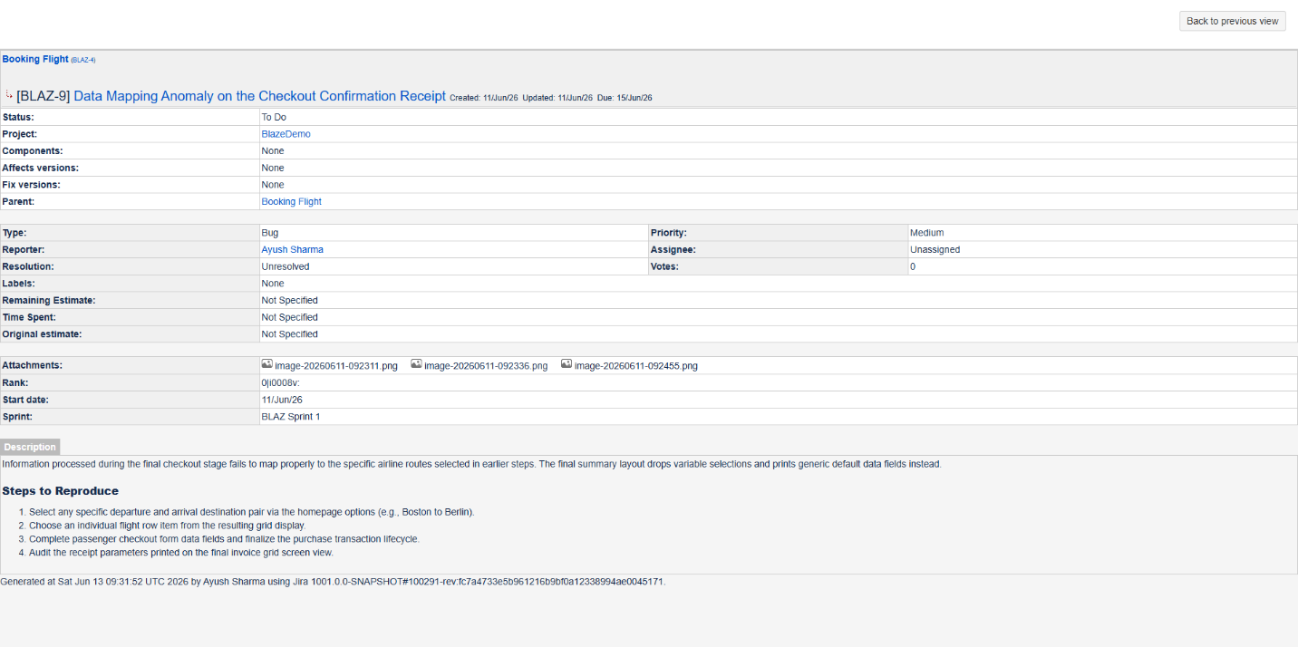

Defect Summary
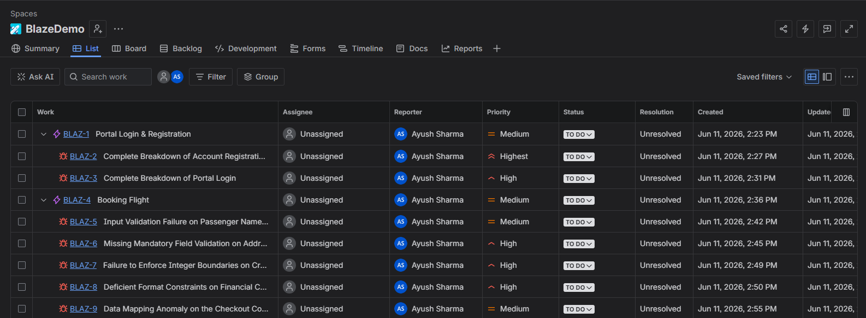

Defect ID | Feature Module | Defect Description | Severity
BUG-01 | Login | Complete breakdown of Account Registration (Throws unhandled 419 Page Expired). | Critical 🔴
BUG-02 | Login | Portal Login authentication engine fails (Trapped on 419 error panel layout). | Critical 🔴
BUG-03 | Flight Booking | Name field on checkout form completely lacks input text character sanitization. | Medium 🟡
BUG-04 | Flight Booking | Missing mandatory field constraints (Allows checking out with empty City/State). | High 🟠
BUG-05 | Flight Booking | Credit Card Expiration Month text field accepts invalid integers (e.g., month 99). | High 🟠
BUG-06 | Flight Booking | Credit Card Number field fails to validate basic format structures (Accepts text strings). | High 🟠
BUG-07 | Flight Booking | Flight details and destination route mismatch rendering on the final receipt summary view. | Medium 🟡

