BlazeDemo Automation Framework
Project Name: BlazeDemo Flight Booking Automation Framework
Prepared By: Ayush Sharma
Github: https://github.com/AYUSH-YL/Capstone_project
Site: https://blazedemo.com/reserve.php
1. Summary
This report details the execution performance and final test metrics for the BlazeDemo Automation Framework regression cycle. Testing was conducted across three progressive runtime environments: Local TestNG execution, containerized Docker sandboxes, and automated CI/CD Jenkins pipelines. The objective was to validate user authentication security vulnerabilities and data-driven end-to-end flight booking workflows.
High-Level Test Metrics Summary:
- Total Test Cases Executed: 5 (1 Portal tests + 4 Flight Booking iterations)
- Passed Tests: 5
- Failed Tests: 0
- Framework Pass Rate: 100%
- Critical Framework Crashes: 2
2. Test Environment
The automation suite was verified across three specific platform layers to ensure true environmental flexibility and robust cross-platform execution.
2.1 Phase 1: Local TestNG Suite Execution
- Objective: Validate code functionality locally using visible UI browser panels for debugging.
- Configuration: Windows 11, Java 17, Eclipse IDE, local browser binaries (Chrome, Firefox, Edge).

Console Output:
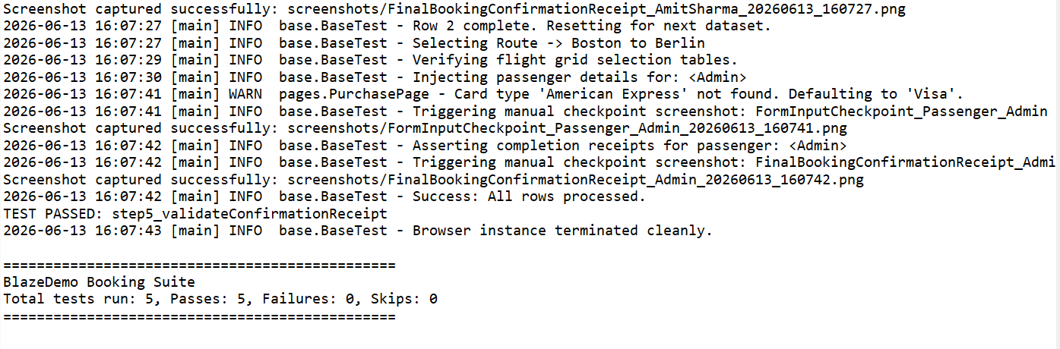
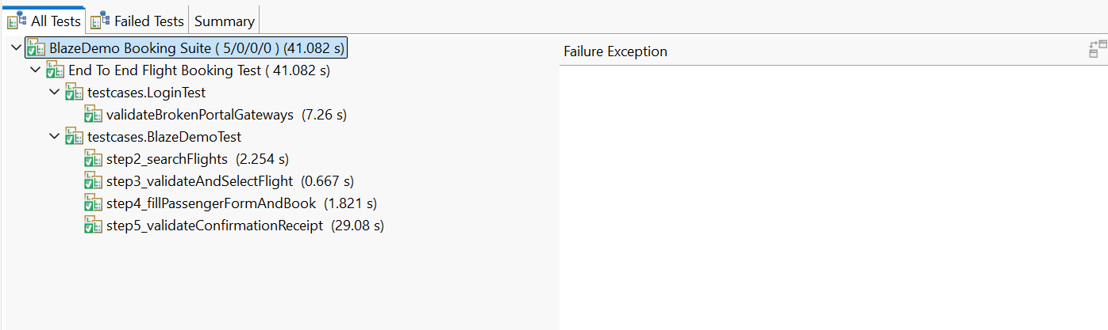

2.2 Phase 2: Isolated Docker Container Execution
- Objective: Validate headless Linux isolation, bypassing local system dependencies.
- Configuration: Docker Desktop Engine, Linux-based Maven runtime base container (3.8.8-eclipse-temurin-17), Headless stable Google Chrome.
Command:- docker run --rm testng-framework
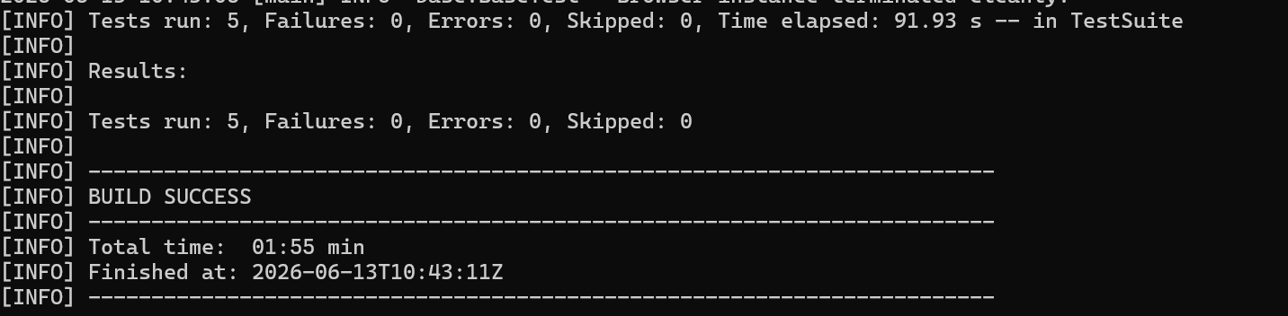

Docker Log :-
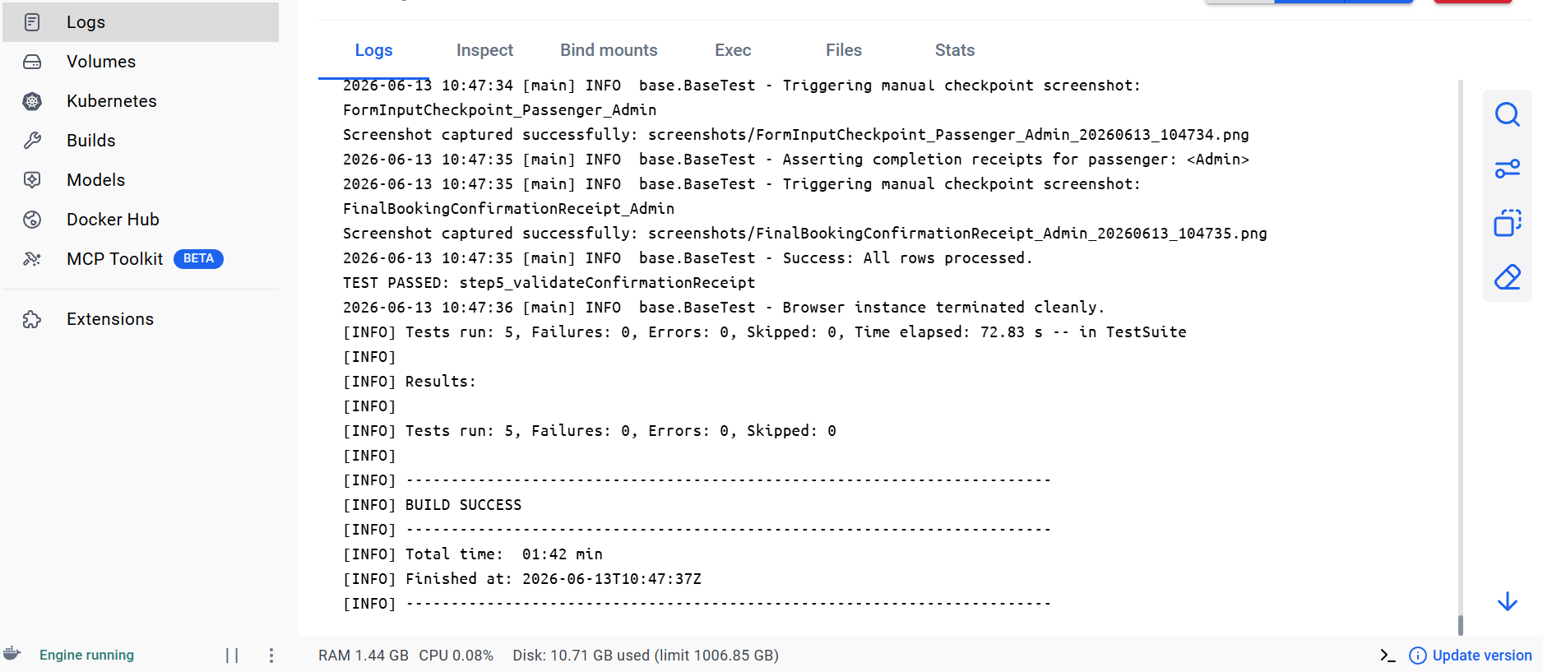

2.3 Phase 3: CI/CD Jenkins Pipeline Orchestration
- Objective: Validate automated Continuous Integration pipeline triggers, artifact fetching, and container teardown lifecycles.
- Configuration: Local Jenkins Server, SCM integration via GitHub, Declarative Jenkinsfile pipeline script.
Jenkins Pipeline :-

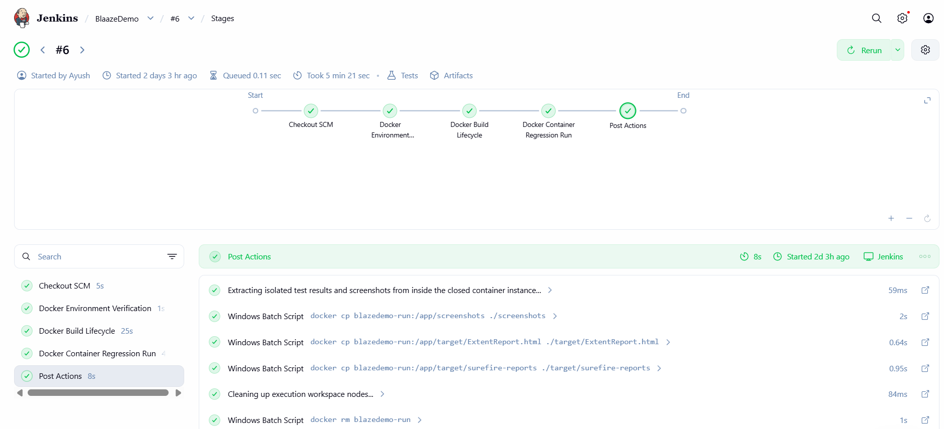
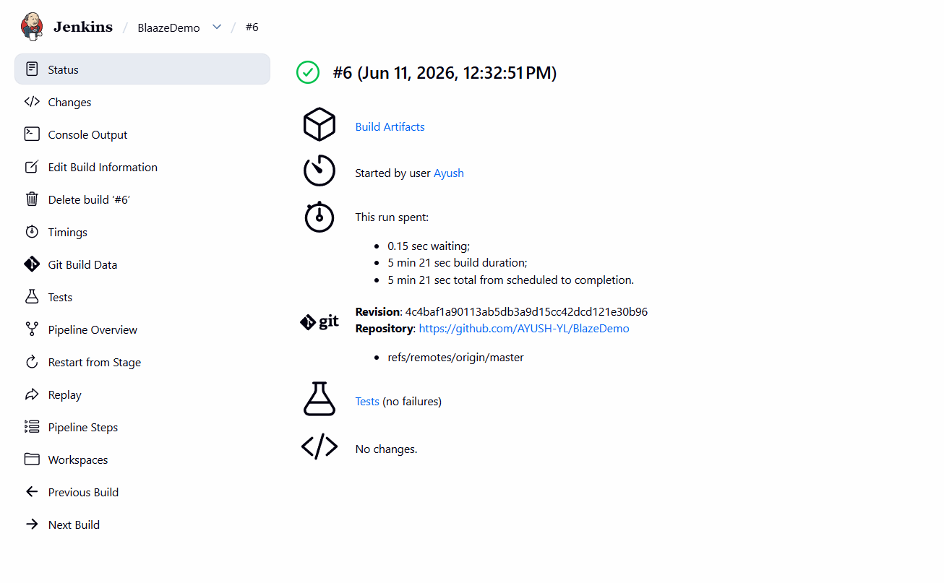

3. Extent Report Reporting Dashboard Analysis
To track execution status visually, the framework utilizes an integrated TestNG extent reporting listener to auto-compile standalone graphic charts.
3.1 Visual Framework Metrics Overview
- Report File Name: ExtentReport.html
- Key Observations:
- The Portal Login & Register leads to error page 419.
- The Flight Booking Pipeline successfully recursively looped through multiple external Excel rows data sheets, capturing clean runtime confirmation receipts.

Extent Report:
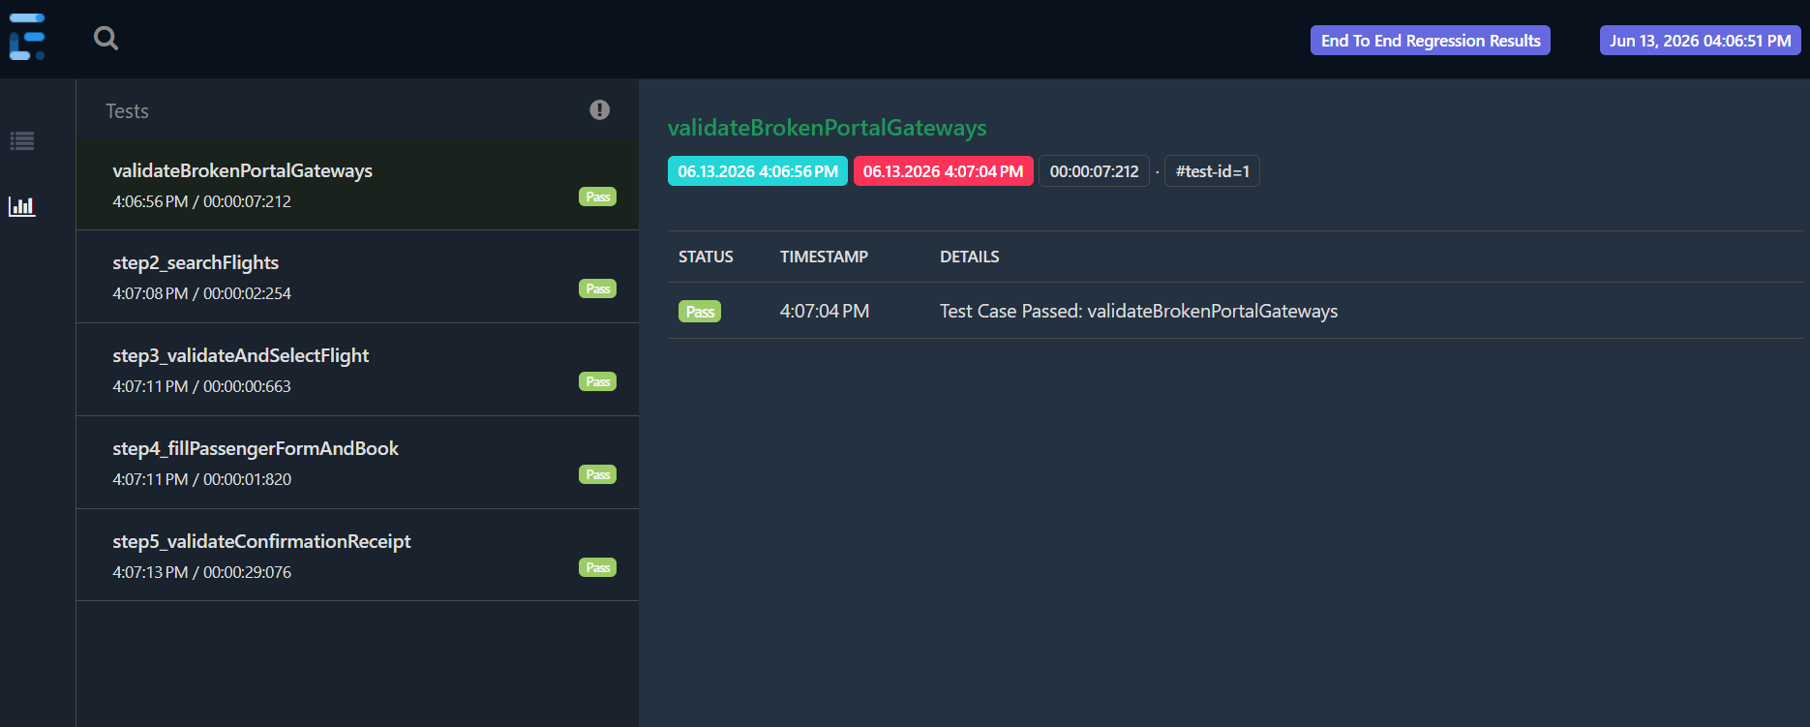

4. Conclusion
The test execution cycle has met all closure exit criteria outlined in the Test Plan. The implementation of the Page Object Model and custom Self-Healing Exception Handling successfully prevented environment test script breakage.

