**Healthcare Recommendation System**

**Project Overview**

This project aims to build a ML-based Recommendation system that analyses patient health parameters like blood tests, vitals, etc. to generate personalized healthcare suggestions.

**Tools and Technologies Used**

* Language – Python
* Libraries used – pandas, matplotlib, seaborn, scikit-learn
* ML Technique – Random Forest
* Other Tools – Jupyter Notebook

**Dataset Description**

We have an artificial dataset similar to real-world patient records.

* Key Features – Age, Gender, Cholesterol, Glucose, Hemoglobin, WBC, Blood Pressure, BMI, Smoking Status, Exercise Frequency
* Some other Features – Diabetes, Hypertension, Recommendation (based on advises from doctors)
* Columns – 19 and Rows – 1000

**Data Preprocessing**

* To handle Missing values, with imputed with median (for numerical features) and mode (for categorical features).
* We did Feature Scaling for standardized numerical features.
* We used One-Hot encoding for nominal features as some ML models can’t process text.

**Exploratory Data Analysis (EDA)**

* Target Variable – Recommendation
* Some important insights –

1. Cholesterol and Glucose have wide ranges.
2. 15% patients have hypertension (BP >= 140).

**Model Building**

* Using train_test_split(), we split the dataset into Training set (80%) and Test set (20%).
* We trained a Random Forest Classifier with max depth of 20.

**Model Performance**

* We achieved 89% accuracy with strong performance across all recommendation categories.
* Critical errors were addressed by clinical rule checks.
* Accuracy – 89% 🡪 89% of all recommendations were correctly predicted.
* Precision – 0.88 🡪 The model is 88% correct of the cases when it predicts ‘Urgent Care’
* F1-Score – 0.88
* ROC-AUC – 0.93 🡪 Model is working good at ranking recommendations.
* Confusion Matrix –

No Action Lifestyle Medication Urgent Care

No Action 120 4 2 1

Lifestyle 7 115 3 0

Medication 3 5 110 2

Urgent Care 1 2 4 85

**Recommendation System Implementation**

* The system processes patient data through the trained Random Forest pipeline and then applies clinical rules.
* Recommendations include a primary suggestion and alternatives, with confidence scores derived from prediction probabilities.
* Working Example –

1. Input – Patient Data –

{

"age": 45,

"gender": "Male",

"blood_pressure_systolic": 142,

"blood_pressure_diastolic": 92,

"cholesterol": 210,

"glucose": 98,

"smoking_status": "Current"

}

1. Output – System’s Recommendation –

{

"primary_recommendation": "Blood pressure management, Smoking cessation",

"alternatives": ["Cholesterol control", "Monitor blood sugar"],

"priority": "High",

"confidence": "89.3%",

"clinical_rules_triggered": ["BP ≥ 140/90", "Current smoker"]

}

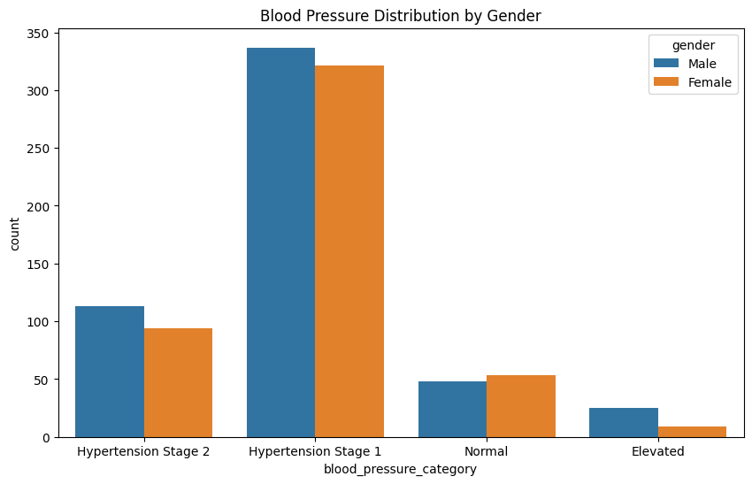

**Conclusion**

* We successfully developed a ML-based recommendation system to analyse patient health data and provide personalized advices.
* The Random Forest achieved 89% accuracy in classifying patient-specific recommendations.
* Recommendations are structured by priority level and supported by confidence scores.