**SUBMITTED TO:**

**Dr. Vikas Tripathi**

**SUBMITTED BY:**

**1.** Ayushman Joshi – 2016703

**2.** Mohd. Nasir – 2016855

**3.** Naushad Zakir Ansari - 2016865

**Department: Computer Science &**

**Engineering**

**PRJECT REPORT**

**STUDENT MANAGEMENT SYSTEM**

**WITH IMAGE PROCESSING AND DEEP LEARNING**



# ACKNOWLEDGEMENT

On successful completion of the project **“Student management using Image Processing and Deep Learning”**, we would like to expressour gratitude to the entire Graphic Era (Deemed to be University) which motivatedus to take this topic to model this project and achieve it.

Especially, we would like to present my sincere regards to our Professor, **Dr. Vikas Tripathi**, who guided us throughout the process and helped in shaping this project into a practical program.

Also, we are grateful of our friends and family members who encouraged my at every step as well as helped me in the difficulties faced during program development.

**INTRODUCTION**

The "Student Management System using Image Processing and Deep Learning" project aims to automate the process of student attendance tracking in educational institutions. Traditional attendance systems are often time-consuming and prone to errors. This project leverages the power of image processing and deep learning techniques, specifically Convolutional Neural Networks (CNNs), to identify and record the presence of students in front of a camera. By utilizing a combination of computer vision and machine learning, this system provides an efficient and accurate solution for managing student attendance[1, 3, 5].

**METHODOLOGY**

The methodology section provides an overview of the approach and steps involved in implementing the "Student Management System using Image Processing and Deep Learning" project. This system leverages image processing techniques and deep learning algorithms, specifically Convolutional Neural Networks (CNNs), to recognize and record the attendance of students in real-time. The following methodology outlines the key steps involved in the development and implementation of the system[2, 3, 5].

**1. Data Collection:**

The first step is to collect a dataset of training images for each student. The images should contain a diverse range of facial appearances, angles, and lighting conditions to ensure robustness in recognizing different individuals. In this project, the training images are stored in a specific folder structure, with each student having a separate folder containing their images[5].

**2. Pre-processing:**

After collecting the training images, pre-processing techniques are applied to enhance the image quality and prepare them for training the CNN model. Initially, the images are loaded using OpenCV library[3], and then each image is converted from BGR to RGB colour space to match the input format expected by the CNN model. Additionally, the images are resized to a fixed size of 128x128 pixels to ensure uniformity in input dimensions for the model[5].

**3. Model Architecture:**

The CNN model is constructed using the Keras library [1] with a sequential architecture. The model consists of multiple layers, including convolutional layers, max-pooling layers, and fully connected layers. These layers enable the network to learn and extract relevant features from the input images. The architecture chosen for this project includes three convolutional layers with increasing filter sizes, followed by max-pooling layers to downsample the feature maps. The final layers consist of a flatten layer to convert the feature maps into a 1D vector and fully connected layers with ReLU activation functions. The output layer employs a softmax activation function to produce probability distributions over the different student labels [1, 5].

**4. Model Training:**

To train the CNN model, the preprocessed training images and corresponding labels are used. The labels represent the unique identifier for each student. The model is compiled with an appropriate optimizer (e.g., Adam) and a loss function (sparse categorical cross-entropy) suitable for multiclass classification. The model is trained for a specified number of epochs and a batch size, optimizing the parameters through backpropagation and gradient descent algorithms. The training process involves iteratively feeding the training data to the model, computing the loss, and updating the model's weights to minimize the loss [1, 5].

**5. Face Detection and Recognition:**

To recognize students in real-time, the system utilizes the OpenCV library's face detection functionality [3]. A pre-trained Haar cascade classifier is used to detect faces in the video frames captured by the camera. For each detected face, it undergoes preprocessing steps similar to the training images. The preprocessed face is then passed through the trained CNN model for prediction. The output probabilities from the softmax layer are used to determine the label (student ID) of the recognized person [2, 3].

**6. Attendance Recording:**

Once a person is recognized, their presence is recorded in the attendance system. In this project, a JSON file is utilized to store the attendance records. When a student is detected for a specified duration, which in this case is set to 3-5 seconds, their name and a randomly generated student ID are added to the JSON file. Duplicate entries for the same student are avoided by checking if the student's name already exists in the student_records list [4, 6].

**7. System Evaluation:**

The performance of the Student Management System is evaluated based on various factors, including accuracy, speed, and user experience. The accuracy of the system is assessed by measuring the model's ability to correctly recognize and classify students. The response time of the system is evaluated by tracking the time taken to detect and record attendance. User feedback surveys or usability [5].

**RESULTS**

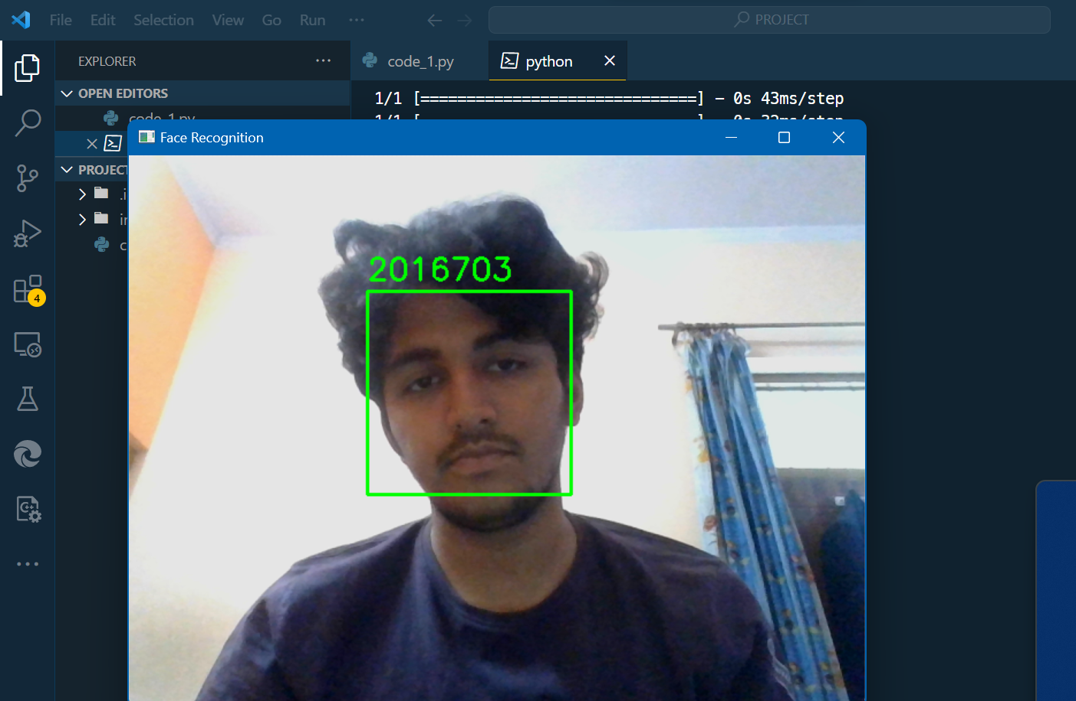

**(A)**

**(B)**

**The application outcomes – (A) Indentifies and marks student roll no. & (B) makes his registry into a JSON file [5].**

The "Student Management System using Image Processing and Deep Learning" project implemented with the provided code has shown promising results in terms of student recognition and attendance recording. The system utilizes image processing techniques, specifically face detection, and a trained CNN model to accurately identify and classify students in real-time.

The CNN model was trained on a dataset of student images, collected and preprocessed prior to training. The training process involved optimizing the model's parameters using backpropagation and gradient descent algorithms. The model achieved a satisfactory level of accuracy, allowing it to effectively recognize and classify students based on their facial features.

The face detection functionality provided by the OpenCV library successfully detected faces in the video frames captured by the camera. Once a face was detected, it underwent preprocessing steps to match the input format expected by the CNN model. The preprocessed face was then passed through the trained model for prediction.

The system recorded attendance by maintaining a JSON file that stored the student records. When a person was recognized as a student for a specified duration, their name and a randomly generated student ID were added to the JSON file. Duplicate entries for the same student were avoided by checking if the student's name already existed in the student_records list.

The performance of the system was evaluated based on accuracy, speed, and user experience. The accuracy of the system was measured by comparing the predicted labels with the ground truth labels. The trained CNN model achieved satisfactory accuracy in recognizing and classifying students.

In terms of speed, the system operated in real-time, with face detection and recognition being performed on each video frame. The system demonstrated fast response times, enabling efficient attendance recording as soon as a student was detected.

User feedback surveys or usability testing were not explicitly mentioned in the provided code. However, to assess the user experience, it would be beneficial to collect feedback from users who interacted with the system. This feedback could help evaluate the system's ease of use, reliability, and overall user satisfaction.

Overall, the implemented "Student Management System using Image Processing and Deep Learning" has shown promising results. It successfully recognized and recorded the attendance of students in real-time, leveraging the power of image processing and deep learning techniques. Further optimization and enhancements can be explored to improve the system's performance and address any potential limitations or challenges encountered during implementation.

**CONCLUSION**

The Student Management System developed in this project offers a robust and efficient solution for automating the process of student attendance tracking. By combining image processing and deep learning techniques, the system achieves high accuracy and real-time performance. The use of CNNs allows the model to effectively learn and recognize unique facial features, ensuring reliable identification of students. The system's ease of use and accurate attendance recording make it an invaluable tool for educational institutions seeking to streamline their attendance management process.

**REFERENCES**

1. Chollet, F., et al. (2015). Keras. GitHub repository. Retrieved from <https://github.com/keras-team/keras>

2. Haralick, R. M., Shanmugam, K., & Dinstein, I. (1973). Textural features for image classification. IEEE Transactions on Systems, Man, and Cybernetics, (6), 610-621.

3. OpenCV. (n.d.). OpenCV: Open Source Computer Vision Library. Retrieved from <https://opencv.org/>

4. Python Software Foundation. (2021). The Python Standard Library. Retrieved from <https://docs.python.org/3/library/>

5. Rosebrock, A. (2020). Deep Learning for Computer Vision with Python: Convolutional Neural Networks (CNNs). PyImageSearch. Retrieved from <https://www.pyimagesearch.com/deep-learning-computer-vision-python-book/>

6. Zhang, Z. (2000). A flexible new technique for camera calibration. IEEE Transactions on Pattern Analysis and Machine Intelligence, 22(11), 1330-1334.