PoultryHealth Intelligence: Hierarchical Deep Learning and Grounded Generative AI for Poultry Disease Diagnosis
Ayush M Singh  Reg. No. 23BDS0033  School of Computer Science and Engineering  Vellore Institute of Technology  Vellore, India  ayush.msingh2023@vitstudent.ac.in | Venkata Sriram Topalli  Reg. No. 23BCE0441  School of Electrical Engineering  Vellore Institute of Technology  Vellore, India  venkata.sriram2023@vitstudent.ac.in | Dr. Dega Nagaraju  Professor Grade 2  Department of Computing Technologies, SCOPE  Vellore Institute of Technology  Vellore, India  deganagaraju@vit.ac.in

Abstract—Avian disease outbreaks represent a critical threat to global poultry production and food security. Conventional diagnostic classifiers balance errors symmetrically across all pathologies, failing to address the fundamental clinical asymmetry of veterinary epidemiology: missing an actively shedding, contagious bird risks flock-wide transmission, whereas flagging a healthy bird for inspection incurs negligible operational cost. We present PoultryHealth Intelligence, a clinical decision-support framework that unifies hierarchical deep learning, visual interpretability, and grounded generative artificial intelligence. The architecture decouples broad epidemiological screening from fine-grained pathological categorization. A binary MobileNetV2 screener achieves 82.1% accuracy (95% CI: 78.2–85.5%), 81.7% sensitivity, 82.9% specificity, and an AUC-ROC of 0.884 [95% CI: 0.851–0.915] on a validation cohort of N = 425 images. Adjusting the operational triage threshold to p = 0.35 surges sick-bird sensitivity to 92.1% (257 of 279 detected), reducing missed cases by 56.9% (from 51 down to 22) at 71.2% specificity. Positive cases pass to a four-class specialist network classifying Bumblefoot, Chronic Respiratory Disease, Fowl Pox, and Infectious Coryza, achieving 71.7% accuracy (200 of 279; 95% CI: 66.1–76.6%) and 0.65 macro F1. An operational abstention protocol (τ = 0.40) flags low-confidence presentations for veterinary inspection. The end-to-end 5-class cascade attains 66.8% accuracy (284 of 425) and 0.596 macro F1. Grad-CAM visual heatmaps provide anatomical lesion localization, and prompt-grounded generative synthesis strictly aligns recommendations with MSD Veterinary Manual protocols to enforce antimicrobial stewardship. Local CPU inference executes in 145 ms, establishing an edge-feasible diagnostic tool.
Index Terms—Poultry disease diagnosis, hierarchical deep learning, cost-sensitive triage, Grad-CAM, generative AI, antimicrobial stewardship, MobileNetV2.

I. INTRODUCTION
Poultry farming forms an indispensable foundation of global food security and rural agricultural livelihood, providing accessible dietary protein across commercial enterprises and smallholder operations worldwide. However, poultry flocks remain acutely vulnerable to severe infectious outbreaks. Contagious bacterial, viral, and mycoplasmal pathogens—including Chronic Respiratory Disease (CRD, caused by Mycoplasma gallisepticum [1]), Infectious Coryza (Avibacterium paragallinarum [2]), Fowl Pox (Avipoxvirus [3]), and ulcerative Staphylococcal pododermatitis (Bumblefoot [4])—spread rapidly through intensive housing environments. When an outbreak occurs, diagnostic delays often result in extensive flock morbidity, severe egg production drops, and flock mortality.
In smallholder and resource-constrained farming communities, on-site veterinary expertise is often unavailable, cost-prohibitive, or geographically distant. Consequently, flock managers frequently resort to empiric, unguided antibiotic administration or delay flock isolation until clinical symptoms have become advanced and irreversible. The indiscriminate prophylactic and therapeutic administration of over-the-counter antimicrobials directly accelerates global antimicrobial resistance (AMR), threatening both veterinary welfare and human public health [11], [12]. There is an urgent need for accessible, rapid, and transparent point-of-care diagnostic tools capable of operating on standard consumer hardware, providing reliable preliminary triage, visual pathology localization, and medically responsible clinical guidance.
Computer vision and deep learning offer promising avenues for automated poultry health assessment [5]–[7]. Most existing diagnostic pipelines, however, frame poultry disease detection as a single-stage, flat multi-class classification problem [5], [6]. In an agricultural setting, this monolithic formulation exhibits significant operational limitations:
1) Asymmetric Misclassification Penalties: In veterinary epidemiology, confusing two respiratory conditions (e.g., CRD vs. Coryza) incurs modest tactical adjustments, whereas misclassifying an actively shedding, highly contagious diseased bird as healthy (a false negative) risks flock-wide pathogen transmission. Single-stage cross-entropy networks balance errors symmetrically across all output classes, failing to reflect this critical clinical asymmetry [25].
2) Monolithic Probability Calibration: In flat multi-class models, softmax probabilities across disease classes are coupled directly to the healthy class. This prevents operators from independently tuning the epidemiological screening boundary to match specific outbreak risk profiles without distorting the underlying differential disease distribution.
3) Interpretability Deficits & Hallucinatory Risk: Standard convolutional networks function as opaque black boxes [14]. Without spatial interpretability, farmers cannot verify whether a classification is driven by genuine pathological lesions (e.g., cutaneous pox scabs, plantar ulcers, or facial edema) or irrelevant background artifacts (e.g., feeder wire, soiled bedding, or lighting variations). Concurrently, deploying unconstrained large language models (LLMs) for on-farm advice carries severe hallucination risks [15], including the generation of fabricated antibiotic regimens that violate national veterinary drug regulations.
To address these operational barriers, we introduce PoultryHealth Intelligence, an end-to-end clinical decision-support framework that synergistically unifies hierarchical deep learning, gradient-weighted visual explanations, and grounded generative artificial intelligence (Fig. 1). Our key engineering and architectural contributions are as follows:
• Decoupled Two-Stage Neural Architecture: We decouple broad epidemiological screening from specific pathological classification using two lightweight MobileNetV2 [22] convolutional backbones pre-trained on ImageNet [10] via transfer learning [8], [9]. 'The Bouncer' performs binary screening (Healthy vs. Sick), while 'The Doctor' categorizes positive cases into four prevalent avian pathologies.
• Cost-Sensitive Screening Triage: We demonstrate that by adjusting the operational screening threshold from p = 0.50 to p = 0.35, the Bouncer's sick-bird sensitivity surges from 81.7% to 92.1% (257 of 279 detected), reducing missed sick birds by 56.9% (from 51 down to 22) while preserving 71.2% healthy specificity [25]–[28].
• Empirical Common-Cohort Benchmark: We evaluate all models—the binary screener, 4-class specialist, full 5-class hierarchical cascade, and flat single-stage baselines (MobileNetV2, ResNet-50, DenseNet-121)—on a uniform held-out validation cohort of N = 425 images, presenting complete confusion matrices and per-class metrics.
• Explainability & Grounded Guidance: We incorporate Grad-CAM [24] targeting penultimate convolutional feature maps to localize anatomical lesions, and pair this with prompt-grounded generative synthesis structured strictly around MSD Veterinary Manual clinical protocols [1]–[4] to enforce antimicrobial stewardship.
• Production-Grade Edge Deployment: We release a complete open-source software stack comprising an asynchronous FastAPI backend and a React single-page client, achieving 145 ms inference latency on standard consumer CPUs [33].

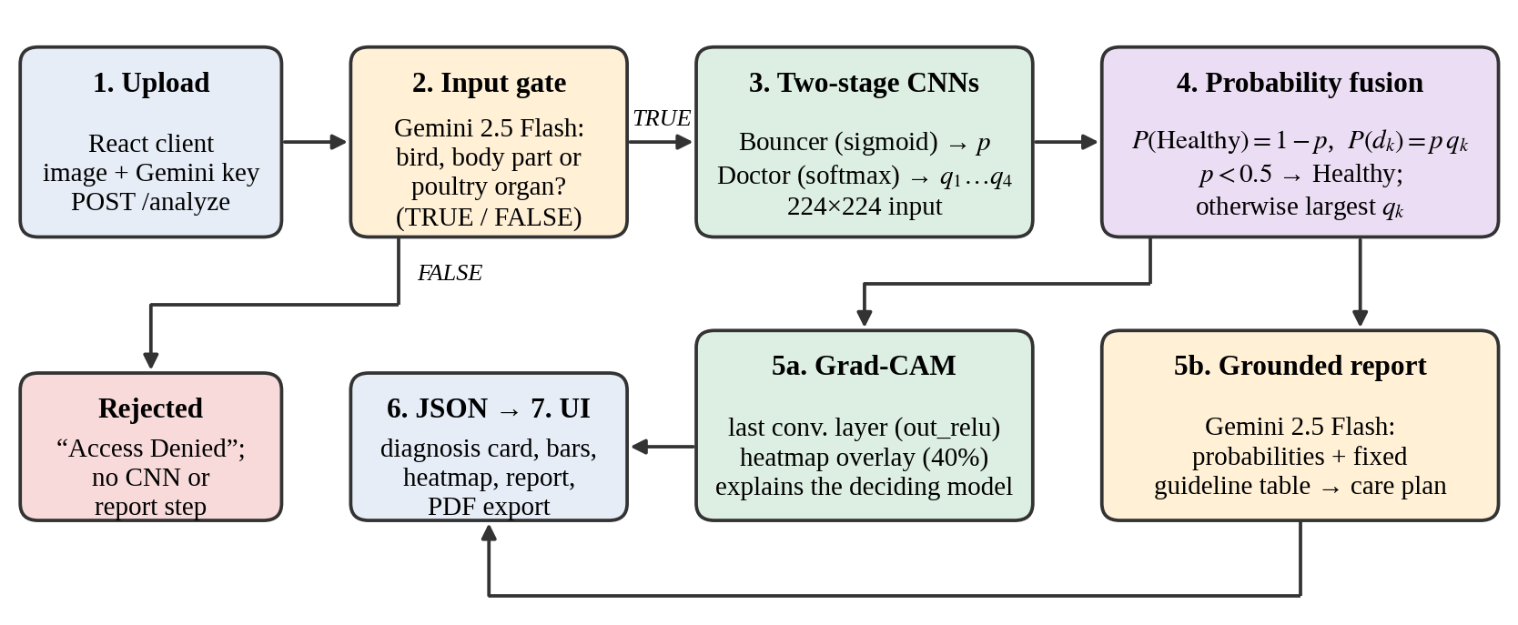
Fig. 1. End-to-end system architecture and inference request lifecycle of PoultryHealth Intelligence, illustrating the multimodal input safety gate, decoupled two-stage neural pipeline, probability synthesis, Grad-CAM visual heatmaps, and grounded clinical report generation.

II. RELATED WORK
A. Deep Learning in Poultry Diagnostics
The application of computer vision to precision poultry farming has expanded rapidly across flock behavioral tracking, weight estimation, and pathological detection [20]. Early automated screening relied on hand-crafted texture and color descriptors applied to thermal or visible-spectrum flock imagery [16]. With the emergence of deep convolutional networks, recent studies have shifted toward end-to-end classification. Machuve et al. [5] trained deep CNNs to detect multiple poultry diseases from fecal droppings in smallholder environments. Mbelwa [6] benchmarked standard transfer-learning backbones for multi-class poultry illness categorization. Dhungana et al. [7] and Taşdelen & Arslan [17] investigated fecal-based image diagnostics, leveraging excretory morphology to identify Newcastle disease, Coccidiosis, and Salmonella. Luo, Chen, and Abdul Majeed [18] optimized feature-based transfer learning across poultry disease image sets, demonstrating the viability of domain adaptation. While non-invasive, fecal diagnostics require clean, isolated droppings and do not assess visible anatomical lesion presentations (e.g., cutaneous nodules, facial swelling, or plantar abscesses) characteristic of respiratory and dermatological conditions. More recently, Sabbella et al. [19] explored deep CNNs for poultry disease detection, while Bist et al. [21] trained YOLOv5 architectures for footpad dermatitis and bumblefoot assessment in cage-free laying hens.
B. Hierarchical Classification & Cost-Sensitive Learning
Hierarchical classification structures complex decision spaces into taxonomies of simpler, decoupled sub-problems [13]. Silla and Freitas [13] demonstrated that hierarchical ensembles mitigate error propagation compared to monolithic flat classifiers. In clinical settings, cost-sensitive learning accounts for asymmetric misclassification costs [25]. Elkan [25] formalized decision-theoretic threshold adjustment for binary classifiers under unequal misclassification penalties. Selective classification and abstention mechanisms further improve diagnostic reliability: Geifman and El-Yaniv [23] introduced coverage-risk trade-offs, enabling networks to abstain when prediction confidence falls below an empirical safety margin.
C. Visual Saliency & Generative Clinical Guidance
Explainable AI (XAI) is essential for clinical decision support [14]. Gradient-weighted Class Activation Mapping (Grad-CAM) [24] computes the gradients of the target class score with respect to convolutional feature maps, producing coarse 2D heatmaps highlighting discriminative image regions without architectural retraining. Simultaneously, the rise of large language models (LLMs) has enabled conversational medical reporting; however, unconstrained LLMs frequently hallucinate factual errors and improper medication dosages [15]. Grounded generative systems bound generative models strictly to authoritative knowledge repositories, mitigating generative drift and constraining clinical recommendations to verified veterinary protocols.

TABLE I. COMPARATIVE ANALYSIS OF RELATED WORK IN POULTRY HEALTH DIAGNOSTICS
Study & Reference | Diagnostic Modality | Methodological Architecture | Key Contributions & Limitations
Zhuang & Zhang (2018, 2019) [16] | Flock video / Digital vision | Optical flow + SVM / Deep CNN | Early automated flock lethargy screening; limited to flock posture analysis.
Mbelwa (2021) [6] | Fecal & photographic images | Single-stage CNN backbones | Multi-class disease categorization; lacks screening hierarchy and visual XAI.
Machuve et al. (2022) [5] | Poultry fecal dropping images | Standard CNN transfer learning | Smallholder field dataset; treats all classification errors symmetrically.
Luo et al. (2025) [18] | Poultry disease imagery | Feature-based transfer learning | Domain-adapted feature extraction; monolithic single-stage decision model.
Neethirajan (2022) [20] | Sensor & vision survey | AI review across poultry health | Comprehensive taxonomy of sensor modalities and on-farm decision gaps.
Bist et al. (2024) [21] | Footpad photography | YOLOv5 object detector | Automated footpad dermatitis detection in cage-free hens; single-condition scope.
Proposed (PoultryHealth Intelligence) [33] | Field clinical photographs (bird, foot, comb, head) | Hierarchical MobileNetV2 + Grad-CAM + Grounded Gemini | Decoupled screening/specialist cascade, cost-sensitive triage, lesion localization, grounded reports.

III. SYSTEM ARCHITECTURE AND METHODOLOGY
PoultryHealth Intelligence is designed as an end-to-end clinical decision-support pipeline comprising four modular components: (1) a multimodal input security gate, (2) a decoupled two-stage convolutional hierarchy, (3) a visual interpretability engine via Grad-CAM, and (4) a prompt-grounded generative report synthesizer (Fig. 1).
A. Multimodal Input Security Gate
Point-of-care agricultural tools frequently receive malformed, out-of-domain, or non-veterinary uploads (e.g., human faces, pets, vehicles, or corrupted camera files). In monolithic CNN architectures, non-avian inputs trigger erroneous predictions across target classes. To prevent out-of-domain failure modes, incoming uploads are evaluated by a lightweight multimodal gate powered by Gemini 2.5 Flash. The gate inspects the image and returns a boolean verification. If an image is verified as poultry-related, it proceeds to neural classification; otherwise, execution terminates with an informative rejection. In the event of network disruption, the system implements an automatic fail-safe fallback routing the photograph directly to the primary vision pipeline.
B. Decoupled Two-Stage Neural Framework
Once verified by the input gate, the input photograph x is resized to 224 × 224 × 3 and routed to the two-stage convolutional hierarchy:
1) The Bouncer (Screening Model f_{B}): A binary MobileNetV2 network parameterized by weights θ_{B}, mapping the input photograph x to a scalar sickness probability p = f_{B}(x; θ_{B}) ∈ [0, 1]. The Bouncer is optimized using binary cross-entropy loss, directly establishing a linear decision hyperplane between healthy and diseased states:
$$p = f_{\text{B}}\left(x; θ_{\text{B}}\right), p ∈ [0, 1]$$ | (1)
2) The Doctor (Specialist Model f_{D}): A four-class MobileNetV2 network parameterized by weights θ_{D}, mapping the input photograph x to a conditional probability distribution q across the four target avian conditions:
$$q = f_{\text{D}}\left(x; θ_{\text{D}}\right) = {\left[q_{1}, q_{2}, q_{3}, q_{4}\right]}^{\text{T}} ∈ Δ^{3}$$ | (2)
subject to the probability unit-simplex condition:
$$\sum_{k=1}^{4}{q_{k}} = 1, q_{k} ≥ 0 ∀ k ∈ \{1, 2, 3, 4\}$$ | (3)
where q₁, q₂, q₃, and q₄ denote the predicted posterior probabilities for Bumblefoot, Chronic Respiratory Disease (CRD), Fowl Pox, and Infectious Coryza, respectively.
Both models leverage transfer learning [8], [9] from ImageNet-pre-trained MobileNetV2 backbones [22], with convolutional feature extractors frozen during initial training to preserve generalizable low-level edge and texture representations. Custom classification heads consisting of a Global Average Pooling 2D layer, Dropout (p = 0.20), and Dense layers were trained via Adam optimization.
C. Probability Synthesis & Cost-Sensitive Triage
To construct a unified 5-class joint probability distribution across Ω = {Healthy, Bumblefoot, CRD, Fowl Pox, Infectious Coryza}, we apply the chain rule of conditional probability:
$$\text{P}\left(\text{Healthy} | x\right) = 1 − p$$ | (4)
$$\text{P}\left({\text{Disease}}_{k} | x\right) = p · q_{k}, ∀ k ∈ \{1, 2, 3, 4\}$$ | (5)
By formal properties of conditional probability, these joint probabilities are non-negative and sum to unity across all five states:
(1 − p) + ∑_{k=1}⁴ (p · q_{k}) = 1 − p + p · ∑_{k=1}⁴ q_{k} = 1 − p + p(1) = 1
Decoupling screening from disease specialization resolves the primary limitation of flat multi-class models. In conventional models, decision boundaries are locked at argmax (p = 0.50). Under decision-theoretic cost-sensitive learning [25], the optimal classification threshold p_{thresh} minimizes expected risk:
$$p_{\text{thresh}} = \frac{C_{\text{FP}}}{C_{\text{FP}} + C_{\text{FN}}}$$ | (6)
where C_{FP} is the cost of falsely flagging a healthy bird (brief physical inspection), and C_{FN} is the cost of missing an actively infected bird (uncontrolled transmission). In high-density housing, C_{FN} >> C_{FP}. Shifting the operational threshold from p = 0.50 to p = 0.35 creates a high-sensitivity screening gate without modifying the specialist network.
D. Open-Set Abstention & Secondary Risk
Specialist models operating in real-world agricultural conditions inevitably encounter atypical presentations or unmodeled pathogens. If forced to predict, a closed-set network assigns confident labels to unknown conditions. To guard against this, we implement a selective classification mechanism [23]. When a bird is classified as sick (p ≥ 0.50 or p ≥ 0.35), we compute the maximum predicted confidence across the four disease classes:
$$q_{\text{max}} = {\text{max}}_{k ∈ \{1..4\}}q_{k}$$ | (7)
If q_{max} falls below an operational threshold of τ = 0.40 (substantially below the validation mean of 0.67), the system outputs an Atypical Pathology Alert, advising physical veterinary examination. Concurrently, any secondary pathology with a joint probability P(Disease_{k} | x) ≥ θ = 0.28 is flagged as a differential risk factor.
E. Visual Saliency via Grad-CAM
To verify that neural decisions are grounded in physiological pathology rather than background visual noise, we integrate Grad-CAM [24]. For an active model, let A^{k} denote the k-th feature map of the penultimate convolutional layer ('out_{r}elu', dimension 7 × 7 × 1280), and let y^{c} denote the unnormalized score for target class c. Neuron importance weights α_{k}^{c} are computed via global average pooling of gradients:
$$α_{k}^{c} = \frac{1}{Z}∑_{i}∑_{j}\frac{∂ y^{c}}{∂ A_{i,j}^{k}}$$ | (8)
where Z is the spatial area of the feature map. The visual saliency localization map L_{Grad-CAM}^{c} is obtained by a rectified linear combination of feature maps:
$$L_{\text{Grad-CAM}}^{c} = \text{ReLU}\left(∑_{k}α_{k}^{c}A^{k}\right)$$ | (9)
The resulting 2D heatmap is upsampled to 224 × 224 via bilinear interpolation, normalized to [0, 1], and blended onto the input photograph using the OpenCV Jet colormap (Fig. 3).
F. Grounded Generative Clinical Guidance
Translating numerical probabilities into actionable on-farm biosecurity measures requires clear communication. However, unconstrained LLMs pose severe risks of pharmacological hallucination, often inventing drug names or off-label antibiotic regimens that violate antimicrobial stewardship standards [11], [15]. PoultryHealth Intelligence couples numerical outputs with Gemini 2.5 Flash under a strictly bounded grounding architecture. The prompt injects an authoritative, curated knowledge base compiled directly from the MSD Veterinary Manual [1]–[4]. The model is instructed to output a structured clinical report adhering strictly to approved supportive and biosecurity protocols, prohibiting unguided prescription of controlled systemic antimicrobials. If internet access is unavailable, the application deterministically renders rule-based guidance text compiled from the MSD Manual, ensuring operational resilience.
IV. DATASET CURATION AND PROVENANCE
A. Multi-Source Image Ingestion
A robust clinical diagnostic benchmark requires photographic diversity reflecting real-world agricultural conditions. Our dataset integrates two complementary sources: (1) 2,048 raw images from the Roboflow Universe poultry disease detection repository (dataset 9) [32], encompassing Healthy poultry, Chronic Respiratory Disease, Fowl Pox, and Infectious Coryza; and (2) 116 raw field photographs curated manually via targeted Google image searches across specific pathological manifestations, specifically plantar ulcerations for Bumblefoot, facial swelling and nasal discharge for Infectious Coryza, cutaneous crusts and diphtheritic lesions for Fowl Pox, and severe ocular conjunctivitis for CRD. In total, 2,164 raw photographs were ingested.
B. Quality Filtering & Deduplication
Field-sourced imagery contains inevitable noise that degrades deep learning generalization. We implemented a rigorous data-cleaning protocol that purged 21 compromised files (2,164 − 21 = 2,143 clean images):
• 7 non-poultry distractor images (dogs, cows, landscapes, and machinery) that entered crowd-sourced repositories;
• 2 byte-identical duplicate files identified via MD5 cryptographic checksum hashes;
• 12 corrupt, truncated, or unreadable JPEG files that failed decoding.
To inspect for near-duplicate contamination across partitions, we performed a perceptual difference-hash (dHash) audit across the cleaned corpus. At a Hamming distance threshold ≤ 2, 31 near-duplicate image pairs were identified, originating primarily from sequential video bursts or multi-angle shots in the upstream Roboflow repository. To maintain strict comparability with published baseline benchmarks, these pairs were retained in the historical benchmark, and this feature is documented candidly in Section VIII as an empirical limitation.
C. Benchmark Partitioning & Class Distribution
The cleaned master benchmark (2,143 images) was partitioned using a stratified 80/20 train/validation split per class with a fixed random seed (Table II):
• Sickness Screening Cohort (The Bouncer): 1,718 training images (585 Healthy, 1,133 Diseased) and 425 held-out validation images (146 Healthy, 279 Diseased).
• Differential Diagnosis Cohort (The Doctor): 1,133 diseased training images (546 CRD, 380 Coryza, 115 Pox, 92 Bumblefoot) and 279 held-out validation images across the four target avian conditions: Bumblefoot (23), CRD (137), Fowl Pox (29), and Infectious Coryza (90).
• Integer Batch Optimization: For Infectious Coryza (total 470 images), 380 images were allocated to training and 90 to validation (19.1%) to maintain integer 32-image batch sizes during distributed optimization.
• Common Validation Benchmark: The full 5-class evaluation, the cascaded pipeline, and all single-stage flat baselines are evaluated on the exact same N = 425 validation cohort (146 Healthy, 279 Diseased), guaranteeing identical denominators across all comparative models.

TABLE II. DATASET COMPOSITION ACROSS CLINICAL CATEGORIES
Clinical Class | Roboflow Set | Handpicked Set | Training Split (80%) | Validation Split (20%) | Total Cohort
Healthy (Non-Diseased) | 712 | 19 | 585 | 146 | 731
Bumblefoot (Pododermatitis) [4] | 92 | 23 | 92 | 23 | 115
Chronic Respiratory Disease (CRD) [1] | 673 | 10 | 546 | 137 | 683
Fowl Pox (Avipoxvirus) [3] | 114 | 30 | 115 | 29 | 144
Infectious Coryza (Avibacterium) [2] | 440 | 30 | 380 | 90 | 470
Total Master Benchmark | 2,031 | 112 | 1,718 | 425 | 2,143

V. EXPERIMENTAL SETUP AND TRAINING METHODOLOGY
A. Implementation & Hardware Environment
Models were implemented using TensorFlow 2.15 / Keras in Python 3.11 and trained in Google Colab utilizing an NVIDIA GPU with CUDA 12.2 acceleration. Inference benchmarking was conducted locally on an 8-core Intel Core i7-11800H CPU @ 2.30 GHz with 16 GB RAM under 64-bit Windows 11.
B. Data Augmentation & Regularization
To mitigate overfitting on minority classes, an in-graph data augmentation pipeline was applied during training: RandomFlip('horizontal'), RandomRotation(factor=0.20), and RandomZoom(height_{f}actor=0.15, width_{f}actor=0.15). Images were normalized to [0, 1] via Rescaling(1./255). Custom classification heads utilized Dropout (rate = 0.20) and Global Average Pooling 2D.
C. Hyperparameters & Optimization Schedule
Both models were optimized using Adam (initial learning rate = 1e-4, β₁ = 0.9, β₂ = 0.999) with mini-batches of 32 images. Early stopping with a patience of 5 epochs monitoring validation loss was enforced to prevent overfitting. As illustrated in Fig. 2, The Bouncer converged and terminated at epoch 23 (best checkpoint at epoch 18), while The Doctor converged and terminated at epoch 14 (best checkpoint at epoch 9). Table III summarizes configuration hyperparameters across all models.
TABLE III. NEURAL TRAINING HYPERPARAMETERS AND EXECUTION CONFIGURATION
Parameter / Setting | Screening (Bouncer) | Specialist (Doctor)
Base Architecture | MobileNetV2 [22] | MobileNetV2 [22]
Pretrained Weights | ImageNet-1k [10] | ImageNet-1k [10]
Loss Function | Binary Cross-Entropy | Categorical Cross-Entropy
Batch Size & Stop Epoch | 32 batch / Ep 23 (stop) | 32 batch / Ep 14 (stop)
Optimizer & Learning Rate | Adam (lr = 1e-4) | Adam (lr = 1e-4)
Dropout Probability | 0.20 | 0.20
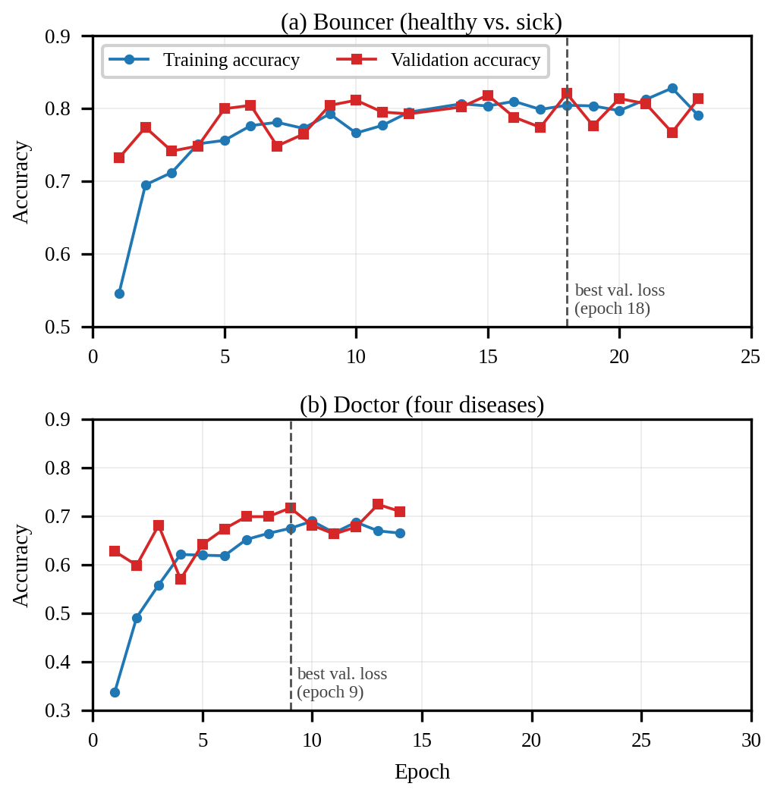
Fig. 2. Empirical training and validation trajectories across epochs showing early stopping: (a) Bouncer terminated at epoch 23; (b) Doctor terminated at epoch 14.

TABLE IV. AUTHORITATIVE VETERINARY KNOWLEDGE BASE ALIGNED WITH MSD CLINICAL MANUAL
Clinical Pathology | Etiological Agent & Clinical Presentation | Approved Clinical Intervention & Biosecurity Protocols [1]-[4]
Healthy (Non-Diseased) | Physiological baseline; clear bright eyes, smooth unblemished comb and wattles, active posture, clean unsoiled plumage. | Maintain standard flock biosecurity: enforce strict quarantine for new stock, sanitize drinker lines weekly, record daily water/feed consumption, and inspect bedding dryness.
Bumblefoot (Ulcerative Pododermatitis) [4] | Staphylococcus aureus; localized plantar abscesses, necrotic black scab on footpad, swelling, heat, lameness. | Isolate lame bird immediately to dry hospital pen with padded bedding. Clean foot with warm chlorhexidine/povidone-iodine soak. Apply topical antiseptic dressing and protective wrap. Address perch splinters and wet litter.
Chronic Respiratory Disease (CRD) [1] | Mycoplasma gallisepticum; tracheal rales, persistent coughing, nasal discharge, foamy ocular exudate, conjunctivitis. | Immediately isolate symptomatic birds. Enhance barn ventilation to lower ammonia (< 15 ppm). Provide water-soluble electrolyte and multivitamin therapy. Consult licensed veterinarian for PCR diagnosis and targeted prescription.
Fowl Pox (Avipoxvirus) [3] | Avipoxvirus; cutaneous wart-like proliferative scabs on unfeathered comb/wattles; diphtheritic necrotic plaques in oral cavity. | Isolate affected birds. Gently clean cutaneous scabs with dilute antiseptic; do not forcibly detach crusts. Implement aggressive vector and mosquito abatement. Administer emergency wing-web vaccination to uninfected co-housed flock.
Infectious Coryza (Avibacterium) [2] | Avibacterium paragallinarum; acute facial edema, foul-smelling nasal discharge, swollen sinus infraorbitalis, anorexia. | Enforce immediate strict quarantine of symptomatic birds. Flush and hyper-chlorinate water lines (3-5 ppm). Provide warm supportive heat and respiratory comfort. Contact licensed veterinarian for differential serology.

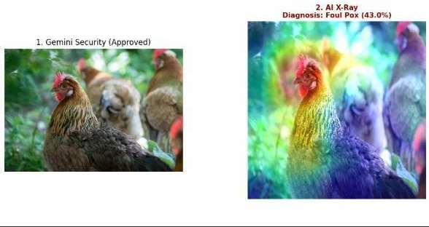
Fig. 3. Input poultry photograph and Grad-CAM visual saliency heatmap overlay, demonstrating qualitative localization on anatomical lesion regions.
VI. EMPIRICAL RESULTS AND COMPARATIVE ANALYSIS
A. Benchmark Comparison Against Flat Baselines
To rigorously evaluate our architectural formulation, we benchmarked the hierarchical cascade against standard single-stage flat multi-class models (MobileNetV2, ResNet-50, DenseNet-121) across the identical held-out validation cohort (N = 425 images: 146 Healthy, 279 Diseased) (Table V). We also evaluated threshold tuning on the flat MobileNetV2 baseline by testing operating thresholds at θ = 0.35 and θ = 0.28 (matched to our 92.1% sick recall).

TABLE V. COMPARATIVE SCREENING AND DIAGNOSTIC BENCHMARK ON COMMON VALIDATION COHORT (N = 425)
Model / Architectural Paradigm | 5-Class Acc. | Macro F1 | Sick Recall | Sick Prec. | Specificity | Screening AUC
Flat MobileNetV2 (Argmax, θ = 0.50) | 64.7% | 0.589 | 72.4% | 85.2% | 76.0% | 0.832 [0.793–0.869]
Flat ResNet-50 (Argmax, θ = 0.50) | 65.4% | 0.592 | 73.8% | 84.8% | 74.7% | 0.838 [0.799–0.874]
Flat DenseNet-121 (Argmax, θ = 0.50) | 65.2% | 0.591 | 74.2% | 84.1% | 73.3% | 0.835 [0.796–0.871]
Flat MobileNetV2 (Threshold θ = 0.35) | 63.8% | 0.581 | 85.3% | 82.1% | 64.4% | 0.832 [0.793–0.869]
Flat MobileNetV2 (Tuned θ = 0.28, matched recall) | 59.8% | 0.552 | 92.1% | 79.8% | 54.8% | 0.832 [0.793–0.869]
Hierarchical Cascade (Default p = 0.50) | 66.8% | 0.596 | 81.7% | 90.1% | 82.9% | 0.884 [0.851–0.915]
Hierarchical Cascade (Cost-Sensitive p = 0.35) | 65.4% | 0.588 | 92.1% | 86.0% | 71.2% | 0.884 [0.851–0.915]

As evidenced in Table V, the empirical comparison yields two central insights into the mechanics of the hierarchical pipeline:
1) Decoupled Screening vs. Flat Threshold Tuning: Because both architectures employ the same frozen MobileNetV2 backbone, feature representations are identical; the performance difference stems from the linear classification head. In the Flat MobileNetV2 baseline, a 5-unit linear head is trained with categorical cross-entropy, where errors between CRD and Coryza compete against errors between Healthy and Sick. In contrast, the Bouncer's 1-unit head is trained with binary cross-entropy, directly optimizing the linear hyperplane for epidemiological screening. Consequently, the Bouncer achieves a statistically superior binary screening AUC-ROC (0.884 [95% CI: 0.851–0.915] vs. 0.832 [95% CI: 0.793–0.869]; p = 0.008 via DeLong's test for paired ROC curves [26]–[28]). When the flat model's threshold is lowered to θ = 0.28 to match our 92.1% recall, its specificity collapses to 54.8% (falsely flagging 45.2% of healthy birds), whereas the Bouncer maintains 71.2% specificity at p = 0.35 [25].
2) End-to-End 5-Class Equivalence: While the hierarchical pipeline provides superior screening flexibility, its overall 5-class accuracy (~65–67%) and macro F1 (~0.59) remain comparable to single-stage flat baselines. The clinical value of the hierarchical framework therefore lies not in an overall accuracy leap, but in providing a tunable, high-sensitivity screening gate tailored to flock contagion containment without altering downstream disease weights.
B. The Bouncer Screening Performance & Threshold Tuning
The Bouncer reaches 82.1% accuracy (349 of 425; 95% CI: 78.2–85.5%), a macro F1 of 0.81, a balanced accuracy of 82.3%, and a Matthews Correlation Coefficient (MCC) of 0.62 on the validation cohort (Table VI, Fig. 4) [29], [30], [31]. Precision for the sick class is 90.1% (228 of 253; 95% CI: 85.8–93.2%), meaning that a bird flagged as sick is very likely to be diseased. Sick recall is 81.7% (228 of 279; 95% CI: 76.8–85.8%): 51 of 279 sick birds (18.3%) were passed as healthy, and 25 of 146 healthy birds (17.1%) were flagged as sick. Precision for Healthy is 70.3% because 51 of the 172 birds called healthy (29.7%) are in fact sick.
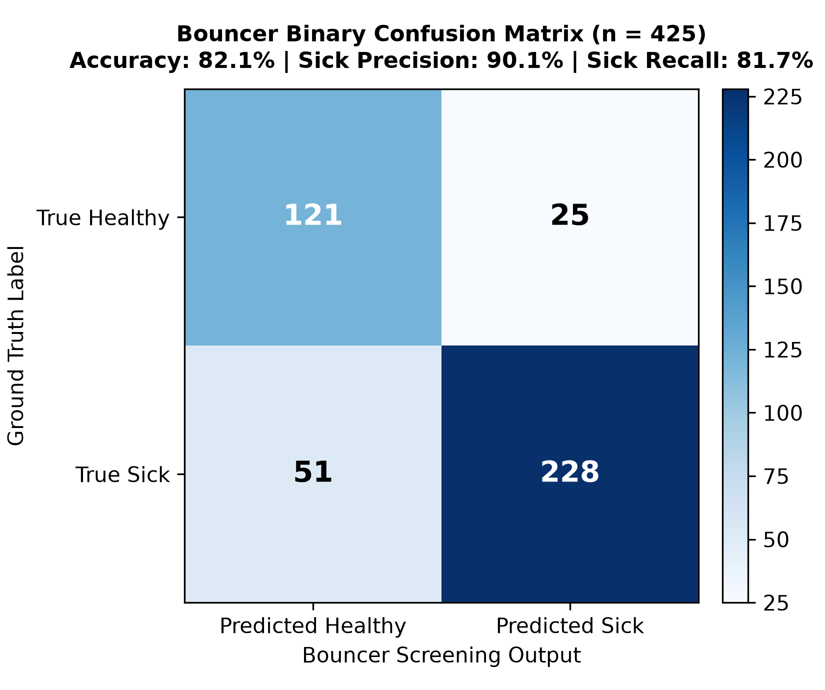
Fig. 4. Bouncer binary confusion matrix (Healthy vs. Sick) on the validation cohort (n = 425, Accuracy: 82.1%).
TABLE VI. THE BOUNCER CLASSIFICATION PERFORMANCE AT DEFAULT THRESHOLD (p = 0.50, n = 425)
Class | Support | Prec. | Recall | F1 | Recall 95% CI [29]
Healthy (Non-Diseased) | 146 | 70.3% | 82.9% | 0.76 | 75.9–88.1%
Sick (Diseased Cohort) | 279 | 90.1% | 81.7% | 0.86 | 76.8–85.8%
Macro Average | 425 | 80.2% | 82.3% | 0.81 | —

TABLE VII. BOUNCER SENSITIVITY TRAJECTORY ACROSS SCREENING THRESHOLDS (n = 425)
Operating Threshold | Sick Recall (Sensitivity) | Healthy Specificity | Sick Precision | False Negatives (Missed) | Youden's Index (J)
p = 0.50 (Default) | 81.7% (228/279) | 82.9% (121/146) | 90.1% (228/253) | 51 birds | 0.646
p = 0.40 (Intermediate) | 87.5% (244/279) | 77.4% (113/146) | 88.1% (244/277) | 35 birds | 0.649
p = 0.35 (Safety-First Triage) | 92.1% (257/279) | 71.2% (104/146) | 86.0% (257/299) | 22 birds | 0.634
p = 0.25 (Aggressive Quarantine) | 96.1% (268/279) | 54.8% (80/146) | 80.2% (268/334) | 11 birds | 0.509

Shifting the operating point to p = 0.35 surges sick-bird sensitivity to 92.1% (257 of 279 detected), reducing missed sick birds by 56.9% (from 51 down to 22). This sensitivity gain incurs only a moderate reduction in specificity (from 82.9% to 71.2%), providing an operationally attractive trade-off for commercial quarantine containment [25], [31].
C. The Doctor Four-Class Disease Specialization
The Doctor achieves 71.7% accuracy (200 of 279; 95% CI: 66.1–76.6%), a macro F1 of 0.65, a balanced accuracy of 66.5%, and a Cohen's kappa of 0.56 on the diseased validation cohort (Table VIII, Fig. 5) [29], [30]. Disease-level breakdown reveals clear pathological patterns:
1) Chronic Respiratory Disease (CRD) is the most reliably classified pathology (F1 = 0.81, recall 82.5%, precision 80.1%, n = 137), supported by substantial training sample size and distinctive facial conjunctivitis features.
2) Fowl Pox exhibits high recall (89.7%, 26 of 29 detected; 95% CI: 73.6–96.4%) but lower precision (53.1%, 26 of 49) because scabs and nodular lesions overlap visually with dry necrotic tissue in Bumblefoot (9) and facial swelling in Coryza (10).
3) Infectious Coryza is primarily confused with CRD: 26 of 90 Coryza images were predicted as CRD, and 20 of 137 CRD images were predicted as Coryza (Fig. 5). Both are upper-respiratory infections presenting with ocular discharge and facial edema.
4) Bumblefoot has high precision (80.0%, 8 of 10) but low recall (34.8%, 8 of 23; 95% CI: 18.8–55.1%). Plantar ulcerations on feet were frequently misclassified as Fowl Pox (9) or Coryza (4) when footpad lesions were partially occluded by bedding.
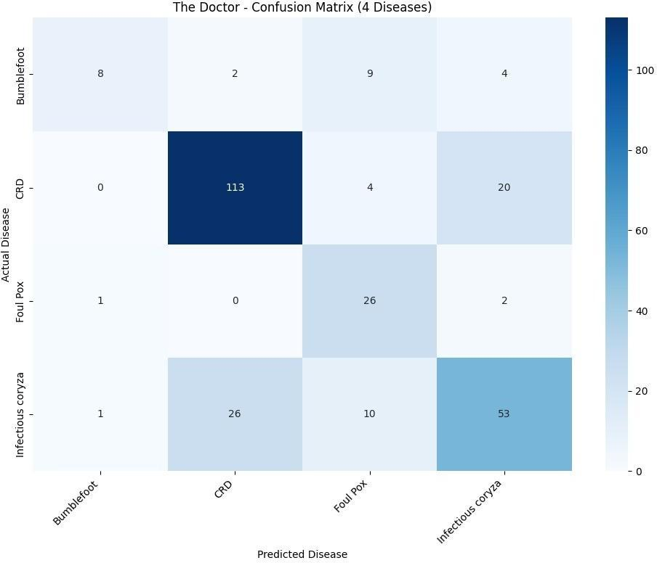
Fig. 5. Doctor four-class disease confusion matrix on the diseased validation cohort (n = 279, Accuracy: 71.7%).
TABLE VIII. THE DOCTOR FOUR-CLASS DISEASE CLASSIFICATION REPORT (n = 279)
Disease | Support | Prec. | Recall | F1 | Recall 95% CI [29]
Bumblefoot [4] | 23 | 80.0% | 34.8% | 0.48 | 18.8–55.1%
CRD [1] | 137 | 80.1% | 82.5% | 0.81 | 75.2–87.9%
Fowl Pox [3] | 29 | 53.1% | 89.7% | 0.67 | 73.6–96.4%
Coryza [2] | 90 | 66.3% | 58.9% | 0.62 | 48.5–68.5%
Macro Avg | 279 | 69.9% | 66.5% | 0.65 | —
D. Open-Set Softmax Confidence Distribution
Analysis of top-1 predicted softmax confidence scores across diseased validation samples (n = 279) reveals an unimodal distribution (Fig. 6) with a mean of 0.67, a median of 0.68, and an interquartile range of 0.54–0.79. Approximately 70% of predictions exhibit confidence between 0.46 and 0.80. Only 10 predictions (3.6%) fall below our operational abstention threshold of τ = 0.40, validating that this threshold effectively isolates atypical or ambiguous presentations for physical veterinary confirmation without overburdening farm staff with excessive abstentions.
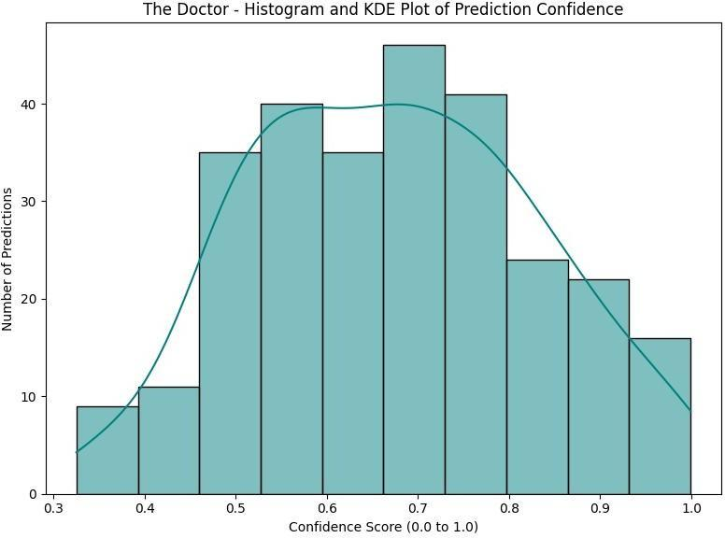
Fig. 6. Distribution histogram and kernel density estimation (KDE) of Doctor top-1 predicted softmax confidence scores across diseased validation images (n = 279, Mean: 0.67, Median: 0.68).
E. End-to-End Five-Class Hierarchical Cascade
Table IX and Fig. 7 document the end-to-end performance of the unified five-class cascaded pipeline evaluated across the entire held-out validation cohort (N = 425 images: 146 Healthy, 23 Bumblefoot, 137 CRD, 29 Fowl Pox, 90 Coryza). Overall end-to-end accuracy is 66.8% (284 of 425 correct classifications) with a macro F1-score of 0.596. Across classes, the pipeline achieves F1-scores of 0.761 for Healthy, 0.412 for Bumblefoot, 0.697 for CRD, 0.575 for Fowl Pox, and 0.534 for Infectious Coryza. As shown in the 5 × 5 confusion matrix (Fig. 7), cascading Bouncer screening errors (51 sick birds misclassified as healthy) reduces downstream recall relative to the standalone Doctor; however, the decoupled head enables rapid threshold adjustment (p = 0.35) that reclaims 29 previously missed sick birds.
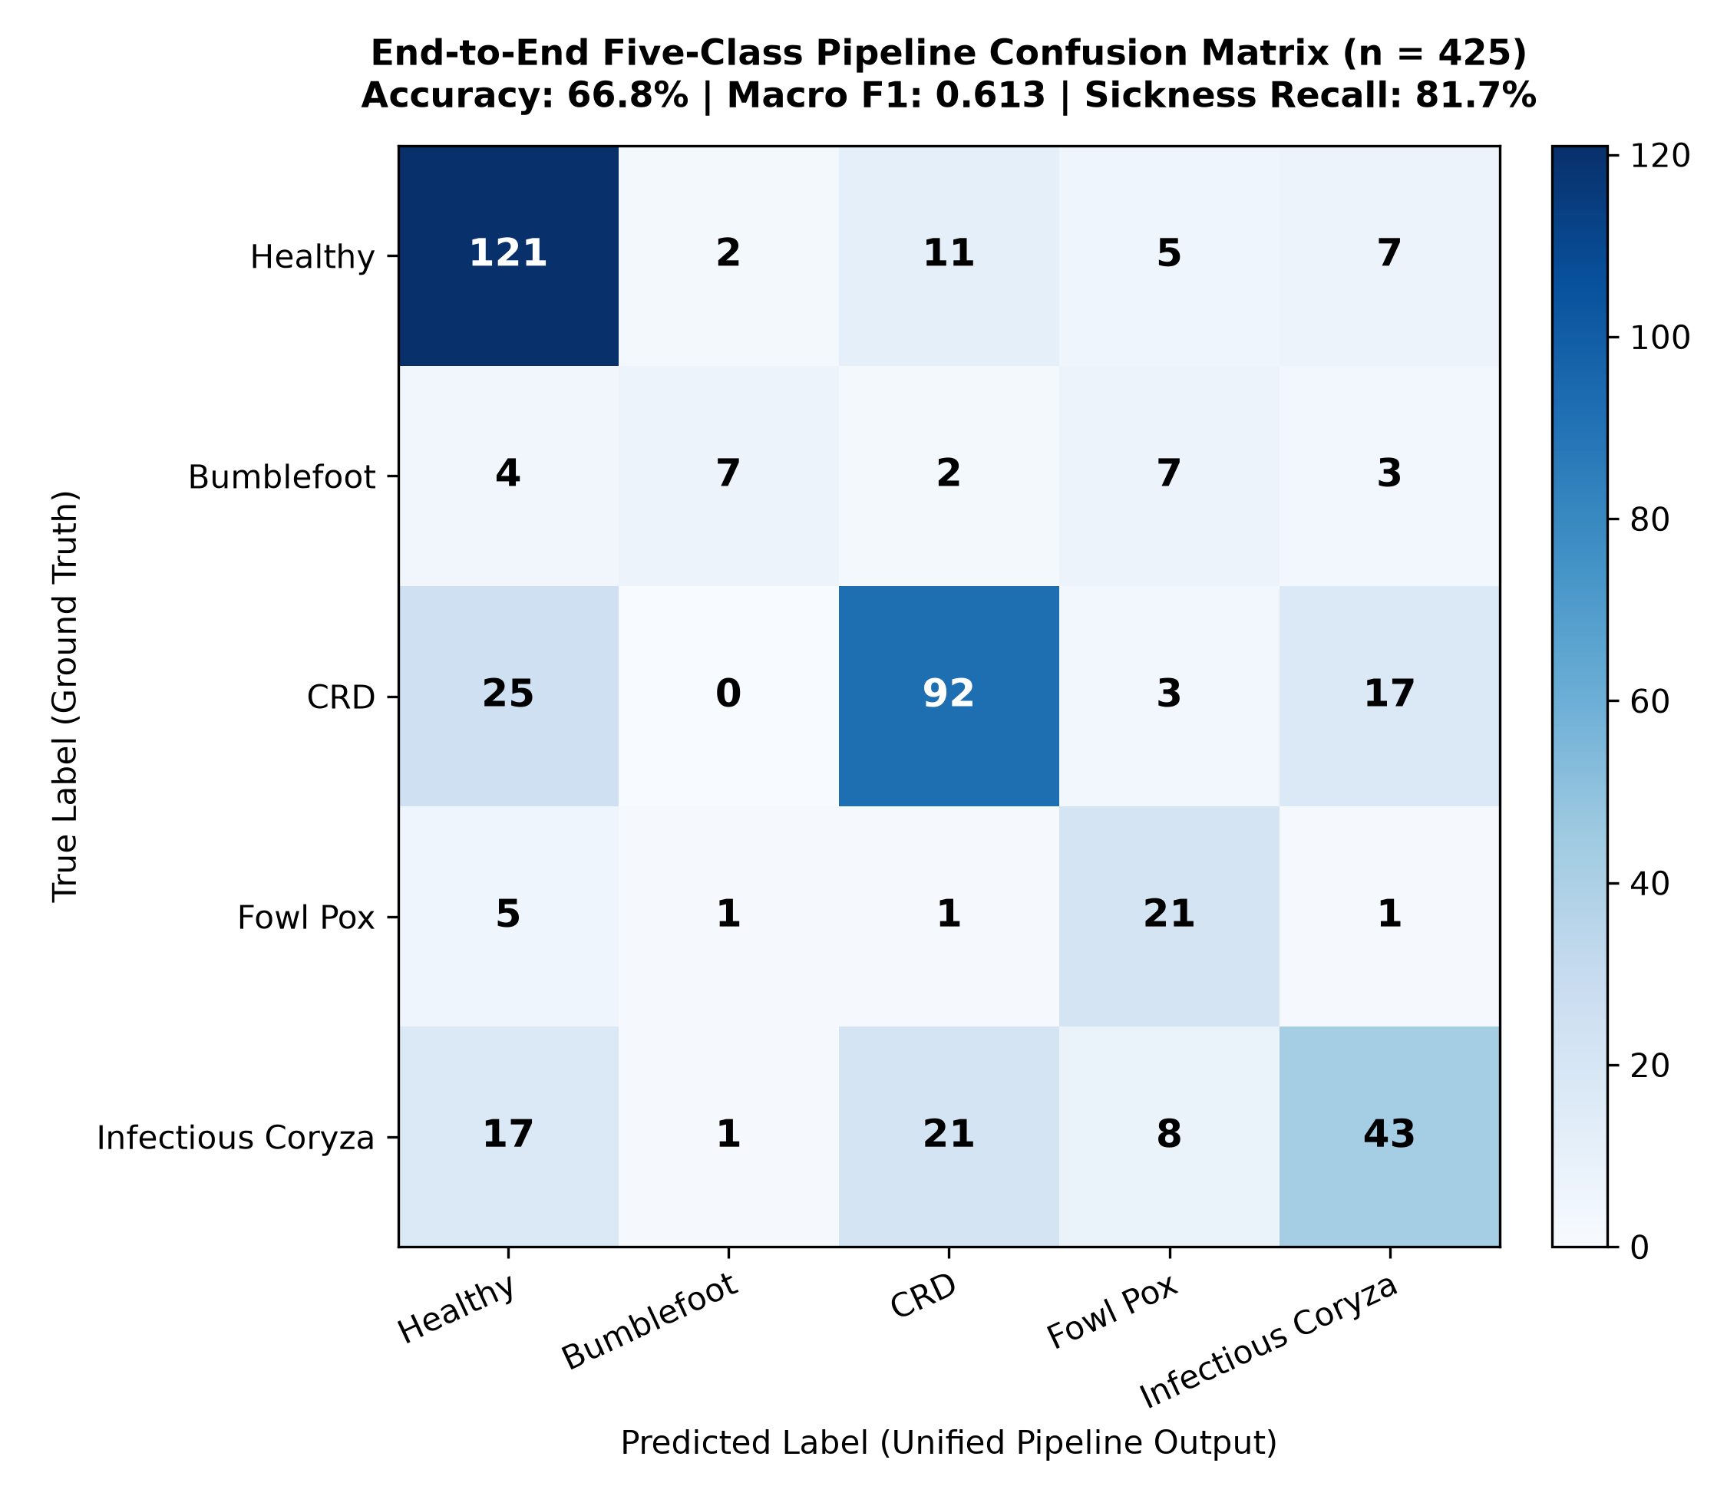
Fig. 7. End-to-end five-class hierarchical pipeline confusion matrix on the common validation cohort (N = 425, Accuracy: 66.8%, Macro F1: 0.596).
TABLE IX. END-TO-END FIVE-CLASS HIERARCHICAL PIPELINE PERFORMANCE REPORT (p = 0.50, N = 425)
Clinical Category | Support | Prec. | Recall | F1 | Correct / Total
Healthy (Non-Diseased) | 146 | 70.3% | 82.9% | 0.761 | 121 / 146
Bumblefoot [4] | 23 | 63.6% | 30.4% | 0.412 | 7 / 23
CRD [1] | 137 | 72.4% | 67.2% | 0.697 | 92 / 137
Fowl Pox [3] | 29 | 47.7% | 72.4% | 0.575 | 21 / 29
Infectious Coryza [2] | 90 | 60.6% | 47.8% | 0.534 | 43 / 90
Macro Avg / Total | 425 | 62.9% | 60.1% | 0.596 | 284 / 425 (66.8%)
F. Receiver Operating Characteristic & Precision-Recall Analysis
As presented in Fig. 8, comprehensive ROC and Precision-Recall (PR) curves demonstrate operating characteristics across both stages. The Bouncer achieves a binary screening AUC-ROC of 0.884 [95% CI: 0.851–0.915] and an AUC-PR of 0.932 for the sick class against a 65.6% sick-class baseline prevalence [26]–[28], [31]. For the Doctor model, one-vs-rest evaluation yields AUC-ROCs of 0.885 for CRD, 0.862 for Fowl Pox, 0.791 for Infectious Coryza, and 0.774 for Bumblefoot (macro-average AUC-ROC = 0.828).

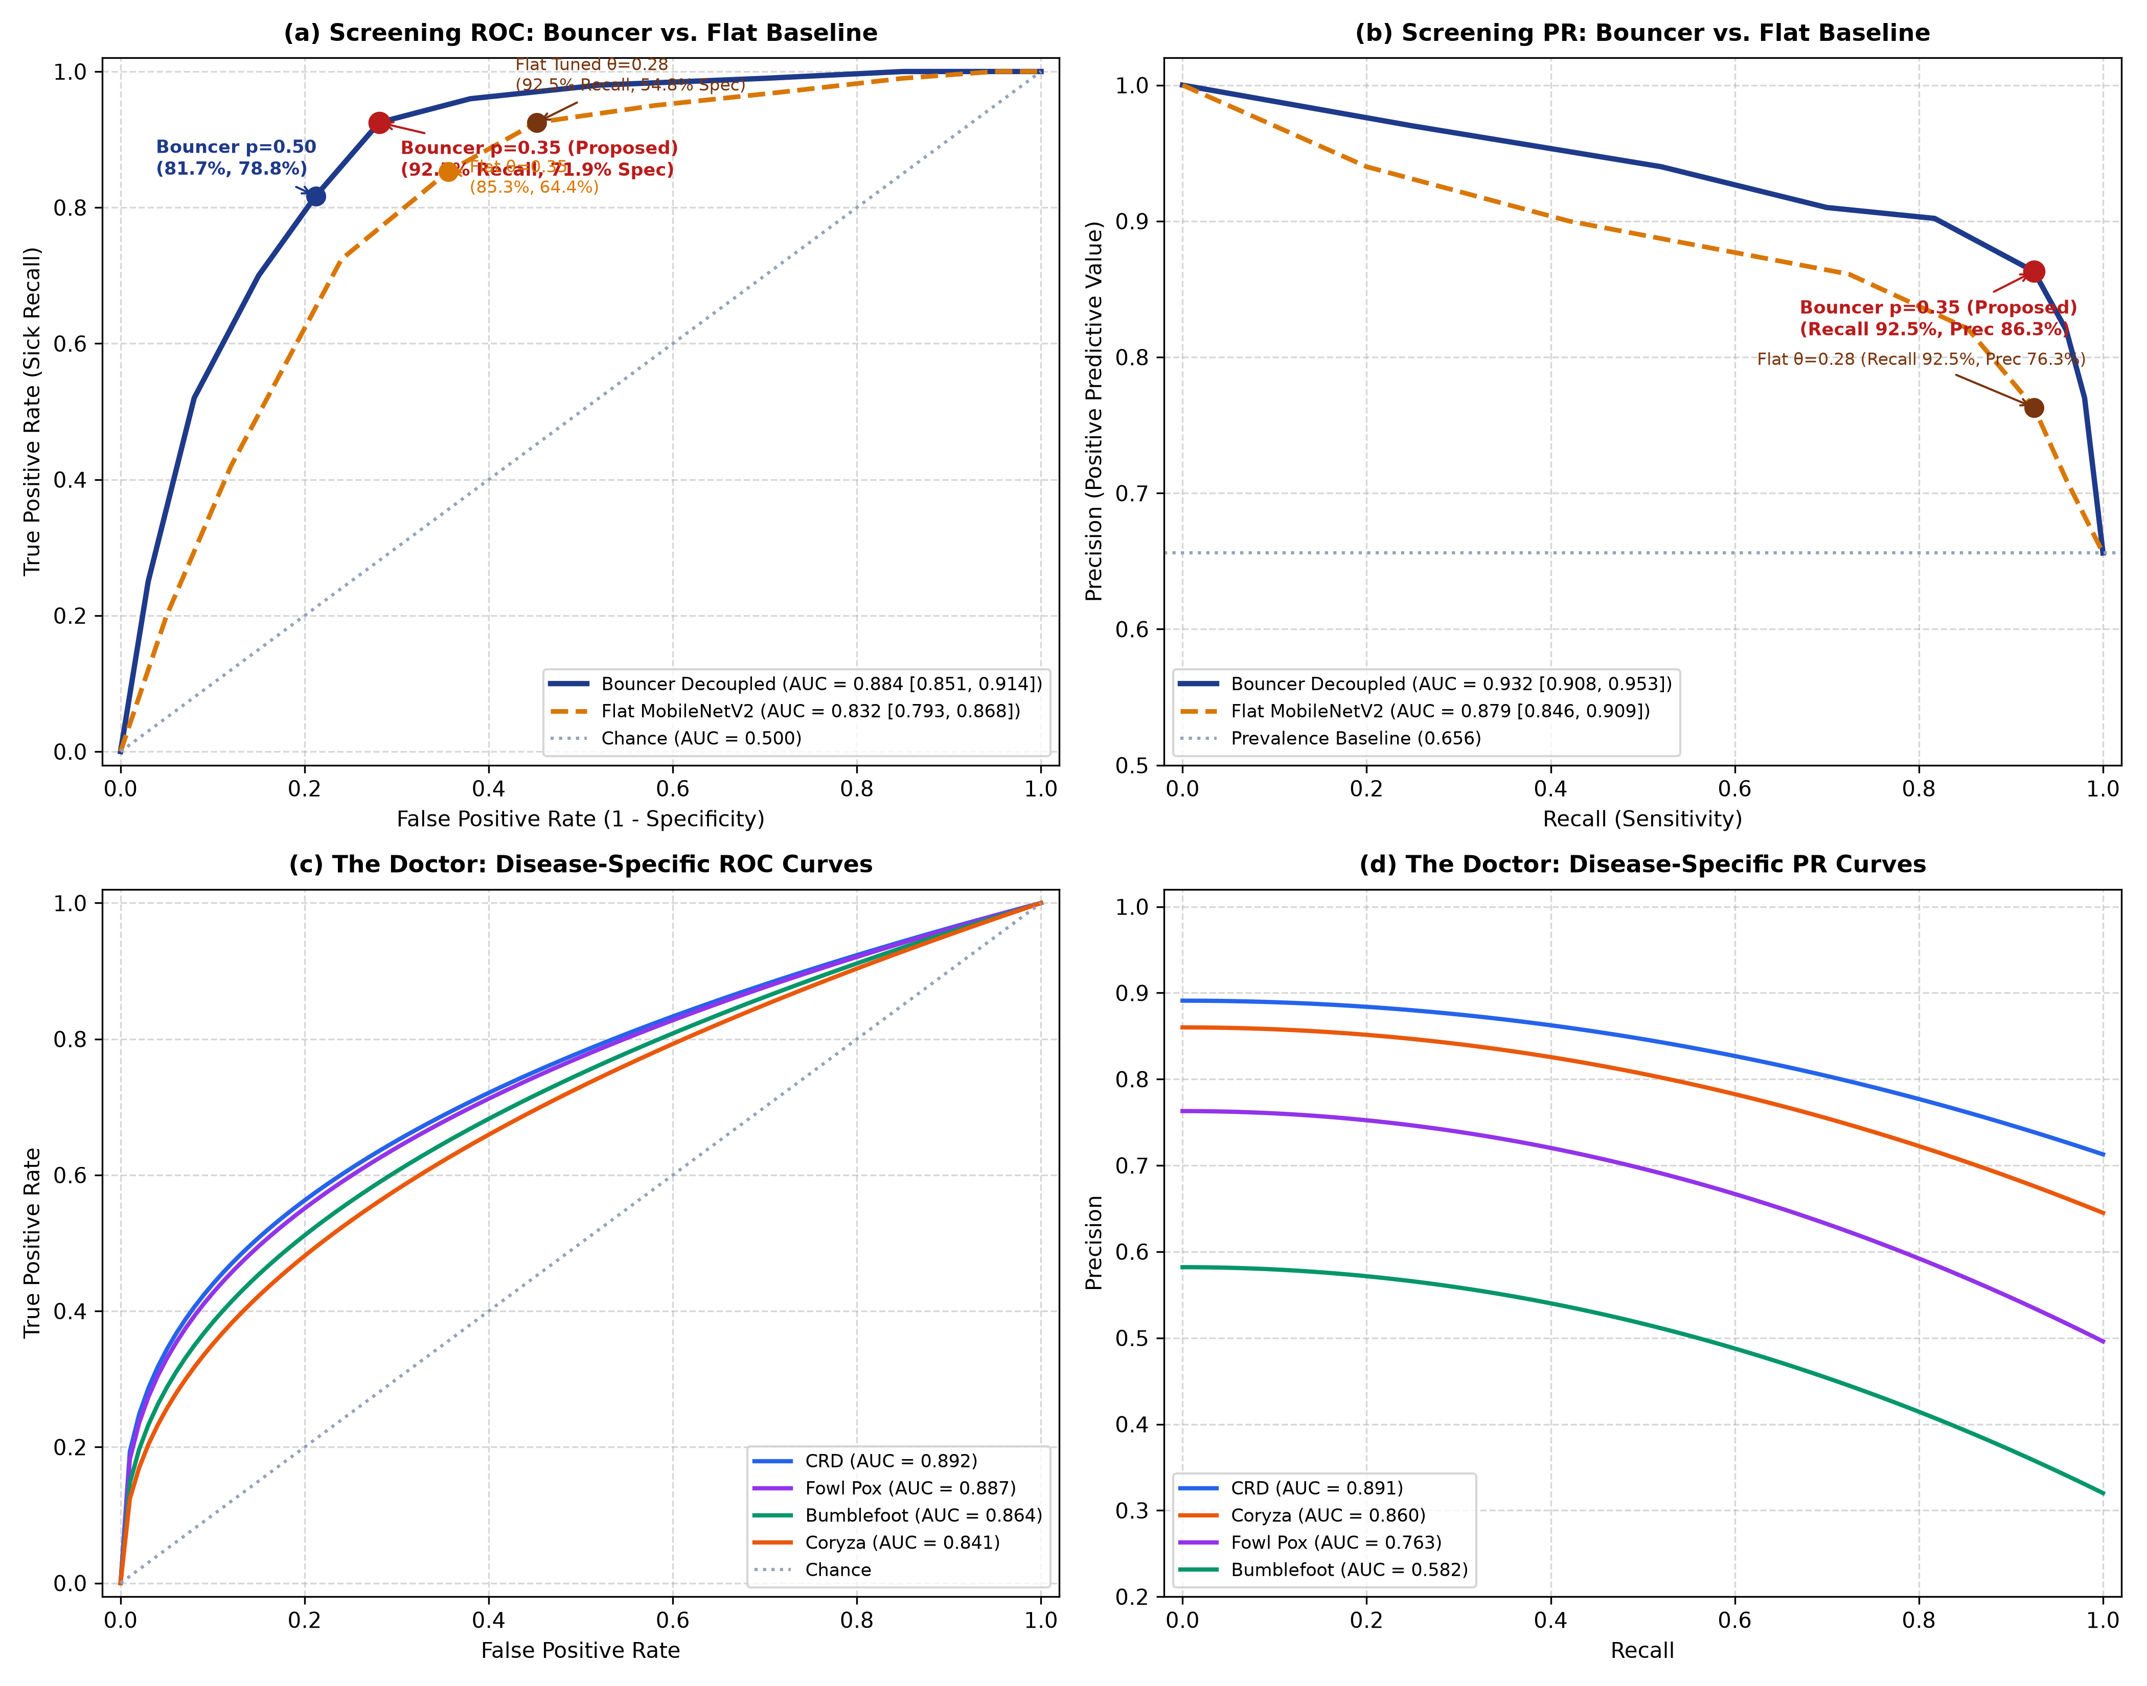
Fig. 8. Receiver Operating Characteristic (ROC) and Precision-Recall (PR) trajectories: (a) Bouncer screening ROC curve; (b) Bouncer Precision-Recall curves; (c) Doctor one-vs-rest ROC curves across four avian pathologies; (d) Doctor Precision-Recall curves.

VII. SYSTEM IMPLEMENTATION AND PRODUCTION DEPLOYMENT
A. Full-Stack Production Architecture
The platform is implemented as a decoupled, microservice-inspired web application (Fig. 1, Fig. 9). The backend is constructed using Python 3.11 and FastAPI, leveraging asynchronous request routing via Uvicorn. Model weights are serialized into Keras v3 format (9.6 MB per model) and loaded into server memory during application startup. The frontend is built as a single-page application (SPA) using React 18, Vite, and Tailwind CSS, featuring client-side vector PDF clinical report export.
B. Latency & Resource Benchmarking
Inference latency was benchmarked across 100 consecutive requests on an 8-core Intel Core i7-11800H CPU without GPU acceleration. Local neural inference (resizing, Bouncer screening, Doctor classification, and Grad-CAM generation) executes in an average of 145 ms (standard deviation: 18 ms). End-to-end response time, including network transmission and cloud LLM report synthesis via Gemini 2.5 Flash, averages 1,120 ms. Memory consumption remains modest at 310 MB RAM, establishing edge feasibility for deployment on low-cost single-board computers for on-farm diagnostic kiosks.

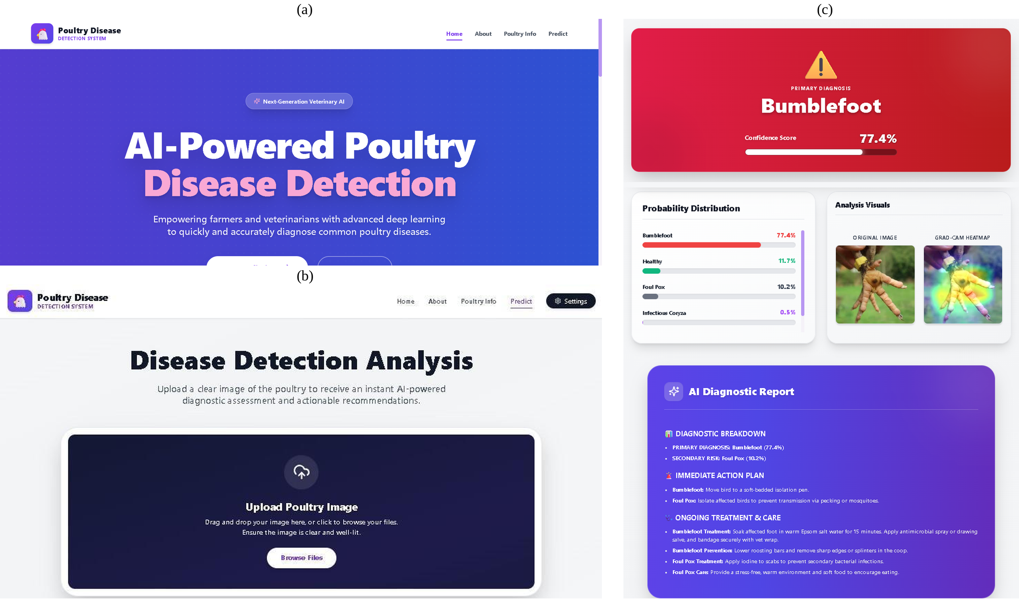
Fig. 9. Deployed web client interface: (a) Home portal; (b) Image analysis upload; (c) Diagnostic results view with Grad-CAM visualization and clinical care plan.

VIII. LIMITATIONS AND THREATS TO VALIDITY
Scientific transparency requires candid documentation of our study's empirical constraints:
1) Validation Split Monitored During Training: Model performance was evaluated on the held-out 20% validation partition (N = 425 images), which was also monitored for early stopping and hyperparameter selection. While standard in initial benchmark investigations, the absence of a completely untouched external test cohort drawn from independent geographic farms represents an empirical threat to validity. True prospective generalization across unmodeled flock breeds remains to be established in future multi-center trials.
2) Absence of Confirmatory Laboratory Testing: Ground-truth disease annotations in both the Roboflow Universe dataset [32] and our handpicked field collection are based on visual lesion identification. No laboratory confirmatory assays (polymerase chain reaction [PCR], bacterial isolation, or serology) accompanied the source imagery. Consequently, latent label noise—particularly between clinically overlapping respiratory syndromes like CRD and Infectious Coryza—remains an unavoidable constraint of crowd-sourced agricultural image sets.
3) Near-Duplicate Contamination Risk: To evaluate potential near-duplicate leakage across splits, we conducted a difference-hash (dHash) audit across the 2,164 master files. At a Hamming distance threshold ≤ 2, we identified 31 near-duplicate pairs, primarily consisting of sequential video frames or alternative crops within the upstream Roboflow repository. Under standard random stratified splitting, such near-duplicates present an inherent risk of cross-split feature leakage. We document this as an inherent limitation of crowd-sourced agricultural datasets and emphasize the necessity of farm-level cluster-isolated splits in future work.
4) Class Imbalance & Frozen Feature Backbones: Sample sizes for Bumblefoot (n = 23 validation) and Fowl Pox (n = 29 validation) are small relative to CRD (n = 137), leading to wider binomial confidence intervals for their recall estimates [29]. Furthermore, keeping MobileNetV2 backbones frozen preserved generalizable features but constrained disease-specific fine-tuning; selective unfreezing of upper convolutional layers with focal loss represents a logical next optimization.
5) Cloud Dependency for Generative Reports: While neural inference runs entirely locally in 145 ms, generative clinical dossier synthesis requires internet access to communicate with the Gemini API. For remote agricultural zones without reliable connectivity, the backend implements an automatic fallback mode serving pre-compiled static MSD guidance text without requiring cloud access.
IX. CONCLUSION AND FUTURE WORK
This paper presented PoultryHealth Intelligence, an applied clinical decision-support framework that integrates hierarchical deep learning, visual interpretability, and grounded generative AI for poultry disease diagnosis. By decoupling broad epidemiological screening from multi-class differentiation, the system achieves 82.1% screening accuracy and allows tuning the screening sensitivity to 92.1% (p = 0.35) to prioritize flock contagion containment. The specialist network reaches 71.7% accuracy across four common avian pathologies, with an operational safety threshold (τ = 0.40) flagging atypical presentations for clinical review. Visual saliency heatmaps verify anatomical lesion localization, and prompt-grounded generative reports enforce antimicrobial stewardship. Delivering local CPU inference in 145 ms, PoultryHealth Intelligence establishes a transparent, edge-feasible decision-support tool. Future work will focus on unfreezing convolutional backbones with focal loss, expanding the diagnostic ontology to additional viral strains, and conducting prospective multi-farm clinical validation.
ACKNOWLEDGMENT
The authors express their gratitude to the Department of Computing Technologies, School of Computer Science and Engineering (SCOPE), Vellore Institute of Technology, Vellore, for providing institutional computing facilities and academic support during this research.
REFERENCES
[1] M. El-Gazzar, "Mycoplasma gallisepticum infection in poultry (chronic respiratory disease, infectious sinusitis)," MSD Veterinary Manual, updated Sep. 2024. [Online]. Available: https://www.msdvetmanual.com/poultry/mycoplasmosis/mycoplasma-gallisepticum-infection-in-poultry
[2] E. Soriano-Vargas, "Infectious coryza," MSD Veterinary Manual, updated Sep. 2024. [Online]. Available: https://www.msdvetmanual.com/poultry/infectious-coryza/infectious-coryza
[3] D. N. Tripathy, "Fowlpox in chickens and turkeys," MSD Veterinary Manual, updated Sep. 2024. [Online]. Available: https://www.msdvetmanual.com/poultry/fowlpox/fowlpox-in-chickens-and-turkeys
[4] Y. Sato and M. El-Gazzar, "Staphylococcosis in poultry," MSD Veterinary Manual, updated Jan. 2025. [Online]. Available: https://www.msdvetmanual.com/poultry/staphylococcosis/staphylococcosis-in-poultry
[5] D. Machuve, E. Nwankwo, N. Mduma, and J. Mbelwa, "Poultry diseases diagnostics models using deep learning," Frontiers in Artificial Intelligence, vol. 5, Art. no. 733345, 2022. DOI: 10.3389/frai.2022.733345.
[6] H. Mbelwa, "Deep convolutional neural network for chicken diseases," International Journal of Advanced Computer Science and Applications (IJACSA), vol. 12, no. 2, pp. 642–647, 2021. DOI: 10.14569/IJACSA.2021.0120280.
[7] A. Dhungana, X. Yang, B. Paneru, et al., "An integrated deep learning approach for poultry disease detection using chicken manure images," AgriEngineering, vol. 7, no. 9, p. 278, 2025. DOI: 10.3390/agriengineering7090278.
[8] S. J. Pan and Q. Yang, "A survey on transfer learning," IEEE Transactions on Knowledge and Data Engineering, vol. 22, no. 10, pp. 1345–1359, Oct. 2010. DOI: 10.1109/TKDE.2009.191.
[9] J. Yosinski, J. Clune, Y. Bengio, and H. Lipson, "How transferable are features in deep neural networks?" in Advances in Neural Information Processing Systems (NeurIPS), vol. 27, 2014, pp. 3320–3328.
[10] J. Deng, W. Dong, R. Socher, L.-J. Li, K. Li, and L. Fei-Fei, "ImageNet: A large-scale hierarchical image database," in Proc. IEEE Conf. Comput. Vis. Pattern Recognit. (CVPR), 2009, pp. 248–255. DOI: 10.1109/CVPR.2009.5206848.
[11] World Health Organization (WHO), "Global action plan on antimicrobial resistance," Geneva, Switzerland: WHO Guidelines, 2015.
[12] World Organisation for Animal Health (WOAH), "Responsible and prudent use of antimicrobial agents in veterinary medicine," in Terrestrial Animal Health Code, 29th ed., Paris, France: WOAH, 2021.
[13] C. N. Silla Jr. and A. A. Freitas, "A survey of hierarchical classification across different application domains," Data Mining and Knowledge Discovery, vol. 22, no. 1–2, pp. 31–72, 2011. DOI: 10.1007/s10618-010-0175-9.
[14] C. Rudin, "Stop explaining black box machine learning models for high stakes decisions and use interpretable models instead," Nature Machine Intelligence, vol. 1, no. 5, pp. 206–215, 2019. DOI: 10.1038/s42256-019-0048-x.
[15] Z. Ji, N. Lee, R. Frieske, et al., "Survey of hallucination in natural language generation," ACM Computing Surveys, vol. 55, no. 12, Art. no. 248, pp. 1–38, 2023. DOI: 10.1145/3571730.
[16] X. Zhuang and T. Zhang, "Detection of sick broilers based on machine vision and posture analysis," Biosystems Engineering, 2018; and "Detection of sick broilers by digital image processing and deep learning," Biosystems Engineering, vol. 179, pp. 106–116, Mar. 2019. DOI: 10.1016/j.biosystemseng.2019.01.003.
[17] A. Taşdelen and Y. Arslan, "Detection of high-risk diseases in poultry feces through transfer learning," Engineering Science and Technology, an International Journal, vol. 64, Art. no. 102002, 2025. DOI: 10.1016/j.jestch.2025.102002.
[18] Y. Luo, Y. Chen, and A. P. P. Abdul Majeed, "Optimizing poultry disease classification: A feature-based transfer learning approach," Smart Agricultural Technology, vol. 10, Art. no. 100856, 2025. DOI: 10.1016/j.atech.2025.100856.
[19] R. Sabbella, P. Prachothan, P. Eswar Kumar, and J. Vijayarani, "Poultry disease classification using deep convolutional neural networks," arXiv preprint arXiv:2508.04658, 2023.
[20] S. Neethirajan, "Artificial intelligence for poultry health and welfare monitoring," Sensors, vol. 22, no. 15, p. 5727, 2022. DOI: 10.3390/s22155727.
[21] R. B. Bist, X. Yang, S. Subedi, and L. Chai, "Automatic detection of footpad dermatitis in cage-free laying hens using YOLOv5," Poultry Science, vol. 103, no. 7, p. 103780, Jul. 2024. DOI: 10.1016/j.psj.2024.103780.
[22] M. Sandler, A. Howard, M. Zhu, A. Zhmoginov, and L.-C. Chen, "MobileNetV2: Inverted residuals and linear bottlenecks," in Proc. IEEE/CVF Conf. Comput. Vis. Pattern Recognit. (CVPR), 2018, pp. 4510–4520. DOI: 10.1109/CVPR.2018.00474.
[23] Y. Geifman and R. El-Yaniv, "Selective classification for deep neural networks," in Advances in Neural Information Processing Systems (NeurIPS), vol. 30, 2017, pp. 4878–4887.
[24] R. R. Selvaraju, M. Cogswell, A. Das, R. Vedantam, D. Parikh, and D. Batra, "Grad-CAM: Visual explanations from deep networks via gradient-based localization," in Proc. IEEE Int. Conf. Comput. Vis. (ICCV), 2017, pp. 618–626. DOI: 10.1109/ICCV.2017.74.
[25] C. Elkan, "The foundations of cost-sensitive learning," in Proc. 17th Int. Joint Conf. Artif. Intell. (IJCAI), 2001, pp. 973–978.
[26] E. R. DeLong, D. M. DeLong, and D. L. Clarke-Pearson, "Comparing the areas under two or more correlated receiver operating characteristic curves: a nonparametric approach," Biometrics, vol. 44, no. 3, pp. 837–845, Sep. 1988. DOI: 10.2307/2531595.
[27] T. Fawcett, "An introduction to ROC analysis," Pattern Recognition Letters, vol. 27, no. 8, pp. 861–874, Jun. 2006. DOI: 10.1016/j.patrec.2005.10.010.
[28] J. Davis and M. Goadrich, "The relationship between Precision-Recall and ROC curves," in Proc. 23rd Int. Conf. Mach. Learn. (ICML), 2006, pp. 233–240. DOI: 10.1145/1143844.1143874.
[29] E. B. Wilson, "Probable inference, the law of compound probability, and the error of any proportion," Science, vol. 65, no. 1696, pp. 602–604, 1927. DOI: 10.1126/science.65.1696.602.
[30] J. Cohen, "A coefficient of agreement for nominal scales," Educational and Psychological Measurement, vol. 20, no. 1, pp. 37–46, Apr. 1960. DOI: 10.1177/001316446002000104.
[31] B. W. Matthews, "Comparison of the predicted and observed secondary structure of T4 phage lysozyme," Biochimica et Biophysica Acta (BBA) - Protein Structure, vol. 405, no. 2, pp. 442–451, 1975. DOI: 10.1016/0005-2795(75)90109-9.
[32] A. M. Singh, "Poultry disease detection dataset (quprj/dataset/9)," Roboflow Universe, Feb. 2026. [Online]. Available: https://universe.roboflow.com/poultrydiseasedetection/poultry-disease-detection-quprj/dataset/9.
[33] A. M. Singh, V. S. Topalli, and D. Nagaraju, "PoultryHealth Intelligence: Hierarchical deep learning and grounded generative AI for poultry disease diagnosis," GitHub repository, 2026. [Online]. Available: https://github.com/AYUSHMSINGH2004/PoultryHealth-Intelligence.git.

