**GIT ASSIGNMENT**

**1. Create a directory ‘project_dir’ & cd to ‘project_dir’**

**2. Initialize git version database. (git init)**

**3. Create a new file index.html.**

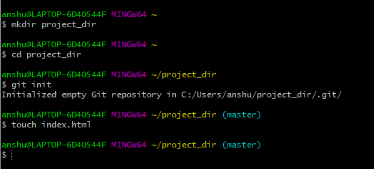

**4. Check the git status. You should find index.html as untracked file.**

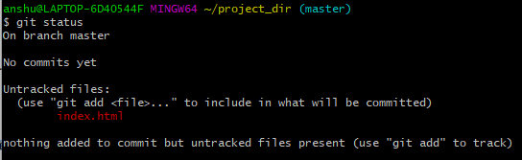

**5. Stage the index.html file.**

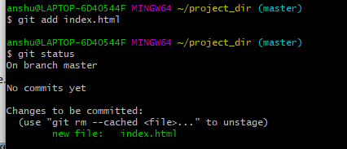

**6. Commit index.html**

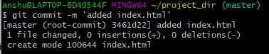

**7. Make few changes in index.html & create a new file info.txt file.**

**8. Check git status. You should find index.html & info.txt as untracked files.**

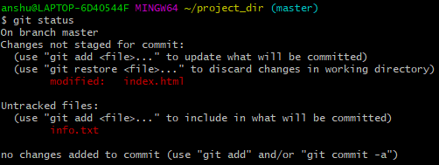

**9. Configure GIT to ignore all txt files.**



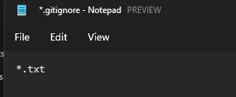

**10. Again check the git status. You should find only index.html as untracked file.**

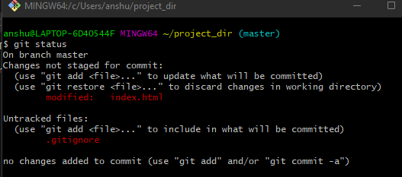

**11. State & commit index.html**

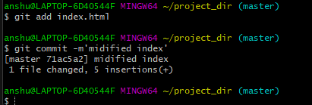

**12. Log all your comments so far.**

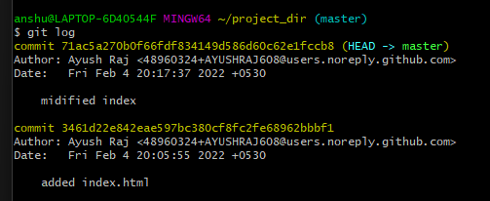

**13. Make some changes in index.html.**

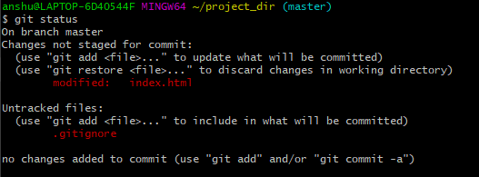

**14. Revert the change made in the previous step using git command.**



**15. Again change index.html.**

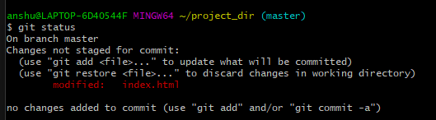

**16. Stage index.html**

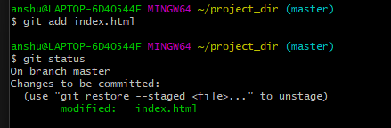

**17. Revert back the last stage.**

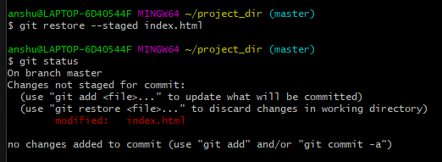

**18. Rename ‘add’ command to ‘my-add’.**



**19. Using my_add command Stage index.html again & commit the changes.**

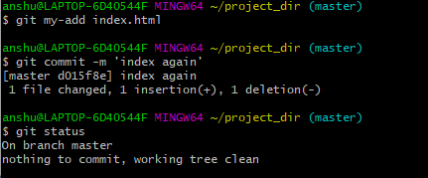

**20. Revert the last commit.**

