SALESFORCE
PLATFORM DEVELOPER
Project Guide: Student Support Request Management System

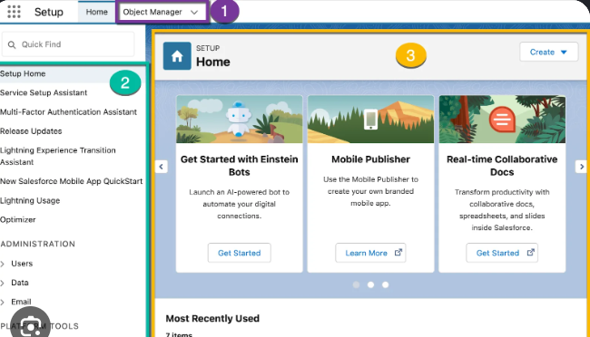
Registered email: ayushbhosale2024.mech@mmcoe.edu.in
Learning-focused implementation guide | October 2026

Project Description
The Salesforce Platform Developer project demonstrates how to build a small, data-driven business application on Salesforce. The example application, Student Support Request Management System, allows students or staff to submit support requests, categorize and prioritize them, and track progress. A custom Salesforce object stores the requests, Apex applies server-side rules, and a Lightning Web Component (LWC) provides a focused user interface.
The guide follows the same overall structure as the supplied reference document: project description, scenarios, architecture, prerequisites, milestones, implementation steps, testing, deployment, interface overview, and conclusion. The diagrams and interface illustration have been changed to fit Salesforce development.

Project Objectives
- Create a Salesforce development environment using a Developer Edition org or Trailhead Playground.
- Design a custom data model for support requests and define appropriate fields and picklist values.
- Write Apex classes to validate and create request records using Salesforce data access patterns.
- Build a Lightning Web Component that lets a user submit a request and view recent requests.
- Write Apex tests, verify permissions, and deploy source changes with Salesforce CLI or an approved deployment process.

Example Scenarios
Scenario 1: A student cannot access the course portal. They submit a request with category IT and priority High. The record is saved and appears in the request list.
Scenario 2: A student needs access to a laboratory. They submit a Facilities request. The support team reviews the record and updates its status to In Progress.
Scenario 3: A timetable correction is completed. An authorized staff member changes the status to Resolved, giving the requester a clear progress indicator.

Main Features

Virtual Internship Program: Salesforce Developer Track
The supplied program screenshot shows the Salesforce Developer Track under the Virtual Internship Program. It lists an estimated duration of 14 hours 20 minutes, the Salesforce category, an Intermediate level, and 100% progress. The page also provides a Trailblazer profile link and an Access Resource button. These details can be used to document the learning path associated with this project.
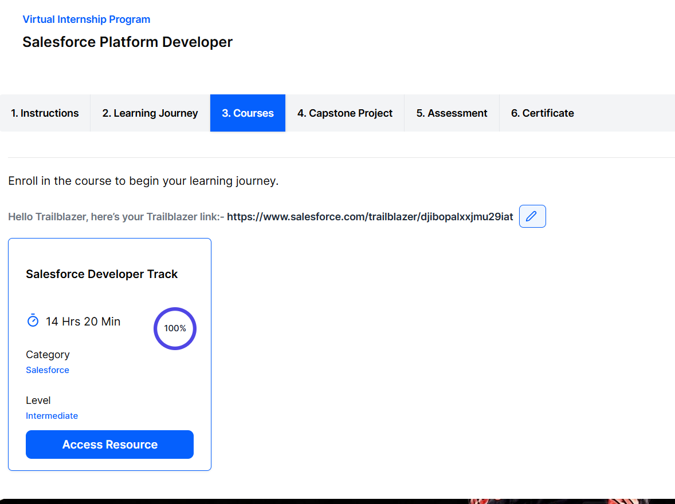
Figure: Salesforce Developer Track shown in the Virtual Internship Program.
- Request form with subject, category, priority, and description.
- Server-side validation to prevent blank or excessively long subjects.
- Recent request list with status and priority.
- Permission-aware data access and controlled record visibility.
- Automated Apex tests to verify valid and invalid requests.

Technical Architecture
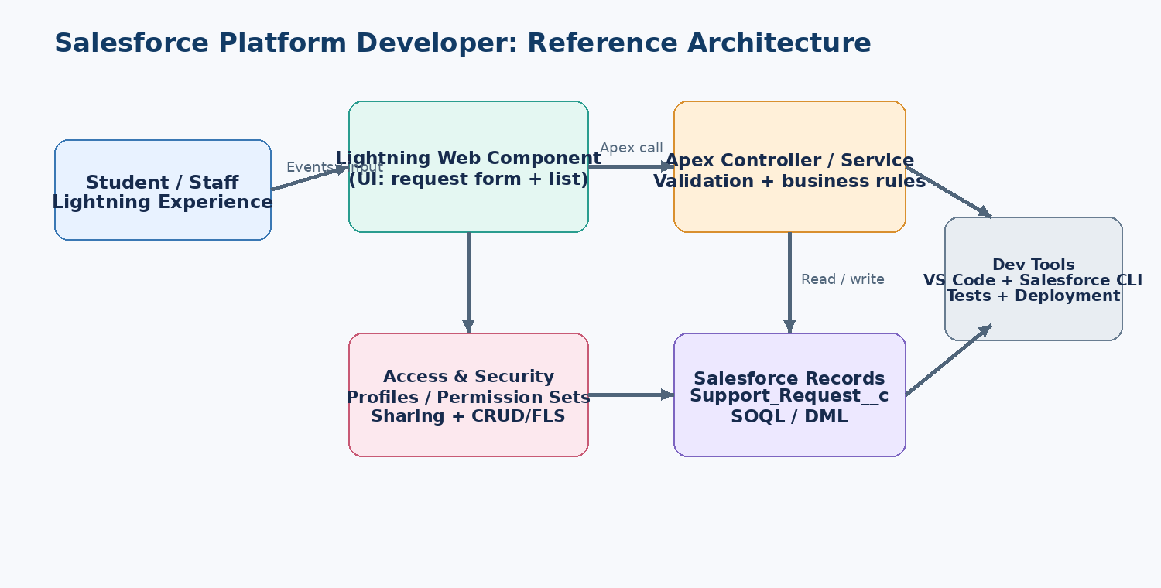
Description: The user interacts with a Lightning Web Component in Salesforce Lightning Experience. The component calls an Apex controller, which validates input and performs approved data operations on the Support Request custom object. Salesforce identity, sharing, object permissions, and field-level security must be considered at every layer. Salesforce CLI and a source-controlled project support testing and deployment.
Database note: This sample uses a single custom object, Support_Request__c. An ER diagram is not required for a one-object starter version. If you add related objects such as Department__c or Support_Agent__c, include a data model diagram showing the relationships.

Prerequisites
- A Salesforce Developer Edition org or Trailhead Playground.
- A basic understanding of CRM records, objects, fields, and permissions.
- Visual Studio Code and Salesforce Extensions for VS Code.
- Salesforce CLI (sf) and a supported Node.js LTS installation where required by the tooling.
- Basic Apex, SOQL, JavaScript, HTML, and CSS knowledge.
- Access to Salesforce Trailhead and official developer documentation.

Project Workflow
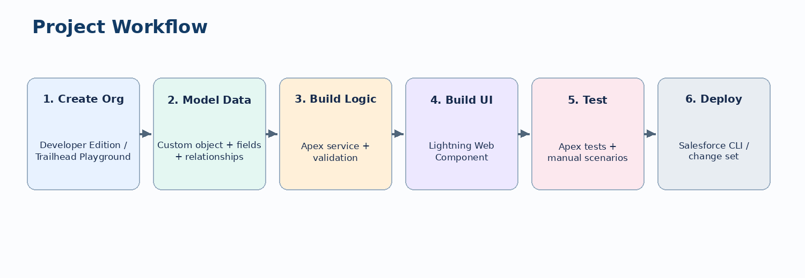
The milestones below take the project from environment setup through implementation, testing, and deployment. Menu labels can change slightly as Salesforce updates its tools.

Milestone 1: Environment Setup and Architecture

Activity 1.1: Create a Salesforce development org
- Open https://developer.salesforce.com/signup or use a Trailhead Playground from https://trailhead.salesforce.com.
- Register with a real email address that you can access. The email supplied for this document is ayushbhosale2024.mech@mmcoe.edu.in; use it only if you want that address associated with the org.
- Open the activation email, verify the account, set a password, and store the login details securely.
- Sign in to Salesforce and confirm that the org opens in Lightning Experience.
Important: The email printed here is for identification in the document. This guide does not create an account, reset a password, or connect to your Salesforce org.

Activity 1.2: Install developer tools
- Install Visual Studio Code from https://code.visualstudio.com/.
- Install Salesforce CLI using the official setup guide: https://developer.salesforce.com/tools/salesforcecli.
- In VS Code, open Extensions and install Salesforce Extension Pack.
- Open the Command Palette (Ctrl+Shift+P), search for “SFDX: Create Project” or the current Salesforce project creation command, and create a standard project.
- Authorize your development org from VS Code or the CLI. Give the connection an easy alias such as studentSupportDev.

Activity 1.3: Connect the org
sf org login web --alias studentSupportDev --instance-url https://login.salesforce.com
sf org display --target-org studentSupportDev

For a Trailhead Playground or sandbox, follow the login flow appropriate to that org. Do not place passwords or access tokens directly in source files.

Activity 1.4: Understand the project structure
force-app/
main/
default/
classes/
lwc/
objects/
permissionsets/
tabs/
sfdx-project.json

The classes folder contains Apex classes and tests. The lwc folder contains each Lightning Web Component bundle. The objects folder stores custom object and field metadata. Salesforce CLI commands and generated project files may vary by CLI version.

Milestone 2: Create the Data Model

Activity 2.1: Create the custom object
- In Salesforce Setup, open Object Manager and choose Create > Custom Object.
- Set Label to Support Request and Plural Label to Support Requests.
- Set Object Name to Support_Request. Salesforce will use the API name Support_Request__c.
- Enable useful options such as Allow Reports and Track Field History if they fit your requirements.
- Save the object, then create the fields listed below.
Field label | Type / API name | Purpose
Subject | Text (Subject__c) | Short description; required.
Category | Picklist (Category__c) | IT, Academic, Facilities, Other.
Priority | Picklist (Priority__c) | Low, Normal, High.
Status | Picklist (Status__c) | New, In Progress, Resolved.
Description | Long Text Area (Description__c) | Details about the issue.
Tip: Salesforce automatically provides standard fields such as Owner, Created Date, and Last Modified Date. Keep field-level security and record visibility aligned with the intended users.

Activity 2.2: Set field values and validation
- Make Subject required and choose a sensible maximum length, for example 120 characters.
- Use picklists for Category, Priority, and Status so records have consistent values.
- Create a validation rule if the business requirement needs more control, such as preventing a resolved request from having a blank resolution note.
- Grant access through permission sets rather than granting broad permissions to every user.

Milestone 3: Apex Business Logic
Apex is Salesforce's server-side programming language. The following example is a teaching starter, not a complete production implementation. Confirm object and field API names after creating them.

Activity 3.1: Create an Apex controller
public with sharing class SupportRequestController {
@AuraEnabled
public static Id createRequest(
String subject,
String category,
String priority,
String description
) {
if (String.isBlank(subject)) {
throw new AuraHandledException('Subject is required.');
}
if (subject.length() > 120) {
throw new AuraHandledException(
'Subject must be 120 characters or fewer.'
);
}
Support_Request__c requestRecord = new Support_Request__c(
Subject__c = subject.trim(),
Category__c = category,
Priority__c = priority,
Status__c = 'New',
Description__c = description
);
insert requestRecord;
return requestRecord.Id;
}
@AuraEnabled(cacheable=true)
public static List<Support_Request__c> getRecentRequests() {
return [
SELECT Id, Subject__c, Category__c, Priority__c, Status__c,
CreatedDate
FROM Support_Request__c
WITH USER_MODE
ORDER BY CreatedDate DESC
LIMIT 10
];
}
}

Security note: `with sharing` helps enforce record sharing, but it does not by itself enforce object and field permissions. Use user-mode operations or explicit CRUD/FLS checks appropriate to your design. Validate picklist values and handle exceptions deliberately.

Activity 3.2: Create an Apex test
@IsTest
private class SupportRequestControllerTest {
@IsTest
static void createsRequestWithRequiredFields() {
Test.startTest();
Id requestId = SupportRequestController.createRequest(
'Course portal access',
'IT',
'High',
'Unable to sign in to the portal.'
);
Test.stopTest();
Support_Request__c saved = [
SELECT Id, Subject__c, Status__c
FROM Support_Request__c
WHERE Id = :requestId
];
System.assertEquals('Course portal access', saved.Subject__c);
System.assertEquals('New', saved.Status__c);
}
@IsTest
static void rejectsBlankSubject() {
try {
SupportRequestController.createRequest(
' ', 'IT', 'Normal', 'Test'
);
System.assert(false, 'Expected a validation exception.');
} catch (AuraHandledException expected) {
System.assert(true);
}
}
}

This test illustrates the pattern. In a real project, adapt tests to your org's validation rules, required fields, record types, permissions, and current Apex testing behavior. Add tests for boundary lengths, invalid categories, access restrictions, and query results.

Activity 3.3: Understand SOQL and DML
- SOQL retrieves records, for example the query in getRecentRequests().
- DML statements such as insert, update, and delete modify records.
- Bulkify logic when processing collections, avoid queries or DML inside loops, and design around Salesforce governor limits.

Milestone 4: Lightning Web Component (LWC)
Lightning Web Components are reusable UI components built with HTML and JavaScript. This example keeps the form intentionally small so the data flow is easy to understand.

Activity 4.1: Generate the component
sf lightning generate component --name supportRequestForm --type lwc --output-dir force-app/main/default/lwc

If the command syntax differs in your installed CLI, use the command's --help output or generate the component through the Salesforce VS Code command palette.

Activity 4.2: Component HTML
<template>
<lightning-card title="New Support Request" icon-name="standard:case">
<div class="slds-p-around_medium">
<lightning-input
label="Subject"
value={subject}
onchange={handleSubjectChange}
required>
</lightning-input>
<lightning-combobox
label="Category"
value={category}
options={categoryOptions}
onchange={handleCategoryChange}>
</lightning-combobox>
<lightning-combobox
label="Priority"
value={priority}
options={priorityOptions}
onchange={handlePriorityChange}>
</lightning-combobox>
<lightning-textarea
label="Description"
value={description}
onchange={handleDescriptionChange}>
</lightning-textarea>
<lightning-button
class="slds-m-top_medium"
label="Submit Request"
variant="brand"
onclick={handleSubmit}>
</lightning-button>
</div>
</lightning-card>
</template>

Activity 4.3: Component JavaScript
import { LightningElement } from 'lwc';
import { ShowToastEvent } from 'lightning/platformShowToastEvent';
import createRequest from '@salesforce/apex/SupportRequestController.createRequest';
export default class SupportRequestForm extends LightningElement {
subject = '';
category = 'IT';
priority = 'Normal';
description = '';
categoryOptions = [
{ label: 'IT', value: 'IT' },
{ label: 'Academic', value: 'Academic' },
{ label: 'Facilities', value: 'Facilities' },
{ label: 'Other', value: 'Other' }
];
priorityOptions = [
{ label: 'Low', value: 'Low' },
{ label: 'Normal', value: 'Normal' },
{ label: 'High', value: 'High' }
];
handleSubjectChange(event) { this.subject = event.target.value; }
handleCategoryChange(event) { this.category = event.detail.value; }
handlePriorityChange(event) { this.priority = event.detail.value; }
handleDescriptionChange(event) { this.description = event.target.value; }
async handleSubmit() {
if (!this.subject.trim()) {
this.dispatchEvent(new ShowToastEvent({
title: 'Missing subject',
message: 'Enter a subject before submitting.',
variant: 'error'
}));
return;
}
try {
await createRequest({
subject: this.subject,
category: this.category,
priority: this.priority,
description: this.description
});
this.dispatchEvent(new ShowToastEvent({
title: 'Request submitted',
message: 'Your support request was created.',
variant: 'success'
}));
this.subject = '';
this.description = '';
} catch (error) {
this.dispatchEvent(new ShowToastEvent({
title: 'Unable to submit',
message: error?.body?.message || 'Please try again.',
variant: 'error'
}));
}
}
}

For a complete UI, add the component's XML metadata file, expose it to an appropriate Lightning page target, and include a separate request-list component or refresh the list after submission. The mockup below is an illustrative design, not a screenshot of a live Salesforce org.

Activity 4.4: Interface mockup
Description: The illustrative console places the request form on the left and recent requests on the right. A production implementation should use standard Lightning base components and the Salesforce Lightning Design System for consistency and accessibility.

Milestone 5: Testing, Debugging, and Deployment

Activity 5.1: Deploy source to the development org
sf project deploy start --source-dir force-app/main/default --target-org studentSupportDev

Deploy metadata only after confirming the target org and reviewing the changes. For a beginner project, deploy first to a dedicated development org, not a production org.

Activity 5.2: Run Apex tests
sf apex run test --target-org studentSupportDev --test-level RunLocalTests --wait 10

Check the test output and Salesforce Setup debug logs for errors. A deployment may require tests depending on the target and deployment method.

Activity 5.3: Functional test checklist
- Submitting a valid request creates one Support_Request__c record with Status New.
- Submitting a blank subject shows a clear validation message and does not create a record.
- Submitting a subject longer than the allowed length is rejected.
- The category and priority values match the configured picklists.
- A user without required permissions cannot access restricted fields or records.
- The request list shows the most recent records and does not expose records the user is not authorized to see.
- Apex tests pass in the target org, including both positive and negative test cases.

Activity 5.4: Deployment options
For learning, Salesforce CLI is a practical way to deploy source to a development org. Teams may use sandboxes, change sets, DevOps Center, or CI/CD pipelines depending on their release process. Validate all metadata dependencies and permissions before deployment.

Exploring the Application Pages

Support Request Form
The form collects the subject, category, priority, and description. Client-side checks improve the experience, while Apex validation remains necessary because users and integrations can call server-side methods in ways that bypass the form.

Recent Requests
The recent-request list should show only the fields needed for triage, such as subject, priority, status, and created date. Use a secure Apex query or Lightning Data Service, and make sure record visibility matches the organization's sharing model.

Important Implementation Notes
- The UI image in this guide is a conceptual mockup created for this document. It is not a live Salesforce screenshot.
- API names must match the actual object and fields created in your org.
- The example is a learning scaffold. Add production-grade CRUD/FLS enforcement, robust exception handling, accessibility checks, and tests before real-world use.
- Never paste passwords, session IDs, or secrets into source code, screenshots, or public repositories.
- Use Salesforce's current documentation because CLI commands, platform behavior, and setup labels can change.

Conclusion
The Salesforce Platform Developer project demonstrates the main stages of building a custom application on the Salesforce Platform: setting up a development org, modeling data, writing Apex business logic, creating a Lightning Web Component, testing behavior, and deploying source. The Student Support Request Management System provides a practical starting point for learning how a user interface, server-side logic, records, and access controls work together.
Possible future improvements include email notifications, assignment rules, reports and dashboards, file attachments, record ownership workflows, an approval process, and a more complete request history. Each enhancement should be paired with appropriate permissions and automated tests.

Official Learning Resources
- Salesforce Trailhead: Developer Beginner: https://trailhead.salesforce.com/content/learn/trails/force_com_dev_beginner
- Salesforce Development Essentials Guide: https://trailhead.salesforce.com/content/learn/projects/get-started-with-salesforce-development/get-ready-to-develop
- Salesforce Platform Developer Exam Guide: https://help.salesforce.com/s/articleView?id=005298965&language=en_US&type=1
- Lightning Web Components Developer Guide: https://developer.salesforce.com/docs/platform/lwc/guide/get-started-introduction.html
- Salesforce DX Developer Guide: https://developer.salesforce.com/docs/platform/sfdx-dev/guide/sfdx-dev-develop.html
- Salesforce CLI Setup: https://developer.salesforce.com/tools/salesforcecli
- Salesforce Developer Edition Signup: https://developer.salesforce.com/signup
Prepared using the supplied project-guide PDF as the structural reference and Salesforce's official learning and developer documentation for the topic-specific content.

