BOOK NOW
MOVIE BOOKING APP
Salesforce Project Documentation

Documentation Scope and Evidence Note
This report is a structured project blueprint for the Book Now Movie Booking App on Salesforce. It describes a proposed data model, user experience, Apex logic, Flow automation, security configuration, Agentforce support, deployment, and maintenance. Actual configuration screenshots, test results, and deployment evidence must be inserted from the working Salesforce org. The diagrams included here are original conceptual illustrations, not screenshots of a live org.

1. Project Overview
Book Now is a movie-ticket booking application intended to let customers browse movies, view theatre and show information, select available seats, and confirm bookings through a clear digital journey. Salesforce acts as the platform for managing movie, theatre, screen, show, seat, and booking records, applying booking rules, and supporting customer service.
The business purpose is to reduce manual booking effort, improve visibility of seat inventory, prevent duplicate seat allocation, and provide a consistent booking experience. Authorized staff can maintain schedules, review bookings, and assist customers.

2. Objectives
- Simplify movie discovery and ticket booking through a Lightning user interface.
- Maintain movie, theatre, screen, show, seat, and booking information in Salesforce.
- Display seat availability and prevent duplicate active allocation for the same show.
- Automate booking status updates and customer notifications using suitable flows.
- Use Apex for server-side validation and transaction-critical booking operations.
- Protect customer and booking information using profiles, permission sets, sharing, and field-level security.
- Provide booking-related guidance through a custom Agentforce agent.
- Monitor business performance using reports and dashboards.

3. Solution Architecture

The customer interacts with Lightning pages or Lightning Web Components. Apex validates and coordinates booking operations. Salesforce records store the business data. Flows support notifications and suitable status automation. Agentforce answers booking-related questions using only configured topics, actions, and permitted data.

3.1 Data Model and Object Naming
Object label | API name | Purpose
Movie | Movie__c | Movie title, genre, language, duration, rating and release date.
Theatre | Theatre__c | Theatre name, location and contact details.
Screen | Screen__c | Auditorium or screen within a theatre.
Show | Show__c | Movie, screen, date/time, ticket price and status.
Seat | Seat__c | Seat number, row, type and screen association.
Booking | Booking__c | Customer, show, booking reference, total and status.
Booking Seat | Booking_Seat__c | Junction record connecting a booking with selected seats.
Suggested relationships: Theatre to Screen; Screen to Seat and Show; Movie to Show; Show to Booking; Booking to Booking Seat; Seat to Booking Seat. Use lookup or master-detail relationships according to ownership, sharing, and deletion requirements. Confirm the final relationship type in the actual org.

3.2 Suggested Fields and Naming
Object | Field label | API name | Type / purpose
Movie | Genre | Genre__c | Picklist.
Movie | Duration Minutes | Duration_Minutes__c | Number.
Show | Show Date Time | Show_Date_Time__c | Date/Time.
Show | Ticket Price | Ticket_Price__c | Currency.
Show | Show Status | Show_Status__c | Scheduled, Cancelled, Completed.
Seat | Seat Number | Seat_Number__c | Text.
Seat | Seat Type | Seat_Type__c | Regular, Premium, Recliner.
Booking | Booking Reference | Booking_Reference__c | Unique reference / Auto Number.
Booking | Booking Status | Booking_Status__c | Pending, Confirmed, Cancelled.
Booking | Total Amount | Total_Amount__c | Currency.
Booking Seat | Seat | Seat__c | Lookup to Seat__c.
Booking Seat | Show | Show__c | Lookup to Show__c.

4. Phase 1 – Requirement Analysis

4.1 Stakeholders
- Customer: searches movies, selects a show and seats, and views booking confirmation.
- Booking Administrator: maintains movie, theatre, screen, show and booking records.
- Support Agent: responds to booking questions and customer issues.
- System Administrator: manages configuration, access, deployment and monitoring.

4.2 Functional Requirements
- Display available movies and key details.
- Allow selection of theatre, show date and show time.
- Display seat availability for the selected show.
- Collect booking details and calculate the total ticket amount.
- Confirm a booking only after server-side validation succeeds.
- Generate a unique booking reference.
- Allow authorized users to review or cancel bookings under the business policy.
- Provide an Agentforce entry point for common booking questions.

4.3 Non-Functional Requirements and Business Rules
- Users must access only records and fields required for their role.
- Booking logic must handle simultaneous requests for the same seat safely.
- Screens should be readable, responsive and provide clear errors.
- A seat may have only one active confirmed allocation for a particular show.
- A cancelled show must not accept new bookings.
- Only authorized users may cancel or manually modify confirmed bookings.

5. Phase 2 – Data Model, UI and Security

5.1 Data Model Configuration
- Create the custom objects using the API names in the data model table.
- Create fields, picklist values, relationship fields and validation rules.
- Use Auto Number or a controlled reference-generation method for booking references.
- Create tabs and add the objects to the Book Now Lightning application.
- Create sample movies, theatres, screens, seats and shows for testing.

5.2 UI Screens
Screen | Main content | Purpose
Movie Catalogue | Movie cards, genre, duration, language | Browse movies.
Show Selection | Theatre, date, show time and ticket price | Choose a show.
Seat Selection | Available, selected and unavailable seats | Choose seats.
Booking Review | Show, seats, customer details and price breakdown | Review before confirming.
Booking Confirmation | Reference, show details, seats and status | Confirm result.
Admin Console | Movie, show, seat and booking records | Staff operations.

5.3 Security Configuration
- Start with least-privilege profiles and grant additional access through permission sets.
- Configure object permissions and field-level security for customer and staff roles.
- Set organization-wide defaults, role hierarchy and sharing rules to match record visibility needs.
- Restrict customer personal information and booking administration actions.
- Use sharing-aware Apex and enforce CRUD/FLS checks or user-mode operations.
- Test with representative customer, support and administrator users.
Payment safety: do not store raw card numbers, CVV values, or payment credentials in Salesforce custom fields. Use an approved payment provider and store only permitted transaction references and status.

6. Phase 3 – Backend Development, Apex and Automation

6.1 Component Naming
Type | Suggested name | Purpose
Apex Controller | MovieCatalogueController | Retrieve movie and show catalogue data.
Apex Service | BookingService | Validate and create booking transactions.
Apex Selector | BookingSelector | Centralize reusable booking queries, if used.
Apex Test | BookingServiceTest | Test success, validation and seat conflicts.
LWC | movieCatalogue | Display movies.
LWC | showSelection | Display show choices.
LWC | seatSelection | Display seat map and selection.
LWC | bookingConfirmation | Display confirmation.

6.2 Apex Booking Logic
BookingService should receive a show identifier and selected seat identifiers, validate the show, re-check seat availability, calculate the amount, create Booking__c and Booking_Seat__c records, and return the booking identifier only after success. Transaction failure should not leave partial records.
// Illustrative structure only. Replace comments with org-specific implementation.
public with sharing class BookingService {
@AuraEnabled
public static Id createBooking(Id showId, List<Id> seatIds) {
if (showId == null || seatIds == null || seatIds.isEmpty()) {
throw new AuraHandledException('Select a show and at least one seat.');
}
// Query and validate the show and selected seats.
// Re-check availability within the transaction.
// Apply concurrency-safe seat reservation / uniqueness controls.
// Enforce CRUD/FLS and sharing for the running user.
// Insert Booking__c and Booking_Seat__c records atomically.
// Return the created Booking__c Id.
return null; // Replace after implementation.
}
}

Important: a simple query-then-insert check may allow two simultaneous requests to book the same seat. The completed implementation needs a concurrency-safe reservation or uniqueness strategy and tests for competing requests. This sample is a design scaffold, not production-ready code.

6.3 Apex Testing
- Valid booking creates one booking and the expected booking-seat records.
- Empty seat selection is rejected.
- Invalid or cancelled show is rejected.
- Already allocated seats cannot be booked again.
- Unauthorized users cannot access restricted operations or fields.
- Cancellation releases seats only according to the approved policy.
- Bulk and boundary tests respect governor limits.

6.4 Flow Automation
Flow API name | Type | Purpose
Booking_After_Create_Flow | Record-triggered, after save | Send confirmation after booking becomes Confirmed.
Booking_Status_Update_Flow | Record-triggered, after save | Handle status-change follow-up actions.
Book_Now_Booking_Screen_Flow | Screen Flow | Guide show selection and booking review, if appropriate.
Show_Cancellation_Flow | Screen or autolaunched Flow | Support authorized show cancellation and communication.
Keep transaction-critical seat allocation and validation in one authoritative Apex service. Use Flow for orchestration and notifications. Add fault paths, clear error messages, and avoid duplicating business rules across Flow and Apex.

6.5 Validation Rules
Rule name | Purpose
Booking_Require_Show | Prevent booking without a show.
Booking_Require_Seats | Prevent confirmation without linked seats.
Booking_Valid_Total_Amount | Prevent negative or invalid totals.
Show_Require_Future_Date | Prevent scheduling new shows in the past, subject to admin policy.

7. Phase 4 – UI, Agentforce and Reporting

7.1 Customer Booking Journey
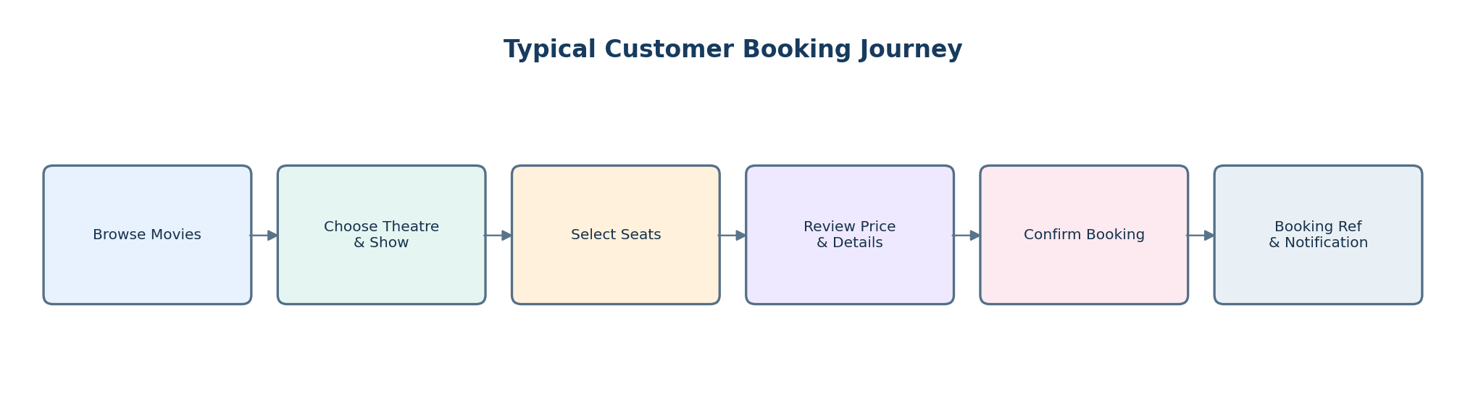
The seat map should distinguish available, selected and unavailable seats. Show the price summary before confirmation. After a successful transaction, display the booking reference. Error messages should explain the next action.

7.2 Agentforce – Booking Assistance
A custom Agentforce agent can act as a conversational help channel for booking-related queries. Its responses and actions depend on the topics, instructions, actions, data permissions and authentication configured by the project team.
- Movie Information: explain how customers can find movie details.
- Show Timings: guide customers to locate theatre, date and show information.
- Seat Selection Help: explain seat categories and availability indicators.
- Booking Status: locate an authenticated customer's booking through an approved secure action.
- Cancellation Guidance: explain the policy and route eligible requests through an authorized action or human support.

Agentforce Guardrails
- Never claim a booking is confirmed unless the booking service reports success.
- Never disclose another customer's booking or personal information.
- Require authentication and authorization for booking changes or cancellation.
- Escalate unsupported, ambiguous or sensitive requests to human support.
- Test normal questions, missing data, denied access, failed actions and prompt-injection attempts.

7.3 Reports and Dashboards
Report / dashboard | Suggested measures
Daily Booking Summary | Created, confirmed and cancelled bookings; ticket value by day.
Show Occupancy | Booked seats versus total seats per show.
Movie Performance | Bookings and ticket revenue by movie.
Cancellation Analysis | Cancellation count and rate by show, movie and date.
Operations Dashboard | Upcoming shows, occupancy, booking trends and exceptions.

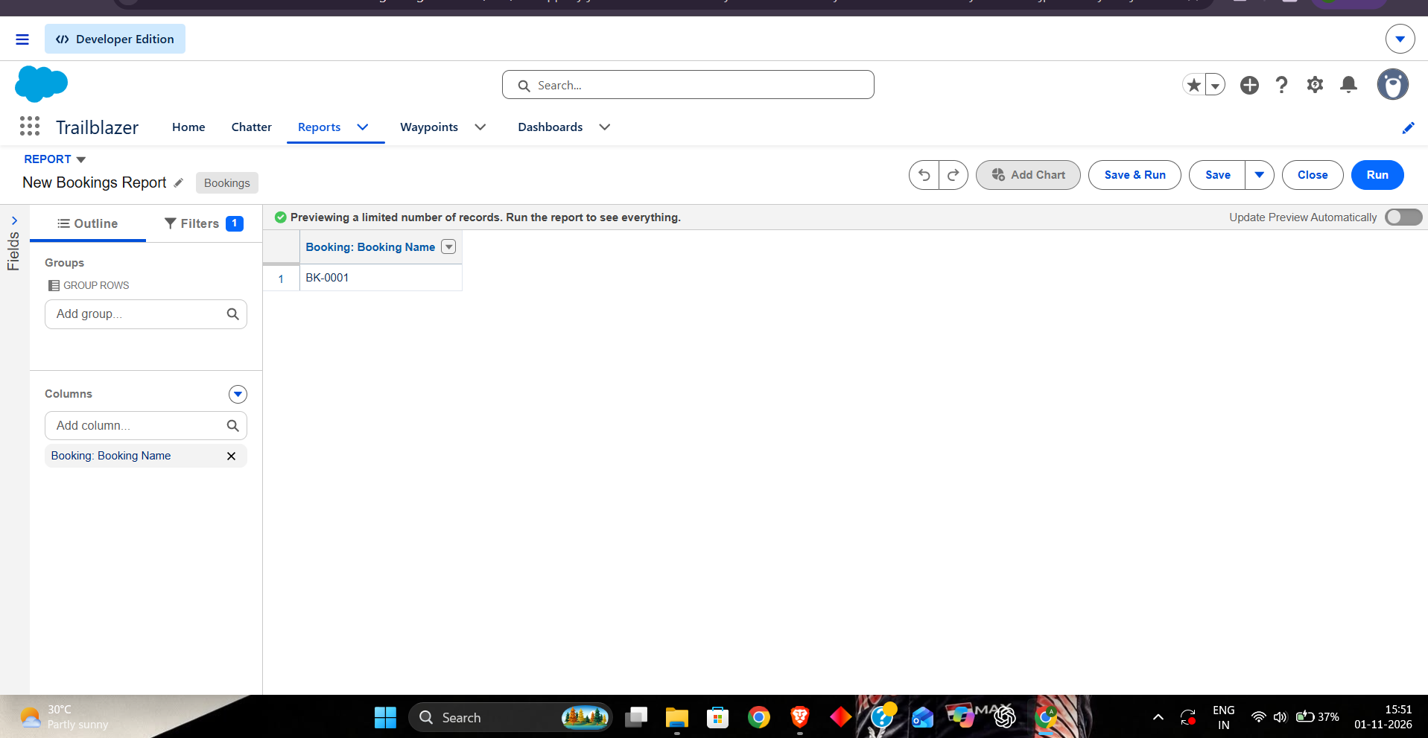

8. Phase 5 – Deployment, Maintenance and Monitoring

8.1 Deployment Strategy
- Develop and test in a dedicated development org or sandbox.
- Store metadata and code in version control with reviewed changes.
- Deploy objects, fields, permission sets, Apex, LWC, flows, tabs and app metadata in dependency order.
- Run Apex tests and functional, security and regression testing in the target environment.
- Validate environment-specific settings, integrations and Agentforce access separately.
- Deploy to production through the approved release process and retain a rollback plan.

8.2 Maintenance Plan
- Review movie, theatre, screen, seat and show records for accuracy.
- Review failed flows, Apex exceptions and integration errors.
- Update tests whenever booking rules or fields change.
- Review access and permission sets after staff role changes.
- Maintain release notes, data dictionary, flow descriptions, Apex documentation and support procedures.

8.3 Monitoring Procedures
Area | Monitor | Response
Apex | Debug logs, Apex Jobs and recorded exceptions | Investigate failures and governor-limit issues.
Flows | Failed or paused interviews and fault notifications | Review fault details and correct data or configuration.
Bookings | Pending, failed, duplicate and cancelled booking reports | Reconcile records and investigate seat conflicts.
Security | Setup Audit Trail and periodic permission reviews | Remove excessive access and correct sharing.
Agentforce | Conversation outcomes and action results, where available | Improve instructions, permissions, tests and handoffs.

8.4 Documentation Summary
- Maintain an object and field data dictionary.
- Document flow triggers, entry criteria, actions, fault paths and owners.
- Document Apex class purpose, method contracts, security model and tests.
- Maintain deployment steps, environment settings, release history and rollback notes.
- Record Agentforce topics, actions, guardrails and escalation paths.

9. Visual Evidence Checklist
Insert genuine screenshots from the actual Salesforce org. Ensure each screenshot identifies the relevant Setup page or application component. Hide passwords, tokens, payment details and customer personal information. The spaces below are placeholders, not claimed evidence.

9.1 Objects, Fields and Relationships
Object Manager pages for Movie__c, Theatre__c, Screen__c, Show__c, Seat__c, Booking__c and Booking_Seat__c; field lists; relationship fields; Schema Builder.

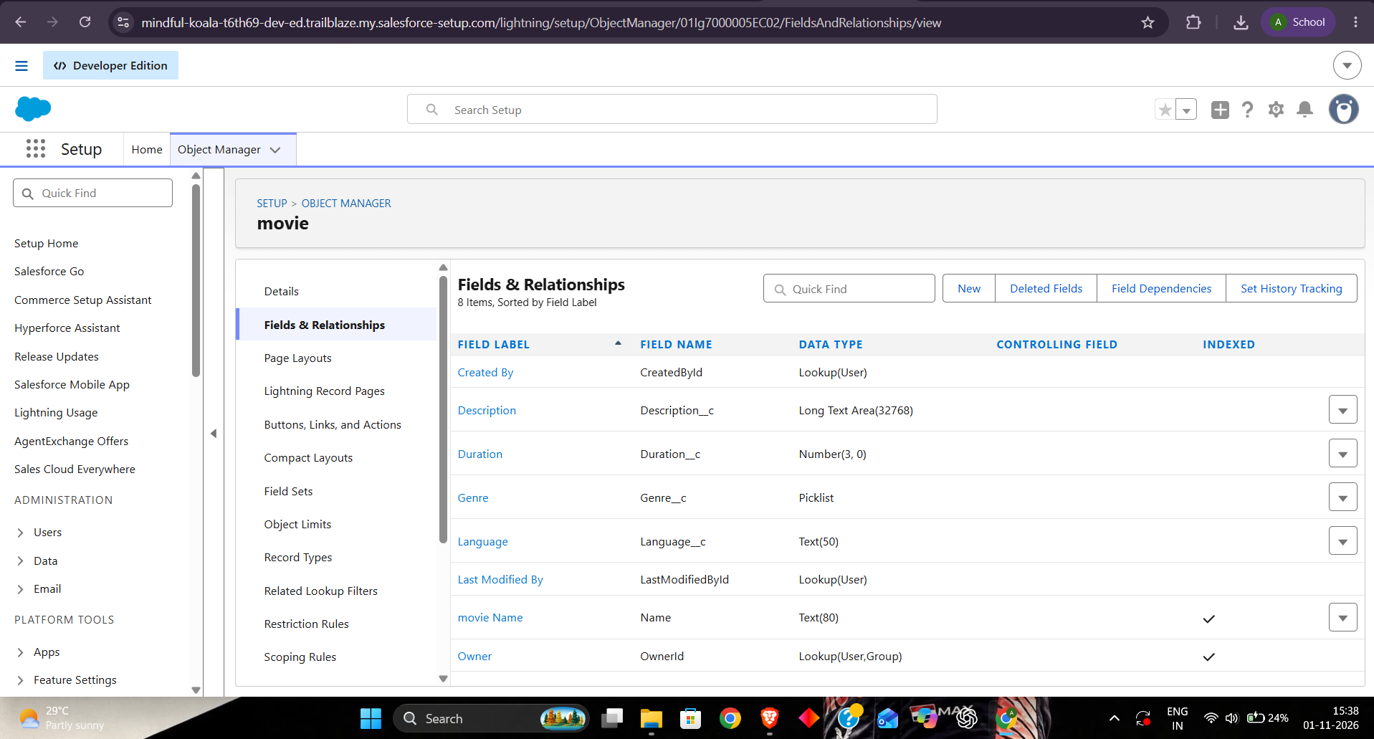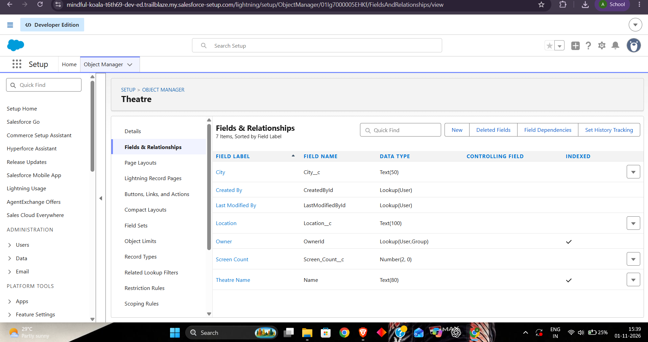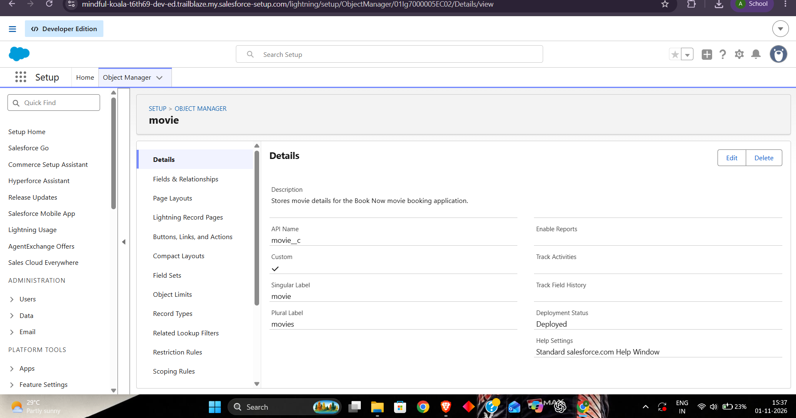

9.2 Record-Triggered Flows and Screen Flows
Flow Builder showing flow API name, trigger, entry criteria, elements, fault paths and active status.
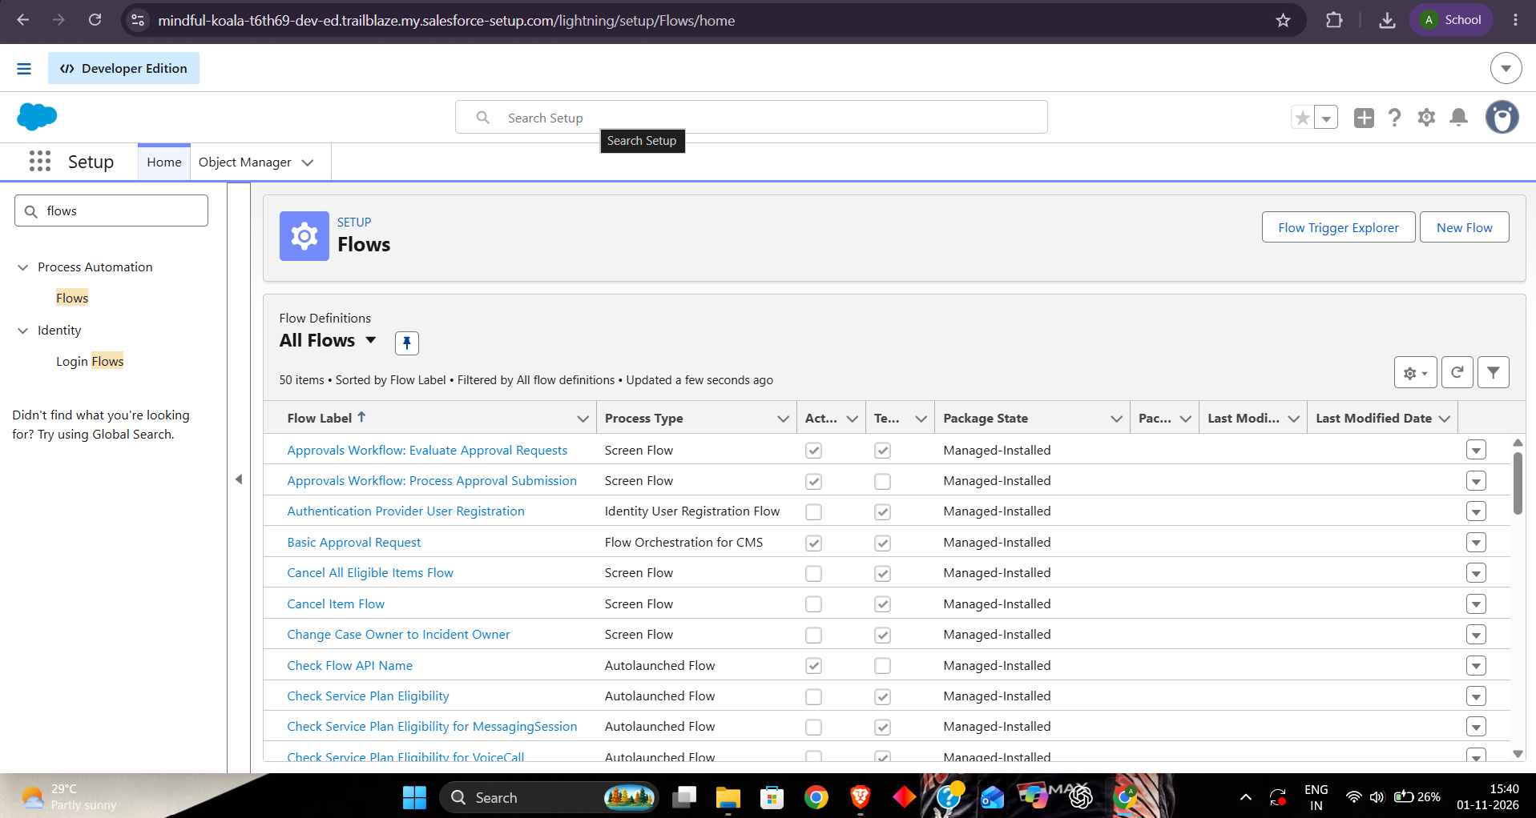

9.3 Validation Rules and Apex Classes
Validation rule formulas, Apex classes, Apex test classes and test execution results.

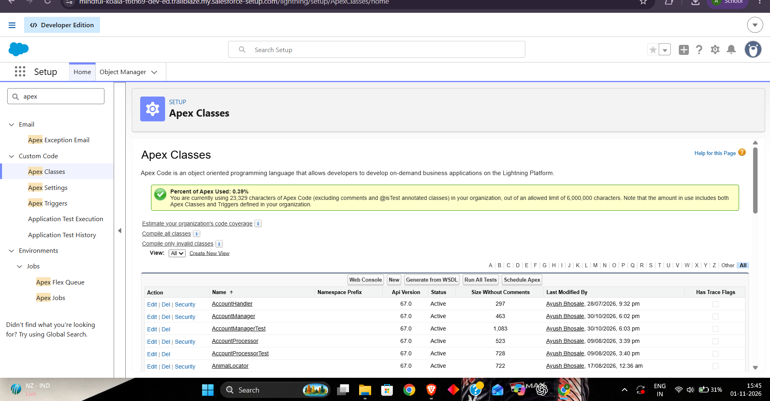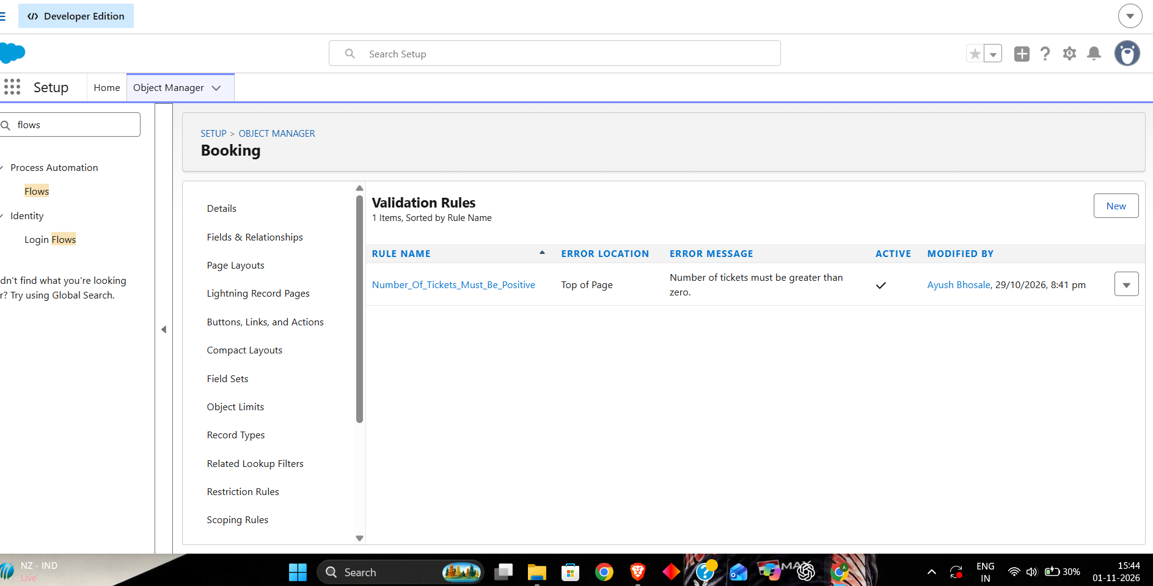

9.4 Profiles, Permission Sets and Sharing
Object/field permissions, sharing settings, role hierarchy and sharing rules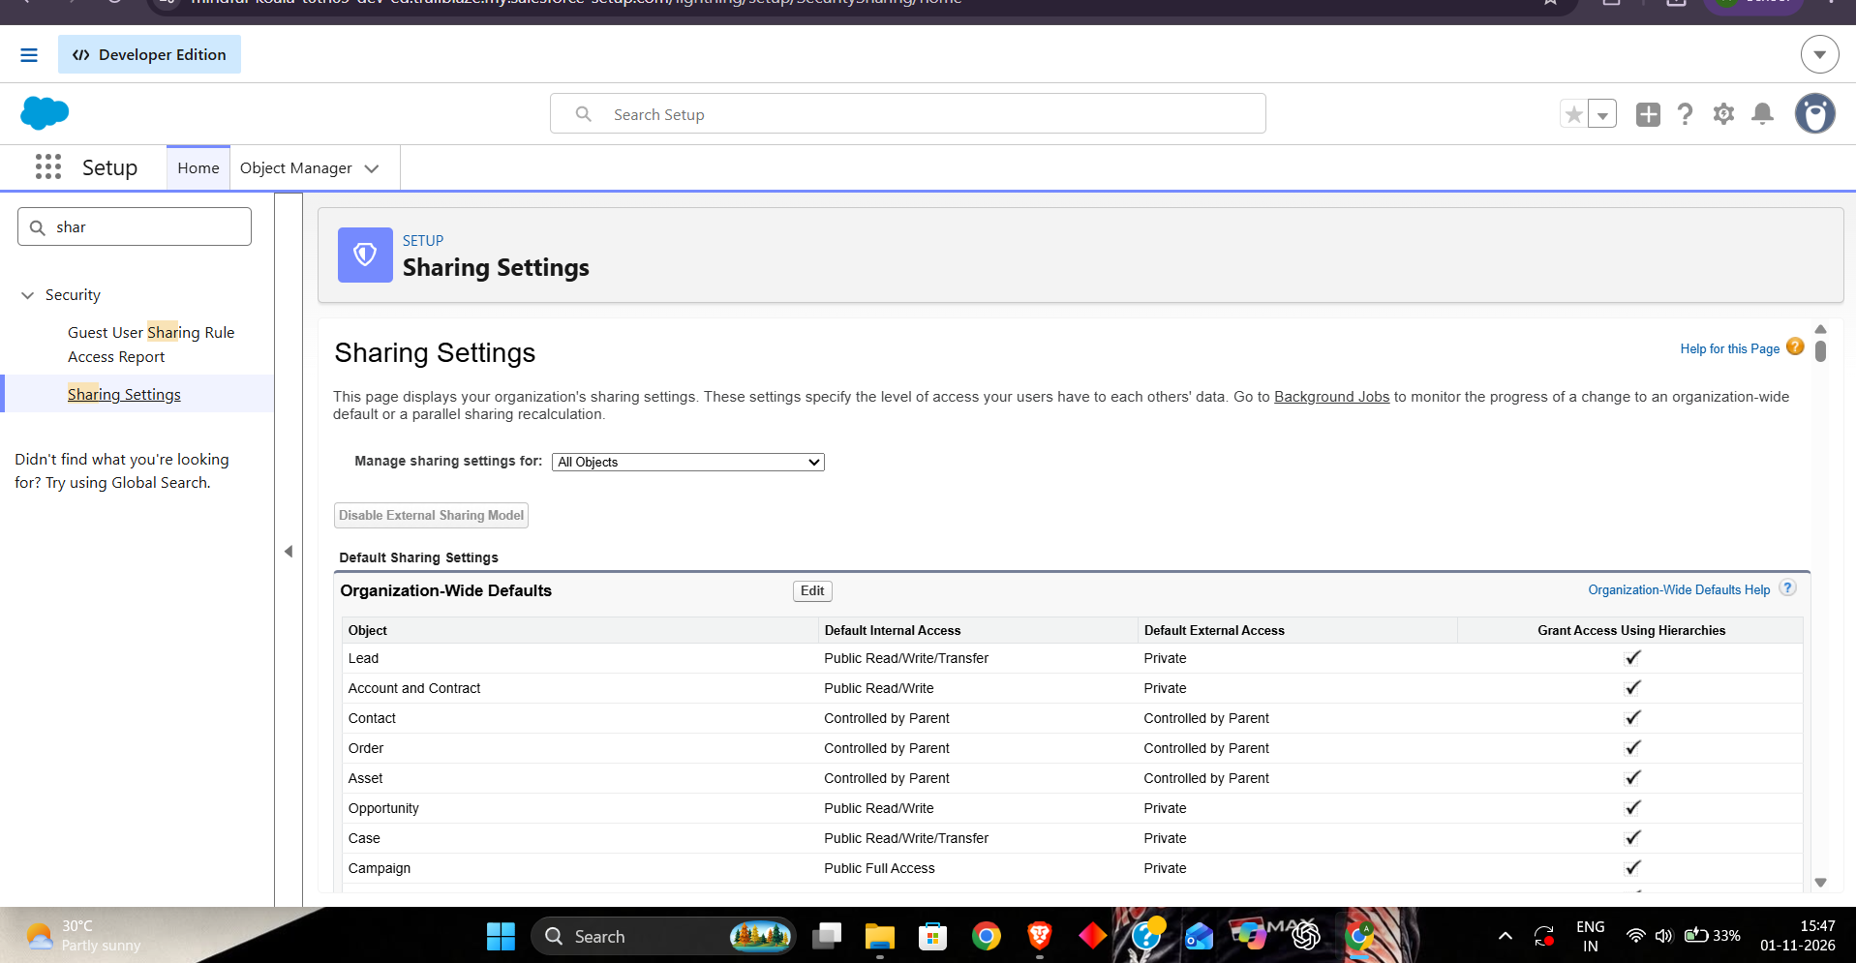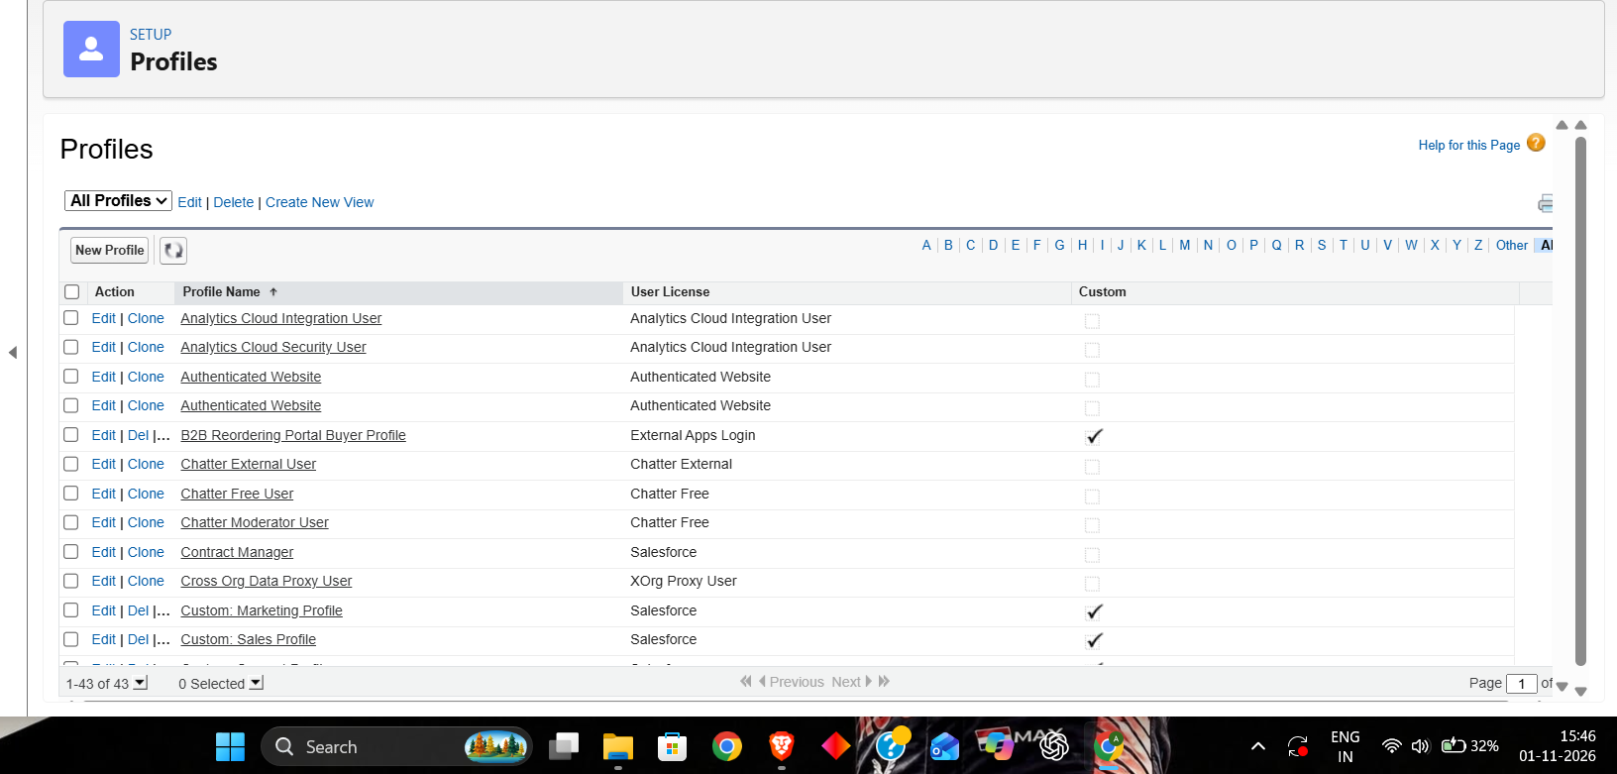

10. Conclusion
The Book Now Movie Booking App combines Salesforce data modeling, Lightning UI design, Apex development, Flow automation, security configuration, reporting and Agentforce. It demonstrates how a business process can be represented through connected records and supported by controlled server-side operations and guided customer interactions.
The intended outcome is a structured movie-booking solution that helps customers discover shows, select seats and manage bookings while giving staff tools to maintain schedules and monitor operations. A successful implementation must verify seat availability under concurrent requests, enforce access controls, test automation, and capture evidence from the actual Salesforce org.

Skills Demonstrated
- Salesforce objects, fields, relationships and data modeling
- Lightning App Builder and screen design
- Apex, SOQL, DML, transaction handling and unit testing
- Record-triggered flows, screen flows and validation rules
- Profiles, permission sets, sharing and CRUD/FLS security
- Agentforce topics, actions, instructions and guardrails
- Reports, dashboards, deployment planning and maintenance

Appendix – Build and Submission Checklist
- Confirm booking, cancellation and seat-allocation rules.
- Create objects, fields, relationships, tabs and sample records.
- Configure permission sets, sharing and validation rules.
- Build Apex service methods and unit tests.
- Build Lightning pages and LWC components.
- Create flows and configure fault handling.
- Configure and test Agentforce topics and actions.
- Build reports and dashboards; complete end-to-end and security testing.
- Insert genuine screenshots and captions in the visual evidence section.
- Proofread the report and export to the required submission format.

Supplementary Implementation Specification
This section expands the project documentation to explicitly cover the business overview, phase-wise implementation, entity relationships, automation components, role-based security, testing evidence, and Agentforce configuration. Items described as proposed or illustrative must be checked against the actual Salesforce org before submission.

A. Business Overview and Objectives
The Book Now application is intended to support the end-to-end movie-ticket booking process in Salesforce. It organizes movie, theatre, screen, show, seat, customer, and booking information so that users can find a show, select seats, review the price, and receive a booking reference. Administrators and theatre staff can maintain schedules and review booking activity according to their assigned access.
- Centralize movie, theatre, show, seat, and booking records.
- Make show discovery and seat selection straightforward for customers and booking staff.
- Reduce manual work through booking validation, status automation, and confirmation notifications.
- Prevent duplicate seat allocation for the same show through server-side booking controls.
- Provide role-appropriate access to customer and operational information.
- Offer booking-related help through a configured Agentforce agent.

B. Phase-wise Implementation Sequence
Phase | Implementation activities
1. Requirement analysis | Identify actors, booking journey, cancellation rules, seat categories, business constraints, and acceptance criteria.
2. Data model design | Create Movie__c, Theatre__c, Screen__c, Show__c, Seat__c, Booking__c, and Booking_Seat__c; define fields and relationships.
3. Backend development | Build Apex service methods for seat availability, price calculation, booking creation, booking updates, and safe transaction handling.
4. UI development | Build Lightning App Pages or LWCs for movie browsing, show selection, seat selection, booking review, and confirmation.
5. Automation | Configure record-triggered flows, screen flows, validation rules, formula fields, and booking confirmation email actions.
6. Testing | Run positive, negative, security, flow, and seat-conflict tests; record actual outcomes and resolve defects.
7. Deployment and support | Deploy approved metadata, monitor failures, maintain documentation, and review access and data quality.

C. Data Model and ER Diagram
The following ER diagram is a proposed logical model. The final diagram must be reconciled with the actual object relationships in Object Manager or Schema Builder. The relationship labels describe the intended business links; they do not assert that these relationships have already been configured.
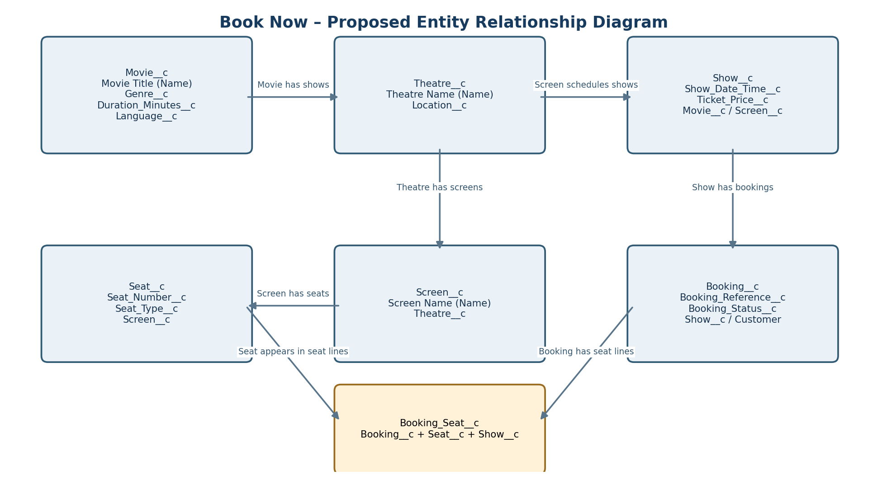
Core relationships: Movie__c to Show__c; Theatre__c to Screen__c; Screen__c to Seat__c and Show__c; Show__c to Booking__c; Booking__c to Booking_Seat__c; and Seat__c to Booking_Seat__c. Booking_Seat__c acts as a junction/detail object so one booking can include multiple seats.

C.1 Suggested formula and calculation fields
- Show duration display: derive a readable duration from the related movie's Duration_Minutes__c where the relationship and formula support it.
- Booking seat count: maintain a count of linked Booking_Seat__c records using a roll-up summary when the relationship is master-detail, or calculate it through Apex/Flow when it is a lookup.
- Booking total: calculate from the selected seat prices and applicable fees or discounts. Use a currency field updated by the booking service when the calculation spans child records.
- Seat availability: calculate for a specific show, not only for the physical Seat__c record, because the same physical seat can be available for one show and booked for another.

D. Automation Components

D.1 Record-triggered flows
Flow API name | Trigger | Purpose
Booking_Confirmation_Email_Flow | Booking__c, after save | When status changes to Confirmed, send a confirmation email using a configured email alert or action.
Booking_Status_Change_Flow | Booking__c, after save | Handle approved follow-up actions when a booking is cancelled or its status changes.
Show_Status_Notification_Flow | Show__c, after save | Notify appropriate users when a show is cancelled or materially changed, if required by policy.

D.2 Screen flows
Book_Now_Booking_Screen_Flow can guide a user through selecting a show, choosing seats, reviewing the booking summary, and submitting the request to the authoritative booking service. The flow should display validation errors returned by Apex and should not independently mark seats as booked.

D.3 Validation rules and formula fields
- Booking_Require_Show: prevent saving a booking without a show reference.
- Booking_Valid_Total_Amount: reject a negative total amount.
- Show_Require_Future_Date: prevent creation of a show in the past, with any administrator exception explicitly defined.
- Booking_Is_Confirmed: formula checkbox that evaluates whether Booking_Status__c equals Confirmed.
- Show_Is_Bookable: formula checkbox for simple show status/date criteria; final seat availability must still be checked transactionally by Apex.

D.4 Apex responsibilities
BookingService should own the authoritative seat-availability check, total calculation, booking creation, and booking status updates. It should use sharing-aware access and CRUD/FLS enforcement. Seat availability must be evaluated per Show__c and Seat__c combination. A simple query followed by an insert is not enough to prevent two concurrent transactions from reserving the same seat; implement and test a concurrency-safe reservation strategy or uniqueness constraint appropriate to the final data model.

E. Security Model by Role
Use a least-privilege baseline. Profiles establish baseline login and object access; permission sets grant additional capabilities. Organization-wide defaults, role hierarchy, teams, and sharing rules control record visibility. The exact settings below are a suggested starting point and must be verified in Setup.
Role | Suggested access assignment | Access scope
System Administrator | System Administrator profile; tightly controlled admin permission set if needed | Full configuration and data access for administration, deployment, and support.
Theatre Manager | Restricted standard profile plus Theatre_Manager_Permissions | Manage assigned theatre, screens, shows, and related operational bookings; no broad setup administration.
Booking Agent | Restricted standard profile plus Booking_Agent_Permissions | Create and view permitted bookings, assist customers, and perform only approved booking updates.

E.1 Suggested sharing approach
- Set internal organization-wide defaults for Booking__c and other sensitive operational objects to Private where practical, then grant access through ownership, role hierarchy, and sharing rules.
- Share theatre and show records with the relevant Theatre Manager role or group based on theatre assignment.
- Give Booking Agents access only to bookings required for their support responsibilities.
- Restrict sensitive customer fields using field-level security, even when a user can access the parent record.
- Review guest-user access carefully if the app is exposed through an Experience Cloud site; do not expose booking records through broad public sharing.

F. Testing Plan and Results Record
No live Salesforce test execution data was supplied with the request. Therefore, this report provides a test plan and results table for completion. Do not mark tests as Passed until the corresponding test has been run in the target org and its evidence has been captured.
Test ID | Scenario | Expected result | Actual status
TC-01 | Browse active movies | Active movie records appear with correct details. | Pending evidence
TC-02 | Select a scheduled show | Only eligible shows can proceed to booking. | Pending evidence
TC-03 | Book available seats | Booking and booking-seat records are created; reference is returned. | Pending evidence
TC-04 | Attempt duplicate seat booking | Second conflicting request is rejected. | Pending evidence
TC-05 | Book a cancelled show | Request is blocked with a clear error. | Pending evidence
TC-06 | Confirm booking email | Email action runs only after successful confirmation. | Pending evidence
TC-07 | Unauthorized record access | User cannot view or change records outside assigned access. | Pending evidence
TC-08 | Agentforce booking query | Agent responds only with permitted, verified booking information. | Pending evidence

F.1 Screenshot evidence to attach
- Object Manager and Schema Builder: object definitions, fields, and relationships.
- Flow Builder: record-triggered flows, screen flow, entry criteria, elements, fault paths, and activation state.
- Validation Rules and Formula Fields: formulas and active status.
- Apex: BookingService, test class, and actual test execution result.
- Security: profiles, permission sets, role hierarchy, organization-wide defaults, and sharing rules.
- Agentforce: agent setup, topics, prompts/instructions, actions/data actions, and safe test interactions.
- User experience and analytics: booking screens, Lightning App Pages, reports, and dashboards.

G. Agentforce Configuration Record
The custom Book Now agent is intended to assist with movie discovery, show information, seat-selection guidance, booking-status questions, and cancellation-policy guidance. The actual agent should be configured with narrowly scoped topics, clear instructions, approved actions, and access checks.
Topic | Supported interaction / action
Movie and Show Information | Answer questions using permitted movie/show data or guide the user to catalogue pages.
Seat Availability Guidance | Explain seat states; retrieve availability through an approved action that checks the selected show.
Booking Lookup | Use an authenticated, permission-checked action to retrieve only the current customer's booking details.
Booking Cancellation Help | Explain policy and initiate an authorized cancellation process only after identity and eligibility checks.
Prompt and action guidance: the agent should ask for missing non-sensitive booking context, use only approved Salesforce actions, confirm the result returned by the action, avoid exposing other customers' records, and hand off requests it cannot safely complete. The report does not claim that these topics or actions are already configured in the org.

Final Submission Note
Before submission, replace all proposed API names and role settings with the actual Salesforce configuration, complete the testing results with real outcomes, and insert genuine screenshots. The ER diagram is a proposed logical design and should be updated if the deployed relationships differ.

