**Deep Learning-Based Skin Disease Prediction Using Convolutional Neural Networks (CNN)**

**Student Details:**

Name: Ayush Singh

Roll Number: E23MCAG0060

Class/Section: MCA(Data Science)/ B3

Email: E23MCAG0060@bennett.edu.in

Name: Amishu Negi

Roll Number: E23MCAG0091

Class/Section: MCA(Data Science)/ B5

Email: E23MCAG0091@bennett.edu.in

**Project Overview**

**Problem statement-**

Creating the deep learning model for skin diseases prediction using Convolutional Neural Networks (CNN).

**Purpose-**

Our project addresses the healthcare challenges faced by individuals in small towns and villages, where the lack of dermatologist accessibility poses serious issues for skin diseases. The unavailability of specialized medical services in these areas hinders timely diagnosis and treatment. To tackle this problem, we are developing a model that serves as an accessible tool for early detection and diagnosis of skin diseases. By leveraging technology, our goal is to improve public health outcomes and contribute to the well-being of individuals in underserved regions with limited access to medical professionals.

**Scope-**

The project's scope includes creating an ecosystem for dermatologists and individuals in underserved areas facing skin diseases. Emphasizing early detection and diagnosis, the initiative integrates technology for remote consultations and data-driven diagnostics. The goal is to establish an inclusive healthcare solution, improving skin health outcomes in regions with limited access to specialized services.

**1.Introduction**

The skin, being one of the largest and most prominent organs in the body, plays a crucial role in supporting survival by acting as a protective barrier against injuries, heat, and damage caused by ultraviolet rays. Unfortunately, over 900 million people worldwide suffer from various skin diseases, making it a prevalent health concern. Skin disorders can vary in severity, with some being situational due to environmental factors like pollution, while others may have a genetic basis. The diverse nature of these conditions, ranging from minor to life-threatening, makes accurate identification essential. Although not always curable, treatments aim to alleviate symptoms. The complexity of skin characteristics, including unevenness, tone, and hair presence, poses challenges in examining and analyzing skin diseases effectively. Skin cancer, a commonly occurring yet largely preventable cancer, underscores the importance of early and precise diagnosis for managing disease severity. Recent advancements in deep learning-based convolutional neural network (CNN) models have significantly enhanced the classification of skin diseases. This study focuses on using these methods to diagnose four prevalent skin diseases: Eczema, a red and itchy skin condition common in children; Psoriasis, affecting areas like elbows, knees, and the scalp; Herpes, characterized by sores and itching; and Melanoma, a type of skin cancer arising from melanocytes. Each of these diseases has distinct features and characteristics. Eczema, a chronic condition, may be linked with asthma or hay fever and tends to flare periodically [1]. Psoriasis affects specific areas and is often accompanied by itching, stinging, and a burning sensation [2]. Genital herpes, for which there is no cure, manifests as pain, itching, and sores around the genitals, anus, or mouth. Melanoma, a skin cancer type, develops from pigment-controlling cells and may be associated with other health conditions such as diabetes, heart disease, and depression. This paper delves into the identification and classification of these four common skin diseases using deep learning methods.

**2. Literature Review**

The prevalence of skin diseases in humans has seen a significant increase, prompting researchers to explore various machine learning and deep learning approaches for their detection. Abbadi et al. [3] introduced a system for diagnosing Psoriasis, utilizing skin color and texture features extracted from the Gray Level Co-occurrence Matrix (GLCM). Feed-forward neural networks were employed to classify images into Psoriasis-infected and non-infected categories. Połap et al. [4] proposed an intelligent skin disease detection system based on sensors, analyzing camera footage to identify skin diseases. Their CNN architecture exhibited promising results with a training accuracy of 82.4%. Addressing the cost and time constraints associated with skin disease diagnosis, [5] presented an automatic eczema detection and severity measurement model. This system, relying on image color and texture features, can detect infected areas of eczema. Support Vector Machine (SVM) classification is then used to categorize identified regions as mild or severe. Similarly, machine learning classifiers have been employed in chronic kidney disease identification [6], with Naive Bayes achieving the highest accuracy of 99.1% on a reduced dataset. Abdulbaki et al. [7] proposed a cloud computing-based architecture combined with Back-propagation Neural Network (BpNN) for eczema diagnosis. Janoria et al. [8] introduced a transfer learning-based CNN architecture for skin cancer identification, using CNN for feature extraction and machine learning classifiers for disease diagnosis. The VGG-16 CNN model with the K-Nearest Neighbor algorithm achieved the highest accuracy of 99%. Bhadula et al. [9] evaluated the performance of various machine learning algorithms in conjunction with Convolutional Neural Network (CNN), finding that the CNN model outperformed others with training and testing accuracies of 99.1% and 96%, respectively. Shanthi et al. [10] proposed a CNN architecture for the automatic diagnosis of skin diseases, consisting of 11 layers, including multiple convolution, pooling, activation layers, and a softmax classifier. The experimental analysis revealed an accuracy of approximately 99%. Similar CNN models have been suggested for the diagnosis of kidney disease [11], heart disease [12], rice plant disease [13], and Alzheimer’s disease [14].

**3. Methodology**

In this section, the details of the skin disease diagnosis process along with various CNN models are discussed in appropriate subheadings. Figure 1 illustrates the details of the working procedure. The procedure starts with data collection followed by categorization of the collected images. Then the images are resized and noisy data are discarded. Image augmentation are performed for increasing the dataset. After that, the features are extracted using CNN models and finally the classification is performed.

**3.1Dataset Collection**

The skin, a vital and prominent organ essential for survival, is unfortunately afflicted by various skin diseases affecting approximately 900 million people. These conditions range from minor inconveniences to life-threatening issues. Our research focuses on four prevalent types of skin diseases: Atopic dermatitis (Eczema), Actinic Keratosis, Dermatofibroma, and Melanoma. Images of diseased skin were sourced from various outlets. Following image collection, we manually curated the dataset by identifying and excluding noisy, low-contrast images. The final dataset comprises of 1608 images of diseased skin, including Dermatofibroma 400 images, 400 Actinic Keratosis images, 408 Atopic Dermatitis images, and 400 Melanoma images. To ensure representation across different body parts, we collected sample images for each disease class, resulting in a comprehensive set of images displayed in Figure 2.

**--­­**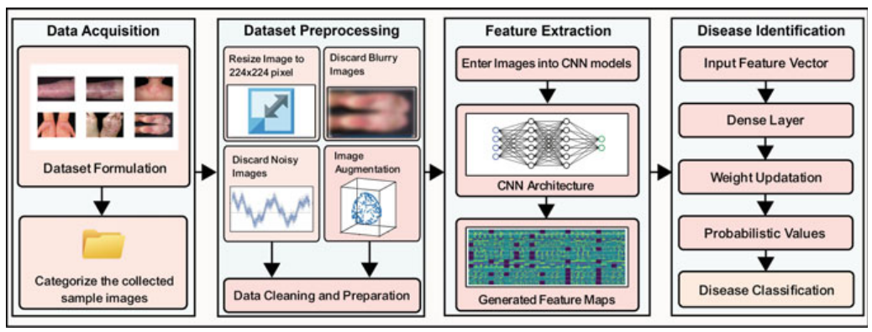

Fig. 1 The working procedure of deep learning-based skin disease prediction model where firstly the data is collected followed by categorizing the dataset. Various data pre-processing and cleaning operations are performed and features are extracted using CNN architectures. Finally, the classification is performed using the dense layer of CNN.

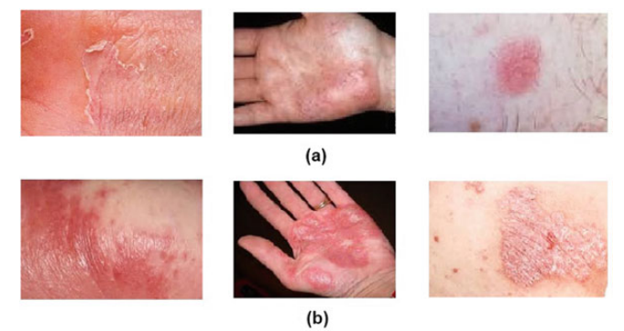

**Fig. 2** Sample images of our skin disease dataset, a Eczema, b Psoriasis

**Table 1** Total training and validation images after augmentation.

|  |  |  |  |  |
| --- | --- | --- | --- | --- |
| **Disease type** | **Before augmentation** | **After augmentation** | **Training data** | **Validation data** |
| Dermatofibroma | 100 | 400 | 320 | 80 |
| Actinic Keratosis | 100 | 400 | 320 | 80 |
| Atopic Dermatitis | 102 | 408 | 324 | 84 |
| Melanoma | 100 | 400 | 320 | 80 |
| **Total -** | 402 | 1608 | 1284 | 324 |

* 1. **Data Augmentation**

To address the issue of overfitting, the incorporation of data augmentation plays a crucial role. This technique allows practitioners to significantly enhance the diversity of available data for training models without the need for additional data collection. In our dataset, we applied various data augmentation methods, including a 20% increase in brightness, a 10% enhancement in contrast, random rotation of 5 degrees Celsius, and horizontal flipping. This approach aims to improve interaction and account for all potential variations, resulting in the generation of five distinct augmented versions for each sample image. The augmentation process is detailed in Table 1, which illustrates the increased number of dataset images.

For the training and validation data, we implemented an 80–20 data split, resulting in 7,224 training images and 1,805 validation images. To evaluate the model, we utilized 400 skin disease images sourced from the Internet for testing purposes. These testing images share similar characteristics with the training images, and to prevent any bias, they were entirely separate from the training and validation data.

* 1. **CNN Architectures**

Convolutional Neural Network is supervised machine learning algorithms to specify image identification and classification, trained by using labeled data with their respective classes.

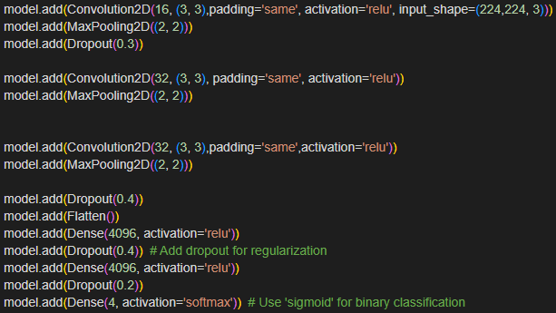

**4. Design**

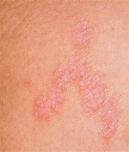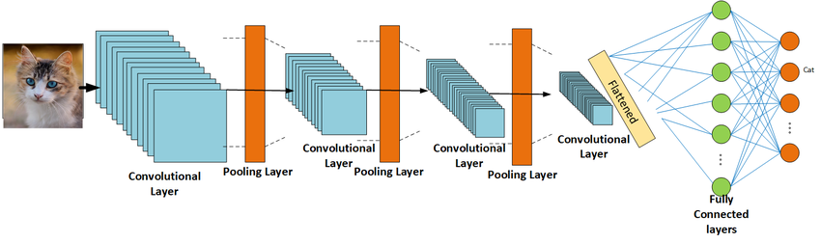

**Fig 3** CNN implementation design

**5. Implementation**

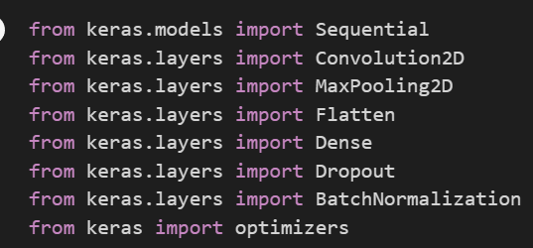

These libraries are imported for implementing CNN model.

**Following steps are performed for implementing our CNN model**

**Input Layer:**

**Input shape: (224, 224, 3), indicating an input image size of 224x224 pixels with 3 color channels (RGB).**

**Convolutional Layers:**

**First Convolutional Layer:**

* **16 filters with a kernel size of (3, 3).**
* **Padding is set to 'same', meaning zero-padding is added to the input so that the output has the same height and width.**
* **ReLU (Rectified Linear Unit) activation function is used.**

**Second Convolutional Layer:**

* **32 filters with a kernel size of (3, 3).**
* **Padding is 'same', and ReLU activation is used.**

**Third Convolutional Layer:**

* **32 filters with a kernel size of (3, 3).**
* **Padding is 'same', and ReLU activation is used.**

**MaxPooling Layers:**

**MaxPooling is applied after each convolutional layer with a pool size of (2, 2), which reduces the spatial dimensions (width and height) of the input by a factor of 2.**

**Dropout Layers:**

* **Dropout is applied after the first MaxPooling layer with a dropout rate of 0.3.**
* **Another Dropout layer is added after the third Convolutional layer with a dropout rate of 0.4.**
* **One more Dropout layer with a dropout rate of 0.4 is added after the Flatten layer.**
* **A final Dropout layer with a dropout rate of 0.2 is added before the output layer.**
* **Dropout is a regularization technique that helps prevent overfitting by randomly setting a fraction of input units to zero during training.**

**Flatten Layer:**

**Flattens the input to a one-dimensional array before passing it to the fully connected layers.**

**Fully Connected (Dense) Layers:**

* **Two fully connected layers with 4096 neurons and ReLU activation functions are added.**
* **Another Dense layer with 4 neurons and a softmax activation function is added as the output layer.**
* **The output layer represents the probabilities of the input image belonging to each of the 4 classes, and softmax ensures that the sum of these probabilities is 1.**



**6. Results**

* 1. **Experimental Setup**

The experiment was conducted using a machine having a configuration of Intel core i5 processor, 8GB Ram, Nvidia Gtx-1060 graphics. For performing the classification, Keras framework with tensorflow back-end has been used to train the models in colaboratory. The dataset has been divided into 80–20 split for train, validation, respectively. A total of 400 images has been considered for testing the models. 56fold cross validation with 20 epochs has been considered during the training and validation process. Adam optimizer algorithm has been used for updating the weights. Since our dataset consists of only 4 classes hence categorical_crossentropy loss function has been used.

The hyper parameters used in our experiment are as follows:

* Input Image Size: 224 × 224
* Epoch: 20
* Activation: ReLu, Softmax
* Dropout function
* Optimizer: Adam
* Metrics: Accuracy

**6.2 CNN Performance**

First of all the input images are fed through the CNN architectures. Each of the CNN model consists of multiple convolution and pooling layer. Each of these layers convert the input images into feature vectors. The feature maps of eczema and psoriasis sample images are shown in Fig. 4.

Fine tuning method has been used for the classification process where we freezed all of the layers of CNN architectures except the final dense layer. In the final dense layer the weight has been updated using Adam optimizer.

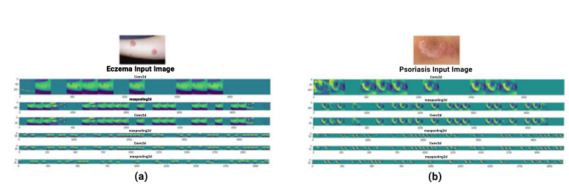

Fig. 4 Feature maps generated from input skin disease image. Here a illustrates the original eczema disease image followed by the feature maps generated by multiple convolution and pooling layer, b illustrates the original psoriasis disease image followed by the feature maps generated by multiple convolution and pooling layer

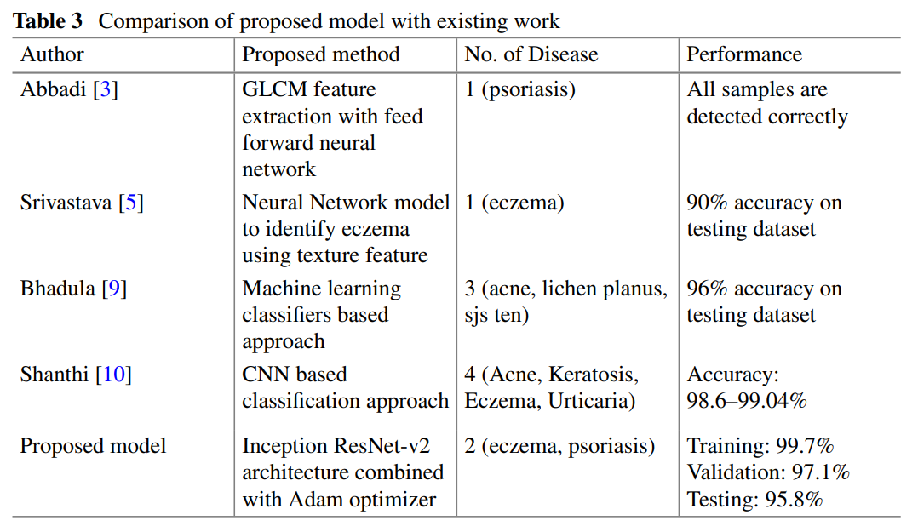

**7. Discussions**

Various researchers have presented different methodologies for the detection of diverse skin diseases. Table 3 provides a statistical comparison between our proposed solution and several other works. Analyzing the outcomes presented in Table 3 reveals that many studies have focused on the feature and texture selection process, recognizing the varied shapes and colors associated with different skin diseases. Notably, most CNN methods have achieved comparable levels of accuracy.

Through experimental analysis on a skin disease dataset, the following observations were made:

* In contrast to the transfer learning method, fine-tuning significantly enhances the accuracy of any CNN model on a specific dataset.
* Regarding execution time, the Adam optimizer outperformed the Rmsprop optimizer, which took more time for the classification task.
* In terms of accuracy, both the Adam and Rmsprop optimizers demonstrated similar performance, suggesting the applicability of either optimizer for classification tasks.
* A learning rate of 0.001 with a momentum of 0.9 proved to be more effective in updating weights. Nevertheless, learning rates of 0.01 and 0.0001 exhibited similar performance.

**8. Conclusion**

Disease recognition along with the help of computational assistance will assist medical science to prosper in a bigger dimension. In this paper, we proposed deep learning based skin disease detection methods using different CNN architectures to identify 4 common skin diseases named eczema, psoriasis, melanoma and herpes. Fine tuning method was used to train CNN architectures. Finally, two approaches for the practical application has been demonstrated, (i) Smartphone oriented approach and (ii) Web server oriented approach. These practical application canbe effectively utilized in real-time diagnosing and assessing the severity of the skin diseases.

**9. References**

1. Ruzicka, T., Ring, J., Przybilla, B.: Handbook of atopic eczema, 2nd edn. Springer Science & Business Media (2013)

2. Lowes, M.A., Suarez-Farinas, M., Krueger, J.G.: Immunology of psoriasis. Ann. Rev. Immunol. 32, 227–255 (2014)

3. Al Abbadi, N.K., Dahir, N.S., AL-Dhalimi, M.A., Restom, H.: Psoriasis detection using skin color and texture features. J. Comput. Sci. 6(6), 648–652 (2010)

4. Połap, D., Winnicka, A., Serwata, K., K¸esik, K., Wo´zniak, M.: An intelligent system for monitoring skin diseases. Sensors 18, 2552 (2018)

5. Alam, M.N., Munia, T.T.K., Tavakolian, K., Vasefi, F., MacKinnon, N., Fazel-Rezai, R.: Automatic detection and severity measurement of eczema using image processing. In: 2016 38th Annual International Conference of the IEEE Engineering in Medicine and Biology Society, pp. 1365–1368. IEEE (2016)

6. Khan, M.T.I., Prottasha, M.S.I., Nasim, T.A., Mehedi, A.A., Pranto, M.A.M., Asad, N.A.: Performance analysis of various machine learning classifiers on reduced chronic kidney disease dataset. Int. J. Rec. Res. Rev. (IJRRR), XIII(4), 16–21 (2020)

7. Shawkat Abdulbaki, A., Najim, S.A.M., Abdulrasoul Khadim, S.: Eczema disease detection and recognition in cloud computing. Res. J. Applied Sci. 13, 182–188 (2019)

8. Janoria, H., Minj, J., Patre, P.: Classification of skin disease from skin images using transfer learning technique. In: 2020 4th International Conference on Electronics, Communication and Aerospace Technology (ICECA), pp. 888–895. IEEE (2020)

9. Bhadula, S., Sharma, S., Juyal, P., Kulshrestha, C.: Machine learning algorithms based skin disease detection. IJITEE 9(2), 4044–4049 (2019)

10. Shanthi, T., Sabeenian, R.S., Anand, R.: Automatic diagnosis of skin diseases using convolution neural network. Microprocess. Microsyst. 76, 103074 (2020)

11. Bhaskar, N., Manikandan, S.: A deep-learning-based system for automated sensing of chronic kidney disease. IEEE Sens. Lett. 3, 1–4 (2019)

12. Shankar, V., Kumar, V., Devagade, U., Karanth, V., Rohitaksha, K.: Heart disease prediction using CNN algorithm. SN Comput. Sci. 1, 170 (2020)

13. Prottasha, M.S.I., Hossain, A.B.M., Rahman, M.Z., Reza, S.M.S., Hossain, D.A.: Identification of various rice plant diseases using optimized convolutional neural network. Int. J. Comput. Dig. Syst. (IJCDS) 9 (2021)

14. Farooq, A., Anwar, S., Awais, M., Rehman, S.: A deep CNN based multi-class classification of Alzheimer’s disease using MRI. In: 2017 IEEE International Conference on Imaging Systems and Techniques (IST), pp. 1–6. IEEE, Beijing, China (2017)

**10. Acknowledgments**

I am deeply thankful to Manoj Sir for their guidance, mentorship, and invaluable insights throughout the research process. Their expertise and encouragement have been crucial in shaping the direction of this work.