**ANKARA YILDIRIM BEYAZIT ÜNİVERSİTESİ**

**ELEKTRİK VE ELEKTRONİK FAKÜLTESİ**

**2023-2024 ÖĞRETİM YILI GÜZ DÖNEMİ**

**EE407-REPORT**

INSTRUCTOR

Prof.Dr. İLYAS ÇANKAYA

AHMET YOLDAŞ

19050211052

ANKARA - JANUARY,2024

**CONTENTS**

1. **Introduction**
2. **Definition**
3. **Purpose**
4. **System Requirments**
5. **Code GUI**
6. **Code**
7. **Circuit**
8. **Conclusion**
9. **Introduction**

This project designed a GUI using interface elements such as necessary buttons, text editing areas and drop-down menus. This design, carried out on MATLAB, aims to calculate the threshold values required for humidity and water engine operation. Data from the humidity sensor is used to enable activation of the water motor.

The circuit on the Arduino UNO board includes connections with the humidity sensor, and the basic measurements of the project were carried out on this circuit. Additionally, a BC548 type transistor was used for the smooth operation of the water engine.

This design ensures the functionality of the project by aiming to activate the water engine based on humidity values.

1. **Definition**

**MATLAB:** It is a programming platform specifically developed for engineers and scientists to analyze and design complex systems and products. This platform is used to perform various engineering tasks such as mathematical modeling, data analysis, simulations, and more.

**HUMIDITY SENSOR:** Humidity sensors are devices that measure environmental humidity levels and transfer this information to a control system. The humidity sensor used in the project allows controlling humidity in various applications. In particular, this sensor was used to obtain humidity values ​​in the system and activate the water engine according to these values.

**ARDUINO UNO:** Arduino UNO is an ideal board for those who want to enter the field of electronics and coding. This board appeals to a wide range of users and enables the development of microcontroller-based projects. Within the project, the Arduino UNO board works integrated with the humidity sensor, reads environmental data and executes control algorithms.

**WATER ENGINE:** Water engines are devices that convert water into mechanical energy designed to perform a specific task. Within the scope of the project, the water engine is controlled by information received from the humidity sensor and performs the water supply function when a certain humidity threshold is reached.

**BC548:** BC548 is a type of bipolar transistor and was used in the project to control the water motor. Transistors are used to control the flow of electricity in a circuit. The BC548 transistor has been the preferred element in the project to enable or disable the water motor depending on the information from the humidity sensor.

This system aims to maintain a certain humidity level by controlling the water motor based on humidity values. Additionally, these platforms are brought together to analyze the data from the humidity sensor, harmonize it with the control algorithms coded on the Arduino UNO, and manage the water motor.

1. **Porpose**

**I. Learning to Use MATLAB Codes:**

Learning the effective use of Matlab codes involves gaining the basic skills necessary to understand the basic building blocks of the program and perform various mathematical and numerical operations. This stage aims to gain knowledge on topics such as understanding the Matlab programming language, using basic commands, and data manipulation.

**II. Connections of Volt, Ground and Resistors:**

It is critical to connect the circuit elements correctly to achieve the required result. In this context, it means learning the correct positions and connections of volts, ground and resistors on the circuit, understanding and applying the basic principles of electrical circuits. Creating electronic circuits and connecting them properly is of fundamental importance to achieve the expected results.

**III. Learning the Benefits of Arduino UNO with MATLAB:**

The integration of Arduino UNO with MATLAB combines the physical computing capabilities provided by the Arduino platform and the analytical capabilities of MATLAB, enabling its use in various projects. This phase includes learning the interaction of Arduino UNO with MATLAB, gaining knowledge on topics such as reading data from sensors, motion control and real-time applications.

**IV. Learning GUI Design and Receiving User Input with App Designer:**

App Designer is MATLAB's graphical user interface design tool. GUI design and receiving user input involves creating user-friendly interfaces and inputting MATLAB codes through these interfaces. This phase covers the skills of designing a user-friendly interface, understanding user input, and integrating these inputs with MATLAB codes.

1. **System Requirments**
2. MATLAB
3. Arduino UNO
4. Humidty Sensor
5. Water Engine
6. Transistor BC548
7. Cables
8. Breadboard
9. **Code GUI**

**metin, ekran görüntüsü, dikdörtgen, ekran, görüntüleme içeren bir resim

Açıklama otomatik olarak oluşturuldu**

1. **Code**

**Properties**

**metin, ekran görüntüsü, yazı tipi, sayı, numara içeren bir resim

Açıklama otomatik olarak oluşturuldu**

The Properties section is the section where you define the properties of an application in MATLAB App Designer and assign initial values for these properties. These properties represent the application's state, user inputs, graphical objects, and other important elements.

In general, the Properties section is important for managing the runtime state of the application and monitoring the user's interactions. These features determine the working logic of our application.

**Startup**

**metin, yazı tipi, ekran görüntüsü içeren bir resim

Açıklama otomatik olarak oluşturuldu**

**COM selection**



**metin, ekran görüntüsü, yazı tipi, çizgi içeren bir resim

Açıklama otomatik olarak oluşturuldu**

It automatically assigns the port to which Arduino is connected into the edit field.

**PLOT**

**metin, ekran görüntüsü, yazı tipi içeren bir resim

Açıklama otomatik olarak oluşturuldu**

**metin, yazı tipi, çizgi, ekran görüntüsü içeren bir resim

Açıklama otomatik olarak oluşturuldu**

The plot code displays the humidity values measured by the sensor in a graph. It also controls a specified threshold value and if the humidity value exceeds this threshold value, it keeps the D13 pin disabled, but otherwise, the D13 pin becomes active and the water motor starts watering the pot.

**Time Value**

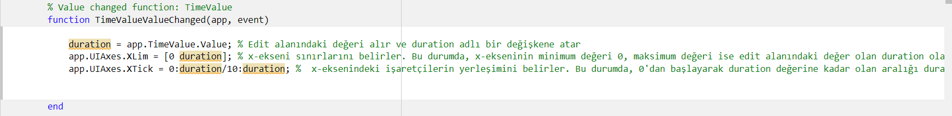

This function dynamically updates a graphical user interface element if a value in the edit field changes by updating the axis boundaries and pointer positions based on that value.

**Treshold**



We can determine the treshold value with dropdown while the system is running.

**Color**

**metin, ekran görüntüsü, yazı tipi içeren bir resim

Açıklama otomatik olarak oluşturuldu**

**metin, ekran görüntüsü, yazı tipi, yazılım içeren bir resim

Açıklama otomatik olarak oluşturuldu**

**Width**

**metin, ekran görüntüsü, yazı tipi içeren bir resim

Açıklama otomatik olarak oluşturuldu**

**metin, ekran görüntüsü, yazı tipi içeren bir resim

Açıklama otomatik olarak oluşturuldu**

**SAVE**

**metin, yazı tipi, çizgi, ekran görüntüsü içeren bir resim

Açıklama otomatik olarak oluşturuldu**

This function allows the user to select a file type with dropdown and save a graphic element in the GUI according to the selected file type.

**PIRINT**

**metin, yazı tipi, çizgi, ekran görüntüsü içeren bir resim

Açıklama otomatik olarak oluşturuldu**

Represents a function that provides output by displaying or printing an axis object on the GUI.

**Grid**

**metin, ekran görüntüsü, yazı tipi içeren bir resim

Açıklama otomatik olarak oluşturuldu**

**Marker**

**metin, ekran görüntüsü, yazı tipi içeren bir resim

Açıklama otomatik olarak oluşturuldu**

**EXCEL**

metin, yazı tipi, çizgi, ekran görüntüsü içeren bir resim

Açıklama otomatik olarak oluşturuldu

This code opens the Excel file when the button in the GUI application is pressed, and also includes a function that writes a matrix to the Excel file using the value from an edit field in the GUI.

**EXIT**

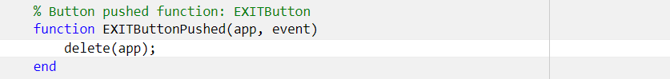

Exits the application.

1. **Circuit**

alet, makine, elektronik mühendisliği, metin içeren bir resim

Açıklama otomatik olarak oluşturuldu

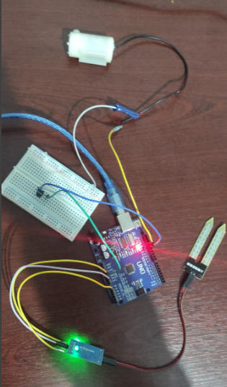

1. **Conclusion**

In this project, we focused on keeping the soil moisture value of the plant we are trying to grow at a certain level. When the soil moisture value falls below the determined threshold value, the system automatically activates the water engine and starts watering the plant. In case the water motor could not draw enough power through the Arduino, an NPN type transistor was used. In this way, the system works smoothly. On the interface, not only graphic drawing but also print, save and Excel operations can be performed through buttons designed to allow the user to set the desired color and threshold value.

The main features of the project are:

* A line chart was used to visually monitor the plant's soil moisture level.
* The humidity level falling below the specified threshold value enables the water engine to be automatically activated.
* NPN type transistor was used to meet the power need of the water engine.
* Graphic drawing can be adapted to the user's preferred color selection.
* In the user-friendly interface, there are convenient buttons to perform print, save and Excel operations as well as drawing graphics.
* The user can customize the threshold value and other important parameters set via the interface.
* This design offers a user-friendly pot irrigation system, both visually and functionally, to automate plant care and keep the soil moisture level at desired values.