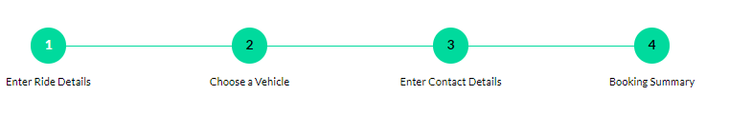



Car Package

**Details for Outstation Booking**

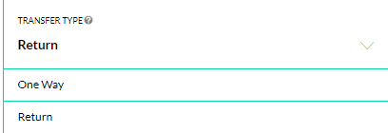

If suppose the user selects **Round trip** then the below inputs form will be there. Follow savari Mithila ki

**For Round Trip**

* *FROM (Enter Pickup city) - (this section will not be integrated with Map, it will be limited to certain cities like Patna only)
* *TO (Enter Destination City) - (It will be integrated with a map)
* *Travel Date – (It will show the calendar, disable the past dates)
* *Pick-up time – (show it as a dropdown as Savari Mithila ki)
* *Return date – (show it in the calendar, enable dates only after the travel date)
* Name -
* *Phone Number – like below, restricted to India only



*Note: Map section will show the overview along with the summary details*

**For One Way**

* *Enter Pickup city - (this section will not be integrated with Map, it will be limited to certain cities only)
* *Enter Destination City - (It will be integrated with a map)
* *Travel Date - (It will be integrated with a map)
* *Pick-up time – (show it as a dropdown as Savari Mithila ki)
* Name -
* * Phone Number – like below, restricted to India only



*Note: Map section will show the overview along with the summary details*

**Details for Local Booking**

* *Select city - (this section will not be integrated with Map, it will be limited to certain cities like Patna only)
* *Select package (it will be in drop down) options will be

4 hours, 40 km

6 hours, 60 km

8 hours, 80 km

12 hours, 120 km

WEDDING

* *Travel Date - (It will show the calendar, disable the past dates)
* Name -
* *Phone Number – like below, restricted to India only



*Note: The map section will show the only summary details*

**Details for car package**

* *Select city - (this section will not be integrated with Map, it will be limited to certain cities like Patna only)
* *Number of Days – (Show it in drop down from 1-15)
* *Booking Date – (after selecting the date on the calendar, it should automatically select the other dates based on the above input)
* Name -
* * Phone Number – like below, restricted to India only



*Note: The map section will show the only summary details*

**Note:**

* All input form areas will be broad so that it should be easy to TAP on Mobile

Refer: <https://cabbazar.com/city/patna>

* There should be a small “question mark” “?” on the top of each field to assist the user
* Please test the form after being developed