**# Build-a-Simple-Web-Developer-Portfolio-Page-Without-A-Framework**

**# Learning to code from Scratch**

**# My-Portfolio-My-Advert**

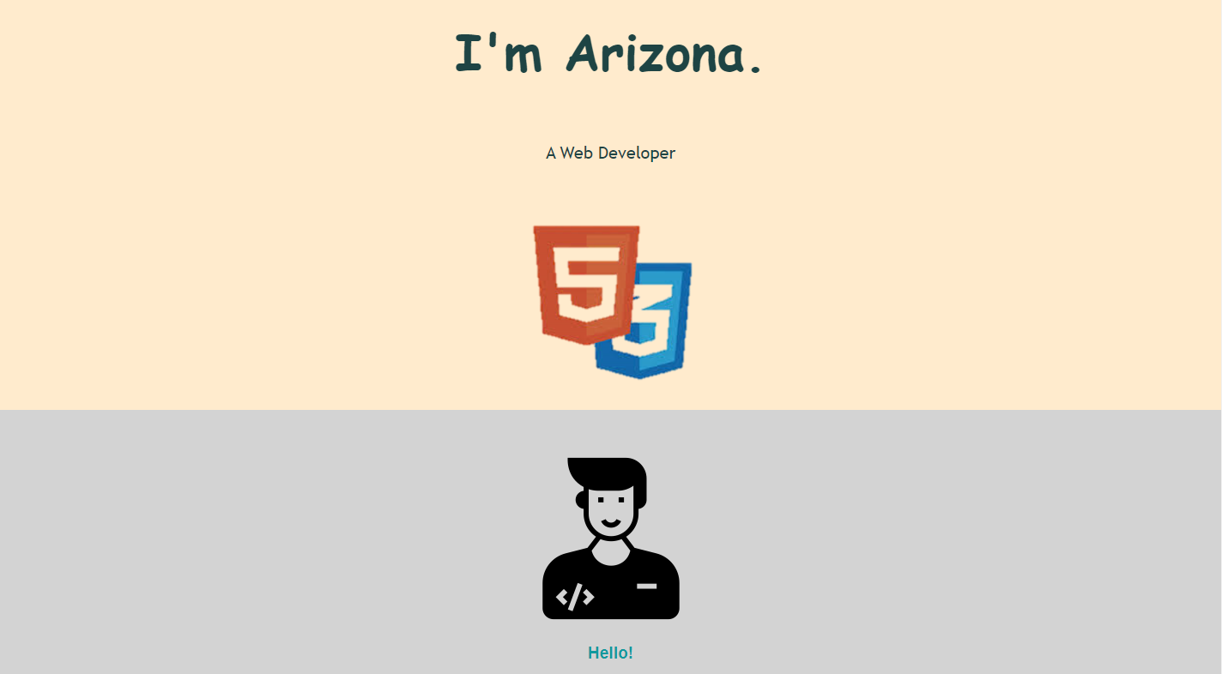

**Fig 1. Header Section**

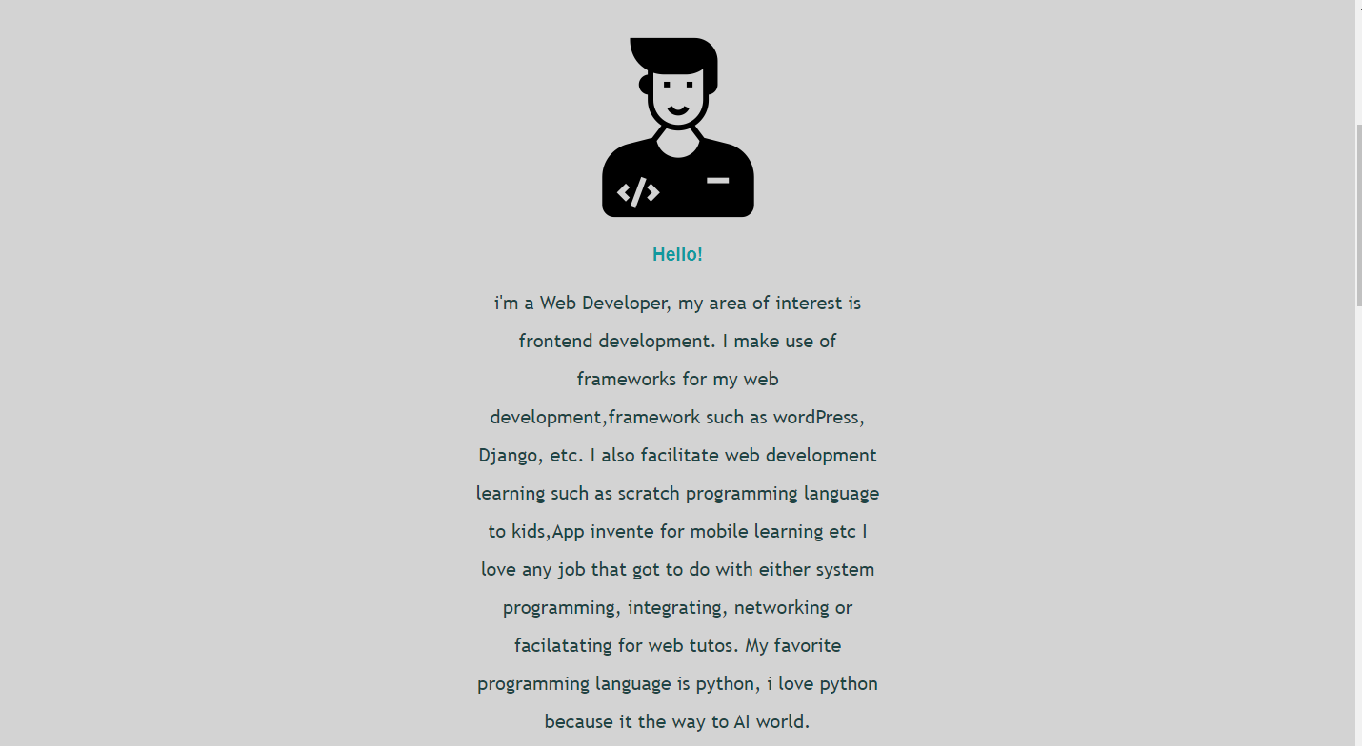

**Fig:2 About-Me Section**

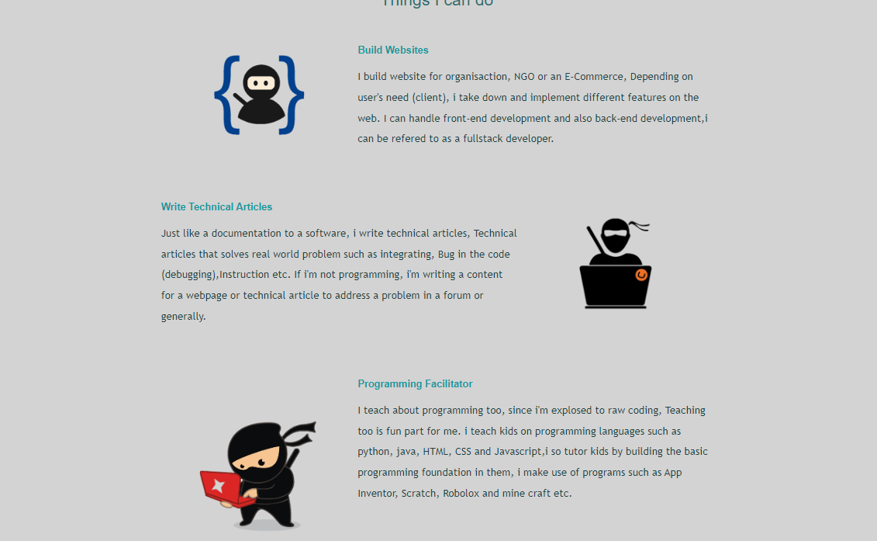

**Fig:3 Things I can do Section**

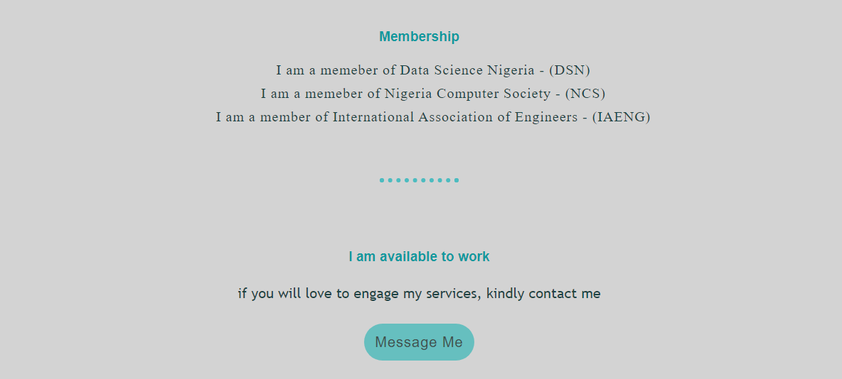

**Fig:4 Membership section**