Task & To-Do Management System
  - Mid-Semester Project Report
  - Software Engineering
  - Submitted by
Name | Registration No.
Rounak Das | 20243585
Priyansh Agarwal | 20243537
Shashank Karn | 20243546
Shivam Verma | 20243263
  - Date: 10-19-2026

1. Problem Statement and Motivation
Students and small teams usually have a lot of tasks going on at the same time, like assignments, lab work, project work and personal to-dos. Most of the time these tasks are kept in notebooks, phone notes or WhatsApp messages. Because of this, tasks get forgotten, deadlines are missed and it is hard to see what is done and what is still left.
There are big tools like Jira and Trello, but they have a lot of features that a student does not need, and some of them need a paid plan for team features. We wanted to build a simple web app where a user can make an account, add their tasks and see them on a Kanban board with three columns: To Do, In Progress and Done.
This project also lets our team practise the software engineering process that we learned in class, like requirements, design, Agile sprints and testing, on a real working system.

2. Project Objectives
- Build a web application where users can sign up and log in securely.
- Let users add, view, edit and delete their tasks with a title, description, priority, due date and status.
- Show the tasks on a Kanban board with To Do, In Progress and Done columns.
- Keep each user’s tasks private so that one user cannot see or change another user’s tasks.
- Follow an Agile approach with short sprints and a product backlog.
- Write automated tests for the backend and do manual testing of the UI.

3. Scope of the Project

3.1 Features Included
- User sign up, log in and log out
- Add, view, edit and delete tasks
- Task fields: title, description, priority (low / medium / high), due date and status
- Kanban board with three columns (To Do, In Progress, Done)
- Changing the status of a task from the card
- Due date shown and entered in MM-DD-YYYY format
- Search and filter tasks (planned for the second half)
- Sprints with a progress chart (planned for the second half)
- Overdue highlighting and dark mode (planned for the second half)

3.2 Features Excluded
- Mobile app (only a web app is made)
- Sharing tasks between users or team workspaces
- Email or push notifications and reminders
- File attachments on tasks
- Password reset through email
- Online deployment (the project runs locally)

3.3 Assumptions and Constraints
- Users have a modern web browser (Chrome, Firefox, Edge or Safari).
- Node.js 20 or newer is installed on the machine that runs the project.
- The app runs on a local machine, so only a small number of users is expected.
- The project has to be done in one semester by a team of four students.
- Only free and open-source tools are used.

4. Stakeholder Identification
Stakeholder | Role / Interest
Students / end users | Use the app to keep track of their tasks and deadlines.
Project team (4 members) | Design, build, test and document the system.
Course instructor | Evaluates the project and gives feedback.
Teaching assistants | Help with reviews and checking progress.

5. Requirements Specification

5.1 Functional Requirements
ID | Requirement
FR1 | The system shall allow a new user to sign up with name, email and password.
FR2 | The system shall not allow two accounts with the same email.
FR3 | The system shall allow a registered user to log in with email and password.
FR4 | The system shall allow a logged in user to log out.
FR5 | The system shall allow a user to add a task with title, description, priority, due date and status.
FR6 | The system shall show the user’s tasks on a Kanban board with To Do, In Progress and Done columns.
FR7 | The system shall allow a user to edit any of their tasks.
FR8 | The system shall allow a user to change the status of a task to move it to another column.
FR9 | The system shall allow a user to delete a task after confirming.
FR10 | The system shall only show a user their own tasks.
FR11 | The system shall show and accept due dates in MM-DD-YYYY format.
FR12 | The system shall allow the user to search and filter tasks.
FR13 | The system shall allow the user to group tasks into sprints and see a progress chart.
FR14 | The system shall highlight overdue tasks.
FR15 | The system shall support drag-and-drop between columns.
FR16 | The system shall have a dark mode.

5.2 Non-Functional Requirements
ID | Type | Requirement
NFR1 | Security | Passwords shall be stored as bcrypt hashes and never as plain text.
NFR2 | Security | All task requests shall need a valid JWT token.
NFR3 | Performance | Pages and API calls should respond in under 1 second on a normal laptop.
NFR4 | Usability | A new user should be able to add their first task without any help.
NFR5 | Reliability | Wrong input (empty title, bad date, wrong priority) shall show an error and not crash the app.
NFR6 | Portability | The app shall run on Windows, macOS and Linux with Node.js.
NFR7 | Maintainability | Code shall be split into frontend and backend folders with small modules.

5.3 Prioritisation of Requirements
We used the MoSCoW method to prioritise the requirements. This list also works as our product backlog.
Priority | Requirements | Status
Must have | FR1, FR2, FR3, FR4, FR5, FR6, FR7, FR8, FR9, FR10, NFR1, NFR2 | Done
Should have | FR11, FR12, NFR5 | FR11 and NFR5 done, FR12 planned
Could have | FR13, FR14, FR15, FR16 | Planned
Won’t have (this semester) | The excluded features in Section 3.2 | Not planned

6. Requirements Model

6.1 Use-Case Diagram
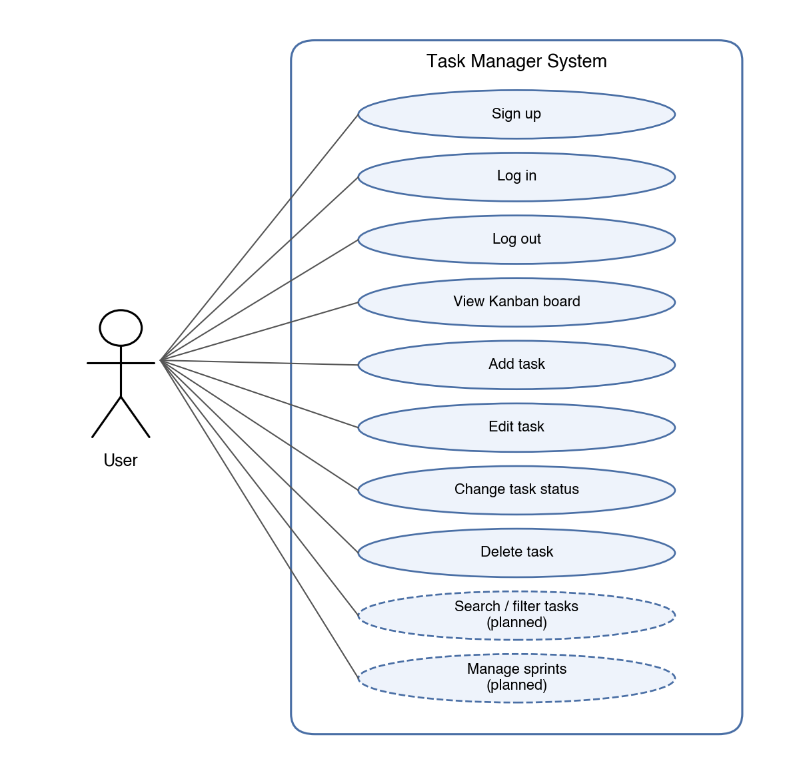
Figure 1: Use-case diagram

6.2 Use-Case Descriptions
ID | Use case | Actor | Precondition | Main flow | Alternate flow
UC1 | Sign up | User | User does not have an account | User enters name, email and password and clicks Sign Up. Account is made and the board opens. | Email already used or password under 6 characters: error message is shown.
UC2 | Log in | User | User has an account | User enters email and password and clicks Log In. Board is shown. | Wrong email or password: “Wrong email or password” is shown.
UC3 | Add task | User | User is logged in | User clicks “+ Add Task”, fills the form and clicks Save. Task shows in the right column. | Empty title or bad date: error is shown in the form.
UC4 | Edit task | User | Task exists | User clicks Edit, changes fields and clicks Save. Card is updated. | Same validation as UC3.
UC5 | Change status | User | Task exists | User picks a new status from the dropdown on the card. Card moves to that column. | Server error: message shown on the board.
UC6 | Delete task | User | Task exists | User clicks Delete and confirms. Card is removed. | User cancels: nothing happens.

7. System Design

7.1 Architecture
The system uses a simple client-server (three-tier) architecture. The React frontend runs in the browser and talks to the Express backend through a REST API using JSON. The backend checks the JWT token, runs the logic and reads or writes data in a SQLite database file.
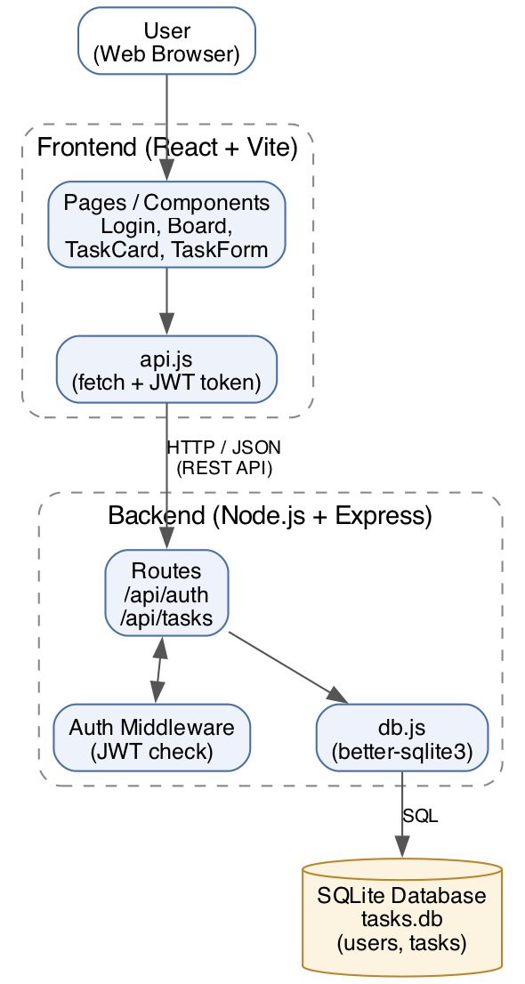
Figure 2: System architecture

7.2 Module Description
Module | File(s) | Description
Login page | client/src/components/Login.jsx | Log in and sign up form. Saves the token after login.
Board | client/src/components/Board.jsx | Loads tasks and shows them in three columns. Handles add, edit, status change and delete.
Task card | client/src/components/TaskCard.jsx | Shows one task with priority, due date, status dropdown, Edit and Delete buttons.
Task form | client/src/components/TaskForm.jsx | Popup form to add or edit a task. Checks the MM-DD-YYYY date format.
API helper | client/src/api.js | All fetch calls to the backend. Adds the JWT token to every request.
Auth routes | server/src/routes/auth.js | /register, /login and /me. Hashes passwords with bcrypt and makes JWT tokens.
Task routes | server/src/routes/tasks.js | GET, POST, PUT and DELETE for tasks. Validates the data.
Auth middleware | server/src/middleware/auth.js | Checks the JWT token and puts the user id on the request.
Database | server/src/db.js | Opens the SQLite file and creates the tables if needed.
Seed script | server/scripts/initDb.js | Adds a demo user and some sample tasks.

7.3 REST API
Method | URL | Login needed | Description
POST | /api/auth/register | No | Make a new account, returns token and user
POST | /api/auth/login | No | Log in, returns token and user
GET | /api/auth/me | Yes | Get the logged in user
GET | /api/tasks | Yes | Get all tasks of the user
POST | /api/tasks | Yes | Add a task
PUT | /api/tasks/:id | Yes | Update a task (any field)
DELETE | /api/tasks/:id | Yes | Delete a task

7.4 Database Design
The database has two tables. One user can have many tasks, and each task belongs to exactly one user through the user_id foreign key. Due dates are stored as YYYY-MM-DD so that they sort correctly, and the frontend changes them to MM-DD-YYYY for the user.
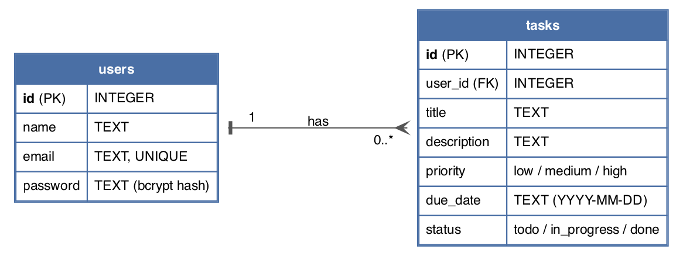
Figure 3: ER diagram

7.5 Sequence Diagram: Log In
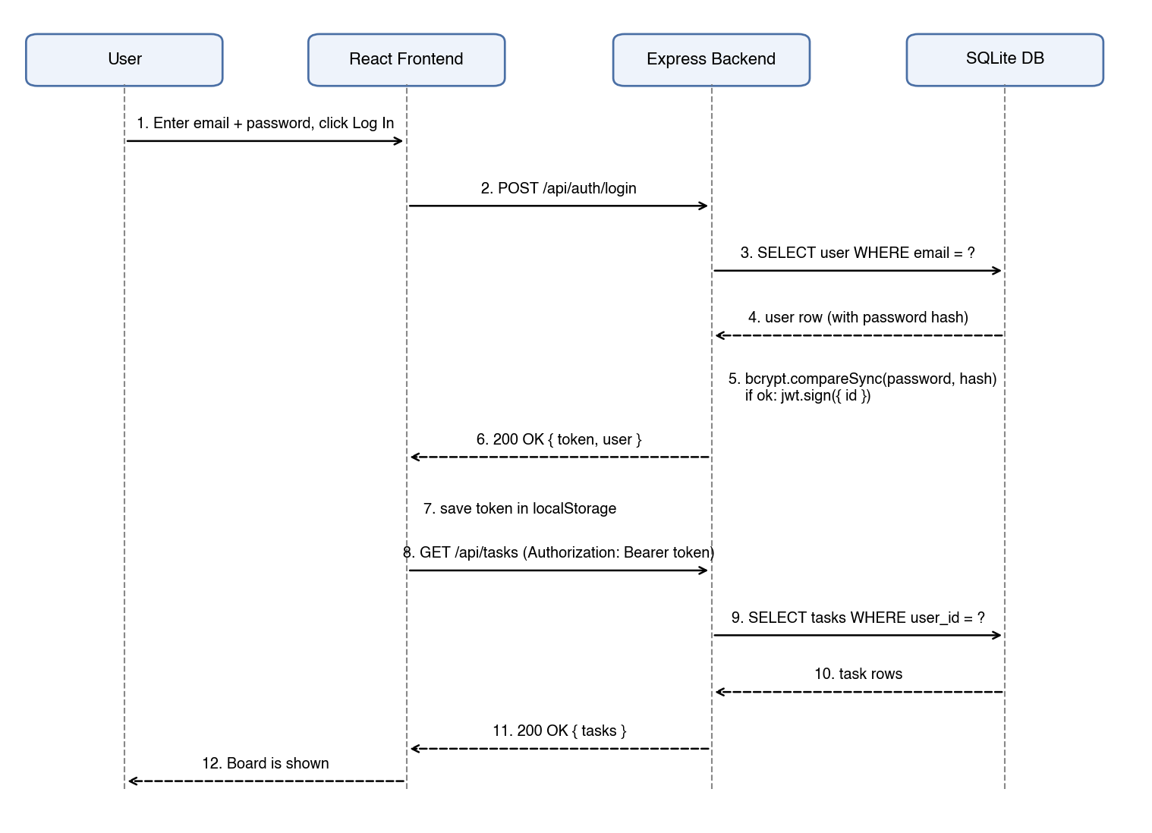
Figure 4: Sequence diagram for logging in and loading the board

7.6 Activity Diagram: Add Task
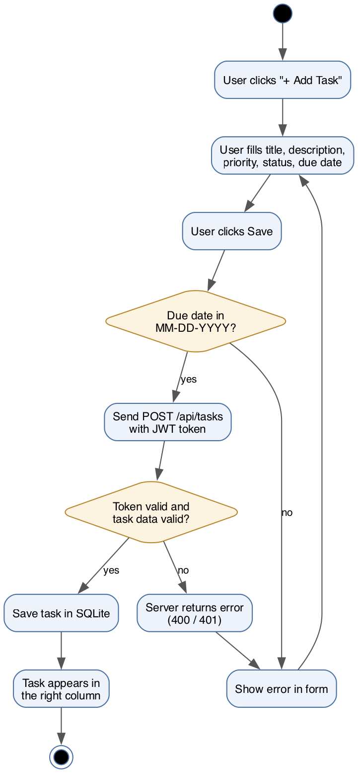
Figure 5: Activity diagram for adding a task

8. Technology Stack and Justification
Part | Technology | Why we chose it
Frontend | React 18 with Vite | Most of the team already knew some React. Components make the board, card and form easy to split up. Vite starts fast and has a simple proxy for the API.
Backend | Node.js + Express | Same language (JavaScript) as the frontend, so everyone can read all the code. Express is small and easy to learn.
Database | SQLite (better-sqlite3) | No database server to install, the whole database is one file. Good enough for a small number of users.
Login | JWT + bcrypt | JWT tokens are simple to use with a REST API. bcrypt is a standard way to hash passwords.
Testing | Jest + Supertest | Jest is the most common JavaScript test tool. Supertest lets us call the API in tests without starting the server.
Version control | Git + GitHub | Each member works on branches and we can see who did what.

9. Implementation Progress

9.1 Features Completed
- Sign up, log in and log out with JWT tokens and bcrypt password hashing
- Add, edit and delete tasks
- Kanban board with To Do, In Progress and Done columns and a task count for each column
- Changing task status from a dropdown on the card
- Due dates in MM-DD-YYYY format with validation on both frontend and backend
- Each user only sees their own tasks
- Sample data script with a demo user
- 15 automated backend tests
This means our working end-to-end feature is task management: the user logs in on the React page, the request goes to the Express API, the task is saved in SQLite and then shown on the board.

9.2 Features Under Development
- Search and filter tasks by title, priority and status
- Drag-and-drop between columns
- Sprints with a progress chart of tasks left
- Highlighting overdue tasks
- Dark mode

9.3 Screenshots of the Working System
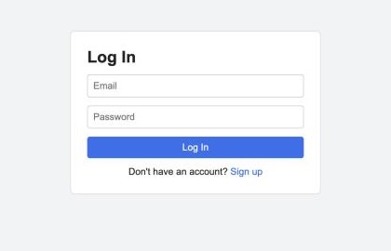
Figure 6: Log in page
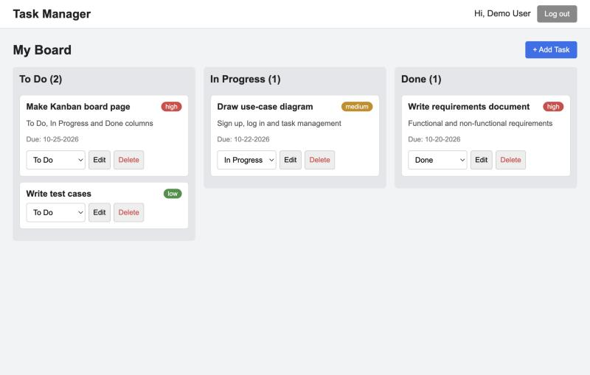
Figure 7: Kanban board after logging in with the demo user
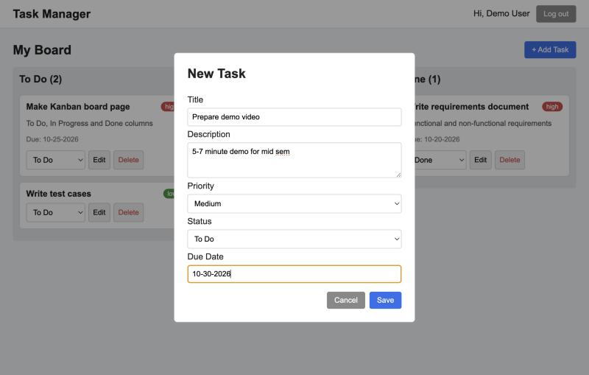
Figure 8: Add task form

9.4 Important Implementation Decisions
- JWT instead of sessions. The server does not need to remember who is logged in. The token is saved in the browser’s localStorage and sent with each request.
- Every task query checks user_id. All SELECT, UPDATE and DELETE queries use WHERE user_id = ?, so a user can never change another user’s task even if they guess the task id.
- Dates stored as YYYY-MM-DD, shown as MM-DD-YYYY. The database format sorts correctly and the user sees the format they asked for. We used a text box instead of the browser date picker because the date picker shows the date in the computer’s own format (for example DD/MM/YYYY), not MM-DD-YYYY.
- Validation on both sides. The form checks the date format before sending, and the server checks the title, priority, status and date again, so bad data cannot get in even if someone calls the API directly.

10. Testing Performed
We did two kinds of testing:
- Automated tests for the backend API using Jest and Supertest. Each test file uses a fresh in-memory SQLite database.
- Manual testing of the UI in Google Chrome using the demo user.

10.1 Test Cases
ID | Test case | Input | Expected result | Actual result | Status
T1 | Sign up | name, email, password “secret123” | 201, token and user returned | 201, token and user returned | Pass
T2 | Duplicate email | Same email again | 400 error | 400 error | Pass
T3 | Short password | Password “123” | 400 error | 400 error | Pass
T4 | Log in | Correct email and password | 200, token returned | 200, token returned | Pass
T5 | Wrong password | Password “wrongpass” | 401 error | 401 error | Pass
T6 | /me without token | No Authorization header | 401 error | 401 error | Pass
T7 | Tasks without login | GET /api/tasks, no token | 401 error | 401 error | Pass
T8 | Add task | title “Write SRS”, priority high, due date | 201, status “todo” | 201, status “todo” | Pass
T9 | Add task without title | description only | 400 error | 400 error | Pass
T10 | Wrong priority | priority “urgent” | 400 error | 400 error | Pass
T11 | Wrong due date | due_date “2026-13-45” | 400 error | 400 error | Pass
T12 | List tasks | GET /api/tasks | 1 task returned | 1 task returned | Pass
T13 | Change status | PUT status “done” | status “done”, title same | status “done”, title same | Pass
T14 | Other user’s task | Second user lists and deletes | List empty, delete gives 404 | List empty, delete gives 404 | Pass
T15 | Delete task | DELETE /api/tasks/:id | 200, task gone from list | 200, task gone from list | Pass
M1 | Log in from UI | demo@example.com / password123 | Board with sample tasks | Board with sample tasks | Pass
M2 | Wrong password in UI | demo@example.com / wrongpass | “Wrong email or password” | “Wrong email or password” | Pass
M3 | Sign up from UI | New name, email, password | Empty board opens | Empty board opens | Pass
M4 | Add task from UI | Title, description, date 10-30-2026 | Card in To Do with “Due: 10-30-2026” | Card in To Do with “Due: 10-30-2026” | Pass
M5 | Wrong date format | Date “2026/10/30” | “Due date must be in MM-DD-YYYY format” | Message shown, task not saved | Pass
M6 | Impossible date | Date “13-45-2026” | “Due date is not valid” | Message shown, task not saved | Pass
M7 | Edit task | Click Edit, change title | Form filled with old values, card updated | Form filled (date as 10-30-2026), card updated | Pass
M8 | Change status from card | Pick “In Progress” | Card moves to In Progress | Card moves to In Progress | Pass
M9 | Log out | Click Log out | Log in page shown | Log in page shown | Pass
T1 to T15 are automated tests and M1 to M9 are manual tests. All 24 test cases passed.

10.2 Evidence
Output of npm test in the server folder:
PASS tests/auth.test.js
Auth
✓ user can sign up
✓ cannot sign up twice with the same email
✓ cannot sign up with a short password
✓ user can log in
✓ cannot log in with wrong password
✓ cannot get user without token
PASS tests/tasks.test.js
Tasks
✓ cannot get tasks without logging in
✓ user can add a task
✓ cannot add a task without a title
✓ cannot add a task with a wrong priority
✓ cannot add a task with a wrong due date
✓ user can see their tasks
✓ user can move a task to done
✓ other user cannot see or delete the task
✓ user can delete a task
Test Suites: 2 passed, 2 total
Tests: 15 passed, 15 total
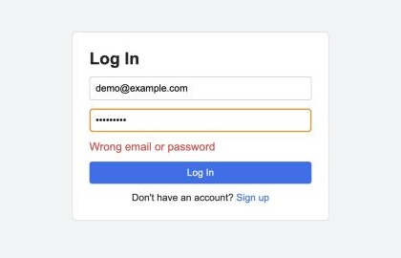
Figure 9: Test M2, wrong password message
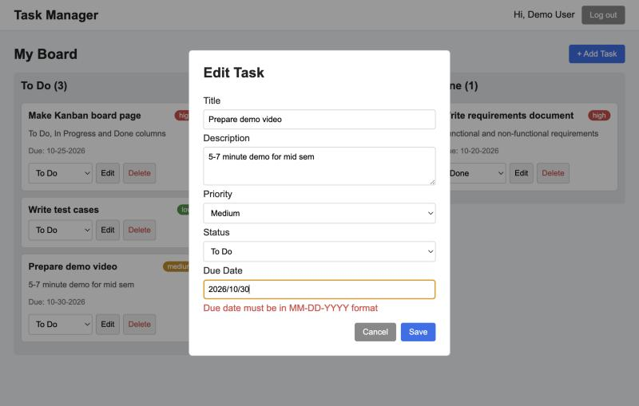
Figure 10: Test M5, wrong date format message

11. Project-Management Status

11.1 Original Project Plan
We follow Agile with two sprints, as planned at the start of the project.
Phase | Work | Planned
Planning | Choose topic, problem statement, stakeholders, requirements, backlog | Before mid-sem
Design | Architecture, ER diagram, use cases, UI wireframes | Before mid-sem
Sprint 1 | Login and sign up, task add / edit / delete, Kanban board, backend tests | Before mid-sem
Sprint 2 | Search and filter, drag-and-drop, sprints and progress chart, overdue highlighting, dark mode | After mid-sem
Final | Final testing, final report, final demo | End of semester

11.2 Current Progress
Work | Status
Problem statement, scope and requirements | Done
Design diagrams (architecture, ER, use case, sequence, activity) | Done
Sprint 1 features | Done
Backend automated tests | Done (15 tests passing)
Manual UI testing | Done (9 test cases)
Sprint 2 features | Not started
Overall we think the project is about 50% done.

11.3 Delayed or Pending Tasks
- Drag-and-drop was moved to Sprint 2. For now the status is changed with a dropdown, which was quicker to build and test.
- Frontend tests (React components) are not written yet.

11.4 Risks and Mitigation
Risk | Impact | Mitigation
Team members busy with other exams and assignments | Sprint 2 may be late | Keep Sprint 2 tasks small and do the must-have ones first
Drag-and-drop library is hard to learn | Feature might not finish | Status dropdown already works as a backup
Different Node.js versions on members’ laptops | Project might not run for everyone | README says Node.js 20 or newer, everyone uses the same version
Merge conflicts in Git | Lost time | Small branches, pull often, frontend and backend owned by different members
Losing data in the local database | Demo might break | npm run db:init makes the sample data again in a few seconds

12. Individual Contribution
Member | Role | Work
Rounak Das | Backend and database | Express server, login and sign up with JWT and bcrypt, task routes, SQLite database, sample data, backend tests, first version of the frontend, report draft, database design
Priyansh Agarwal | Testing and diagrams | Test case table, test evidence, UML diagrams (use case, sequence, activity), architecture diagram, use case descriptions
Shashank Karn | Frontend and UI | UI fixes, wireframes, demo recording and editing, demo video link
Shivam Verma | Report and project management | SRS, final report, project plan, meeting log, contribution record, final ZIP and Moodle upload

13. Challenges Faced and Solutions
Challenge | What we did
The browser date picker showed dates in the computer’s format (DD/MM/YYYY), but we wanted MM-DD-YYYY. | Used a normal text box with an MM-DD-YYYY placeholder and converted the date to YYYY-MM-DD before saving.
The SQLite library (better-sqlite3) did not install on older Node.js versions. | Agreed that everyone uses Node.js 20 or newer and wrote it in the README.
Making sure one user cannot see another user’s tasks. | Added user_id to every task query and wrote a test for it (T14).
Running npm install in the wrong folder (repo root) gave errors. | Wrote clear steps in the README to run commands inside server and client.

14. Work Planned for the Remaining Semester
- Search and filter tasks by title, priority and status.
- Drag-and-drop to move cards between columns.
- Sprints: create a sprint, add tasks to it and show a chart of tasks left.
- Highlight tasks that are past their due date.
- Dark mode.
- Frontend tests and more backend tests.
- Final report, final demo video and project presentation.

15. References
- I. Sommerville, Software Engineering, 10th ed. Pearson, 2016.
- K. Beck et al., “Manifesto for Agile Software Development,” 2001. https://agilemanifesto.org
- React Documentation. https://react.dev
- Vite Documentation. https://vitejs.dev
- Express Documentation. https://expressjs.com
- SQLite Documentation. https://www.sqlite.org/docs.html
- better-sqlite3 Documentation. https://github.com/WiseLibs/better-sqlite3
- M. Jones, J. Bradley and N. Sakimura, “JSON Web Token (JWT),” RFC 7519, IETF, 2015.
- Jest Documentation. https://jestjs.io
- Supertest. https://github.com/ladjs/supertest

Appendix A: AI Tool Usage Disclosure
Item | Details
Tool | Claude (Anthropic), used through Claude Code
Purpose | Understanding the project requirements, technical guidance on the tech stack, generating parts of the code, diagrams and a first draft of this report
Nature of generated content | Starter code for the backend and frontend, test cases, diagram drawings and report text
Verification / modification by students | The team read and ran all the code, ran the automated tests, tested the app manually in the browser, and checked and edited the report

Appendix B: How to Run
cd server
npm install
cp .env.example .env
npm run db:init
npm run dev
In a second terminal:
cd client
npm install
npm run dev
Open http://localhost:5173 and log in with demo@example.com / password123.

