PCIe IP Integration - Alpha
FPGA Board:
- Kintex UltraScale+ (xcku5p-ffvd900-2LV-e)
- Cyclone IV GX
Tool: Vivado and Quartus Prime
Block Diagram:
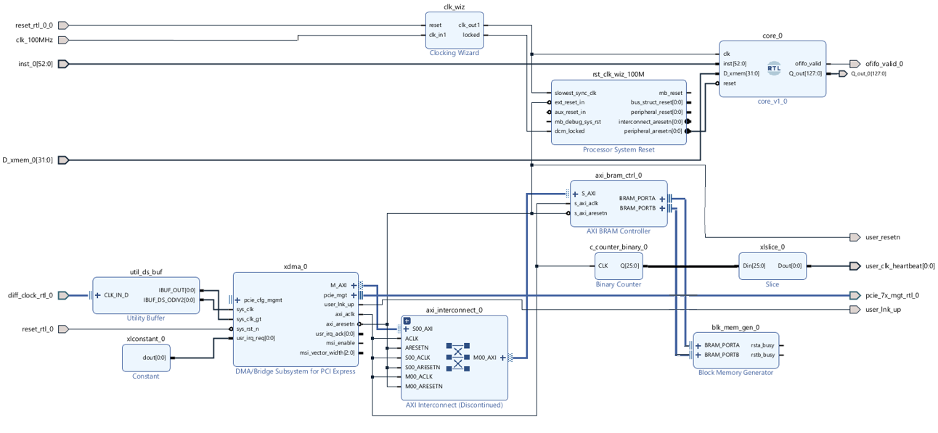
Figure-1: PCIe integrated with the Corelet
Mapping, Placement and Route:
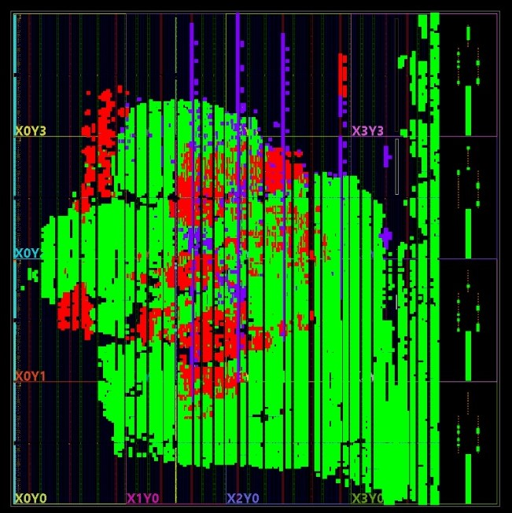
Figure-2: LUTs mapped to FPGA board
Explanation:
- PCIe interconnect IP is integrated with the Corelet of the reconfigurable systolic array.
- The idea is to have a multi-core architecture where the users/servers can configure multiple corelets and efficiently communication between them via the PCIe hub/interface.
- For this implementation, the input activation is directly connected to the Corelet.
- The weights are loaded by the user/server onto the 2 FPGA SRAM modules (activation/weight SRAM and psum SRAM) that are instantiated externally outside the corelet on the FPGA (these are hard macros).
- The PCIe DMA engine interfaces with a sub-ordinate AXI interface on it’s (PCIe’s) Master port.
- The AXI relays the data to corresponding SRAMs with appropriate control signals.
- Similarly, the AXI interface can also receive data from SRAMs (psum SRAM).

