PYTHON-PRACTICE
https://www.w3schools.com/python/default.asp
What is Python?
>> Python is a popular programming language. It was created by Guido van Rossum, and released in 1991.
It is used for:
- web development (server-side),
- software development,
- mathematics,
- system scripting.

What can Python do?
- Python can be used on a server to create web applications.
- Python can be used alongside software to create workflows.
- Python can connect to database systems. It can also read and modify files.
- Python can be used to handle big data and perform complex mathematics.
- Python can be used for rapid prototyping, or for production-ready software development.

Python Data Types:
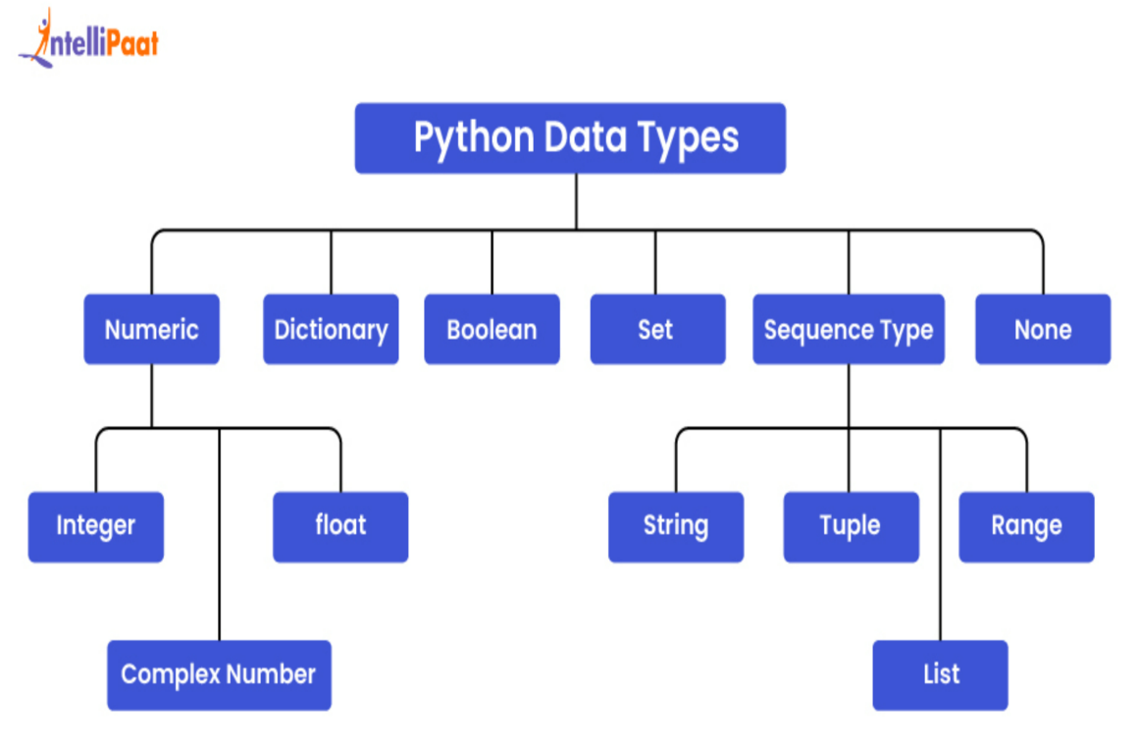
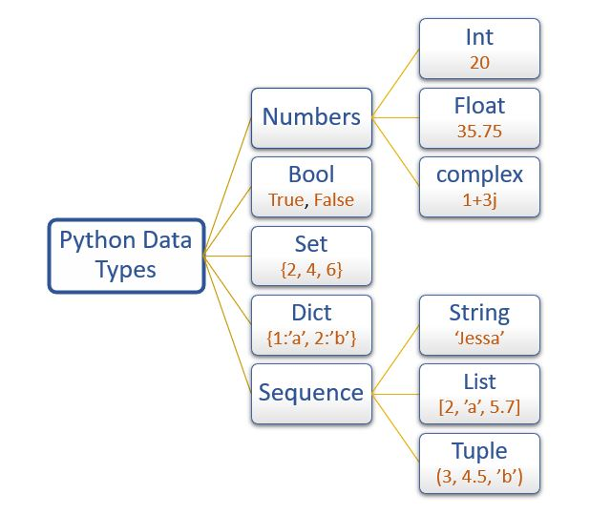

Python Output / Print:
Python program | Description
print ("Hello World!") | By using print(..) we can execute or print the program.

Double Quotes: Text in Python must be inside quotes. You can use either " double quotes or ' single quotes:
If we forget to put the text inside quotes, Python will give an error...
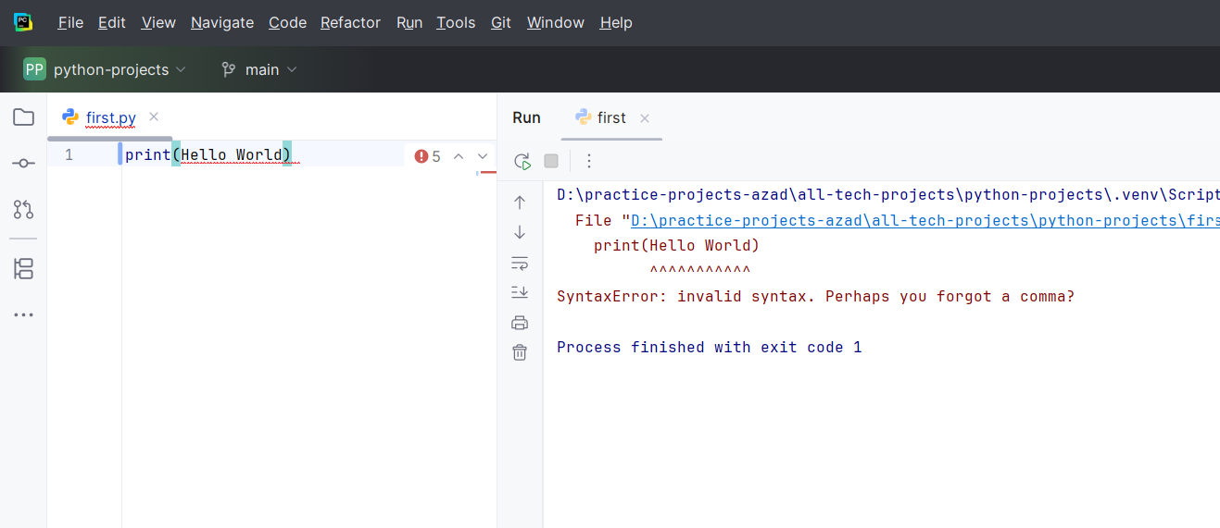

print("Hello World!", end=" ")  print("I will print on the same line.") | Print Without a New Line  By default, the print() function ends with a new line.  If you want to print multiple words on the same line, you can use the end parameter:
Note that we add a space after end=" " for better readability.
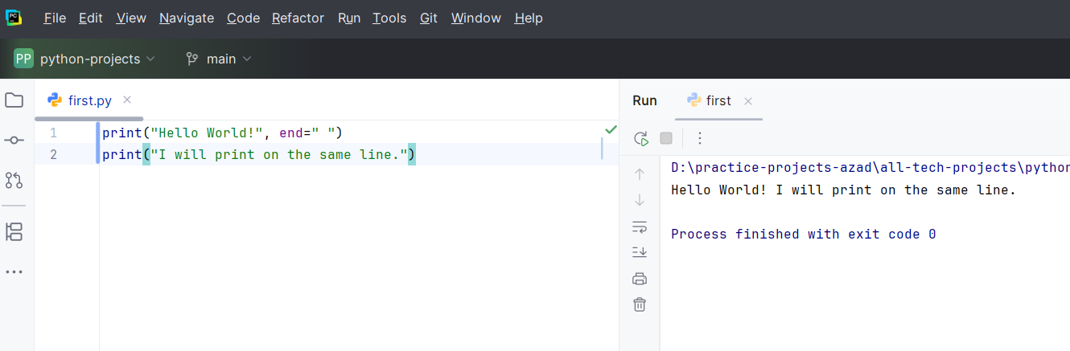

Print Numbers: For String we must use quotes but for numbers we no need to put quotes and we can add the numbers also.
print(3)  print(358)  print(50000) | print(3 + 3)  print(2 * 5)

Mix Text and Numbers: We can combine text and numbers in one output by separating them with a comma:
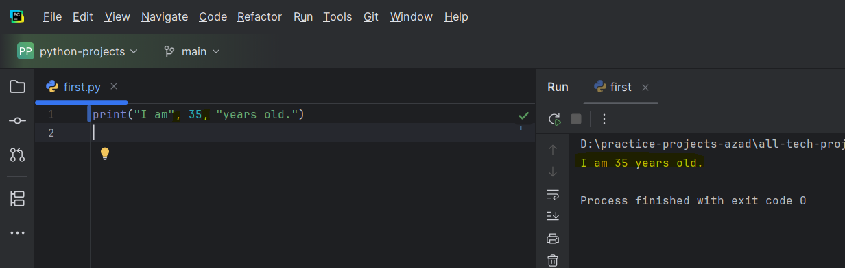
Python Comments:
Comments can be used to explain Python code.
Comments can be used to make the code more readable.
Comments can be used to prevent execution when testing code.
Comments start with a #, and Python will ignore them:
print("Hello, World!") #This is a comment  #This is a comment  print("Hello, World!") | Comments can be placed at the end of a line, and Python will ignore the rest of the line:  A comment does not have to be text that explains the code, it can also be used to prevent Python from executing code:
Python Variables: Variables are containers for storing data values. Python has no command for declaring a variable. A variable is created the moment you first assign a value to it.
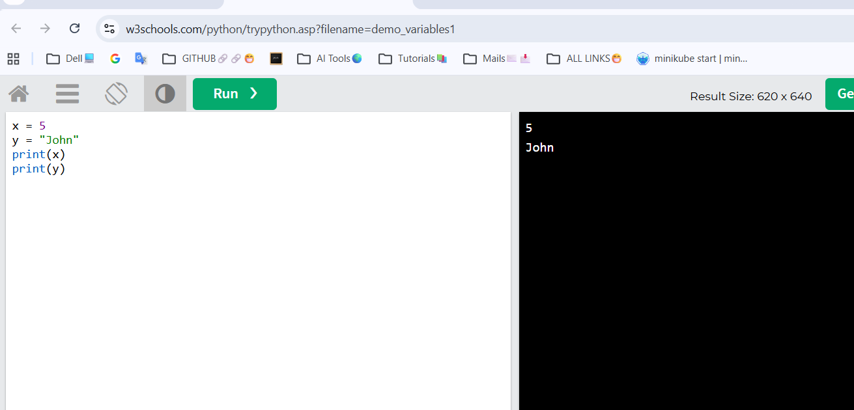
Variables do not need to be declared with any particular type, and can even change type after they have been set.
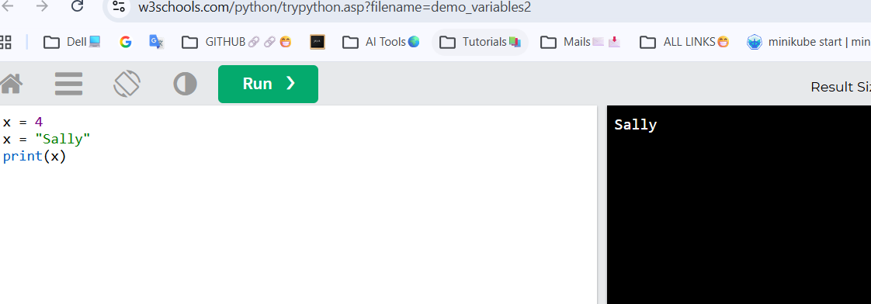
Casting: If you want to specify the data type of a variable, this can be done with casting.
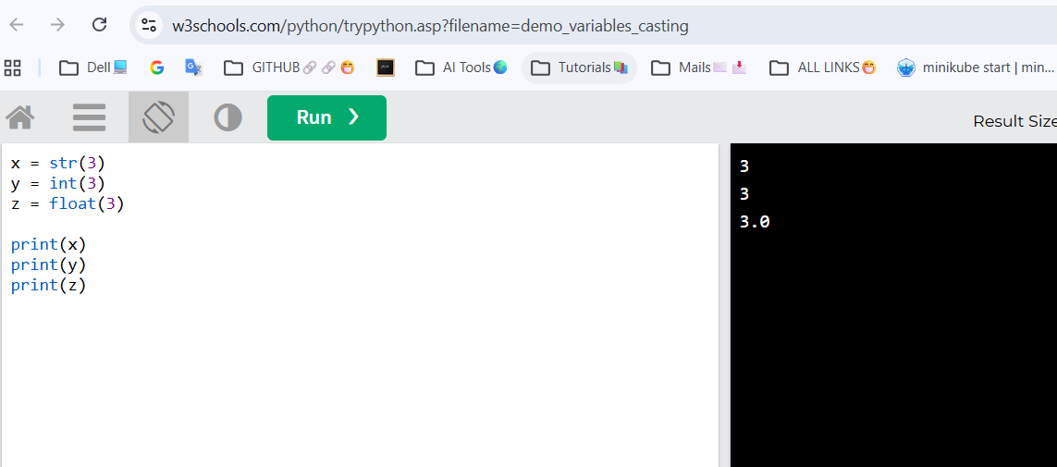
Python - Variable Names:
Variable Names
A variable can have a short name (like x and y) or a more descriptive name (age, carname, total_volume).
Rules for Python variables:
- A variable name must start with a letter or the underscore character
- A variable name cannot start with a number
- A variable name can only contain alpha-numeric characters and underscores (A-z, 0-9, and _)
- Variable names are case-sensitive (age, Age and AGE are three different variables)
- A variable name cannot be any of the Python keywords.
Legal variable names: | Illegal variable names:
myvar = "John"  my_var = "John"  _my_var = "John"  myVar = "John"  MYVAR = "John"  myvar2 = "John" | 2myvar = "John"  my-var = "John"  my var = "John"
NOTE: Remember that variable names are case-sensitive
Multi Words Variable Names:
Variable names with more than one word can be difficult to read.
There are several techniques you can use to make them more readable:
Variable define in several techniques | Examples
Camel Case technique | myVariableName = "John" Each word, except the first, starts with a capital letter
Pascal Case technique | MyVariableName = "John" Each word starts with a capital letter
Snake Case technique | my_variable_name = "John" Each word is separated by an underscore character

