Identifying Key Entities in Recipe Data

Business Objective:

The goal of this assignment is to train a Named Entity Recognition (NER) model using Conditional Random Fields (CRF) to extract key entities from recipe data. The model will classify words into predefined categories such as ingredients, quantities and units, enabling the creation of a structured database of recipes and ingredients that can be used to power advanced features in recipe management systems, dietary tracking apps, or e-commerce platforms.

Data Ingestion and Preparation
  - Loading the dataset
    - Import the dataset
      - There is a json file named ingredient_and_quantity.json which is imported and converted to the dataframe.
      - There are 285 rows and 2 columns(input and pos) in the dataset.

Recipe Data Manipulation
    - Create input_tokens and pos_tokens columns by splitting the input and pos from the dataframe
      - Both the input_tokens and pos_tokens are split by splitting on space character because the results are satisfactory
    - Provide the length for input_tokens and pos_tokens and validate their length
      - There are five rows where the length of input_tokens and pos_tokens are not same
    - Define a unique_labels function and validate the labels in pos_tokens
      - There are three unique levels i.e. [ 'ingredient', 'unit', 'quantity']
    - Provide the insights seen in the recipe data after validation
      - All the rows where the length of position tags and input tokens were removed as it contained some human data collection error

Train Validation Split
    - The data was split into a ratio of 70 percent training data and 30 percent validation data
    - It resulted into 196 training samples and 84 validation samples
    - The X_train data and Validation data was converted to list
    - It was made sure that all the labels are present in the training data
- Exploratory Recipe Data Analysis on Training Dataset
  - To get the distribution of input tokens and pos tokens, both the lists are flattened
  - It was validated that the number of tokens and pos are same
  - Input tokens are categorised into ingredients, units and quantities
  - Top 10 items in category ingredient:
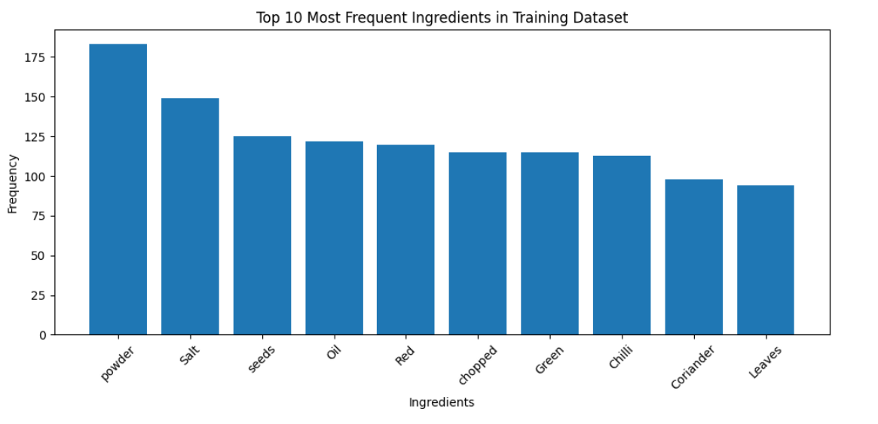
  - Top 10 items in category units
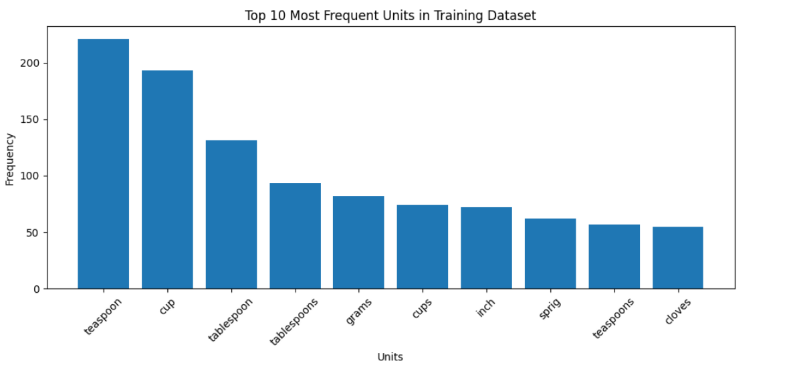
- Feature Extraction for CRF model
  - Different features are created for each input token using spcy library
    - - `bias` - Constant feature with a fixed value of 1.0 to aid model learning.
    - - `token` - The lowercase form of the current token.
    - - `lemma` - The lowercase lemma (base form) of the token.
    - - `pos_tag` - Part-of-speech (POS) tag of the token.
    - - `tag` - Detailed POS tag of the token.
    - - `dep` - Dependency relation of the token in the sentence.
    - - `shape` - Shape of the token (e.g., "Xxx" for "Milk").
    - - `is_stop` - Boolean indicating if the token is a stopword.
    - - `is_digit` - Boolean indicating if the token consists of only digits.
    - - `has_digit` - Boolean indicating if the token contains at least one digit.
    - - `has_alpha` - Boolean indicating if the token contains at least one alphabetic character.
    - - `hyphenated` - Boolean indicating if the token contains a hyphen (-).
    - - `slash_present` - Boolean indicating if the token contains a slash (/).
    - - `is_title` - Boolean indicating if the token starts with an uppercase letter.
    - - `is_upper` - Boolean indicating if the token is fully uppercase.
    - - `is_punct` - Boolean indicating if the token is a punctuation mark.
    - - `is_quantity` - Boolean indicating if the token matches a quantity pattern or keyword.
    - - `is_unit` - Boolean indicating if the token is a known measurement unit.
    - - `is_numeric` - Boolean indicating if the token matches a numeric pattern.
    - - `is_fraction` - Boolean indicating if the token represents a fraction (e.g., 1/2).
    - - `is_decimal` - Boolean indicating if the token represents a decimal number (e.g., 3.14).
    - - `preceding_word` - The previous token in the sentence, if available.
    - - `following_word` - The next token in the sentence, if available.
    - - `prev_token` - The lowercase form of the previous token.
    - - `prev_is_quantity` - Boolean indicating if the previous token is a quantity.
    - - `prev_is_digit` - Boolean indicating if the previous token is a digit.
    - - `BOS` - Boolean indicating if the token is at the beginning of the sentence.
    - - `next_token` - The lowercase form of the next token.
    - - `next_is_unit` - Boolean indicating if the next token is a unit.
    - - `next_is_ingredient` - Boolean indicating if the next token is not a unit or quantity.
    - - `EOS` - Boolean indicating if the token is at the end of the sentence.
    - A new feature class_weight is created for each token:
      - To give priority to those categories which are less frequent
      - Frequency counts were calculated for each category and weight is given inversely proportion to the frequency counts
- Model Building
  - CRF model was intialiased and fit on the data
  - Following hyperparameters were used while fitting the model:
    - algorithm='lbfgs' - Optimisation algorithm used for training. `lbfgs` (Limited-memory Broyden–Fletcher–Goldfarb–Shanno) is a quasi-Newton optimisation method. |
    - c1=0.5 - L1 regularisation term to control sparsity in feature weights. Helps in feature selection. |
    - c2=1.0 - L2 regularisation term to prevent overfitting by penalising large weights. |
    - max_iterations=100 - Maximum number of iterations for model training. Higher values allow more convergence but increase computation time. |
    - all_possible_transitions=True - Ensures that all possible state transitions are considered in training, making the model more robust.
- Evaluation of Training dataset using CRF model
  - Classification Report
    - The results are pretty good at the training data with most of the metrics being close to 1
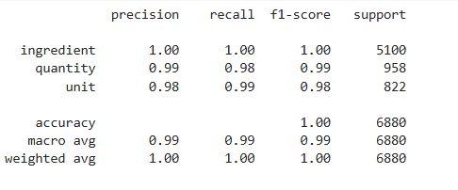
  - Confusion Matrix
    - Ingredient category is classified with the 100% accuracy
    - There are some misclassified tokens which are classified wrongly with Units and Quantity interchangeably
- Prediction and Model Evaluation
  - Classification report
    - The metrics have somehow dropped a little bit as compared to the model performance on the training data
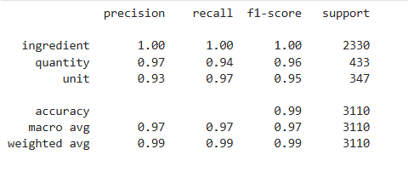
  - Confusion Matrix
    - Same as the above observation
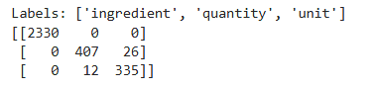
- Error analysis on Validation Data
  - Provide Insights from the Validation dataset
    - All the tokens which are classified wrongly are stored in a dataframe
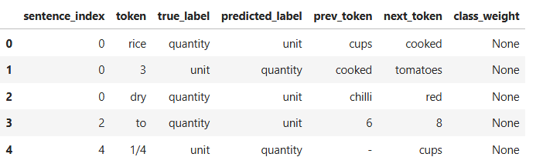
    - Overall accuracy of the model on validation dataset came out to be 0.9877
  - Analyse errors by label type
    - Ingredient
      - There are no misclassified tokens in ingredients category
    - Units
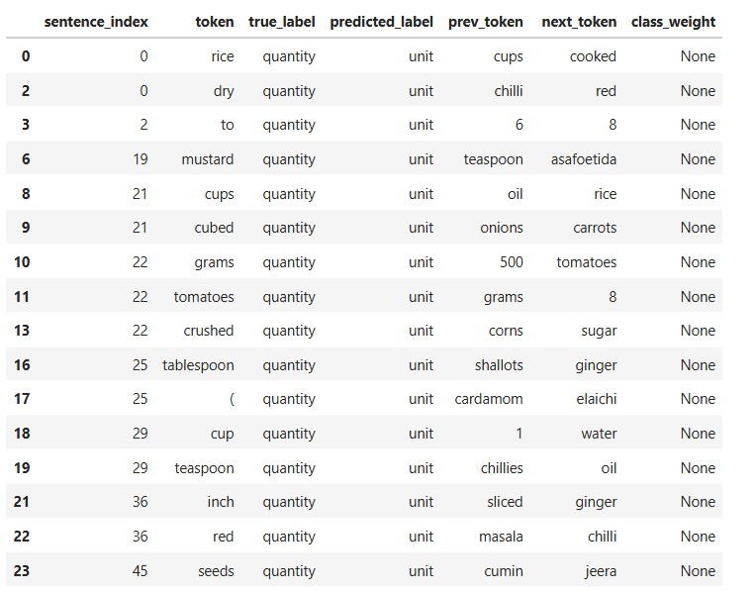
    - Quantities
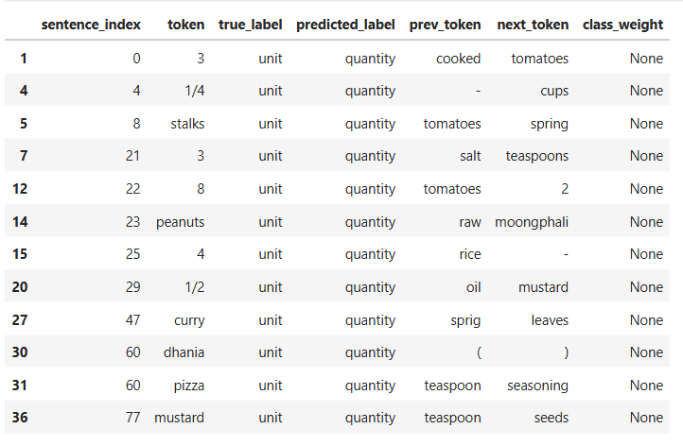
  - Provide Insights from the Validation dataset
    - Ingredient words are predicted very correctly and there are almost no errors for ingredient.
    - The model clearly understands ingredient tokens like rice, mustard, tomatoes and onion.
    - Quantity tokens are often predicted as unit.
    - Many quantity errors come from words that are not real quantities, such as rice, dry, red, seeds and powder.
    - These words are wrongly labelled as quantity in the data, which confuses the model.
    - Unit tokens are sometimes predicted as quantity.
    - Fraction values like 1/2 and 1/4 look like numbers, so the model thinks they are quantity.
    - Some ingredient words are wrongly labelled as unit, which causes more confusion.
    - All errors happen only between quantity and unit.
    - Ingredient is never confused with quantity or unit.
    - This shows the model logic is correct and consistent.
    - Bias features strongly support ingredient and unit labels.
    - The is_quantity feature helps the model predict quantity.
    - The is_unit feature helps the model predict unit.
    - The class_weight feature reduces the dominance of ingredient label.
    - Context features like previous and next token are very important.
    - Quantity and unit words appear close to each other in recipes, so confusion is expected.
    - Most errors come from language ambiguity and noisy labels, not from poor model performance.
    - Overall, the CRF model works very well and learns useful patterns from the data.

