Chief Investment Officer's Report

Karl Polen

October 1, 2017

It is a privilege to deliver this Investment Section to the Comprehensive Annual Financial Report of the Arizona State Retirement System. In this section we will discuss our investment philosophy, the investment environment and our investment results. We will also discuss our commitment to compliance, governance, rigorous measurement, and transparent reporting. Finally, we will deliver various documents and schedules providing detailed information about the ASRS investment program.

## Investment Philosophy

ASRS believes that the strategic asset allocation is the most important investment decision. Investment returns are largely, but not entirely, determined by choices made in the strategic asset allocation process. The ASRS investment team seeks to enhance returns compared strategic asset allocation benchmarks through its implementation of the investment program and tactical positioning relative to strategic targets.

Fundamentally, investment returns are rewards for risks taken. Traditional financial theory tends to regard volatility, the propensity of asset prices to go up and down, as the fundamental measure of risk. However, more recent literature takes a more nuanced view of risk considering characteristics such as valuation, liquidity, quality, momentum and market capitalization as fundamental risk factors which drive return. ASRS positions its portfolio mindful of all these risks and the risk premiums associated with them in order to structure a portfolio designed to achieve positive risk adjusted returns.

ASRS is a long term investor with a multi-decade horizon for its decisions. Additionally, the requirements to generate cash to fund payments to beneficiaries are highly forecastable and known well in advance. The current capital value of the ASRS trust is more than 30 times the annual cash requirement to fund benefits. This positions ASRS ideally with a natural advantage to use this liquidity and long term perspective to patiently seek market rewards.

ASRS gains advantage over the market by acting as a liquidity provider funding less liquid assets when warranted by the risk premiums available from this type of investment. Notably, ASRS has significantly enhanced its returns and diversification through the implementation of its private markets investing program which includes investments in real estate, private equity and private debt. In another example, ASRS is a value oriented investor seeking to capitalize on market dislocations which affect asset prices and risk premiums. Although any form of market timing is notoriously difficult, ASRS nevertheless favors assets priced cheaply to historic norms. Our goal is to buy assets when they are cheap and then patiently wait for them to recover.

Our long horizon for our investments is a key advantage that allows us to tolerate short term volatility and enables us to focus on value, liquidity and other risk factors that produce superior returns but require patience to achieve results.

## Investment Environment and Results

Global capital markets have been impacted in recent years by the global financial crisis and other market dislocations. Equity markets have generally been positive since the crisis and the most recent fiscal year was another strong year for equities. The U.S. market continued its expansion and the employment picture showed steady improvement. European growth improved with the support of very low interest rates and accommodative monetary policy. In this environment, bond market results were mixed. While high yield markets performed well in conjunction with a surging stock market, investment grade bonds suffered as the Federal Reserve raised short term interest rates and announced plans to begin tightening monetary policy.

The following chart shows market returns for the last 15 years for the public market asset classes included in the ASRS strategic asset allocation.

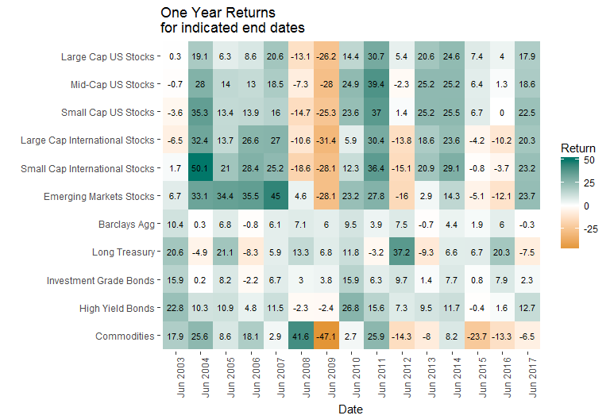

The following chart shows returns earned by ASRS over the last 40 years compared to market benchmarks. ASRS returns were 13.9% in the most recent fiscal year. While this one year return was 10bp (one tenth of one percent) below its benchmark, ASRS outperformed market benchmarks in all longer periods including a 9.7% compounded return for the last 42 years, compared to a benchmark of 9.5%.

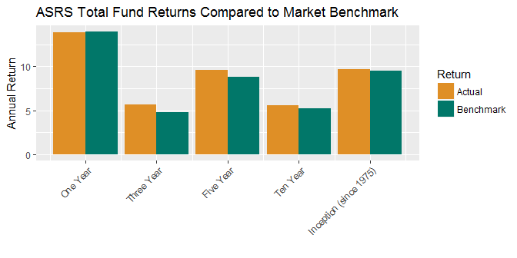

The effects of seemingly small differences in performance are very significant in dollar terms when compounded over multiple years. The following chart shows that over $1.5 billion has been added to fund value from above market returns over the last five to ten years.

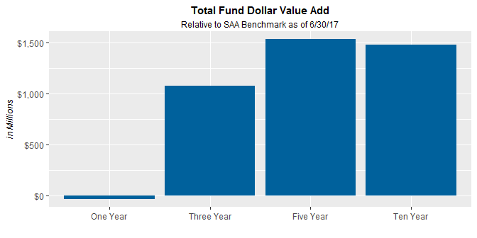

The largest contributor to value added has been the private markets program which has added $800 million of value. This is more than half of the total value added even though the private markets program represented less 20% of the assets invested on average over the last ten years. The remaining $700 million of value added came from public markets assets, including $300 million resulting from the internally managed enhanced index portfolios.

## Governance and Compliance

ASRS operates the investment program in accordance with statutory requirements under the direction of the ASRS Board and Executive Director. ASRS has adopted a formal and well documented governance process as set forth in the Board Governance Manual and various Strategic Investment Policies and Standard Operating Procedures which have been adopted by the board and ASRS management.

The investment program is further guided by an Investment Policy Statement which incorporates Investment Beliefs which are adopted by the ASRS Board. As noted above, the investments are implemented in accordance with a Strategic Asset Allocation which are also adopted by the board with input from investment staff and the external investment consultant. Copies of the Investment Policy Statement and Strategic Asset Allocation are included in the materials for this Investment Section.

Investments are implemented by the ASRS investment team under the direction of the Executive Director and with oversight by the external investment consultant and the board investment committee. In accordance with written policies, investment decisions are made by asset class committees which meet monthly, or more frequently if necessary, and are documented by formal minutes and meeting materials which consist of staff reports and external consultant reports. The external investment consultant attends the asset class committee meetings to remain informed on investment matters and to monitor that all governance procedures are followed.

Compliance with statutes and policies is further monitored by our custody bank which checks every trade and reports daily on the compliance status of the portfolio. Additionally, external consultants monitor the private markets program reviewing partnerships annually to confirm that fees are correctly calculated and reported, valuation policies are observed and that partnerships are being administered in accordance with the terms of the partnership agreement.

## Cost

While cost management is not an investment strategy per se, cost reduction is one of the most important ways to improve investment performance. ASRS aggressively manages cost to help ensure the highest value is achieved for all our investment expenditures.

In the case of public markets where research and experience indicate that the prospects for adding value through management are limited, we are parsimonious in the payment of fees. We manage approximately 50% of public market assets in house at effectively zero incremental cost. Internally managed assets are implemented in enhanced index strategies designed to earn a premium compared to market returns. As noted above, approximately $300 million has been added to fund value as a result of these programs.

In private markets, costs are necessarily higher to implement these programs and we carefully monitor investments to ensure these costs are appropriately rewarded. As noted above, the private markets program has contributed $800 million (net of all fees and costs) to total fund value over the last ten years. During that period, private market returns were 10.3% per year which was 1.4% year higher than their benchmark. This compares to public market returns which were 5.3% over the same time frame. We are extremely cost conscious in the implementation of the private markets program. We reduce costs by concentrating our relationships with a smaller number of highly qualified managers who agree to enter in to custom negotiated partnerships at reduced fees. These partnerships, called "separate accounts", provide benefits to ASRS beyond reduced fees including custom investment criteria and favorable liquidity terms that give ASRS rights to influence or determine the pace of investment and liquidation of the partnership. ASRS plans to continue to grow the separate account program to around 75% of private market assets.

## Reporting and Performance Measurement

ASRS has implemented a comprehensive and transparent system of reports to keep the ASRS Management, Board and the public informed on ASRS investments. ASRS complies with all required reporting under GASB standards and voluntarily complies with recommended disclosures of the Government Financial Officers Association ("GFOA"). All GFOA recommended disclosures are included in this investment section.

Additionally, ASRS has been a leader in adopting rigorous investment performance measurement systems. ASRS believes that sophisticated performance measurement contributes to the efficacy of portfolio management, improves decisions and leads to better results. Starting in 2012, ASRS implemented performance measurement systems in its private markets investments based on new research recommending "public market equivalent" measurements of performance. ASRS continued the performance measurement project focusing on public equities and implementing Brinson style attribution analysis across the portfolio, returns based performance analysis using various statistical methods across rolling time frames and and holdings based style analysis across rolling time frames. These methods were extended to fixed income assets in 2017. ASRS plans to complete the performance measurement project in 2018 by adding processes for total fund attribution analysis.

## Technology

ASRS is committed to using state of the art technology to bring the most sophisticated analytical methods to its decisions, to implement quality in data bases and information systems and to continuously enhance the producitivity of the investment team. As noted above, ASRS is implementing an ambitious performance measurement system project greatly increasing both the quality and quantity of information available for investment decisions. We are implementing this at very low incremental cost utilizing the analytical expertise and software coding skills of existing staff. Through automation of tasks previously performed by hand we are increasing the amount of time available for higher value and more creative work. We also increase the reliability of information through automation and elimination of manual steps. We plan to continue these efforts through completion of the performance measurement system, further enhancements to reporting systems, market monitoring systems and potential enhancements of risk management systems.

## Conclusion

It is an honor to serve the members and beneficiaries as your Chief Investment Officer. We hope you find the materials in this Investment Section informative and helpful in understanding the investments of the Arizona State Retirement System.

Sincerely,

Karl Polen