

Functional Safety Concept Lane Assistance

**Document Version: 1.0**

**Template Version 1.0, Released on 2017-06-21**



# Document history

|  |  |  |  |
| --- | --- | --- | --- |
| Date | Version | Editor | Description |
| June 23, 2018 | 1.0 | Aftab Engaria | Initial Draft |
|  |  |  |  |
|  |  |  |  |
|  |  |  |  |
|  |  |  |  |

# Table of Contents

Document history

Table of Contents

Purpose of the Functional Safety Concept

Inputs to the Functional Safety Analysis

Safety goals from the Hazard Analysis and Risk Assessment

Preliminary Architecture

Description of architecture elements

Functional Safety Concept

Functional Safety Analysis

Functional Safety Requirements

Refinement of the System Architecture

Allocation of Functional Safety Requirements to Architecture Elements

Warning and Degradation Concept

# Purpose of the Functional Safety Concept

The functional safety concept is a high level approach to look at the general functionality of the item without going into technical detail. The goal is to identify safety requirements and then allocate those requirements to different parts of the item architecture. From the result of the functional safety concept technical safety requirements can be derived within a subsequent technical safety concept. Functional safety requirements also have attributes that are specified in the functional safety concept. Finally, to prove that a system actually meets requirements, they have to be verified and validated.

# Inputs to the Functional Safety Concept

## Safety goals from the Hazard Analysis and Risk Assessment

|  |  |
| --- | --- |
| **ID** | **Safety Goal** |
| Safety_Goal_01 | The oscillating steering torque from the LDW function shall be limited. |
| Safety_Goal_02 | LKA function shall be time limited and the additional steering torque shall end after a given timer interval so that the driver cannot misuse the system for autonomous driving |
| Safety_Goal_03 | LKA function has to be deactivated if camera sensor is not able to detect lanes correctly |
| Safety_Goal_04 | LKA has to be sensible for different coloring of lane lines, reliably detect and react on merging lanes in advance. |

## Preliminary Architecture

Following figure describes a preliminary architecture for the lane assistance item.

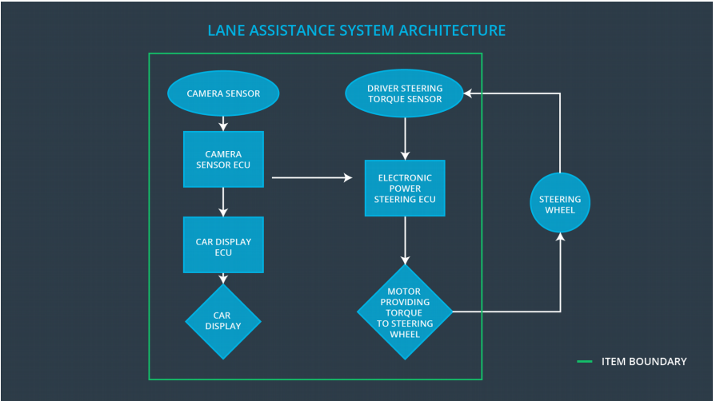

### Description of architecture elements

|  |  |
| --- | --- |
| **Element** | **Description** |
| Camera Sensor | Capture road images and provide them to the Camera Sensor ECU. |
| Camera Sensor ECU | Analyze provided images to calculate the car position on the road respect to the road lanes. |
| Car Display | Provide feedback to the driver displaying warnings and the Lane Departure Assistance status. |
| Car Display ECU | Drive the Car Display component to show the Lane Keeping Assistance warning and Lane Departure Assistance status. |
| Driver Steering Torque Sensor | Measure the torque applied to the steering wheel by the driver. |
| Electronic Power Steering ECU | Use the information received from the Driver Steering Torque Sensor and the torque requested by the Lane Keeping Assistance and Lane Warning and request the necessary torque to be applied by the Motor actuator. |
| Motor | Applies the torque indicated by the Electronic Power Steering ECU to the steering wheel. |

# Functional Safety Concept

The functional safety concept consists of:

* Functional safety analysis
* Functional safety requirements
* Functional safety architecture
* Warning and degradation concept

## Functional Safety Analysis

|  |  |  |  |
| --- | --- | --- | --- |
| **Malfunction ID** | **Main Function of the Item Related to Safety Goal Violations** | **Guidewords (NO, WRONG, EARLY, LATE, MORE, LESS)** | **Resulting Malfunction** |
| Malfunction_01 | Lane Departure Warning (LDW) function shall apply an oscillating steering torque to provide the driver a haptic feedback | MORE | The Lane Departure Warning function applies an oscillating torque with very high torque amplitude (above limit) |
| Malfunction_02 | Lane Departure Warning (LDW) function shall apply an oscillating steering torque to provide the driver a haptic feedback | MORE | The Lane Departure Warning function applies an oscillating torque with very high torque frequency (above limit) |
| Malfunction_03 | Lane Keeping Assistance (LKA) function shall apply the steering torque when active in order to stay in ego lane | NO | The Lane Keeping Assistance function is not limited in time duration which lead to misuse as an lane autonomous driving function. |
| Malfunction_04 | The Lane Departure Warning function shall be deactivated when the camera sensor stop working. | WRONG | The Lane Departure Warning start acting randomly when the camera sensor is not working. |
| Malfunction_05 | The Lane Keeping Assistance function shall be deactivated when the camera sensor stop working. | WRONG | The Lane Keeping Assistance start acting randomly when the camera sensor is not working. |

## Functional Safety Requirements

Lane Departure Warning (LDW) Requirements:

|  |  |  |  |  |
| --- | --- | --- | --- | --- |
| **ID** | **Functional Safety Requirement** | **ASIL** | **Fault Tolerant Time Interval** | **Safe State** |
| Functional  Safety  Requirement  01-01 | The lane keeping item shall ensure that the lane departure oscillating torque *amplitude* is below Max_Torque_Amplitude | C | 50ms | Lane Assistant functionality off |
| Functional  Safety  Requirement  01-02 | The lane keeping item shall ensure that the lane departure oscillating torque frequency is below Max_Torque_Frequency | C | 50ms | Lane Assistant functionality off |

Lane Departure Warning (LDW) Verification and Validation Acceptance Criteria:

|  |  |  |
| --- | --- | --- |
| **ID** | **Validation Acceptance**  **Criteria and Method** | **Verification Acceptance**  **Criteria and Method** |
| Functional  Safety  Requirement  01-01 | Test how drivers react to different torque amplitudes to prove that an appropriate value was chosen | Verify that system turns off if LKA ever exceeds Max_Torque_Amplitude. |
| Functional  Safety  Requirement  01-02 | Test how drivers react to different torque frequencies to prove that an appropriate value was chosen. | Verify that system turns off if LKA ever exceeds Max_Torque_Frequency. |

**[Instructions: Fill in the functional safety requirements for the lane keeping assistance]**

Lane Keeping Assistance (LKA) Requirements:

|  |  |  |  |  |
| --- | --- | --- | --- | --- |
| **ID** | **Functional Safety Requirement** | **ASIL** | **Fault Tolerant Time Interval** | **Safe State** |
| Functional  Safety  Requirement  02-01 | The lane keeping item shall ensure that the lane keeping assistance torque is applied for only Max_Duration. | B | 500ms | Lane Assistant functionality off |

Lane Keeping Assistance (LKA) Verification and Validation Acceptance Criteria:

|  |  |  |
| --- | --- | --- |
| **ID** | **Validation Acceptance**  **Criteria and Method** | **Verification Acceptance**  **Criteria and Method** |
| Functional  Safety  Requirement  02-01 |  |  |

## Refinement of the System Architecture

**[Instructions: Include the refined system architecture. Hint: The refined system architecture should include the system architecture from the end of the functional safety lesson including all of the ASIL labels.]**

## Allocation of Functional Safety Requirements to Architecture Elements

**[Instructions: Mark which element or elements are responsible for meeting the functional safety requirement. Hint: Only one ECU is responsible for meeting all of the requirements.]**

|  |  |  |  |  |
| --- | --- | --- | --- | --- |
| **ID** | **Functional Safety Requirement** | **Electronic Power Steering ECU** | **Camera ECU** | **Car Display ECU** |
| Functional  Safety  Requirement  01-01 |  |  |  |  |
| Functional  Safety  Requirement  01-02 |  |  |  |  |
| Functional  Safety  Requirement  02-01 |  |  |  |  |

## Warning and Degradation Concept

**[Instructions: Fill in the warning and degradation concept.]**

|  |  |  |  |  |
| --- | --- | --- | --- | --- |
| **ID** | **Degradation Mode** | **Trigger for Degradation Mode** | **Safe State invoked?** | **Driver Warning** |
| WDC-01 |  |  |  |  |
| WDC-02 |  |  |  |  |