**OUTPUT**

First few content

Removed quantity

Clustering white wines

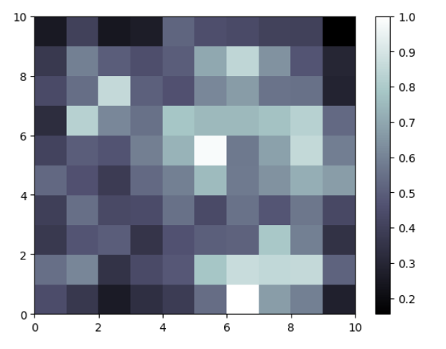

Visualization of wine quality

