Documentation

This assignment is to create User Module where user can create account and login into the application, and Admin Module where admin can Login into Admin-Dashboard.

We create this application by using HTML 5 for Front end and CSS for styling the website and PHP for server side programming and Ajax for data transmission to the server.

User Module:

User Module consists of Login Page (index.php), Sign Up (user-registration.html) page and Home page(home.php). The main goal of this user module is it allows users to create account and login to the application , after logging into the application the user will be able to add some data into the database and added data will retrieved and shown to the user .

Work Flow:

Have an accountaccount

Create Account

No

Yes

Login with username and password

Username,password matched

No

Yes

Home Page

Creating Account:

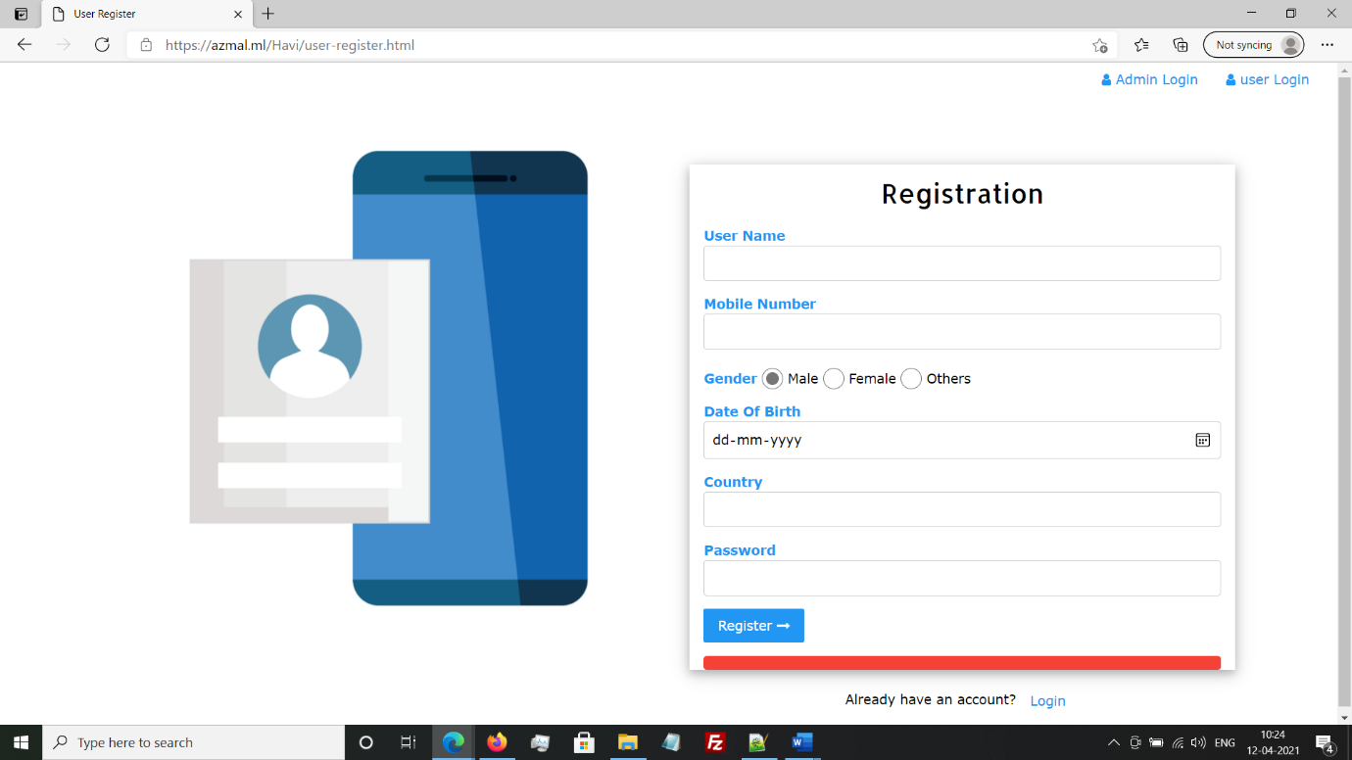

User-registration.html

For creating account user has to navigate to User Regristration page(user-registration.html) . After navigating to registration page user has to fill all the details , after filling the details user clicks on register button then the account is created if username and mobile number are not previously registered.

Process:

Each input filed in the registration form is assigned with a unique Id , when user clicks on Register button then onclick event is invoked , then the function invoked onclicking the buton collects the value of the input fields using DOM and sends data to user-register form using Ajax. If the input fileds are kept empty then it throws an error (Please fill Details). If the data is not sent to the user-registerform then it throws an error(Cannot connect to server).If the data is submitted to user-registerform then it sends back a acknowledgement then it shows Account created and navigates to the Login page if the data insertion is successful or shows failure message .As we are using Ajax the page does its operation with out reloading the webpage.

**Internal Working of User Register Form:**

The data which is submitted by the user in user-regsitration will be sent to user-registerform(user-registerform.php) by using POST method , the data is then entered into database(table:users) by using “INSERTION OPERATION” , if the insertion is done then it sends back success message to the user-registration page and then it navigates to Login Page.If the insertions fails then it sends back failure message to the user-registration page and shows error message.

Login:

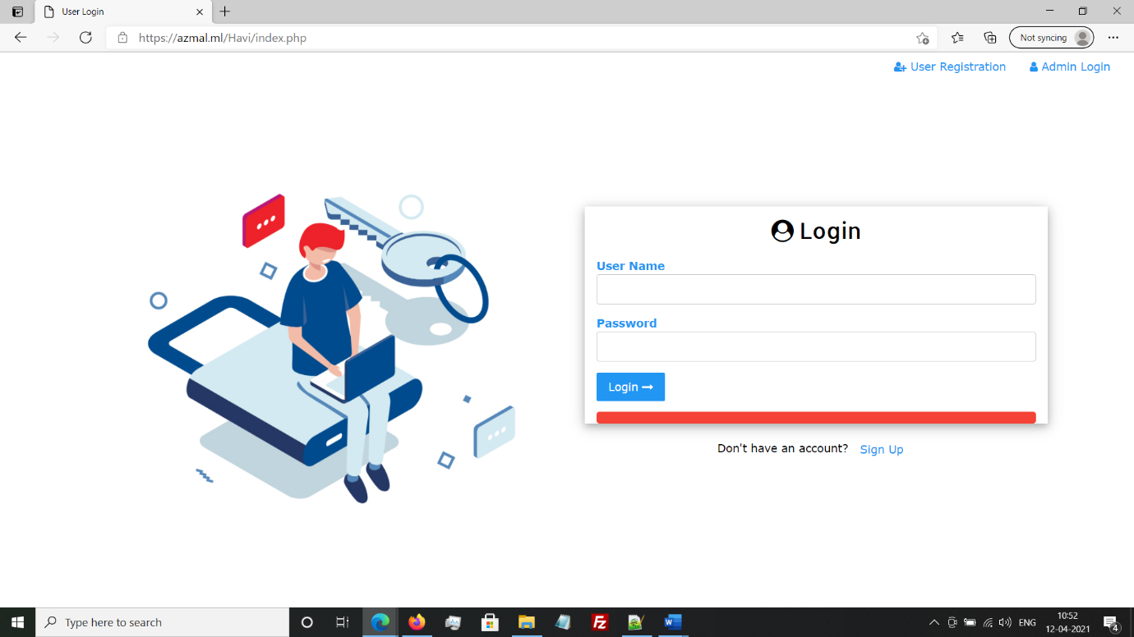

Index.php

For logging into the website user has to first create an account , there after creating account he will be navigating to the login page.The Login page contains two inpu fields UserName and Password , user has to give his login credentials and click on login button , on clicking on Login button onclick event is invoked and the data is sent to login-check page(login-check.php) by using Ajax. If the data is sent to Login-check it shows please wait…. on the login button and waits for acknowledgement from the login-check , if the data is not sent to login-check it shows an error Cannot connect to server , as we are using Ajax for data transmission the web page does not reload or navigates to Login-check.

**Working of Login-Check:**

On clicking on the login button in index.php , the input data entered is sent to Login-check by using POST method and login-check page gets the data entered by the user here and checks whether the username and password matches or not , if the data matches it set cookies and sessions of the user details and then the user is navigated to the home page(home.php) else it throws an error Inavlid credentials.

**Use of Check UserLogin Status:**

When the user entered data is matched with the database content then the login-check set Cookies and sessions of UID(user Id) username(username) and password(pass).These cookies are used in checkuserloginstatus page and checks whether the data is correct or not not and they store values as log_id,log_username,log_pass of the logged user if the data is correct.And we use this values by including in necessary files and acces logged user information.

Home Page:

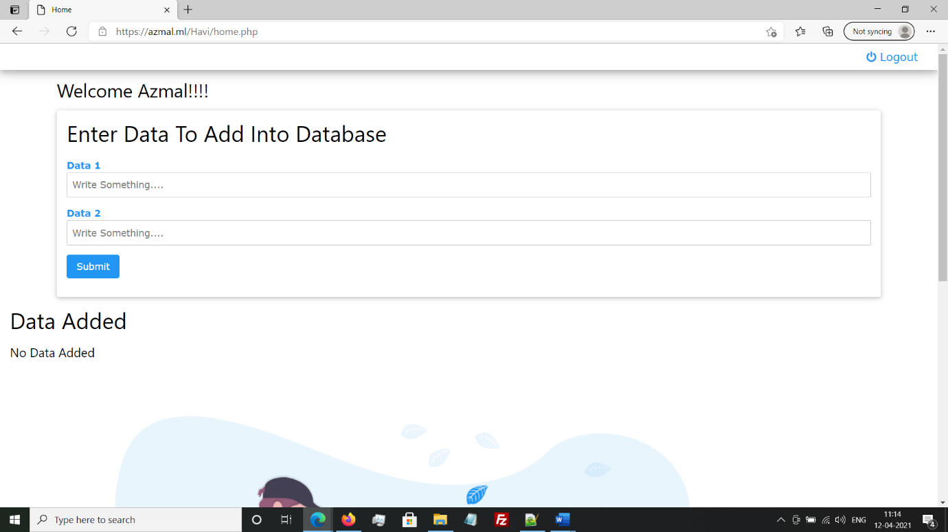

home.php

After Logging into the application the user is navigated to the home page where it shows welcome message (using logged user details from check user login status file ) and a list where user can add data into the database and added data is retrieved and shown below to the user.This form contains input fields and these input fields are assigned with unique id’s.When user clicks on submit button the onclick event is invoked and its sends data using Ajax to the data-add form.The data added to the data base is retrieved by using uid (which we get from checkuserloginstatus) and shown to the user in a grid view.

Working Data Add Form:

The data which is sent from the home page is taken by the data-add from by using POST method and these data is added to database(Table:data) using “INSERTION OPERTAION” if the insertion operation is sucessful the succes message is sent to home page(“Item Added”).If the insertion is failed then it sents failure message to home page.

User-Logout:

User-logout page is used to logout user from the application. The main task of this page is clear the cookies and session data of the logged user.The data in the checkuseroginstatus is cleared by removing the cookies and session data . If the logout is succesful the user is navigated to the login page(index.php) by clearing his all data.

Admin Module:

Admin Module is for the admin where admin can login into the admin-dashboard and see the users registered in the application.

Work Flow:

Enter admin name and password

Correct credentials

or not No

Yes

Admin-dashboard

Admin-Login:

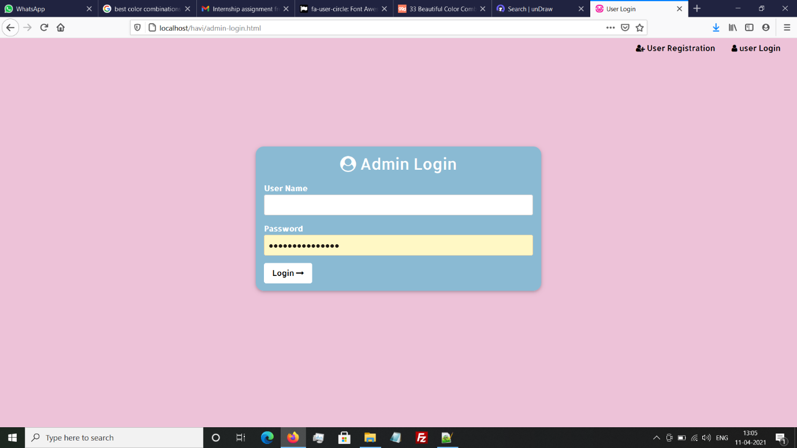

Admin-login.php

Admin-login page where admin can login , this page contains two input fileds admin name and password and these two input fields are assigned with two unique Id’s on clicking on login button the onclick event is invoked and it sents data to the admin-login-check page .If the data is sent to adminLogin-check it shows please wait…. on the login button and waits for acknowledgement from the adminlogin-check , if the data is not sent to adminlogin-check it shows an error Cannot connect to server. This is also done by using Ajax and POST method.

Working of admin-logincheck:

On clicking on the login button inadmin-login.php , the input data entered is sent to adminlogin-check by using POST method and adminlogin-check page gets the data entered by the admin and checks whether the username and password matches or not , if the data matches it set cookies and sessions of the user details and then the user is navigated to the admin-dashboard page(admin-dashboard.php) else it throws an error Inavlid credentials.

Use of checkadminloginstatus:

When the admin entered data is matched with the content then the adminlogin-check set Cookies and sessions of AID(adminId) adminname(adminname) and password(password).These cookies are used in checkadminloginstatus page and checks whether the data is correct or not not and they store values as log_aid,log_adminname,log_password of the logged admin if the data is correct.And we use this values by including in necessary files and acces logged admin information.

Admin-Dashboard: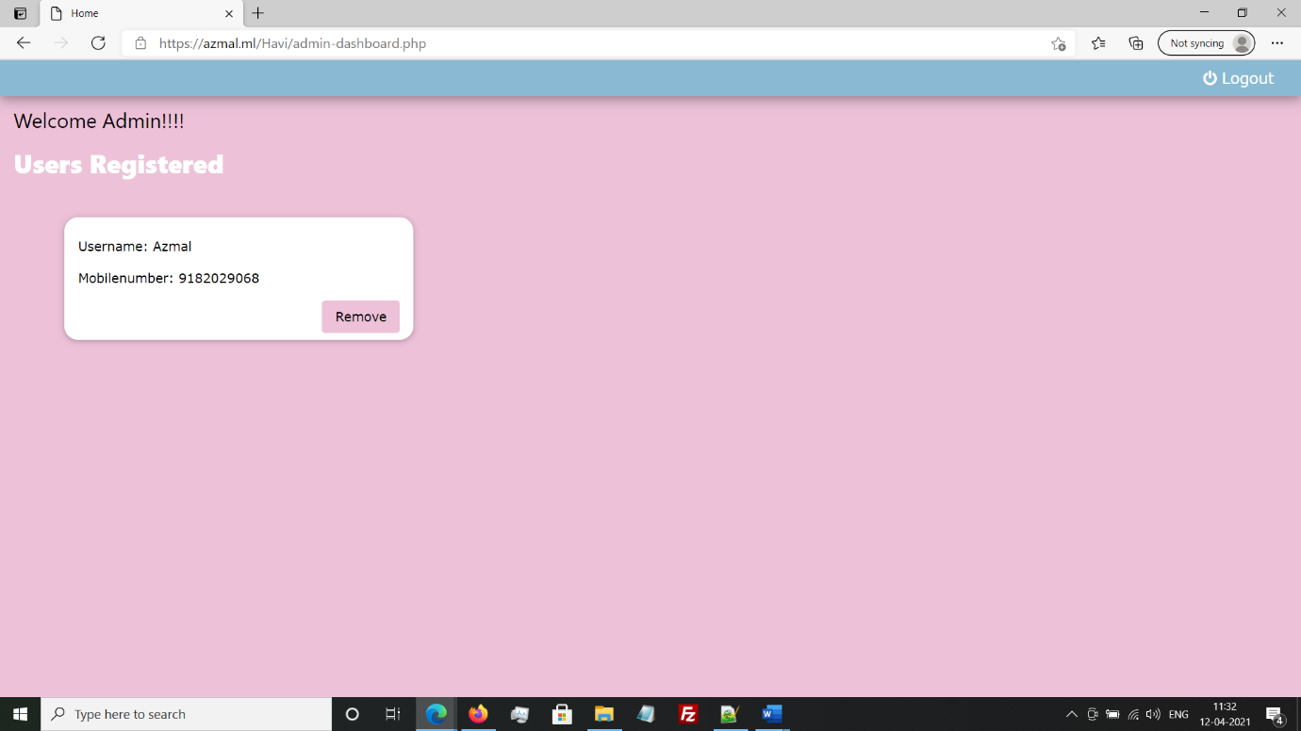

Admin-dashboard.php

After Logging into the application the adminis navigated to the admin-dashboard page where it shows welcome message and a list where number of users registered into the application in a grid view(which is retrived from database,table:users) .With this it also shows a Remove button on every card .When admin clicks on remove and a onclick event is invoked and it passes the uid associated with the card and these id is passed to the remove-user page by using ajax method.

Working Remove user Form:

The data which is sent from the admin-dashboard page is taken by the remove-user by using POST method and these data is deleted from database(Table:users) using “DELETE OPERTAION” if the deletion operation is sucessful the succes message is sent and it reloads the admin dashboard . If the deletion is failed then it sents failure message to admin-dashboard page.

Admin-Logout:

Admin-logout page is used to logout admin from the application. The main task of this page is clear the cookies and session data of the logged admin.The data in the checkadminloginstatus is cleared by removing the cookies and session data . If the logout is succesful the admin is navigated to the login page(admin-login.php) by clearing his all data.

Database Connection (db_conx.php):

$db = mysqli_connection(localhost,username,password,databasename);

The above line is used to create databse connection in PHP. Where username is the server username ,password is the server password and database name is the name which we want to connect to the database.

Tables:

We use the below code for creating Users table in php

include_once("db_conx.php");

//users Table

$sql = "CREATE TABLE users(

uid INT NOT NULL PRIMARY KEY AUTO_INCREMENT,

username VARCHAR(70) NOT NULL,

mobilenumber VARCHAR(15) NOT NULL,

gender VARCHAR(30) NOT NULL,

dateofbirth DATE NOT NULL,

country VARCHAR(30) NOT NULL,

password VARCHAR(70) NOT NULL

)";

if (mysqli_query($db,$sql)) {

echo "Table users created successfully<br>";

} else {

echo "Error creating table $sql. " . mysqli_error($db);

}

We use below code fro creating data table so that user can add data into database

//data Table

$data = "CREATE TABLE data(

did INT NOT NULL PRIMARY KEY AUTO_INCREMENT,

uid INT(10) NOT NULL,

data1 VARCHAR(70) NOT NULL,

data2 VARCHAR(70) NOT NULL

)";

if (mysqli_query($db,$data)) {

echo "Table data created successfully<br>";

} else {

echo "Error creating table $data. " . mysqli_error($db);

}

Website Link: https://azmal.ml/Havi/