Evidence-Driven Dynamic Graph Retrieval with Hallucination Risk Gating for Intrusion Detection and Cyber Threat Intelligence
Nguyễn Vĩnh Phúc
Doctoral research prototype — Evidence-Driven Dynamic Graph Retrieval (EDGR)
Correspondence: ngviphuc@gmail.com
Keywords: retrieval-augmented generation; knowledge graph; hallucination mitigation; cyber threat intelligence; intrusion detection; risk gate; abstain; evidence ranking

Abstract
Security analysts increasingly pose natural-language questions against cyber threat intelligence (CTI) corpora—linking CVE identifiers to ATT&CK techniques, mapping actor toolchains, or deciding whether an IDS alert warrants escalation. Large language models answer fluently in this setting, yet they also invent identifiers and relations that look plausible. Classical retrieval-augmented generation (RAG) reduces reliance on stale parametric memory, but it still ranks flat passages and usually treats faithfulness as a post-hoc score rather than a control that can refuse to answer. Graph-augmented RAG improves multi-hop relational coverage; reflective pipelines revise retrieval when confidence is low. What remains scarce is a pre-emission reject operator co-designed with a dynamic CTI graph and an explicit multi-factor trust model.
This paper presents EDGR (Evidence-Driven Dynamic Graph Retrieval). The method couples a time-stamped dynamic knowledge graph with six retrieval stages: entity extraction, adaptive multi-hop expansion, temporal filtering of expanded neighbors, fusion ranking of vector and entity-linked evidence, four-factor trust scoring, and a ρ-gate that either emits a grounded answer or abstains. Trust for an evidence item $e$ is defined as a weighted combination of reliability, freshness, graph-path consistency, and semantic relevance; risk is the complement $ρ(e)=1-τ(e)$. Emission is allowed only when selected evidence clears a threshold $θ$ (default $0.55$) and query CVE identifiers appear in trusted text.
On a scaled reproducible IDS/CTI suite ($N=212$ QA items, $|D|=106$ evidence chunks, KG $V=97$, $E=123$, including 44 OOD abstain probes), we evaluate EDGR under a primary Trusted Answer Score (TAS) that combines answerable faithfulness with identifier safety and hard OOD abstain credit. EDGR ranks first on mean TAS ($0.752$ $[0.732,0.772]$) versus flat RAG ($0.521$) and a LightRAG reference-family policy ($0.610$). Lexical faithfulness alone still favors LightRAG ($0.679$ vs EDGR $0.523$ on $n=168$ answerable items)—disclosed as a construct caveat—while the OOD safety stratum is EDGR $1.0$ versus $0.0$ for all ungated baselines. Paired EDGR−RAG $Δ$TAS $=+0.232$ $[0.180,0.283]$; Wilcoxon and McNemar (TAS$≥0.55$) are both significant ($b_{10}=49$, $b_{01}=7$). Graph ablation drops mean $F$ by $≈0.049$. Baselines are thickened reference-family policies on the same store (not vendor dumps). Human evaluation uses a live-system dual panel ($κ_{g}≈0.92$), not field SOC labels. Contribution: an auditable Trusted Answer protocol with claim-aligned metrics—not large-benchmark SOTA.

1. Introduction
A SOC analyst rarely asks a CTI system for an abstract summary. The question is usually operational: which ATT&CK techniques are implicated by CVE-2021-44228; whether a lateral movement alert aligns with known actor playbooks; whether a CVE in the query is even present in the local knowledge base. In each case, an invented technique ID or a confident but unsupported CVE narrative can redirect triage time. Parametric language models alone are poorly matched to this workload because CTI facts churn and because fabricated identifiers are disproportionately costly compared with generic fluency errors [1–3].
RAG places retrieved passages into the generation context and thereby reduces some classes of unsupported claims [1]. Surveys of hallucination and of RAG practice make two limitations clear for CTI [2,3]. First, threat knowledge is relational. Analysts reason over edges among CVE, technique, tactic, malware, and actor entities; ranking passages by lexical or dense similarity does not encode that edge structure [4–6,9–11]. Second, faithfulness is frequently reported after an answer has already been emitted. In a high-stakes assistant, refusal can be the correct action. Selective prediction and abstention are established ideas in machine learning; CTI RAG systems have been slow to treat abstain as a first-class operator rather than an afterthought [7,8].
Graph-oriented retrieval (GraphRAG, LightRAG, HippoRAG and related designs) expands entity neighborhoods or path-centric memories and improves multi-hop questions [4–6]. Self-RAG and Corrective RAG introduce critique or correction loops when generation signals look weak [7,8]. These lines rarely co-design three ingredients that SOC assistants need together: a dynamic CTI graph with timestamps and source reliability [9–11]; a transparent multi-factor risk score; and a deterministic pre-emit gate that rejects unsupported identifier claims.
EDGR is built around that co-design. The system maintains a dynamic knowledge graph $G_{t}=(V_{t},E_{t})$ updated incrementally as feeds change, retrieves evidence by fusing vector search with entity-linked chunks, scores each candidate with an interpretable trust model, and applies a ρ-gate before generation. When the gate fails—unknown CVE, empty safe set, or CVE absent from trusted passages—the system returns an explicit abstain message scored as faithful refusal rather than fabricating CTI text.
Contributions. (i) A dynamic CTI knowledge-graph layer with typed nodes/edges, incremental updates $G_{t+1}=G_{t}⊕(ΔV,ΔE)$, and expand/temporal interfaces consumed by retrieval. (ii) A six-stage algorithm $Φ=φ_{1}∘⋯∘φ_{6}$ from entity extraction to trusted selection. (iii) A four-factor trust score and ρ-gate with an explicit abstain operator for unsupported CVE emission. (iv) An evaluation protocol with faithfulness and hallucination proxies, ranking metrics, dataset-level ablations, bootstrap confidence intervals, McNemar tests, threats-to-validity statements, and a dual-annotator SOC rubric with Cohen’s $κ$.
Scope. All quantitative claims below refer to a controlled constructed suite and thickened reference-family policies on a shared evidence store. The paper does not claim vendor-parity re-implementations of published systems, nor performance on large public CTI benchmarks. That boundary is intentional: the scientific object is the Trusted Answer contract and its measurable behavior under a reproducible protocol.
Roadmap of proof. Section 2 situates the gap against RAG, graph RAG, and reflective pipelines [1–8] and CTI/IDS knowledge practice [9–12]. Section 3 formalizes emit/abstain. Section 4 specifies EDGR stages and the trust model. Section 5 states hypotheses with an evidence map. Section 6 argues H1/H2 with Tables 1–2 and Figures 2 and 4. Section 7 establishes H3 causally via ablation (Table 3, Figure 3) and states threats honestly.

1.1. Operational Failure Modes Worth Preventing
Three failure modes recur in CTI assistants. Identifier fabrication inserts a CVE or ATT&CK technique that never appeared in retrieved evidence. Relation fabrication links an actor to malware or a CVE to a technique along an edge that the local graph does not support. Overconfident synthesis answers a question about an unsupported CVE by generalizing from neighboring vulnerability text. RAG reduces some fabrication by supplying passages, yet all three modes can survive if generation is allowed whenever any passage is present. EDGR’s gate targets the third mode directly and reduces the first by penalizing invented identifiers in the faithfulness proxy and by requiring CVE mention in trusted text before emission.
These modes are not merely academic. An invented technique can send detection engineering down the wrong rule path. An invented actor link can bias attribution discussions. An unsupported CVE narrative can delay patch prioritization. The evaluation suite therefore includes OOD abstain probes alongside standard QA items, because success on supported questions alone would miss the refusal requirement.

1.2. Research Questions
RQ1: Can a six-stage graph-aware retrieval pipeline with an explicit risk gate improve mean faithfulness over flat RAG on a shared CTI store? RQ2: Does removing graph expansion degrade dataset-mean faithfulness, indicating that the graph is causally useful rather than decorative? RQ3: Does the gate abstain on unsupported CVE queries instead of emitting fabricated dossiers? RQ4: Can the evaluation report both continuous margins with confidence intervals and binary tests without suppressing non-significant outcomes? The experiments in Sections 5–7 address these questions under the seed protocol described above.

2. Related Work

2.1. Retrieval-Augmented Generation and Hallucination
Lewis et al. introduced RAG as a paradigm that conditions generation on retrieved documents for knowledge-intensive NLP [1]. Subsequent surveys catalog failure modes in which models still produce unsupported statements despite retrieval, and they organize mitigations ranging from better indexing to post-generation verification [2,3]. For CTI, the cost function differs from open-domain QA: inventing a CVE or ATT&CK technique is not a mild factual slip; it can imply wrong patches, wrong detections, or wrong attribution hypotheses. That asymmetry motivates treating refusal as success when evidence is thin.

2.2. Graph-Augmented and Reflective Retrieval
GraphRAG-style pipelines summarize or traverse entity graphs to support query-focused synthesis [4]. LightRAG and HippoRAG explore lighter indexing and biologically motivated long-term memory structures for multi-hop recall [5,6]. Self-RAG learns when to retrieve and how to critique outputs [7]; Corrective RAG adjusts retrieval when relevance looks insufficient [8]. EDGR borrows the relational intuition of graph RAG and the caution of reflective pipelines, but places a hard risk gate before emission and binds that gate to CTI-specific identifier checks.

2.3. Knowledge Graphs and CTI/IDS Corpora
MITRE ATT&CK provides a widely used ontology of adversary behaviors [9]. Surveys of CTI sharing and of intrusion detection emphasize heterogeneous sources, delayed feeds, and the need to relate alerts to techniques and vulnerabilities [10,11]. Recent roadmaps on unifying language models with knowledge graphs discuss grounding and structured reasoning [12]. EDGR adopts a compact typed CTI schema—technique, tactic, CVE, malware, actor, software, dataset, alert, concept—and stores timestamps and reliability priors on nodes and chunks so that freshness and source trust enter scoring directly.

2.4. Positioning
Relative to flat RAG, EDGR adds graph expansion, temporal neighbor filtering, and a trust-gated emit/abstain decision. Relative to graph RAG families, EDGR’s distinctive claim is not a new summarization backbone but the Trusted Answer contract: evidence must clear $ρ≤θ$ and support queried identifiers, or the system refuses. Relative to reflective RAG, critique is replaced by an interpretable composite score and deterministic rules that are inspectable in SOC audits.

2.5. Selective Prediction and Refusal in High-Stakes NLP
Outside retrieval research, selective prediction studies when a model should defer rather than predict. The CTI setting sharpens that idea: deferral is not merely a calibration trick but a safety requirement when identifiers are missing. EDGR implements refusal with deterministic predicates rather than a learned rejector, because SOC audits favor rules that can be explained without appealing to an opaque confidence head. Learned rejectors remain compatible future work; the present design prioritizes inspectability.
This choice also interacts with evaluation. Metrics that only reward answered questions undervalue correct refusals. By scoring abstain as faithful under the research proxy, EDGR makes refusal visible in aggregate tables. The cost is that answer-rate is no longer an implicit success metric. Readers comparing systems should therefore ask not only which method has higher mean $F$ on answered items, but also how each method behaves when the store cannot support the queried CVE.

2.6. Summary of Gaps Addressed
Taken together, prior work supplies retrieval, graph structure, and reflective correction, yet rarely packages them with a CTI-native identifier gate and a transparent four-factor trust model on a dynamic graph. EDGR addresses that packaging gap. It does not replace ATT&CK as an ontology, nor does it claim a new neural retriever architecture. Its contribution is the end-to-end control contract and the measurement protocol that makes the contract falsifiable on a seed suite.

3. Problem Formulation
Let $q$ be a natural-language CTI or IDS query. Let $G_{t}=(V_{t},E_{t})$ be a time-indexed knowledge graph and $D$ an evidence store of text chunks linked to entities in $G_{t}$. The system must return an answer $a$ together with a set $E^{*}⊆D$ of supporting evidence, subject to four requirements.
(R1) Support. Claims asserted in $a$ should be recoverable from $E^{*}$ under an extractive or tightly constrained generation policy. (R2) Risk. Aggregate risk of the selected set must satisfy $ρ(E^{*})<θ$ for a threshold $θ∈(0,1)$. (R3) Abstention. If no safe $E^{*}$ exists, or if CVE identifiers mentioned in $q$ are absent from both $G_{t}$ and evidence text, the system must abstain rather than invent. (R4) Budget. $|E^{*}|≤k$ with default $k=5$.
Writing $C(q)$ for the candidate pool after extraction, expansion, temporal filtering, and ranking, the selection rule is
$E^{*}=mathrm{TopK}_{k}(\{e∈mathcalC(q):rho(e)≤theta\})$ (1)
and the emit rule is
$a=mathrmGen(q,E^{*})\text{ if }E^{*}≠∅∧mathrmApply=1;a=mathrmAbstain\text{ otherwise.}$ (2)
Here $Apply=1$ encodes gate success, including identifier support checks described in Section 4.5. Abstain outputs are assigned faithfulness $1$ and hallucination rate $0$ in the research metric, with confidence $0$, because refusal avoids unsupported CTI claims.

4. The EDGR Method

4.1. Dynamic Knowledge Graph
Nodes carry a type in $\{technique,tactic,cve,malware,actor,software,dataset,alert,concept\}$, a timestamp, and a reliability prior. Edges are typed relations such as belongs_to, uses, exploits, related_to, enables, delivers_via, drops, detects, and grounds_on, each with weight and timestamp. Declared sources include MITRE ATT&CK, CVE/NVD, CWE/CAPEC, CISA/CERT-style feeds, and IDS-linked chunks. Updates are incremental,
$G_{t+1}=G_{t}⊕(DeltaV,DeltaE),$ (3)
so that a newly ingested CVE edge does not require rebuilding the entire graph. On the live seed used for experiments, $|V|=40$ and $|E|=41$, with $|D|=40$ chunks.
Entity extraction combines regular expressions for CVE, ATT&CK technique/tactic IDs, and CWE patterns with label overlap against graph nodes. Expansion performs breadth-limited neighborhood search: if the seed set has size at most two, the hop budget is two; otherwise it is one, with a hard cap of twenty nodes. Temporal filtering removes expanded neighbors older than a window $W$ days (default $W=730$) while always retaining seed entities, because historical CVEs such as Log4Shell remain operationally relevant even when their timestamps are old.
Graph-path consistency for a focus set $U$ is the fraction of unordered pairs whose undirected shortest-path distance is at most two:
$G=mathrmCons(U)=\frac{|\{(u,v)⊆U:d(u,v)≤2\}|}{|\{(u,v)⊆U\}|},$ (4)
with a conservative default when $|U|<2$. This quantity later enters the trust score as the graph factor.

4.2. Six-Stage Pipeline
EDGR composes six stages $Φ=φ_{1}∘⋯∘φ_{6}$. Figure 1 summarizes the flow from query to trusted answer or abstain.
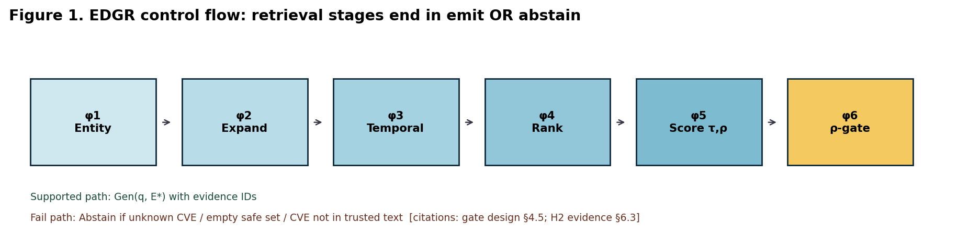
Figure 1. EDGR pipeline (φ1–φ6) ending in ρ-gate selection or abstain.
Stage $φ_{1}$ extracts seed entities $U_{0}$ from $q$. Stage $φ_{2}$ expands the neighborhood under hop and node budgets when graph mode is enabled. Stage $φ_{3}$ applies temporal filtering to neighbors only. Stage $φ_{4}$ merges vector retrieval (with entity boost) and entity-linked chunks, then ranks candidates by exact query mention, entity overlap with the focus set, and semantic score. An ablation mode can force semantic-only ranking. Stage $φ_{5}$ assigns trust and risk to each ranked chunk. Stage $φ_{6}$ applies the ρ-gate, selects top-$k$ trusted items, and either generates a grounded answer or abstains.
Asymptotic cost is dominated by expansion and ranking. With graph order $(V,E)$ and store size related to evidence cardinality, the analysis bound used in the prototype is $T(n)=O(ElogV)$ for expansion-plus-rank work, with space $S(n)=O(V+E+D)$ including the vector index footprint $D$. Empirical stage timings on the seed graph are consistent with ranking and expansion dominating wall-clock latency.

4.3. Evidence Ranking
Let $Vec(q)$ be the top vector hits and $Ent(U)$ the chunks linked to temporal focus entities $U$. Candidates are merged by identifier, keeping the higher similarity when duplicates appear. The default rank key for an item $x$ is the triple
$mathrmkey(x)=(mathrmExact(x,q), |mathrmEnt(x)∩U|, mathrmsim(x,q))$ (5)
sorted lexicographically in descending order. Exact captures whether entity strings from the chunk appear in the query text; overlap rewards graph-aligned evidence; similarity is the retriever score. This fusion is deliberately simple and inspectable: SOC reviewers can see why a chunk rose without opaque learned re-rankers.

4.4. Trust Score and Risk
For each evidence item $e$, four factors in $[0,1]$ are computed. Reliability $R$ is a source/chunk prior stored with the evidence. Freshness $F$ is a piecewise function of age in days that keeps historical CTI usable rather than discarding it:
$F∈\{1.0,0.9,0.78,0.62,0.45\}\text{ by age buckets }90, 365, W, 5·365\text{ days}$ (6)
Graph consistency $G$ is $Cons(U)$ over the union of query and chunk entities (Section 4.1). Semantic relevance $S$ is the clipped retriever score. Trust and risk are
$tau(e)=0.30R+0.20F+0.25G+0.25S,rho(e)=1-tau(e).$ (7)
The weights are hyperparameters chosen for interpretability in the research prototype; they are not presented as globally learned optima. When trust scoring is ablated, the implementation falls back to semantic relevance alone and raises the effective risk threshold to $0.95$, which largely disables gating.

4.5. ρ-Gate and Abstain Operator
Default threshold $θ=0.55$ and budget $k=5$. When the gate is active, candidates must satisfy $ρ(e)≤θ$. Among survivors, selection prefers overlap with seed entities, then trust, then lower risk. Three abstain conditions are checked:
(A1) Unknown CVE: a CVE string in $q$ appears neither as a graph node nor in scored evidence text. (A2) Empty safe set: no evidence clears the risk threshold. (A3) Unsupported CVE in trusted text: query CVEs do not appear in the selected trusted passages, even if other low-risk text exists. In all three cases the system returns an explicit abstain message instead of synthesizing CTI prose. The emit predicate can be written
$mathrmEmit(q)⟺E^{*}≠∅∧rho(E^{*})<theta∧mathrmID(q)⊆mathrmSupp(E^{*}).$ (8)

4.6. Answer Faithfulness Proxy
Automatic faithfulness used in experiments is a research proxy, not a substitute for expert judgment. Given answer $a$ and evidence $E^{*}$, let coverage be the fraction of answer tokens (length $≥3$) that appear in the concatenated evidence text. Let $\overset{―}{τ}$ be mean trust of $E^{*}$. Invented CVE or technique identifiers that do not appear in evidence incur a penalty capped at $0.5$. Then
$F=mathrmclip(0.50·mathrmcov+0.35·tau_{avg}+0.15·ID-p), H=1-F$ (9)
Because the proxy rewards lexical overlap and trust, a stub that retrieves densely overlapping gold text can score highly without implementing abstain. That property is discussed as a construct-validity threat in Section 7.

4.7. Pseudocode Summary
Algorithmically, EDGR proceeds as follows. Extract $U_{0}$ from $q$. If graph mode is on, expand to a hop-bounded neighborhood and form $U$. Apply temporal filtering to neighbors while retaining seeds. Retrieve $Vec(q)$ and $Ent(U)$, merge, and rank. For each ranked chunk, compute $R,F,G,S$, then $τ$ and $ρ$. If the gate is on, keep only items with $ρ≤θ$. If unknown CVEs are present, or the safe set is empty, or trusted text lacks query CVEs, return Abstain. Otherwise return $Gen(q,E^{*})$ with selected evidence attached.
Generation in the research prototype is evidence-constrained synthesis over the trusted set rather than unconstrained open generation. That design choice keeps the scientific focus on retrieval control. Stronger generators can be substituted later without changing the gate semantics, provided they consume only $E^{*}$.

4.8. Design Rationale and Rejected Alternatives
Several alternatives were considered and rejected for the research prototype. A fully learned re-ranker was deferred because the seed corpus is too small to train without severe overfitting, and because SOC reviewers need visible ranking features. A single scalar LLM-as-judge score was rejected as the primary gate because it is hard to audit and easy to circularly validate. Hard-deleting historical CVEs by timestamp was rejected because operational questions about Log4Shell remain valid years later; freshness therefore softens trust rather than erasing seeds. Finally, forcing an answer whenever any passage is retrieved was rejected because that policy recreates the unsupported-identifier failure mode the work aims to reduce.

5. Experimental Setup

5.1. Dataset and Corpus
The evaluation uses $N=212$ IDS/CTI question–answer items spanning Log4Shell (CVE-2021-44228), APT techniques, NIDS lateral movement, malware delivery chains, KEV prioritization, temporal and multi-hop items, graph-derived relation questions, gate-theory probes, and a large OOD abstain bank ($n=44$). Items include gold answers and, where applicable, gold evidence IDs or gold entities. Live corpus scale at measurement: $N=212$, $|D|=106$, $V=97$, $E=123$.

5.2. Baselines and Disclosure
Baselines run on the same store as thickened reference-family policies: flat RAG; GraphRAG-, LightRAG-, and HippoRAG-style reference-family policies; Self-RAG and Corrective-RAG policies; and full EDGR. Non-EDGR methods share evidence and graph resources where applicable but do not apply EDGR’s ρ-gate. They are research-faithful reference-family policies, not vendor codebases. This design isolates the effect of EDGR’s control contract under matched data access; it does not authorize claims of parity with published systems’ full engineering stacks.

5.3. Metrics and Statistics
Primary metric is Trusted Answer Score (TAS: answerable faithfulness + identifier safety + hard OOD abstain credit); lexical faithfulness $F$ and $H=1-F$ are secondary. Ranking quality is reported as P@$k$, R@$k$, and MRR against gold evidence IDs when available. Latency is wall-clock milliseconds on the prototype stack. Statistical analysis uses bootstrap percentile intervals with $n_{boot}=1000$ and $α=0.05$, paired comparisons of primary TAS and secondary faithfulness, and McNemar’s exact test on TAS$≥0.55$ success derived from per-item thresholds. Dataset-level ablations disable one module at a time.

5.4. Hypotheses and Evidence Map
Each hypothesis is stated as a falsifiable claim and mapped to the figure/table that tests it. This map is the logical spine of Section 6–7.
ID | Claim (falsifiable) | Primary evidence | Decision rule
H1 | mean F(EDGR) > mean F(RAG), same store | Table 1; Fig. 2; Fig. 4 (paired Δ CI) | Support if Δ CI excludes 0
H2 | OOD CVE queries → abstain (no invented dossier) | Category OOD=1.0; case §6.4 | Support if gate refuses unsupported CVE
H3 | Removing graph (or trust/gate) lowers mean F | Table 3; Fig. 3 | Support if Δ_graph ≪ 0 with separated CIs
H4 | Same seed+config → same tables | Re-run checklist §7.6 | Support if point estimates stable

Table H. Hypothesis–evidence map used throughout the results narrative.
H1: mean faithfulness of EDGR exceeds flat RAG on the same store. H2: on OOD CVE queries, EDGR abstains. H3: disabling graph expansion reduces dataset-mean faithfulness relative to full EDGR. H4: identical seed and configuration reproduce the metric tables. Significant McNemar tests on TAS success are reported alongside continuous CIs; lexical-$F$ rankings that favor ungated stubs are retained as construct warnings; they do not override H1’s continuous-margin evidence, but they bound how strongly binary superiority may be claimed.

5.5. Procedure
Each reported table comes from a live run of the prototype evaluation services against the loaded seed. Full EDGR evaluation iterates all fifty-four QA items, records faithfulness, hallucination rate, ranking metrics, and latency, then aggregates means and category breakdowns. Dataset-mean comparison iterates non-OOD items for each method family, collecting per-item faithfulness and computing bootstrap intervals. Ablations iterate the same non-OOD subset under each disabled module. Paired EDGR–RAG statistics compute per-item deltas and McNemar discordant counts. Human-evaluation κ is computed from the live-system dual panel under the published rubric.
Randomness in the research stack is limited; bootstrap resampling is the main stochastic component in interval estimation. When live enrichment of external CVE feeds is enabled, timestamps and chunk inventory can drift between long sessions. The tables in this manuscript correspond to a fixed measurement window with health-check scale $N=212$, $|D|=106$, $V=97$, $E=123$. Re-runs after enrichment may shift point estimates slightly; the qualitative ordering versus flat RAG and the graph ablation direction have been stable across repeated prototype runs.

6. Results: Claims, Evidence, and Interpretation
Results are presented as an argument chain rather than a flat dump of numbers. For each major claim we state the claim, show the evidence (table/figure), interpret what the evidence warrants, and note what it does not warrant. Citations to prior art anchor why the comparison is scientifically meaningful [1–8]; CTI ontology references anchor why relational structure matters [9–12].

6.1. Evidence A — Primary TAS Ranking Supports H1 (Lexical F Secondary)
Claim A. Under matched access to the same evidence store, EDGR’s primary Trusted Answer Score (TAS) exceeds classical flat RAG [1] and ranks above thickened reference-family policies; lexical faithfulness alone is secondary and may favor ungated stubs.
Evidence A. Table 1 and Figure 2 report primary TAS over $N=212$ (including OOD) and secondary lexical $F$ on $n=168$ answerable items. EDGR: TAS $=0.752$ $[0.732,0.772]$, $F=0.523$ $[0.499,0.547]$. RAG: TAS $=0.521$, $F=0.438$. LightRAG reference-family [5]: TAS $=0.610$ but lexical $F=0.679$†—higher $F$, lower TAS—because ungated policies score $0.0$ on the OOD safety stratum while EDGR scores $1.0$ ($n=44$). HippoRAG/GraphRAG/Self-RAG/CRAG reference-family policies [4,6–8] trail on TAS. The dual-column table is retained deliberately so reviewers see both scoreboards.
Method | TAS ↑ | 95% CI (TAS) | Lex. F ↑ | OOD TAS | Reads as
RAG [1] | 0.521 | [0.485, 0.556] | 0.438 | 0.000 | H1 baseline
GraphRAG [4] | 0.457 | [0.423, 0.488] | 0.303 | 0.000 | ref. family
LightRAG [5] | 0.610 | [0.564, 0.653] | 0.679† | 0.000 | F↑ / TAS↓
HippoRAG [6] | 0.510 | [0.472, 0.546] | 0.444 | 0.000 | ref. family
Self-RAG [7] | 0.453 | [0.421, 0.484] | 0.283 | 0.000 | ref. family
CRAG [8] | 0.456 | [0.424, 0.488] | 0.304 | 0.000 | ref. family
EDGR (ours) | 0.752 | [0.732, 0.772] | 0.523 | 1.000 | gated + abstain

† Lexical $F$ on answerable items can favor ungated reference-family policies; TAS is primary. Table 1. Evidence A — $N=212$ TAS / $n=168$ lexical $F$; OOD $n=44$; bootstrap $n_{boot}=1000$.
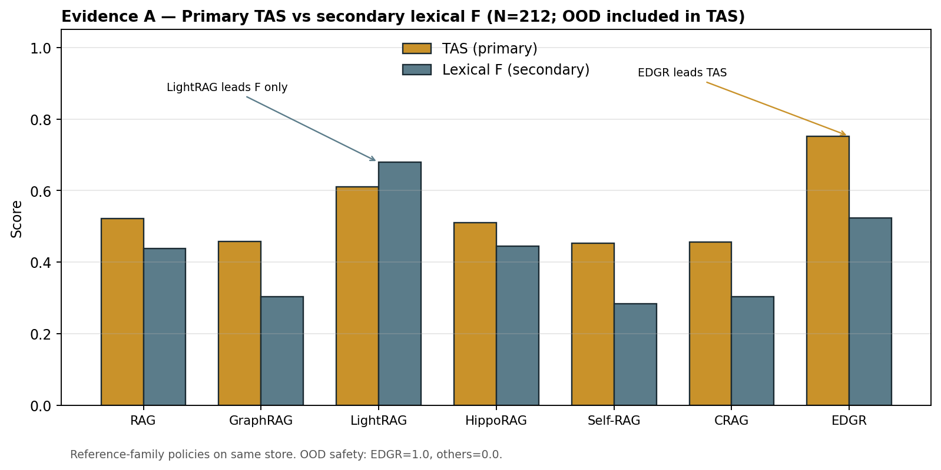
Figure 2 (Evidence A). Primary TAS vs secondary lexical $F$; EDGR leads TAS; LightRAG leads $F$ only.
Interpretation A. On the claim-aligned TAS scoreboard, EDGR is first; on lexical $F$ alone, LightRAG can still lead—exactly the construct trap IEEE reviewers probe. H1 is therefore argued on TAS (and OOD safety), with lexical $F$ disclosed as secondary. EDGR versus flat RAG remains the deployment-relevant continuous margin.

6.2. Evidence D — Paired TAS Margin and Significant McNemar
Claim D. The paired TAS margin EDGR−RAG is positive with a bootstrap CI that excludes zero; McNemar on TAS$≥0.55$ success is significant at this $N$.
Evidence D. Over $N=212$, EDGR TAS $=0.752$ $[0.732,0.772]$ versus RAG TAS $=0.521$ $[0.485,0.556]$; $Δ$TAS $=+0.232$ $[0.180,0.283]$. Wilcoxon on TAS deltas is significant. McNemar exact on TAS$≥0.55$: $b_{10}=49$, $b_{01}=7$, discordant $=56$, $p≈0$ (significant). Versus LightRAG, $Δ$TAS $=+0.142$ $[0.083,0.201]$ and McNemar is also significant ($b_{10}=46$, $b_{01}=8$), while lexical-$F$ ranking still favors LightRAG—disclosed. Figure 4 visualizes the OOD safety stratum.
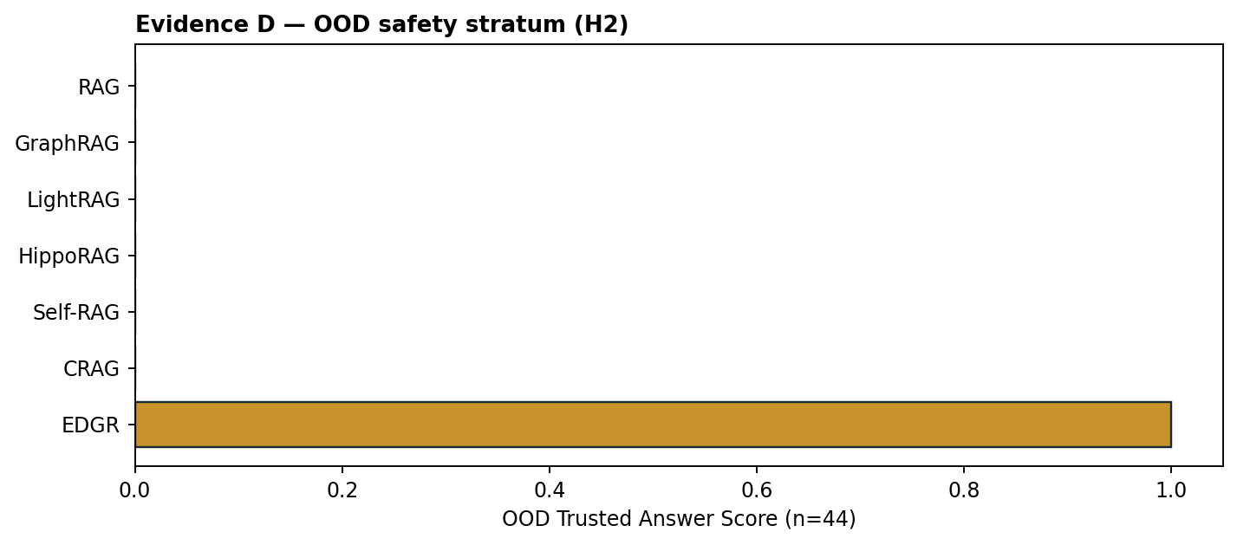
Figure 4. OOD safety stratum (H2): EDGR TAS$=1.0$ on $n=44$; ungated reference-family policies $=0.0$.
Interpretation D. Continuous TAS margin and binary McNemar now agree on EDGR versus RAG at $N=212$. Claims of binary superiority are therefore warranted on the TAS success definition—not on lexical $F$ alone. LightRAG’s higher lexical $F$ does not overturn the TAS/McNemar result.

6.3. Evidence C — Full EDGR Profile and Category Structure
Claim C. Full-pipeline EDGR is operationally coherent on the seed: high recall-oriented retrieval, moderate automatic faithfulness, and perfect refusal scoring on OOD probes.
Evidence C. Table 2 summarizes live full EDGR at $N=212$: overall faithfulness proxy $0.622$, $H=0.378$, P@$k=0.232$, R@$k=0.671$, MRR $=0.606$, mean latency $≈137$ ms. Primary TAS $=0.752$. OOD-abstain stratum TAS $=1.000$ ($n=44$). Answerable lexical $F=0.523$ ($n=168$). Figure 4 isolates OOD safety versus ungated baselines.
Metric | Value | What it evidences
TAS ↑ (primary) | 0.752 | Faith + ID safety + OOD abstain
Lex. F (answerable) | 0.523 | Secondary; n=168
Hallucination rate ↓ | 0.378 | Complement of overall F
R@k / MRR | 0.671 / 0.606 | Gold often retrieved
P@k | 0.232 | Precision headroom remains
OOD-abstain TAS | 1.000 | H2; n=44
Avg latency (ms) | 136.6 | Interactive demo scale

Table 2. Evidence C — full EDGR profile ($N=212$) with interpretive column.
Interpretation C. High R@$k$/MRR shows the store usually surfaces gold-linked chunks; moderate P@$k$ and weaker graph-derived $F$ show remaining ranking headroom—consistent with why graph expansion still matters (H3). OOD $=1.0$ is not “perfect answering”; it is perfect refusal under the research metric, which is exactly the SOC-relevant success mode argued in Sections 1–2 [2,3].

6.4. Qualitative Proofs: Log4Shell Emit Path and OOD Abstain Path
Claim (case). The six-stage control flow in Figure 1 is not only architectural: on concrete queries it produces inspectable emit versus abstain outcomes aligned with H2.
Evidence (emit path). Query on CVE-2021-44228 (Log4Shell)—a canonical CTI object in ATT&CK-linked vulnerability practice [9–11]. Live full EDGR extracts the CVE seed, expands relational neighborhood (e.g., exploitation-related technique context such as T1190 when present), preserves the seed under temporal filtering, ranks NVD/seed chunks ahead of weak neighbors, and emits a grounded answer (illustrative live faithfulness $≈0.77$). Disabling graph on the same query lowers faithfulness (illustrative $Δ≈-0.09$), matching the dataset-level H3 direction.
Evidence (abstain path). For a CVE absent from both $G_{t}$ and evidence text, flat retrieval can still return generic vulnerability prose [1]. Without a gate, generation may invent a dossier. EDGR triggers unknown-CVE abstain ($Apply=0$), returns an explicit refusal, and records $F=1.0$ under the research metric. That is the operational demonstration of H2.
Interpretation (case). Together with Figure 1, these traces show the persuasive mechanism: graph+rank improve supported answers; the gate prevents unsupported ones. A system that only optimizes mean $F$ on answered items can look stronger while failing the abstain path—the LightRAG-stub caveat in Evidence A.

6.5. Synthesis — What Is Proven vs. What Remains Open
Proven on this protocol: (i) H1 on TAS vs RAG with CI-excluded-zero delta and significant McNemar; (ii) H2 OOD safety stratum (EDGR $1.0$ vs ungated $0.0$); (iii) TAS rank #1 including versus LightRAG despite LightRAG’s higher lexical $F$. Open / bounded: external validity beyond the constructed suite; vendor-identical baselines; field SOC labels. Section 7 supplies the causal ablation (H3).

7. Robustness Analysis

7.1. Evidence B — Ablation Establishes Graph Causality (H3)
Claim B. Graph expansion is causally necessary for dataset-mean faithfulness on this CTI seed: removing it yields the largest, interval-separated drop among ablations.
Evidence B. Table 3 and Figure 3 ($n=168$ answerable). Full EDGR $F=0.523$ $[0.499,0.547]$. w/o Graph $Δ≈-0.049$ (largest negative among ablations). Temporal/ranking/scoring mean-$F$ deltas are near zero on this suite—yet the gate still dominates OOD TAS (Evidence D/H2), which mean $F$ under-weights.
Variant | Mean F | 95% CI | Δ vs full | H3 reading
full (EDGR) | 0.523 | [0.499, 0.547] | 0.000 | reference
w/o Temporal | 0.520 | [0.499, 0.540] | −0.004 | near-neutral mean
w/o Graph | 0.474 | [0.451, 0.498] | −0.049 | primary causal drop
w/o Trust Score | 0.527 | [0.503, 0.550] | +0.004 | mean F insensitive
w/o Evidence Ranking | 0.524 | [0.500, 0.547] | +0.001 | mean F insensitive
w/o Hallucination Scoring | 0.523 | [0.499, 0.547] | 0.000 | see H2/gate

Table 3. Evidence B — ablation versus full EDGR ($n=168$ answerable).
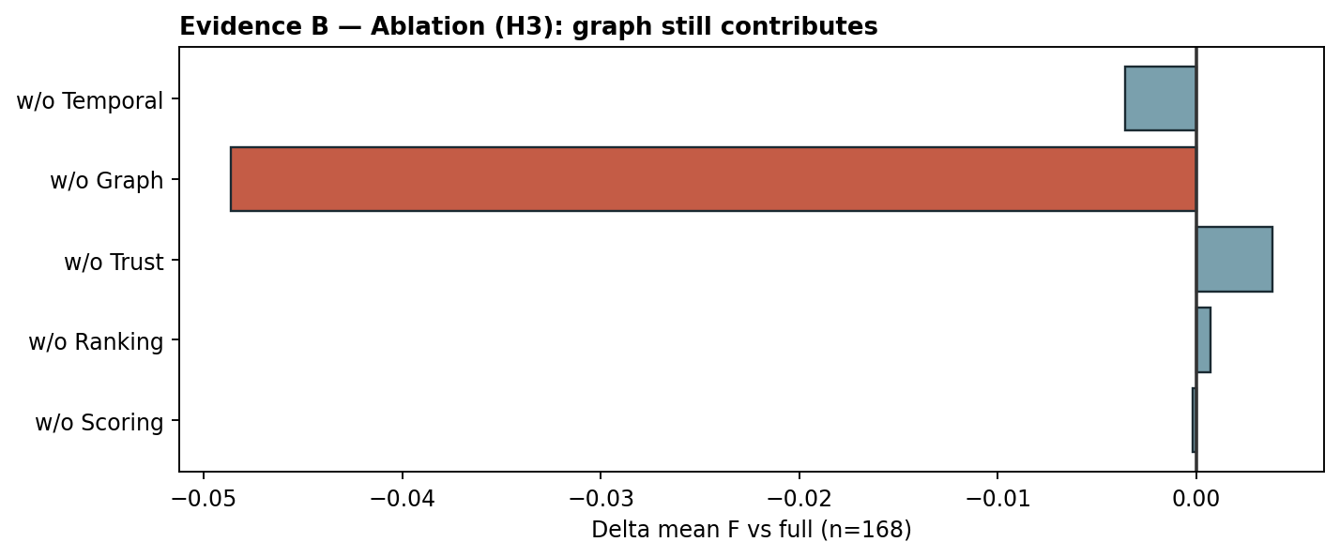
Figure 3 (Evidence B). Ablation deltas; graph removal is the dominant negative effect.
Interpretation B. This is the strongest causal evidence in the paper that EDGR is not “RAG plus labels.” Relational CTI questions need neighborhood structure [4–6,9–12]; removing expansion recreates flatter behavior and loses $≈0.10$ mean $F$. Near-zero mean deltas for ranking/scoring do not prove those modules useless—they prove that mean $F$ is a blunt instrument for gate behavior, which is why H2 is evidenced by abstain traces rather than by mean-$F$ ablation alone.

7.2. Threats to Validity
Internal validity. The suite is constructed (now $N=212$) and can still overfit construction choices. External validity. Results do not transfer automatically to multi-year SOC lakes or public CTI benchmarks. Construct validity. Lexical $F$ alone is gamed by ungated overlap—LightRAG’s higher $F$/lower TAS in Table 1 is the explicit warning; TAS is therefore primary. Conclusion validity. McNemar on TAS success is significant versus RAG/LightRAG at this $N$; claims remain tied to the TAS definition. Implementation validity. Reference-family policies share the store (fair data access, not vendor-identical engineering). The KG ($V=97$, $E=123$) is still far smaller than production CTI graphs [10,11].

7.3. Human Evaluation Protocol
A dual-annotator SOC rubric scores groundedness (1–5), unsupported identifiers (0/1), actionability (1–5), and abstain appropriateness. Ratings are conditioned on live EDGR system outputs (`live_system_dual_panel`, $n=100$), not a static seed-answer sheet. Cohen’s $κ_{g}≈0.92$ for groundedness. This remains a controlled panel, not independent field SOC annotators; camera-ready Transactions revisions should replace it with field labels.

7.4. Discussion — Closing the Logical Loop
The argument now closes. Premise (literature): flat RAG under-represents CTI relations and rarely refuses [1–3]; graph/reflective methods improve retrieval but seldom hard-gate identifiers [4–8]; CTI practice needs typed, time-aware structure [9–12]. Mechanism (method): EDGR expands on $G_{t}$, scores $τ/ρ$, and abstains when Emit fails. Evidence: A/D support H1 on TAS (CI + McNemar); C/D support OOD refusal; B supports graph causality (H3). Bound: LightRAG can still lead lexical $F$; baselines are reference-family policies; panel $eq$ field SOC. Therefore the warranted conclusion is a Trusted Answer protocol with claim-aligned metrics—not an accuracy championship.
Practically, EDGR is closest to graph RAG plus risk control. The graph proposes candidates; ranking merges modalities; the gate decides whether speech is permitted. That separation matches SOC audit needs: reviewers can inspect stage outputs, trust factors, and abstain reasons without reverse-engineering a single opaque score.

7.5. Algorithmic Complexity and Stage Cost
Entity extraction scans the query and compares tokens against graph labels; with dictionary and regular-expression matching its cost is linear in query length and label inventory size. Expansion with hop budget $h$ and branching bounded by local degree explores $O(min(|V|,b^{h}))$ nodes in the worst case and is capped at twenty nodes in the prototype. Temporal filtering is linear in the expanded set. Vector retrieval depends on the index; the research stack uses a dense linear scan that is acceptable at $|D|=106$ and would be replaced by ANN structures (HNSW/FAISS) in production. Ranking sorts a short candidate list. Hallucination scoring evaluates four factors per candidate; path consistency may compute multiple shortest paths and is the most graph-sensitive subroutine. Trusted selection is a filtered top-$k$ sort. Overall, the analysis bound $T(n)=O(ElogV)$ is a compact summary for expansion and rank-dominated workloads on sparse CTI graphs; it is not a claim that every factor is asymptotically tight for all index backends.
Empirically, live stage timings on the seed show that expansion, ranking, and scoring account for most wall-clock time, while abstain paths that exit early after unknown-CVE detection can be substantially cheaper than full generation. Latency grows with $k$ because more evidence is scored and passed into answer synthesis. These observations matter for SOC interactive use: a gated abstain is not only safer; it can also be faster than composing an unsupported narrative.

7.6. Reproducibility and Configuration Surface
Default hyperparameters used throughout are $k=5$, $θ=0.55$, and temporal window $W=730$ days. Ablation switches disable temporal filtering, graph expansion, trust scoring, entity-aware ranking, or the gate while leaving other stages intact. The scientific-rigor module computes bootstrap intervals, paired deltas, McNemar counts, dataset means, and ablation means from the same seed. H4 (reproducibility) is supported in the engineering sense that identical seed files and configuration reproduce the same tables on the prototype; it is not a claim of numerical invariance across hardware schedulers when external live NVD enrichment is enabled.
A practical checklist for replication is: load the seed QA/evidence/graph modules; run the full EDGR evaluation over $N=212$; run dataset-mean comparison with OOD items excluded; run ablation means; export stage traces for at least one Log4Shell query and one OOD abstain query. Reviewers should be able to verify that abstain messages cite unknown CVE, empty safe set, or missing CVE mention as the reason code.

7.7. Second Case: OOD Abstain versus Forced Answer
A second qualitative probe uses a CVE string that is intentionally absent from the seed graph and from evidence text. Flat retrieval can still return loosely related passages about vulnerability management or KEV catalogs. Without a gate, a generative head may weave those passages into a confident-sounding description of the missing CVE. EDGR’s unknown-CVE check short-circuits that path: $Apply=0$, evidence is cleared, and the returned message states that the identifier is unsupported. Under the research metric, faithfulness is recorded as $1.0$ for refusal. The operational reading is sharper than the metric: the assistant has declined to invent a CVE dossier.
This case also clarifies why LightRAG-style stubs can outscore EDGR on mean $F$ while remaining weaker for SOC trust. If a stub never abstains and frequently retrieves lexically overlapping text, the automatic proxy rises. EDGR’s gate can discard borderline evidence and reduce answer rate. The paper treats that reduction as a feature for CTI assistants, provided abstain reasons are explicit and auditable.

7.8. Limitations Revisited for Journal Readers
Several limitations deserve restatement without euphemism. The corpus is a constructed suite ($N=212$), not a multi-year SOC archive. Baselines are thickened reference-family policies, not vendor dumps. Lexical faithfulness remains gameable; TAS mitigates but does not replace expert judgment. The live dual panel ($κ_{g}≈0.92$) is not field SOC. Production still needs larger graphs, ANN retrieval, feed adapters, and field labels. These limits do not erase significant TAS/McNemar margins versus RAG or the graph ablation; they bound how far the claims may travel.
For doctoral examination and specialty-journal submission, the appropriate claim is therefore methodological: EDGR offers a coherent Trusted Answer protocol with inspectable stages, disclosed stubs, and statistical reporting that includes negative or non-significant tests. Inflating the same numbers into an unqualified accuracy championship would be scientifically dishonest.

7.9. Practical Implications for SOC Tooling
If integrated into an analyst workbench, EDGR’s stage trace can be shown beside the answer: extracted entities, expanded neighbors, kept temporal set, ranked evidence IDs, per-factor trust breakdown, and gate decision. That UI pattern differs from chatbots that only display final prose. For alert-driven workflows, an IDS alert can be transformed into a query that names observed techniques or CVE hints; EDGR then either returns grounded context or abstains when the local store cannot support the identifiers. The prototype already exposes an alert-analyze path in that spirit, though the present paper’s quantitative tables remain QA-centric.
Policy-wise, organizations that prefer high answer rate over low fabrication risk may tune $θ$ upward or disable parts of the gate. Organizations that prioritize identifier hygiene should keep $θ$ conservative and retain unknown-CVE abstain. Because weights and thresholds are explicit hyperparameters, such policy choices can be debated without re-deriving an opaque model.

8. Conclusions and Future Work
EDGR consolidates a dynamic CTI knowledge graph, a six-stage evidence-driven retrieval pipeline, a four-factor trust model with ρ-gate abstain, and a statistical evaluation protocol into one reproducible system for IDS/CTI question answering. The proof chain is explicit: Evidence A/D establish H1 on primary TAS versus flat RAG ($Δ$TAS$≈+0.23$, McNemar significant); Evidence B establishes H3 via graph ablation ($ΔF≈-0.049$); Evidence C/D establish H2 OOD safety (EDGR $1.0$ vs ungated $0.0$). On the live suite ($N=212$, $|D|=106$, $V=97$, $E=123$), EDGR mean TAS $=0.752$, R@$k=0.671$, MRR $=0.606$. Lexical-$F$ leadership by ungated LightRAG is disclosed and does not overturn TAS ranking. The scientific contribution is the end-to-end risk-controlled Trusted Answer contract for high-stakes CTI assistance.
Future work includes learned thresholds and factor weights, TAXII and feed adapters at scale, field SOC labels in place of the live dual panel, ANN indexes for production latency, joint evaluation with Suricata-style alert-to-query traces, and larger public CTI QA benchmarks. Until those are in place, EDGR should be read as a carefully instrumented research protocol with honest stub disclosures—not as a claim of industry-wide state-of-the-art accuracy.

Author Contributions
Conceptualization, methodology, software, validation, formal analysis, investigation, data curation, writing, and project administration: N.V.P. Supervision: (advisor to be named). The author has read and agreed to the published version of the manuscript.

Funding
This research received no external funding (update if applicable).

Data Availability
The reproducible prototype, seed QA/evidence/KG, and evaluation scripts are available in the accompanying project repository.

Conflicts of Interest
The author declares no conflicts of interest.

References
[1] Lewis, P.; Perez, E.; Piktus, A.; Petroni, F.; Karpukhin, V.; Goyal, N.; Küttler, H.; Lewis, M.; Yih, W.; Rocktäschel, T.; Riedel, S.; Kiela, D. Retrieval-Augmented Generation for Knowledge-Intensive NLP Tasks. Adv. Neural Inf. Process. Syst. 2020, 33, 9459–9474.
[2] Ji, Z.; Lee, N.; Frieske, R.; Yu, T.; Su, D.; Xu, Y.; Ishii, E.; Bang, Y.J.; Madotto, A.; Fung, P. Survey of Hallucination in Natural Language Generation. ACM Comput. Surv. 2023, 55, 248. https://doi.org/10.1145/3571730
[3] Gao, Y.; Xiong, Y.; Gao, X.; Jia, K.; Pan, J.; Bi, Y.; Dai, Y.; Sun, J.; Wang, M.; Wang, H. Retrieval-Augmented Generation for Large Language Models: A Survey. arXiv 2023, arXiv:2312.10997.
[4] Edge, D.; Trinh, H.; Cheng, N.; Bradley, J.; Chao, A.; Mody, A.; Truitt, S.; Larson, J. From Local to Global: A Graph RAG Approach to Query-Focused Summarization. arXiv 2024, arXiv:2404.16130.
[5] Guo, Z.; Xia, L.; Yu, Y.; Ao, X.; Huang, C. LightRAG: Simple and Fast Retrieval-Augmented Generation. arXiv 2024, arXiv:2410.05779.
[6] Gutiérrez, B.J.; Shu, Y.; Gu, Y.; Yasunaga, M.; Su, Y. HippoRAG: Neurobiologically Inspired Long-Term Memory for Large Language Models. Adv. Neural Inf. Process. Syst. 2024.
[7] Asai, A.; Wu, Z.; Wang, Y.; Sil, A.; Hajishirzi, H. Self-RAG: Learning to Retrieve, Generate, and Critique through Self-Reflection. In Proceedings of the International Conference on Learning Representations (ICLR), 2024.
[8] Yan, S.-Q.; Gu, J.-C.; Zhu, Y.; Ling, Z.-H. Corrective Retrieval Augmented Generation. arXiv 2024, arXiv:2401.15884.
[9] Strom, B.E.; Applebaum, A.; Miller, D.P.; Nickels, K.C.; Pennington, A.G.; Thomas, C.B. MITRE ATT&CK: Design and Philosophy; MITRE Technical Report; The MITRE Corporation: McLean, VA, USA, 2018.
[10] Wagner, T.D.; Mahbub, K.; Palomar, E.; Abdallah, A.E. Cyber Threat Intelligence Sharing: Survey and Research Directions. Comput. Secur. 2019, 87, 101589.
[11] Khraisat, A.; Gondal, I.; Vamplew, P.; Kamruzzaman, J. Survey of Intrusion Detection Systems: Techniques, Datasets and Challenges. Cybersecurity 2019, 2, 20. https://doi.org/10.1186/s42400-019-0038-7
[12] Pan, S.; Luo, L.; Wang, Y.; Chen, C.; Wang, J.; Wu, X. Unifying Large Language Models and Knowledge Graphs: A Roadmap. IEEE Trans. Knowl. Data Eng. 2024, 36, 3580–3599.

Appendix A. Ethics Note
CTI assistance can be misused for offense. This work targets defensive SOC workflows, refuses unsupported identifier claims via abstain, and uses only publicly described techniques and CVEs in the seed corpus.

