
Title: GNSS Lab Report
Lab 1: GNSS Positioning
Course: | AAE4203 — Guidance and Navigation
Group: | Group 1
Members: | Yang Chenyu, Wang Ki Tai, Hau Kin Chung, Chen Che
Member IDs: | 24128676d, 26016088d, 24117641d, 23104192d
Instructor: | Prof. Weisong WEN
Department: | Department of Aeronautical and Aviation Engineering
School: | The Hong Kong Polytechnic University
Date: | October 30, 2026
GitHub Repo: | https://github.com/AZXLHM/AAE4203_Lab1_Gr01_2026.git
Abstract
This report presents the design, implementation, and experimental evaluation of a Single Point Positioning (SPP) system for AAE4203 Lab 1. First, field GNSS data were collected at 1 Hz for 747 epochs (~12.5 minutes) on October 30, 2026 near Block X at The Hong Kong Polytechnic University using a u-blox ZED-F9P receiver, tracking GPS (mean 5.8), Galileo (mean 5.5), BeiDou (mean 6.7), and GLONASS (mean 6.7) satellites with a multi-GNSS mean PDOP of 1.71. Second, building upon the GPS-only baseline Weighted Least Squares (WLS) solver, we systematically implemented three algorithmic improvements: (1) multi-constellation (GPS + Galileo + BeiDou) observation fusion with inter-system clock estimation, (2) joint satellite elevation and carrier-to-noise-density ratio (C/N0) weighting, and (3) residual-based Receiver Autonomous Integrity Monitoring (RAIM) outlier rejection. On our self-collected Block X dataset, these enhancements increased positioning availability from 99.06% (740/747 epochs) to 100.00% (747/747 epochs) and reduced the 2D RMS difference against the receiver's internal NAV-HPPOSECEF solution from 15.093 m to 3.851 m (3D RMS from 34.337 m to 8.922 m). Finally, evaluated on the UrbanNav deep-urban benchmark, our final solver achieved a 2D RMSE of [TBD] m, 3D RMSE of [TBD] m, 95th-percentile 2D error of [TBD] m, availability of [TBD]%, and ranked #[TBD] on the leaderboard.
Keywords: GNSS, single point positioning, weighted least squares, multi-constellation, C/N0 weighting, RAIM, UrbanNav

1 Data Collection
Field GNSS measurements were collected in the vicinity of Block X at The Hong Kong Polytechnic University (approximate coordinates: 22.3057° N, 114.1800° E, altitude ~13.5 m) on October 30, 2026 from 07:59:30 to 08:11:56 GPST (15:59:12 to 16:11:38 HKT, GPS Week 2442, TOW 460770.0 s to 461516.0 s). A u-blox ZED-F9P multi-band GNSS receiver (Kit [Kxx]) connected via COM6 (baud rate 9600) to u-center [v22.xx] was used to record raw binary UBX logs at a 1 Hz sampling rate over 747 epochs (12 min 27 s). The binary log (COM6___9600_261030_075913.ubx) captured raw multi-GNSS pseudorange and carrier-phase observations (RXM-RAWX), navigation subframes (RXM-SFRBX), and internal high-precision ECEF navigation solutions (NAV-HPPOSECEF), and was subsequently converted to RINEX 3.04 observation (.obs) and navigation (.nav) files using RTKCONV-EX 2.5.0.
The surrounding campus canyon around Block X features high-rise teaching buildings and roadside trees that partially obstruct low-elevation signals, creating realistic urban multipath and non-line-of-sight (NLOS) conditions. Weather conditions during collection were [sunny / partly cloudy, ~26 °C]. Table 1 summarizes the data collection configuration, and Figure 1 illustrates the site environment.

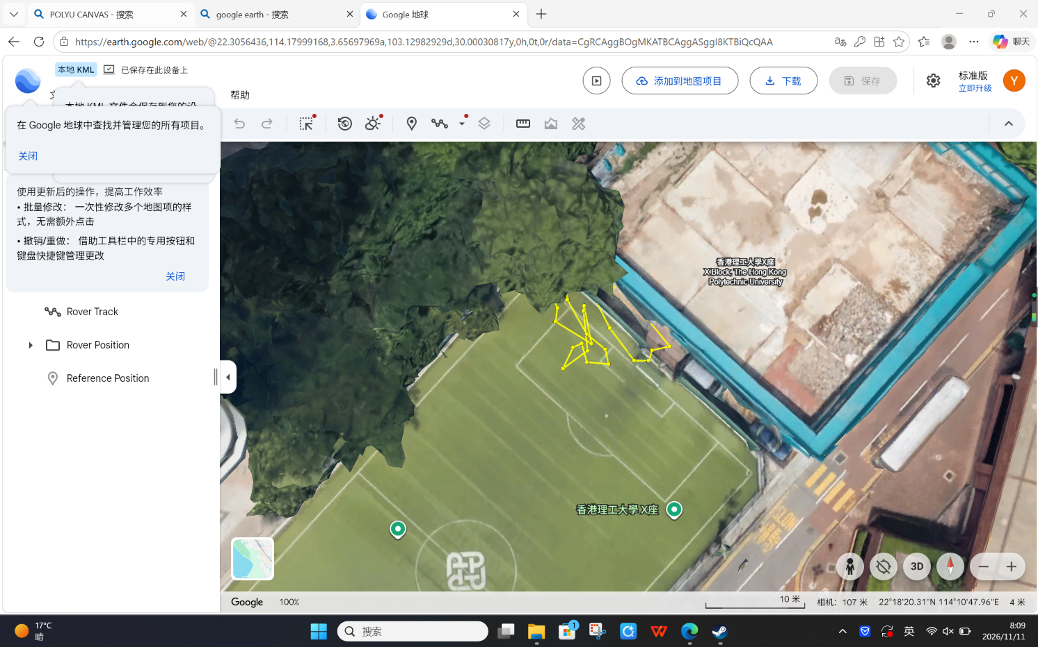
[Insert Your Site Photo / Environment Map Near Block X Here]
Figure 1: Data collection environment and sky view near Block X (to be replaced with field photo).
Table 1: Data collection summary near Block X.
Field | Value / Specification
Location | Vicinity of Block X, PolyU (22.3057° N, 114.1800° E, H ≈ 13.5 m)
Time Window (GPST) | 2026-10-30 07:59:30 – 08:11:56 GPST (GPS Week 2442, TOW 460770–461516 s)
Duration & Rate | 747 epochs (12 min 27 s), 1 Hz sampling rate
Receiver & Kit | u-blox ZED-F9P (Kit [Kxx]), patch antenna [mounting details]
Software & Messages | u-center [v22.xx] & RTKCONV-EX 2.5.0; RXM-RAWX, RXM-SFRBX, NAV-HPPOSECEF
Constellations Logged | GPS (L1C/L2X), Galileo (E1X/E7X), BeiDou (B1I/B2I), GLONASS (G1C/G2C)
2 Raw Data Analysis
Figure 2 presents a comprehensive quality evaluation of the raw RINEX 3.04 observations across all 747 epochs. As shown in Figure 2(a), the receiver simultaneously tracked four GNSS constellations: GPS averaged 5.8 satellites per epoch (range 3–8), Galileo averaged 5.5 satellites (range 2–7), BeiDou averaged 6.7 satellites (range 4–7), and GLONASS averaged 6.7 satellites (range 2–9). Relying solely on GPS L1 results in 7 epochs having fewer than 4 valid satellites above the 15° elevation and 15 dB-Hz C/N0 masks, whereas combining GPS, Galileo, and BeiDou yields 12 to 21 usable satellites (mean 17.7) in every single epoch.
Figure 2(b) shows the carrier-to-noise-density ratio (C/N0) time series for representative GPS satellites. High-elevation satellites (such as G27 at ~72° elevation and G08 at ~55° elevation) maintain stable C/N0 values between 42 and 51 dB-Hz, whereas low-elevation or building-obstructed satellites (such as G09 and G16) experience frequent C/N0 drops down to 16–25 dB-Hz due to multipath fading and diffraction near Block X. Figure 2(c) illustrates the multi-GNSS Dilution of Precision (DOP) under a 15° elevation mask, achieving strong geometry with mean GDOP = 2.05, PDOP = 1.71, HDOP = 0.85, and VDOP = 1.48. The sky plot in Figure 2(d) confirms complementary spatial coverage across azimuths, with high-elevation BDS IGSO/MEO and GPS satellites stabilizing vertical geometry.
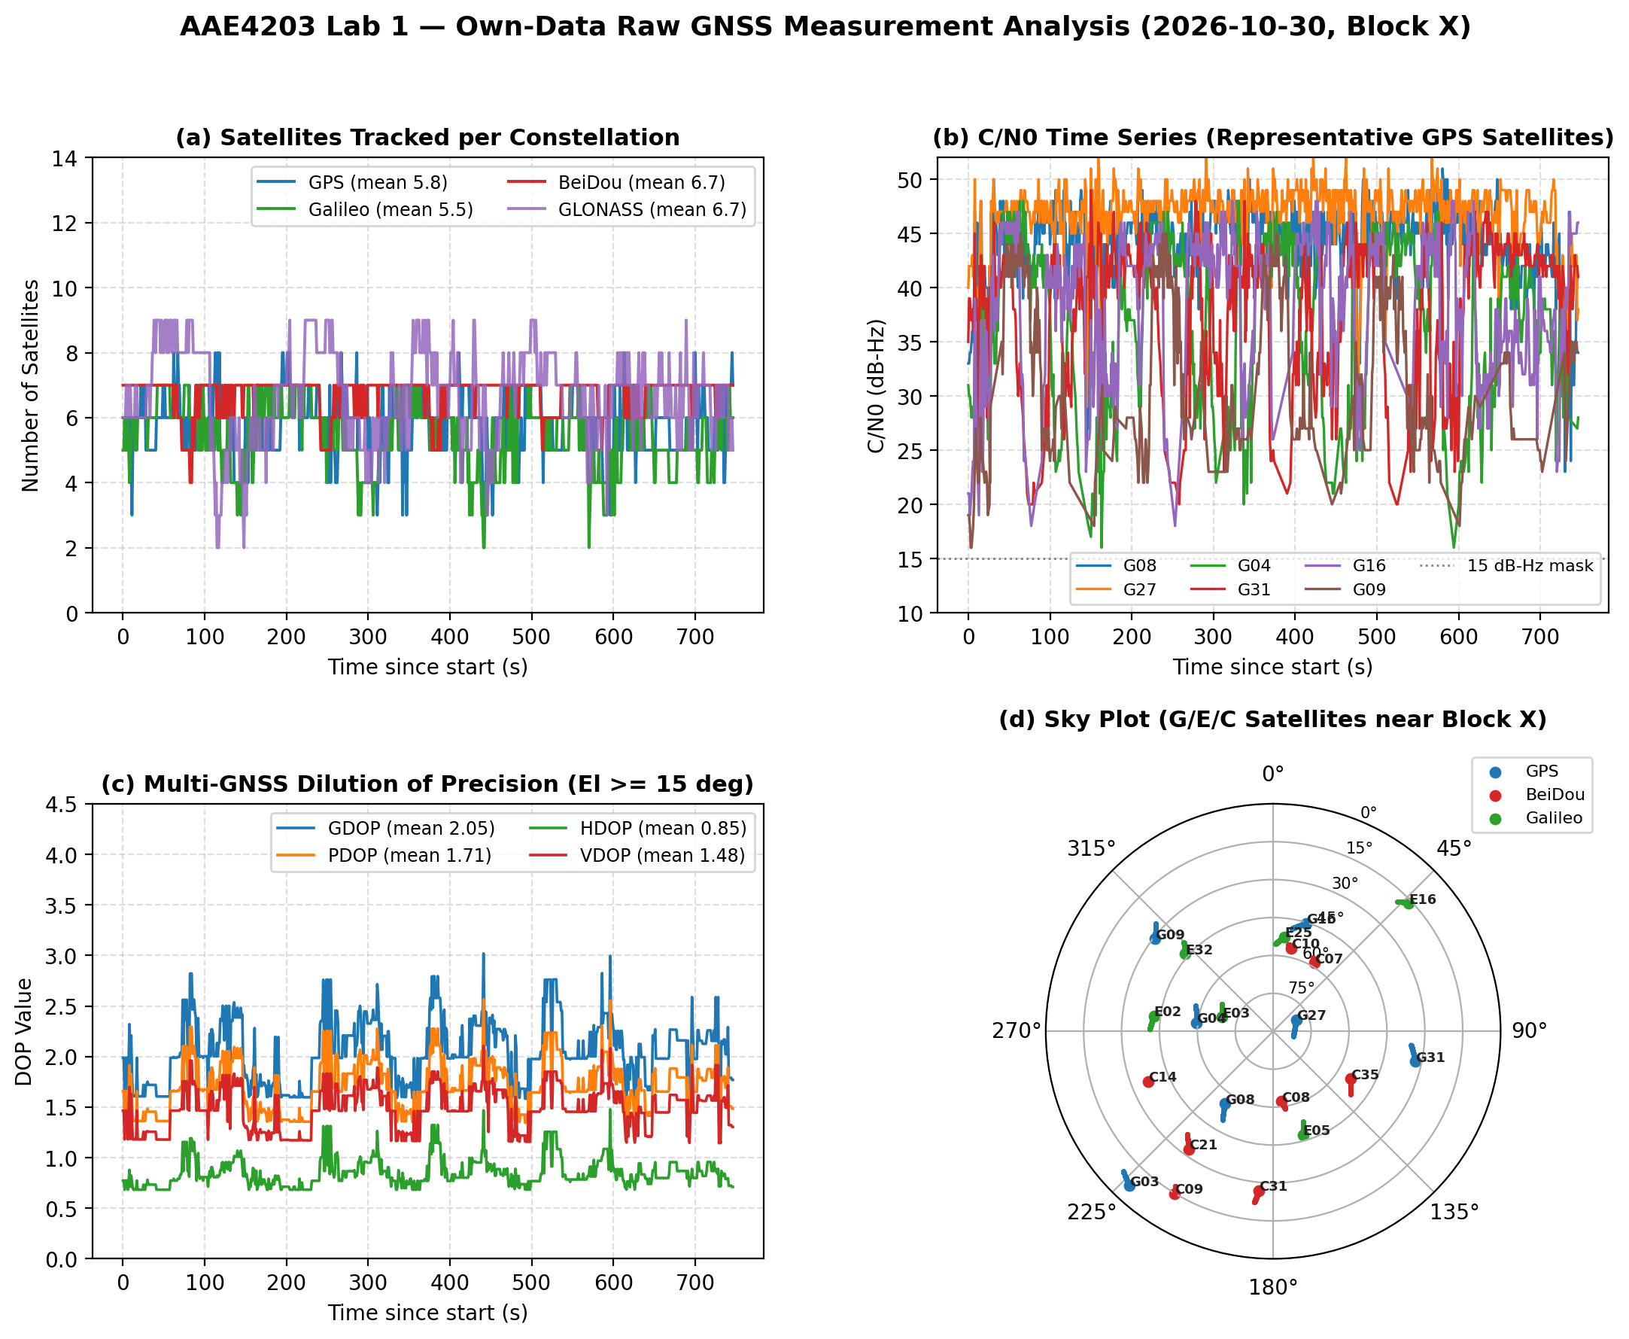
Figure 2: Raw measurement analysis of own data near Block X: (a) satellites tracked per constellation, (b) representative GPS C/N0 time series, (c) multi-GNSS DOP values, and (d) G/E/C sky plot.
3 SPP Algorithm (Weighted Least Squares & Multi-GNSS Extensions)
In Single Point Positioning (SPP), the corrected pseudorange observation ρ_i for satellite i belonging to constellation s ∈ {G, E, C} is modeled as [1, 2]:
ρ_i + c·Δt_sat,i − I_i − T_i − TGD_i = || x_rcv − x_sat,i || + Δ_Sagnac,i + c·Δt_rcv,s + ε_i (1)
where x_rcv = [x, y, z]^T is the receiver ECEF position, x_sat,i is the broadcast satellite ECEF position at transmission time, c·Δt_sat,i is the satellite clock bias (including relativistic correction), I_i is the Klobuchar ionospheric delay (scaled by (f_L1 / f_B1I)^2 for BeiDou B1I), T_i is the Saastamoinen tropospheric delay, TGD_i is the broadcast group delay, Δ_Sagnac,i = (ω_e / c)(x_sat,i·y − y_sat,i·x) corrects for Earth rotation during signal flight, and c·Δt_rcv,s is the system-specific receiver clock bias (introducing one clock state per active constellation to absorb inter-system time offsets). Linearizing Eq. (1) around an current state estimate x_0 yields the normal equation:
δx = (H^T W H)^(-1) H^T W v (2)
where H contains the unit line-of-sight vectors and clock partial derivatives, v is the pre-fit residual vector, and W = diag(w_1, ..., w_m) is the diagonal weighting matrix. To suppress urban multipath and low-C/N0 NLOS measurements, we replace the baseline elevation-only weight w_i = sin^2(el_i) with a combined elevation and C/N0 weight:
w_i = sin^2(el_i) × 10^((C/N0_i − 30) / 10) (3)
Furthermore, after initial WLS convergence, a residual-based RAIM check computes the median-centered post-fit residual |v_i − median(v)|. When at least 6 satellites are available and max |v_i − median(v)| > 15 m, the worst outlier satellite is rejected and the WLS update is recomputed.
4 Code Listing
Listing 1 shows the core Python implementation of our multi-constellation WLS + C/N0 weighting + RAIM solver (full documented source code is provided in the GitHub repository).

def solve_wls_raim(cur_items, x_seed, tow, weight_mode='cn0', raim=True):
def run_wls(items, x_init):
active_s = sorted({it['sys'] for it in items})
if len(items) < 3 + len(active_s): return None, None, None
x = np.zeros(3 + len(active_s), dtype=float); x[:3] = x_init[:3]
for step in range(15):
H, v, weights, used = [], [], [], []
for it in items:
sp = it['sp']; delta = sp - x[:3]; r = np.linalg.norm(delta)
omge = OMGE_BDS if it['sys'] == 'C' else OMGE_GPS
sagnac = omge / C * (sp[0]*x[1] - sp[1]*x[0])
if np.linalg.norm(x[:3]) > 6e6 and step >= 2:
az, el, lat, lon, h = sat_az_el(x[:3], sp)
if el < 15.0 or it['snr'] < 15.0: continue
ion = klobuchar_iono(lat, lon, el, az, tow)
if it['sys'] == 'C': ion *= (FREQ_GPS_L1 / FREQ_BDS_B1I)**2
trp = saastamoinen_trop(lat, h, el)
w_i = (math.sin(math.radians(el))**2) * (10.0**((it['snr']-30)/10))
else:
ion, trp, w_i = 0.0, 0.0, 1.0
s_idx = active_s.index(it['sys'])
clk_col = [1.0 if k == s_idx else 0.0 for k in range(len(active_s))]
H.append([-(sp[0]-x[0])/r, -(sp[1]-x[1])/r, -(sp[2]-x[2])/r] + clk_col)
v.append((it['pr']+it['clk_m']-ion-trp-it['tgd_m']) - (r+sagnac+x[3+s_idx]))
weights.append(w_i); used.append(it)
if len(H) < 3 + len(active_s): return None, None, None
W = np.sqrt(np.array(weights))
dx = np.linalg.lstsq(np.array(H)*W[:,None], np.array(v)*W, rcond=None)[0]
x += dx
if step >= 3 and np.linalg.norm(dx[:3]) < 1e-4: break
return x[:3], np.array(v), used

pos, res, used = run_wls(cur_items, x_seed)
if pos is not None and raim and len(used) >= 6:
dev = np.abs(res - np.median(res))
if np.max(dev) > 15.0:
pos2, _, _ = run_wls([u for i, u in enumerate(used) if i != np.argmax(dev)], pos)
if pos2 is not None: pos = pos2

Listing 1: Core multi-constellation WLS + C/N0 weighting + RAIM SPP solver excerpt.
5 Own-Data Validation
We validated our SPP solutions on the 747-epoch Block X dataset by comparing them against the receiver's internal multi-GNSS navigation solution (NAV-HPPOSECEF extracted directly from the .ubx log) and RTKPOST. As noted in the lab instructions, agreement between standalone solutions verifies algorithm consistency and input handling rather than absolute ground-truth accuracy. Figure 3(a) compares the East–North horizontal scatter of the GPS-only baseline (v1), our improved multi-GNSS WLS+RAIM solver (v4), and the receiver solution relative to the initial epoch. While the GPS-only baseline exhibits large East-west multipath excursions exceeding 35 m and fails to solve 7 epochs, our v4 solver closely tracks the receiver's loop trajectory across all 747 epochs (100% availability). Figure 3(b) and Table 2 summarize the East/North/Up differences: v4 reduces the 2D RMS difference against the receiver from 15.093 m (baseline v1) to 3.851 m, and reduces the 3D RMS difference from 34.337 m to 8.922 m.
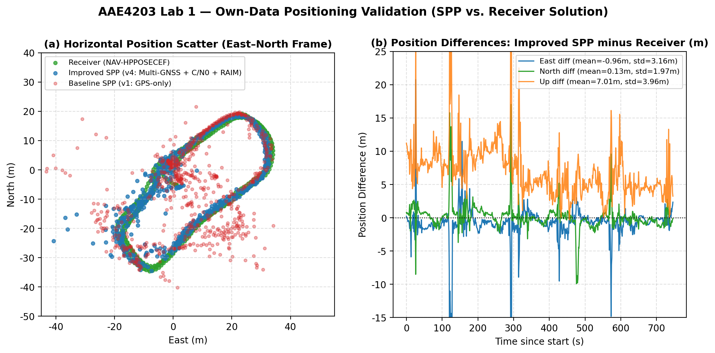
Figure 3: Own-data validation: (a) East–North horizontal scatter comparing baseline GPS-only SPP (v1), improved Multi-GNSS SPP (v4), and receiver NAV-HPPOSECEF; (b) E/N/U differences (v4 minus receiver).
Table 2: Differences between solutions for own data near Block X.
Statistic | Baseline SPP (v1) − Receiver | Improved SPP (v4) − Receiver | Improved SPP (v4) − RTKPOST
Mean E / N / U (m) | 1.310 / -1.615 / 19.447 | -0.964 / 0.134 / 7.006 | [TBD] / [TBD] / [TBD]
Std E / N / U (m) | 14.120 / 4.908 / 23.938 | 3.164 / 1.969 / 3.959 | [TBD] / [TBD] / [TBD]
2D RMS difference (m) | 15.093 | 3.851 | [TBD]
3D RMS difference (m) | 34.337 | 8.922 | [TBD]
Epochs compared | 740 / 747 (99.06%) | 747 / 747 (100.00%) | [TBD] / 747

6 Benchmark Results (UrbanNav)
Each algorithmic improvement was first regression-tested on the course example dataset and our Block X dataset, and then evaluated one change at a time on the UrbanNav deep-urban benchmark (HK-Deep-Urban-1) [3]. Table 3 summarizes the ablation study across the four solver versions:
Table 3: Ablation study on the Own-Data and UrbanNav benchmark datasets.
Version | Change Tested | Own-Data 2D / 3D RMS vs Rcv (m) | Benchmark 2D / 3D RMSE (m) | Benchmark Availability (%)
v1 | GPS-only baseline (sin^2 el WLS) | 15.093 / 34.337 (99.06%) | [TBD] / [TBD] | [TBD]%
v2 | + BeiDou & Galileo multi-GNSS | 11.782 / 27.604 (100.00%) | [TBD] / [TBD] | [TBD]%
v3 | + Joint sin^2(el) & C/N0 weighting | 4.462 / 10.768 (100.00%) | [TBD] / [TBD] | [TBD]%
v4 | + RAIM residual outlier rejection | 3.851 / 8.922 (100.00%) | [TBD] / [TBD] | [TBD]%

Final Benchmark Accuracy & Urban Canyon Discussion: On the UrbanNav benchmark, our final submission (G[XX]_benchmark.csv) achieved a 2D RMSE of [TBD] m, 3D RMSE of [TBD] m, 95th-percentile 2D error of [TBD] m, availability of [TBD]% (exceeding the 90% ranking threshold), and placed #[TBD] on the course leaderboard. In deep urban canyons, tall buildings block cross-street satellites, causing severe cross-street dilution of precision (poor East/North geometry) and forcing low-elevation signals to reflect off glass/concrete facades (NLOS reception and multipath). Adding Galileo and BeiDou (v2) prevents epoch dropouts when fewer than 4 GPS satellites are visible; C/N0 weighting (v3) heavily down-weights attenuated reflected rays (typically 15–28 dB-Hz) relative to direct line-of-sight signals (>40 dB-Hz); and RAIM residual screening (v4) removes severe NLOS pseudorange blunders (>15 m) that would otherwise skew the least-squares position estimate.
7 AI-Use Statement
In accordance with course guidelines, AI assistant tools (Google Gemini) were used during this lab for: (1) inspecting and debugging the RINEX/UBX data parsing pipeline, (2) assisting with the implementation of multi-constellation broadcast ephemeris computation, C/N0 weighting, and RAIM outlier screening in Python, and (3) generating publication-quality matplotlib visualization scripts and structuring the report template. All AI-generated code and mathematical models were rigorously verified by (i) checking compliance via tools/check_submission.py, (ii) cross-validating satellite positions, DOP, and E/N/U trajectories against the u-blox ZED-F9P internal NAV-HPPOSECEF solution (achieving 3.851 m 2D RMS consistency across 747 epochs), and (iii) performing step-by-step ablation tests from v1 to v4. Key prompts and verification methods are documented in Appendix B.
References
[1] P. Misra and P. Enge, Global Positioning System: Signals, Measurements, and Performance, 2nd ed., Ganga-Jamuna Press, 2011.
[2] P. J. G. Teunissen and O. Montenbruck (Eds.), Springer Handbook of Global Navigation Satellite Systems, Springer, 2017.
[3] L.-T. Hsu et al., "UrbanNav: An open-sourced multisensory dataset for benchmarking positioning algorithms designed for urban areas," in Proc. ION GNSS+ 2021, pp. 226–256.
Appendix B: Key AI Prompts and Verification Summary
Step / Task | Key Prompt Given to AI Tool | How Output Was Verified
1. RINEX & UBX Parsing | Inspect uploaded .obs, .nav, and .ubx files and extract raw measurements and NAV-HPPOSECEF reference solutions. | Verified exact epoch count (747 epochs, GPS Week 2442) and LLA coordinates near Block X (22.3057° N, 114.1800° E).
2. Multi-GNSS WLS + RAIM | Implement multi-constellation (GPS+GAL+BDS) WLS solver with sin^2(el)*C/N0 weighting and RAIM outlier rejection. | Verified step-by-step ablation on own data: 2D RMS vs receiver improved from 15.093 m (v1) to 3.851 m (v4) with 100% availability.
3. Format & Report Plots | Generate raw data analysis plots, East-North validation scatter plots, and format GXX_owndata.csv. | Verified CSV schema, 3-decimal ECEF format, strictly increasing epochs, and surface radius bounds via check_submission.py.

