Object-Oriented Midterm-Report

Project explanation:

The project we made is mainly mean to apply the concepts of object-oriented we covered during this the classes , so to do that we have build a small console program that manages a simple parking pass system for a university, The tasks covers registering drivers, assigning passes, parking and removing vehicles, and calculating a basic fee. The program uses object-oriented programming because the system consists of many entities that interact with each other to apllay the main three concepts of object orientated ( inheratince , Polymorphism and Encapsulation.

How required OOP concepts are applied :

we know that the main three concept in object-orinted which we tried too apply in our code are inheritance , Polymorphism and Encapsulation.
This is kind of wide overview of the classes and the blocks of code covered those concepts :

Driver and Vehicle

A driver has a name, an ID, and exactly one vehicle. Both classes use simple property setters to prevent empty names or invalid plates. This shows basic encapsulation by controlling how values are assigned.

ParkingPass, StudentPass, StaffPass

ParkingPass is the base class. The student and staff passes inherit from it and override calculate_fee(). This is where polymorphism appears: when a vehicle is removed, the system just calls calculate_fee() without checking which type of pass it is. Python automatically chooses the correct implementation.

ParkingLot

This class stores the lot name, its capacity, and which plates are currently inside. It uses a set so checking membership is fast. The methods park() and remove() raise the custom ParkingError if something goes wrong.

System

This class manages everything together. It keeps dictionaries for drivers and passes, checks duplicates, and forwards parking actions to the parking lot. It also makes sure that every plate has only one pass.

Exceptions

A custom exception called ParkingError is used for things like a full lot, unregistered plates, or trying to park without a pass. try/except blocks in main() make sure the program never crashes and always returns to the menu.

Usage Guide:

We will briefly show the user how to use our console program smoothly as steps

First : we store our main file in the desktop so access it we will copy the file path
Commend used : cd <file path>
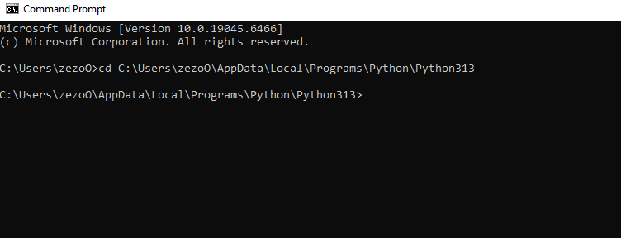

Second : we run the file we stored our work in which is main py
Commend used : python main.py
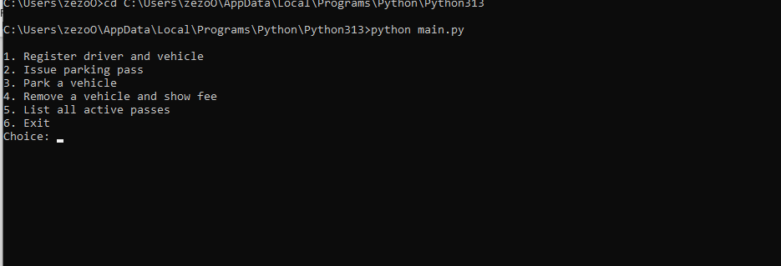

we see that entries filed has been shown successfully

Third :

Example workflow

Choose 1. Register driver and vehicle
Enter full name, ID, license plate, and vehicle type.

Choose 2. Issue parking pass
Enter the driver ID and pass type (student or staff). A short pass ID is printed.

Choose 3. Park a vehicle
Enter the license plate that has a valid pass. The system checks pass validity and lot capacity.

Choose 4. Remove a vehicle and show fee
Enter the license plate and hours parked (e.g., 2.5). The system calculates fee based on the pass type, prints it, and removes the vehicle from the lot.

Choose 5. List all active passes to see issued passes and their owners.

Choose 6. Exit to close the program.

Fourth:
We would be checking couple of test to ensure that the validation and constraints working well

- Encapsulation and Input Validation :
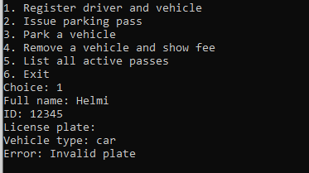

Test result:
It successfully showed that the program refused to accept the user query because the user does not fill all the fields

- Inheritance:
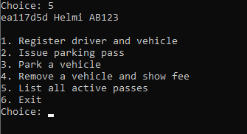

Test Result :
we see that the inheritance concept were performed successfully because when we chosed option 5 it returned to uss all the previous information we entried in the filed either they ar base(parent) like the first option or child class option like the third filed

