http://www.vision.rwth-aachen.de/
Summary Google Course

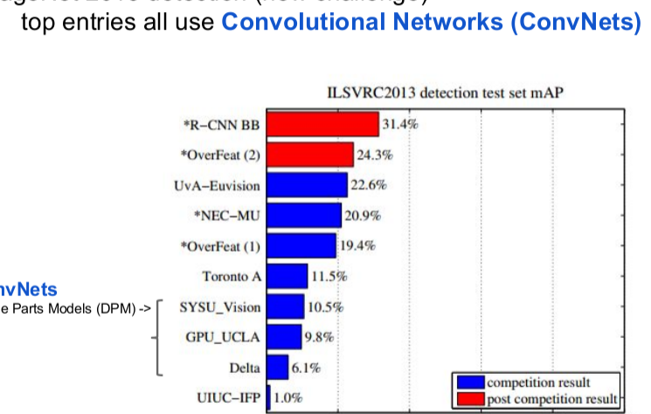
https://sites.google.com/site/deeplearningcvpr2014/

[Razavian et al, 2014]:
"It can be concluded that from now on, deep learning with CNN has to be
considered as the primary candidate in essentially any visual recognition task."

Recurrent
Neural Net

Visualizing and understanding convolutional neural networks. Zeiler, Matthew D., and Rob Fergus. arXiv preprint arXiv:1311.2901 (2013).

[Krizhevsky’12] win 2012 ImageNet classification with a much bigger ConvNet than before:
○ deeper: 7 stages vs 3 before
○ larger: 60 million parameters vs 1 million before
● This was made possible by:
○ fast hardware: GPU-optimized code
○ big dataset: 1.2 million images vs thousands before
○ better regularization: dropout

substantial improvements with fine-tuning on PASCAL
detection: 44.7% to 54.2% mAP

[Branson’14] propose a 2-step fine-tuning method that improves accuracy
i. only train the weights of the new layer(s)
ii. train all weights

R-CNN: bounding-box regression

we need a background cutter

Intra-class variation
Rob Fergus: http://cs.nyu.edu/~fergus

Conclusions
● Deep ConvNets are the new feature extraction baseline for computer
vision
○ low hanging fruits: revisit traditional methods by swapping in deep
ConvNets

sparse representation

Questions to answer:

does Cnn a background cutter OR BOUNDING BOX

what exactly does Pooling Layer do ?

The Learned Features are Generic

Dropout: A Simple Way to Prevent Neural Networks from Overfitting

How is a convolutional neural network able to learn invariant features?

7 Answers


Eren Golge, AI researcher
Answered Apr 23, 2014

The pooling regimes make convolution process invariant to translation, rotation and shifting. Most widely used one is max-pooling. You take the highest activation to propagate at the interest region so called receptive field. Even a images are relatively a little shifted, since we are looking for highest activation, we are able to capture commonalities between images.
For scale invariance, up to my knowledge, no way other than providing different scales of images to network or learned network filters might be applied at different scales.
One another particular approach is Hinton's network that learns possible deforming oprerations at the images with additional network units. http://www.cs.toronto.edu/~hinto...

Abstract
Convolutional Neural Networks (CNNs) require large image corpora to be trained on classification tasks. The variation in image resolutions, sizes of objects and patterns depicted, and image scales, hampers CNN training and performance, because the task-relevant information varies over spatial scales. Previous work attempting to deal with such scale variations focused on encouraging scale-invariant CNN representations. However, scale-invariant representations are incomplete representations of images, because images contain scale-variant information as well. This paper addresses the combined development of scale-invariant and scale-variant representations. . The results show that our multi-scale CNN outperforms single-scale CNN. This leads to the conclusion that encouraging the combined development of a scale-invariant and scale-variant representation in CNNs is beneficial to image recognition performance.
http://www.sciencedirect.com/science/article/pii/S0031320316301224

Thus, large variance in instance scales, which results
in undesirable large intra-category variance in features, may
severely hurt the performance of modern object instance de-
tection methods.

An image classification problem is predicting the label of an image among the predefined labels. It assumes that there is single object of interest in the image and it covers a significant portion of image. Detection is about not only finding the class of object but also localizing the extent of an object in the image. The object can be lying anywhere in the image and can be of any size(scale) as can be seen in the figure 1.

Best explanation for scale and convolution
https://medium.com/ilenze-com/object-detection-using-deep-learning-for-advanced-users-part-1-183bbbb08b19

Continue here tomorrow
https://arxiv.org/pdf/1406.5726.pdf

read this paper !!!!!!!!!!!!!!!!!!!!1

m. However, the CNN
model cannot be trivially extended to cope with the
multi-label image classification problem in an inter-
pretable manner, mainly due to the following reasons.
Firstly, the implicit assumption that foreground ob-
jects are roughly aligned, which is usually true for
single-label images, does not always hold for multi-
label images. Such alignment facilitates the design of
the convolution and pooling infrastructure of CNN
for single-label image classification. However, for a
typical multi-label image, different categories of ob-
jects are located at various positions with different
scales and poses.

hirdly, due to the tremendous
parameters to be learned for CNN, a large number of
training images are required for the model training

With max pooling, the high predictive
scores from those hypotheses containing objects
are reserved and the noisy ones are ignored

Redundant
hypotheses can also be well addressed by max
pooling.
•
No

