## 简易版：

## 动态同义词插件安装

找到部署文档附属文件elasticsearch-analysis-dynamic-synonym-7.17.4.zip

# 假设ES的路径为 /opt/module/es/elasticsearch-7.17.4/

es目录下\plugins新建文件夹analysis-dynamic-synonym

mkdir /opt/module/es/elasticsearch-7.17.4/plugins/analysis-dynamic-synonym

将zip文件解压至该文件夹下

unzip -n elasticsearch-analysis-dynamic-synonym-7.17.4.zip -d /opt/module/es/elasticsearch-7.17.4/plugins/analysis-dynamic-synonym/

如果环境内没有unzip，我们也提供了tar.gz包

tar -zxvf elasticsearch-analysis-dynamic-synonym-7.17.4.tar.gz -C /opt/module/es/elasticsearch-7.17.4/plugins/analysis-dynamic-synonym/

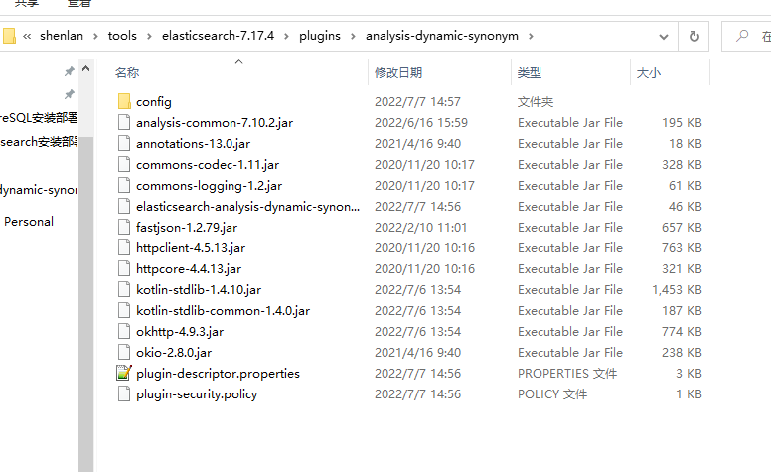

进入config文件夹进行配置

vi /opt/module/es/elasticsearch-7.17.4/plugins/analysis-dynamic-synonym/config/gistool-reload.properties

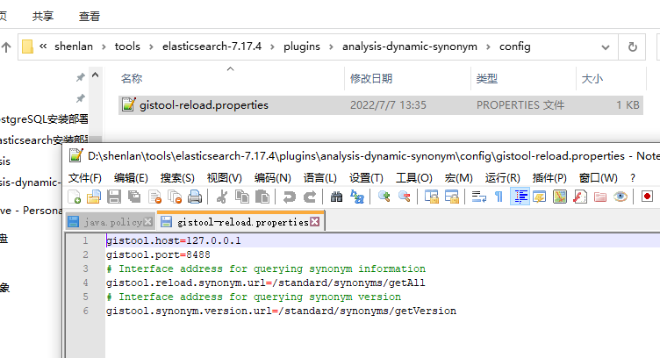

分别可以配置一标地址库项目的 host、port、获取同义词信息的接口路径、获取同义词最新版本号接口路径。

## 启动Elasticsearch

直接启动，会出现以下或其他权限异常直接导致ES关闭

AccessControlException: access denied ("java.net.NetPermission" "connect,resolve")

修改ES目前所使用的jdk的权限赋予来解决问题。

注意：当前环境配置了 %ES_JAVA_HOME% 会优先使用该路径的jdk，其次是 %JAVA_HOME%，再次是ES自带jdk。

%ES_JAVA_HOME% > %JAVA_HOME% > \elasticsearch-7.17.4\jdk

普通JDK：

%JAVA_HOME%\jre\lib\security目录下的文件java.policy，在下面新增三行权限

permission java.net.NetPermission "*", "connect,resolve";

permission java.net.SocketPermission "*", "connect,resolve";

permission java.lang.RuntimePermission "*", "connect,resolve";

例如：vi /usr/jdk/jdk1.8.0_141/jre/lib/security/java.policy

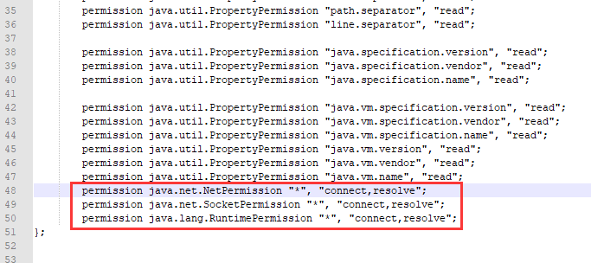

ES自带JDK路径则为：\elasticsearch-7.17.4\jdk\conf\security

启动ES，成功

## 3.创建索引（代码自动执行，跳过该步骤）

将请求地址中的index_standard_menzhi 更换为 index_standard_poi执行，再更换为index_standard_lukou执行。一共执行三次。

PUT <http://127.0.0.1:9201/index_standard_menzhi>

{

    "settings": {

        "index": {

            "max_result_window": 1000000

        },

        "number_of_shards": 3,

        "number_of_replicas": 0,

        "analysis": {

            "filter": {

                "local_doc_filter": {

                    "type": "dynamic_synonym",

                    "synonyms_path": "fromGisTool",

                    "interval": 60

                }

            },

            "analyzer": {

                "ik_syno": {

                    "type": "custom",

                    "tokenizer": "ik_max_word",

                    "filter": [

                        "local_doc_filter"

                    ]

                }

            }

        }

    },

    "mappings": {

        "properties": {

            "geoPoint": {

                "type": "geo_point"

            },

            "suggest": {

                "type": "completion"

            },

            "fulltext": {

                "type": "text",

                "analyzer": "ik_syno"

            },

            "name": {

                "type": "text",

                "analyzer": "ik_syno"

            },

            "nine01ShengZhixiashi": {

                "type": "keyword"

            },

            "nine02Shengshushi": {

                "type": "keyword"

            },

            "nine03QuXian": {

                "type": "keyword"

            },

            "nine04JiedaoZhenXiang": {

                "type": "keyword"

            }

        }

    }

}