Student Grade Management System

Student Name: Aarya Parua
Registration No.: 24BAC100037
Slot: B21 + E14

1. Introduction
Academic record-keeping is one of the most routine but error-prone tasks an instructor performs: tracking who is enrolled, what assignments exist, what each student scored, and how that translates into a final grade. This project implements a terminal-based Student Grade Management System in Java that models that entire workflow end to end — from instructor login, through student and assignment setup and grade entry, to a formatted report card and class summary — without relying on a database, a graphical interface, or any third-party library.
The project was deliberately built around a grade-management domain rather than the more commonly submitted 'Library Management System' style of project, so that the object model (students, assignments, weighted grades, letter-grade rules) would exercise a different set of design decisions — in particular, weighted-percentage computation and enum-driven grading logic — while still fitting cleanly into a layered, exception-safe Java architecture that satisfies the course's object-oriented programming objectives.

2. Problem Statement
Instructors handling small to mid-sized classes without institutional software often resort to spreadsheets or paper records to track student marks across multiple assignments, each carrying a different weight toward a final grade. This approach is error-prone: it offers no validation against duplicate entries, no protection against marks exceeding an assignment's maximum, no centralised authentication, and no consistent way to compute a weighted overall percentage and letter grade.
The problem this project addresses is: how can an instructor reliably register students and assignments, record and update marks, and generate accurate, weighted, auditable report cards and class-wide summaries — entirely from a command line, with data that persists safely between sessions and with every invalid operation caught and reported instead of corrupting the underlying records?

Target Users
- Instructors or teaching assistants who need a lightweight, dependency-free way to manage grades for a single class or section.
- Evaluators / course graders who need to run the application from a terminal without any GUI, database server, or network dependency.
- Students of the Programming in Java course, as a demonstration of layered object-oriented design applied to a real record-keeping problem.

3. Functional Requirements
The system is organised around three major functional modules, each with a clear input/output structure and a menu-driven workflow:

Module 1 — Authentication & Access Control
- Require instructor login (username and password) before any student, assignment, or grade record can be viewed or modified.
- Allow up to three login attempts per session before the application exits.
- Provide a default instructor account (admin / admin123) created automatically on first run for evaluator convenience.

Module 2 — Student & Assignment Management
- Register a new student with a unique roll number, name, and section; reject duplicate roll numbers.
- Remove an existing student, cascading the removal to any grades recorded for them.
- List all registered students in a formatted table.
- Define assignments with a name, a maximum mark, and a percentage weight toward the final grade; list all assignments with their total assigned weight.

Module 3 — Grade Entry & Reporting
- Record or update a student's marks for a given assignment, validated against the assignment's maximum mark.
- Compute a weighted overall percentage per student, renormalised across only the assignments that student has been graded on.
- Map the weighted percentage to a letter grade (A–F), a pass/fail status, and a descriptive remark.
- Generate a per-student report card and a class-wide summary (average, pass count, pass rate).
Every operation follows the same input/output pattern: the instructor is prompted for structured input at the terminal, the system validates and processes it through the service layer, and a confirmation, formatted table, or a specific error message is printed back — giving a clear, predictable request/response loop for every menu option.

4. Non-Functional Requirements
Requirement | How It Is Addressed
Performance | All data is held in memory (HashMap / ArrayList) during a session, so lookups, weighted-percentage computation, and report generation are effectively instantaneous even as the roster grows; disk writes happen only on mutating operations.
Reliability | Every service method that can fail throws a specific checked exception rather than silently corrupting state; invalid operations are rejected before any write to the in-memory model or to disk.
Security | No record can be viewed or modified without a successful instructor login; up to three attempts are allowed before the session terminates, and credentials are never echoed back in error messages.
Usability | A single numbered main menu (options 0–8) with consistent prompts, and a default admin/admin123 account, mean the application can be picked up and evaluated with no prior configuration.
Maintainability | A five-layer architecture (model, exception, service, persistence, presentation) consolidated into seven files with nested types keeps related code together without sacrificing separation of concerns.
Error-Handling Strategy | A single checked-exception hierarchy (GradeSystemException and five nested subtypes) is used consistently across every service method and caught at the Main.java menu loop, so no invalid input can crash the program.
Resource Efficiency / Portability | No external dependencies beyond the Java Standard Library (java.util, java.nio.file, java.io); runs identically via Maven or plain javac/java on any machine with a JDK 17+ installed.

5. System Architecture
The codebase is deliberately consolidated into seven files, using nested static classes to group closely related types instead of spreading them across many small files. The seven files map onto five architectural layers: model, exception, service, persistence, and presentation, with Main.java as the entry point that wires them together.
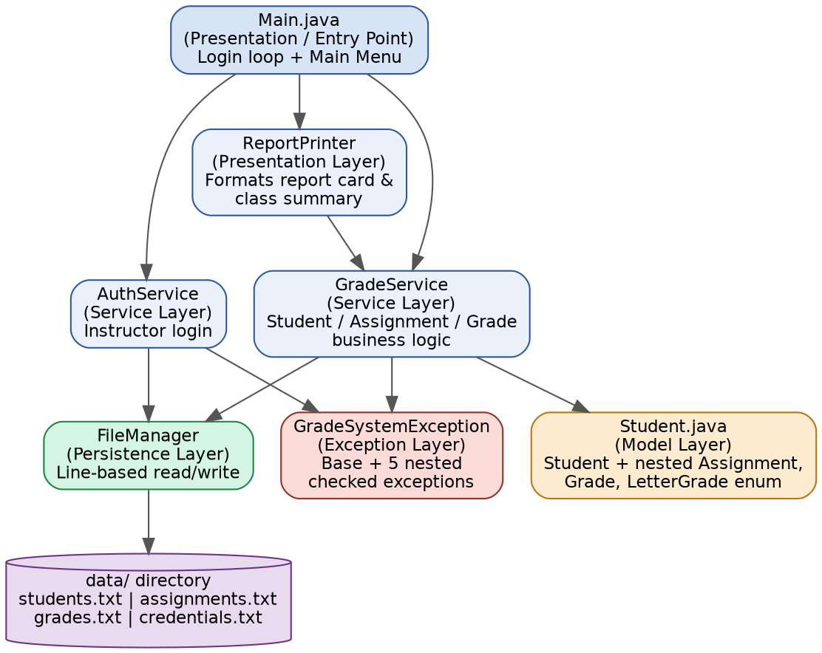
Fig. 6.1 — System architecture and dependency flow between layers.
File | Layer / Responsibility
model/Student.java | Model layer — Student (outer class) plus nested Assignment, Grade, and LetterGrade enum
exception/GradeSystemException.java | Exception layer — base checked exception plus five nested domain exceptions
service/AuthService.java | Service layer — instructor login and credential persistence
service/GradeService.java | Service layer — student/assignment/grade business logic and weighted scoring
util/FileManager.java | Persistence layer — raw line-based reads/writes to the data/ directory
ui/ReportPrinter.java | Presentation layer — formats report cards, class summary, and list views
Main.java | Entry point — login flow, main menu loop, input parsing and validation

6. Design Diagrams

6.1 Use Case Diagram
The instructor is the sole actor in the system. Four use cases (Add Student, Remove Student, Record Grade, View Report Card) require an active login session, modelled here as an include relationship on Login.
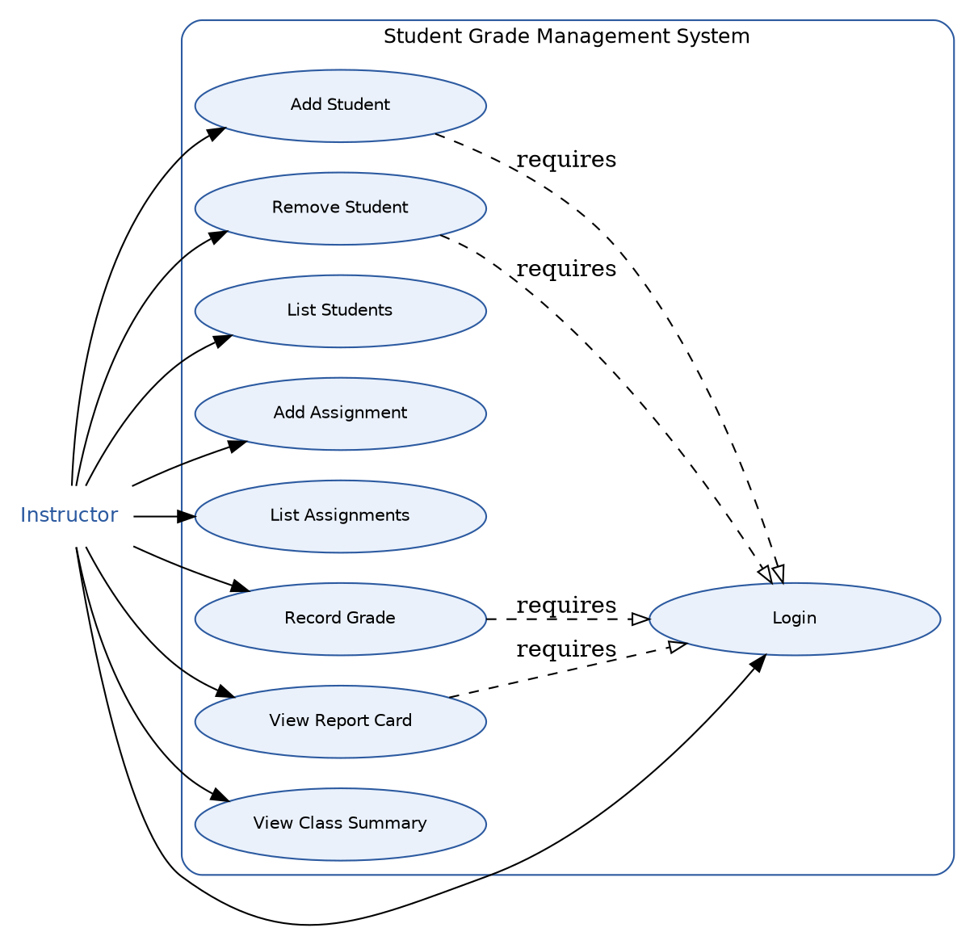
Fig. 7.1 — Use case diagram: Instructor and the nine supported operations.

6.2 Process Flow / Workflow Diagram
The workflow diagram traces a full session: authentication with a bounded number of retries, the main menu loop, dispatch to a service operation, validation, persistence, and the two ways a session can end — a normal Exit choice or an end-of-input (EOF) condition on standard input.
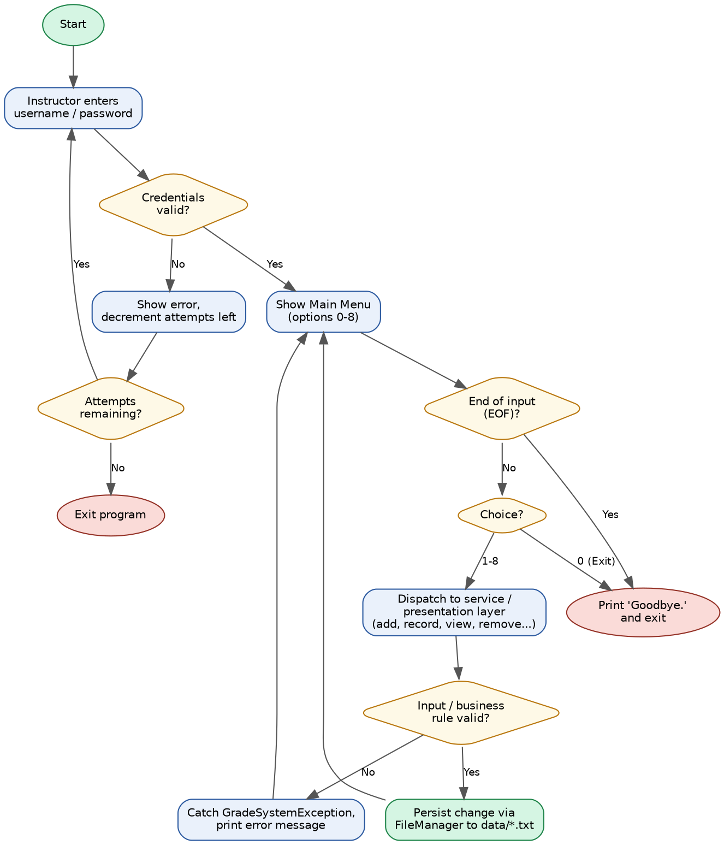
Fig. 7.2 — End-to-end process flow from login through menu dispatch to exit.

6.3 Class Diagram
The class diagram shows the model, exception, service, persistence, and presentation types and how they relate. Assignment, Grade, and the LetterGrade enum are nested inside Student (diamond composition arrows); the five domain exceptions all extend the single GradeSystemException base class.

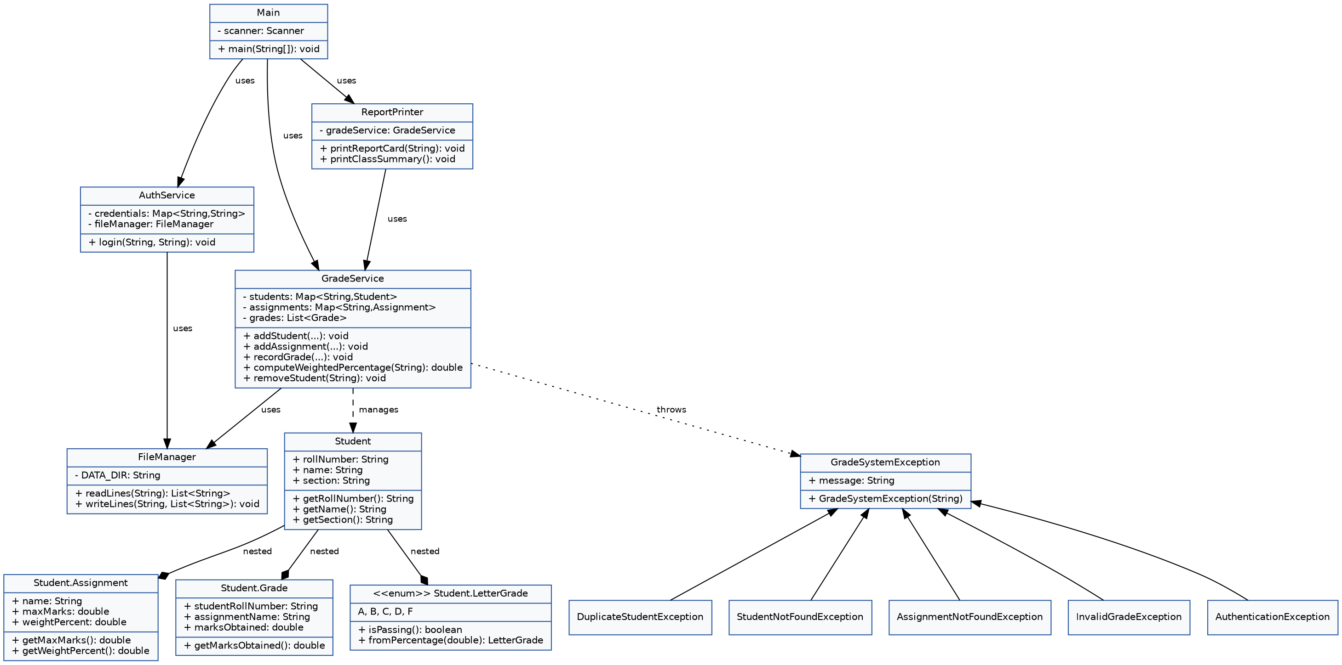
Fig. 7.3 — Class diagram covering all seven files and their relationships.

6.4 Sequence Diagram
The sequence below traces the interaction for Option 4 (View Student Report Card), the most representative read path in the system: it touches the presentation, service, and model layers and demonstrates the checked-exception path when a roll number is not found.
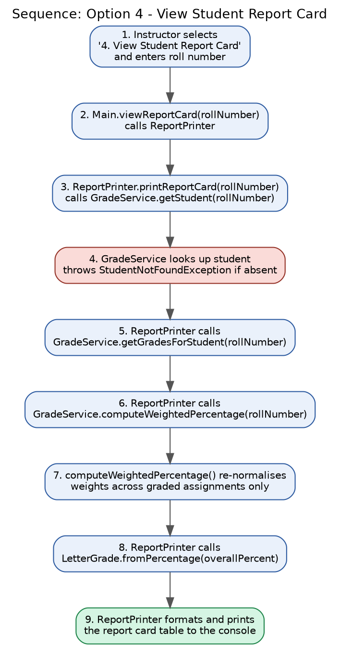
Fig. 7.4 — Sequence of calls for View Student Report Card.

6.5 Data / Storage Design
The system uses flat-file, pipe-delimited storage instead of a relational database, so no formal ER diagram applies; the equivalent storage schema is documented below as four independent record types, related by the student roll number and assignment name acting as natural keys.
File | Record Format | Key(s)
data/students.txt | rollNumber|name|section | rollNumber (unique)
data/assignments.txt | name|maxMarks|weightPercent | name (unique)
data/grades.txt | rollNumber|assignmentName|marksObtained | (rollNumber, assignmentName) composite
data/credentials.txt | username|password | username (unique)
Grade rows reference students.txt and assignments.txt by their natural keys rather than by a generated foreign key, which is sufficient for this scale and keeps the persistence layer free of any relational or ORM machinery.

7. Design Decisions & Rationale
- File consolidation with nested classes: Assignment, Grade, and LetterGrade are nested inside Student.java, and the five domain exceptions are nested inside GradeSystemException.java. This keeps closely related types physically together (seven files instead of fifteen) while each nested static class still compiles to its own .class file and can be imported normally (e.g. Student.Assignment) — readability is improved without sacrificing proper type separation.
- Checked exceptions over return codes: every failure mode (duplicate student, student/assignment not found, invalid grade, failed authentication) is a checked exception extending a single GradeSystemException base. This forces every call site to either handle or declare the failure, so an instructor's mistake — an over-maximum mark, a typo'd roll number — can never be silently ignored.
- Enum-driven grading logic: LetterGrade.fromPercentage() is the single place in the codebase that decides what percentage range maps to which letter grade, remark, and pass/fail status. Adding or adjusting a grade boundary means editing one enum, not hunting through if/else chains scattered across the UI or service layer.
- Renormalised weighted percentage: computeWeightedPercentage() divides the weighted sum by the weight actually used (i.e. only assignments the student has a recorded grade for), rather than assuming every defined assignment is always graded. This means a partially graded student receives a meaningful percentage instead of being penalised for work that has not yet been entered.
- Pipe-delimited flat files over CSV/JSON: chosen specifically because it needs no external parsing library — each model's fromFileFormat() method calls String.split("\\|", -1) and reconstructs the object directly, keeping the persistence layer dependency-free and easy to inspect by hand.
- Defensive EOF handling: readLine() checks Scanner.hasNextLine() before every read and returns null on end-of-stream instead of letting an unchecked NoSuchElementException propagate, so a scripted or automated test run that pipes a shorter input file than the menu expects still exits cleanly with a 'Goodbye.' message rather than a stack trace.

8. Implementation Details

8.1 Technology Stack
Component | Details
Language | Java 17 (compiled and tested on OpenJDK 21, source/target level 17)
Build Tools | Maven (pom.xml) as the primary build path; plain javac / java documented as a fallback
Interface | Command-line (CLI); a single numbered main menu with options 0–8
Persistence | Pipe-delimited flat files in a local data/ directory, created automatically on first run
External Dependencies | None — only the Java Standard Library (java.util, java.nio.file, java.io)

8.2 Grading Logic — LetterGrade enum
The grading rule lives entirely inside a nested enum, so there is exactly one place in the codebase that decides what percentage counts as an A, B, C, D, or F:
public enum LetterGrade {
A(90, 100, "Excellent"),
B(80, 89.999, "Good"),
C(70, 79.999, "Satisfactory"),
D(60, 69.999, "Passing"),
F(0, 59.999, "Fail");

private final double lowerBound;
private final double upperBound;
private final String remark;

public boolean isPassing() { return this != F; }

public static LetterGrade fromPercentage(double percentage) {
for (LetterGrade grade : values()) {
if (percentage >= grade.lowerBound && percentage <= grade.upperBound) {
return grade;
}
}
return percentage > 100 ? A : F;
}
}

8.3 Validated Grade Recording — GradeService
recordGrade() validates that both the student and the assignment already exist and that the marks fall within the assignment's maximum before accepting the entry, and only then persists the change:
public void recordGrade(String rollNumber, String assignmentName, double marks)
throws StudentNotFoundException, AssignmentNotFoundException, InvalidGradeException {
getStudent(rollNumber); // validates existence
Assignment assignment = getAssignment(assignmentName); // validates existence
if (marks < 0) {
throw new InvalidGradeException("Marks cannot be negative.");
}
if (marks > assignment.getMaxMarks()) {
throw new InvalidGradeException(String.format(
"Marks (%.2f) cannot exceed the maximum for '%s' (%.2f).",
marks, assignmentName, assignment.getMaxMarks()));
}
grades.removeIf(g -> g.getStudentRollNumber().equals(rollNumber)
&& g.getAssignmentName().equals(assignmentName));
grades.add(new Grade(rollNumber, assignmentName, marks));
persistGrades();
}

8.4 Weighted Percentage Computation
public double computeWeightedPercentage(String rollNumber) {
List<Grade> studentGrades = getGradesForStudent(rollNumber);
double weightedSum = 0;
double weightUsed = 0;
for (Grade g : studentGrades) {
Assignment a = assignments.get(g.getAssignmentName());
if (a == null) continue; // assignment may have been removed
double scorePercent = (g.getMarksObtained() / a.getMaxMarks()) * 100.0;
weightedSum += scorePercent * a.getWeightPercent();
weightUsed += a.getWeightPercent();
}
if (weightUsed == 0) return 0.0;
return weightedSum / weightUsed;
}

8.5 Persistence Layer — FileManager
FileManager is intentionally domain-agnostic: it only knows how to read and write lines of text inside a data/ directory that it creates on class load. Every service class hands it plain strings and never touches java.nio.file directly, which keeps the persistence mechanism swappable without touching business logic.
public List<String> readLines(String fileName) {
Path path = Paths.get(DATA_DIR, fileName);
List<String> lines = new ArrayList<>();
if (!Files.exists(path)) return lines;
try {
for (String line : Files.readAllLines(path)) {
if (!line.isBlank()) lines.add(line);
}
} catch (IOException e) {
System.err.println("Error reading " + fileName + ": " + e.getMessage());
}
return lines;
}

public void writeLines(String fileName, List<String> lines) {
Path path = Paths.get(DATA_DIR, fileName);
try {
Files.write(path, lines);
} catch (IOException e) {
System.err.println("Error writing " + fileName + ": " + e.getMessage());
}
}

8.6 Defensive Input Handling — Main.java
Because the menu loop reads from standard input, it must also handle the case where input ends abruptly — for example, when a script pipes a fixed set of lines rather than a human typing interactively:
private static String readLine() {
try {
if (!scanner.hasNextLine()) return null;
return scanner.nextLine();
} catch (NoSuchElementException | IllegalStateException e) {
return null;
}
}

9. Screenshots / Results
The application was compiled with javac and run directly with java (java -cp out com.gradesystem.Main), with a scripted sequence of lines piped into standard input so that every menu option, and several error paths, could be exercised and captured exactly as printed by the program.

9.1 Startup and Login

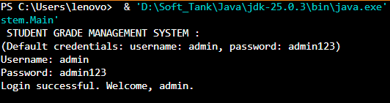

9.2 Adding a Student and Rejecting a Duplicate

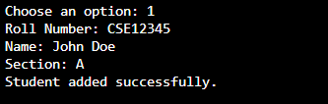

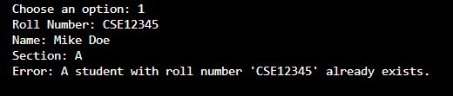

9.3 Recording Grades with Validation
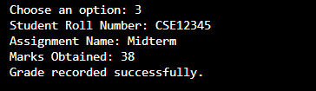
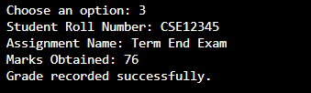

9.4 Report Card Output
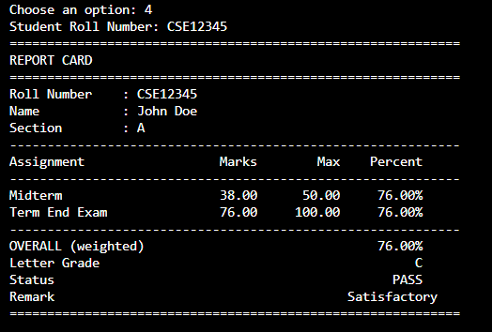

9.5 Class Summary Output

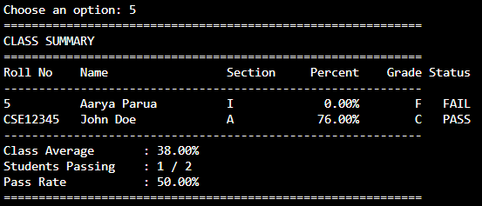

10. Testing Approach
The system was tested by piping fixed text files into standard input (java -cp out com.gradesystem.Main < run.txt), simulating a full instructor session non-interactively so the exact same scenario can be re-run and diffed after any code change. Three scripted scenarios were used:
- Happy-path run: login, add two students, add two assignments, record four grades (including one intentionally over-maximum), view a report card, view the class summary, list students, list assignments, remove a student, and exit.
- Error-path run: one failed login followed by a successful one, a duplicate student add, and lookups/grading/removal attempted against a roll number that does not exist (StudentNotFoundException).
- EOF run: input piped in ends mid-prompt, confirming the program exits with 'Goodbye.' rather than an unhandled NoSuchElementException.
All three scenarios produced the exact output reproduced in Section 10, with no unexpected stack traces and no partial writes to the data/ files — a rejected operation never reaches persistence, and a successful operation is always fully written before the next prompt is shown.

11. Challenges Faced
- Balancing file count against readability: the initial layout spread every model, exception, and enum into its own file (fifteen files total). This made navigation harder than necessary for a project of this size, so related types were consolidated into seven files using nested static classes without losing the benefit of separate compiled types.
- Weighted-percentage edge cases: computing a weighted percentage naively (dividing by 100 regardless of how many assignments were actually graded) unfairly penalised students who had not yet been graded on every assignment. This was resolved by renormalising the weighted sum against the weight actually used, so a partially graded student still gets an accurate in-progress percentage.
- Non-interactive testing of a Scanner-based CLI: piping a fixed script into standard input for repeatable testing initially caused a NoSuchElementException once the script's lines ran out, because Scanner.nextLine() throws when no more input is available. This was fixed by guarding every read with hasNextLine() and treating end-of-stream as a clean, expected exit condition rather than an error.
- Keeping the persistence layer dependency-free: early versions considered a simple CSV library for reading/writing records; ultimately a hand-rolled pipe-delimited format with String.split("\\|", -1) was used instead, since it satisfies the 'no external dependencies' constraint of the course while remaining trivial to parse correctly, including for fields that could otherwise be ambiguous with a plain comma delimiter.

12. Learnings & Key Takeaways
- Checked exceptions, used consistently across a service layer, make illegal states genuinely unrepresentable in the calling code — the compiler forces every failure path to be handled or explicitly propagated, rather than relying on convention or documentation.
- Embedding behaviour inside an enum (LetterGrade.fromPercentage(), isPassing()) keeps a business rule that changes together in one place, instead of duplicating a threshold check anywhere the rule is needed.
- A layered architecture pays off even in a small, single-developer CLI project: because ReportPrinter never touches file I/O and FileManager never touches domain objects, each layer could be tested and reasoned about independently.
- Designing for non-interactive, scripted testing from the start (rather than retrofitting it) surfaced the EOF-handling issue early and resulted in a more robust readLine() implementation than manual interactive testing alone would likely have caught.
- Consolidating related types with nested static classes is a genuine, underused middle ground between one-class-per-file and monolithic files — it improved this project's navigability without weakening encapsulation or type safety.

13. Future Enhancements
- Replace the flat-file persistence layer with an embedded relational database (e.g. SQLite via JDBC) to support concurrent access and more complex queries (e.g. per-assignment class averages) without loading the entire dataset into memory.
- Add password hashing (e.g. SHA-256 with a per-user salt) for the credentials file instead of storing instructor passwords in plain text, to better satisfy the security non-functional requirement in a production setting.
- Support multiple sections or courses within a single run, rather than a single flat student roster, by introducing a Course/Section aggregate above Student.
- Add CSV export of report cards and the class summary, so results can be opened directly in a spreadsheet application without re-parsing the flat data files.
- Introduce a lightweight unit-testing framework (JUnit 5) to complement the current scripted stdin testing, particularly for computeWeightedPercentage() and LetterGrade.fromPercentage(), which are pure functions well-suited to table-driven unit tests.

14. References
- Oracle. "The Java Tutorials." docs.oracle.com/javase/tutorial/ — used for java.nio.file, Scanner, and enum reference material.
- Oracle. "Java SE 17 API Specification." docs.oracle.com/en/java/javase/17/docs/api/ — used for java.util and java.io class references.
- Apache Maven Project. "Maven — Introduction to the POM." maven.apache.org/guides/introduction/introduction-to-the-pom.html — used for the pom.xml build configuration.
- Bloch, J. Effective Java (3rd Edition). Addison-Wesley — general guidance on exception design and enum usage applied throughout the service and model layers.

