My Liugong
Failed Part Management Flow

Entire Process Flow

Go to dealer page
Enter into Qa login
Switch the portal
Call Mangment towards failed part Management
Apply Retreive
Click into QA Update and Fill the all mandatory Details
Submit & close
Enter into a client login

Submit
Check The retrieve status
Go to QA Acknowedgment
Submit
Check the Recipet Update
View
Applied Filters
Enter into call Management towards faild part management
Switch portal
Click Action Toward Approve
Enter a comments & submit
Apply Retreive
Go to a Call anagement & towards Warrenty Claim
Switch the Portal
Check for Status
Enter Comment& Submit.
Go to a Call Management, and Towards Warranty Claim
Apply Filter/Retreive
Switch the portal
Enter into a Dealer loginlogin

Pre-requisites for opening the Portal.

- We have a Three kind of portal to undersatand the following.
- We need a Dealer login
- We need a Cilent login
- We need a QA Coordinator login, to undersatnd the following step.

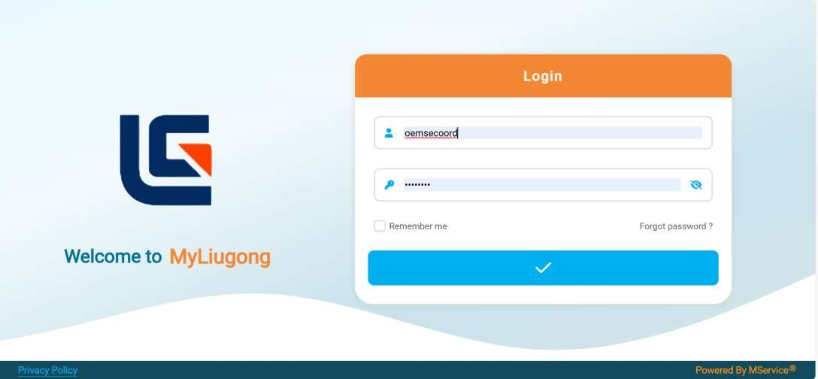

      - On Home Page Select Switch portal
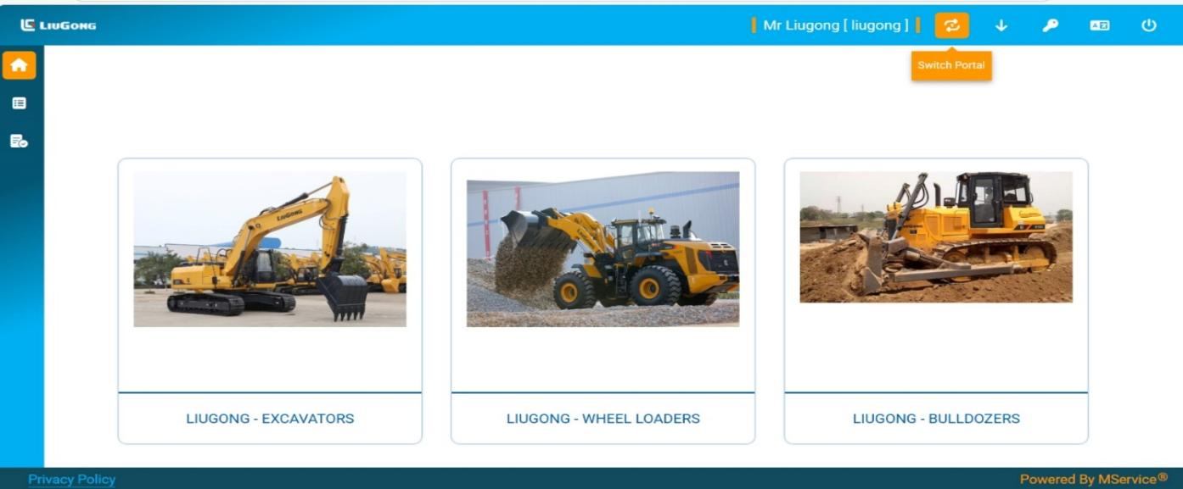

- The new Page should be Display.
- Click on Call Management.
- Click into warranty Claim.
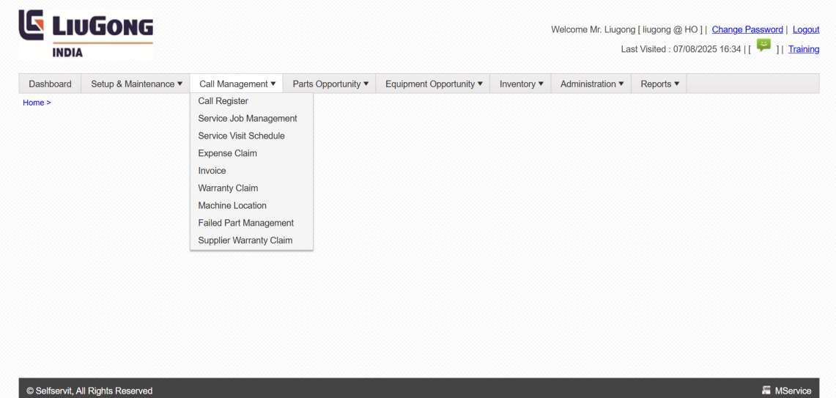

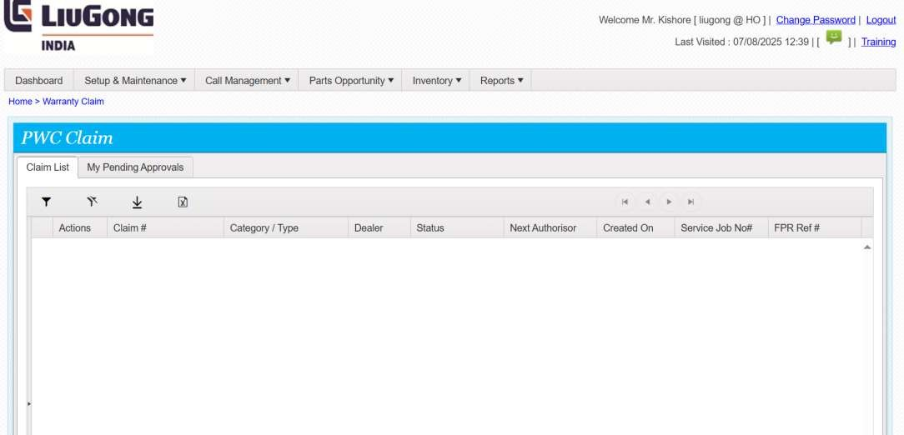

- A Form Will be open we need to Retrieve the My pending approvals
- Click the Download to Retrieve a data.
- Click the data which need to provide a Approve.
- Tap/Right click they show a options.
- In That we need to select a Approve

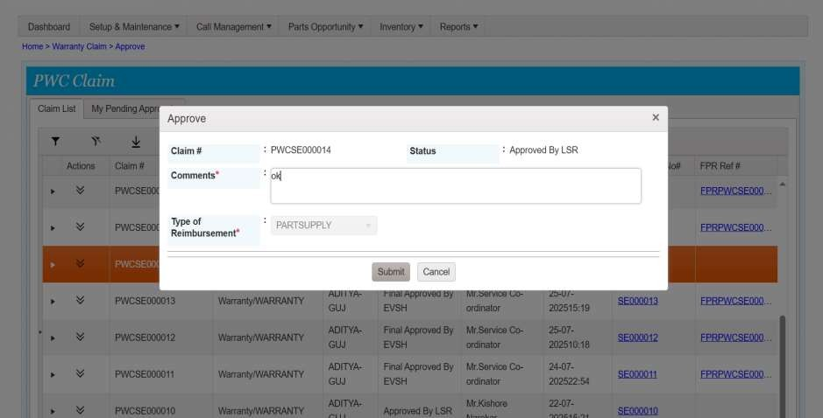

- After Click Approve, we need to fill the form
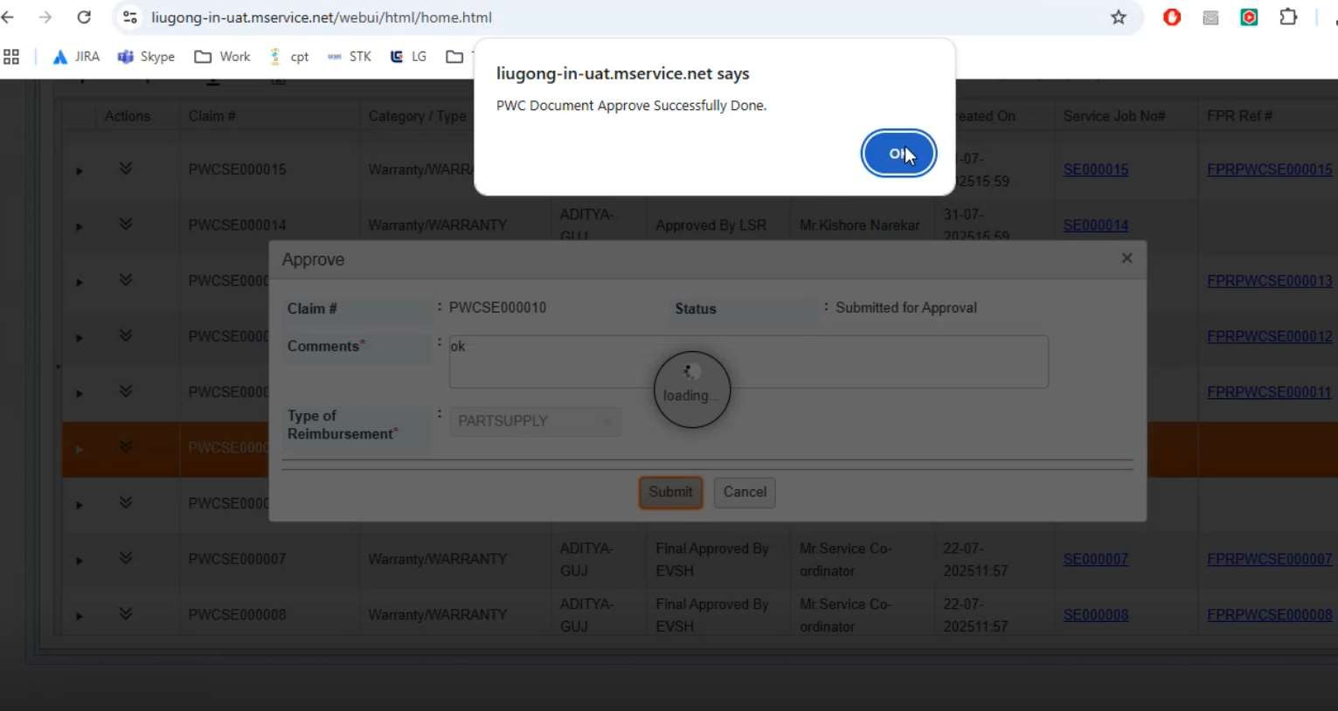
- Enter a comment, and submit it.

- After click into Submit , The page should be load.
- And the page Should be Pop-Up The notification.
- Click into a Ok Button.
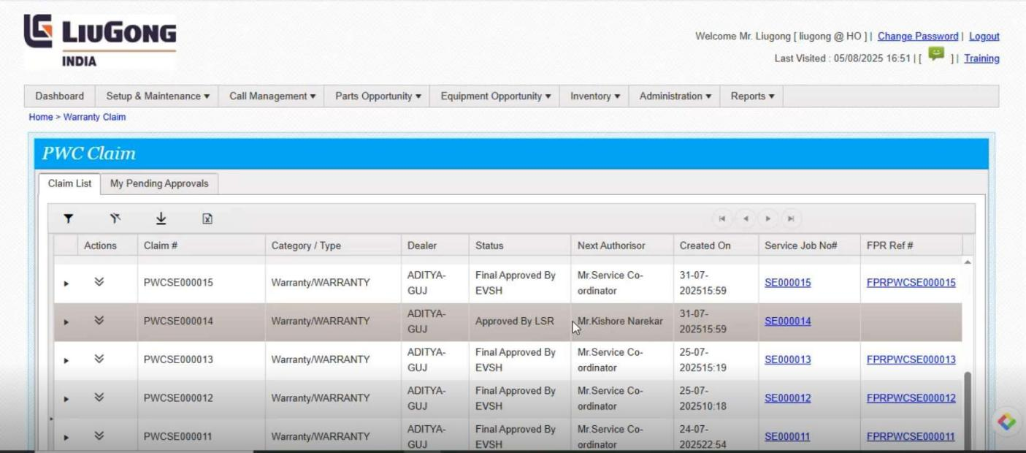

- After Click ok button in the pop-up, they return back to the My pending Approvals page.
- And we See, a Various status like Approved by LSR, Final Approved By EVSH.
- And it also mentioned a Author name.

We need to open a Client Site:

- We enter a valid UN and Password.
- Click into Submit

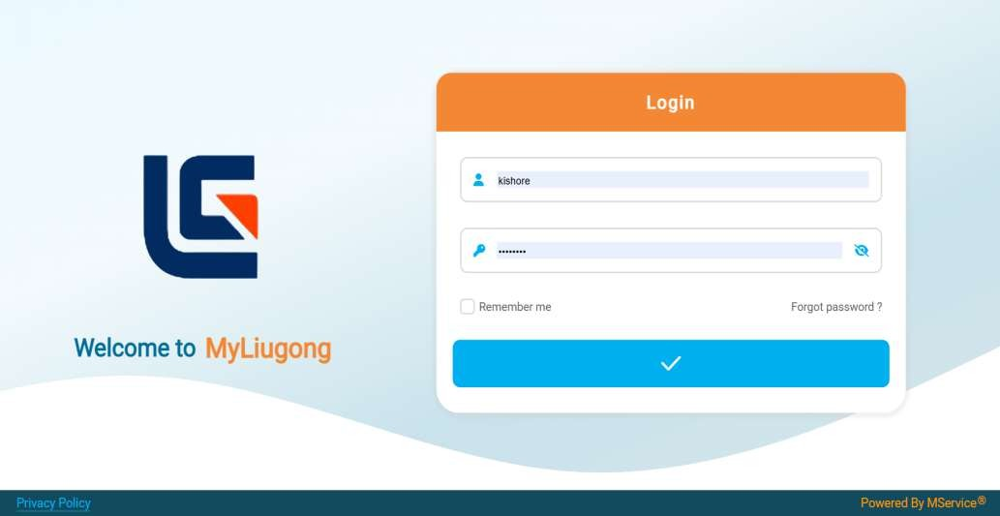

- After enter into a login, the page shows a Home page.
- We need to switch the page.

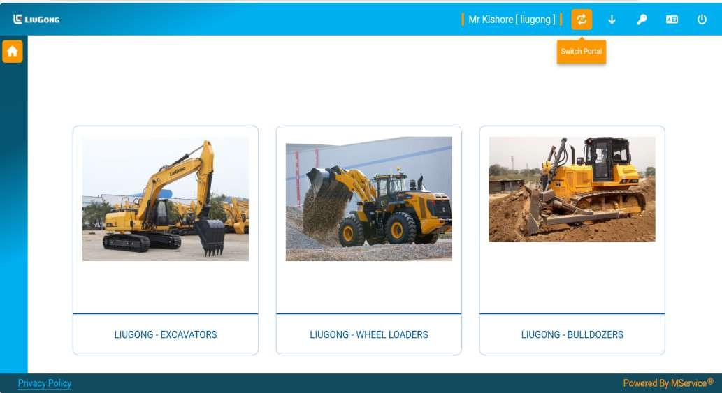

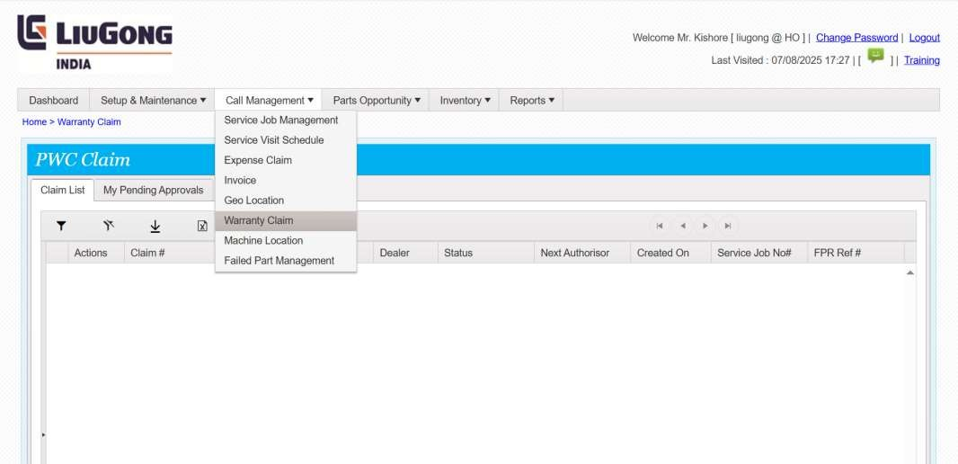

- After enter into a page, we need to Click on Call Management.
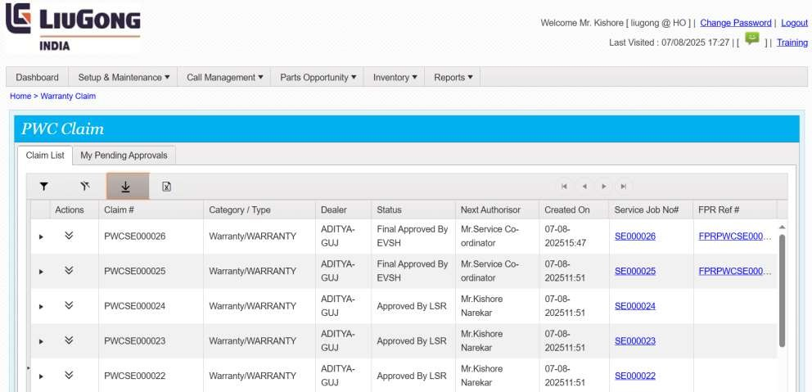
- After Click on Call Management, We Can Click on Warranty Claim.

- After click on Warranty Claim, We can Retrieve the data.
- To retrieve , we click into a Download Button.

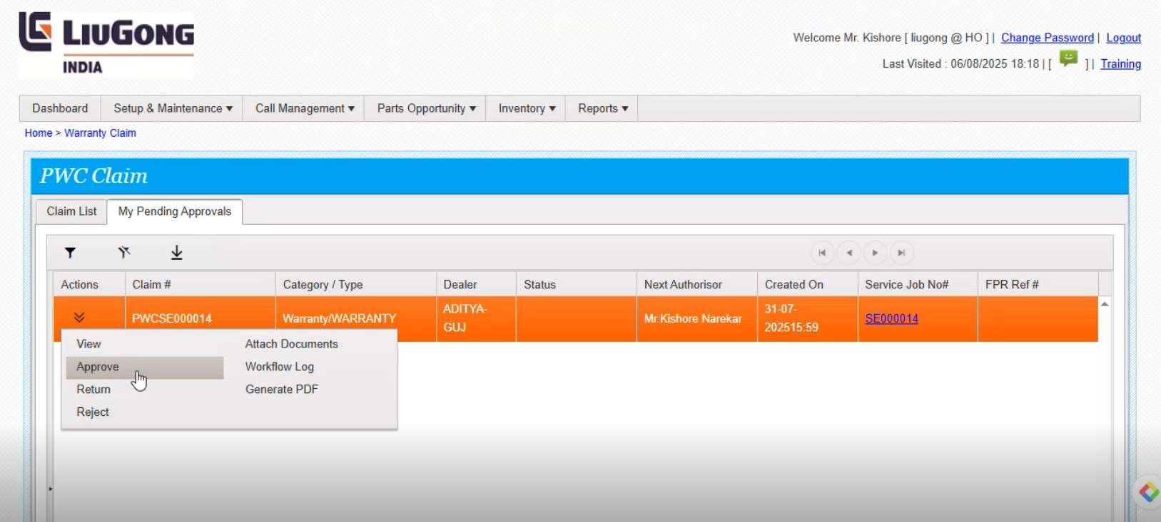

- After retrieve click on some particular task.
- Click on the Action, it shows a View, Approve, Return, Reject options.
- Click into Approve.

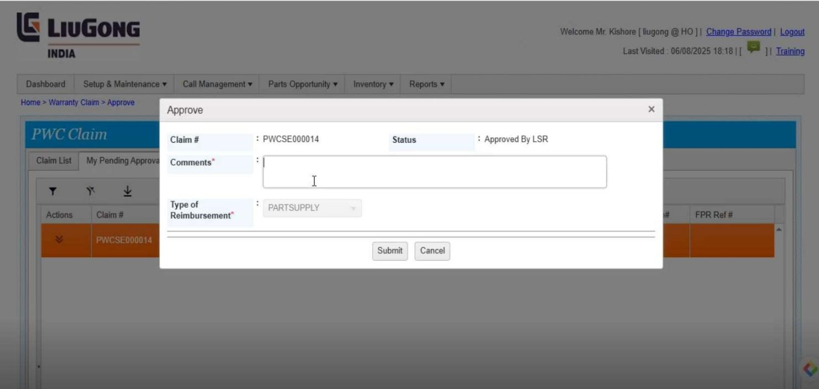

- After click into Approve, the page should be should be display.
- Enter a comments.
- And click on submit.



- After Click into Submit the page should be load.
- And it generate one pop-up message
- Click in on OK Button
- We need to Open a QA Coordinator login
- We enter a valid UN and Password.
- Click into Submit

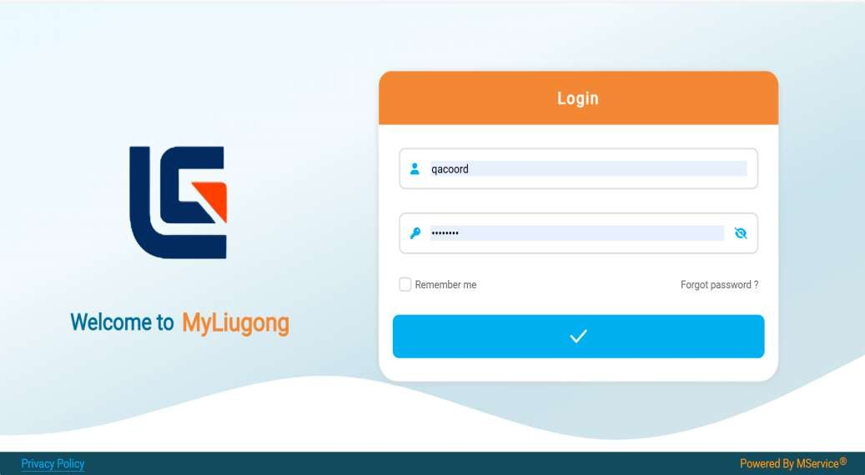
We Need to analysis a This process:

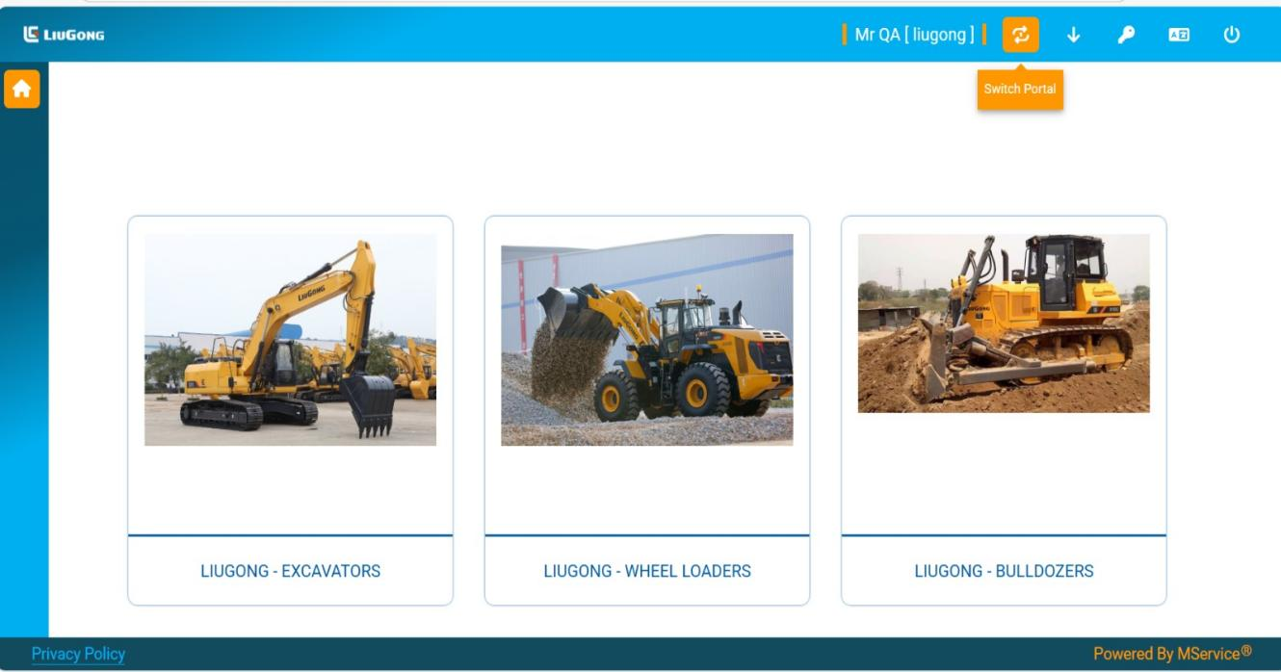

- After enter a site we need to Switch the portal
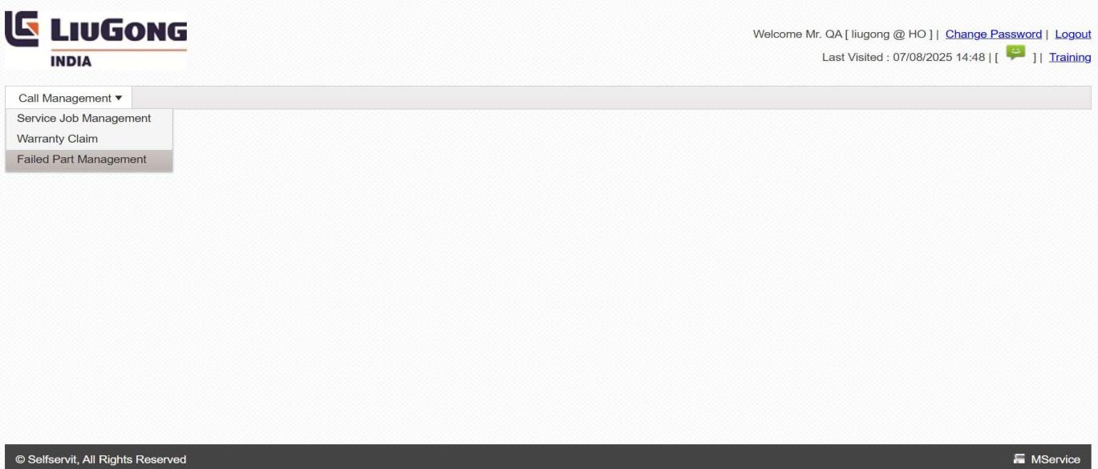

- Click on the call management.
- It Should be Show a Various Options, We need to click on Failed Part Mnagement.
- Enter into the Failed Part Management.
- Click into retrevie button.
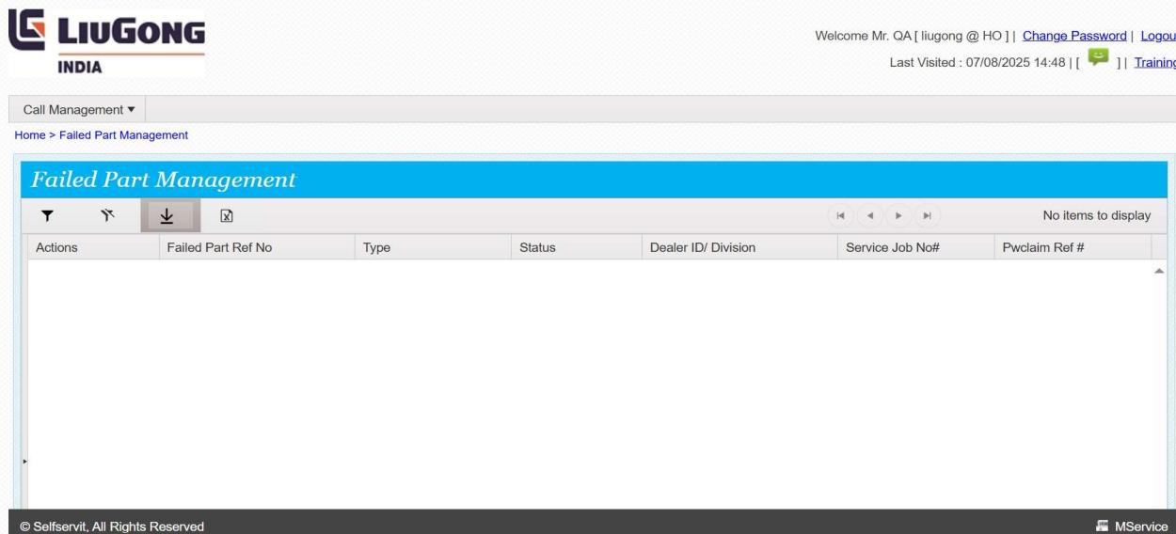

- After applied a Retrieve, This page should be display.
- In this page we need to select a pending Qa Acknowledgement tokens.
- And we need to click on actions, it shows a various option.
- Click into a Qa Update.
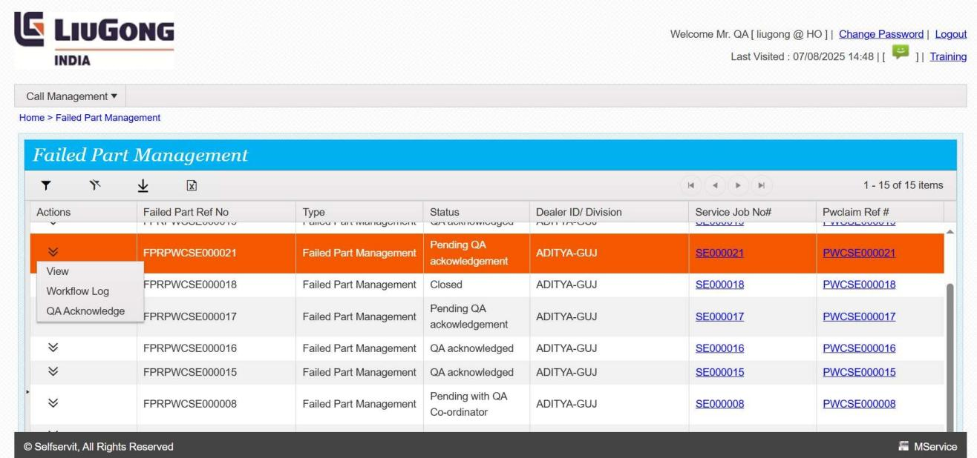

- After enter into a QA Update, we need to enter a failed type.
- A failed type shows a two options , scrap and Send to LIPL
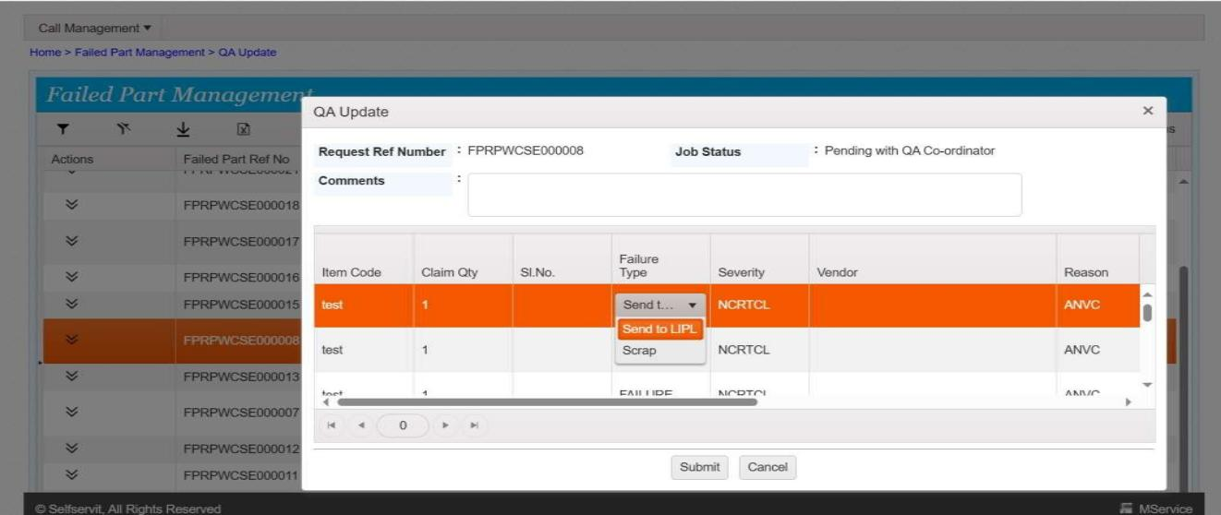
- After enter a Failed Type , go to Severity.
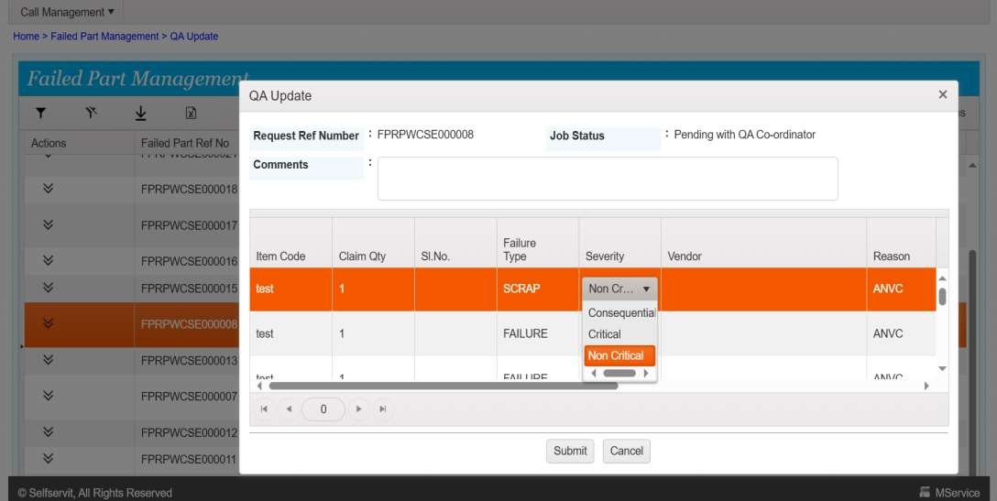
- In Severity we have a three Status like Critical, Non Critical,Consequential.

- This page Shows Critical Severity.

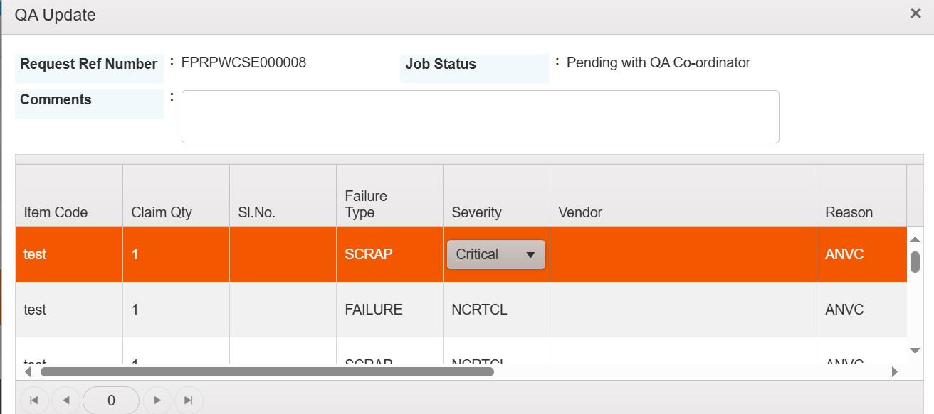

- And next we need to Filled a details of vendors.
- There are various vendors are there, like Ashok Leyland, Genius Engineering, like that we have a various options.
- Click on the option ,on the follow.
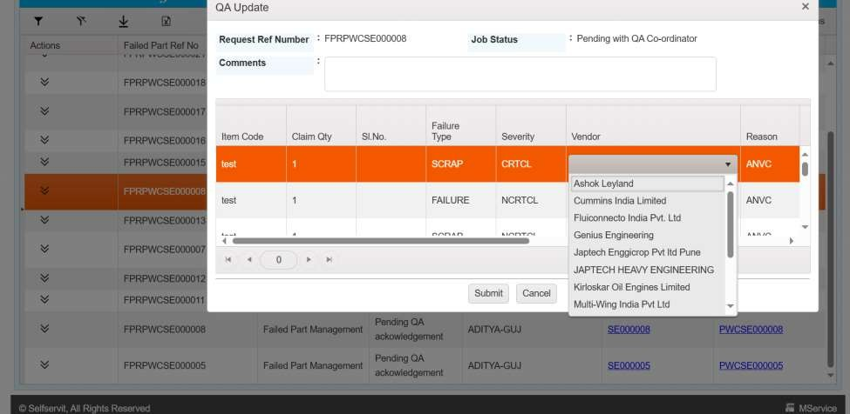
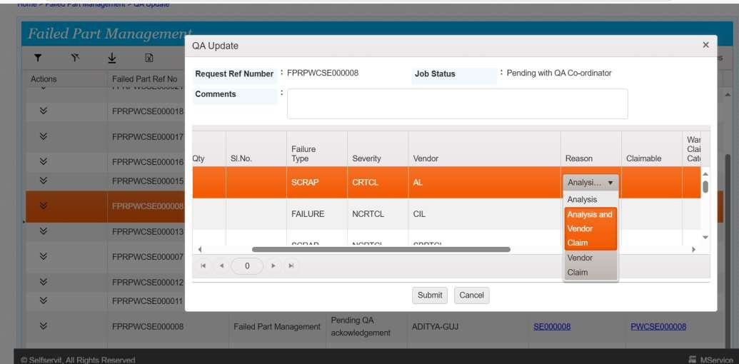

- After Click into a vendor, we go to fill the details of Reason.
- In the reason we have a three options , to select.
- There are Analysis, Analysis on vendor, Vendor Claim.

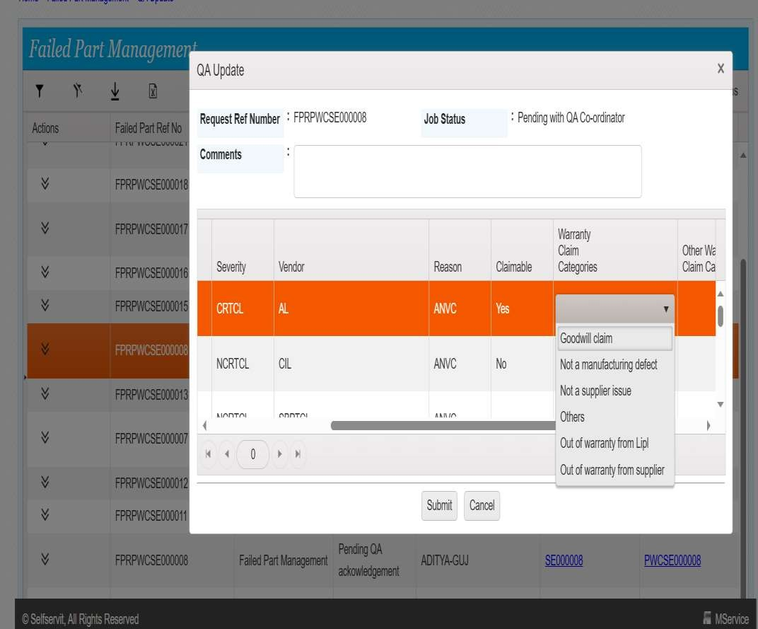

- Now enter to fill the next column as Warranty Claim Categories.
- In this warranty claim , we have a six option ,like Goodwill claim, Not a Supplier issues and also we have other options.

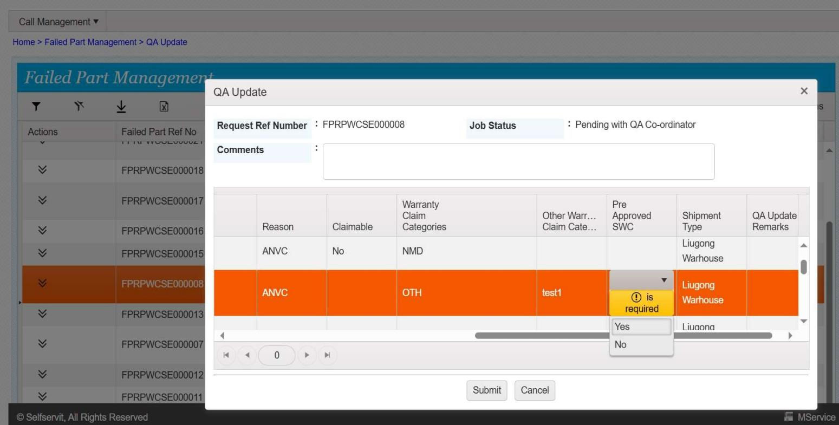

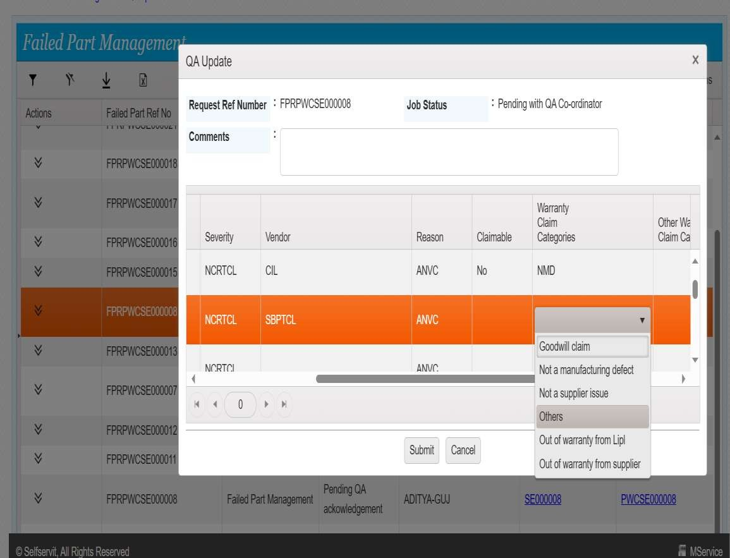
- If we selected a Other option.

- If the Other option is enable, we need to write a commands.
- Enter the Comments in Other Warranty claim Category.
- Ex : I filled test1.

- Enter into a next column pre-approved SWC
- In this we need to required a yes/no can be filled.

- And go to Qa Update Remarks, and enter a Comment on the field.
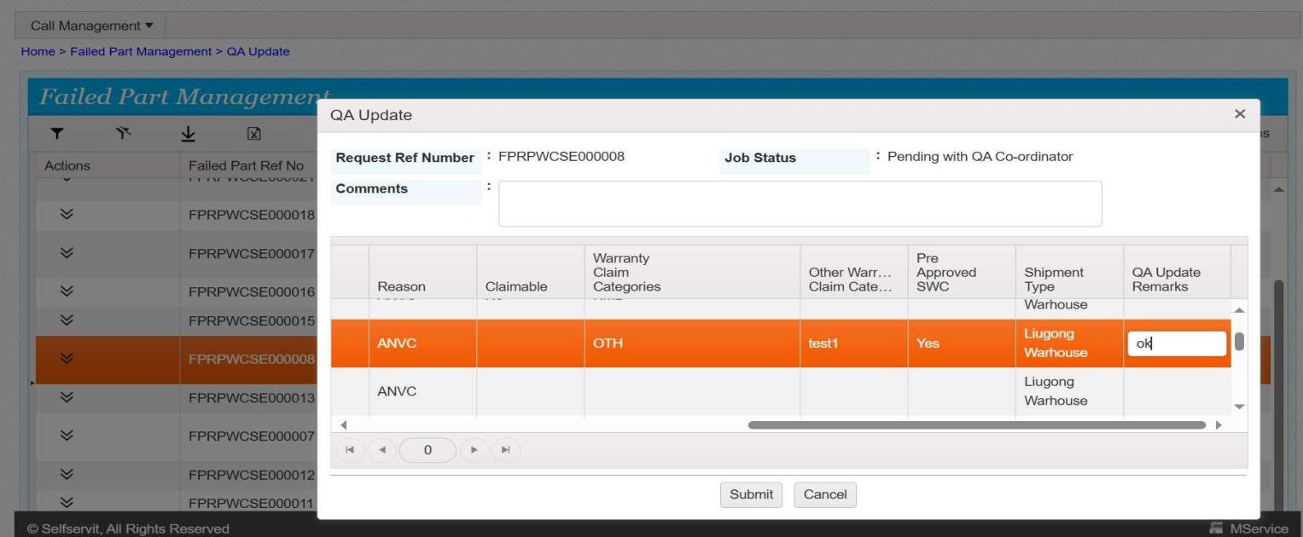

- After enter a QA remarks, Click into Submit.
- After click on submit, the page should be load, and it generated one pop-up message
- And click into OK button.

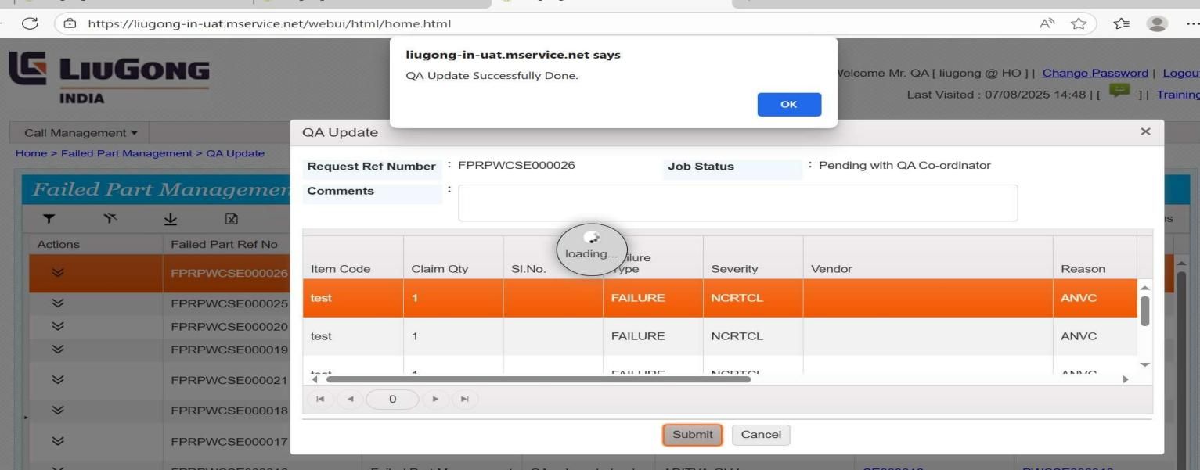

- After click on Submit , the page will be show like this.
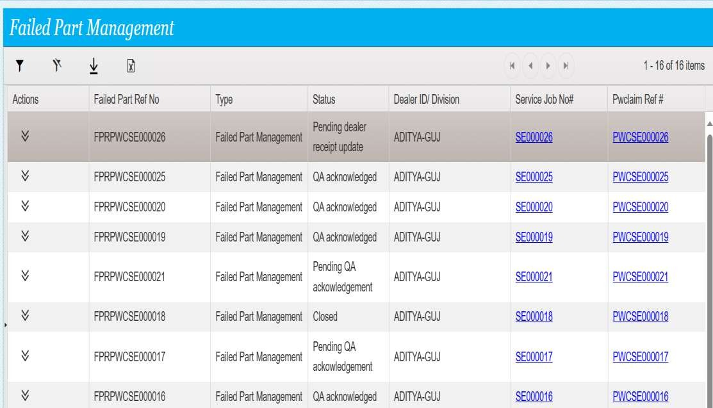
- In this the status will be change a pending dealer receipt update

After the process, and now we come to Dealer page

- In the dealer page directly we log in.
- With th dealer un and password


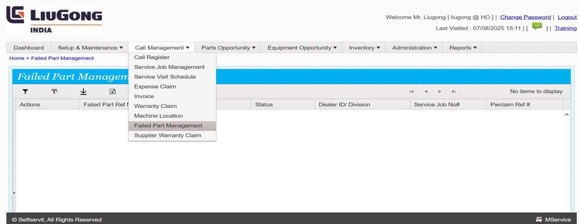
- And switch the page into a next version.
- And go to call Management, in that click into a Failed part Managememt.

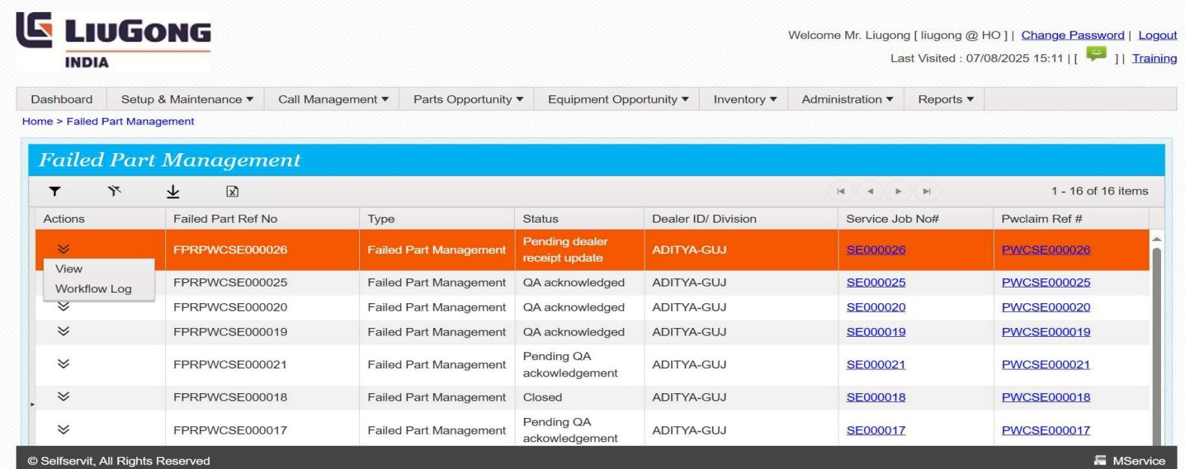
- Now Retrieve the data.
- And click on to a pending dealer receipt update, in that go to a Actions and click on view.

- The view page should be display.
- And they show a all details about the failed part details.
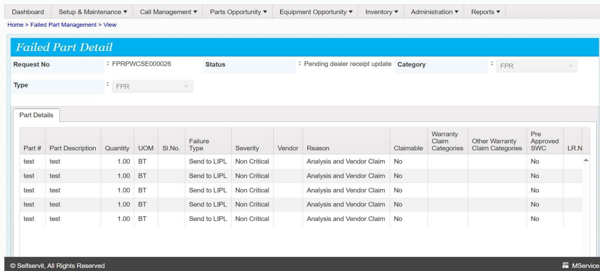

- And close the page, and again click into Receipt Update.
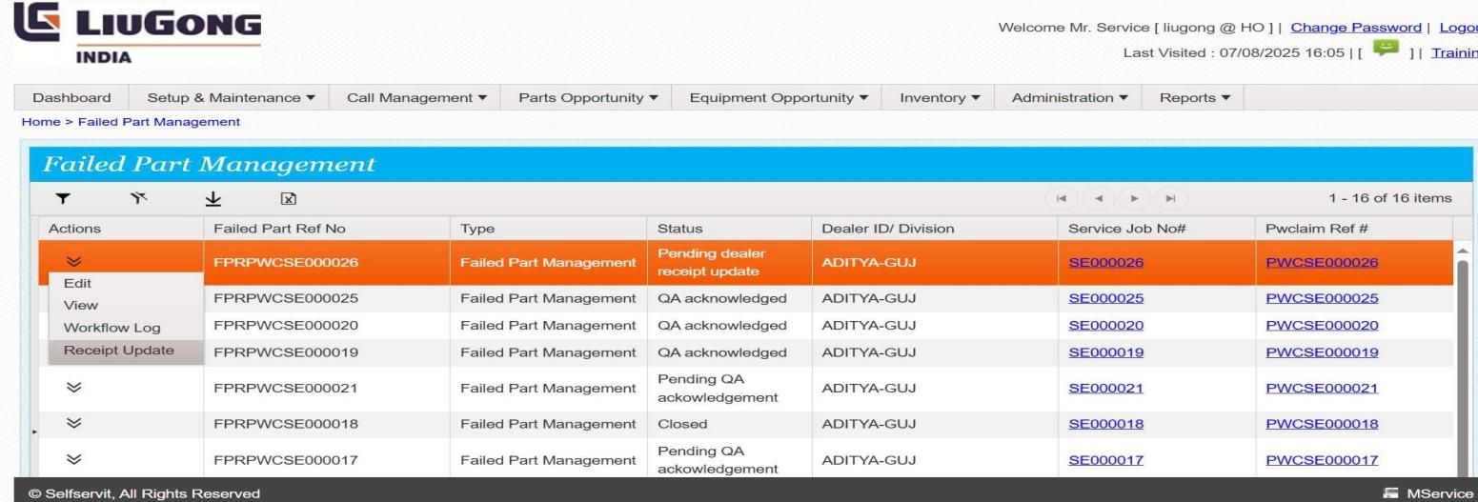

- The Receipt Update page should be displayed.
- In that we enter a SI.no. it must be uniqe.
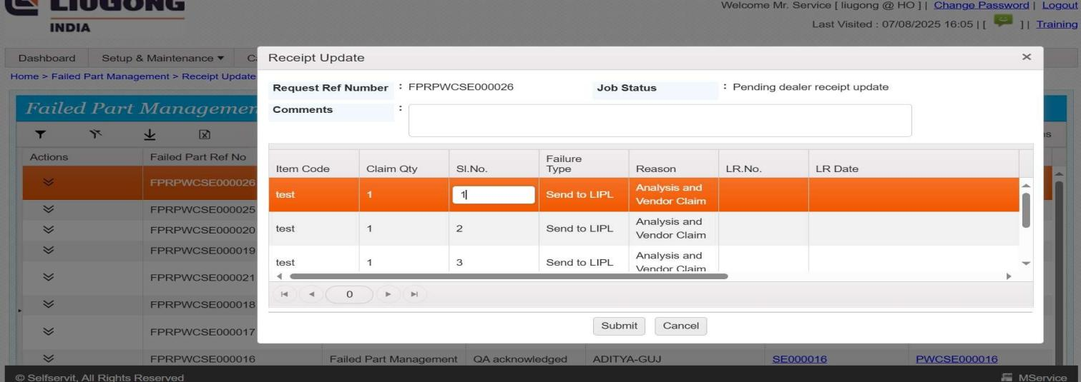

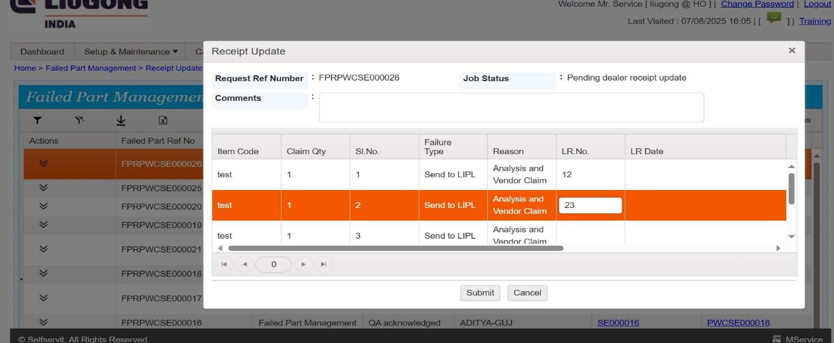
- Ang now fill the LR No , it is like a Transport no. and fill it.
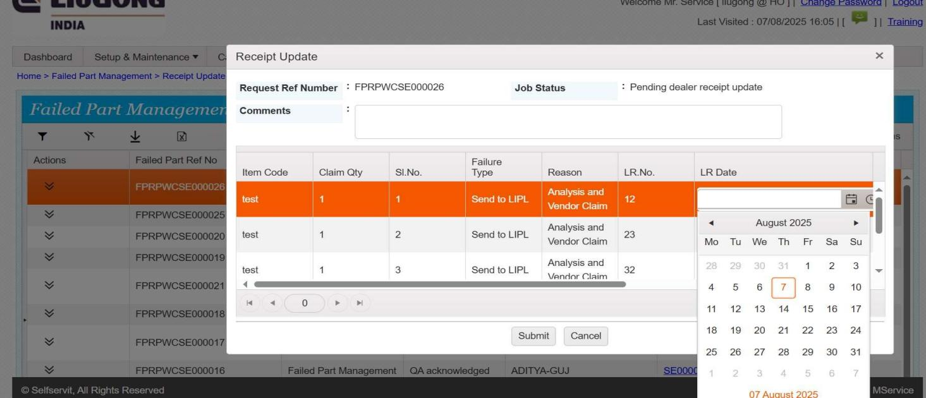
- In the page we enter LR date, by using calnder.
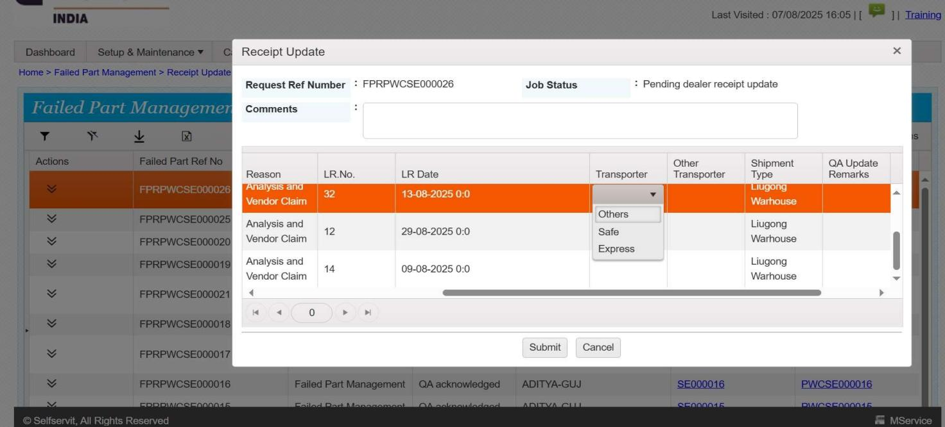
- And, go to Transporter, and it display a two options , like Sale and Express.

- And also we have a other options, if we click ono thers we need to fill the comments.
- Enter a comments in a other Transpotal

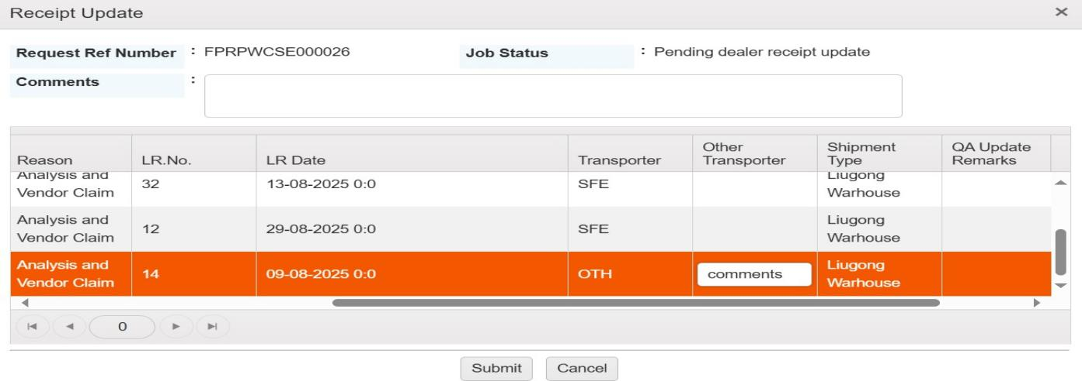
- And now fill the QA Update Remarks.
- And flowed by fill the Receipt Update Remarks.
- And click on submit.
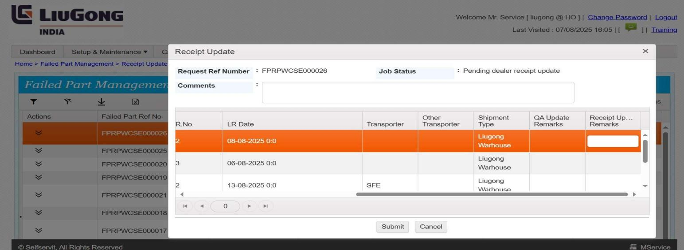

- After submit this page should be display.
- In this page we need to select a QA pending , status record.
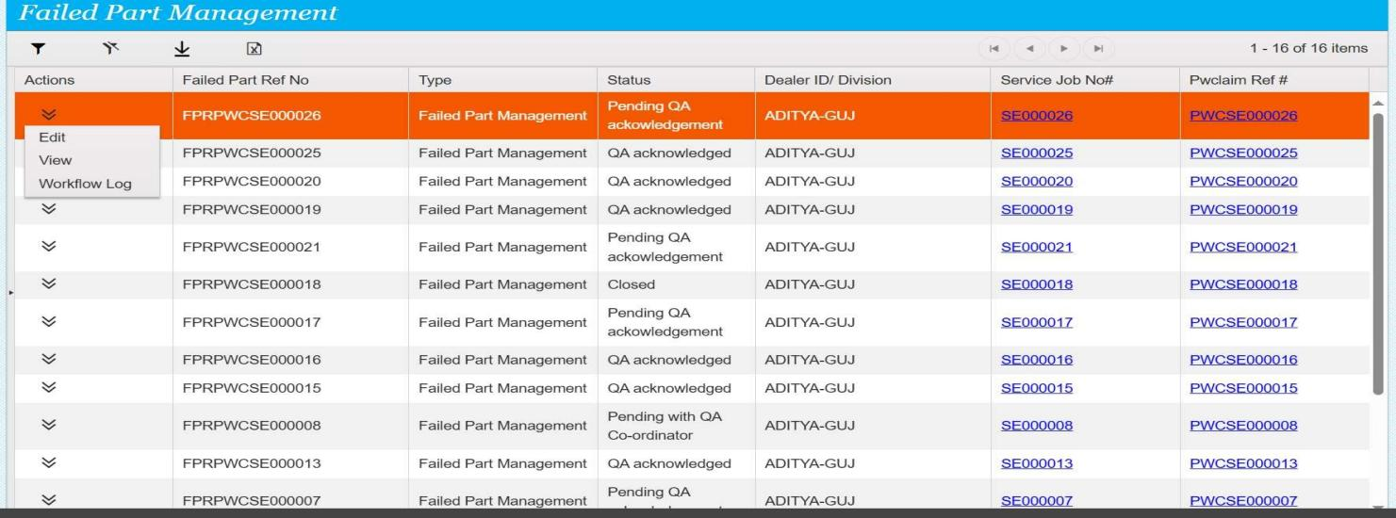
- Click into the Actions, and go with

- Check the all status once , and verified it.
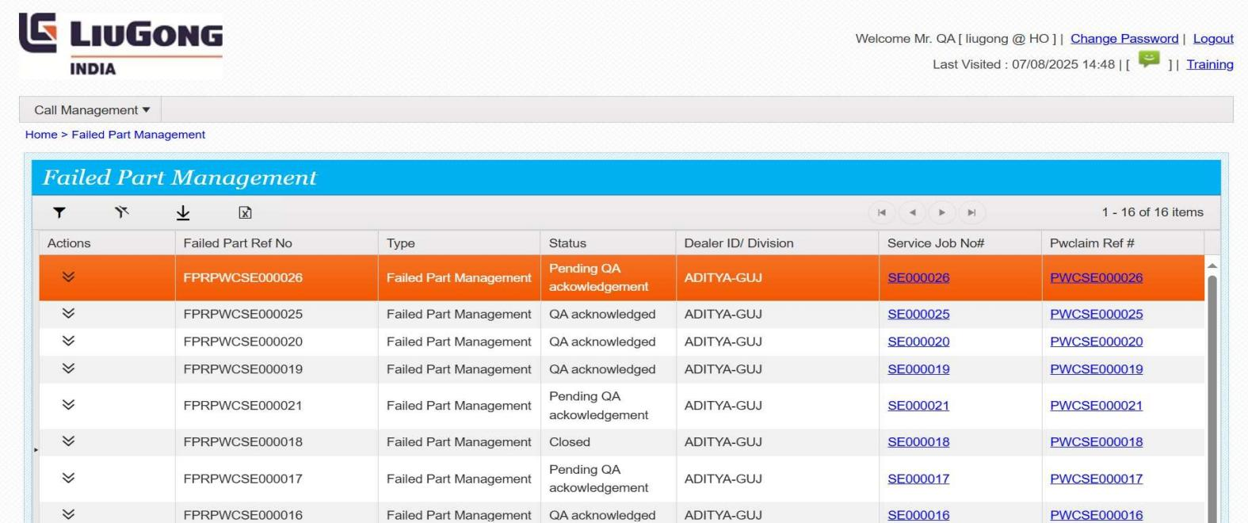

- And go to QA Acknowledge page, in Failed part Manaagement.
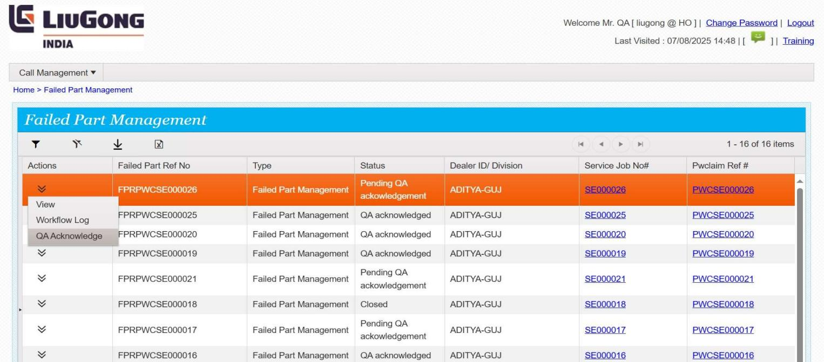

- In that page, we need to go and chick a status.
- A status have various, flows like received, in correct condition, in damage condition.
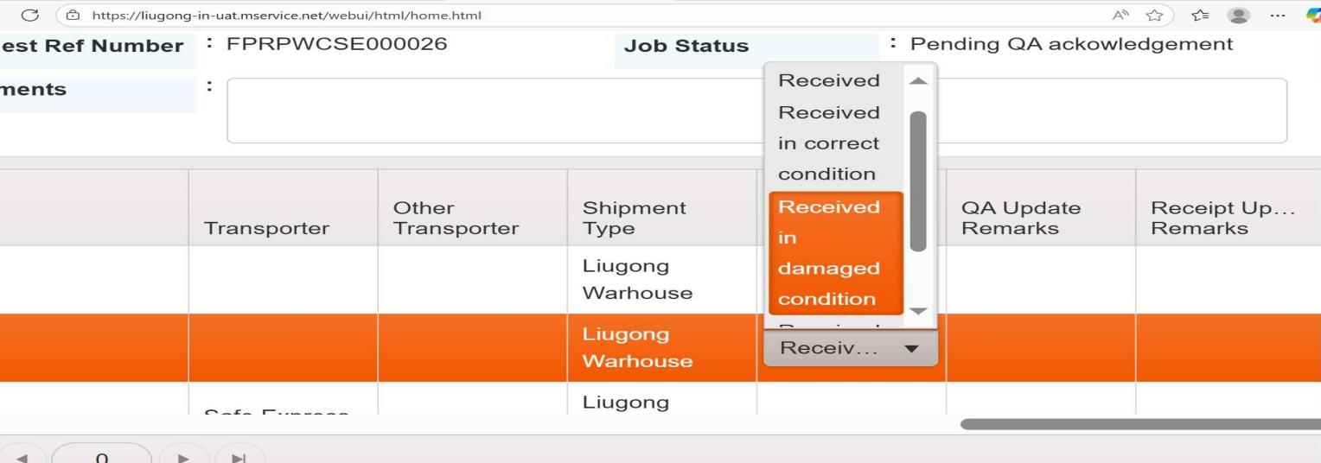
- Click prefferd one.

- Click into a submit button , the page should be load and it will generate one pop-up notification
- And click on OK button.

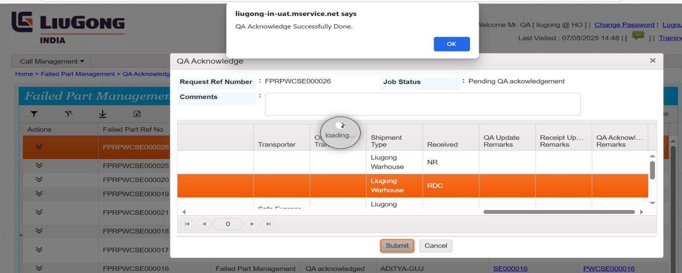

- After submit the page should be back to failed part Management.
- In that the status as change as QA acknowledged.
- And we have one status like Closed
- Click on to the Action , and go to view
- Click on to view button.

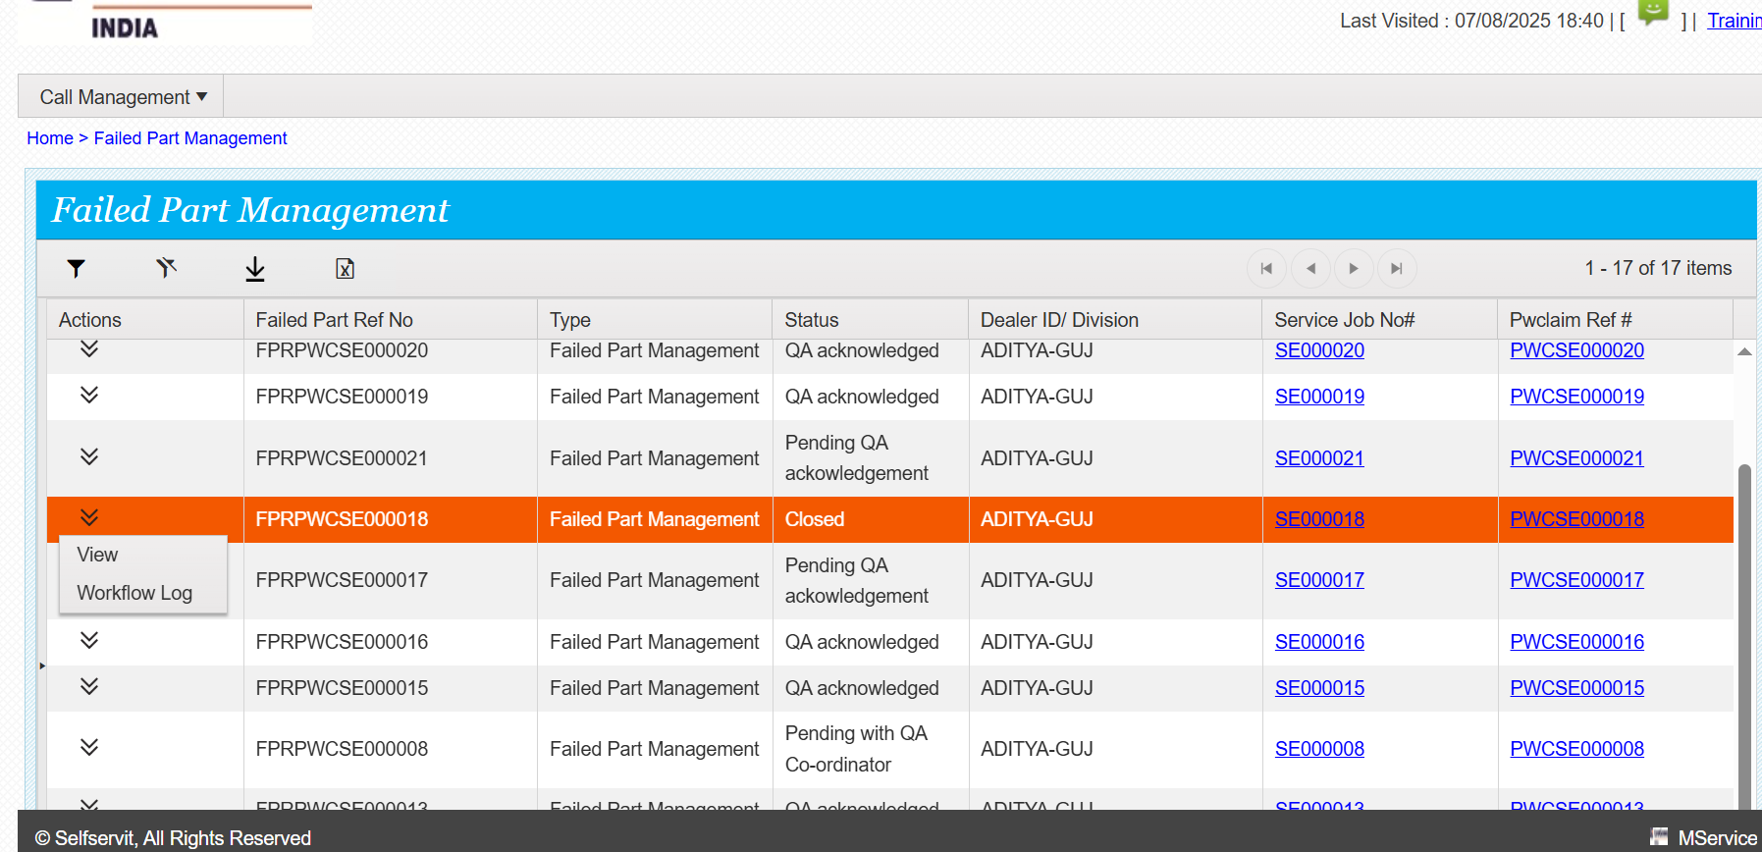

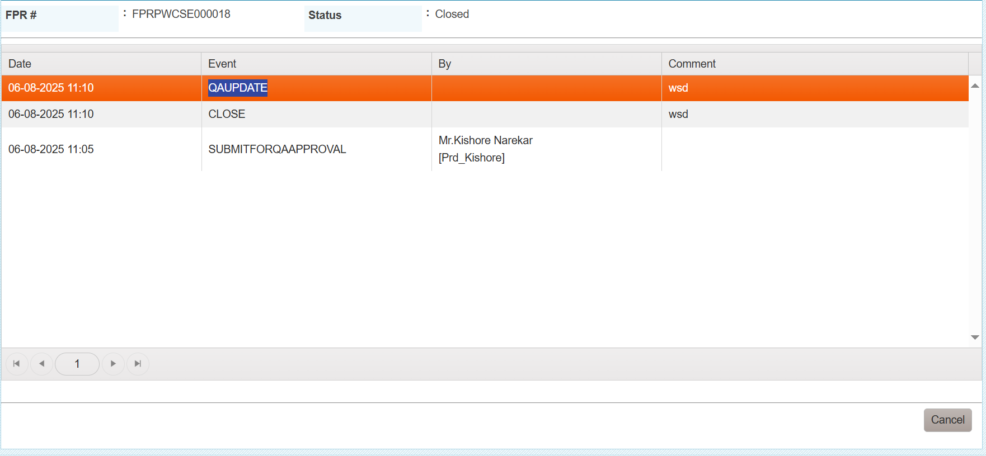
- The view page should be display like this.
- Cilck the Actions, and again enter into a Workflow log page



- Workflow log page should be display
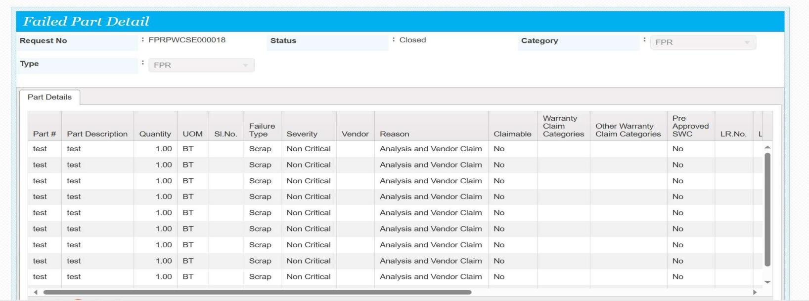
- And close the page

THANK YOU!…

