Proposal

Store Management System

Abstract:
The store management system software is a software designed for the retailer to manage their stock and inventory. Manually storing stock information in pen and paper is very difficult and takes a lot of time. This software makes that job easier. It stores all the stock information in a file and can be easily updated by the employee. Store manager can easily check the stock, manage it accordingly and update it if any changes has occurred. It is easy to use console based system. It also keeps the logs of any chances made in the software.

Objective:
Its primary purpose is to make the stock management easier and bring profit to the store. It will keep track of the stocks which will make it easier for the employee to add or remove accordingly. It will also maintain a log of every sales made in the store. It also keeps the log of any changes made by the user in the software. Finally, it will be console based software, so it is user friendly and easy to use.

Tools:

- Programming Language: This software will be built entirely using Java and its concepts like OOPs and File Handling concept.

- Integrated Development Environment (IDE) : It will be built in Intellij IDEA with jdk 1.8.

- Database: The project output will be stored in text file in proper order for user to view the stocks, logs and balance.

- Version Control: Git will be used for keeping track of changes.

- Storage: It will be stored in GitHub to make it easily available and update easily.

- Documentation: A detailed documentation of the project will be created to make it easy for the user to interact with the software.

Introduction

Store management software is a console-based software build to manage the inventory of a store. Store has collection of many items which is very difficult to manage. Every stores nowadays store their data digitally for their ease. Using a simple yet useful software like this it will be a lot easy for employee to track down the items. When there is a lot of items, remembering every item’s quantity in stock and their prices can be difficult. This software is user-friendly and it will help employee to track items from their inventory.

Features and Functionality:

This software stores the name of product, total quantity in stock, their price and the date it got added or updated.

1. Add new items: We can easily add a new item to the list of items with its name, price, quantity and date.

2. Update an item: We can update the price or quantity of item, if it changes due to price change in market or expiration of product.

3. Buy an item: We can buy item from other vendors or manufacturer if we run out of stock. It will increase the quantity of item in the list.

4. Sell an item: Whenever we sell any item to the customer, it will decrease the total quantity from the inventory.

5. View items: It will display all the items in the inventory.

6. Remove an item: It will remove an item from the inventory.

7. All the item’s information are stored in proper format in a file using file handling.

8. All the changes made in the software are updated in a log file separately.
Implementation Detail:

In this software, I have implemented basic concepts of java programming language. I used four principles of OOP ie. Inheritance, Polymorphism, Abstraction and Encapsulation. I used collection library to work with list of items and manipulate those data. I have also used some other concepts like File handling and exception handling.

Main file :
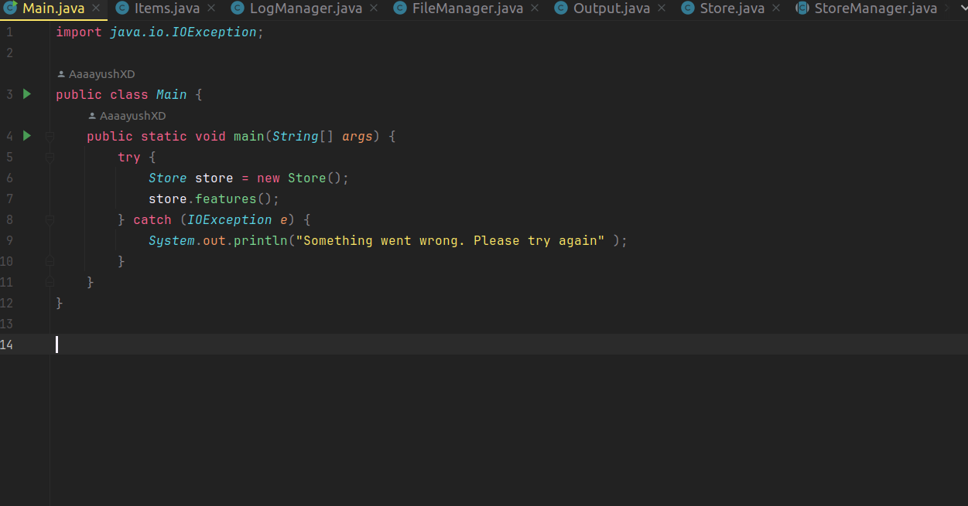

Items class file

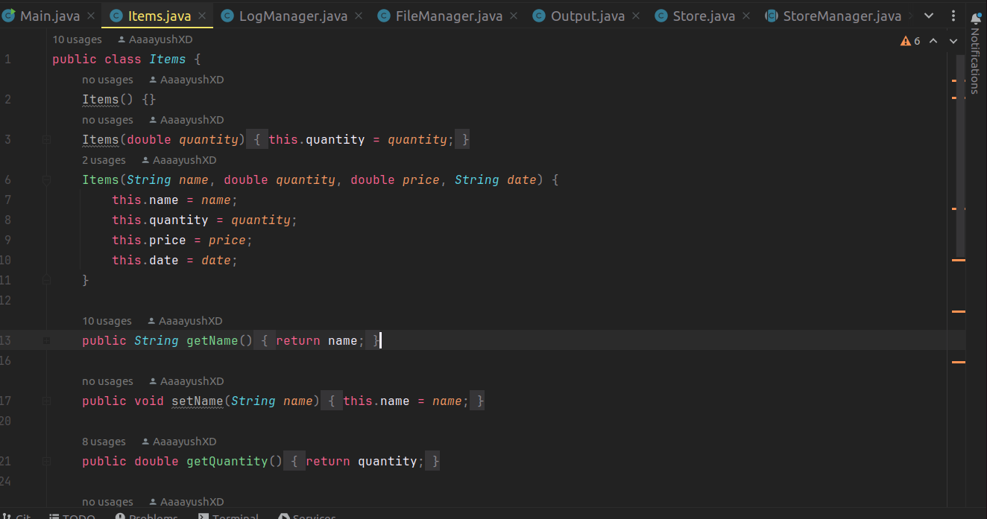
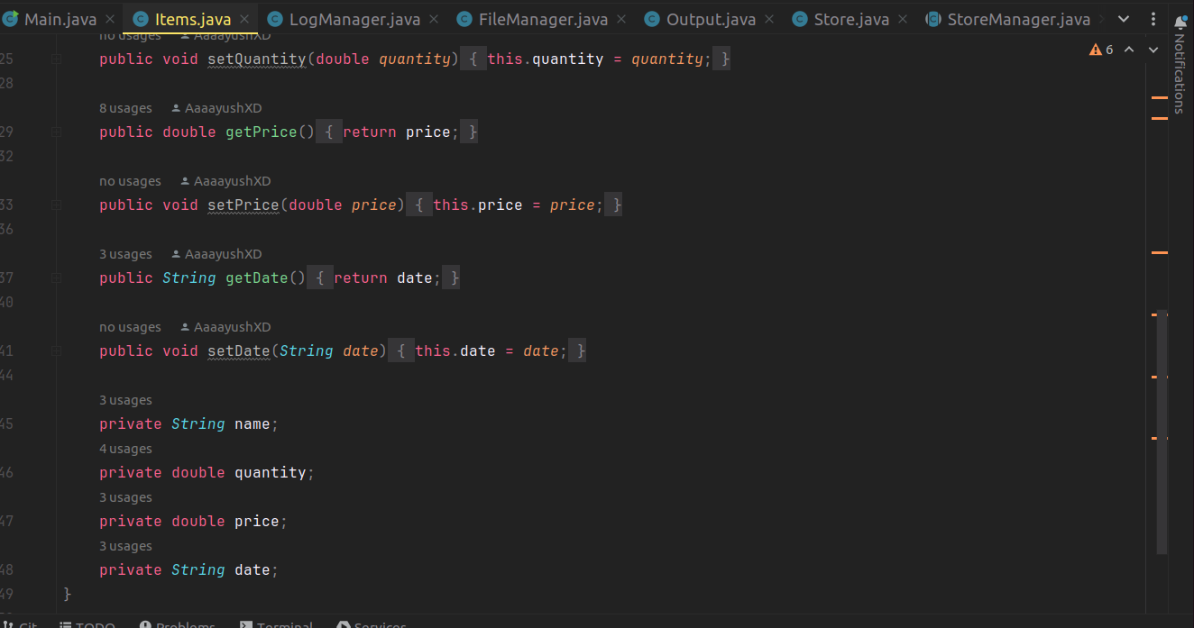

Store Manager Class

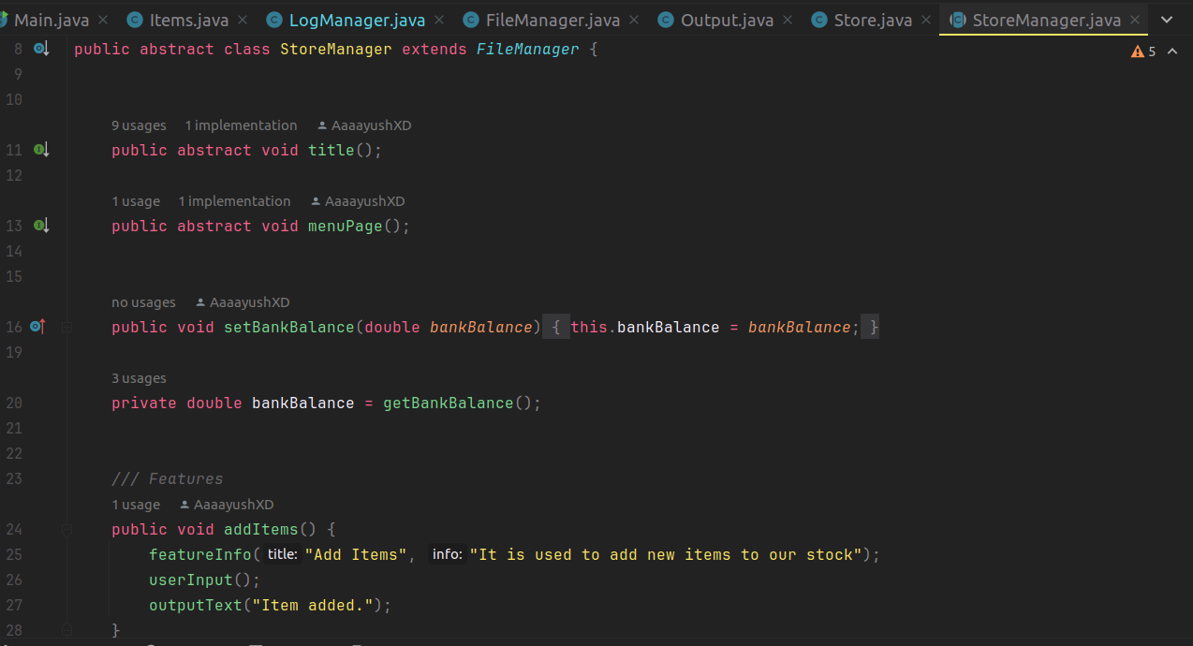

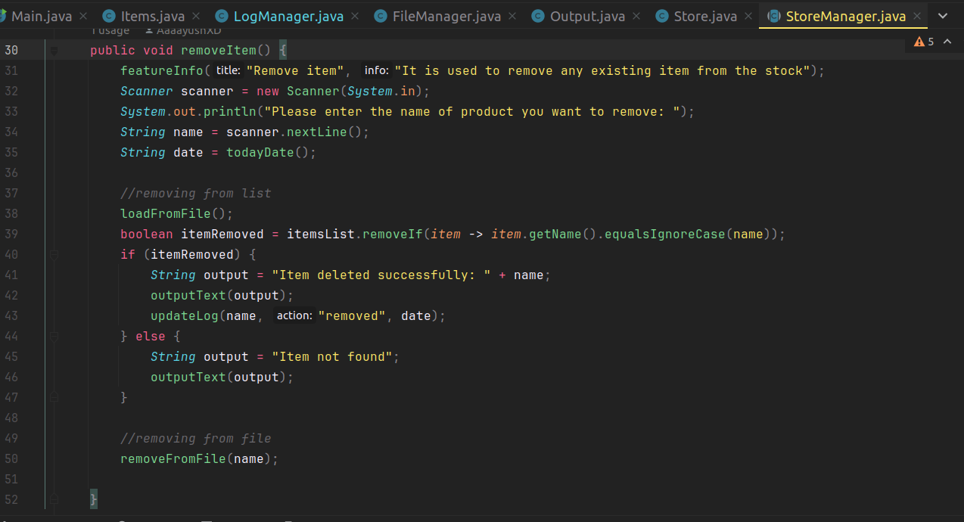

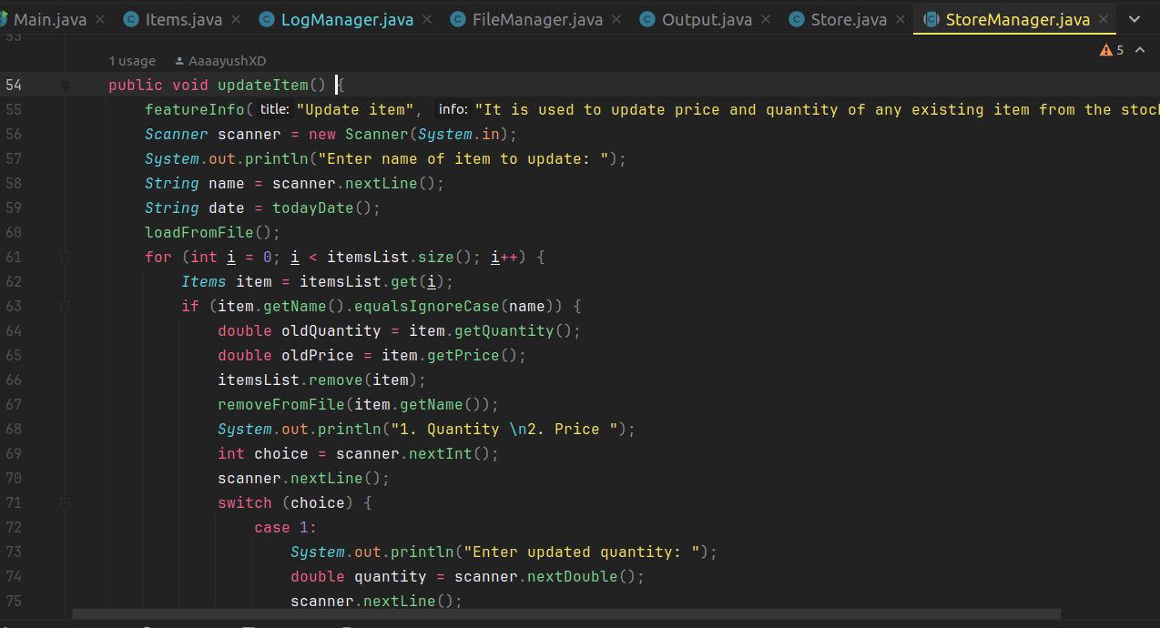
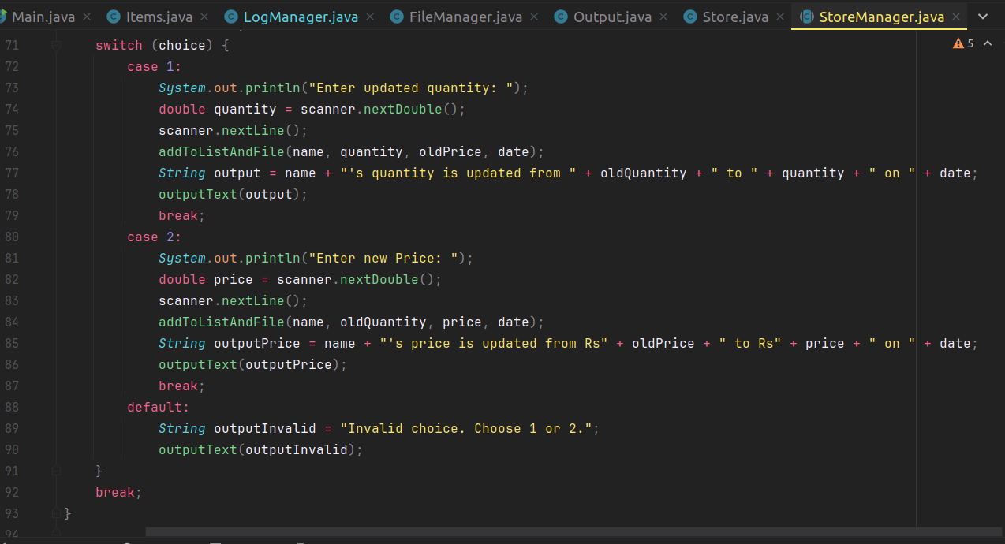

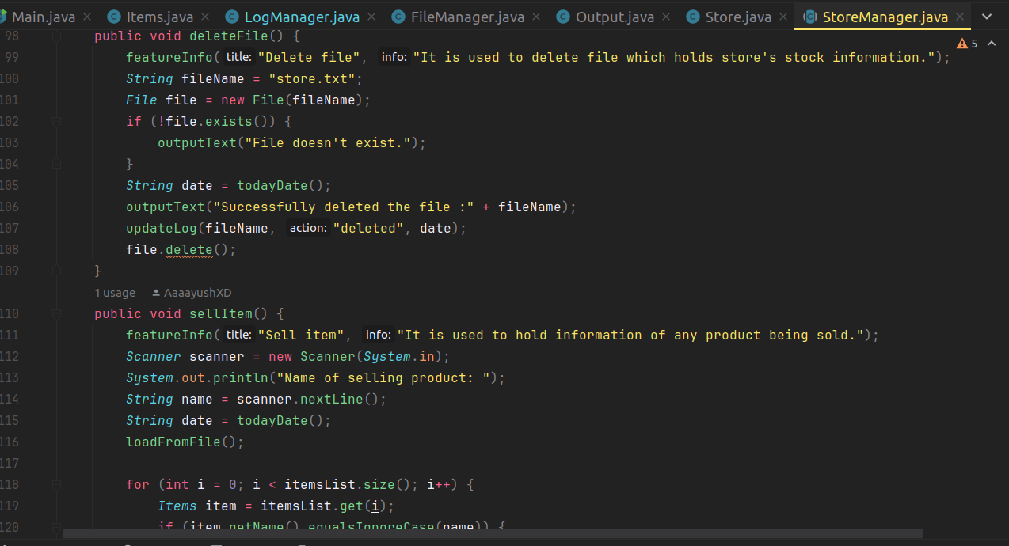
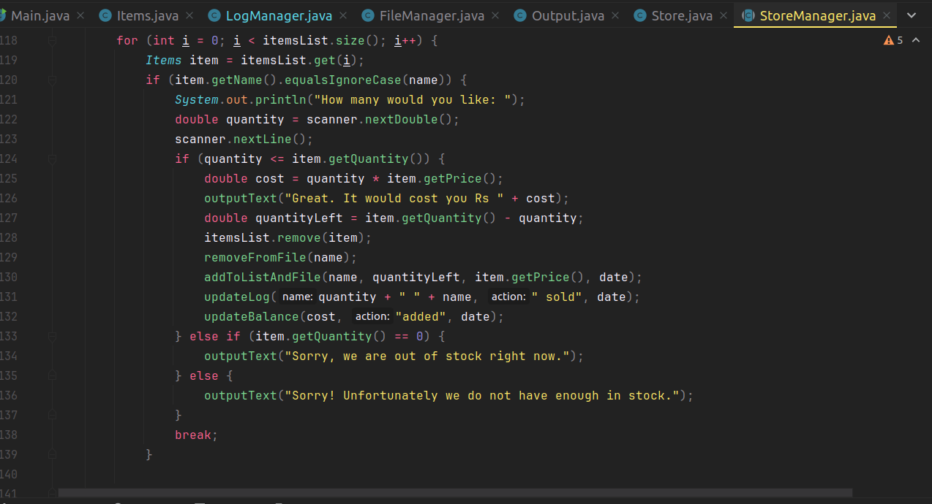

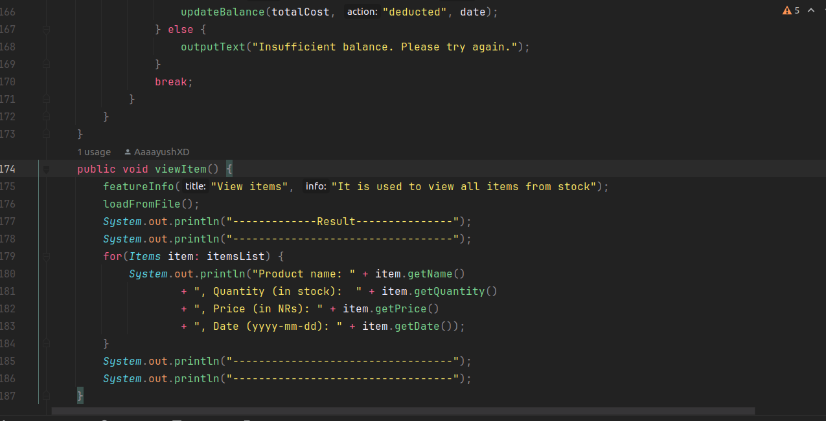
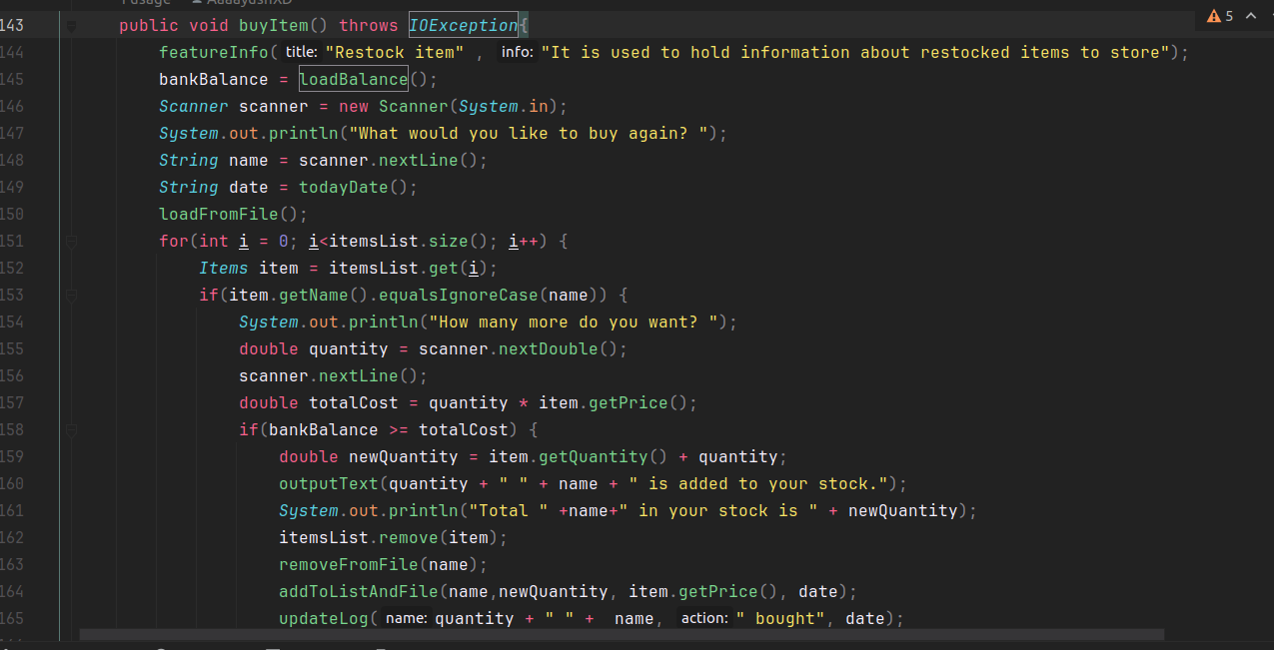
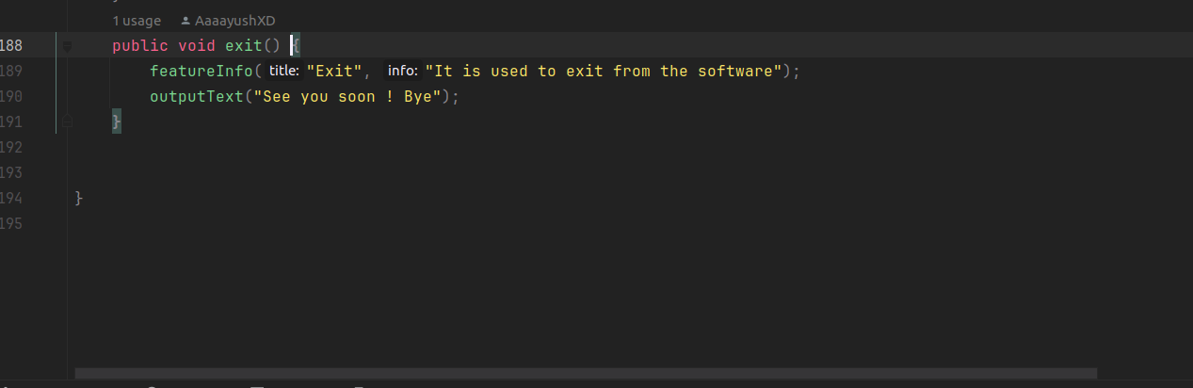

Store class

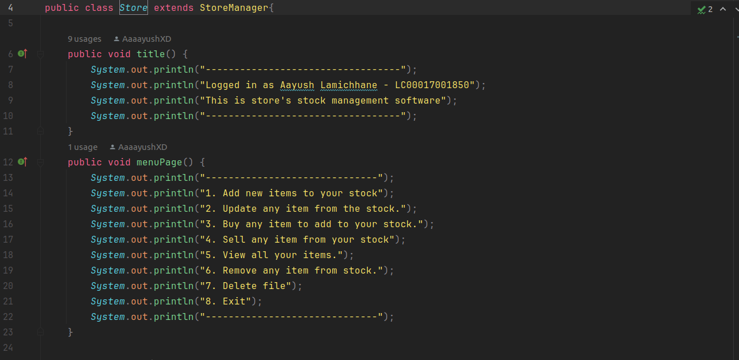

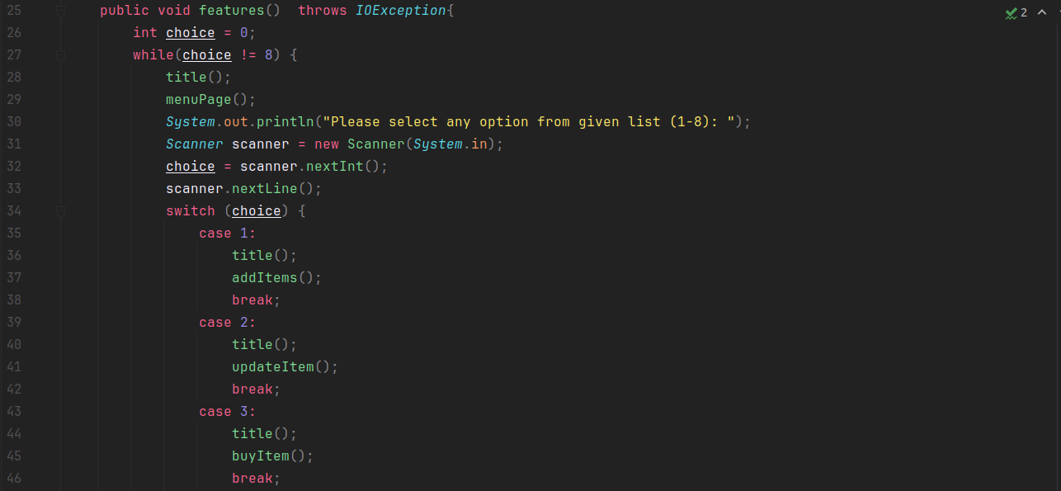

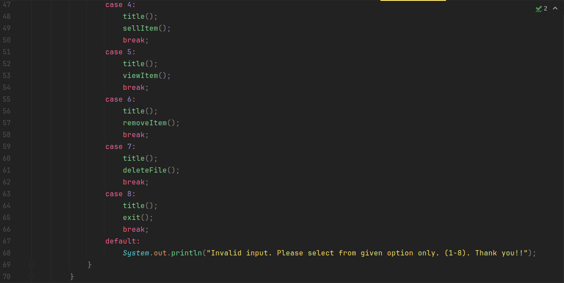

Output class file

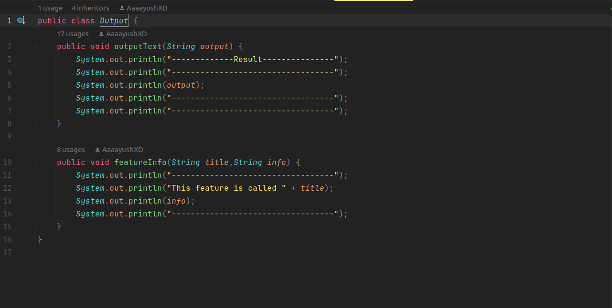

File Manager class

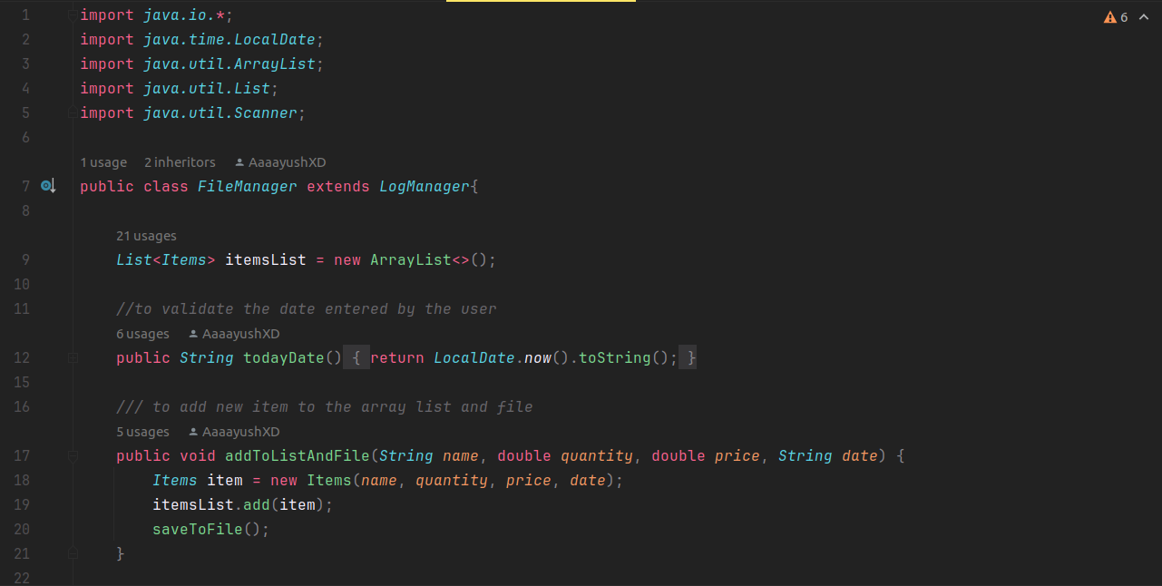

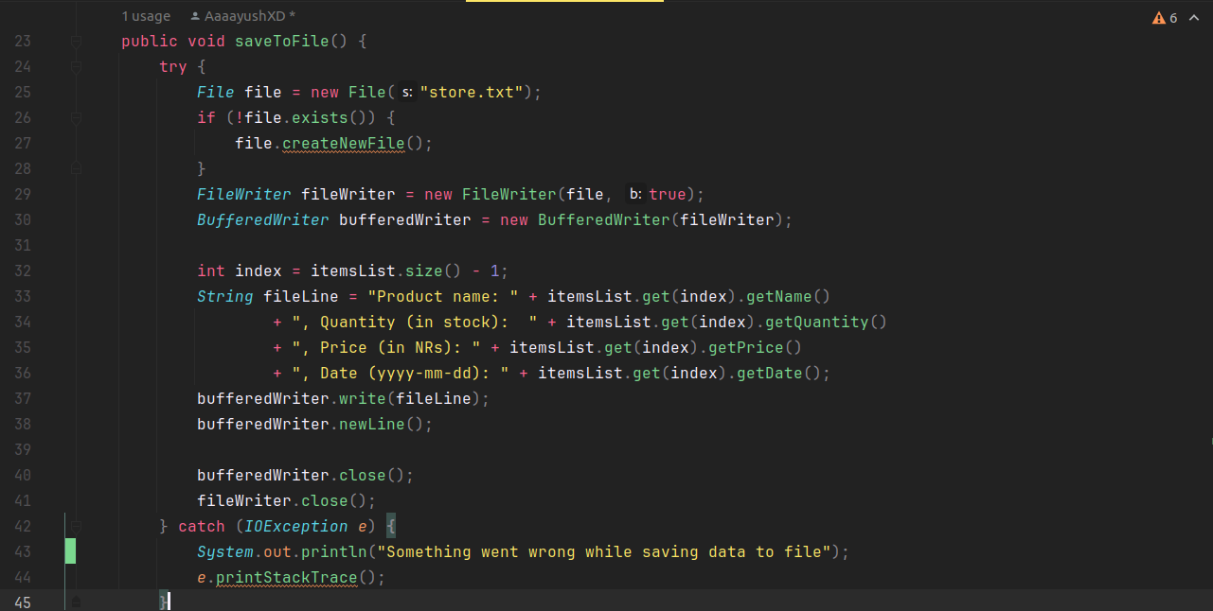

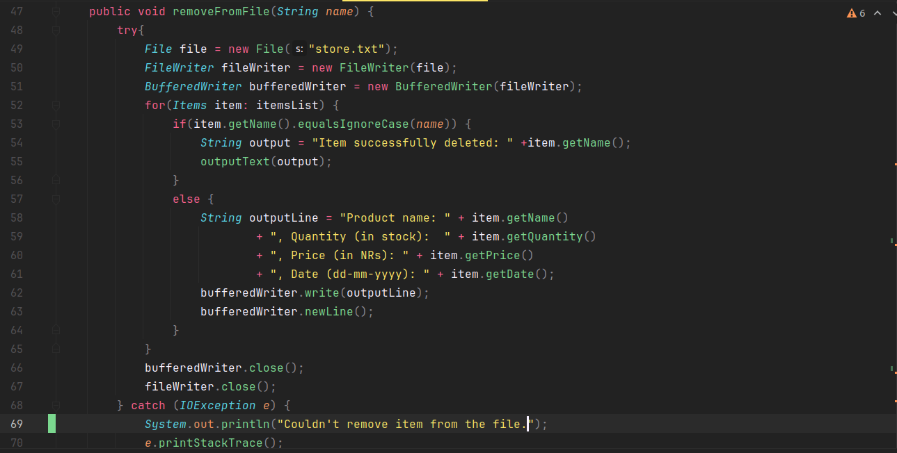

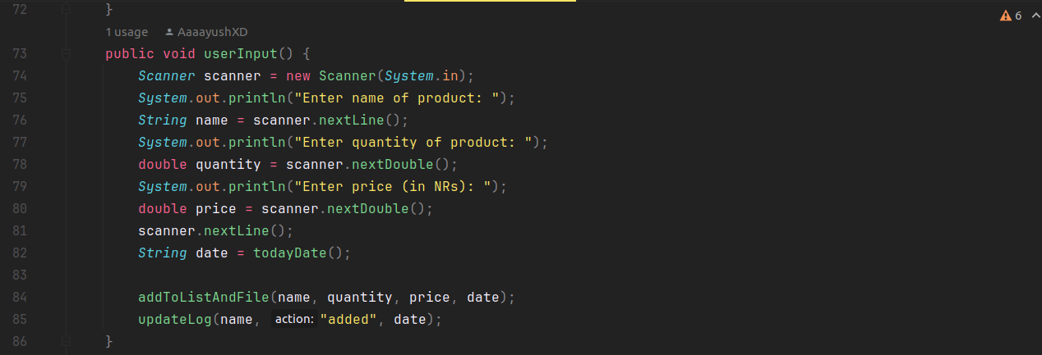
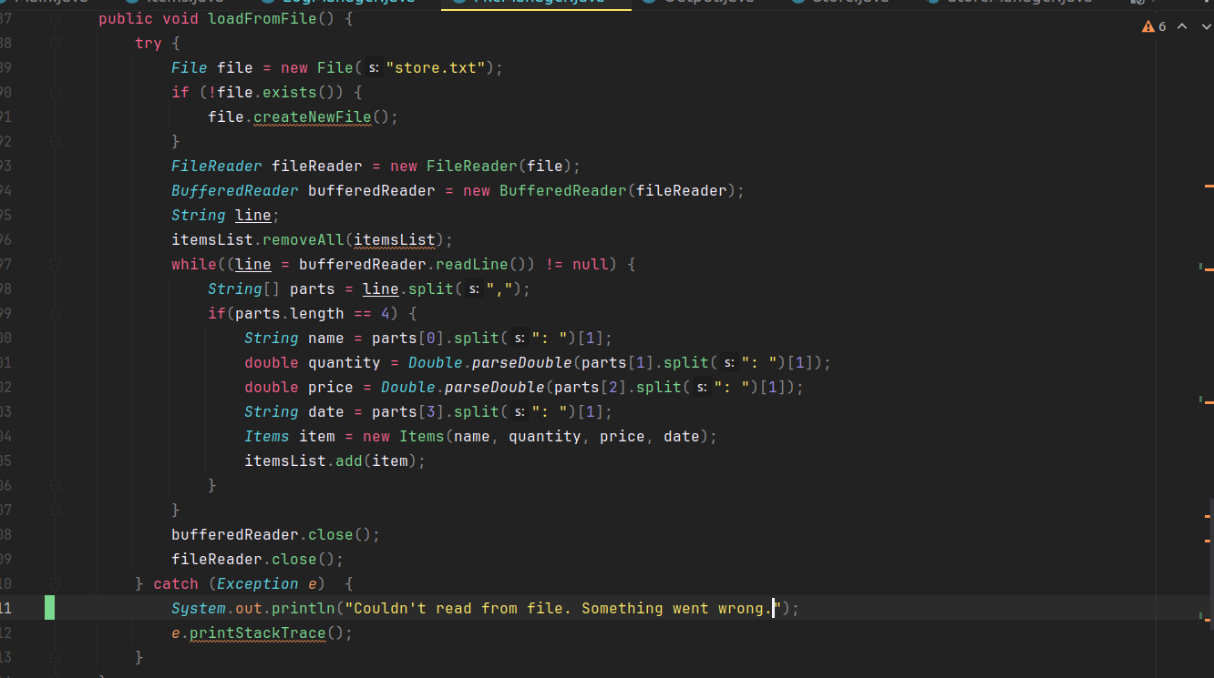

Log Manager Class

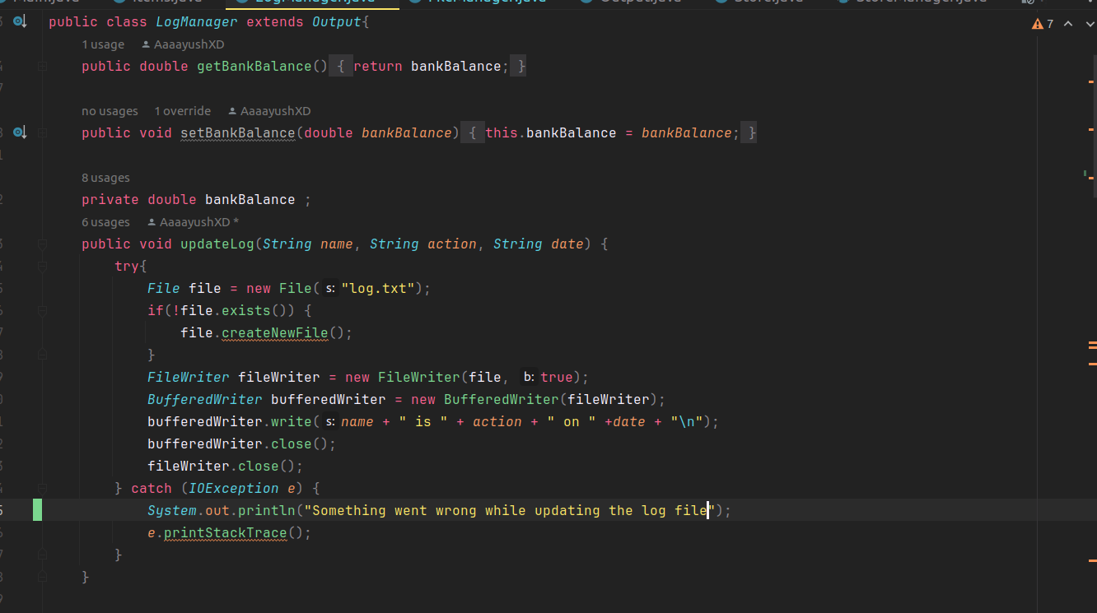
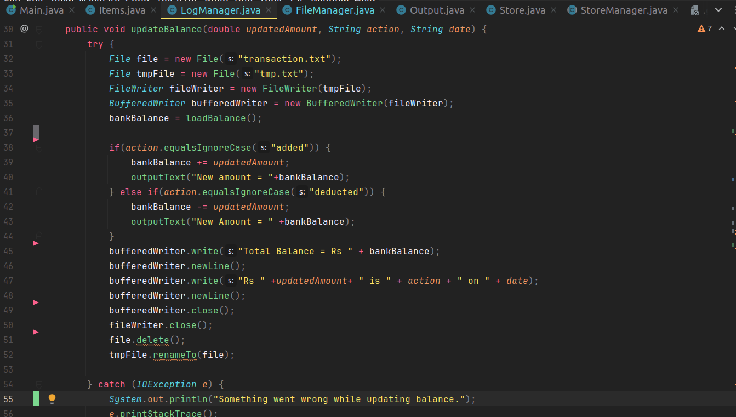

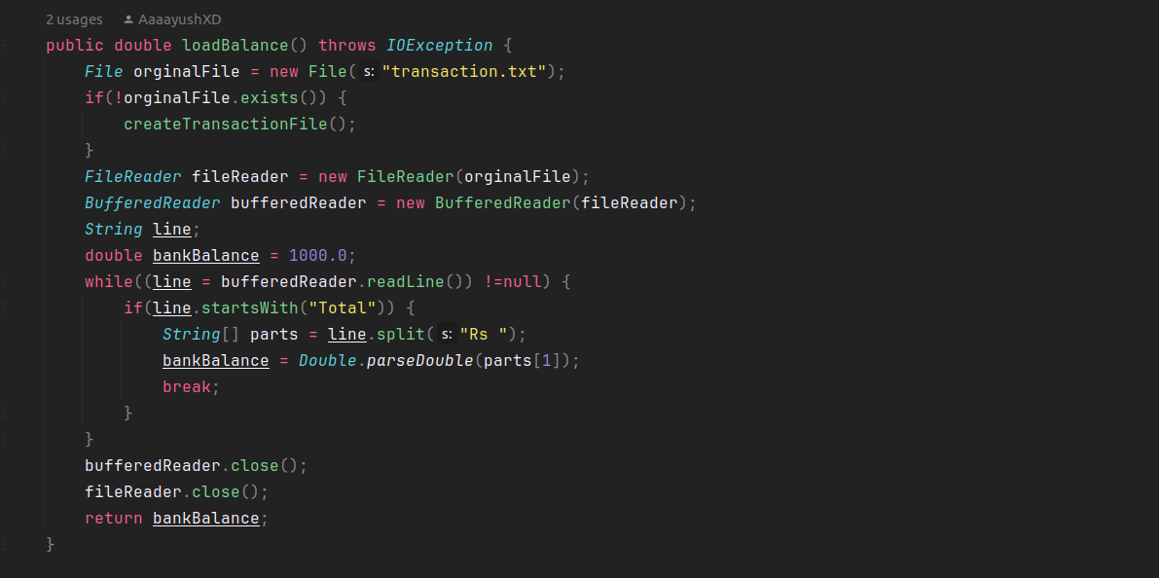

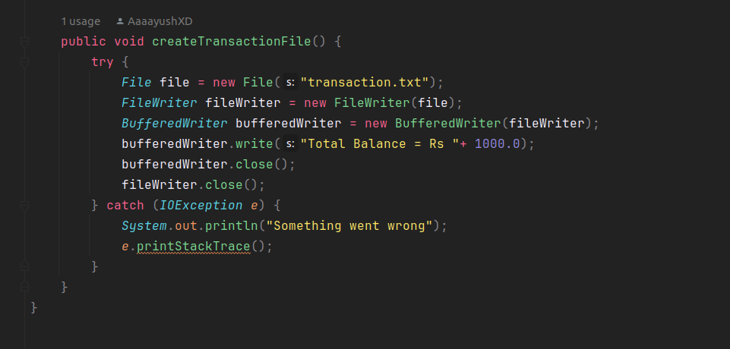

Summary

Store management software is build for store employee to keep track of their inventory. This software is a console-based and easy to use. It is packed with all the basics needs for the management. This software provide features like adding any item to the file, updating items, buy/sell items, view items and remove items from the list. It uses many basics concept of programming like OOPs, file handling and exception handling. It uses inheritance to share variable and methods between child and parent classes. It uses getter and setter to get or set value of private variable within the package. In this software, the data is stored in a file using file handling. All changes made in software are properly stored in log file.

This software will provide all the basic feature needed for a management software. This software helps any store to increase the productivity of the company and be more efficient. This will help to keep the items organized in a file digitally. Employee can manage and keep track of the inventory. In large store, there are thousands of items to be kept in track. It is very difficult to manage all those by a single employee. So, software like these can come in handy. In this software, any items added, updated or removed is stored in a file with all its information like name, quantity, price and date. And also, any changes made is stored in a separate log file. This software also stores the bank balance in store’s account which is used during buying or selling of items.

Challenges and Solution :

While building this project, I faced these problems along the way:
- It was very difficult to handle error and provide clear error message.
- It was difficult to add or fetch data from the file.
- Ensuring input validation was one of the most difficult task.
- I was facing a lot of ConcurrentComodification exception while removing item from a list while iterating over it.
- As the software is console-based, it was really hard to make a good user-friendly system.

Solutions:

- I created a menu with clear options for features to make it more user-friendly.
- I used regular expressions to validate the user’s input.
- I included clear and detailed error message to help user guide through problem and help me during debugging.
- I solved the ConcurrentComodification exception by changing the iteration loop from for-each to traditional for loop.

Conclusion

In a nutshell, we were able to create a mini console-based store managing software. In this software, we have included many features, and have made it very user friendly. I have also stored all the updates in a log file to make it easier to see changes in the future. This project helped me understand many topics in java very well. OOPs, file handling and exception handling are one of the most important concept required in programming. This project covered those topic and made me understand it in a better way.

