DRAFT STATUS (delete before submission)
- Every number in this draft was re-measured on the implementation in project/backend (app/compass, eval). The numbers in the earlier draft came from code that is not in this repository and were replaced.
- Table V is complete.
- Table VI is complete.
- Still to supply: author names, affiliation, email, and the acknowledgment. DPDP-QA and the checklist tests have not been reviewed by a lawyer.

DPDP Compass: Citation-Enforced Hybrid Retrieval and Guardrailed Agents for Auditing Privacy Policies against India's DPDP Act, 2023
[Author names]
[Department, Institution]
[City, India] [email]

Abstract—India's Digital Personal Data Protection (DPDP) Act, 2023 places enforceable duties on organisations that process personal data, and a privacy policy is usually the first evidence of whether those duties are met. Large language models can read a policy against a statute, but they are known to cite provisions that do not exist. We present DPDP Compass, a system that answers questions about the Act and audits privacy policies against 14 obligations, with the legal citation attached by the system and not generated. A clause-aware chunker turns the Gazette text into 83 chunks that keep section, sub-section and page; a three-layer knowledge base adds 74 obligation records and a graph of 264 relationships, each carrying the sentence that states it. Retrieval fuses dense, BM25+ and exact provision lookup and re-ranks with a cross-encoder. On DPDP-QA, 198 questions in English, Hindi and Marathi written from the Act, the full retriever reaches Hit@1 0.790 and nDCG@10 0.898, against 0.548 and 0.725 for dense retrieval, and clause-aware chunks outrank fixed windows of the same size (MRR 0.739 against 0.650). The knowledge graph did not improve ranking. On the 40 DPDP-Synth policies audited (560 decisions), the pipeline agrees with the construction labels at Cohen's kappa 0.784 with every quoted clause verified in the policy, against 0.811 for a single prompt at about half the tokens and 0.576 for keyword rules. On 138 test questions the full system answers 88.7% correctly against 12.1% for the model without retrieval, and no answer cites a provision that does not exist.
Index Terms—Compliance checking, data protection, DPDP Act, knowledge graphs, large language models, legal informatics, privacy policies, retrieval-augmented generation.
I. INTRODUCTION
India's Digital Personal Data Protection (DPDP) Act, 2023 [1] places enforceable duties on every organisation that decides why and how personal data is processed, and gives individuals rights of access, correction, erasure, grievance redressal and nomination. Breach of the duty to take reasonable security safeguards can attract a penalty of up to Rs. 250 crore. For most organisations the first visible evidence of compliance is their privacy policy, and for most citizens the policy is the only description they will ever read of what happens to their data.
Reading a policy against a statute is slow, expert work. Large language models (LLMs) appear to offer a shortcut, but in legal settings they are known to state rules that do not exist and to cite provisions that were never enacted [11], [12]. Retrieval-augmented generation (RAG) [5] reduces this by supplying source text, yet retrieval tuned for open-domain text handles statutes poorly: fixed-size chunks cut sub-sections apart, embeddings blur the exact terms on which legal meaning turns, and nothing prevents the model from citing a section it was never shown.
Prior work on automated analysis of privacy policies targets the GDPR and US practice [6]-[9]. We are not aware of a system or a benchmark built on the text of the DPDP Act. This paper makes four contributions.
1) A clause-aware knowledge base of the Act: a statute chunker that preserves section, sub-section, marginal title and page, a three-layer structure of facts, obligations and principles, and a knowledge graph whose every edge carries the sentence that states it.
2) A multi-agent audit pipeline with citations by construction: each of 14 obligations is judged from its own retrieved policy clauses, the legal citation is attached by the system rather than generated, and guardrails correct findings whose evidence cannot be verified.
3) DPDP-QA, 198 questions in English, Hindi and Marathi with gold provisions and evidence phrases that make retrieval relevance independent of chunking, and DPDP-Synth, a controlled audit set with labels known by construction.
4) An ablation study that isolates chunking, each retriever, fusion, re-ranking and guardrails, and reports a negative result: on this corpus the knowledge graph did not improve ranking.
Section II reviews related work, Section III states the tasks, Section IV describes the system, Section V the experimental setup and Section VI the results. Sections VII and VIII give limitations and conclusions.
II. BACKGROUND AND RELATED WORK
A. The DPDP Act
The Act [1] has 44 sections and a Schedule of penalties. Chapter II sets the obligations of a Data Fiduciary: notice (Section 5), consent and its withdrawal (Section 6), security safeguards, breach intimation, erasure and grievance redressal (Section 8), and children's data (Section 9). Chapter III gives the rights of the Data Principal (Sections 11-14). Many details are left to rules, which matters for evaluation: a question such as the number of hours within which a breach must be reported has no answer in the Act itself.
B. NLP for Privacy Policies
OPP-115 [6] annotated 115 website policies with data-practice categories and enabled supervised policy analysis. Polisis [7] built on it to classify policy segments and answer user questions. PrivacyQA [8] framed policy understanding as question answering with expert annotations. Amaral et al. [9] checked the completeness of policies against the GDPR. These works address the GDPR or US practice, and they classify policy text without tying each decision to a quoted provision of the governing law.
C. Retrieval-Augmented Generation
RAG [5] conditions generation on retrieved passages. Self-RAG [13] lets the model decide when to retrieve and critique its own output, and GraphRAG [14] builds a graph over the corpus to answer questions that need a global view. Our use of a graph is narrower: it stores typed legal relations with provenance, and we measure whether it helps ranking rather than assume that it does.
D. Legal NLP and Hallucination
LegalBench [10] measures legal reasoning in LLMs across many tasks. Dahl et al. [11] document frequent fabricated legal content in general-purpose models, and Magesh et al. [12] find that commercial legal research tools built on RAG still hallucinate. These findings motivate checking every cited provision against the corpus instead of trusting the generator.
E. Retrieval Methods
We combine BM25+ [3], a variant of BM25 [15] that lower-bounds term-frequency normalisation, with Sentence-BERT style dense retrieval [4] using a MiniLM encoder [16], merge them with Reciprocal Rank Fusion [2], and re-rank with a cross-encoder [17]. RAGAS [18] proposed reference-free measures of answer faithfulness; we report related judge-based measures next to citation checks that need no judge.
III. PROBLEM FORMULATION
Let the legal corpus be a set of clauses K = {k1, ..., kn}, where each clause carries its provision identifier (for example Section 8(6)) and page. We address two tasks.
Task 1, grounded question answering. Given a question q, produce an answer a and a set of cited provisions C. Every provision in C must exist in K and must be among the clauses retrieved for q. If K does not answer q, the system should say so.
Task 2, policy audit. Given a privacy policy P and a checklist O of 14 Data Fiduciary obligations, assign each obligation a status in {Satisfied, Partial, Missing, Not applicable}, with a verbatim quote from P for every status other than Missing and the sub-section of the Act that the obligation rests on.
The compliance score is S = 100 (nsat + 0.5 npart) / napplicable.
IV. SYSTEM DESIGN
A. Overview
The system has an offline pipeline that builds a hybrid legal knowledge base from the Gazette text, and an online multi-agent workflow that serves both tasks. All components run in one process with in-memory indexes; saved audits are kept in SQLite. Fig. 1 shows the architecture.
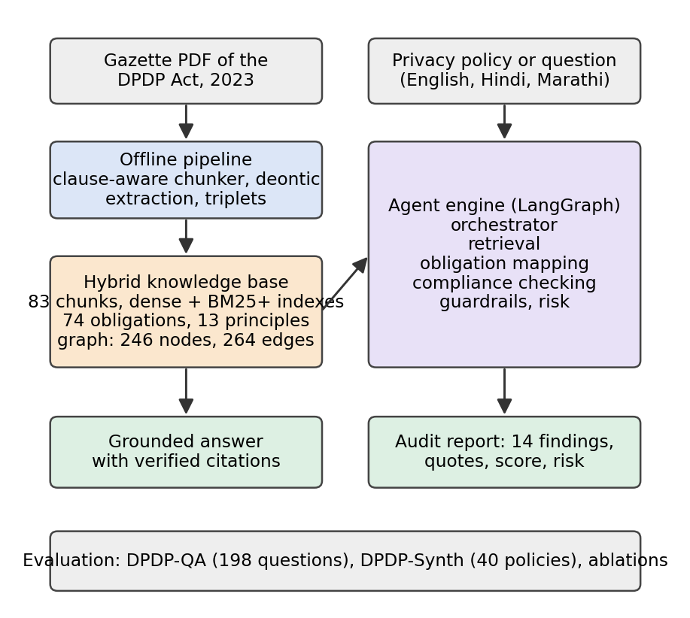
Fig. 1. Architecture of DPDP Compass. Counts are for the knowledge base built from the DPDP Act, 2023.
B. Clause-Aware Chunking of the Statute
The Gazette PDF of the Act yields page headers, a masthead in a legacy font, and marginal notes that the extractor places away from the text they label. A generic splitter mixes these into the text and loses the provision structure. Our statute chunker (i) keeps only body text, using font and size to drop the masthead and to separate the 8-point marginal notes; (ii) detects sections by their running number, accepting a candidate only if it continues the sequence, and assigns each section the marginal note beside it as its title; (iii) splits each section into its numbered sub-sections and lettered clauses, again requiring running order so that a cross-reference at the start of a line is not mistaken for a new sub-section; (iv) packs consecutive sub-sections into chunks of at most 1,200 characters without cutting a sub-section, an over-long one being cut at its lettered clauses with the lead-in repeated; (v) prefixes each chunk with its section number and title and stores section, provisions, chapter and starting page as metadata; and (vi) rebuilds the penalty Schedule, a three-column table that extraction scrambles, into one row per breach.
On the DPDP Act this gives 83 chunks covering all 44 sections, the long title and the Schedule, with a mean length of 770 characters. Only the Schedule, kept whole, exceeds the limit.
C. Three-Layer Knowledge Structure
Layer 1, facts: the 83 clause chunks and the 28 terms defined in Section 2. Layer 2, obligations: normative statements extracted with deontic patterns. A statement is recorded when a legal actor (Data Fiduciary, Data Principal, Consent Manager, Board, Central Government and others) opens a clause as the grammatical subject of shall, shall not, shall have the right or may; actors inside prepositional or relative phrases and definitional uses of shall are excluded, and a leading condition such as "by notification" is stored separately from the action. This yields 74 records: 40 duties, 4 prohibitions, 5 rights and 25 powers. Layer 3, principles: each obligation is mapped by provision to one of 13 principles such as consent, storage limitation, security safeguards and accountability. Fig. 2 shows one provision across the layers.
In an automated check of a random sample of 60 of the 74 triplets, an LLM (qwen3.8-27b) read each triplet against its source sentence and judged 49 correct (precision 0.82, bootstrap 95% CI 0.72-0.92). Of the 11 errors, 6 had an action that was a fragment or condition, 4 a wrong or partial subject and 1 a wrong modality. The extraction rule was revised once, to separate leading conditions, after a first check; the figures are for the revised rule. This check was not performed by human annotators.
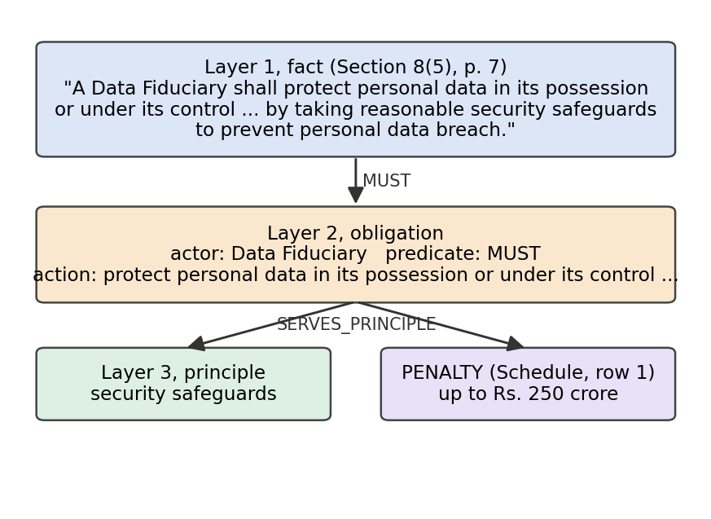
Fig. 2. The three layers for one provision, Section 8(5), and the penalty linked to it in the graph.
D. Triplet Extraction and Knowledge Graph
The same pass emits subject-predicate-object triplets, each with the provision, page and sentence that states it. Predicates come from a closed list: MUST, MUST_NOT, HAS_RIGHT and MAY from Layer 2; SERVES_PRINCIPLE; REFERS_TO for cross-references between provisions, excluding references to other Acts; DEFINED_IN; and PENALTY, which links a Schedule row to its provision. The graph for the Act has 264 relationships over 246 nodes (Table I).
TABLE I
KNOWLEDGE BASE BUILT FROM THE DPDP ACT, 2023
Item | Count
Clause chunks (Layer 1) | 83
Obligation records (Layer 2) | 74
Principles (Layer 3) | 13
Graph nodes | 246
Graph relationships | 264
MUST / MUST_NOT / HAS_RIGHT / MAY | 40 / 4 / 5 / 25
SERVES_PRINCIPLE | 74
REFERS_TO | 81
DEFINED_IN | 28
PENALTY | 7

E. Hybrid Retrieval
Four retrievers run per query (Fig. 3). Dense: all-MiniLM-L6-v2 embeddings with exact cosine similarity. Sparse: BM25+ [3] over stemmed tokens. Metadata lookup: when the query names a provision, the chunks holding that provision are fetched exactly. Graph: provisions connected to the defined terms, actors and principles the query mentions, and provisions cross-referenced by the leading candidates.
Result lists are merged by weighted Reciprocal Rank Fusion, score(d) = sum over retrievers r of w_r / (60 + rank_r(d)) [2], and the top 20 candidates are re-ranked by a cross-encoder (ms-marco-MiniLM-L-6-v2). The weights were chosen on the development split of DPDP-QA from a grid over the metadata and graph weights: w_dense = w_sparse = 1, w_metadata = 1 and w_graph = 0. Graph matches lowered ranking quality at every non-zero weight we tried (Section VI-B), so the deployed system does not use the graph for ranking. The graph is used where structure matters: linking obligations to the exemption provisions that refer to them and provisions to their penalty.
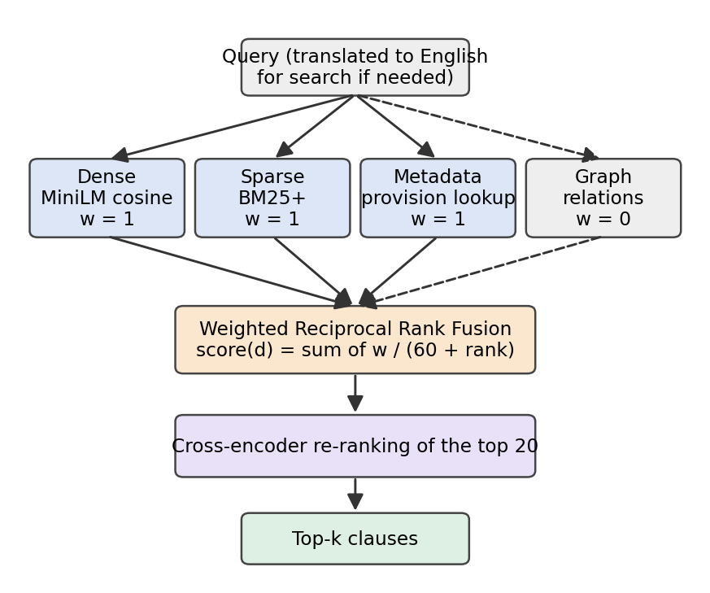
Fig. 3. Hybrid retrieval. The dashed path is the graph retriever, whose fusion weight was set to 0 on the development split.
F. Multi-Agent Workflow
The workflow is a LangGraph state machine (Fig. 4). The orchestrator detects the language (English, Hindi or Marathi) and the intent and routes the request; a question with no policy skips the audit agents. For a question, the answer agent translates a non-English question for search while the answer stays in the user's language, runs hybrid retrieval over the Act and generates from the retrieved clauses. For an audit, the retrieval agent chunks the policy by paragraph, indexes it in memory for the duration of the audit and retrieves three clauses per checklist obligation.
The obligation mapping agent grounds each checklist obligation in the knowledge base: its statutory text by exact lookup, its principle, and the exemption provisions linked to it in the graph. The compliance checking agent receives, per obligation, the statutory text, the tests for Satisfied and Partial, and the three policy clauses retrieved for it, and returns a status and a quote; obligations are sent in batches of seven, each judged from its own clauses. The tests are written so that the same text can be given to human annotators. The risk agent assigns severity from the penalty ceiling in the Schedule (up to Rs. 250 crore for Section 8(5), Rs. 200 crore for Sections 8(6) and 9, and Rs. 50 crore otherwise) and likelihood from the status; no penalty figure is generated by the model. Without a model key the compliance agent falls back to the keyword rules used as a baseline.
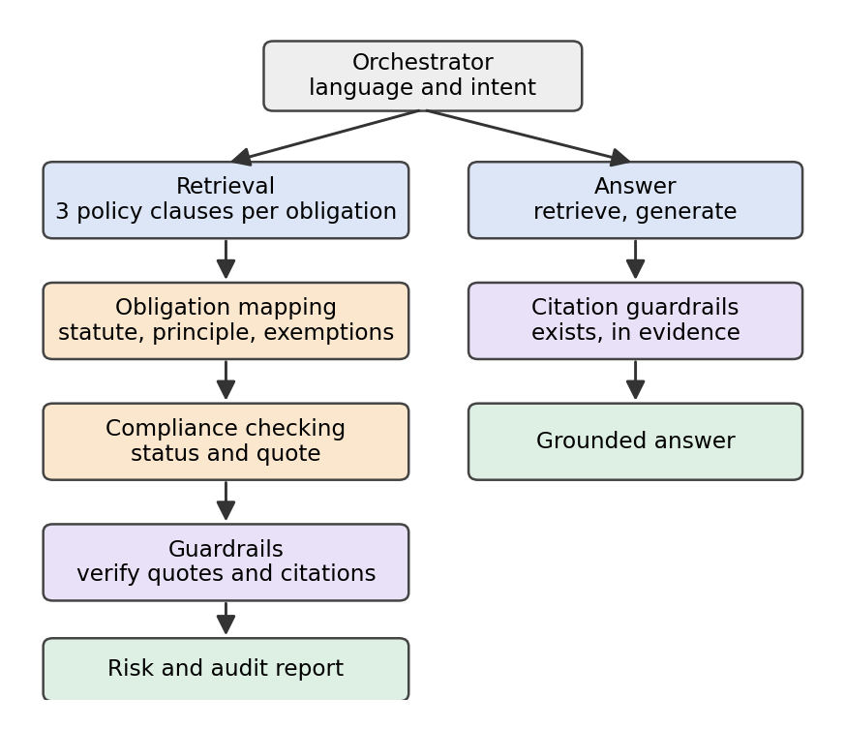
Fig. 4. Agent workflow. A question with no policy takes the right-hand path.
G. Guardrails
The legal citation of a finding is attached by the system from the knowledge base, so the model cannot invent it. The remaining risks are handled by checks that act on the output (Table II). Personal data in a question (names that are introduced, phone numbers, email addresses and identity numbers) is redacted before the question is processed or logged.
TABLE II
GUARDRAILS AND THE ACTION TAKEN ON FAILURE
Check | Action on failure
Policy quote found word for word in the policy | Satisfied becomes Partial; confidence capped at 0.5
Partial finding has policy evidence | Partial becomes Missing
Cited provision exists in the Act | Citation removed
Provisions cited in an answer are in the retrieved evidence | One rewrite requested; result flagged
Retrieved text contains instruction-like content | Flagged; retrieved text is always passed as data
Confidence within 0-1; output schema complete | Clamped or flagged

V. EXPERIMENTAL SETUP
A. Corpus
The Digital Personal Data Protection Act, 2023 (Gazette text, 21 pages). The DPDP Rules, 2025 are not included in the experiments reported here.
B. DPDP-QA
We wrote 198 questions from the text of the Act: 178 in English, 12 in Hindi and 8 in Marathi, the latter two being translations of English items. They cover 43 of the 44 sections and the Schedule, and eleven types: definitions, obligations, rights, exemptions, procedure, penalties, scope, scenarios, provision lookups and two kinds of unanswerable question. Each answerable question has the gold provision, a reference answer and an evidence phrase copied from the Act. A retrieved chunk counts as relevant if it contains the phrase, so relevance does not depend on the chunking. A validator confirms that every phrase occurs in the Act and only inside the gold provision.
Sixteen questions cannot be answered from the Act: ten ask for details the Act leaves to rules or does not contain, such as the number of hours for breach reporting, and six are out of domain. The set is split into development (60) and test (138); translations stay with their source. The test split has 124 answerable questions, 109 of them in English. The development split is used only to choose the fusion weights. The questions have not been reviewed by a lawyer.
C. Audit Data
DPDP-Synth is a controlled set of 40 synthetic policies of fictional companies (560 obligation-level labels: 211 Satisfied, 189 Partial, 160 Missing). For each obligation the generator inserts a clause written for Satisfied or Partial or, for Missing, nothing or a hard negative that uses the topic's vocabulary without meeting the obligation (78 hard negatives). Labels are known by construction. 8 policies carry a prompt-injection sentence. The clauses come from a small set of templates, which makes the set easier than real policies, in particular for keyword matching.
We do not report results on real privacy policies: a gold standard for them requires independent labelling by annotators with legal training, which we leave to future work.
D. Systems Compared
Retrieval: each retriever alone; dense plus sparse with score-weighted fusion and with RRF; then adding graph, metadata lookup and re-ranking. Chunking: clause-aware at 1,200 and 600 characters, whole sections, and fixed windows of 1,200, 600 and 300 characters with 15% overlap, over the same cleaned text and the same retriever. Audit: a keyword-rule baseline; a single LLM prompt with the whole policy and the rubric; the multi-agent pipeline with and without guardrails. Question answering: the LLM without retrieval; dense-only RAG; hybrid RAG; the full system.
E. Metrics
Hit@k, Recall@10, MRR and nDCG@10 for retrieval, with bootstrap 95% confidence intervals and a paired bootstrap test (10,000 resamples). Accuracy, macro-F1, per-class F1 and Cohen's kappa for the audit, plus the absolute error of the compliance score, the share of quoted clauses found verbatim in the policy, and the share of obligations not labelled Satisfied that a system marks Satisfied, on injected and on clean policies. For answers: citation precision and recall against gold provisions, the share of answers citing a provision that does not exist, the share citing outside the retrieved evidence, correctness and unsupported claims graded by an LLM judge against the reference answer, and abstention on unanswerable questions. Latency and tokens per item are recorded.
F. Implementation
Python 3.13, FastAPI and LangGraph; NumPy and rank-bm25 indexes in memory and SQLite for saved audits; openai/gpt-oss-120b served by Groq at temperature 0 with low reasoning effort; qwen3.8-27b as judge; all-MiniLM-L6-v2 and ms-marco-MiniLM-L-6-v2 on CPU. Every run records its dataset hash, and model responses are cached on disk so that a run can be repeated exactly and an interrupted run resumed.
VI. RESULTS
A. Chunking
Table III compares chunkers on the 109 answerable English test questions with dense plus BM25+ retrieval fused by RRF and no re-ranking. Clause-aware chunks beat fixed windows of the same size limit (MRR 0.739 against 0.650, paired bootstrap p = 0.012). Whole sections reach MRR 0.697 (p = 0.144 against ours) and place about 2.4 times as much text in front of the model for the same evidence. Halving the clause-aware limit to 600 characters changes ranking little.
TABLE III
CHUNKING ABLATION (109 ENGLISH TEST QUESTIONS, HYBRID RETRIEVAL, NO RE-RANKING)
Chunking | Chunks | Hit@1 | Hit@5 | MRR | nDCG@10 | Chars in top 5
Clause-aware, 1,200 (ours) | 83 | 0.642 | 0.872 | 0.739 | 0.789 | 4,057
Clause-aware, 600 | 156 | 0.651 | 0.872 | 0.745 | 0.789 | 2,291
Whole sections | 46 | 0.569 | 0.853 | 0.697 | 0.757 | 9,659
Fixed windows, 1,200 | 61 | 0.523 | 0.835 | 0.650 | 0.707 | 5,939
Fixed windows, 600 | 121 | 0.541 | 0.844 | 0.652 | 0.704 | 2,976
Fixed windows, 300 | 244 | 0.385 | 0.725 | 0.525 | 0.587 | 1,480

B. Fusion Weights
On the 58 answerable development questions, before re-ranking, the best metadata weight in the grid {0, 1, 2} was 1. At that weight nDCG@10 fell as the graph weight rose: 0.870 at 0, 0.834 at 0.1, 0.800 at 0.25, 0.748 at 0.5, 0.730 at 1. We therefore set the graph weight to 0.
C. Retrieval
Table IV reports the ablation on the 124 answerable test questions (109 English, 9 Hindi, 6 Marathi), with Hindi and Marathi questions translated to English before search. BM25+ alone ranks the right clause first more often than dense retrieval alone (0.645 against 0.548), which fits statutory text where questions reuse the Act's own terms. Fusing the two by RRF raises Hit@5 to 0.863; score-weighted fusion of the same two lists does better at rank 1 (0.702). Giving the graph an equal vote lowers nDCG@10 from 0.775 to 0.702 (p = 0.008). Exact provision lookup adds 0.024 to Hit@5, and cross-encoder re-ranking brings the full system to Hit@1 0.790 and nDCG@10 0.898, against 0.548 and 0.725 for dense retrieval (paired bootstrap p < 0.001 and p < 0.001). Every answerable test question has a relevant clause in the full system's top 10. Re-ranking on CPU costs about 0.6 s per query.
TABLE IV
RETRIEVAL ABLATION ON THE DPDP-QA TEST SPLIT (124 QUESTIONS, TOP 10)
System | Hit@1 | Hit@5 | R@10 | MRR | nDCG@10 | ms / query
Dense (MiniLM) | 0.548 | 0.855 | 0.903 | 0.667 | 0.725 | 20
Sparse (BM25+) | 0.645 | 0.831 | 0.903 | 0.725 | 0.768 | 0.2
Graph | 0.266 | 0.435 | 0.452 | 0.341 | 0.369 | 0.1
Dense + sparse, weighted | 0.702 | 0.879 | 0.944 | 0.779 | 0.819 | 20
Dense + sparse, RRF | 0.621 | 0.863 | 0.944 | 0.721 | 0.775 | 21
+ graph, equal vote | 0.492 | 0.815 | 0.960 | 0.623 | 0.702 | 20
+ metadata lookup | 0.653 | 0.887 | 0.976 | 0.752 | 0.805 | 22
+ re-ranking (full) | 0.790 | 0.960 | 1.000 | 0.865 | 0.898 | 635
Dense + re-ranking | 0.758 | 0.911 | 0.952 | 0.828 | 0.858 | 694

D. Policy Audit
Table V compares the audit systems against the construction labels. Keyword rules reach accuracy 0.725 (kappa 0.576) and recognise only 14% of hard negatives as Missing. The single prompt reaches 0.875 (kappa 0.811) and the pipeline 0.855 without guardrails and 0.857 with them (kappa 0.784); the 95% intervals of the two model-based systems overlap. On this set, judging each obligation from its own retrieved clauses did not beat reading the whole policy, and it used about 2.1 times the tokens. The policies are short, so the whole policy fits in one prompt; the retrieval step is intended for long policies, which this set does not test.
Guardrails changed 3 of 560 findings and raised the share of verified quotes from 99.2% to 100.0%; the single prompt, which has no quote check, stands at 98.5%. In the policies carrying a prompt-injection sentence the pipeline marked 1.4% of obligations that were not Satisfied as Satisfied, against 2.2% in clean policies (single prompt: 1.4% and 3.6%), so the injected sentence did not raise the rate. The mean absolute error of the compliance score is 4.1 points for the pipeline, 3.9 for the single prompt and 14.1 for keyword rules.
TABLE V
POLICY AUDIT ON DPDP-SYNTH (40 OF 40 POLICIES, 560 DECISIONS)
System | Acc. | Macro-F1 | Kappa | F1 S / P / M | Score err. | Quotes verified | Tokens
Keyword rules | 0.725 | 0.643 | 0.576 | 0.94 / 0.69 / 0.30 | 14.1 | n/a | 0
Single prompt | 0.875 | 0.866 | 0.811 | 0.97 / 0.83 / 0.80 | 3.9 | 98.5% | 2,658
Pipeline, no guardrails | 0.855 | 0.845 | 0.782 | 0.98 / 0.80 / 0.76 | 4.1 | 99.2% | 5,635
Pipeline + guardrails (full) | 0.857 | 0.847 | 0.784 | 0.98 / 0.80 / 0.76 | 4.1 | 100.0% | 5,635

E. Question Answering and Citations
Table VI compares the answering systems. The full system is judged correct on 88.7% of answerable questions (93.5% with partial credit), against 12.1% for the model without retrieval. No answer from the closed-book model or the full system cites a provision that does not exist (0.0%). The full system abstains on 78.6% of unanswerable questions.
TABLE VI
QUESTION ANSWERING ON THE DPDP-QA TEST SPLIT (138 QUESTIONS)
System | Correct | Cit. P | Cit. R | Fabricated | Abstain | Tokens
LLM, no retrieval | 12.1% | 0.064 | 0.089 | 0.0% | 57% | 318
Dense RAG | 82.3% | 0.706 | 0.855 | 0.0% | 93% | 1,240
Hybrid RAG | 79.8% | 0.661 | 0.847 | 0.0% | 79% | 1,267
Full system | 88.7% | 0.705 | 0.952 | 0.0% | 79% | 1,297

F. Error Analysis and Case Study
Retrieval. The full system ranks a relevant clause first for all but 26 of the 124 answerable test questions. The misses are concentrated in definition questions (9 of 21), right questions (4 of 13), procedure questions (4 of 21). In 21 of the 26 misses the relevant clause is still in the top five, and in 11 the clause ranked first is another chunk of the same section as the gold provision: long sections such as the definitions are split across several chunks that share a title and vocabulary.
Audit. The pipeline's 80 errors are mostly Partial judged Missing (39); Missing judged Partial (31); Missing judged Satisfied (5). They fall mainly on access (10), erasure (10), contact (10). Satisfied clauses are almost never missed; the difficulty is the line between a partial clause and a hard negative.
Case study. Section 8(7) requires: "(7) A Data Fiduciary shall, unless retention is necessary for compliance with any law for the time being in force,— (a) erase personal data, upon the Data Principal withdrawing her consent or as soon as it is reasonable to assume that the specified purpose is no longer being served, whichever is earlier; and (b) cause its Data P ..." A synthetic policy states: "RideRaja keeps your information for as long as necessary for our business." The pipeline returns Partial with that quote verified in the policy: a retention statement is present, but nothing commits the company to erase data when consent is withdrawn or the purpose is served. The finding carries the citation DPDP Act, Section 8(7), attached from the knowledge base, and the residual penalty ceiling of the Schedule.
VII. LIMITATIONS
The corpus is one statute of 21 pages, and the Rules are not indexed. DPDP-QA was written by the authors and has not been reviewed by a lawyer. DPDP-Synth is synthetic and built from templates, so conclusions about real policies need a human-labelled set, and its short policies do not exercise retrieval over a long policy. Obligation and triplet extraction is rule-based, and its precision was checked by an LLM, not by annotators. The answer judge is an LLM. The knowledge graph did not improve ranking on this corpus. The keyword baseline cannot read negation. Results marked partial or pending above are incomplete. The system gives guidance, not legal advice.
VIII. CONCLUSION AND FUTURE WORK
We described DPDP Compass, which turns the Gazette text of the DPDP Act into a clause-level knowledge base and uses it to answer questions and to audit privacy policies with citations attached from that knowledge base. Keeping sub-sections whole improved ranking over fixed windows of the same size, and combining dense retrieval, BM25+, exact provision lookup and re-ranking put a relevant clause first for 79% of test questions and in the top ten for all of them. Two results went against our expectations and are reported as such: the knowledge graph lowered ranking quality whenever it was given a vote, and on short synthetic policies the multi-agent audit did not outperform a single prompt, although its quotes were always verifiable.
Future work is to complete the answer-quality evaluation, index the DPDP Rules, 2025, build a benchmark of real policies labelled by annotators with legal training, test the audit on long policies where retrieval should matter, and study how citizens and compliance staff use the answers.
ACKNOWLEDGMENT
[Thank the project guide and the institution here.] Generative AI tools were used in developing the software, in drafting this manuscript and the evaluation questions, and in the automated check of extracted triplets reported in Section IV-C; the authors reviewed the content and are responsible for it.
REFERENCES
[1] The Digital Personal Data Protection Act, 2023, No. 22 of 2023, Gazette of India, Aug. 2023.
[2] G. V. Cormack, C. L. A. Clarke, and S. Buettcher, "Reciprocal rank fusion outperforms Condorcet and individual rank learning methods," in Proc. SIGIR, 2009.
[3] Y. Lv and C. Zhai, "Lower-bounding term frequency normalization," in Proc. CIKM, 2011.
[4] N. Reimers and I. Gurevych, "Sentence-BERT: Sentence embeddings using Siamese BERT-networks," in Proc. EMNLP-IJCNLP, 2019.
[5] P. Lewis et al., "Retrieval-augmented generation for knowledge-intensive NLP tasks," in Proc. NeurIPS, 2020.
[6] S. Wilson et al., "The creation and analysis of a website privacy policy corpus," in Proc. ACL, 2016.
[7] H. Harkous et al., "Polisis: Automated analysis and presentation of privacy policies using deep learning," in Proc. USENIX Security, 2018.
[8] A. Ravichander, A. W. Black, S. Wilson, T. Norton, and N. Sadeh, "Question answering for privacy policies: Combining computational and legal perspectives," in Proc. EMNLP-IJCNLP, 2019.
[9] O. Amaral, S. Abualhaija, D. Torre, M. Sabetzadeh, and L. C. Briand, "AI-enabled automation for completeness checking of privacy policies," IEEE Trans. Softw. Eng., 2022.
[10] N. Guha et al., "LegalBench: A collaboratively built benchmark for measuring legal reasoning in large language models," in Proc. NeurIPS, 2023.
[11] M. Dahl, V. Magesh, M. Suzgun, and D. E. Ho, "Large legal fictions: Profiling legal hallucinations in large language models," J. Legal Anal., 2024.
[12] V. Magesh et al., "Hallucination-free? Assessing the reliability of leading AI legal research tools," J. Empir. Legal Stud., 2025.
[13] A. Asai, Z. Wu, Y. Wang, A. Sil, and H. Hajishirzi, "Self-RAG: Learning to retrieve, generate, and critique through self-reflection," in Proc. ICLR, 2024.
[14] D. Edge et al., "From local to global: A graph RAG approach to query-focused summarization," arXiv:2404.16130, 2024.
[15] S. Robertson and H. Zaragoza, "The probabilistic relevance framework: BM25 and beyond," Found. Trends Inf. Retr., 2009.
[16] W. Wang et al., "MiniLM: Deep self-attention distillation for task-agnostic compression of pre-trained transformers," in Proc. NeurIPS, 2020.
[17] R. Nogueira and K. Cho, "Passage re-ranking with BERT," arXiv:1901.04085, 2019.
[18] S. Es, J. James, L. Espinosa-Anke, and S. Schockaert, "RAGAS: Automated evaluation of retrieval augmented generation," in Proc. EACL (Demos), 2024.

