Extract top 5 cpu consuming processes.
Display the top processes with their PID, CPU usage, memory usage, and command
ps -eo pid=,pcpu=,pmem=,args= --sort=-pcpu | head -n 5
Calculate and display the sum of CPU usage for these top processes
ps -eo pcpu= --sort=-pcpu | head -n 5

top_cpu=$(ps -eo pcpu= --sort=-pcpu | head -n 5)
total=$(awk ‘{sum += $1} END {printf "%.1f", sum}’ $top_cpu)
echo $total
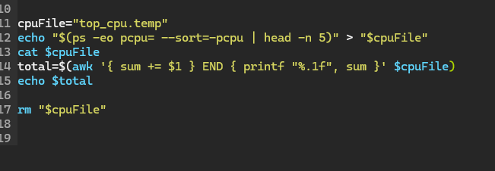
This is my test file to play around with awk more. ^^
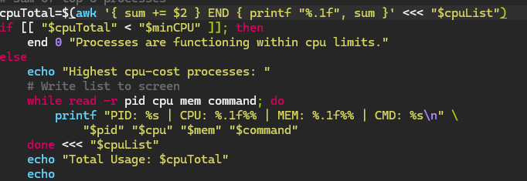
Processes are reading as 0 cpu usage currently. Not sure why that’s happening.
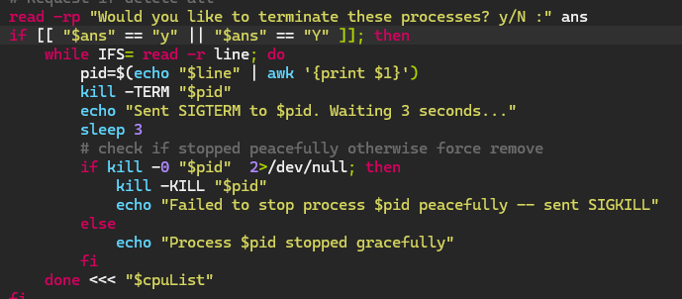
The check to see if the user wants to close the highest cpu-using programs.
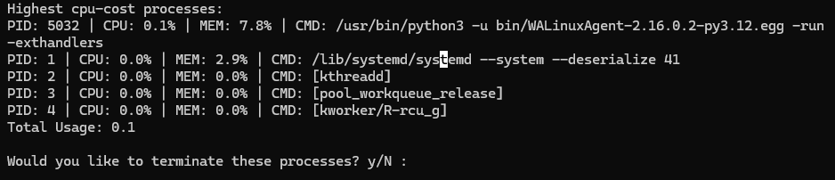
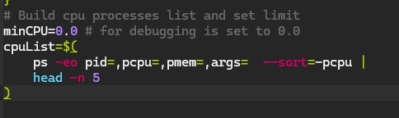
Was unsure whether to group the min cpu and min ram together but I figured the distinction between sections was appropriate.
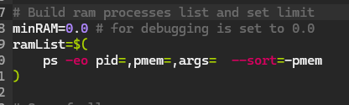
I’ve excluded the 5 limit due to the need to count all ram for the total this time.
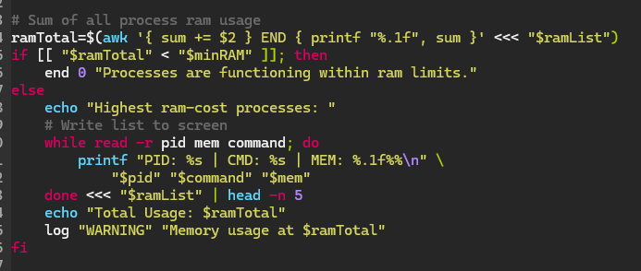
Instead, I put it at the end of the loop to group it simply for that purpose.
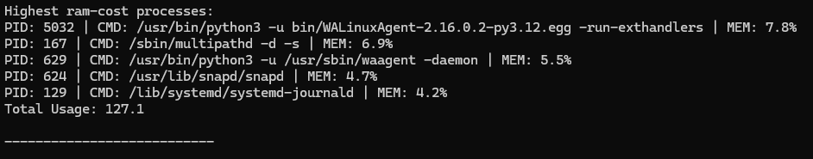
Getting values above 100% for the ram but I think that’s because it’s counting some processes twice. Unsure what it’s counting but I’ll look into it later.
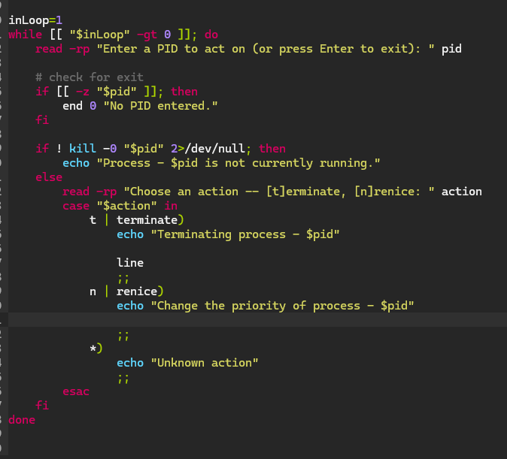
Going to loop over the menu so it’s a conscious decision to exit the program. Using an integer because I think changing Booleans mid-program is difficult in bash.
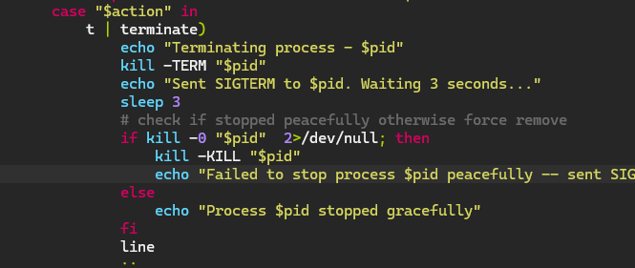
Simply copied the remove function from earlier and pasted it in the ‘t’ action.
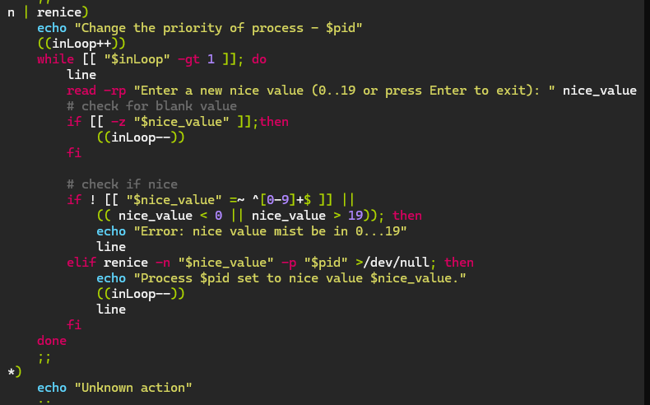
Looping over the nice value to make sure this exit is also conscious and the user doesn’t have to keep entering the same pid because they don’t correctly enter a nice value.
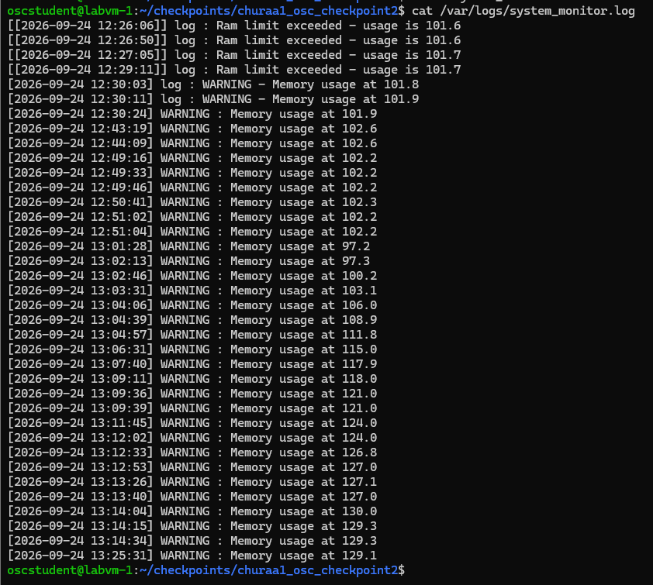
The memory logs from my testing.
Extras::
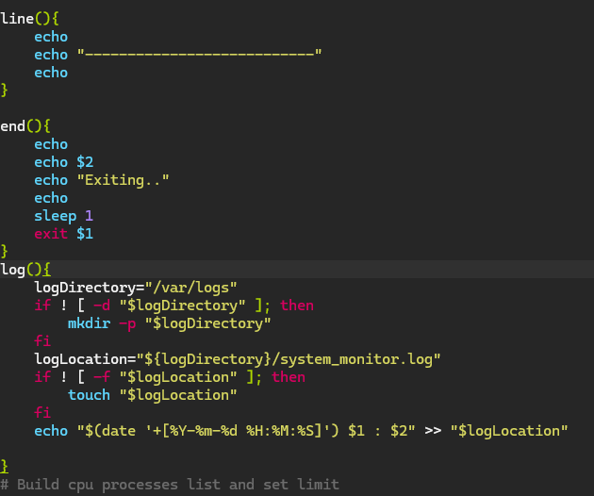
Line to break up and make the outputs easier to read. End to close the program with certain errors and again – readability. Log to output errors to a log file if ram is above expected amount.

