Exercises about OS installations
Sumario
1. Create an empty virtual machine and configure the following settings: 1
2.Install Windows 10 in the virtual machine from exercise 1. You must add the following settings: 6

1. Create an empty virtual machine and configure the following settings:
- QUESTIONS
• For Windows 10 (64 bits, or 32 if you do not have enough RAM in your physical
computer).
• 2GB of RAM memory.
• Boot order (CD and hard drive).
• Two hard drives: one with 50 GB for the operating system and another one with 30
GB empty. Select the type of disk that can dynamically increase.
- ANSWERS
  - 1. Here we can se how the Opererating System that I’ve installed is Windows 10(64-bits)
  - 2.At this photo we can se how the RAM memory I put is 2048 MB that are 2 GB
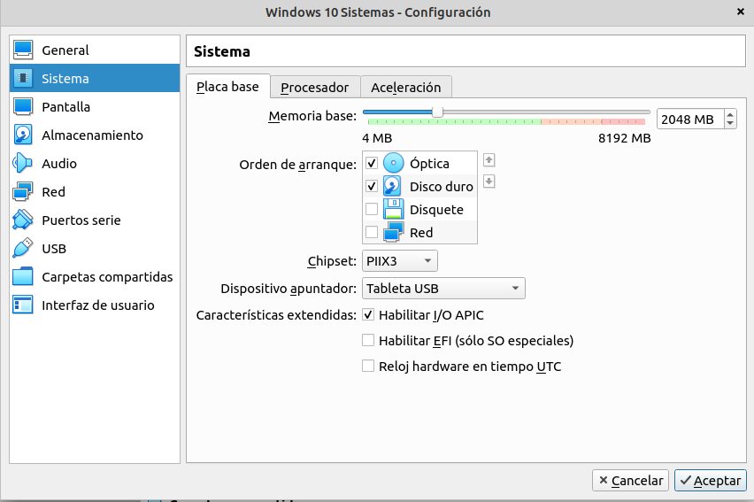
  - 3.On the photo above we can see that I’ve changed the boot order and I put the CD first and the hard drive the second. This should appear with other order, first the disquet, then the CD and trird the hard drive.

  - 4.Finally I’ve created a other hard disk from the storage part on settings.
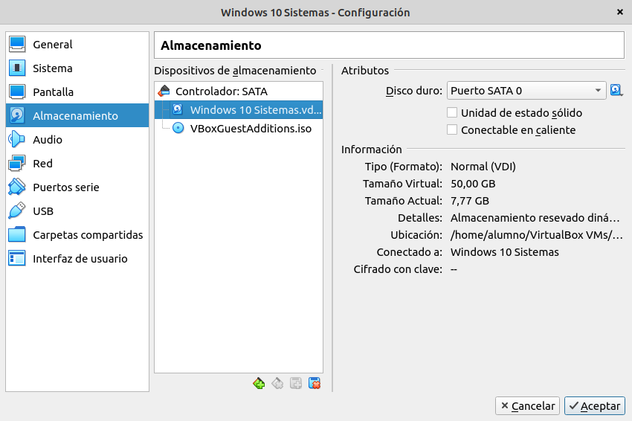
    - For doing this I clivk on that image that represent a hard disk and say, add hard disk
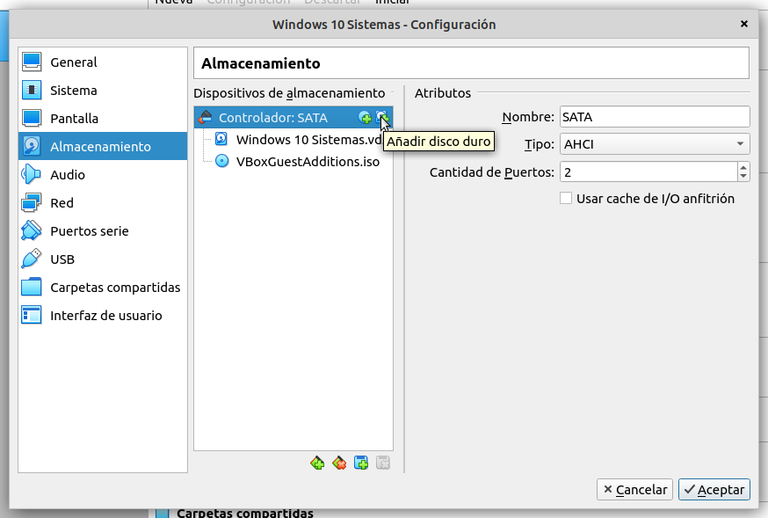
    - Then I click on create image disk
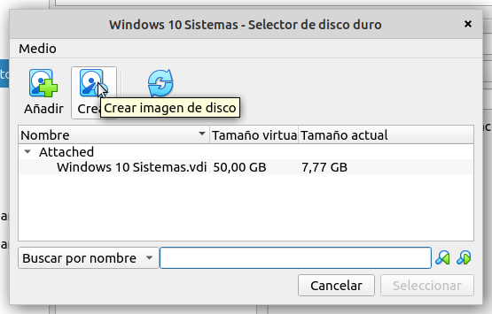
    - The next thing is to select the option VDI
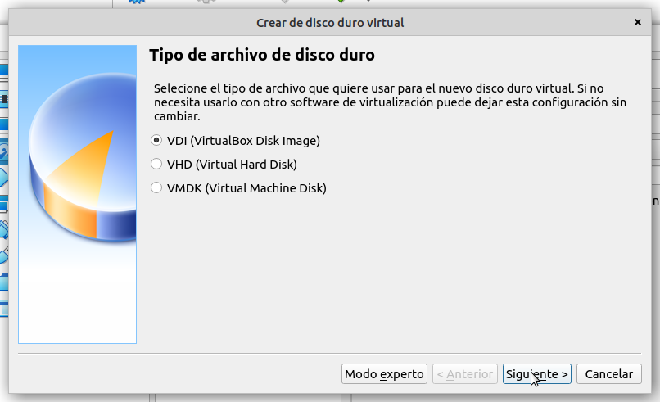
    - Now I clicked on dinamically reserved
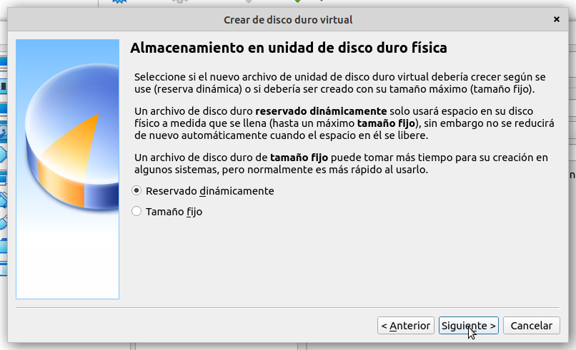
    - Finally I put 30 GB that are going to be empty
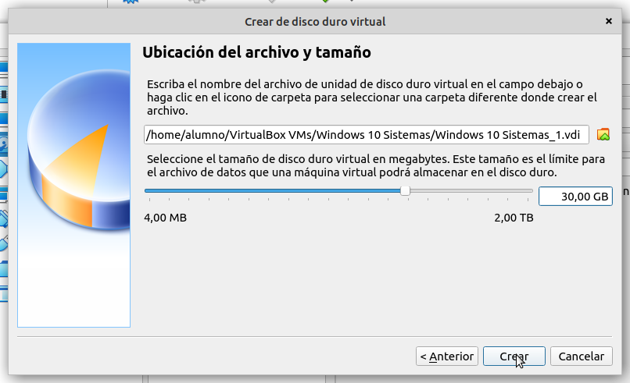
    - And here we can see how the new Hard disk is on the virtual machine
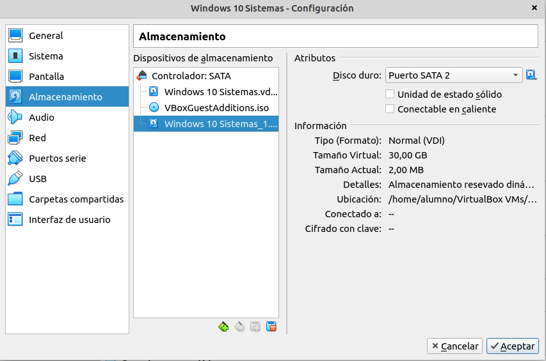

2.Install Windows 10 in the virtual machine from exercise 1. You must add the following settings:
- QUESTIONS:
• USB 3.0 support.
• Shared folders.
• Internet connection including access to the rest of computers of the network.
• You will be able to copy and paste from the host to the guest and vice versa.

- ANSWERS
  - 1. We cant install these option because the computer tell us to put the administrator password
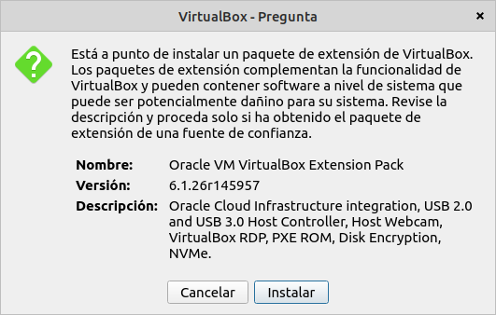

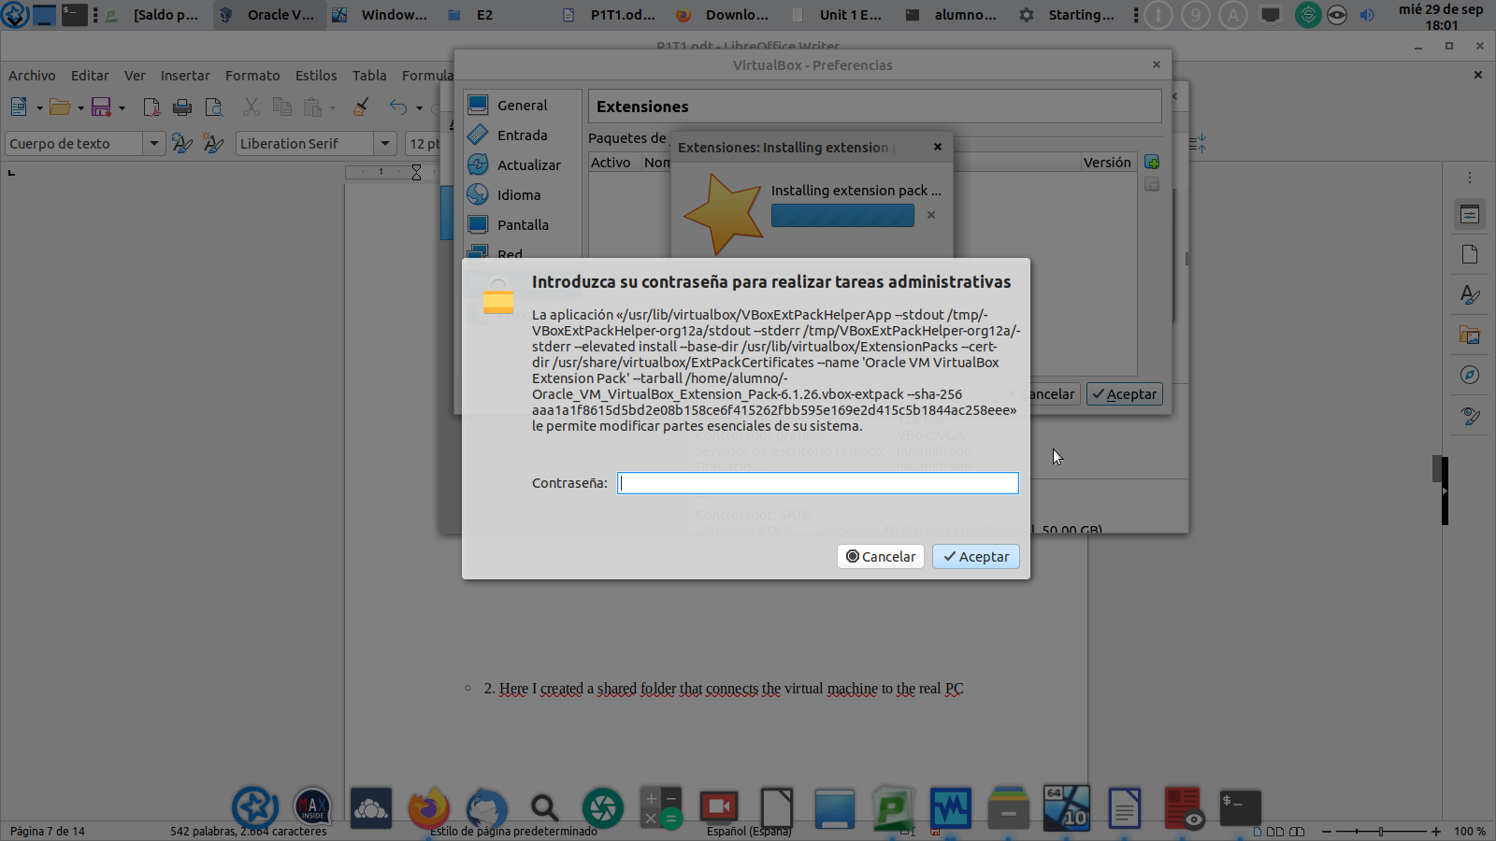

  - 2. Here I created a shared folder that connects the virtual machine to the real PC
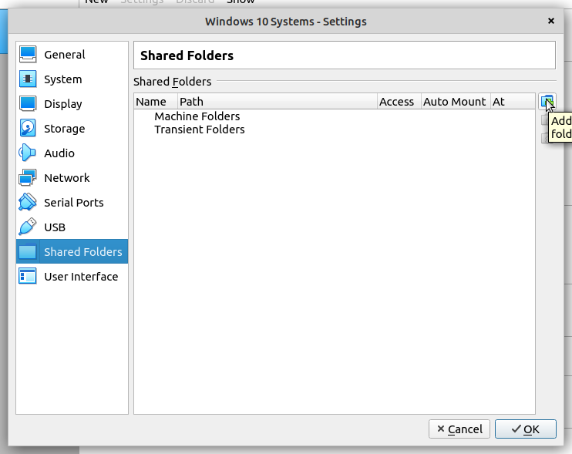
    - First I click on that icon on shared folders in settings
    - This are the settings I put on the shared folder, the name that i put to the folder is Shared_folder, and the path is were the folder is on the real PC
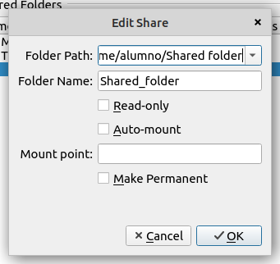
    - On the virtaul machine we can see that a folder was created on the network part, this folder is the shared folder
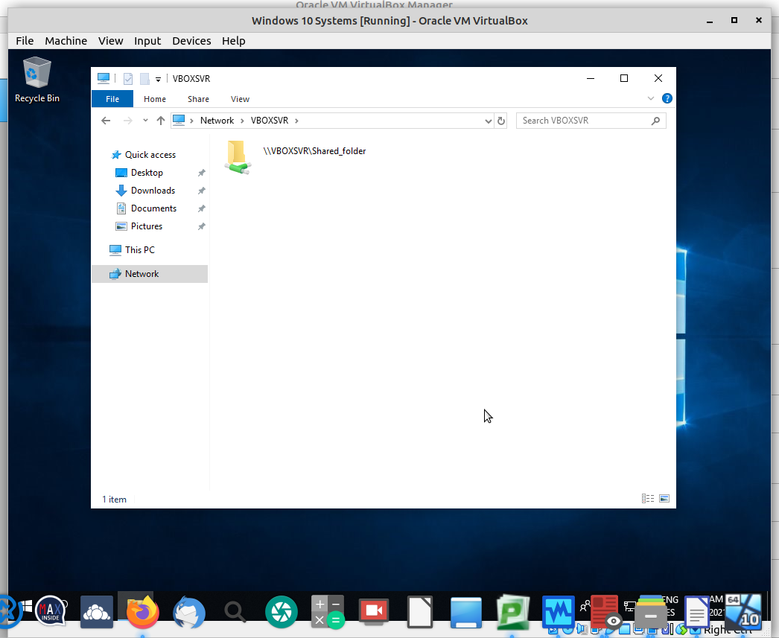
    - Finally we can see that on the real PC we have a folder that is called shared folder
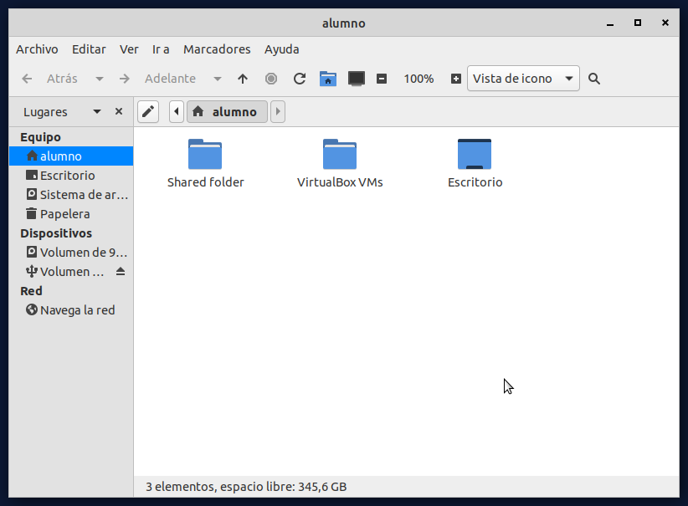

  - 3. Here we can see the configuration of the VM
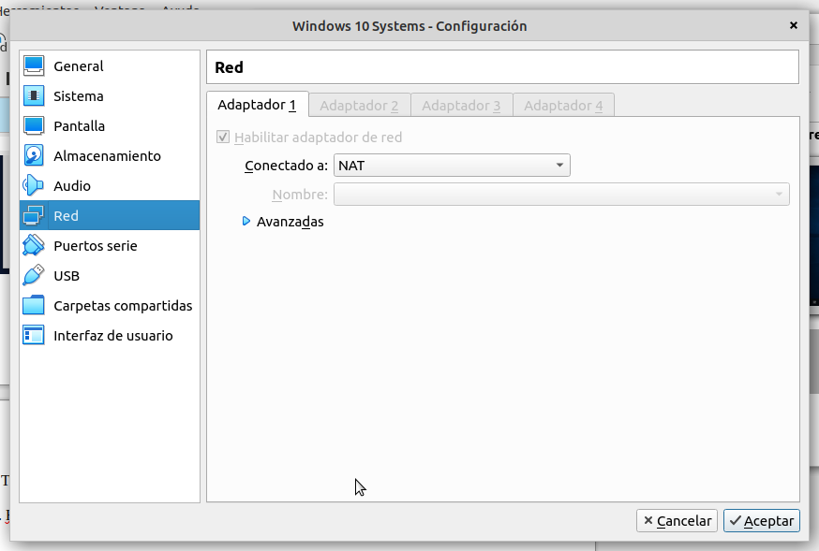
    - And here we can see how I ping from the VM to the real PC
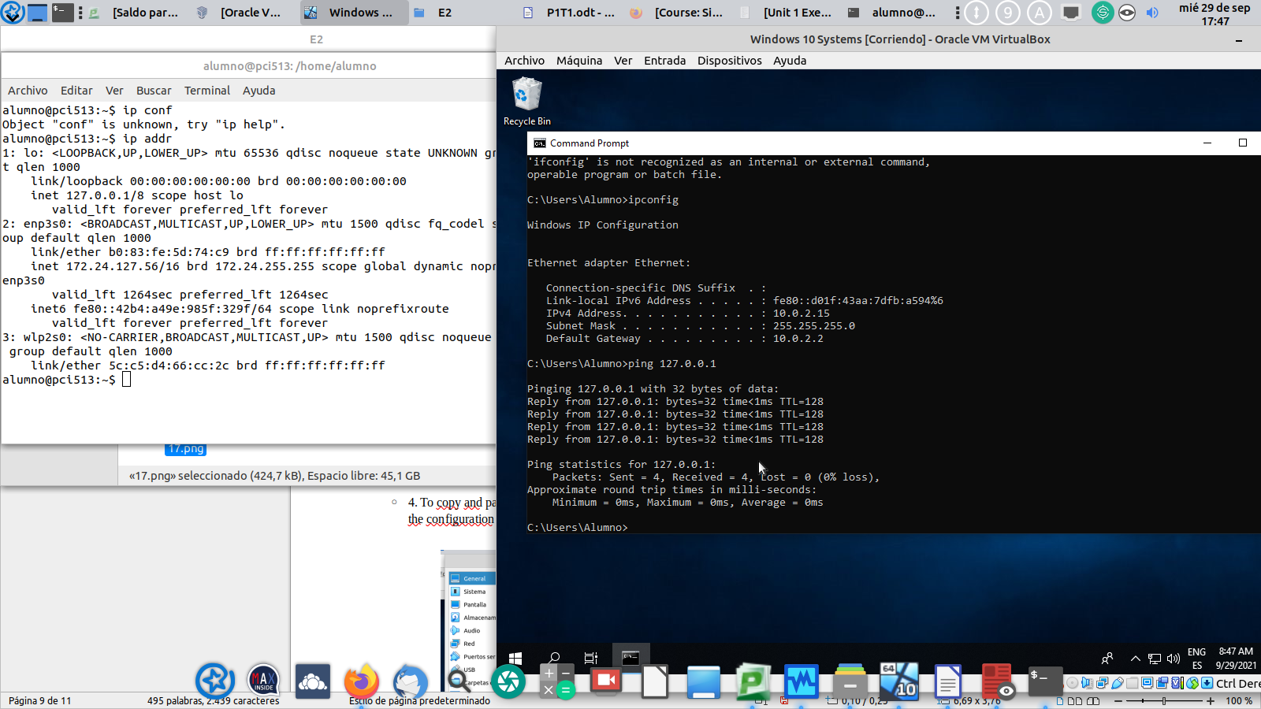
    - And here we can see how I have internet

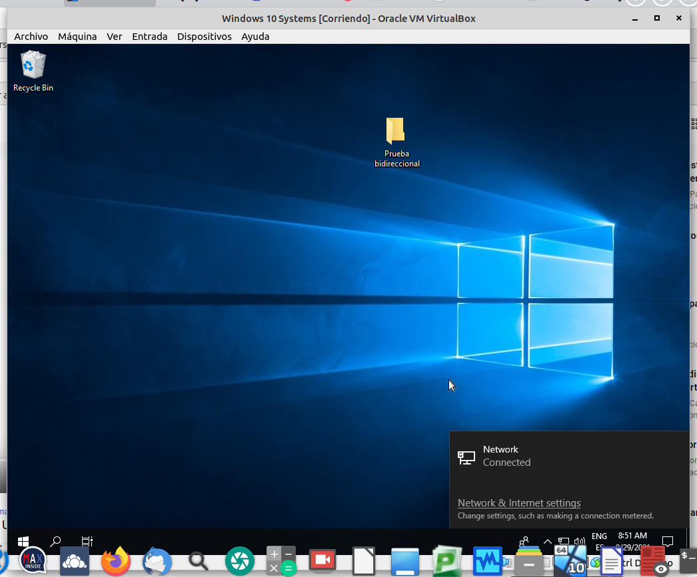

  - 4. To copy and paste from the VM and the real machine you need to put these options on the configuration of the VM. We need Guest additions to do this

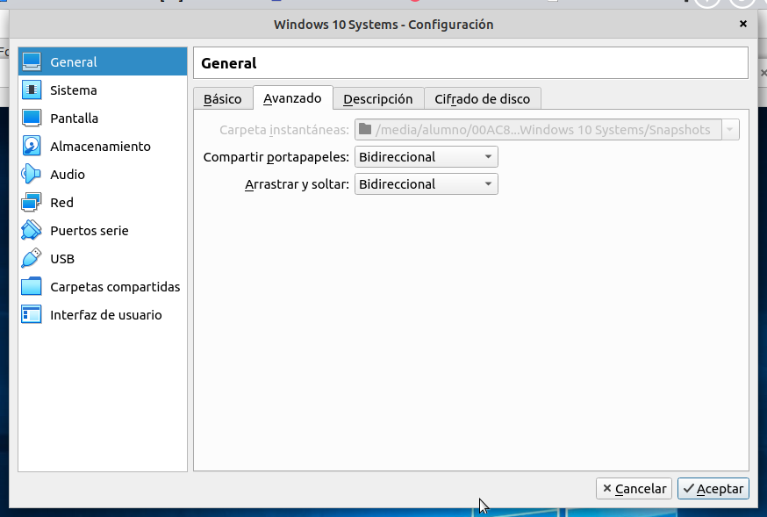

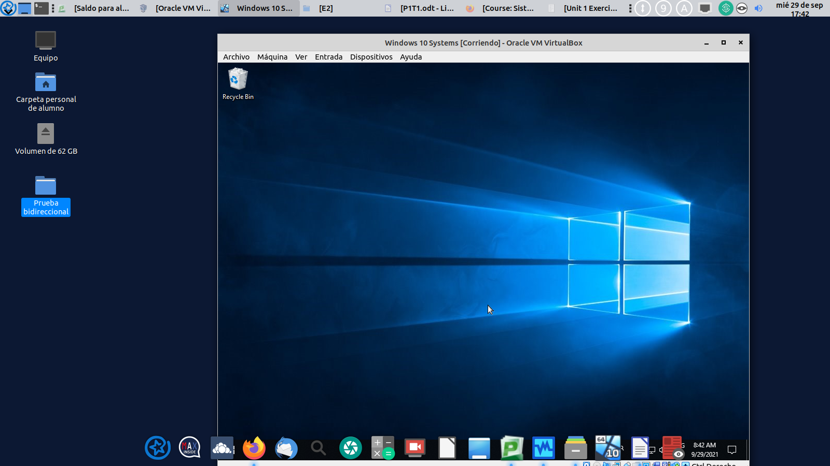
    - Here we can see how this work with the example “prueba bidereccional”

