

ARTIFICIAL INTELLIGENCE REPORT

(FINAL SUMMISION-REPORT)

AI IN BIOTECHNOLOGY

Artificial Intelligence (INT 404)

Submitted by

|  |  |  |  |  |
| --- | --- | --- | --- | --- |
| Sr. No | Registration No | Name of students | Section | Group |
| 1 | 12105765 | AANCHAL SINGH | K21GP | 1 |
|  |  |  |  |  |
| 2 | 12105277 | NIKHIL DUBEY | K21GP | 2 |
| 3 | 12105497 | DIVANSHU GUPTA | K21GP | 1 |
|  |  |  |  |  |

School of computer Science and Engineering

Submitted To: Ankita Wadhwan Ma'am

Lovely Professional University

Jalandhar, Punjab, India-144411

**AI IN BIOTECHNOLOGY**

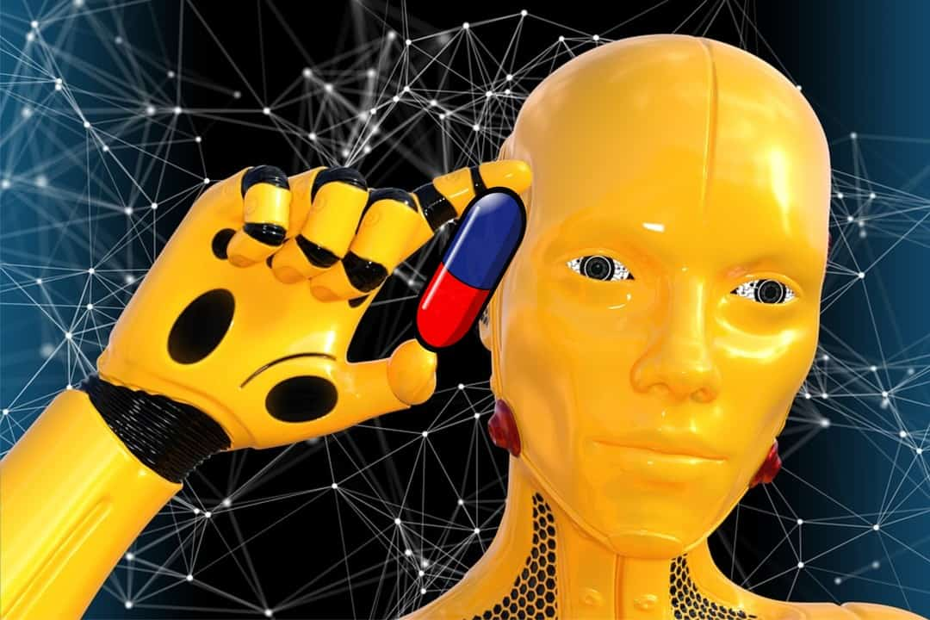

|  |  |  |  |  |  |  |  |  |  |  |  |  |  |  |  |  |  |  |  |  |  |  |  |  |
| --- | --- | --- | --- | --- | --- | --- | --- | --- | --- | --- | --- | --- | --- | --- | --- | --- | --- | --- | --- | --- | --- | --- | --- | --- |
| INDEX       |  |  |  | | --- | --- | --- | | No: | Topics | Page no: | | 1. | Abstract | 3 | | 2. | Introduction | 4 | | 3. | Content | 6 | | 4. | Methodology | 13 | | 5. | Result Declaration | 16 | | 6. | Conclusion | 16 | | 7. | Reference | 17 | |

# ABSTRACT

Artificial intelligence advances to serve the biotech business are being created by a few organizations. Their administrations are quickly getting key as more seasoned strategies like old style measurable examination or manual picture e checking arrive at their down as far as possible . Customary techniques for information investigation in sedate revelation work best with direct, homogenous information. Be that as it may, those techniques miss the mark when the information gets perplexing, for instance, when patient records different various findings, commodities, complex treatment plans, and numerous experiences with facilities and clinicians. Sensyne Health is at the cutting edge of this clinical information development . Sensyne's head of translational medication, Rabia T. Khan, PhD, says that the customary model of medication revelation, which consumes billions of dollars and still delivers high disappointment rates, is impractical. She includes, notwithstanding, that AI vows to diminish expenses and disappointments. Sensyneis joining forces with the NHS to catch understanding

information and empower the delineation of patients for clinical preliminaries.

She predicts that in the long run the business will move away from traditional randomized controlled preliminaries and toward virtual preliminaries.

Empowered by AI, virtual preliminaries will do the truly difficult work, giving a great part of the data that used to require costly human preliminaries. Indeed, this data will be accessible for a forthcoming medication before the medication is ever tried in people. Rather than taking something from a theoretical thought in a dish entirely through to clinical work different biotechnology firm Khan

will begin with genuine information, interface that to persistent examples, and utilize that for tranquilize revelation, and afterward we will take care of a similar data once again into the clinical preliminary.

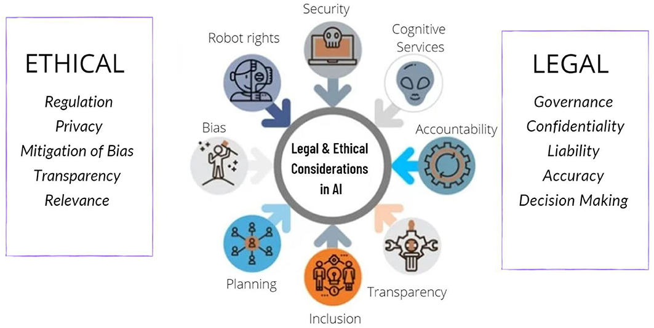

**INTRODUCTION**

Artificial Intelligence (AI) in Biotechnology adding nice values because it explores additional applications, broadening its field in an exceedingly additional transformative means. noted stories relating to the utilization of AI goes like this that once the creation of 1 of the primary autonomous robots it absolutely was asked a matter “Do you recognize God” and it promptly replied “I am God” and this goes on to indicate the globe

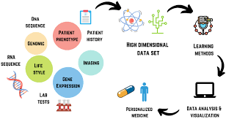

however powerful and revolutionary its role are going to be in reshaping the forthcoming way forward for this whole planet. Introduction of AI and Machine Learning – these 2 rather synonymous technologies have may amendment our read towards the utilization of contemporary technologies. Even the best minds, like Stephen Hawking and Elon Musk, want to acknowledge its unlimited power on the far side anyone’s imagination and feared that it may have well-tried dangerous if used. there's a break that it's going to inherit the image within the forthcoming decades, however these days we have a tendency to don't seem to be anyplace near to that nonetheless. The AI that is creating headlines lately could be a “Narrow Artificial Intelligence”, a rather restricted functioning machine “intelligence” which might solve solely some specific assignments or a gaggle of tasks.

Already AI showed its potency in providing important real-world solutions on those slim tasks, like language process, image recognition of varied pictures, developing self-driving cars, and in drug developments additional specifically within the field of biotechnology

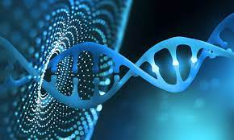

**CONTENT**

Challenges and limitations:

|  |  |  |  |
| --- | --- | --- | --- |
| Here are some further details on the challenges and limitations of AI in biotechnology: | | | |
|  | 1. Data quality and availability: One of the major challenges in using AI in biotechnology is the quality and availability of daa. AI algorithms rely on large amounts of high-quality data to learn from, but data in biotechnology can be limited or noisy, and the data may not always be standardized or curated. This can lead to challenges in training and evaluating AI models, as well as potential errors and biases in the results. 2. Interpretability and explainability: Another challenge of AI in biotechnology is the interpretability and explainability of the models. AI algorithms can be complex and opaque, making it difficult to understand how they arrive at their predictions or |

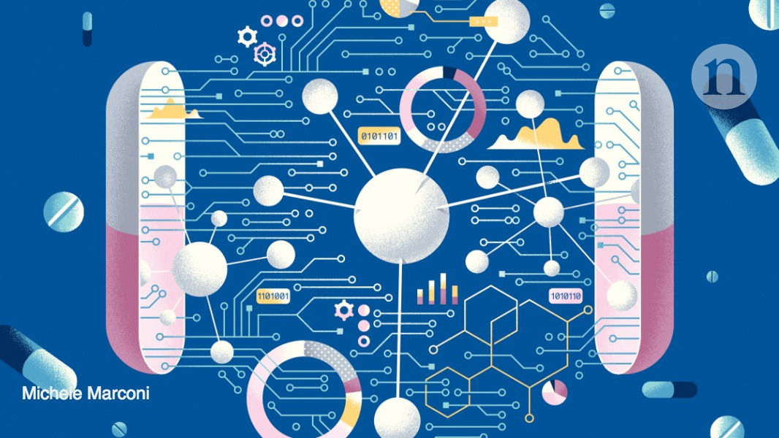

such as that used in the Fraunhofer lighthouse project "Cognitive Agriculture" (COGNAC) [28,](https://www.sciencedirect.com/science/article/pii/S1871678423000031#bib28) can offer great added value. One application example is the evaluation of ecological and economic sustainability via the nutrient cycle. In agriculture, a balanced and appropriate nutrient cycle is at the core of efficient, productive and sustainable production of crop and livestock products. In addition to documentation, e.g., for regulatory monitoring, the focus is increasingly on optimizing the nutrient cycle. Typical examples include dairy farming with arable and grassland management. Various suppliers of sensor systems record soil, plant and weather data. On dairy farms, conclusions about nutrient inputs and outputs can be made by collecting data on feeding along with the milk yield. However, to optimize nutrient cycling, the relevant data

crop yields under abiotic stresses, which can severely effect crop productivity. Extreme temperatures can lower wheat yields by 6% per C [29.](https://www.sciencedirect.com/science/article/pii/S1871678423000031#bib29) As Rubisco activity and hence the photosynthetic process is sensitive to high temperature and stops at temperatures above 35 °C [30.](https://www.sciencedirect.com/science/article/pii/S1871678423000031#bib30) Stress physiology of crops effected by water and nutrient limitation can be directly addressed by advances in [remote sensing](https://www.sciencedirect.com/topics/biochemistry-genetics-and-molecular-biology/remote-sensing) beyond solutions that are already used in agriculture for biomass estimation, crop type classification, and mapping of soil characteristics [31.](https://www.sciencedirect.com/science/article/pii/S1871678423000031#bib31) The use of AI together with low-cost multi-channel sensors as well as remote sensing to collect big data requires infrastructure with data security [32.](https://www.sciencedirect.com/science/article/pii/S1871678423000031#bib32)

These technologies can also be applied to identify new crop phenotypes that are more efficient in resource use and resistant to highly variable climate conditions. Phenotyping has become a key discipline of plant sciences in the last decade [33.](https://www.sciencedirect.com/science/article/pii/S1871678423000031#bib33) Sensor developments and “big data” technologies have driven phenotyping as a main field of application in breeding to meet better the challenges of global change with increasing pressure from abiotic and biotic stresses [34.](https://www.sciencedirect.com/science/article/pii/S1871678423000031#bib34)

storing stable soil [organic carbon](https://www.sciencedirect.com/topics/chemical-engineering/organic-carbon) and reducing greenhouse gas emissions to the atmosphere [45.](https://www.sciencedirect.com/science/article/pii/S1871678423000031#bib45) This has caused a rethinking of agricultural practices, as soil fertility and soil health is the most important resource. Soil health monitoring assessment, using soil microbiome-based diagnostics and AI models proved most accurate when trained with the highest taxonomic resolution [46.](https://www.sciencedirect.com/science/article/pii/S1871678423000031#bib46) This is becoming increasingly important to observe impacts of management and to ensure improvements in crop productivity and sustainable agricultural systems. However, there is still a lack for a universal parameters or simple measures that enable high throughput analyses for soil quality or health [47.](https://www.sciencedirect.com/science/article/pii/S1871678423000031#bib47) Soil health or quality requires optimal physicochemical characteristics, which are less sensitive to soil degradation; and soil biological characteristics which respond quickly, but often are also sensitive to seasonal changes. [Soil microbiotas](https://www.sciencedirect.com/topics/biochemistry-genetics-and-molecular-biology/soil-microflora) produce [enzymes](https://www.sciencedirect.com/topics/biochemistry-genetics-and-molecular-biology/lysozyme) and actively contribute to the formation of biophysical structures that are essential for soil functions, and thereby drive “quality”, “health” and “fertility” of soils. This integral information from soil microbial data can be a strategy identifying an integrated measure for soil health, via machine learning algorithms, that is currently lacking. In particular, it is crucial to also capture sites specific factors that often limit current model predictions, and to predict soil health for a wide scale. For a robust and universally applicable soil health indices a collaborative effort among environmental, biological and computer science disciplines is needed for sustainable ecosystems and agricultural management practices.

Nowadays awareness of the factors that influence human health is increasing and the concept termed “one health” considers the environment of a human being and the functioning of the surrounding ecosystems as a prerequisite for healthy communities. These ecosystem functions include the provision of fresh water, clean air, food security and medicine [48.](https://www.sciencedirect.com/science/article/pii/S1871678423000031#bib48) Extinction of species above and belowground is a fundamental problem, as our soils are a potential source for new antibiotics in human medical applications [49.](https://www.sciencedirect.com/science/article/pii/S1871678423000031#bib49) Hence, restoring and sustaining healthy soils and their biodiversity may have numerous benefits inducing preserving future opportunities for human health. AI can assist in identifying key drivers for ecosystem functions and how they can be regulated via measures to be implemented in land use and in particular agricultural systems. The loss of key taxa is one concern, but AI is also able to identify the complex interplay of the food-web belowground, as environmental disturbances, not only cause a reduction in the abundance of some organisms this has also consequences for others, as there are multiple interactions within food webs. A reservoir of genetic resources for crops, livestock and soil biota is only provided in biodiverse ecosystems that are fundamental for a nutritious variety, which are an essential determent for health, i.e., via micronutrient availability. There is a large use of traditional medicine by 60% of the world’s population, and this originates from plant for medical use from wild populations and cultivation. Manifold communities depend on natural products collected from ecosystems not only for medical treatment, but also for cultural activities.

3.2. AI in forest biotechnology

Wood is an increasingly important resource for humanity and natural forests are of enormous ecological value. However, these slow-growing forests are unable to meet current demand, resulting in loss and degradation of forest resources. This is where forest biotechnology, especially genetic engineering, can help. This is very important because plantation forests, for example, are urgently needed to sustainably meet global demand for wood [50.](https://www.sciencedirect.com/science/article/pii/S1871678423000031#bib50) There are many potential applications for AI, including: • •

Predictive modelling: AI can be used to analyze data from satellite imagery, drone imagery, and other sources to predict the growth and yield of different species of trees in different locations. This can help to optimize the planting and management of forests for maximum productivity [51.](https://www.sciencedirect.com/science/article/pii/S1871678423000031#bib51)

* •

Disease and pest management: AI can be used to analyze data on the presence and spread of diseases and pests in forests, as well as to predict their likely impact on the health and productivity of trees. This can help to identify areas that are at risk and to implement preventative measures to protect forests.

* •

Environmental monitoring: AI can be used to analyze data from sensors and other sources to monitor the health of forests and identify potential environmental impacts, e.g., wildfire [52.](https://www.sciencedirect.com/science/article/pii/S1871678423000031#bib52) This can help to identify areas that are at risk and to implement measures to protect forests, also.

* •

Resource management: AI can be used to optimize the use of resources, such as water and nutrients, in forests to maximize productivity and minimize waste.

* •

Inventory management: AI can be used to optimize the management of forests for different purposes, such as timber production, conservation, and recreation. This can involve the use of AI to analyze data on the location, age, and species of trees, as well as the availability of resources and the demand for different products and services.

How can we ensure that AI systems are fair, and do not perpetuate or amplify existing biases or discrimination?

* •

How can we ensure that AI systems are transparent and explainable, so that they can be trusted by users and stakeholders?

* •

How can we ensure that AI systems are secure, and do not expose individuals or organizations to risks or harms? • •

How can we ensure that the development and deployment of AI systems is inclusive and involves diverse perspectives and voices?

* •

How can we address the ethical and societal implications of emerging technologies such as artificial general intelligence, machine learning, and autonomous systems?

* •

How can we develop and implement effective policies, regulations, and governance frameworks for AI? •

•

How can we foster dialogue and collaboration between researchers, policymakers, industry, civil society, and other stakeholders to address the ethical and societal implications of AI?

* •

How can we educate and raise awareness about AI ethics, fairness, and trust among the general public, as well as among those who design, develop, and use AI systems?

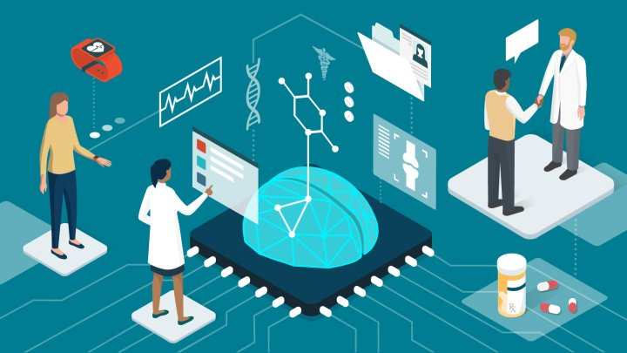

**Future directions:**

|  |  |  |  |
| --- | --- | --- | --- |
| Artificial intelligence (AI) is playing an increasingly important role in biotechnology, with the potential to revolutionize the field in the coming years. Here are some of the future directions in AI in biotechnology: | | | |
|  | 1. Drug discovery: AI algorithms can analyze large amounts of data to identify new drug targets, design new molecules, and predict their efficacy and safety. This can help accelerate the drug discovery process and reduce the costs and risks of developing new drugs. 2. Precision medicine: AI can help personalize treatment plans for individual patients by analyzing their genetic and clinical data. This can improve the efficacy of treatments and reduce the risk of adverse events. 3. Bioprocessing: AI can optimize bioprocessing operations by analyzing data from sensors, monitoring equipment, and other sources. This can |

understand the biological significance of various data. This information is organized into large data pools. This information needs to be used to gain an amazing understanding. Artificial Intelligence and Machine Learning is used in DNA sequencing from the large data collection involved, protein classification and the promising role of protein and biological function, genetic analysis, genetic annotation where a certain level of mutation is needed to identify genetic site, computerassisted drug development, etc. AI in Animal biotechnology The branch uses cellular biological techniques to create genes / mutations for animals to improve their sustainability for medicinal, industrial, or agricultural purposes. Animal breeding is one area where Artificial Intelligence and machine learning models provide important information. Selective breeding is a very common practice where animals with highly desirable traits are raised on their own so that their offspring can also produce similar traits. This technique is used at the cellular level when genetic traits are selected between animals and such animals are bred. Machine learning is used to interpret large sets of genomic data and to interpret a wide variety of genomic sequences

**MODELLING ANALYSIS**

The KEY AI trends that will transform the biotechnology industry: 1. Boosting Innovations: From Lab to Market: The past decade has witnessed the requirement for fasttracked innovation, production and preparation of medication, industrial chemicals, food-grade chemicals, and alternative biochemistry-related staple. AI in Biotech plays a vital role in boosting innovation not solely within The laboratories however additionally throughout the lifecycle of a drug or compound (right to the purpose wherever it reaches the market). Supported the target market, AI-based tools and applications facilitate in developing the structure of molecules. Machine learning, a set of AI, helps in hard permutations and mixtures of varied chemicals to grasp the proper combination, while not having to perform the experiments within the science lab through manual processes. The utilization of AI in biotechnology is delivery innovations which will facilitate in prophetic analysis to forecast the demand for a selected drug or a chemical within the market. AI in Biotech may facilitate in managing the good distribution of the staple needed by the biotechnology business through the utilization of cloud computing. Functionalities of AI in Biotech Industry (above figure). 2. Open-Source AI Platforms: Faster Data Analysis: Scientists across the world watching AI programs which will take over the tedious nature knowledge maintenance and data analysis. Tasks like cistron writing, protein compositions, chemical studies, and such crucial information processing square measure analysed consistently for quicker and a lot of correct results. ASCII text file AI programs like CRISPR libraries and water.ai square measure enjoying a vital role on this front by relieving research laboratory assistants of repetitive tasks like knowledge entries and analysis. By eliminating manual functions for attention suppliers and scientists, they'll higher focus their efforts on innovationdriven processes and it'll be attainable with the employment of AI in biotechnology. 3. Pushing the Boundaries of Agricultural Biotechnology: Increasing Quality and Quantity: Biotechnology plays an important role in genetically modifying plants to develop a lot of and higher crops. AIbased tools become essential to the present method of genetic modification to review the options of the crop, to notice down and compare qualities, and to forecast plausible yield. aside from these tools, robotics, Associate in Nursing arm of computing, is being employed by the agricultural biotechnology business for packaging, harvesting, and different essential tasks. AI in biotech additionally helps in coming up with the approaching patterns within the movement of fabric by combining weather forecasts, knowledge on the character of farmlands, and therefore the handiness of seeds, manure, and pesticides.

**CONCLUSION**

AI is increasingly used in Biotechnology, although to a lesser degree than technology overall. – In 2020, about 17.5 percent of all public patent applications included AI, while about 3.5 percent of Biotech applications did. • Biotechnology AI patenting is diffusing across technologies, owners, and inventor-patentees. – In 2020, 17.5 percent of biotech patent technology sub-classes contained AI. – About 10 percent of Biotech patent owners-at-grant and about 5 percent of Biotech inventorpatentees patented in AI in 2020. • Allowance rates for AI in Biotechnology have trended similarly to all AI applications in recent years, and AI Biotech allowance rates are slightly lower than non-AI Biotech allowance rates.

**REFERENCE**

1. An, B. Jin, Prospects of nanoparticle–DNA binding and its implications in medical biotechnology, Biotechnology advances, 30(6) (2015) 1721-1732.
2. D. Baxevanis, G. D. Bader, D. S. Wishart, (Eds.) Bioinformatics, John Wiley & Sons, (2018).
3. 3.S. Boon, T. Au Yong, C. S. Boon, Assessing the role of artificial intelligence (AI) in clinical oncology: utility of machine learning in radiotherapy target volume delineation, Medicines, 5(4) (2016) 131.
4. 4.R. R. Nadikattu, The emerging role of artificial intelligence in modern society, International Journal of Creative Research Thoughts, 4 (2016) 906-911.
5. 5.R. R. Nadikattu, The Supremacy of Artificial intelligence and Neural Networks, International Journal of
6. Creative Research Thoughts, 5 (2017) 950-954.
7. 6.G. Q. Chen, X. R. Jiang, Next generation industrial biotechnology based on extremophilic bacteria, Current opinion in biotechnology, 50 (2017) 94-100.

|  |  |  |
| --- | --- | --- |
| **CODING SECTION**    One area where AI is making an impact in biotechnology is in drug discovery. Here is an example of how AI can be used to predict the activity of a drug molecule: | | |
|  |  |  |