Game Design Document

Fill up the following document

1. Write the title of your project:

Forrest of Nightmares (Working title)

1. What is the goal of the game?

Playing it

1. Write a brief story of your game.

You are camping in a forest when you friend starts acting weird. After you try to help him, he starts running towards you like a wild animal. Panic-stricken you run in the opposite direction. After you escape the woods, you run towards the town nearby and call the police. Thy find and capture you friend. After questioning you they send you to your hotel, where you find an envelope containing a letter addressed to you which says that the sender knows what happened and they can help you.

(Part 2) You run from the cops to their mansion in the middle of nowhere, and find out that they are insane and that they caused your friend in a feral animal, They want to make millions more to use as super soldiers. So now you run from them and blow up their mansion in the process and when you go back you learn that your friend turned back to normal, so the police let you off the hook.

1. Which are the playing characters of this game?

* Playing characters are the ones who respond to the user based on the input from the user.
* Cars, monkeys, dinos, wizards, etc., are the playing characters in the game.

|  |  |  |
| --- | --- | --- |
| Number | Character Name | What can this character do? |
| 1 | William Jakson | RUN |
| 2 | Jake Ronalds | RUN |
| 3 | Oliver Wilson | EAT YOU |
| 4 | Dr. James Jonas (DR.JJ lmao) | Make you friend eat you also make an army of human weapons and stuff. Is a mad scientist |
| 5 | Ofc. James Ramsey | Arrest you |
| 6 | Ofc. Janson Cootes | Arrest you |
| 7 | Dr Meredith Pierce | Heal you |
| 8 |  |  |

1. Which are the Non-Playing Characters of this game?

* Non-Playing characters are the ones that don't have an action or behavior when the user interacts with the game.
* Hurdles, stones, bananas, coins, etc., are non-playing characters in the game.

|  |  |  |
| --- | --- | --- |
| Number | Character Name | What can this character do? |
| 1 | coins | Give u points |
| 2 | rocks | Obstruct you |
| 3 | Dr. JJ’s Monster | End you by eating you. |
| 4 | Walls | Contain u |
| 5 | Trees | Stop u |
| 6 | Tree Stumps | Obstruct you |
| 7 |  |  |
| 8 |  |  |

Draw your imagination of this game. What does this game look like?

* Draw the game either on your computer or on paper.
* Add images of the game scenes to show each of the playing and non-playing characters at least once.

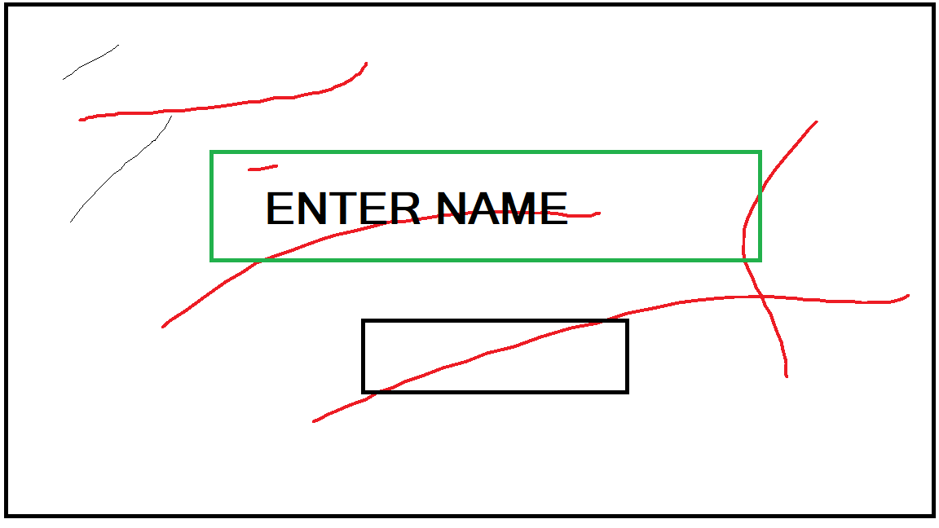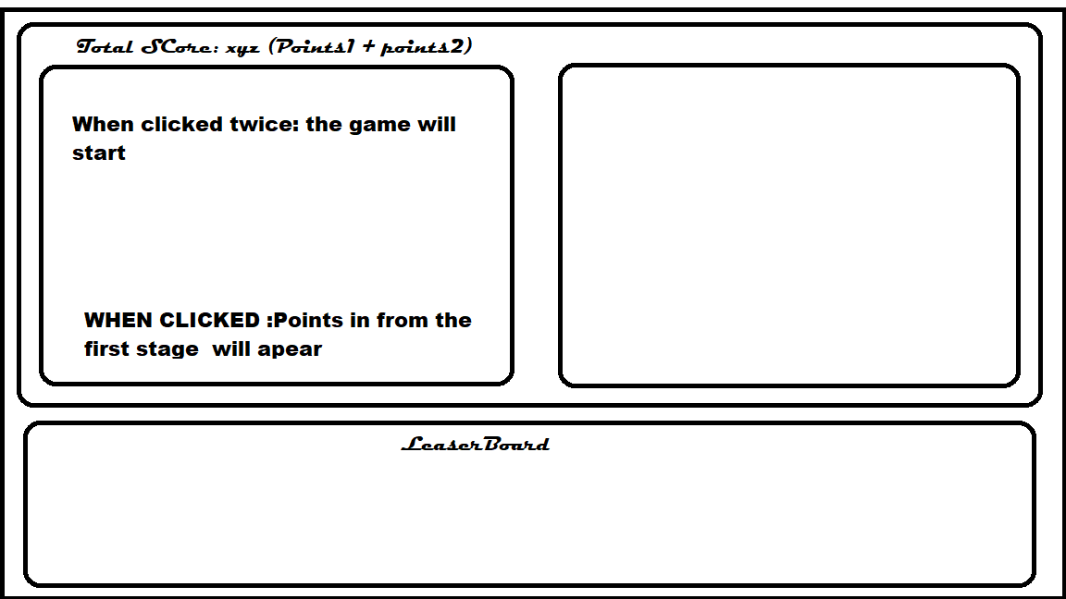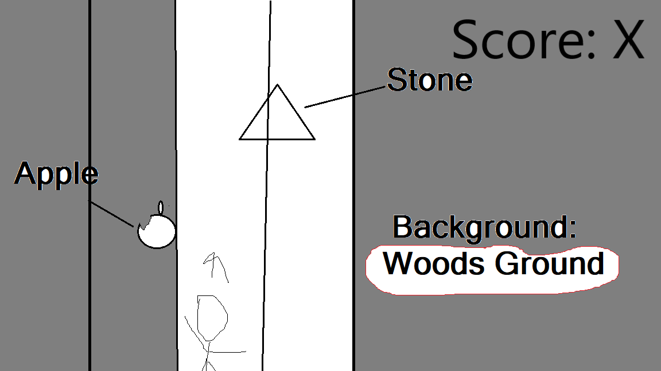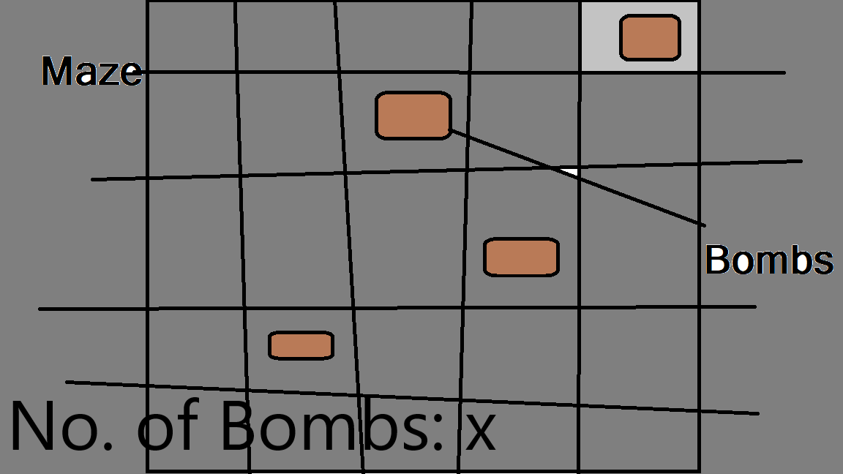

How do you plan to make your game engaging?

Make it good.