

Data Structure Assignment- 1
Course Code: ENCS205

TITLE:
Weather Data Storage using Arrays
(Python Implementation)

Name: Aabha Tomar
Roll no. 2401420005
Semester: 3rd, B. Tech CSE

INTRODUCTION

This project implements a simple weather data storage system using python.
The system uses a 2D array (rows= years, columns= cities) to store sparse temperature data.
Each entry represents the temperature of a particular city in a given year.
A sentinel value (-999) is used to represent missing data.

This project also demonstrates basic operations such as insertion, deletion, retrieval, and traversal of data. Additionally, it highlights the concepts of row-major and column major access in arrays, which are important for understanding how data is stored and accessed in memory.

OBJECTIVES

- To implement a Weather Data Storage System using arrays in python.
- To learn how 2D arrays can represent real-world tabular data (years * cities).
- To perform basic operations: Insert, Delete, and Retrieve weather records.
- To understand row-major and column major access in arrays.
- To handle sparse data using sentinel value (-999).

SYSTEM DESIGN

Classes Implemented:

- WeatherRecord: Stores individual weather data entries (date, city, temperature).
- WeatherDataStorage: Implements a 2D array for years*cities and manages operations.

Operations Supported:

- insert(year, city, temp): Store temperature
- delete(year, city): Remove a record (replace with sentinel).
- retrieve(year, city): Fetch temperature for a given city & year.
- row_major_access(): print data row by row.
- column_major_access(): print data column by column.

IMPLEMENTATION

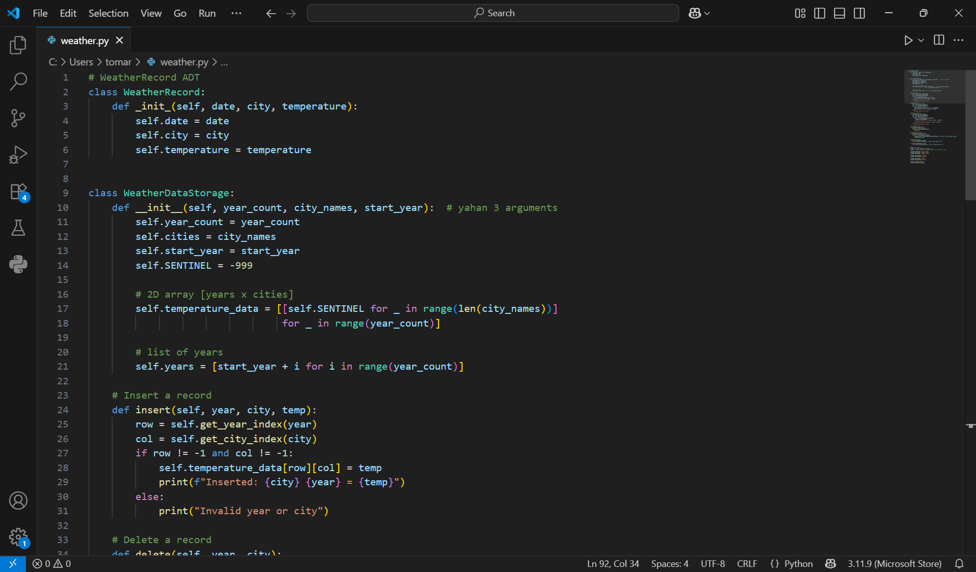

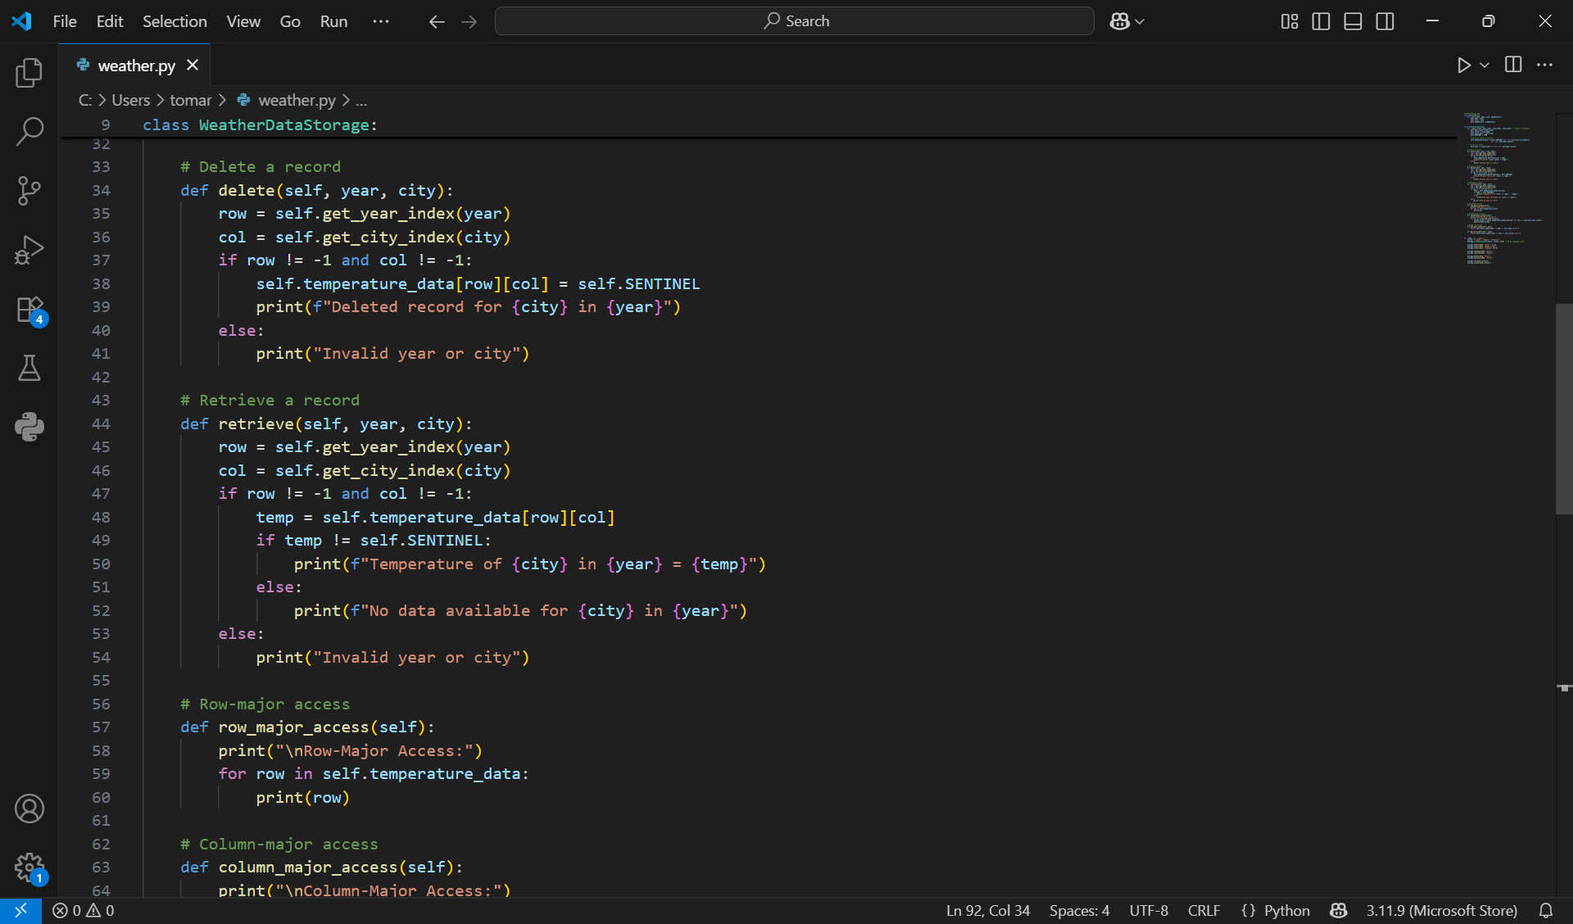

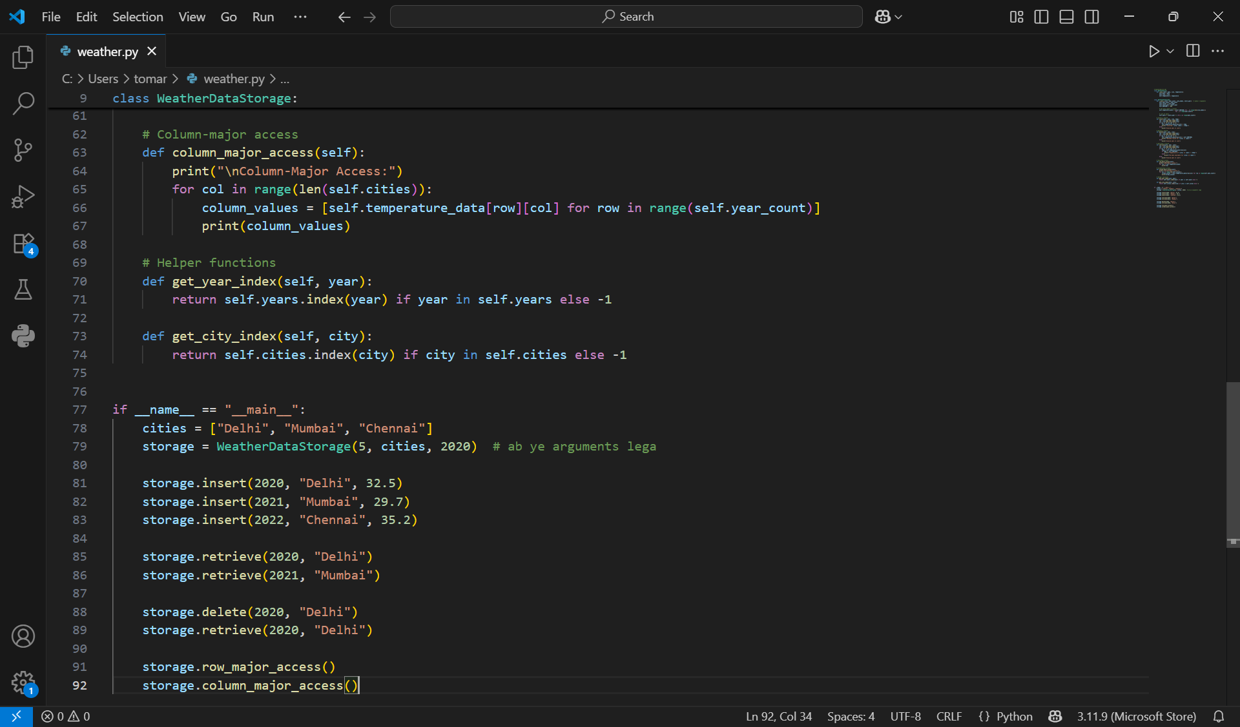

OUTPUT

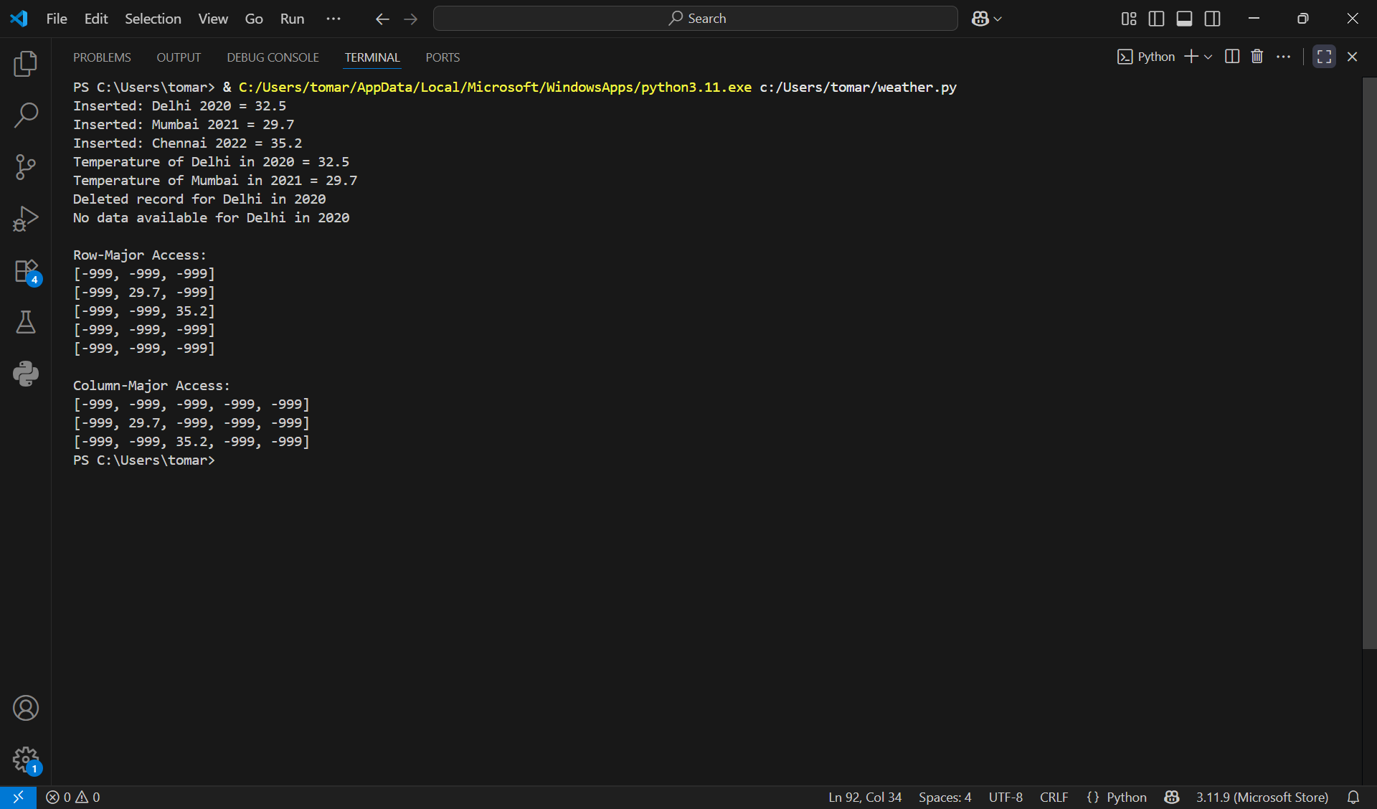

COMPLEXITY ANALYSIS

- Insert: O(1) (direct indexing by year & city)

- Delete: O(1)

- Retrieve: O(1)

- Row-Major Access: O(N × M), where N = years, M = cities

- Column-Major Access: O(N × M)

CONCLUSION

This project successfully demonstrates how a 2D array can be used to implement a simple Weather Data Storage ADT.
The system supports insertion, deletion, retrieval, and traversal (row-major and column-major) efficiently.
It provides hands-on practice of array data structure concepts and shows how arrays can be applied to a real-world scenario like weather monitoring.

