**Prediction of Credit Risk Using South German Bank**

**Wireframe Documentation**

Table of Content

1. Home Page 3
2. Result page 4
3. Data Status Page 5

# Home Page

We have decided to create design of Prediction of Credit Risk Using South German Bank Data project front page in such way that user can insert their value to their requirement in flexible Manner.

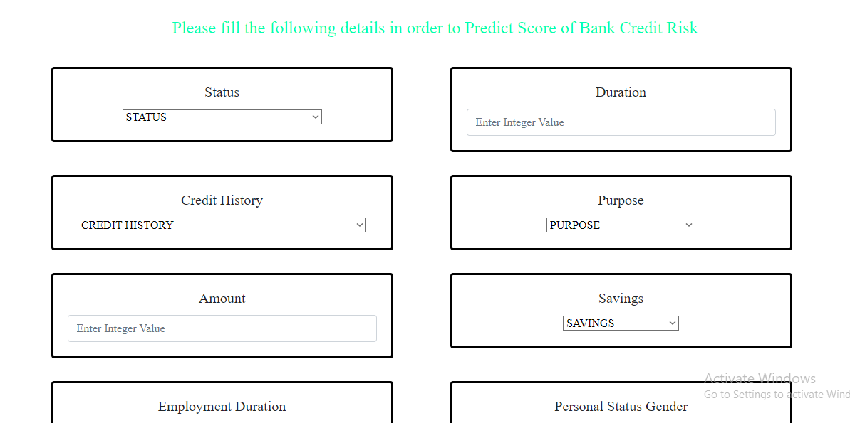

# Result Page

**Figure: - Result Page of Project**

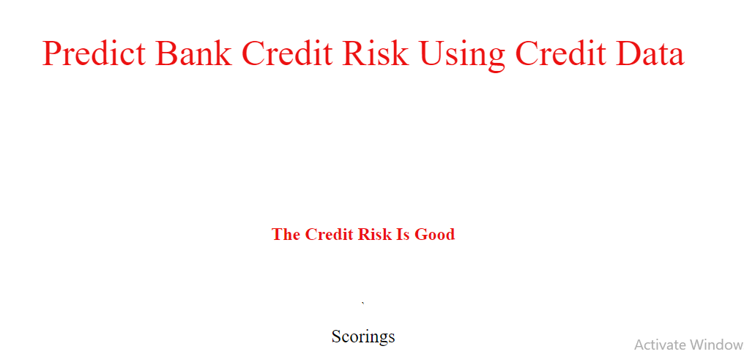

# Data Status Page



**Figure: Status Page**