# HIGH LEVEL DESIGN (HLD)

**Predict Credit Risk Using South German Bank Data**

Revision Number: 1.0

Revision: 10.07.2022

# Document Version Control

|  |  |  |  |
| --- | --- | --- | --- |
| **Date Issued** | **Version** | **Description** | **Author** |
| 10.07.2022 | 1.0 | 1. Document Created | `Abhishek |
|  |  |  |  |
|  |  |  |  |



**Content**

|  |  |  |
| --- | --- | --- |
| **Sr. No.** | **Details** | **Page No.** |
| 1 | Introduction | 2 |
|  | 1.1 Why This High Level Document | 2 |
|  | 1.2 Scope | 2 |
|  | 1.3 Definitions | 2 |
|  | 1.4 Overview | 2 |
|  | 1.5 Uses | 3 |
|  | 1.6 Application | 3 |
| 2 | General Description | 4 |
|  | 2.1 Product Perspective | 4 |
|  | 2.2 Problem Statement | 4 |
|  | 2.3 Proposed Solution | 4 |
|  | 2.4 Technical Requirement | 5 |
|  | 2.5 Data Requirements | 5 |
|  | 2.6 Tool Used | 7 |
|  | 2.7 Constraint | 8 |
| 3 | Design Details | 9 |
|  | 3.1 Process Flow | 9 |
|  | 3.2 Deployment Process | 9 |
|  | 3.3 Event log | 10 |
|  | 3.4 Error Handling | 10 |
| 4 | Performance | 11 |
|  | 4.1 Reusability | 11 |
|  | 4.2 Application Compatibility | 12 |
|  | 4.3 Resource Utilization | 12 |
|  | 4.4 Deployment | 12 |
|  | 4.5 User Interface | 13 |
| 5 | Conclusion | 14 |

## Abstract

This dataset classifies people described by a set of attributes as good or bad credit risks. The data comes in two formats one all numeric & one comes with a cost matrix. The analysis of credit risk depends on the feature that is given in the dataset. There are 20 features available in dataset and one target feature credit risk is present. Total no. of records is 1000 and there is no duplicate value or missing value is present in the dataset. Out of 1000 records 700 records are good risk and 300 records are bad credit risk. The given classification in which the good credit risk is denoted by 1 and bad credit risk is denoted by 0. Two dataset are provided the original dataset, in the form provided by Prof. Hofmann, contains categorical/symbolic attributes and is in the file "German Data". This file has been edited and several indicator variables added to make it suitable for algorithms which cannot cope with categorical variables. Several attributes that are ordered categorical ` have been coded as integer. This was the form used by Stat Log.

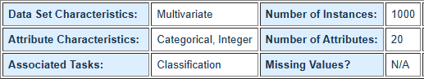

## Introduction

### Why This High-Level Design Document

The purpose of this High Level Design (HLD) Document is to add the necessary detail to the current project description to represent a suitable model for coding. This document is also intended to help detect contradictions prior to coding, and can be used as a reference manual for how the modules interact at a high level.

### Scope

The HLD documentation presents the structure of the system, such as the database architecture, application architecture (layers), application flow (Navigation), and technology architecture. The HLD uses non-technical or mildly-technical terms which should be understandable to the administrators of the system.

### Definitions

Below are given the short form some term that are used in the document.

**Term Definitions**

**Database** Collection of all the information monitored by this system

**CR** Credit Risk

**CD** Credit Data

**IDE** Integrated Development Environment

**AWS** Amazon Web Service

### Overview

The HLD will:

* + - present all of the design aspects and define them in detail
    - describe the user interface being implemented
    - describe the hardware and software interfaces
    - describe the performance requirements
    - include design features and the architecture of the project

### Uses

* This document is designed to help in operational requirement and can be used as a reference manual for how the modules interact.
* HLD briefly describes about the platforms/products/services/processes, flow of traffic that it depends on and includes any important changes that need to be made to them.
* HLD is the input for creating the LLD (Low Level Design) since the key communication items are displayed in HLD which are then converted to detailed communication in LLD, showing connectivity and physical level

### Application

1. Website Development
2. Application Development
3. Data Science Project

## General Description

### Product Perspective

The prediction of credit risk using the South German Bank data application use for to check the whether the person credit risk is good or bad. The credit risk is useful to check that the person is having good credit risk or bad for the loan. In dataset each row represents the each person different conditions.

### Problem Statement

Usually most of the bank's wealth is obtained from providing credit loans so that a marketing bank must be able to reduce the risk of non-performing credit loans. The risk of providing loans can be minimized by studying patterns from existing lending data. One technique that you can use to solve this problem is to use data mining techniques. Data mining makes it possible to find hidden information from large data sets by way of classification. The goal of this project, you have to build a model to predict whether the person, described by the attributes of the dataset, is a good (1) or a bad (0) credit risk.

### Proposed Solution

Credit risk is the possibility of a loss resulting from a borrower's failure to repay a loan or meet contractual obligations. Traditionally, it refers to the risk that a lender may not receive the owed principal and interest, which results in an interruption of [cash flows](https://www.investopedia.com/video/play/what-is-cash-flow/) and increased costs for collection. [Excess cash flows](https://www.investopedia.com/terms/e/excess-cash-flow.asp) may be written to provide additional cover for credit risk. When a lender faces heightened credit risk, it can be mitigated via a higher coupon rate, which provides for greater cash flows. Although it's impossible to know exactly who will default on obligations, properly assessing and managing credit risk can lessen the severity of a loss. Interest payments from the borrower or issuer of a debt obligation are a lender's or investor's reward for assuming credit risk. So from the above problem statement we can consider the some of the input parameter that are required to the calculation of credit risk.

### Technical Requirements

In this Project the requirements to gather data from the client for the predictions of credit risk. For that we are using the different technologies. Below are some requirements for this project.

* Model should be exposed through API or User Interface, so that anyone can test model.
* Model should be deployed on cloud (Azure, AWS, and GCP) or Heroku for the public used.
* Cassandra database should be integrated in this project for storing the client data and then from that we can take it for the further purpose.

### Data Requirements

Data Requirement completely depends on our problem. For training and testing the model, we are using South German Credit Dataset. Here are the features in dataset

|  |  |  |  |  |
| --- | --- | --- | --- | --- |
| Sr.  No. | Column name | Variable name | Description | Data Content |
| 1 | Laufkont | Status | Status of the debtor's checking account with the bank | A11 : ... < 0 DM  A12 : 0 <= ... < 200 DM  A13 : ... >= 200 DM / salary assignments for at least 1 year A14 : no checking account |
| 2 | Laufzeit | Duration | Credit duration in  months | Duration in month |
| 3 | Moral | Credit_history | History of compliance with previous or concurrent credit contracts | A30 : no credits taken/ all credits paid back duly  A31 : all credits at this bank paid back duly  A32 : existing credits paid back duly till now  A33 : delay in paying off in the past  A34 : critical account/ other credits existing (not at this bank) |
| 4 | Verw | Purpose | Purpose for which the | A40 : car (new) |
|  |  |  | credit is needed | A41 : car (used) |
|  |  |  |  | A42 : furniture/equipment |
|  |  |  |  | A43 : radio/television |
|  |  |  |  | A44 : domestic appliances |
|  |  |  |  | A45 : repairs |
|  |  |  |  | A46 : education |
|  |  |  |  | A47 : (vacation - does not |
|  |  |  |  | exist?) |
|  |  |  |  | A48 : retraining |
|  |  |  |  | A49 : business |
|  |  |  |  | A410 : others |

|  |  |  |  |  |
| --- | --- | --- | --- | --- |
| 5 | Hoehe | Amount | Credit amount | Credit amount |
| 6 | Sparkont | Savings | Debtor's savings | A61: ... < 100 DM  A62: 100 <= ... < 500 DM A63: 500 <= ... < 1000 DM A64: >= 1000 DM  A65 : unknown/ no savings account |
| 7 | Beszeit | Employment_durati on | Duration of debtor's employment with current employer | A71: unemployed A72: ... < 1 year  A73: 1 <= ... < 4 years A74: 4 <= ... < 7 years  A75: >= 7 years |
| 8 | Rate | Installement _rate | Credit installments as a  percentage of debtor's disposable income | Instalment rate in percentage of disposable income |
| 9 | Famges | Personal_status_sex | Combined information on sex and marital status | Personal status and sex  A91 : male : divorced/separated A92 : female : divorced/separated/married A93 : male : single  A94 : male : married/widowed A95 : female : single |
| 10 | Buerge | Other_debtors | Is there another debtor or a guarantor for the credit? | Other debtors / guarantors A101 : none  A102 : co-applicant A103 : guarantor |
| 11 | Wohnzeit | Present_residence | Length of time (in years) the debtor lives in  the present residence | Present residence since |
| 12 | Verm | Property | The debtor's most valuable property | A121 : real estate  A122 : if not A121 : building society savings agreement/ life insurance  A123 : if not A121/A122 : car or other, not in attribute 6  A124 : unknown / no property |
| 13 | Alter | Age | Age in years | Age in years |
| 14 | Weitkred | Other_installment_p lans | Installments plans from providers other than the  credit-giving bank | A141 : bank A142 : stores  A143 : none |
| 15 | Wohn | Housing | Type of housing the debtor lives in | A151 : rent  A152 : own A153 : for free |
| 16 | Bishkred | Number_credit | Number of credits including the current one the debtor has (or  had) at this bank | Number of existing credits at this bank |

|  |  |  |  |  |
| --- | --- | --- | --- | --- |
| 17 | Beruf | Job | Quality of debtor's job | A171 : unemployed/ unskilled - non-resident  A172 : unskilled - resident A173 : skilled employee / official  A174 : management/ self- employed/  highly qualified employee/ officer |
| 18 | Pers | People_liable | Number of persons who  financially depend on the debtor | Number of people being liable to provide maintenance for |
| 19 | Telef | Telephone | Is there a telephone landline registered on  the debtor's name? | A191 : none  A192 : yes, registered under the customer’s name |
| 20 | Gastarb | Foregin_worker | Is the debtor a foreign  worker? | A201 : yes  A202 : no |
| 21 | Kredit | Credit_risk | Has the credit contract  been complied with (good) or not (bad)? | (1 = Good, 2 = Bad) |

.

### Tools Used

Python programming language and frameworks such as NumPy, Pandas, Scikit-learn,

Flask and algorithm are used to build the whole model.

* Cassandra is used to insert, delete, retrieve and update the database.
* For visualization of the plots, Matplotlib, Seaborn and Plotly are used.
* AWS & Heroku are used for deployment of the model.
* Front end development is done using HTML/CSS
* Python flask is used for backend development.
* Jupyter notebook is used for EDA purpose.
* GitHub is used as version control system.
* VS Code Is Used as IDE.
* PyCharm is used as IDE.

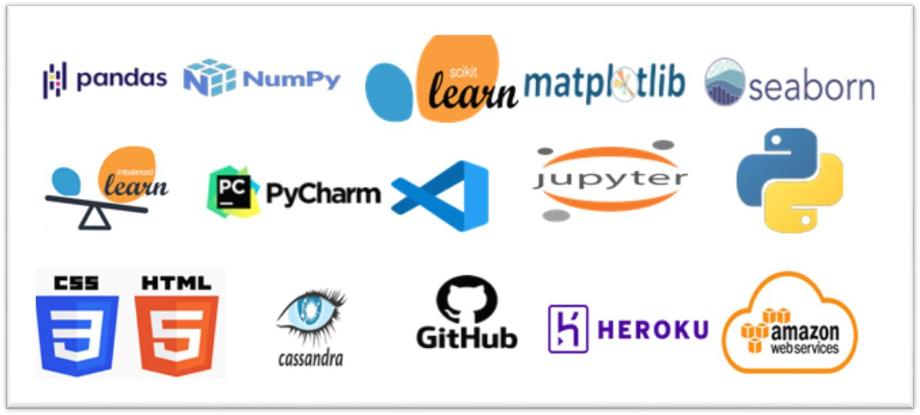

### Constraint

**Figure: - the entire library used in project**

The prediction of credit risk using bank data system must be user friendly, errors free and users should not be required to know any of the back-end working.

## Design Details

### Process Flow

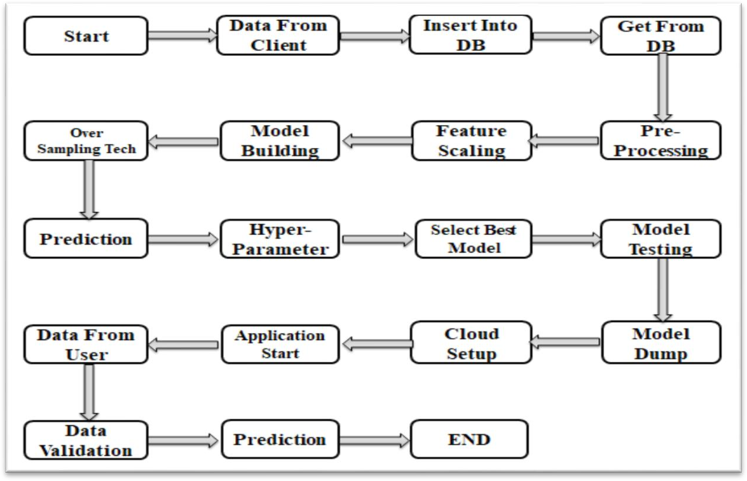

* 1. **Deployment Flow**

**Figure: - The entire Project Flow**

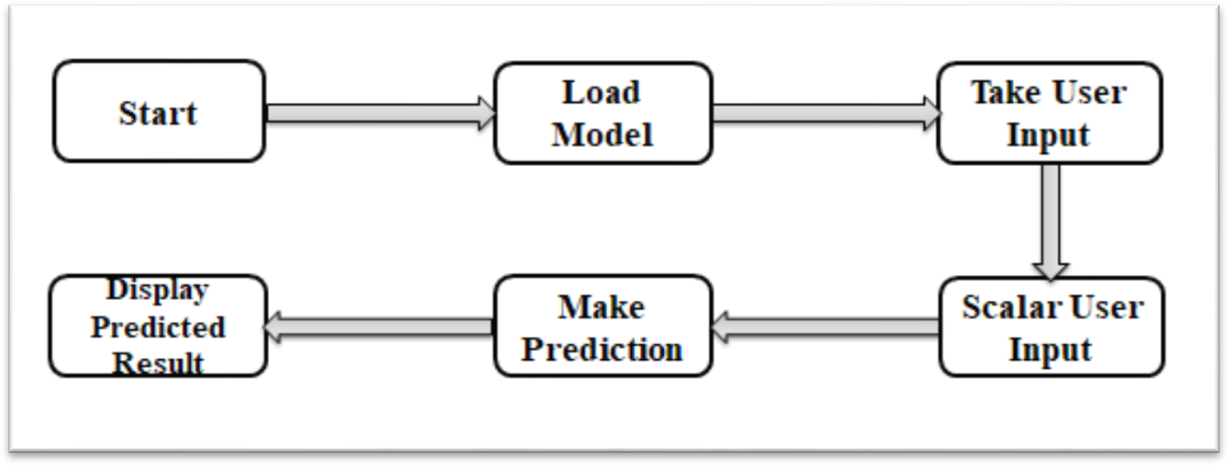

**Figure: - The Deployment Flow**

### Event Log

The System should log every event so that the user will know what process is running internally. Internal Step-By-Step Description

* In this Project we defined logging for every function, class.
* By logging we can monitor every insertion, every flow of data in database.
* By logging we are monitor every step which may create problem or every step which is important in file system.
* We have designed logging in such a way that system should not hang even after so many logging's, so that we can easily debug issues which may arises during process flow.

### Error Handling

Should errors be encountered, an explanation will be displayed as to what went wrong? An error will be defined as anything that falls outside the normal and intended usage.

## Performance

The use of South German bank credit data is used for the prediction of credit risk. So that it should be as accurate as possible. That’s why before building this model we followed complete process of Machine Learning. Here are summary of complete process:

* First we cleaned our dataset properly by removing all null value and duplicate value present in dataset and if not present leave the dataset as it is.
* Then we have to handle the outlier form the dataset so that it can’t effect on the accuracy. So in our dataset there is no outlier present.
* After that we have to scale down the whole dataset in between 0 & 1 with help of Standard Scalar. So that all the data come in one range
* Then we split the whole data set into train-test split with test size will be 25% of the whole dataset for the model training approach.
* After performing above step we ready for model training. In this step, we trained our dataset on different classification algorithm such as Logistic, SVM, RF, DT, Gradient Boosting, XG Boost, Light GBM and Bagging etc.
* After that we use oversampling technique so that our accuracy increases. In that we use ADASYN technique so that our target feature are became equal.
* Then again we fit the new over sampled data into the model and check again our accuracy of our model.
* After that we applied hyper-parameter tuning on all models which I have described above. The reason behind is that we can use best feature so that we get maximum accuracy.
* After that we select best model from the highest accuracy & then we saved the model in pickle file format for model deployment.
* After that our model is ready to deploy. We deployed our model in AWS cloud storage and Heroku platform.

### Reusability

We have done programming of this project in such way that it should be reusable. So that anyone can add and contribute without facing problem.

### Application Compatibility

The different component for this project will be using Python as an interface between them. Each component will have its own task to perform, and it is job of the Python to ensure proper transfer of information.

### Resource Utilization

When any task is performed, it will likely use all the processing power available until that function is finished.

### Deployment

We have deployed the project on AWS cloud & Heroku platform. In aws we use elastic beanstalk service for deployment



### User Interface

**Figure: - Deployment Platform**

We have created an UI interface for user by using HTML and CSS. In which we created two pages, In that 1st one is our main page and 2nd one is our result page.

1. Home Page

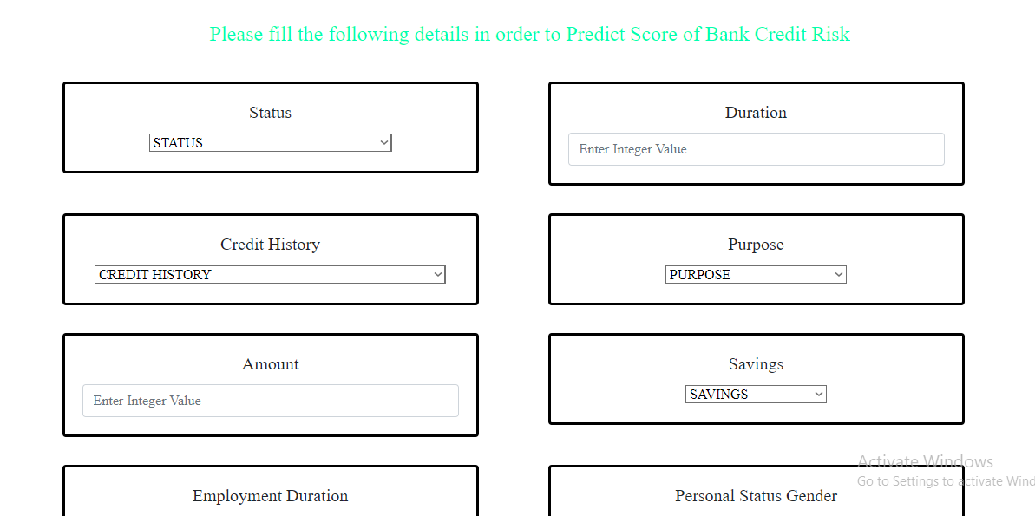

**Figure: - Front Page**

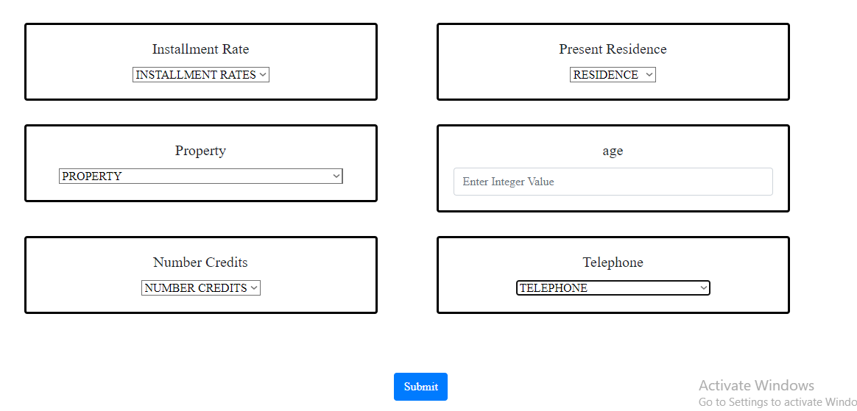

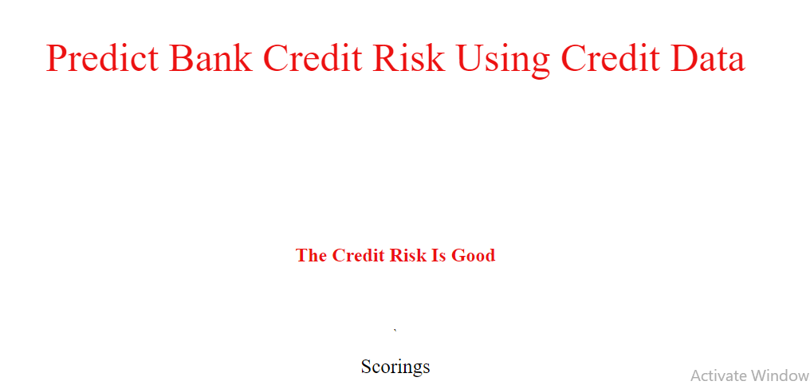

**Figure: - Result Page**

## 5. Conclusion

The Prediction of Credit Risk Using South German Bank Data application will find out the Credit Risk is good or bad. Here from that we decide that the given person eligible for bank loan or not of these.